Blind and Low Vision Education Network NZ

Te Kotuituinga Matauranga Pura O Aotearoa

From the

BLENNZ Board of Trustees

Tēnā koutou
Welcome to this edition of the BLENNZ Board of Trustees Newsletter. 2016 was an exciting year for BLENNZ with a number of events taking place. You can read more on what occurred during the year by accessing the 2016 Annual Report on the BLENNZ Website. We trust that you will enjoy the following highlights.

A hello and introduction from the BLENNZ Board of Trustees
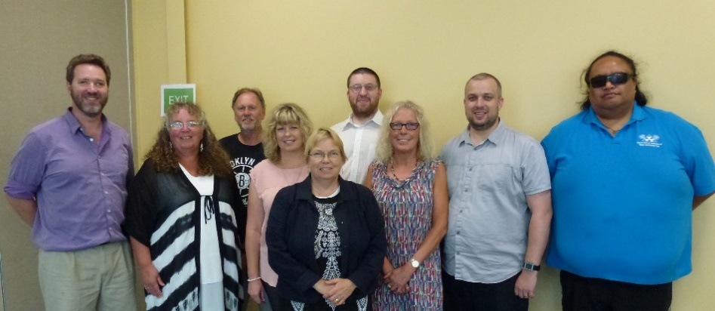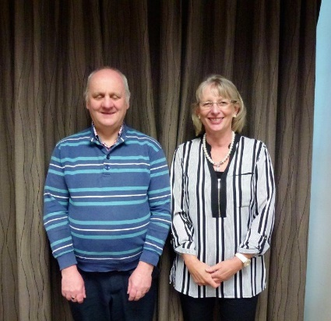
Back row – from left – Mitch Harris and Nathaniel Robson
Front row – from left – Jonathan Godfrey, Karen Stobbs (Principal), Letitia Patete, Gretchen Good, Jane Cox, Nathaniel Louwrens (Chairperson), Nigel Ngahiwi, On the right Neil Jarvis, Janny Cooke (BOT Secretary)
BLENNZ has a national board of trustees, which is representative of BLENNZ and of the wider blindness education sector.
The role of the BLENNZ Board is to govern the school, with a focus on providing an environment that fosters achievement for children and young people who are blind, deaf blind or low vision.

Board of Trustees Mid-term Elections 2017
Please consider standing for the BLENNZ Board of Trustees at the 2017 mid-term elections. The Returning Officer will post nomination forms to parents/caregivers of students on the BLENNZ Roll by Friday November 3rd. Voting day for two parent positions on the Board will held on the 1 December 2017.

Homai Campus School

Pukeko Class
In the spirit of the Special Olympics Pukeko Class made their own collage Olympic Flag. In physical education, they practiced gymnastics, javelin, shotput, running and discus.
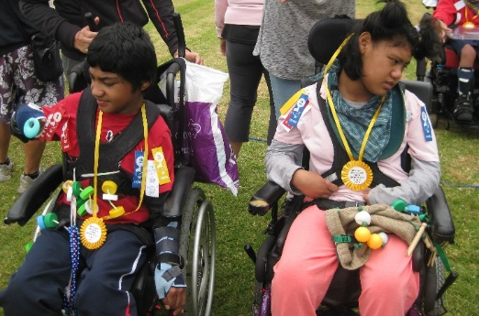
Kerred and Luliet after participating in the wheelchair race

Kiwi Class
Two students attended the Counties Manukau Ribbon Day Athletic Sports at Massey Park, Papakura participating in the assisted 50-meter walk. Two other students took part in the skittles, boccia, obstacle course and wheelchair races and were excited to receive their ribbons and rosettes.

Takahe Class
Took part in Halberg Junior Disability Sports Day. The students participated in blind cricket, swish and blind soccer. The coaches from the Manukau Sports in Schools team supported the students.

Weka Class
Worked hard with the Manukau Sports Team and also during class time so that they could take part in all the events in the Homai Olympics. One of the best events was in the ball-rolling event.

James Cook Satellite Class
Students had a healthy, fit start to the year being involved in training and competing in three athletic events. They participated in the James Cook athletic sports, the Special Olympics Sports day at Massey Park Papakura and the Auckland Secondary Schools athletics at Mt Smart Stadium.
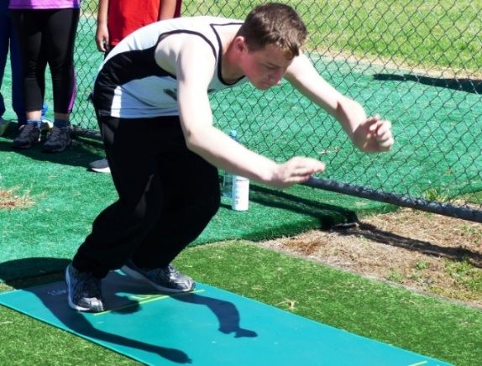
Carlton competing in the Standing Long Jump

Jumpstart
Had an exciting term 2 with rock climbing at Extreme Edge in Panmure, Auckland. They learnt how to attach the cable and climb the wall, stepping away from the climbing wall and returning to the ground by an automated cable.
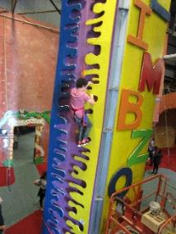

Kickstart
Had a great confidence boosting adventure with their trip to Waiheke Island where they experienced the thrill of Zip lining before experiencing the breathtaking walk back through forest to their base.
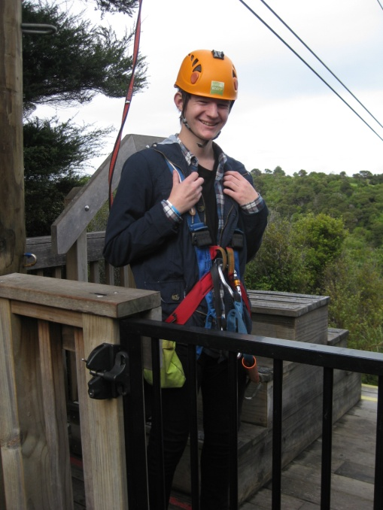
Tim ready to go Zip Lining

Nikau Hostel
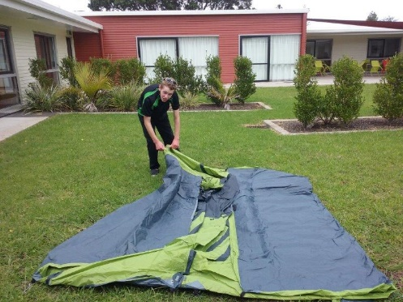
James pitching the tent

Throughout the year, Nikau Hostel hosted a number of social evenings inviting students from Kickstart. Each occasion also had a theme and they also included a quiz, informal concert and bingo night, a Halloween party and end of year BBQ. During the summer months Nikau hostel focused on outdoor activities, the students pitched tents in the Nikau courtyard and spent the night camped out followed by bacon and eggs for breakfast cooked by the students.

Assessment and Teaching:

Centre Highlights / Updates / Activities

Homai Early Childhood Centre

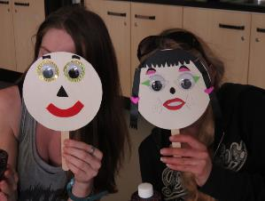
Proud whānau with their funny face resource
Whānau and staff combined their creativity to produce resources for ākonga to use at home and in the centre. Whānau also made sensory bottles with glitter drifting through liquid filled bottles, producing a calming effect for some and visual stimulation for others, especially when a torch light is shone through the bottle in a darkened room. This highlights the importance placed on working with whānau.

BLENNZ Northland Visual Resource Centre
The BLENNZ learner population has increased in Northland so has the number of Resource Teachers Vision – the team are Kate Mabbett, Sue Fletcher, Louise Pyne, Hera McNeill and Kataraina Moore. Later in 2017, the team will hopefully be moving to a refurbished area at Tikipunga High School, which will provide much needed space for a range of activities.

BLENNZ Auckland North
The learners from BLENNZ Auckland North received invitations from Tim Bray Productions to attend audio-described performances at The PumpHouse Theatre in Takapuna. For some of our learners the trip to see these shows was their first experience of live theatre. Ongoing attendances at similar productions are planned.
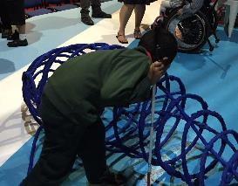
A young learner explores the wire shape that represents a whale

BLENNZ Auckland South
“Aspiring for a bright future – the Aspire Lifeskills Group”
Year 9, 10 and 11 “Aspire Lifeskills Group” was established to build an awareness of employment skills and begin planning for the transition beyond school. The group of 11 students met once per term to complete role-play activities to build their confidence, body language awareness and communication, whilst co-operative games and activities highlight personal strengths. In-between trips, students worked 1:1 with their RTV to increase their vocabulary knowledge, set personal goals and create a step-by-step CV.
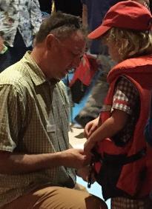
Young learner tries on a life jacket, one of the props used in the show.

BLENNZ Hamilton
Ran a number of low vision awareness workshops in classrooms. They received excellent feedback from these workshops, with two classroom teachers taking the learning opportunities further and publishing the students’ comments to their class blogs. BLENNZ students participated at varying levels, according to age with one student prepared a Powerpoint presentation using JAWS and taking the lead role in delivering the workshop.
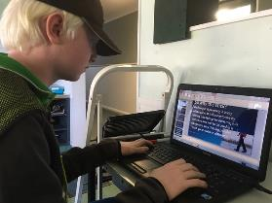
Brayden using JAWS and Powerpoint to edit his workshop presentation.

BLENNZ Tauranga
Welcomed 13 participants from over the Tauranga region to an In-service for teachers, teacher aides and other professionals working with students with additional needs. The audience were very enthusiastic and throughout the in-service asked relevant questions about the learners, they work with. This partnership with the local services is very important for all.

BLENNZ Gisborne
Over the year, the Resource Teachers Vision participated in a range of Professional Development opportunities. This has enabled the RTVs to successfully trial and apply for appropriate assistive technology for learners who are low vision or blind, using the Student Environments Tasks and Tools process.
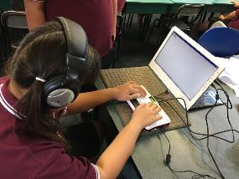
A BLENNZ learner writing on her Braille Sense U2

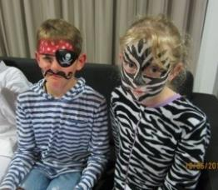
Getting Dramatic

BLENNZ Napier
Two intermediate aged learners attended the ‘Interact, Getting Dramatic’ Immersion Course held in June. In addition to attending a production of The Elephant Thief, the learners explored elements of theatre, costuming, improvisation, and make-up. Through this experience, the learners gained confidence in the Expanded Core Curriculum areas of: social skills, life skills, physical skills, and communication.

BLENNZ Taranaki
Kay Daly - Specialist Developmental Orientation and Mobility Instructor worked with BLENNZ Taranaki staff and learners. One teacher has been on the DOM Supporters course and others have embraced the new O&M knowledge that they have gained from Kay.
O&M is now a regular part of learner’s school programmes.
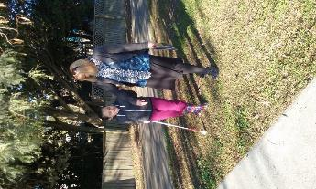

BLENNZ Palmerston North
Staff reviewed their existing Little Sensory Room equipment based on the work of Roman-Lantzy to achieve success for their young learners with Cortical Vision Impairment. These rooms promote object conceptualization, self-identification and spatial relations for these learners.
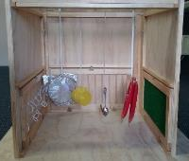
Little Sensory Room

BLENNZ Wellington
O&M in Action – Team Collaboration – An RTV completed his Massey DOM Community Supporters Certificate. As part of team collaboration, the RTV worked with a secondary school student twice a week to both practise and grow the student’s mobility skills. This expertise will support our centre in many ways.
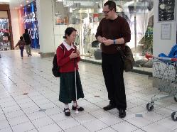
RTV and Student talking in shopping mall

BLENNZ Nelson
Oliver, a year 5 student with Optic Nerve Hypoplasia, recently landed the lead role in the Nelson Youth Theatre performance of Oliver! Rehearsals that were held in the evening and spanned over 3 months, an arduous task for a student whose levels of fatigue would already be significant. The only accommodation Oliver requested was large print in order to learn his lines, although with the glare of theatre lights and no glasses he would have been working extremely hard during performances.

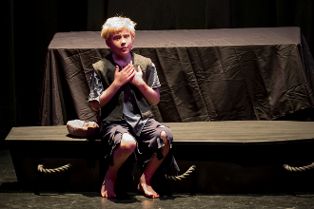
Oliver performing as Oliver in Oliver

BLENNZ Christchurch
BLENNZ Christchurch continues to make the most of their larger facilities by running various programmes for their learners; including music, social and preschool/parent groups. These are exciting and stimulating sessions for all.
This year they started an “iPad Only Club”.

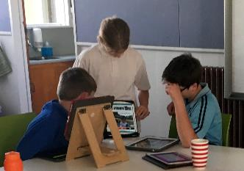
Lily-Kate sharing information with other students

BLENNZ Otago
In term 4, Harry attended his first Immersion Course at Homai. He had an unforgettable start to the week with his first flight and the opportunity to sit in the cockpit.
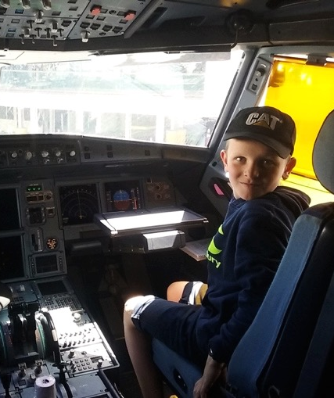

‘A ‘Digitally Speaking’ immersion course for 9-13 year olds was held to share skills about technology. They looked at QR coding, transferring information between devices, bookmaking and touch-typing among many other things. The four days were packed full of activities, which the students approached with energy and enthusiasm.

BLENNZ Southland
A student from BLENNZ Southland also attended the “Interact: getting dramatic” Immersion course. Students went to the play - “The Elephant Thief” and, commented that “Having the touch tour meant I could visualize what the characters looked like in the show. It was good to meet the actors first as it made it easier to understand what/who they are.”
The course gave the student confidence in speaking up and she learnt how to work better with her nerves. This enabled her to more confidently deliver a speech to her class and to read her children’s story aloud with ease.

BLENNZ National Assessment Service
The BLENNZ National Assessment Service (NAS) provides support to 14 Visual Resource Centres located throughout NZ by offering assessment both at Homai Campus, as well as locally in the regions.
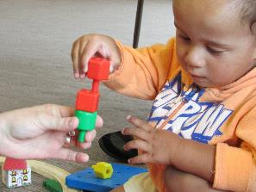
Stacking peg-board pegs
The NAS team had an away trip to Palmerston North and assessed 25 learners over three days. The purpose of regional visits is to support the local team by working collaboratively, sharing information and strategies to enhance outcomes for learners.

BLENNZ Immersion
The purpose of Immersion Courses is to bring groups of learners together to introduce and further develop skills and knowledge in areas of the regular and expanded core curriculum together with complementing local service delivery. Parents accompany their child to courses up to the age of eight and in some circumstances to courses beyond this age.
A range of courses is provided based on learner needs nationally.

BLENNZ DOM
BLENNZ Developmental Orientation & Mobility Services are part of the everyday education of the BLENNZ learner. The BLENNZ Developmental Orientation & Mobility Instructor works alongside the Resource Teacher Vision (RTV's), the learner and other team members involved with that learner. The aim of the service is to provide optimum opportunities for the learner to continue to become as independent and confident in moving as possible.

Homai Campus Music School
The Music School once again enjoyed strong enrolment numbers with 22 students regularly attending. The sense of community amongst the students is evident in their interactions together. One new element added to the programme was an extended lunch break to provide opportunity for informal music making and social skills practice.

Homai School Music Therapy
Seven group and five individual therapy sessions were provided every week for the students. The aim of each session is to support students to attain Expanded Core Curriculum goals through the use of music.

Te Whānau o Homai
Te Whānau o Homai continues to support and promote the educational and developmental needs of Tamariki kāpo.

Youth Library
The Youth Library is based at BLENNZ Homai Campus School and is administered by the Blind Foundation. We have two enthusiastic librarians on site who provide a point of contact for teaching staff and teacher aids throughout New Zealand to request educational items for school children.

Thank you, we hope you enjoyed these highlights.
From the BLENNZ Board of Trustees

