Blind and Low Vision Education Network NZ

Te Kotuituinga Matauranga Pura O Aotearoa

A National Network of Services for Children and Young People

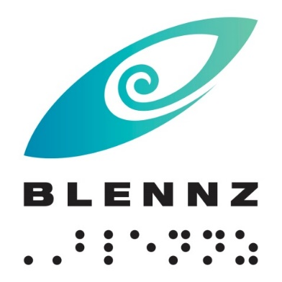

2018 Charter

Strategic Overview
Vision - Every BLENNZ ākonga is well prepared to achieve in life
Mission - To enable ākonga who are blind, deafblind or have low vision to reach their full potential, BLENNZ provides quality education and specialist teaching services in partnership with whānau, educators and the wider community

Beliefs | Values
- Parents and whānau are the prime educators in their child’s learning  - Education is focused on the ākonga within the context of whānau, community and culture  - Learning occurs through active engagement in meaningful environments  - Ākonga have unique needs requiring specialist learning and teaching approaches  - Ākonga have the right to equitable access to education  - Ākonga have a right to belong and to realise their potential as participating and contributing members of society  - Team collaboration promotes positive outcomes for ākonga | BLENNZ whānau includes ākonga, their whānau, educators and the wider community.  Whanaungatanga  At BLENNZ we demonstrate whanaungatanga through valuing people by building relationships with whānau, prioritising time to get to know them and establish connections.  Manaakitanga  At BLENNZ we elevate the mana by showing respect for their emotional, spiritual, cultural, physical and mental wellbeing in the way we welcome, nurture and nourish them.  Awhinatanga  At BLENNZ we demonstrate awhinatanga through the spirit in which we engage and empathise with each other by assisting the learning of ākonga and whānau.  Kotahitanga  At BLENNZ we demonstrate kotahitanga through striving to reach consensus and unity of purpose, while acknowledging and respecting individual differences and perspectives.  Ako  At BLENNZ we demonstrate ako through creating opportunities where we can learn from each other, recognising that everybody brings knowledge and that ākonga and whānau are intertwined.

2016 – 2019 Strategic Goals and 2018 Annual Plan Objectives
Goal 1: All learners are supported by BLENNZ to achieve their full potential through the use of evidence-based practice. | Goal 2: Ākonga progress and achievement is enriched through the building and strengthening of effective learning-centred relationships with each ākonga’s whānau. | Goal 3: Learning is enhanced through the appropriate use of BLENNZ resources, systems and organisational relationships.
- Undertake professional learning to strengthen the skills of curricula leaders in the inquiry process:  - lead and mentor others in inquiry  - complete the development of a guideline to support inquiry within BLENNZ  to enable improved teaching and learning outcomes.  - Focus on numeracy achievement of ākonga by:  - Identifying the achievement outcomes in numeracy for a cohort of ākonga  - Collating resources and  - Providing professional development.  Implement the:  - Online curricula hubs to become the repository of BLENNZ resources and evidence base.  - Homai Early Childhood Centre strategic path through a teacher led inquiry model.  - Residential programme pathways for transition using an evidence based approach. | Communication:  - The Board will initiate regional consultation with a view of hearing the voice of whānau.  - All team leaders embed the provision of a biannual team newsletter and an annual regional whānau event in practice.  - Establish and initiate an online content development work plan reflecting the needs of whānau.  Capability Building:  - To raise awareness of and increase the cultural competency of the BLENNZ te4aching team.  - Collaborate with education and health teams in an initiative to inform the development of parent leadership in visioning and goal setting.  - A teaching team will engage in the ‘my working world’ programme to enhance their reflective practice resulting in stronger professional and parent relationships. | Partnerships:  - Initiate work, with Blind Foundation, to inform a collaborative approach to transition.  - Work with fundholders to develop and trial an approach to enhance outcomes of ākonga who have learning needs which are complex in nature.  - Organise and facilitate a Sector workshop to inform practice in modern learning environments.  - Collaborate with international & national partners to inform effective practice for assessment and intervention with ākonga who have CVI.  Staff:  - Further develop induction resources.  - Develop a PLD framework to support policy  - Develop recommendations for VI Post Grad course.  - Initiate a national AFM system of support  - Develop a database of ākonga who are deafblind.  Property:  - Implement property agreements with MOE  - Progress the sensory schools capital works program.  - Refurbish the BLENNZ Homai Campus swimming pool.

We will achieve this by ensuring each ākonga learning is informed by: | We will achieve this through: | We will achieve this by:
- The use of evidenced based tools and processes that inform learning in the Expanded Core Curriculum.  - BLENNZ teachers who clearly demonstrate evidence based practice across the Expanded Core Curriculum. | - BLENNZ providing effective communication and consultation with whānau.  - Staff who provide parents and whānau with access to information about BLENNZ and other established networks where appropriate.  - Staff who recognise parents and whānau as the primary educator. | - BLENNZ fully utilising the Network to support provision of a consistent service.  - Providing professional development to support the development of succession and leadership across the teaching team.  - Resources to support learning are available, well managed and able to be accessed across the network.  - Learning environments are appropriate for BLENNZ learners.

Annual Plan 2018
Goal 1:
All learners are supported by BLENNZ to achieve their full potential through the use of evidence-based practice
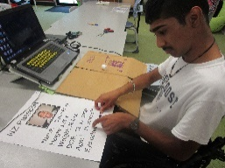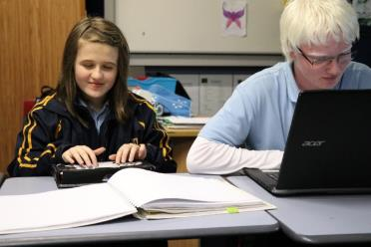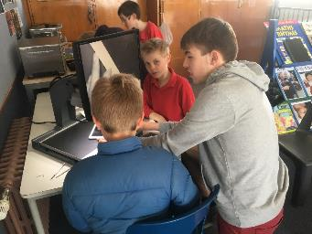

Objective 1: Undertake professional learning to strengthen the skills of curricula leaders in the inquiry process.
Objective 2: Focus on numeracy achievement of ākonga.
Objective 3: Implement the online hubs which become the repository of curricula/pedagogical resources and base for learning communities.
Objective 4: Homai Early Childhood Centre strategic path through a teacher led inquiry model.
Objective 5: Residential programme pathways for transition using an evidence based approach.

Goal 2:
Learner process and achievement is enriched through the building and strengthening of effective learning-centred relationships with each learner’s whānau.
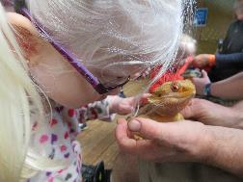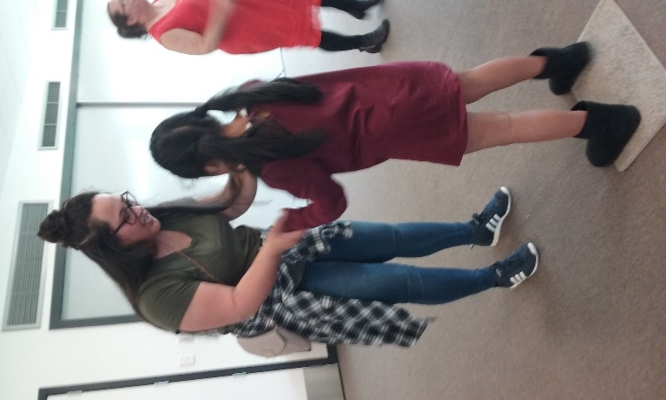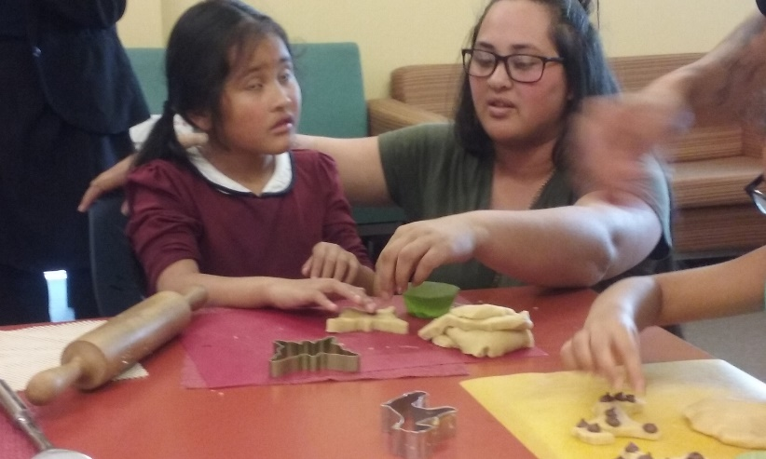

Objective 1: The Board will initiate regional consultation with a view to hearing the voice of whānau.
Objective 2: All team leaders will embed the provision of a biannual team newsletter and an annual regional whānau event in practice.
Objective 3: Establish and initiate an online content development work plan reflecting the needs of whānau.
Objective 4: Raise awareness of an increase the cultural competency of the BLENNZ teaching team.
Objective 5: Collaborate with education and health teams in an initiative to inform the development of parent leadership in visioning and goal setting – Now and Next.
Objective 6: A teaching team will engage in the ‘my working world’ programme to enhance their reflective practice resulting in stronger professional and parent relationships.

Goal 3:
Learning is enhanced through the appropriate use of BLENNZ resources, systems and organisational relationships.
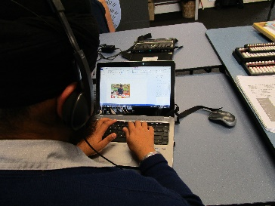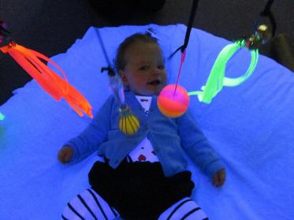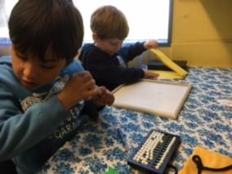
Objective 1: Initiate work with Blind Foundation, to inform a collaborative approach to transition.
Objective 2: Work with fundholders to develop and trial an approach to enhance outcomes of ākonga who have learning needs which are complex in nature.
Objective 3: Organise and facilitate a Sector workshop to inform practice in modern learning environments.
Objective 4: Collaborate with international and national partners to inform effective practice for assessment and intervention with ākonga who have CVI.
Objective 5: Further develop induction resources for staff.
Objective 6: Develop a PLD framework to support policy.
Objective 7: Develop recommendations for VI Post Grad course.
Objective 8: Establish a resource cataloguing system.
Objective 9: Initiate a national AFM system of support.
Objective 10: Develop a database of ākonga who are deafblind.
Objective 11. Implement property agreements with the Ministry of Education.
Objective 12: Progress the Sensory Schools Capital Works programme.
Objective 13: Refurbish the BLENNZ Homai Campus Swimming Pool.

Contact Information:

BLENNZ Board Chairperson:

Mobile: 021 566 295
Email: BOT.Chair@Blennz.school.nz

BLENNZ:
Email: Admin@blennz.school.nz
Facebook: https:www.facebook.com/blindandlowvisioneducationnetworknz/
Twitter: @BLENNZOnline
BLENNZ ICT: info@blennz.school.nz

BLENNZ education services are provided from 14 locations including:
- BLENNZ Homai Campus, Manurewa, Auckland
  - Homai Campus School and satellite class at James Cook High
  - Residential Service
  - Homai Early Childhood Centre
  - Auckland South Visual Resource Centre
- Northland Visual Resource Centre, Manaia View School, Whangarei
- Auckland North Visual Resource Centre, Marlborough Primary School, Glenfield
- Hamilton Visual Resource Centre, Hamilton North School, Hamilton
- Tauranga Visual Resource Centre, Bethlehem, Tauranga
- Gisborne Visual Resource Centre, Riverdale School, Gisborne
- Napier Visual Resource Centre, Henry Hill School, Napier
- Palmerston North Visual Resource Centre, Somerset School, (moving to Awapuni School in 2018) Palmerston North with outpost at Keith Street School, Wanganui
- Taranaki Visual Resource Centre, New Plymouth Girls High School, New Plymouth
- Wellington Visual Resource Centre, Kelburn Normal School, Wellington
- Nelson Visual Resource Centre, Nelson Intermediate School, Nelson
- Christchurch Visual Resource Centre, Burnside, Christchurch with outposts at Oceanview Heights School, Timaru and Cobden School, Greymouth West Coast
- Otago Visual Resource Centre, Dunedin North Intermediate School, Dunedin
- Southland Visual Resource Centre, Ascot Community School, Invercargill.

BLENNZ Web:
Blind and Low Vision Education Network NZ

Vision

Every BLENNZ ākonga is well prepared to achieve in life

Mission

To enable ākonga who are blind, deafblind or have low vision to reach their full potential, BLENNZ provides quality education and specialist teaching services in partnership with whānau, educators and the wider community.

