Blind and Low Vision Education Network NZ

Te Kotuituinga Matauranga Pura O Aotearoa

From the

BLENNZ Board of Trustees – Term 1, 2018

Introduction

Tēnā koutou
Welcome to this edition of the BLENNZ Board of Trustees Newsletter – Term 1, 2018.
This newsletter is to introduce the BLENNZ Board and to outline its direction for 2018.

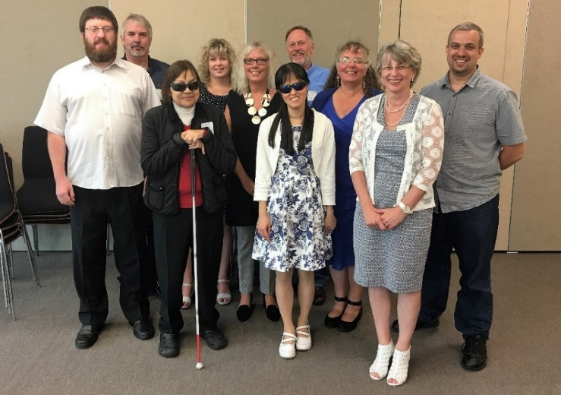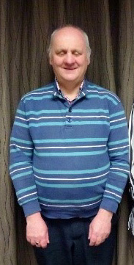

Meet the Board of Trustees
Back row from left – Graeme Hood, Letitia Patete, Mitch Harris
Middle row from left – Nathaniel Robson, Jane Cox, Karen Stobbs, Nathaniel Louwrens
Front row from left – Sarndra Tamepo, Wendy Chiang, Janny Cooke (Board Secretary) Right: Neil Jarvis

BLENNZ has a national board of trustees, which is representative of BLENNZ and of the wider blindness education sector.

The role of the BLENNZ Board is to govern the school, with a focus on providing an environment that fosters achievement for children and young people who are blind, deaf blind or low vision.

Members and roles
Nathaniel Louwrens – Board Chair and Visual Resource Centre Elected Parent Trustee
Nathaniel Robson – Deputy Chair and Visual Resource Centre Elected Parent Trustee
Letitia Patete – Visual Resource Centre Elected Parent Trustee
Mitch Harris – Homai Campus School Elected Parent Trustee
Graeme Hood – Visual Resource Centre Elected Parent Trustee
Jane Cox – Staff Elected Trustee
Neil Jarvis – Appointed, Royal New Zealand Foundation of the Blind known as the Blind Foundation
Wendy Chiang – Appointed, Association of Blind Citizens of NZ Inc
Sarndra Tamepo – Appointed, Tangata Whenua
Karen Stobbs – Principal

A Snap-shot showing roll numbers across the regions as at the end of term 1, 2018
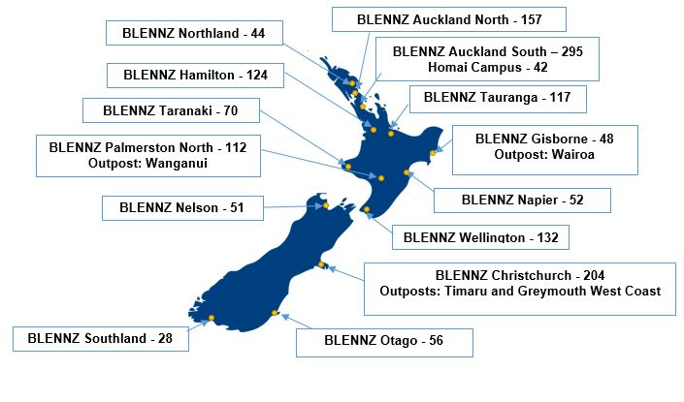

Board Direction for 2018

Consultation
The Board has developed a consultation plan in which they will visit a cross section of regions across the network over a three-year cycle. Over term 2, the Board will be undertaking its consultation process with the BLENNZ parent community. Areas to be covered are Auckland North, Waikato, Bay of Plenty and Southland. More information regarding the up-coming consultations in these areas will be provided early in term 2.

At the April 6th Board meeting, the Board will be determining the focus for their consultation this year.

BLENNZ Charter
Please find attached a copy of the BLENNZ Charter (abridged version). You will note the three key goals and what the team will be working on for the 2018 year.

During the start of the New Year, there is normally a drop in roll numbers from the end of the previous year, which picks up as the New Year commences.

An Introduction to the Board

Nathaniel Louwrens - Chairperson
I am married to Rebecca and together we have five children, two of whom are supported by BLENNZ. I have a background in education as a secondary teacher, and professional development facilitator to schools, so have a good understanding of the education sector. I am currently working in the tertiary sector as an Educational Designer. It is a pleasure to serve the BLENNZ community again, in my second term on the Board of Trustees.

Nathaniel Robson – Deputy Chairperson
I am a parent-elected member of the BLENNZ Board of Trustees, having been on the Board since 2013. I served at Chairperson in 2015-6 and have been deputy Chair since then. I have a daughter who BLENNZ supports with her moderate vision education needs. I am an economist by training and teach at Victoria University of Wellington.

Letitia Patete
Kia ora, my name is Letitia Patete and I am currently a parent representative of the BLENNZ board. I have an 18-year-old daughter who is blind and is currently attending Transition Services at Homai, which is very exciting.
I have been on the BLENNZ Board since December 2013 but I was also previously a member of the Homai Board. I was also chairperson of the Vision Education Agency (which formed BLENNZ), chairperson of the Wellington Resource Centre Committee and a PVI Representative.
I am currently a Human Resources Adviser, but I also have over 15 years office management and financial experience.
I love being part of the BLENNZ Board and contributing in a positive way to bring to life the national network that we all desire and an equitable education for all blind and low vision students in Aotearoa.

Graeme Hood
I am Graeme Hood and live in Taranaki along with my wife and two sons, one who has just started university and the younger who has just started secondary school and is on the BLENNZ role.
I have over 30 years’ experience in secondary education, the last 11 years being in senior management (Principal and Deputy Principal roles). Currently I am employed in tertiary education and I am a keen advocate of using digital technology to both enhance and motivate student learning.
As a parent representative, I want to ensure that the viewpoint of parents who have children on the BLENNZ role are represented at Board level and that this stakeholder group is kept well informed.
Like all our parents, I want the best for our children so they can achieve and become lifelong learners. In working with the board and school, I want to ensure that the BLENNZ vision is realised; “Every BLENNZ learner is well prepared to achieve in life”.

Mitch Harris
Mitch Harris is the father of three daughters, one of whom attends BLENNZ Homai School. He has spent most of his life managing and programming radio stations and networks. Mitch has worked extensively in New Zealand, Australia and the UK providing training programmes and strategic management advice. He currently hosts the 8pm-midnight nationwide talk show on Radio Live. As well, Mitch is interested in organic food production and manufactures a range of organic cooking stocks. He is an avid reader and semi-retired surfer.

Jane Cox
My name is Jane Cox and I have been the Staff Trustee on the BLENNZ Board since 2013. I enjoy working in a collaborative and consultative manner with fellow Board members and I am currently on the following committees:
- RAMS (Risk Assessment Management System)
- Finance
- Swimming Pool Upgrade
I joined BLENNZ in 2002 initially as a Resource Teacher: Vision, then as a Senior Teacher. For the past 8 years’ I have been the Manager of the BLENNZ Christchurch Visual Resource Centre.
I am active within the wider vision community and am a Director on the Lighthouse Vision Trust Board, which focuses on making equipment and technology available to members of the blind and low vision community.

Neil Jarvis
Neil Jarvis is the Appointee of the Blind Foundation, and first joined the BLENNZ Board in 2012.
Neil is General Manager Strategic Relations at the Blind Foundation, where he has worked in various roles since 2004.
Neil is blind. He has 30 years’ experience working in the not-for-profit, public and private sectors in the UK and New Zealand. This included a stint working for, and later Chairing the Board of the Greenwich & Lewisham Young People’s Theatre in London. This theatre company specialized in youth theatre and theatre in education.

Wendy Chiang
Wendy is Blind Citizens NZ’s appointed representative to the BLENNZ Board of Trustees. Auckland-based since 1995, Wendy was mainstream educated as a low vision student and has completed tertiary qualifications in education, psychology and public health. Currently, Wendy works as the Community Worker at Auckland Disability Law.

Sarndra Tamepo
Ko Ngāti Porou me Ngāti Awa oku iwi;
No Kawerau ahau;
Ko Sarndra Tamepo toku ingoa.
I came to live in Tamaki Makaurau 15 years ago when I lost my sight due to complications with diabetes. I became a registered member of the Blind foundation then and gained a certificate in adaptive technology in 2003. In 2004, I attended AUT and in 2010, graduated with a B.Sc. majoring in counselling. I was the recipient of a kidney in 2011 and have enjoyed my whangatanga, for the last 7 years with a disability organisation and trustee of, in South Auckland, called Te Roopu Waiora.
I look forward to a productive and pro-active association with the BLENNZ board and hope to be a supportive and constructive member of this group.

Karen Stobbs - Principal
Ko Aoraki te maunga,
Ko Waimakariri te awa
Ko Otautahi wā kāinga
Ko Karen Stobbs ahau
Ko au te Tumuaki o BLENNZ.

I have been privileged to have worked in this field for many years. Initially training as a primary school teacher, I went on to work in a range of settings including early childhood, primary and secondary. To be in education you need to believe in the positive potential that exists within each of us to learn and grow. This is also true of organisations. From both a BLENNZ and an individual perspective, I believe we need to continue to keep pushing the boundaries, facilitating truly inclusive learning environments that foster a belief in what might be possible, raising expectations, in a system that is flexible enough to meet changing need over time. I truly value being part of an organization that walks alongside people over an extended period. That realizes the importance of hearing the voice of ākonga, parents and professionals, knowing that it takes multiple perspectives to achieve great outcomes, and works purposefully to place tamariki and whānau at the centre of our decision making.

Board meeting dates for 2018:
23 February, 6 April, 22 June, 24 August, 26 October, 7 December

