Blind and Low Vision Education Network NZ

Te Kotuituinga Matauranga Pura O Aotearoa

From the BLENNZ Board of Trustees – Term 4, 2018

Introduction

October 2018

Tēnā koutou

Welcome to this second 2018 BLENNZ Board of Trustees Newsletter.

Since the Term 1, Board Newsletter two changes have occurred in the membership of the Board.

In April 2018 Neil Jarvis, Appointed Trustee, Blind Foundation signalled his departure as he would be leaving the Blind Foundation. Neil was replaced by Catherine Rae, National Manager Independent Living, Blind Foundation.

Sarndra Tamepo, Tangata Whenua Appointed Trustee signalled her departure from the Board effective from the 31st July 2018. Sarndra was replaced by Nigel Ngahiwi who had previously served as a member on the BLENNZ Board.

The Board acknowledged and thanked Neil and Sarndra for their commitment and dedication during their time as members of the BLENNZ Board of Trustees.

Members and roles:
Nathaniel Louwrens – Board Chair and Visual Resource Centre Elected Parent Trustee
Nathaniel Robson – Deputy Chair and Visual Resource Centre Elected Parent Trustee
Letitia Patete – Visual Resource Centre Elected Parent Trustee
Graeme Hood – Visual Resource Centre Elected Parent Trustee
Mitch Harris – Homai Campus School Elected Parent Trustee
Jane Cox – Staff Elected Trustee
Catherine Rae, Appointed member, Royal New Zealand Foundation of the Blind known as the Blind Foundation
Wendy Chiang – Appointed member, Association of Blind Citizens of NZ Inc.
Nigel Ngahiwi – Appointed member, Tangata Whenua
Karen Stobbs – Principal

2018 Board Consultation
During April, May and June the Board undertook a number of Community Consultations across the country plus two ākonga focus groups - one in May and the second on the 30 July. The Board valued meeting with the parents and ākonga and to have had the opportunity to engage with staff across the six Visual Resource Centres.

2017 Annual Report
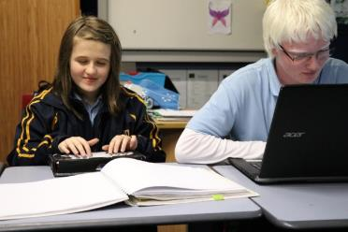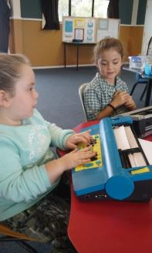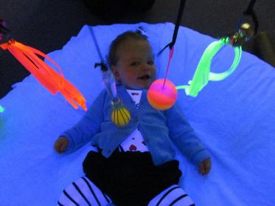

The 2017 Annual Report was prepared and filed with the Ministry of Education on the 31 May 2018.
Some highlights from the report include:
- Learner Achievement from the Homai Campus School
- Early Childhood Centre and Visual Resource Centres
- Immersion courses
- Developmental Orientation and Mobility
- Homai Campus Music School and Music Therapy Programme
- Te Whānau O Homai
- Blind Foundation Youth Library
The Annual Report can be located on the BLENNZ Website under “All About BLENNZ”, “Our Board of Trustees” where you can access and read the achievements of ākonga.

Board Strategic Priorities Identified for 2019
- Transition - from secondary school through to life beyond school
- Succession – staff planning
- Wellbeing of Ākonga

School Board Triennial Elections 2019
The School Board of Trustees Triennial Elections will take place in 2019. The proposed election time line is as follows:
Close Main Roll Wednesday 8 May
Call for Nominations by Friday 10 May
Close of Supplementary Roll Wednesday 22 May
Nominations Close 24 May
Voting Papers Sent by 29 May
Election Day 7 June
Vote Count 13 June
Board Takes Office 14 June

Please consider standing for the BLENNZ Board of Trustees at the next elections. You can make a difference in the education of children who are blind, deafblind or have low vision by becoming a trustee on the BLENNZ Board.

The BLENNZ Board is a national board made up of members from throughout New Zealand. Six meetings are held throughout the year plus one Board Strategy day held on a Saturday normally in August. Board meetings are held in Auckland at the Homai Campus starting at 12.30pm and finishing at 4.00pm. Trustees from out of Auckland are provided with return airfares and when necessary accommodation. All trustees receive an attendance fee for each Board meeting attended.

BLENNZ also has the Homai Early Childhood Centre on the Homai campus. This is a licensed centre attended by young children from within Auckland and as a national resource for early childhood immersion courses. Because of current legislation, this centre is currently governed under a separate trust and trust board, the Homai Early Childhood Centre Education Trust (HECCET) Board of Trustees. Seven members of the BLENNZ Board serve on the Trust Board and attend meetings three times a year. These meetings occur on the same day as the BLENNZ Board meetings and are held at 11.00am.

Board meeting dates for 2019:
22 February – HECCET / BLENNZ.
29 March - BLENNZ
21 June
23 August - HECCET / BLENNZ. 24 August BOT Strategy Day
2 November - BLENNZ
6 December – HECCET / BLENNZ

The BLENNZ Board of Trustees wishes to you Merry Christmas and a Safe and Happy Holiday Season

