Blind and Low Vision Education Network NZ

**Te Kotuituinga Matauranga Pura O Aotearoa**

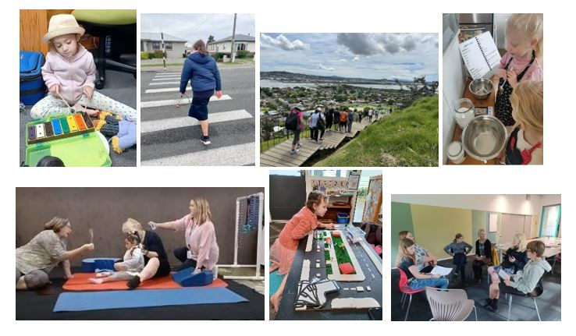

**A National Network of Services for Children and Young People**

**2024 Charter**

This document describes the services and structure of BLENNZ and can be read in association with:

* 2023 – 2025 Strategic Plan and
* 2024 Annual Plan.



Contents

BLENNZ Homai National Campus 3

Where are we located regionally 4

BLENNZ Board of Trustees 6

Who we are 6

Intent ………………….. 8

Resourcing 9

BLENNZ Services 9

School Services 9

Homai Campus School 9

James Cook High School Satellite 10

Tamaoho Satellite 10

Scott Point Satellite 10

Future Satellite Provision 10

Regional Services 10

Visual / Sensory Resource Centres 10

Early Learning Services 11

Specialist Services including DOM 12

Residential Services 12

Immersion Courses – Short Term 12

Transition Programmes  - Long Term Immersion 13

Residential ……………………………………………………………………………………………………………………………………………….. 13

National Services 13

Assessment Services 13

AFM Library Service and Production Service 14

Administration Services 14

Property ……………………………………………………………………………………………………………………………………………………. 14

Health, Safety and Wellbeing 19

Guiding Documents - All 19

## BLENNZ Homai National Campus

Our national campus in South Auckland, our networks turangawaewae, is where you will find BLENNZ Homai Campus Specialist School and Residential Hostels – Nikau Whare and Titoki as well as the Bach. The campus also has facilities for our Assessment Services, Early Learning and Administration services.

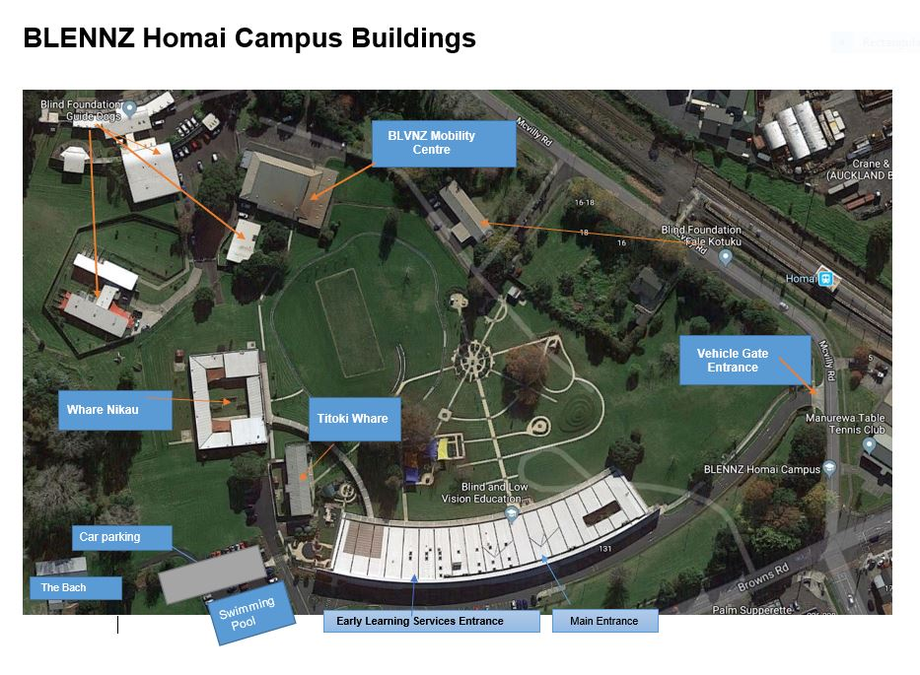

## Homai Campus School

## Where are we located regionally

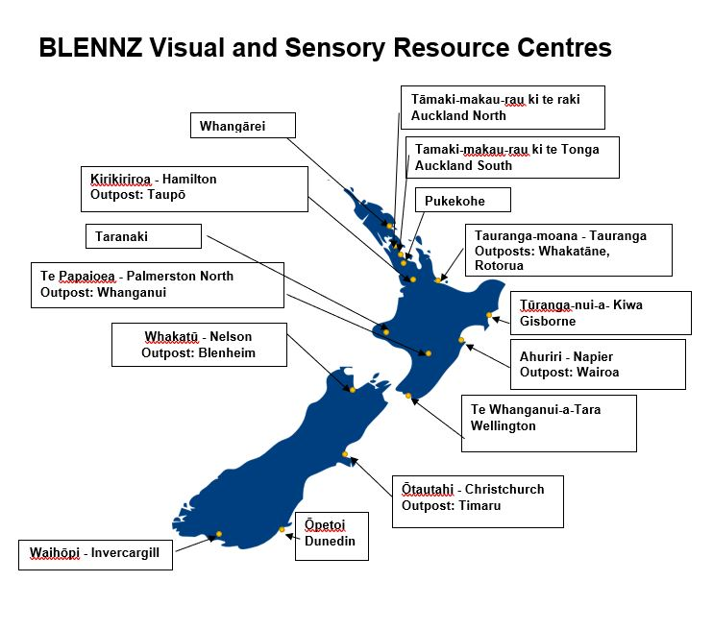

| **Vision** **- Every BLENNZ ākonga is well prepared to achieve in life** |
| --- |
| **Mission - To enable ākonga who are blind, deafblind or have low vision to reach their full potential, BLENNZ provides quality education and specialist teaching services in partnership with whānau, educators and the wider community** |

| **Beliefs** | **Values** |
| --- | --- |
| * Parents and whānau are the prime educators in their child’s learning. * Education is focused on the ākonga within the context of whānau, community and culture. * Learning occurs through active engagement in meaningful environments * Ākonga have unique needs requiring. specialist learning and teaching approaches. * Ākonga have the right to equitable access to education. * Ākonga have a right to belong and to realise their potential as participating and contributing members of society. * Team collaboration promotes positive outcomes for ākonga. | BLENNZ whānau includes ākonga, their whānau, educators and the wider community.  **Whanaungatanga**  At BLENNZ, we demonstrate whanaungatanga through valuing people by building relationships with whānau, prioritising time to get to know them and establish connections.  **Manaakitanga**  At BLENNZ, we elevate mana by showing respect for the emotional, spiritual, cultural, physical and mental wellbeing in the way we welcome, nurture and nourish people.  **Awhinatanga**  At BLENNZ, we demonstrate awhinatanga through the spirit in which we engage and empathise with each other by assisting the learning of ākonga and whānau.  **Kotahitanga**  At BLENNZ, we demonstrate kotahitanga through striving to reach consensus and unity of purpose, while acknowledging and respecting individual differences and perspectives.  **Ako**  At BLENNZ, we demonstrate ako through creating opportunities where we can learn from each other, recognising that everybody brings knowledge and that ākonga and whānau are intertwined. |

## BLENNZ Board of Trustees

Chairperson and Visual Resource Centre Parent Elected Trustee: Christopher Gunn

Principal: Karen Stobbs

Staff Elected Trustee: Tracey O’Sullivan

Homai Campus School Trustee – Justine Edwards - Selected

Visual Resource Centre Parent Elected Trustees:

* Kevin Manson – Elected
* David Cullen - Elected
* Ross Meikle – Selected

Appointed Trustees:

* Nigel Ngahiwi – Tangata Whenua
* Pauline Melham – Blind Citizens NZ
* Martine Abel-Williamson – Royal New Zealand Foundation of the Blind (aka Blind Low Vision NZ)

Board Secretary - Janny Cooke

BLENNZ Board of Trustees is committed to a network that continues to learn and develop, where:

* Ākonga are actively supported by BLENNZ to achieve their potential through the use of evidenced-based practices.
* Learning is enriched/improved through ongoing relationship development between BLENNZ, ākonga and their whānau.
* Ākonga learning is enhanced through the appropriate use of BLENNZ resources, systems and organisational relationships.

2023 – 25 BLENNZ Board are focussed strategically on the redevelopment of the BLENNZ curriculum committing to an explicitly inclusive bi-cultural BLENNZ Curriculum which enables ākonga to develop the life skills and attitudes necessary to prepare them for the world beyond school.

## Who we are

The Blind and Low Vision Education Network NZ (BLENNZ) is a national school that provides a network of education services to 1630 blind, deafblind and low vision ākonga throughout New Zealand from birth to 21, including those who have additional learning needs. BLENNZ was established as a national network of services in January 2005. It is one of the five specialist schools nationally that have been legislated to provide residential provision for ākonga.

The purpose of BLENNZ is to ensure that the education needs of ākonga who are blind, deafblind or have low vision are identified and appropriate programmes and services are available. It aims to support the government goals for education by enhancing education opportunities for its ākonga, facilitating access to and participation in the regular curriculum and developing skills for independence.

Historically blindness education services were provided either by the Royal New Zealand Foundation of the Blind (known as Blind Low Vision NZ) through the services based on Homai Campus, or by Visual and Sensory Resource Centres that were part of the state education system. In July 2000 Homai National School for the Blind and Vision Impaired became a state residential special school and in 2005 all of the services were amalgamated to form BLENNZ.

This amalgamation of services was achieved through many years of combined advocacy from parents, teachers, service providers and sector organisations, who expressed a strong desire for a unified, nationally coordinated system for service provision. BLENNZ aims to achieve such co-ordination and cohesion and to reflect the special character of the school through the following objectives:

* Development of nationally consistent practice which is evidence-based
* Implementation of the principles of the National Plan
* Learning and teaching in the Expanded Core Curriculum in the context of the Key Competencies, as expressed in the BLENNZ Curriculum
* Learning and teaching based on the Expanded Core Curriculum as a means of accessing Te Whāriki
* Determination, monitoring and review of ākonga outcomes
* Clear mechanisms for accountability
* Staffing levels within international benchmarks
* Improved access to services for children and their families/whānau
* Equitable, cohesive and seamless services.

BLENNZ is a national school with a national community, which includes ākonga, their whānau, Resource Teachers Vision and blindness educators, partner service providers such as the Blind Low Vision NZ, and blindness education sector groups including:

* Parents of Vision Impaired NZ Incorporated (PVI)
* Kāpō Māori Aotearoa New Zealand Inc and Te Whānau o Homai
* Association of Blind Citizens New Zealand Incorporated (ABC NZ)
* Deafblind Association NZ Charitable Trust

Collaboration with providers such as Blind Sports NZ are also connections we seek to actively pursue in the interest of ākonga.

BLENNZ also works in partnership with our Sensory School partner Ko Taku Reo to promote access and inclusion of ākonga who are deafblind through capability building and collaboration between our teams.

BLENNZ education services are provided from 15 locations including:

* BLENNZ Homai Campus, Manurewa, Auckland
  + Homai Campus School and satellite classes at:
    - James Cook High
    - Tamaoho School
    - Scott Point
  + Residential Services, short and long term courses and residential
  + Early Learning Services
  + National Assessment Services
  + Tāmaki-makau-rau ki te tonga - Auckland South Visual Resource Centre
* Whangārei Visual Resource Centre, Tikipunga High School, Whangārei
* Tāmaki-makau-rau ki te raki - Auckland North Visual Resource Centre, BLENNZ Scott Point School, Hobsonville
* Pukekohe Visual Resource Centre, Tamaoho School, Pukekohe
* Kirikiriroa - Hamilton Visual Resource Centre, Hamilton North School, Hamilton
  + Outpost in Taupō
* Tauranga-moana - Tauranga Visual Resource Centre, Bethlehem, Tauranga.
  + Outposts in Whakatane and Rotorua
* Tūranga-nui-akiwa - Gisborne Visual Resource Centre, Cobham School, Gisborne
* Ahuriri - Napier Visual Resource Centre, Henry Hill School, Napier
  + Outpost in Wairoa
* Te Pap-i-Oea - Palmerston North Visual Resource Centre, Awapuni Primary School, Palmerston North
  + Outposts at Keith Street School, Whanganui
* Taranaki Visual Resource Centre, New Plymouth Girls High School, New Plymouth
* Te Whanga-nui-a-Tara - Wellington Visual Resource Centre, 27 Kowhai Road, Kelburn, Wellington
* Whakatū - Nelson Visual Resource Centre, Salisbury School, Nelson.
  + Outpost in Blenheim
* Ōtautahi - Christchurch Visual Resource Centre, Burnside, Christchurch.
  + Outposts at Oceanview Heights School, Timaru
* Ōtepoti - Dunedin Visual Resource Centre, 38 Riselaw Road, Carton Hill, Dunedin
* Waihōpai - Invercargill Visual Resource Centre, Ascot Community School, Invercargill.

Where appropriate Sensory/Visual Resource Centres have established outposts, currently five, located to enhance access to ākonga.

## Intent

The general intent of BLENNZ is to provide a cohesive national infrastructure to support excellence in teaching and improved outcomes for ākonga who are blind, deafblind or low vision. It is a system based on collaborative partnerships between ākonga, parents, educators, the blind community and service providers. Interagency collaboration will be sought, particularly with the Ministry of Education, Blind and Low Vision NZ and Health and Disability Support Services.

It will be a system where practice is ākonga centred and whānau focussed. Services will be available at locations that enable most productive access and participation, with a range of programmes and services available to ākonga according to their educational needs. We seek to An and their right to learn and develop in an inclusive and enabling environment.

## Resourcing

Resourcing for BLENNZ is documented annually in a **Resourcing Notice for the Blind and Low Vision Education Network NZ. This is developed in partnership between Ministry of Education and BLENNZ and is signed off prior to the end of each calendar year in preparation for the year ahead. T**he Resourcing Notice records BLENNZ’s resourcing for the current school year. It outlines the basis of the resourcing received, sets the purposes for which funding can be used and explains the payment, reporting cycle and processes. BLENNZ’s Annual Plan, Annual Report and Resource Notice Reporting will be the basis for addressing the accountabilities relating to this resourcing.

## BLENNZ Services

In 2024 the Blind and Low Vision Education Network NZ will provide services through a range of services. All work to establish and sustain purposeful intentional partnerships based on empathetic action, promoting early identification and referral, quality assessment, active learning in authentic contexts, using routines-based approach from the beginning. Teaching and learning is informed by evidence and research, adapted to be culturally appropriate to Aotearoa NZ. Members of these teams will also form collaborative partnerships to inform and provide assessment, immersion and professional learning and development opportunities both internally and externally as needed.

Our Services comprise:

* School Services
* Regional Services
  + Residential Services which includes Early Learning and Developmental Orientation and Mobility Services
* National Services which include Assessment Services, Library and AFM Production Services
* Administration Services

## School Services

### Homai Campus School

The Homai Campus School is a specialist school for blind, deafblind and low vision ākonga, including those with additional disabilities.  It provides specialised programmes of teaching and learning within the Expanded Core Curriculum and in the context of the New Zealand Curriculum. Older ākonga leaving the school are supported by BLENNZ staff and appropriate outside agencies to facilitate transition to a productive post school life.

Inclusion in the school programme may be short, medium or long term. Admission will be dependent on both meeting the documented criteria and on the ākonga IEP team determining it to be the best placement.

### James Cook High School Satellite

The BLENNZ Homai James Cook Satellite classes, provide a programme based at a local secondary school for a group of young people who have some barriers to learning, in addition to their blindness or low vision. A new build for our satellite provision at James Cook High School is in the final planning stages and construction is expected to commence in 2024.

### Tamaoho Satellite

The BLENNZ Homai Tamaoho Satellite, has two classes of ākonga of primary age. This satellite is co-located with BLENNZ Pukekohe Visual Resource Centre.

### Scott Point Satellite

The BLENNZ Homai Scott Point Satellite has capacity for three classes of ākonga of primary age. In 2024 two classes are operational. This satellite is co-located with BLENNZ Auckland Northwest Visual Resource Centre.

### Future Satellite Provision

Continued planning is underway in collaboration with the Ministry of Education, Auckland based Network team, and the MOE National Network team to ensure pathways of learning are available for ākonga attending BLENNZ satellites as they reach secondary age.

## Regional Services

BLENNZ Resource Teachers Vision work in a range of settings including homes, Early Learning, Primary and Secondary settings. Teachers work alongside our Developmental Orientation and Mobility Specialists. They work collaboratively with bilingual and māori immersion settings to promote and enable access to learning for ākonga, in a manner that works with the kaupapa of the Kura or Kōhunga reo.

Both DOM and RTV are providing an itinerating service, this specialist teaching team are based at BLENNZ Visual Resource Centres and their respective outposts, and offer a range of provisions including direct teaching, advice and guidance, group sessions and professional learning opportunities.

All teaching teams are supported through our team of senior leaders who operate at a national and regional level, working collaboratively to lead and inform practice in their respective areas of specialist knowledge and skills.

### Visual / Sensory Resource Centres

96.3% of BLENNZ ākonga are living at home and being educated in their local community. BLENNZ will provide specialist educational support to these ākonga through Resource Teachers Vision and Developmental Orientation and Mobility Instructors who are based in Visual/Sensory Resource Centres.

Key services may include:

* Assessment and evaluation, including functional/sensory vision assessment
* Early intervention services
* Direct programmes of teaching and learning in the Expanded Core Curriculum in the context of the Key Competencies, of the New Zealand Curriculum and the strands of Te Whāriki for children in early childhood centres and local schools
* Facilitation and consultation with early childhood and class teachers, other professionals and relevant agencies
* Professional development for class teachers and paraprofessionals
* Education and support programmes for parents and families
* Provision of accessible format materials in partnership with Blind Low Vision NZ
* Access to resources and technology

Visual Resource Centre staff will work in collaboration with regular and specialist educators, and alongside therapists including those with skills and expertise in working effectively with Māori whānau and Pasifika families. Their relationships with Blind Low Vision NZ Services, Ko Taku Reo, together with local MOE service offices, will be effective and ensure cohesive and collaborative provision of services.

Each Centre will continue to develop effective partnerships with relevant health providers, such as Low Vision Clinics, Disability Support Services, Needs Assessment Services and Audiology Services.

BLENNZ promote a network wide, consistent and coordinated approach to both early learning and Developmental Orientation and Mobility.

### Early Learning Services

In support of a consistent, network wide approach we have established an Early Learning Service known as BELS (BLENNZ Early Learning Services). Emphasising the construct of placing the child within the context of whānau centred practice from the beginning of their journey with BLENNZ.

This teaching team work intentionally to establish and sustain partnerships that promote consistent pedagogy and practice in early childhood through:

* Online support
* Face to face and online modelling, mentoring and coaching – adjusting their role in the partnership depending on their partners need.
* Immersion courses for parents/ caregivers
* Professional learning and development.

The service provides information online (hard copy as appropriate) for advice for parents, educators and internal workforce development.

### Specialist Services including DOM

BLENNZ provides specialist services including Developmental Orientation and Mobility (DOM) for ākonga whose resourcing is aggregated to BLENNZ. In these cases BLENNZ will facilitate the referral process for assessment and programme provision for specialist services such as occupational therapy, physiotherapy. These services are provided on the basis of a Memorandum of Understanding between BLENNZ and Ministry of Education.

BLENNZ DOM work closely with BLENNZ RTV to build knowledge and competence to enable safe role release and provide ākonga the greatest opportunity to learn through modelling and oversight of programmes with teaching teams and parents.

This may include both face to face and online support. The team also develop resources and provide professional learning and development opportunities to build competence, confidence in the interest of ākonga.

## Residential Services

Residential facilities based at Homai Campus enable BLENNZ to bring together ākonga, whānau and educators to build knowledge, skills and networks within an accessible environment. It provides a rare opportunity for this low incidence population to experience learning in an environment that is designed to enable access and reduces isolation.

On campus we have three residential facilities: Whare Nikau; Titoki Whare and The Batch.

Whare Nikau provides accommodation for ākonga attending weeklong assessments, specialist secondary school and transition programmes, short term and longer term programmes of teaching and learning.

Whare Titoki offers both teaching and accommodation spaces. The ground floor offers two learning spaces for both the longer-term Transition programme and Short Term Immersion Courses. The second floor offers communal kitchen areas which can be utilised effectively for teaching and learning it also has some overflow accommodation to complement Whare Nikau. In 2022 part of the upper floor was redeveloped to establish a small flat which provides opportunity to promote skills in independence.

The Bach enables BLENNZ to provide accommodation for adults visiting the campus in support of ākonga, assessment, teaching and learning, at a cost effective rate.

### Immersion Courses – Short Term

Residential facilities are available for short-term immersion courses of learning and teaching in the Expanded Core Curriculum for groups of ākonga with similar needs. From time to time when numbers make it fiscally responsible they may be provided off campus.

In 2024 BLENNZ intends to offer 17 residential on campus courses and 4 online courses, 4 Child and Whanau courses and 3 Staff Professional Education Programme (PEP) courses more may be added if needed.  All residential courses are led by different groups of Resource Teachers Vision from throughout the network, according to their areas of particular strength and expertise. Teams may include where relevant, specialist colleagues from allied organisations such as Blind and Low Vision NZ (aka Blind Foundation), Blind Sports NZ or members of the blindness community who have the relevant skills and experience.

### Transition Programmes  - Long Term Immersion

Residential placements will be provided to ākonga in the Transition Pathway Programme.  The Transition Pathway Programme is a long-term immersion option which will provide an opportunity for young adults to develop the skills they require to enable them to make a successful transition to life beyond school. Programmes in the Expanded Core Curriculum will be coordinated across school and residential settings, with the residential programme also providing specific social and learning programmes in accordance with ngā ākonga Individual Education or Transition Plan and learning pathways developed with family, to further develop their independent living skills. They will work through a programme over the course of a year and depending on progress may have the opportunity to live in a supported flatting situation as they make the transition to their life beyond school. For some this may include working towards employment, tertiary study, life in community, flatting and/or supported living.

### Residential

Residential placements may also be provided support to ākonga access to educational settings, including ākonga attending James Cook Main School and James Cook Satellite class.

All ākonga accessing longer term residential programmes are required to meet the criteria as outlined in BLENNZ policy.

## National Services

### Assessment Services

The National Assessment Service provides educational assessments locally and regionally.

Comprehensive assessment is carried out by a transdisciplinary team that includes family members and professionals knowledgeable in the developmental and educational implications of blindness and low vision. This team includes specialist teachers, therapists and health professionals.

Assessments are Individual Plan (IP), Individual Education Plan (IEP) and Individual Transition Plan (ITP) focused and support developmental and educational planning. They include:

* Homai Campus based assessment, in collaboration with families and Resource Teachers Vision
* Assessments provided off-campus in collaboration with regional teams. This enables growth in the capability and capacity of regional assessment teams and build education-health linkages nationally.

This team also works collaboratively with clinicians and educators to inform effective practice, providing extensive professional learning informed by research on assessment, diagnosis and strategies to enhance access and reduce barriers to learning.

### AFM Library Service and Production Service

BLENNZ provides an Accessible Format Production Service and quality integrated Library that enables BLENNZ ākonga to access appropriate learning resources in the required format to enhance learner outcomes. These national services are carefully structured and designed to ensure material is quality assured and is available in a timely manner.

National, regional and school production are closely integrated to ensure both consistency and quality are continuously monitored. Extensive professional development is provided to all Resource Producers to support new learning.

## Administration Services

Administration Services will provide support to the other service strands. A range of administration services are grouped together to achieve the most effective, efficient, accountable and flexible use of the available resources.  There is also significant delegation within national guidelines, of work responsibilities, financial and other resources to regional sites.

Administration services include:

* Administration
* Secretarial
* Finance
* Human Resources
* Property
* Site coordination
* Network coordination
* Travel/Accommodation/Catering

### Property

#### BLENNZ Homai Campus

The redevelopment of the Homai Campus school and residential buildings was completed in August 2011, and the extension to the Titoki building in March 2012 and more recently in 2022, through SIP funding, and investment this space was further developed to accommodate the changing needs of ākonga.

In 2014 the development of an outdoor learning environment including both new playgrounds and gardens for the Homai Campus School and Homai Early Childhood Centre was initiated with the vast majority of the development completed in 2015.  This initiative was made possible through the significant support and commitment of The Potter Masonic Trust and Freemasons and culminated in a formal opening in 29th May 2015.  The Outdoor Learning Environment (OLE) continued to be developed through the considered allocation of BLENNZ resourcing and the ongoing generosity of Freemasons in 2017. It now includes an astro turf sports area, a courtyard and water feature. All of these features incorporate rich learning opportunities. In 2022 four pieces of outdoor fitness equipment were replaced with more durable models for the outdoor environment.

In 2021 a basketball court was added to the OLE. The old swimming pool has now been handed over by the Ministry of Education to Blind & Low Vision NZ (BLVNZ). The new pool facility is now completed the building also includes a room for students to access gym equipment.

BLENNZ Homai Campus includes two residential facilities, provided by Ministry of Education, which enable residential provision and one facility that is the responsibility of BLENNZ. Residential facilities include: Titoki Whare; Nikau Whare and The Bach. Titoki was refurbished by the MOE, Nikau was a new build in 2011 by the MOE as part of the new school build, and The Bach was transferred to BLENNZ by the MOE following the completion of the new school. In 2022 BLENNZ applied for and was granted School Investment Project (SIP) monies to upgrade the teaching spaces in Titoki, BLENNZ added some accumulated funds to this to enable adaption of the accommodation space upstairs to provide a small flat, promoting independent living for those transitioning from school.

Redefined boundaries between BLVNZ and BLENNZ have been agreed upon in principle by the parties concerned, as well as the Ministry of Education, however we are still awaiting final documentation. In the meantime, BLENNZ and BLVNZ have partnered together to establish new fence lines and access to and from their respective grounds. BLENNZ is also liaising with the Ministry of Education when necessary, in relation to the establishment and building of a new Kura on its western boundary.

BLENNZ also has responsibility for the Tauranga Sensory Resource Centre, a standalone facility.

#### Resource Centres

Reinstatement of a National Strategic Group in respect to Capital Sensory Works occurred at the end of 2021 and has continued to meet monthly in 2022. This draws together MOE and the Sensory Schools (BLENNZ and Ko Taku Reo), to promote proactive approach to property and enhances congruence between Property teams at National and Regional level.

The group operates across three areas:

* Considering roll growth and proactive planning to inform national network development
* Establishment and maintenance of Property Occupancy Agreements that are fair and reasonable
* Problem solving to address matters that need an immediate response.

Staff shortages within MOE Property teams has meant progress was slow in 2022, however at this time progress has been made as follows.

| Resource Centre Elaine | Priority | Refurbish | Relocate & Refurbish | Rebuild | Outpost / Situation | POD Date and Status |
| --- | --- | --- | --- | --- | --- | --- |
| Whangarei VRC | Very Low |  | Completed |  |  | Tikipunga High School |
| Auckland North VRC  and Satellite | Very Low |  |  | Completed |  | Not at this time  Scott Point Host School |
| Pukekohe VRC and Satellite | Very Low |  |  | Completed |  | December 2021  Tamaoho Host School  Signed by all parties |
| Hamilton Sensory | Very Low |  |  | Completed | Taupo – Established Base  Otorohanga - base | May 2022  Hamilton North SS Host  Signed by all parties |
| Tauranga Sensory | Medium |  |  | Completed  Space issues | Whakatane – No base  Rotorua – Temporary Base with Ko Taku Reo | BLENNZ Site |
| Gisborne VRC | Very High |  | Evacuated due to H&S Temporary location to Cobham school |  |  | Cobham School Host |
| Napier VRC | Medium  Outpost Very High |  |  |  | Wairoa – Established base  Refurbishment planned however site is now to be demolished | Transfer of Assets 2005  Henry Hill School Host |
| Palmerston North Senso |  |  | Completed |  | Whanganui – Established base Keith Street | April 2022  Awapuni School Host and  May Keith Street School Host |
| New Plymouth VRC |  |  | Completed |  |  | July 2014  MOE signed |
| Wellington VRC | Very Low |  |  | Completed |  | BLENNZ resigned document 11/23 awaiting sign off MOE and Kelburn |
| Nelson VRC |  |  | Temporary relocation completed | New Build near completion | Blenheim - pending colocation with Southern Health School | March 2021  Salisbury School Host  No MOE signature |
| Christchurch VRC | Med |  | Temporary long-term location |  | Base – initial planning for rebuild underway  Timaru – Established base | Long term lease LINZ – supported by property management team. |
| Dunedin VRC |  |  | In progress | Completed |  | April 2022  Sara Cohen Host  no MOE signature |
| Invercargill VRC | Low/Med |  |  |  |  | Believed to be 2010  Ascot Host School |

The above information has incorporated the status of the Property Occupancy Documents which was a focus of the MOE Sensory Schools Property Group team. Progress has been made however it is clear that there is still work to be undertaken in this area, however this has been impacted by change and loss of staff within the MOE property group.

## Health, Safety and Wellbeing

BLENNZ is committed to meeting the requirements of the Health and Safety at Work Act 2015 to do what is “reasonably practicable” to keep workers and others healthy and safe. BLENNZ will continue to have strong policies and regular monitoring and review processes in place to ensure that there are systems to identify, assess and manage risks ahead of any harm and remove or reduce those risks “so far as is reasonably practicable.”

## Framework of Indicators of Ākonga Achievement

With the current refresh of the Curriculum this has been under review for school, regional and national services.

The 2024 Framework of Indicators of Ākonga Achievement is provided for the Board’s reference.

## Guiding Documents - All

Within the context of Aotearoa New Zealand the documents that guide and inform our practice include:

* Tirititi o Waitangi
* United Nations Rights of the Child
* New Zealand Disability Strategy 2016 – 2026
* The Training and Education Act 2020
* The Statement of National Education and Learning Priorities (NELP) 2020
* Ka Hikitia – Ka Hāpaitia | The Māori Education Strategy 2023 Refresh
* Action Plan for Pacific Education 2023 – 2030 (2023 Refresh)
* A National Plan for the Education of Learners Who Are Blind and Vision Impaired in Aotearoa / New Zealand Revised 2009: For Early Childhood and Compulsory Sector Learners