
Panui

Term 4 2014

Homai Campus School and Residential Services

Rāranga ai te tuakiri o te tāngata kea whatu i ngā koingo o te iwi hei taupe kit e korowai o te ngākau.

Kia Ora, Ni Hau, Talofa Lava, Kia Orana, Malo e lelei, Salam Alaikum, Namaste, Ni Sa Bula, Fakalofa Lahi Atu and Greetings.

On the 14th November the diggers rolled onto the campus to begin the construction of the BLENNZ Outdoor Learning Environment. The design is the result of Jill Rice, an experienced landscape designer, working closely with BLENNZ staff to create a unique environment to support the learning of all BLENNZ ākonga coming onto the campus.
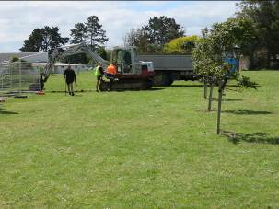
It is a space for building independence while their health and wellbeing is protected and nurtured. A space where they can explore, experience, socialise and be challenged.

We thank the Potter Masonic Trust and the Northern Division Freemasons for their generous support in enabling this dream to come to fruition through their substantial gifts.

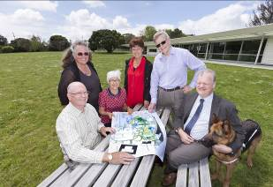

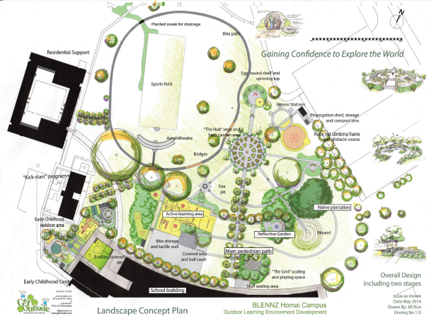

It is planned to complete on March 2015 with most of the work happening over the school holidays. So very exciting.

I wish everyone a restful break and will see everyone back on Tuesday 3rd February for the beginning of term 1 2015.

Barbara Whitley
Senior Manager School and Residential

Iulieta celebrated White Sunday with her family on the 12th October. She brought her clothes into school to dress up. Iulieta looked amazing in her pulatasi, she was so happy she smiled and chatted with the people she met.
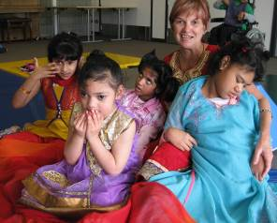
On October 25th, we celebrated Diwali, the festival of lights, with our classmates. Our families came to visit us throughout the day, to share in our dancing and admiring us in our beautiful clothes. It was a fantastic day.
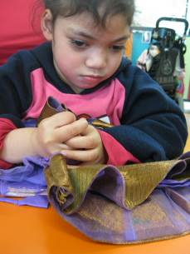

Manuae explores a shiny silky sari with
glass beads sewn onto it.

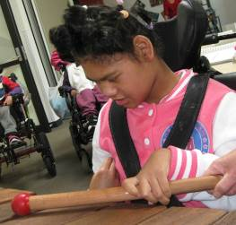

Iulieta enjoys exploring the wooden marimba and playing it with a variety
of beaters
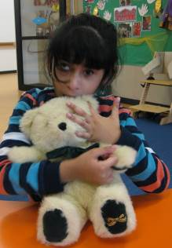

Prisha explores the soft fur of the
bear and also locates its eye which
is hard.
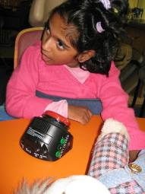
Riya explores
The different textures of the clothes
on her bear and uses her switch to hear parts of the story

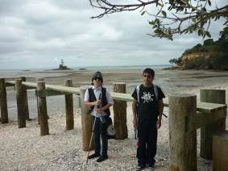
The end of the year is in sight and everyone is looking forward to a long summer holiday. It has been a long cold winter but there is definitely a hint of summer in the air. This last term has been a short one for the students with everyone gone by the 11th December. All students have celebrated various successes throughout the year. Unity made great progress in swimming, performing at a National level, Cam was a Rockfest finalist and he also had the privilege of meeting Andrea Bocelli while he was in the country.

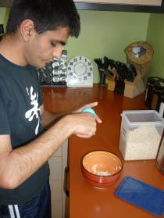

Michael making porridge

Freedom did extremely well in her chosen sport, Goalball, competing in a national competition in October. Both Tamati and Michael are proud of the Orientation and Mobility skills they have achieved this year. Paige transitioned to James Cook Satellite Class at the beginning of term 4. He is making new friends and learning how to use technology.

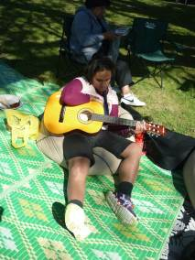

Unity under the oak tree

Michael and Paige at Awhitu

Paige and Tamati belong to the Ngati Kapo Group that meet each month on campus. Cam and Freedom have joined the recently formed Young Writers Group. Paige, Michael and Unity attend the BLENNZ Music School once a Month. The three of them have been busy practicing for their end of year concert to be held later this month. Just recently on a Wednesday afternoon everyone has been joining the Kickstart students to learn how to play Swish, a blind friendly variation of table tennis.

Some of the weekend outings this term have included a visit to MOTAT and Western Springs, the Papatoetoe night market, A&P show at Clevedon, a picnic at Awhitu, Ambury Regional Park and a fireworks display at Papakura.
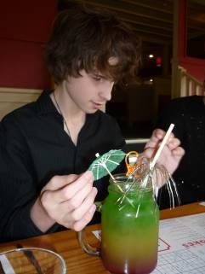

Cam checking out his cocktail

During the year students and staff have been busy making and selling wheat bags, marmalade and worm tea. We made enough money for all the students to have a meal at Cobb and Co. this was a nice way to finish the year. All the students enjoyed the night out and especially the fancy cocktail drinks.

Have a very Merry Christmas and a safe, enjoyable and happy holiday.

This term Tui class has had the opportunity to celebrate Diwali with Kiwi and Weka classes. Tui class went to the ADL room to cook an Indian meal (Dhal with rice). During this session, the students explored the different ingredients such as onions, red lentils, tomatoes, garlic, ginger and different spices. All of the students were coactively involved in chopping the onions; opening the cans; rinsing the rice and lentils. While they were preparing for the Diwali celebration, the students learnt that during Diwali all the celebrants wear new clothes and share sweets and snacks with family members and friends. They also learnt that Diwali is one of the most important festivals of India and it’s called ‘festival of lights’. People light candles, clay lamps and fireworks during the night.
Tui class experienced a taste of Indian culture by listening to Bollywood music and tasting Indian food with Kiwi and Weka classes.

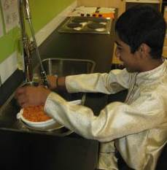
Dylan stirring the lentils around with
one hand, making sure they don’t
spill over the edge of the sieve.
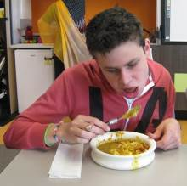

Rod enjoying his Indian
lunch

+

As the end of the year draws nearer we begin to look back at what we have achieved since Term 1 in the Kickstart Transition Programme. With this, comes the issuing of the Blundell Award. Each year a student receives this award to recognise their hard work and commitment throughout the year. The recipient is chosen for their contributions to the Kickstart group, to BLENNZ and to the wider community. The chosen student has a direction for their future and the potential to achieve their career goals.
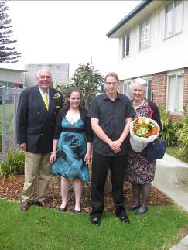
Richard, Bronwyn,
Adam and Sally after the presentation

On Friday 14 November Richard Blundell and Sally Winstone (son and daughter of the late Lady Blundell, wife of former Governor-General of New Zealand) joined the Kickstart group for the award ceremony. It is always a special day in the Kickstart calendar and staff and students dressed up for the occasion. After the ceremony a lovely morning tea was enjoyed by all.

This year saw something new. The award was split in half and two recipients were chosen. Congratulations to Adam and Bronnie, the very deserving Blundell award winners for 2014.

Thank you to all of our guests who joined us on the day.

By Cassandra Embling

Week 4 of the fourth term the Kickstart group went on their end of year week away trip to Wellington and Christchurch. We used different types of transport including the train, planes and ferry. We did many neat activities like visiting
Parliament, the Seal Safari tour, punting down the Avon River and much more.

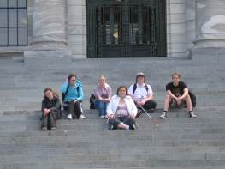
On the steps at parliament
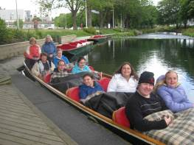
Punting down the Avon River

In Christchurch we stayed at an old jail that had been converted into a back packer’s accommodation.
This was an awesome experience as not many people can say they have stayed in a jail and not committed a crime. I think the high light for everyone was the Seal Safari trip. Being in a four wheel drive vehicle and getting bumped around and having a laugh was just the best. It was a really good trip and we all got to use our orientation and mobility skills in several unfamiliar environments. Everyone enjoyed themselves.

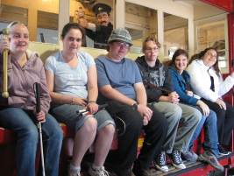
Cable car ride in Welllington

By Bronnie Taylor

Near the beginning of this year, Kickstart was introduced to a new game - Swish. It is similar to table tennis in that you hit a ball across a table and you have to get it under or over the net to get a goal. The only differences are the table has sides on it so the ball doesn't fall off so easily, the net is a solid wooden board and the ball has bottle tops in it so that it can be heard by the players. Cassie Embling has played tournaments of this game for many years, and decided to bring the love for this game over here to New Zealand. She has been in talks with the Blind Foundation to get a Swish table for Awhina House, as well as getting one built for Kickstart itself. We have had many great games of Swish over the past year and it will definitely provide a lot of entertainment for future Kickstart students. Cassie taught us the game well and a lot of us are getting quite good. In fact, on 3 December, Kickstart will be hosting a doubles tournament between Kickstart and the hostel students, so they can see how the game goes too.
Over the past few weeks, Cassie and a few other students have been helping the hostel students train for this tournament. We have also been able to show a few other people the game as well. On the day of the Blundell award, we were able to show Richard Blundell, and Clive Lansink how to play. Swish has brought us many great times, and will continue to do so in the future!

By Natalie Te Paa

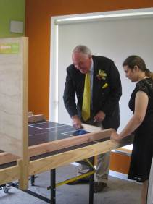
Haley gives Richard Blundell
Some Swish tips

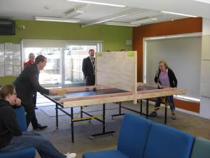
Cassie teaching Swish techniques

During the year Kiwi class has been involved in a SPEC [South Pacific Educational Courses] programme with a gardening context. The intention is to bring a wide range of hands on learning experiences that meet the individual student’s needs and learning styles. Much of the planning was around investigating textures and using tactile exploration. Students were involved in a variety of activities where they explored soil, seeds, leaves, plants, twigs, and flowers. The shapes, colours, textures and smells of many of these flowers are made into artwork to decorate the classroom. The class went on a visit around the school to find trees in bloom in spring. With support
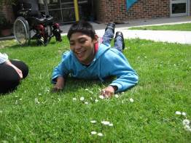

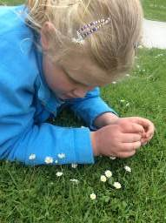
Kerred and August exploring the grass and the daisies

Students gathered flowers and made bouquets which they took home to share with the family. The students have their own pots of strawberry plants and sugar
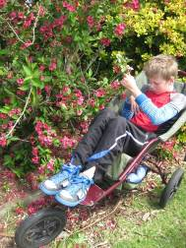
peas that they are observing as they grow, flower and produce fruit. On one sunny day students had time on the grass
listening to the mower nearby then rolling in the freshly cut grass. There were lots of smiles and giggles for this activity. This gardening module provides the opportunity for students to develop their understanding of the ‘living world’ around them.
Jessee feeling the flowers

The Outdoor Learning Environment.

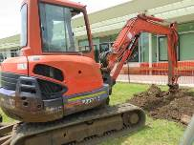
One morning we looked out of the classroom and saw a digger working on the Outdoor Learning Environment. Giovanni, Rimoni and Okahu were very excited and could not wait to go out and have a look.
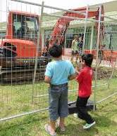
First of all we had a look at the sign which said “DANGER” and we talked about what the word meant.
The driver started up the digger and started to make a drain which really interested the boys. They were really sorry when the driver had to stop.
We are looking forward to a lot more fun watching the Outdoor Learning Environment take shape.
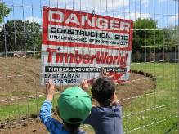

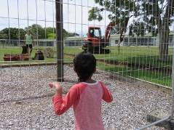

This term Takahe class have been studying Rangoa Maori as part of the Mana Maori special interest module of Kiwi Quest. The students listened to a story of a young girl helping her Nan to make some Rongoa for her mum when she was ill. The students then had to search the internet for different plants used by Maori for medicine. They each choose one type of plant to study. The class went on an outing to the Botanical Gardens to identify, touch, smell and in some cases taste the plants they were studying about. The students then wrote up the information using the appropriate assistive technology and shared the information with their classmates.

It is a large tree found in coastal forest of the upper North Island. The spreading branches produce bright shiny green leaves made up of 5 leaves. Puriri can have a long fruiting and flowering season. These are both valuable for birds as the pink flowers give nectar and the berries are a good source of food.
Maori used Puriri leaves for medicinal purposes. Boiled leaves were used for sprains, backache, ulcers and sore throats. Puriri wood is very strong and durable. Maori used it for making tools and weapons.
Puriri By Nuku

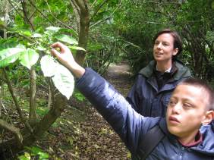

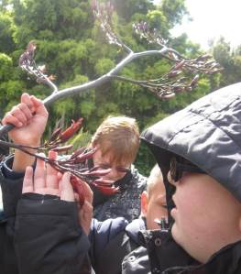
Harakeke has many Rongoa

Its sap can be used on wounds and boils. Its leaves can also be used to wrap broken bones, and the root sap can be used for disinfectant. The sap from harakeke has blood-clotting and disinfectant qualities. It is a mild pain-killer. by Logan 7 November

Koromiko By Adrea 14 November 2014.
Koromio leaves are a yellow, green colour and they are dull not glossy. The flowers grow in bunches on the end of the branches. They have a strong scent and butterflies and bees love them.
Koromiko is found in the North Island it is fast growing and prefers to grow on the edge of the bush and wetlands.
Koromiko flowers in August. After 1 to 2 years it produces seeds in November. The seeds blow away in the wind. Koromiko does not like growing in the shade.
Koromiko leaves are used in rituals by a Tohunga to ensure that they have a good crop of kumara.
The shoots can be chewed to stop you from feeling hungry.
If you boil the leaves and drink the liquid it is good for treating diarrhoea and dysentery.
Koromiko is a Hebe, the name came from the daughter of Hera and Zeus, cupbearer of the gods and the goddess of youth.

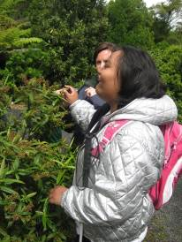

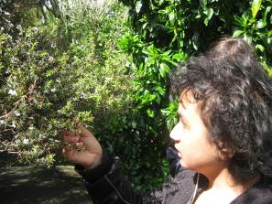
Jack Schwenke 7 November
Manuka
Manuka is used in Rongoa for treating skin disease. Crushed berry poultices are used on wounds, and the leaves can be boiled, and the steam inhaled to treat colds.

Amandeep 17 November 2014
Harakeke
The Harakeke plant is found throughout New Zealand. The seed is currently used for oil. Early recordings in history show a wide range of uses for Harakeke such as healing burns, gunshot and bayonet wounds. The roots noted as being used for colds and headaches whereas the leaves are used for stomach trouble. The liquid from boiling the roots is apparently a good substitute for castor oil. For centuries, Maori have used nectar medicine. Boiled or crushed Harakeke roots are applied for boils, tumours and abscesses. Juice from pounded roots was used as a disinfectant. The gum-like sap produced by Harakeke contains enzymes that give it clotting and antiseptic qualities to help healing. The sap was also applied to wounds, aching teeth and body pains. Splints were made from Korari, are flower stalks and leaves. Harakeke as bandages and can secure broken bones much like plaster is used today( research taken from internet).

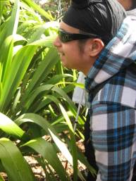

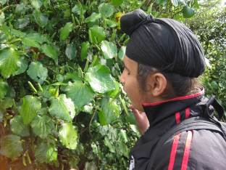
Kawakawa or pepper tree.
Amitoj November 7, 2014

The leaf and bark were used to heal cuts, wounds and stomach pains. For toothache, a kawakawa poultice was applied, or the leaves were chewed. The leaf and bark were a remedy for stomach ache, and the root was chewed for dysentery.

Kawakawa was used in the umuroa, an oven or vapour bath for those with rheumatism or other complaints. Stones were heated by fire and water was poured over a thick bed of kawakawa leaves was put on the stones, followed by kete (flax baskets). The patient sat on top. Other leaves could also be used, including koromiko, mānuka, kāretu, karamū and poroporo.

Description
A Kawakawa plant is found throughout the North Island, and on the east coast of the South Island. The glossy leaves are often covered with insect holes. The name Kawakawa in Māori refers to the bitter taste of the leaves, from kawa bitter.

