Fixing a WCIB Cane

Starring Freedom and Jesse
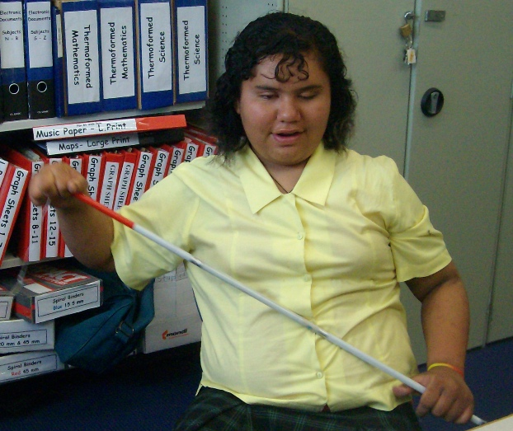

Sometimes a mobility cane snaps so what can you do?
Using your ‘technologically advanced cane fixing kit’ (a paper clip and string) you can fix it!

First get the tip off!
- You might need a vice,
- But try warm water or pliers first.
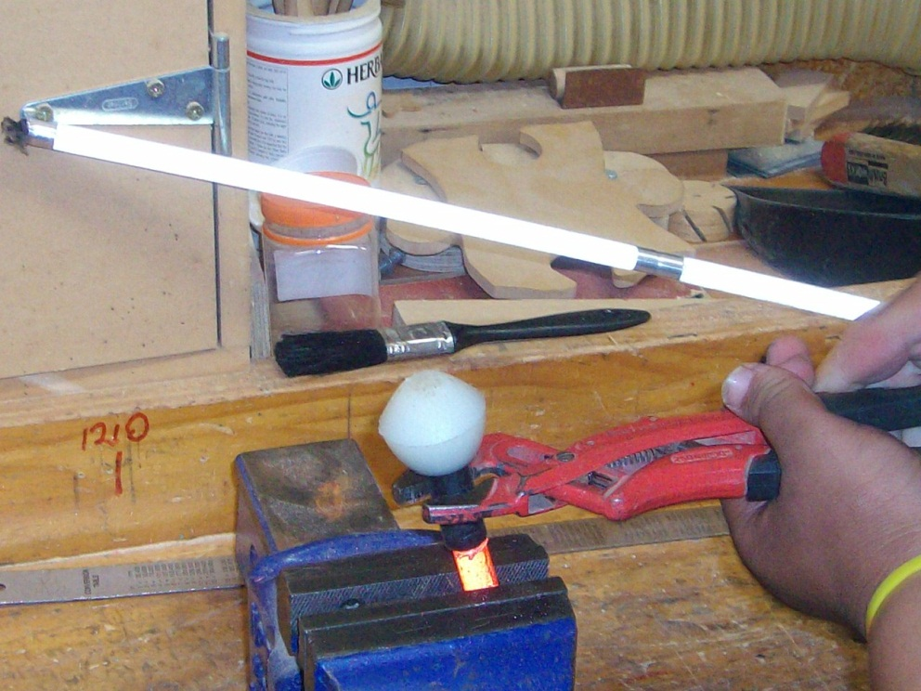

Then pull the string end and the elastic out of the ‘tip’ end of the cane.
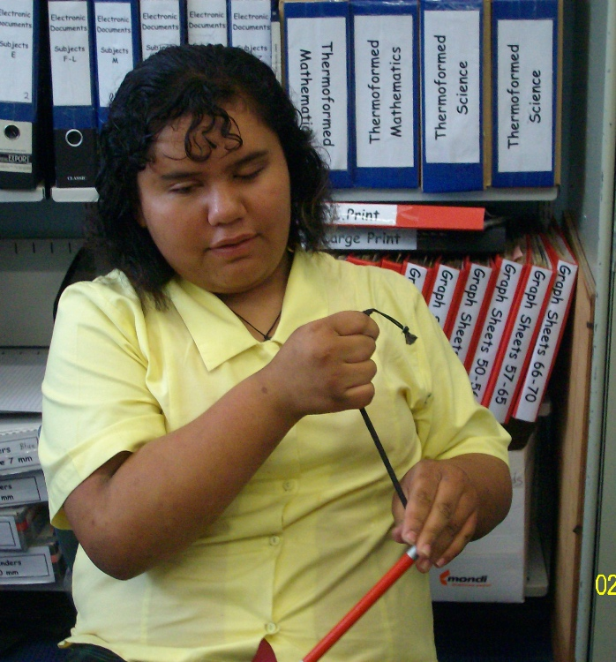

Then undo the string at the end of the elastic.
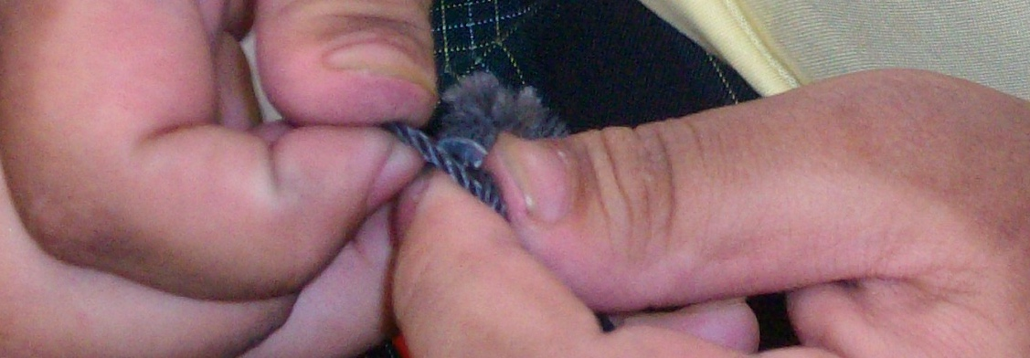

If need be jam something into the elastic loop to stop it ‘pinging’ into the cane parts.
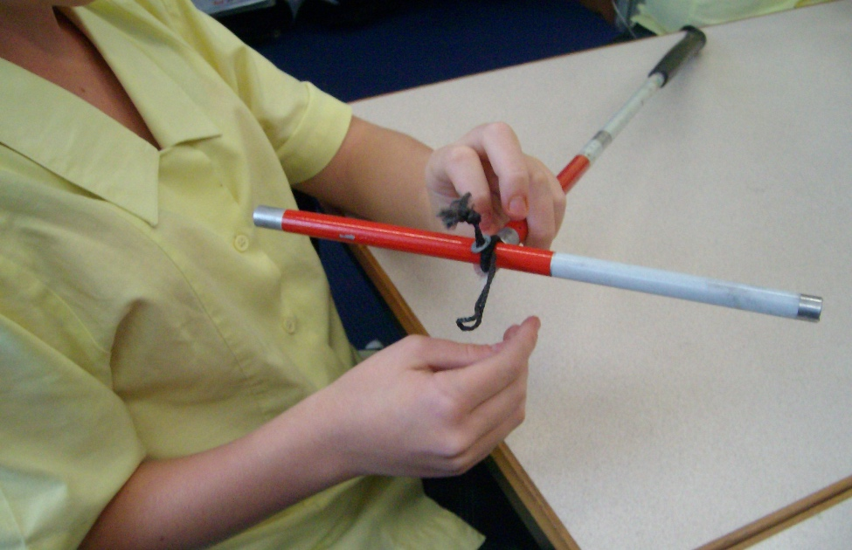
Then knot your string to the elastic – tie the opposite end to the paperclip or weight.
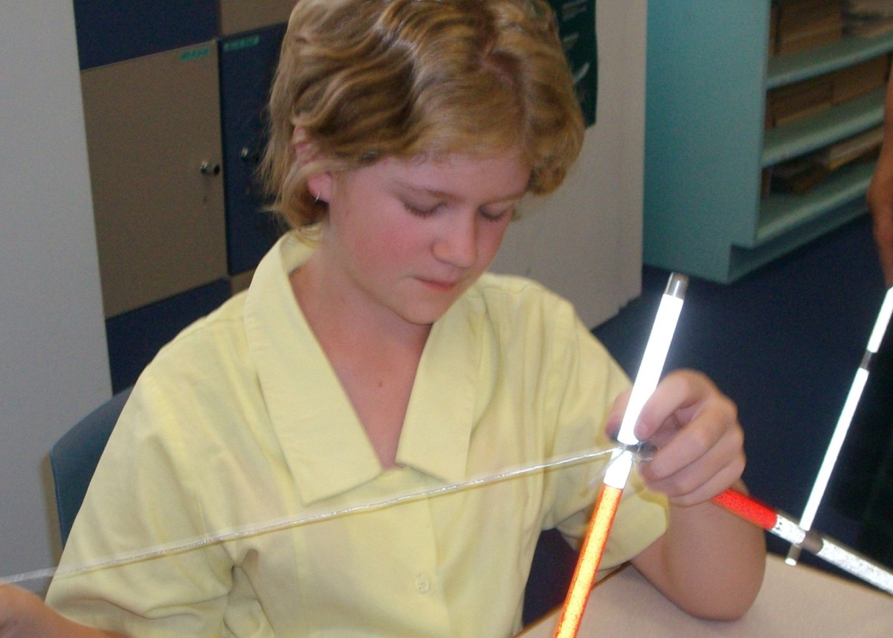

Pull the cane to pieces until you have the handle and string and a few bits!
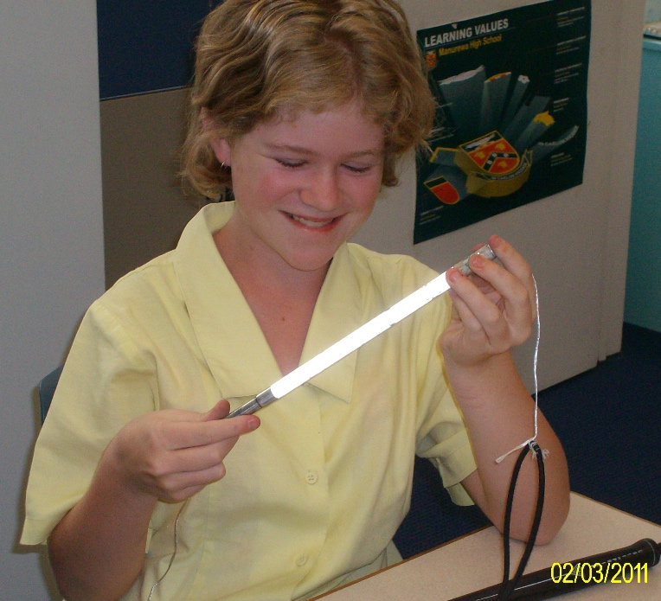

Remove the broken bit and find a new piece to replace it. You might need to use pliers, or something sharp, to remove bits inside the cane parts.

Rethread your cane by threading the paper clip end of the string attached to the elastic through each part. Be careful to place the pieces the correct way to ‘fit together’.
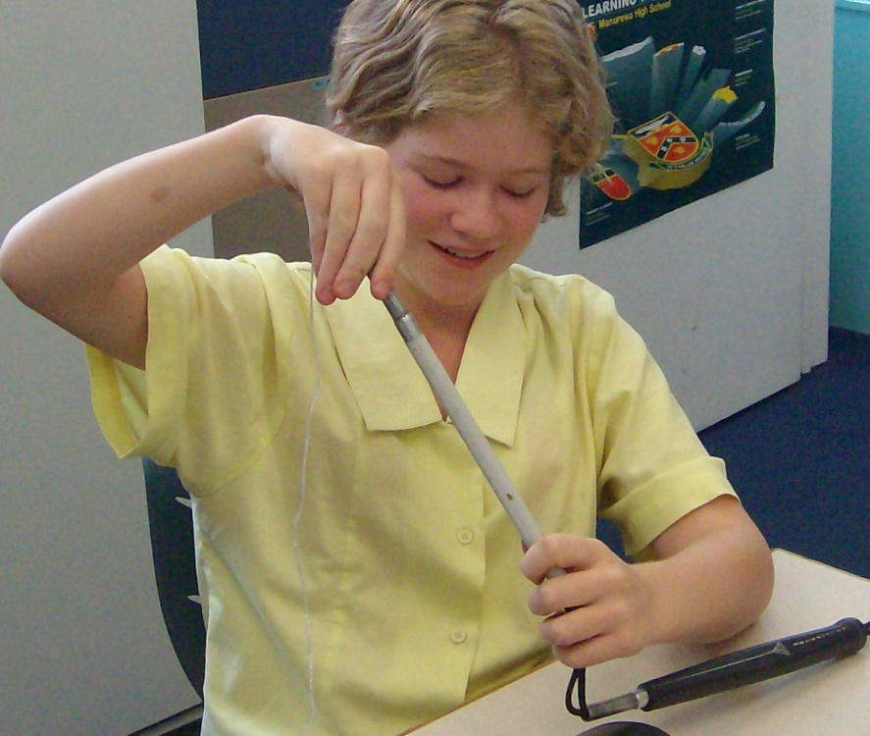

Or if you shortcut like Freedom, put all the pieces together and thread!
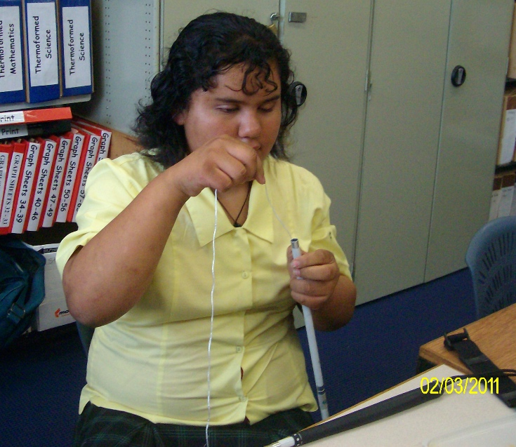

The last bit has two ‘short’ ends.
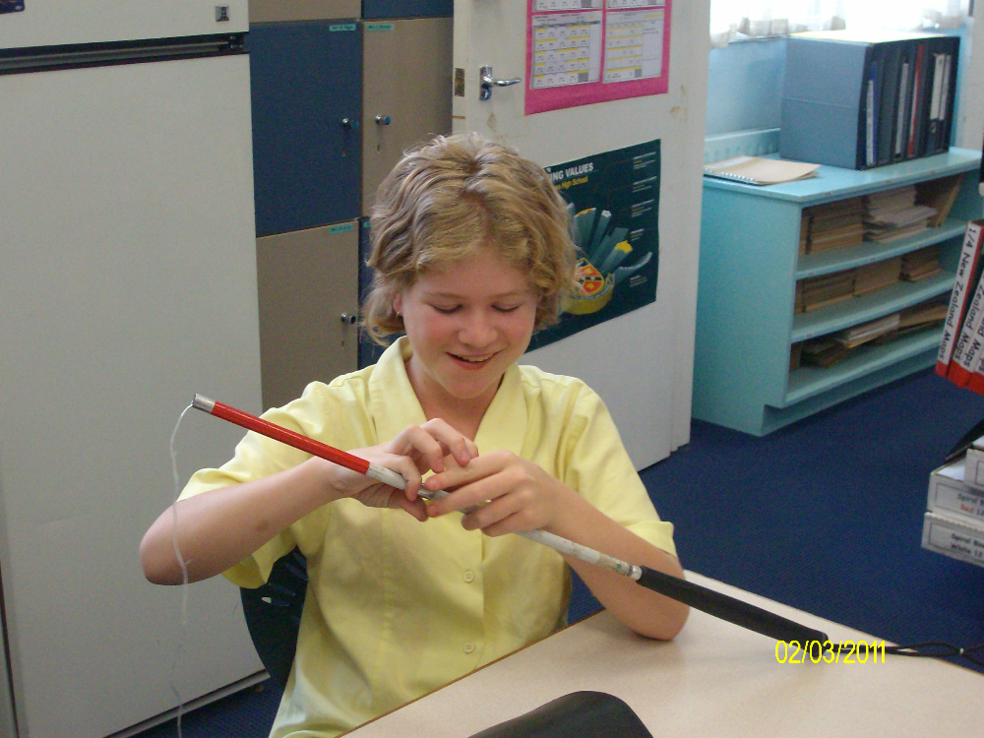

Pull the elastic through the last bit of the cane using the string.
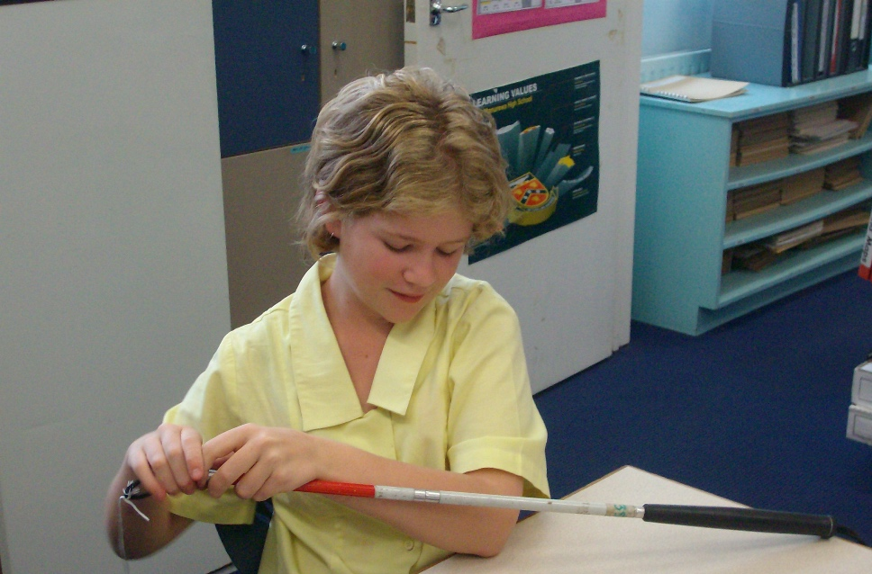

Rethread the little metal and string through the elastic, and cut your string.
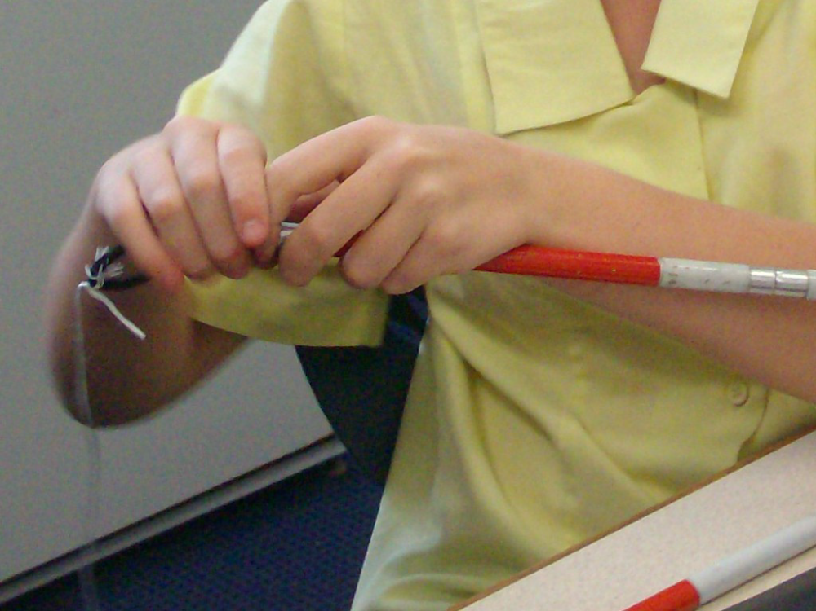

And you are done!
See your O&M if you need a new cane or check with your local Resource Teacher: Vision for more information.

Developed by Moving Forward Ltd and BLENNZ, 2014.

