Introducing the cane
The cane can be part of an overall O&M programme.
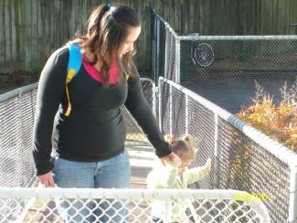
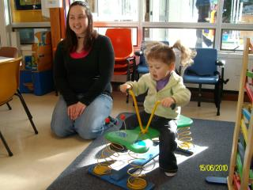

Introducing the cane
When to introduce a cane is a family and team decision. We believe early is best but it must be positive for the child and family.
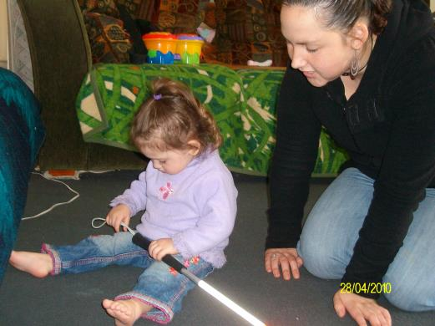

Take time and keep it low key!
Explore it and play with it.
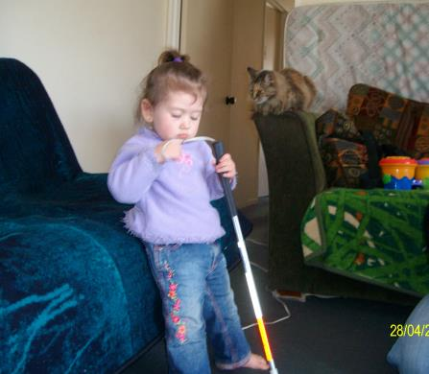

Play games and don’t worry if it isn’t used properly
It’s about making the cane a normal part of the day and routine.
- Bonk things with it,
- Tap a drum,
- Put it in the buggy.
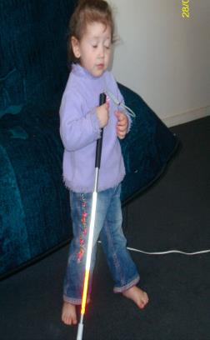

Have a place to hang it
This way the child can help get it as part of the routine.
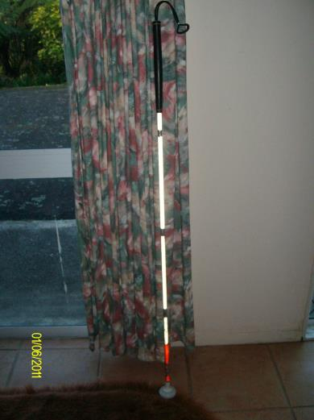

Personalise your cane
- You can hang a toy on it,
- Give it a name,
- Decorating it with stickers is always fun too!
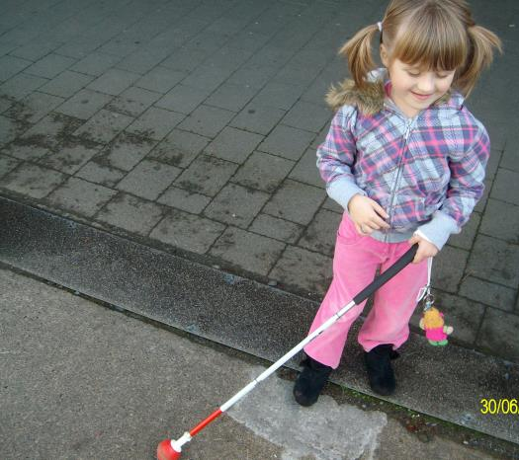

Use other techniques with the cane to explore the exciting world!
Self protection.
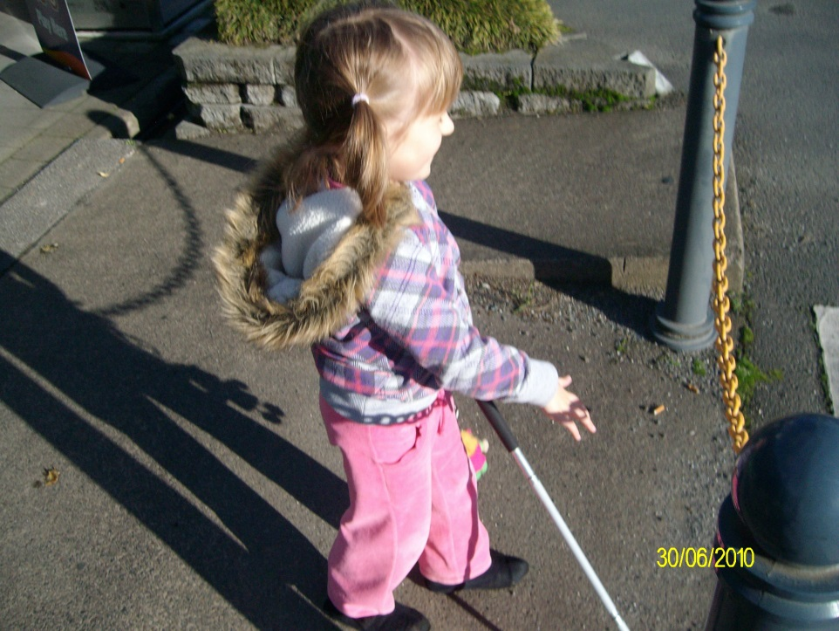

Trailing.
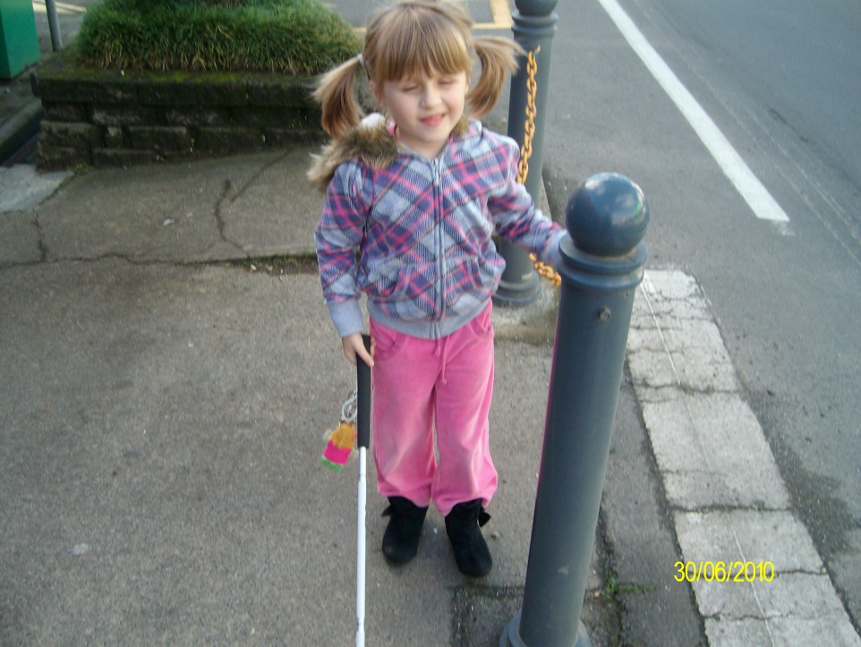

Have a motivating reason for using it!
Check with your local Resource Teacher: Vision for more information.
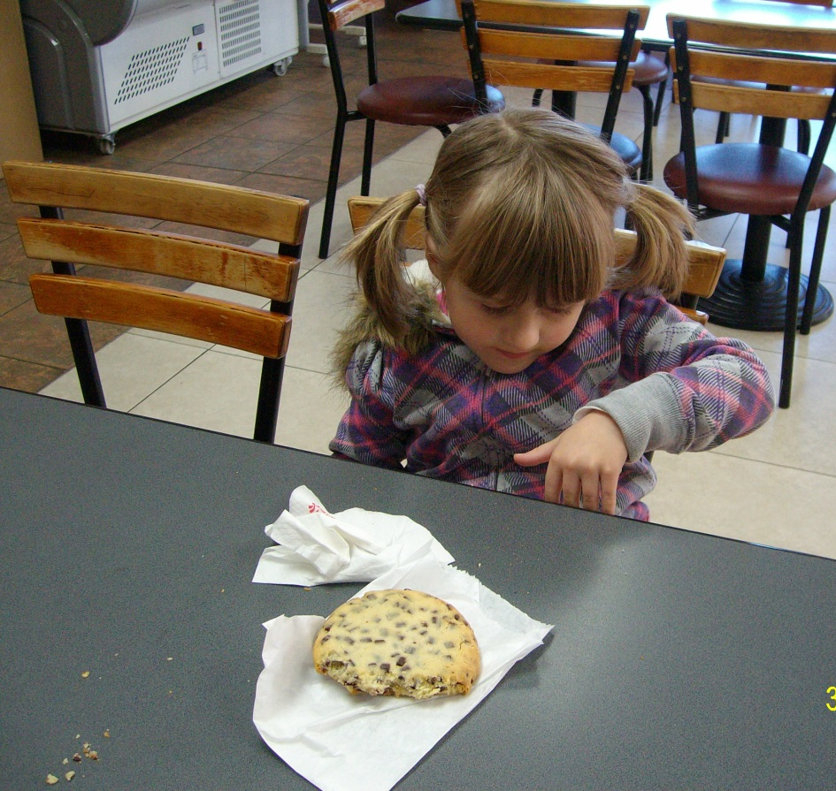

Developed by Moving Forward Ltd and BLENNZ, 2014.

