Panui
Term 1 2017

Homai Campus School and Residential Services
Rāranga ai te tuakiri o te tāngata kea whatu i ngā koingo o te iwi hei taupe kit e korowai o te ngākau.
Weave the identity of the people, sow the desires of a nation, thus to be adorned by the cloak of the heart
Kia Ora, Ni Hau, Talofa Lava, Kia Orana, Malo e lelei, Salam Alaikum, Namaste, Ni Sa Bula, Fakalofa Lahi Atu and Greetings.
You will see from the class articles that along with some incredibly wet weather they have been studying water in all its many forms; from flowing, to ice to bubbles.
Sports continue to be an important activity with students involved in the Interschool Adapted sports at Mt Roskill as well as the Secondary School Special Olympics Athletes Day.
We have made a step towards completing stage two of the outdoor learning environment – Freemasons Park with the development of The Grid. This is a wheelchair- friendly space made up of squares for gathering, playing, counting and stepping.
Have a great break and we look forward to seeing everyone back on the 1st May.
Aku mihi nui ki a koutou
Barbara Whitley
Senior Manager School and Residential Service
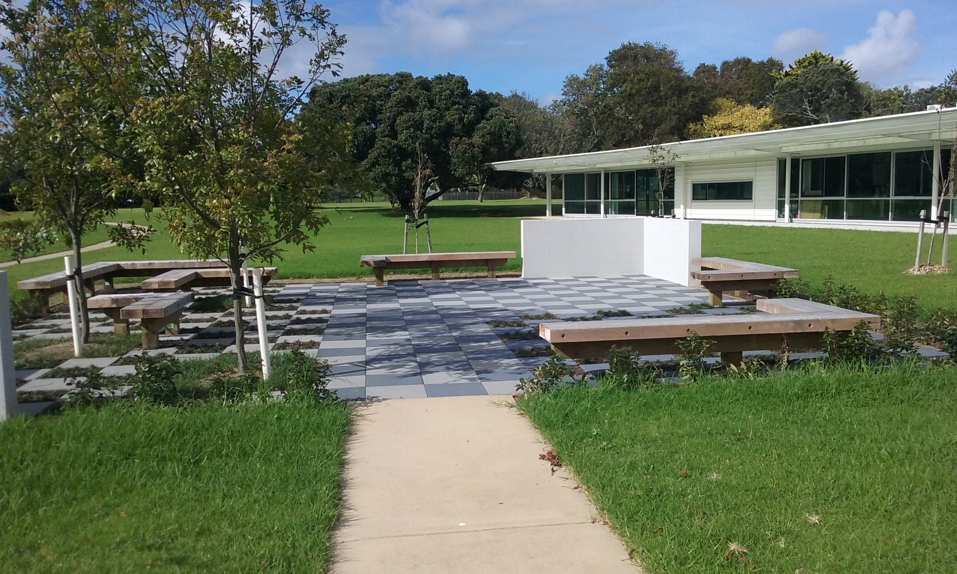

Kiwi Class
This term Kiwi class have been involved in water activities. The weather has meant we have put more emphasis on walking in the rain using coats and umbrellas than we might otherwise have done. This was fun although we did not picnic outside as often as we had hoped!
Students have played in bowls of icy water and bowls of warm water. They have observed ice melt and experienced items that float and those that sink. Exploring bubbles and having opportunity to blow some was fun. Items related to the beach such as shells, sand, collage fish, and water in a spray bottle have been explored.
Many songs, poems and stories about ‘water’ have been used in individual and group language and music times. In Art we made rainbow fish and a sea mural.
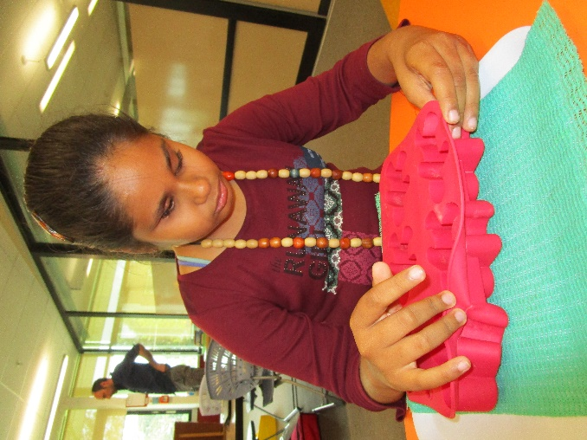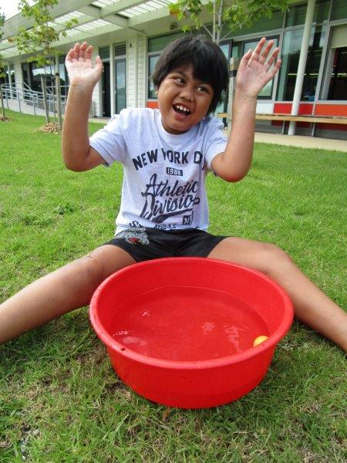
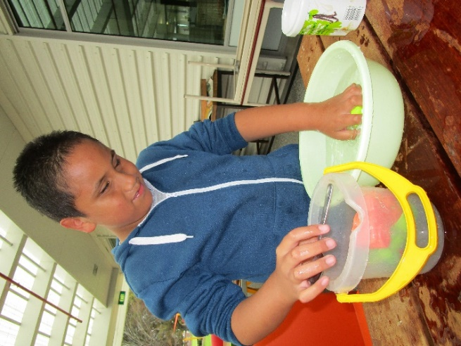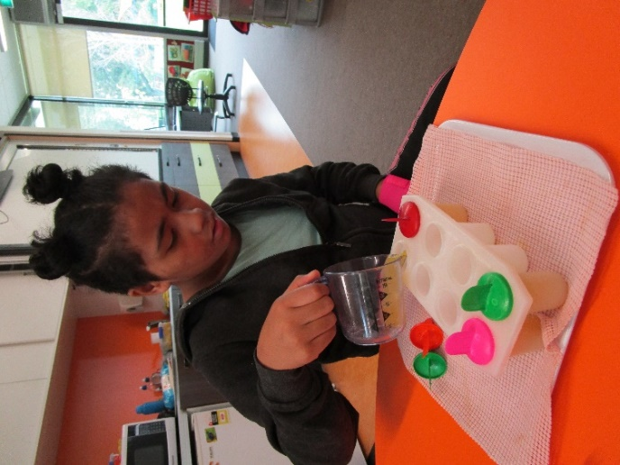

Takahe Class
This term Takahe class have been preparing for the Interschool Adapted Sports Day. The students participated in different events “Pool noodle Javelin”, “Frisbee throw”, Hurdles, Standing Long Jump, Jumping sacks and running races. All the students participated and were awarded ribbons for 1st, 2nd, 3rd and participation in the different events.
. 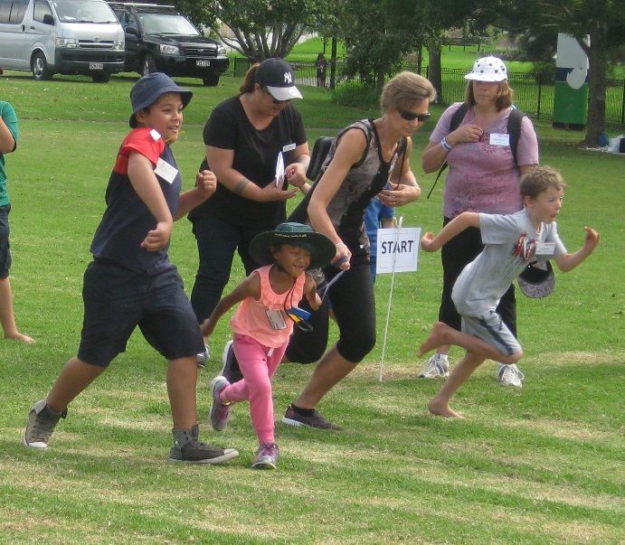
Precious taking part in a running race at the Interschool Adapted sports at Mt Roskill.
Takahe had a number of outings to Totara Park where the students have been learning how to climb up on to the flying fox and to hold on as it moves through the air. They went down the long slide and challenged themselves to climb on different equipment each time. Theses outings provided the students with many learning opportunities for managing themselves.
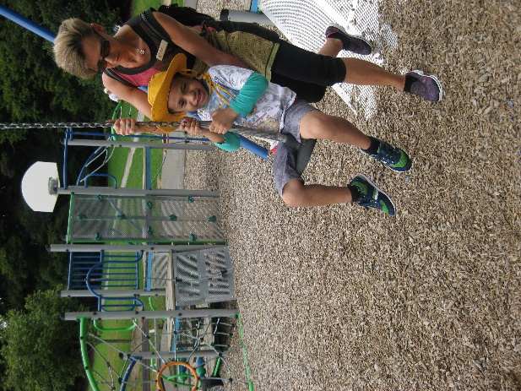
Haydon on the flying fox at Totara Park with the support of the physiotherapist.
The theme this term was water and the class performed many experiments to investigate the different properties of water. They made ice and observed how long it took to melt and what happened when it was put into a bowl of water. They tested different objects to see if they would sink or float.
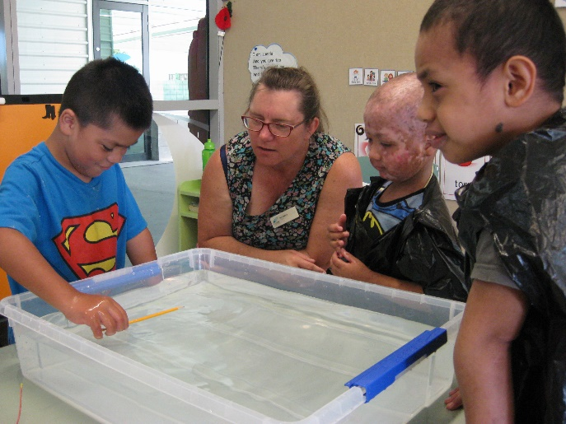
Takahe students perform an experiment to see if a pencil will sink or float. They predicted that it would float because it was light and it was made out of mainly wood. Their prediction was correct.
The class started the Jolly Phonics program and have all learnt the different poems and made use of the ‘Penfriend’ to record and listen to themselves reciting the poems.
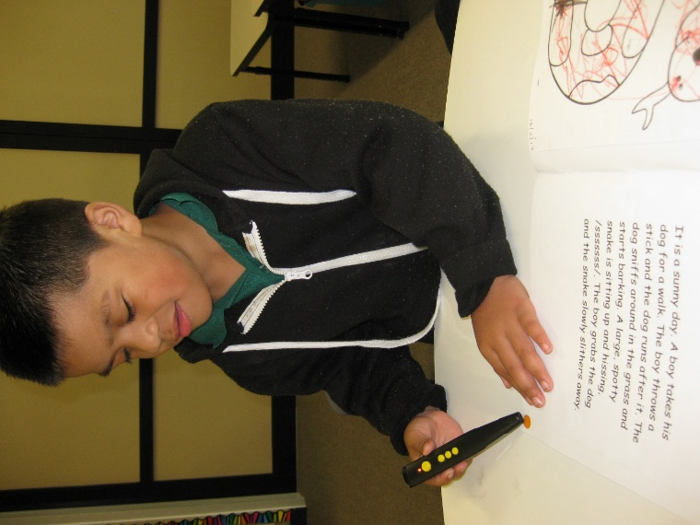
Sunia uses the “Penfriend” to listen to his Jolly Phonics poem.

Tui Class
This term Tui class have participated in a variety of activities that focused on water. Students experienced and participated in water play activities. We filled trays of water and the students had lots of fun exploring objects that were placed in the water. Kerred laughed each time he got splashed when he picked up the sponge and dropped it into the tray of water. We filled up some small water balloons and placed them into the trays with water. Students explored the balloons by picking them up, squeezing them and feeling them slip through their fingers. We explored coloured ice cubes. August and Jesse picked up the ice cubes and had a taste. Kerred actively reached out to grasp the cubes. Jesse and Iulieta enjoyed swimming with Kiwi class. Kerred and August enjoyed foot spas. On a rainy day, we went out for a walk. August and Iulieta used an umbrella to keep the rain from falling on them. As part of our theme, we listened to stories and poems about water. One of our favourite poems was ‘under the sea’. Students explored tactile pictures of fish, tadpoles and seaweed while listening.
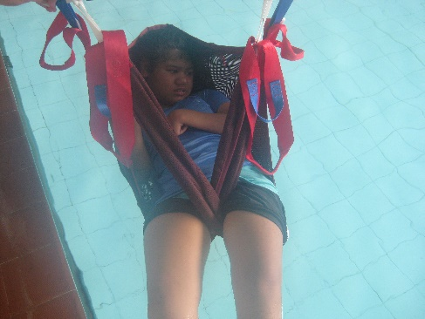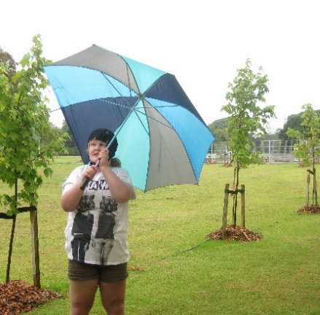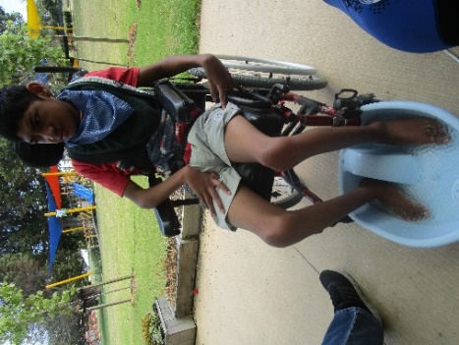

Kickstart
One of the EOTC outings I really enjoyed was when we went to the Ambury Farm. They had a lot of animals like cows, horses, chickens and Kunekune pigs. I really enjoyed seeing the horses they were so cute and friendly. We even brought them some carrots.
For lunch, we cooked a BBQ which was really nice. It was really good having lunch in the fresh air.
Overall it was a really lovely outing I’m sure we will visit the Ambury Farm again soon.

Katie Byriell
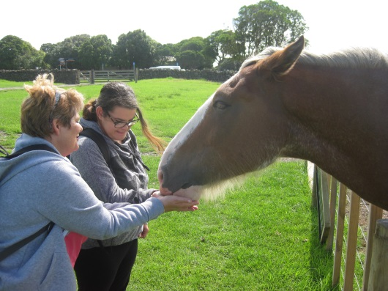
Katie and Jude feeding the Clydesdale horse
This week we went to Manukau City. The purpose of this outing was to collect for the Red Puppy Appeal. For about two and a half hours Kickstart collected donations, the proceeds of which will help fund blind and low vision people to receive a guide dog. We at all enjoyed this activity because we were able to contribute to the blind community and help provide for those who need them with guide dogs.

David Boyd
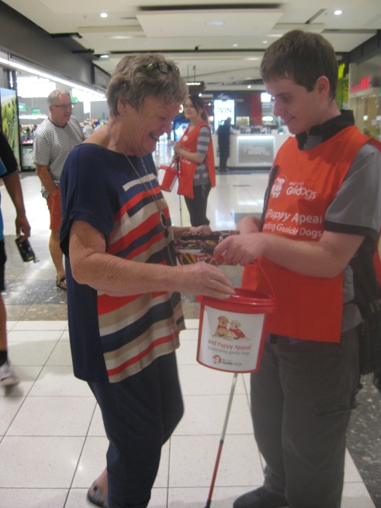
David collecting for the Red Puppy Appeal
Kia Ora My name is Jake and I’m one of the students attending the Kickstart programme this year. I am really enjoying the course because I get to do a lot of things that weren’t available back home. Although the programme is a lot of fun, it’s also very busy and usually leaves us exhausted at the end of the day. My favourite part of the programme so far is just chilling with my flatmates and riding around on the trikes.

Jake Thompson
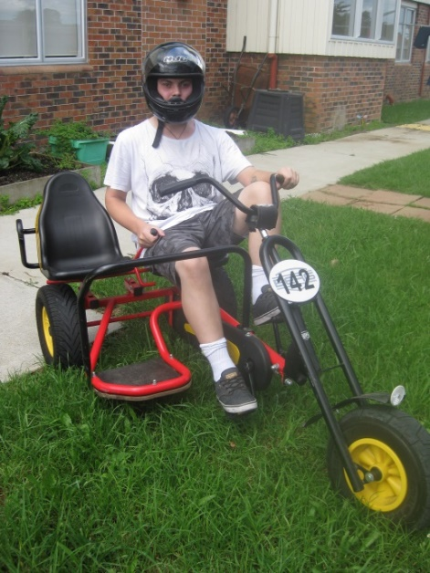
Jake the ‘Triker’ Biker
The students here at Kickstart went from complete strangers, starting awkward ice breaking conversations and being cautious about what we say or do around each other to joking around, messing with each other and forming bonds that will never be forgotten. Who would of thought moving in with a bunch of strangers with different quirky behaviours would be such a great idea!

Lorna Coker
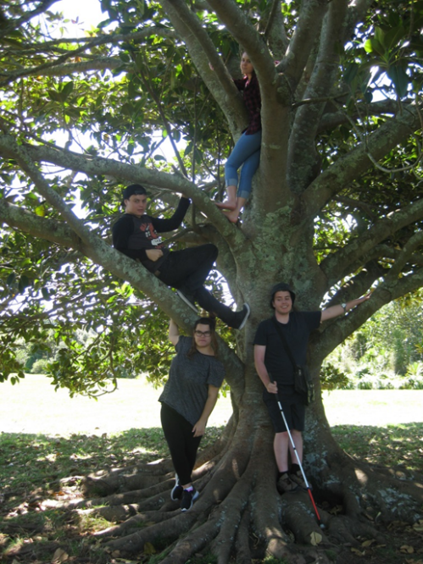
Student’s tree climbing at the Botanic Gardens

Nikau
This Term we welcomed Jayke Hopa to the hostel, he has come from Putaruru to attend Manurewa High School. We also welcomed a new staff member Renee Sisitoa.
We had a camping weekend early in the term when the weather finally warmed up. The boys enjoyed the whole experience, from putting up the tents, pumping up their air beds through to the final night when we toasted marshmallows over a little outdoor cooker.
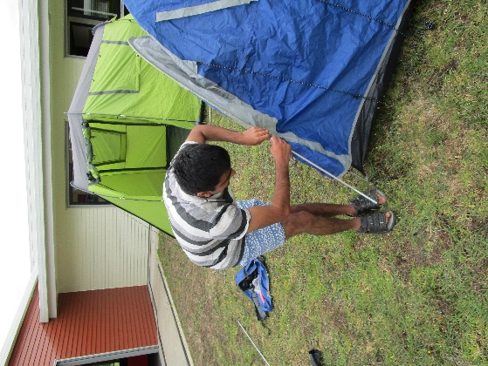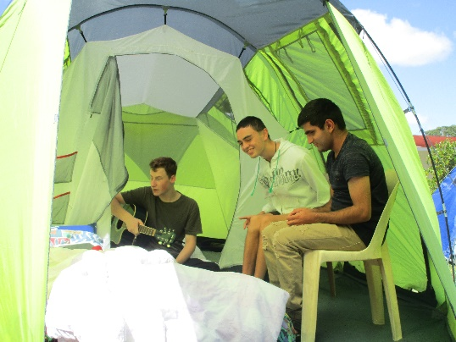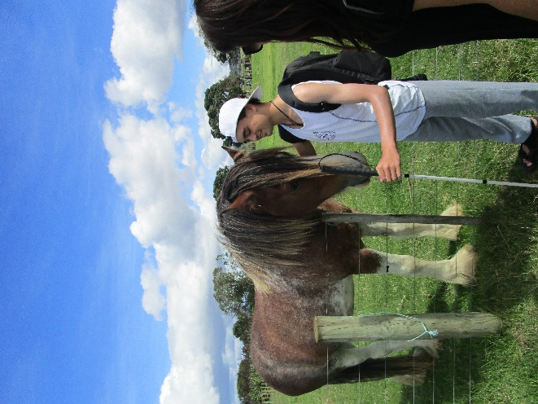

Other activities have included a visit to Ambury Farm where the animals are friendly and are always keen for a pat. The two giant Clydesdale horses are always a huge hit with the students, especially if you have an apple for them. This is always a lovely way to spend a couple of hours wandering around the farm or just relaxing in the sunshine.

In February we attended ‘Elvis in the Park’ this is held in the Botanical Gardens each year. It was an interesting afternoon where we listened to a range of performers imitating Elvis. The students recognised many of the songs performed.
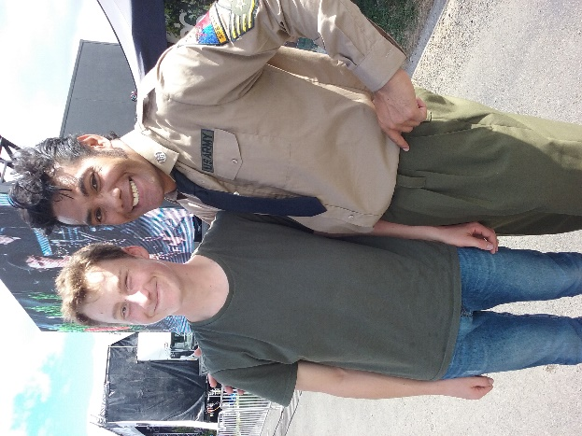

Students continue to build up their daily living skills which will support their future independence. Students cook meals, bake, wash and dry the dishes, make their school lunch, as well as being responsible for their personal laundry. All are making great progress. Students are kept busy leaving no time for a dull moment.
Nikau students have made a great start to the year.
We hope you have an enjoyable holiday break and we look forward to Term 2.

Weka Class

A Bubble Party
On a beautiful sunny day the staff and students in Weka Room decided to have a Bubble Party. We invited the students from Kiwi Room to join us under the trees where there was a lovely breeze. We had bubble machines and wands, and some special bubble mix which made extra big and long lasting bubbles. The breeze helped us make bubbles which flew across the playground. The sun made all the pretty bubble colours shine. Riya particularly loved the bubbles drifting past her face. Everybody said that they could not wait for another Weka Room Bubble Day.

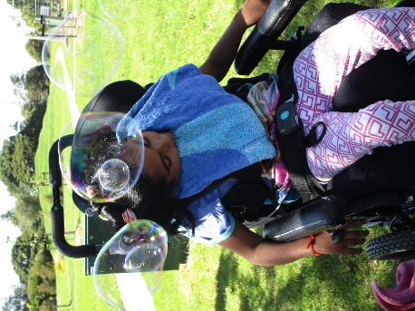

Pukeko Class
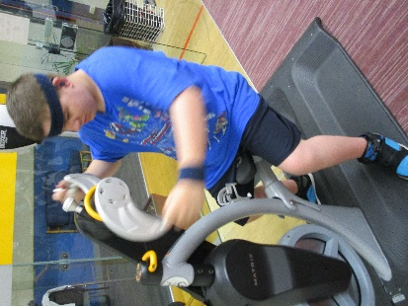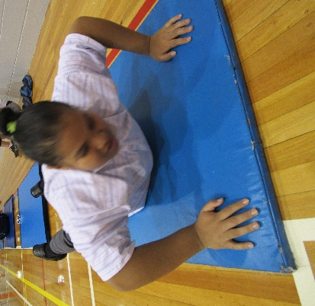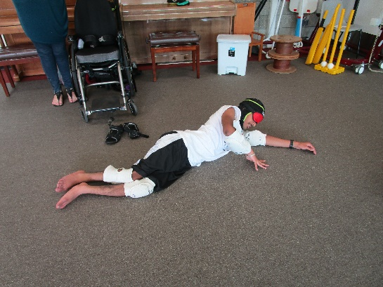

Pukeko Class have enjoyed attending adapted sports weekly this term at the Allan Brewster Leisure Centre in Papatoetoe. We have experienced exercising on mats, Spin class on bikes, lawn bowls, blind cricket and goal ball. We have also had the opportunity to participate with Counties Manukau Sports instructors who visit our school once a week.

James Cook Satellite Class
Adapted Sports report by Elizabeth Hollingworth
This term on Wednesdays, we have been going to Allan Brewster Centre in Papatoetoe for Adapted Sport. Pukeko and Kickstart also go to this programme. Our coach is Yvonne and she is very good at encouraging us and teaching the programme.
We have been doing goalball and we have been learning how to block when the ball comes. We also do indoor bowling. When you do bowling, you hold the ball in your hand and roll it on the ground.
In the last week of term, we did Boot Camp. Boot Camp is a hard workout using different equipment and doing different exercises. There were bikes, weights, running and floor exercises. We rotated around each exercise station. It was a very good physical workout.
I cannot wait to do Adapted Sport next term.
Secondary School Special Olympics Athletes Day 28th March 2017 report written by Jack and Marie
The James Cook Satellite Class along with Pukeko Class participated in the Secondary School Athletics day at Massey Park in Papakura. It was a hot and tiring day but it was well worth it because everyone had lots of fun. At the opening ceremony, Nuku recited the Olympic Oath in front of the athletes and spectators – he did an excellent job speaking clearly and confidently.
Everyone can enter up to three events. I was pleased with my results – my jump was 2 metres and I threw 4 metres and placed 2nd in my running race. Although competing in races can make the athletes feel nervous the result is one of excitement and achievement.

Baking Biscuits report by Adrea Thompson
This term I enjoyed baking biscuits for the James Cook admin staff. Each Thursday we make a batch of afghans or melting moments and sell them to the office ladies. I can remember all of the ingredients and can get them ready independently. I am an expert at measuring and mixing and I have got very good at shaping the biscuits so that they are all the same size
We sell the biscuits to the staff to help with our fundraising. We have used some of the money on an EOTC to watch Moana.

Jaws Immersion course by Amitoj Singh
On the 20th of March 2017 I went to a Jaws immersion course. Jaws is a screen reader software program that blind people use on their laptop or computers. Jaws is very hard at first but it gets easier as you learn it. I had to concentrate, think and remember stuff and it was very hard work. I learnt many things about Jaws - I can now carry out Google searches and I can find a music clip on You Tube. I learnt how to create and find headings in a document and overall I feel more confident to use JAWS independently.
It was enjoyable catching up with my friends on the course and I liked talking to my friends and I will keep in touch on skype. The course was very enjoyable and I am looking forward to attending the next course.

Moana report by Nuku Rawiri
This term we studied the movie Moana and we read some Maui legends. We watched Moana at Sylvia Park. We liked the movie especially the songs. My favourite song was You’re Welcome.
My favourite part of the plot in Moana was when Maui pushed Moana off the boat.
My favourite but sad part of the Maui legend is when Maui’s mother Taranga wraps her baby Maui in her hair and throws him in the sea because she thinks he is dead. When he grew up he went searching for his mother and was reunited with his whanau.
We enjoyed our E.O.T.C to Moana because we did our learning out of the class and it did not feel like schoolwork LOL. I still did learning though, like doing my Orientation and Mobility – walking around the mall, and self-management - buying my own lunch.
It was a fantastic day.

Adapted Board Games by Marie and Carlton
Board games are a fun way to learn a huge variety of skills and concepts. These include communication and recreation skills, Mathematics - geometry and special concepts, thinking skills - planning and strategizing.
Carlton enjoyed the competitive aspect and it has renewed his interest in some board games like chess, checkers and Ludo.

