Panui

Term 3 2016
Homai Campus School and Residential Services
Rāranga ai te tuakiri o te tāngata kea whatu i ngā koingo o te iwi hei taupe kit e korowai o te ngākau.
Weave the identity of the people, sow the desires of a nation, thus to be adorned by the cloak of the heart
Kia Ora, Ni Hau, Talofa Lava, Kia Orana, Malo e lelei, Salam Alaikum, Namaste, Ni Sa Bula, Fakalofa Lahi Atu and Greetings.
Term 3 has been a busy and exciting time. Throughout the year we have been supported in our sports programme by amazing staff from the John Walker Field of Dreams Foundation. This programme has provided learning experiences in adapted sports both at school and outside the classroom. They were very much involved in the BLENNZ Homai Campus Olympic Day. The students have gained a great deal from the work of this organisation.
We were very sad to farewell Becker Broughton who has been in the James Cook Satellite Class for a number of years. He brought his knowledge of Tikanga Māori to his role and shared this knowledge, skills and culture with us. Across BLENNZ and on the Homai Campus he has our appreciation and respect. We wish him all the very best in his retirement.

Barbara Whitley
Senior Manager School and Residential Services.

Weka Class

In Weka Class we have been enjoying walks to the Hub to explore the spring changes which are happening with some of our favourite plants. One very sunny day the rosemary and lavender was scenting the whole area as we walked around. Prisha and Riya really enjoyed running their hands in the leaves and taking in the scent. We brought some back to place on our theme related display table. More recently we went to one side of the Hub and discovered lovely bright blossom on the kowhai trees. They were a beautiful bright yellow. We look forward to more discoveries in the Hub as spring moves on into summer.
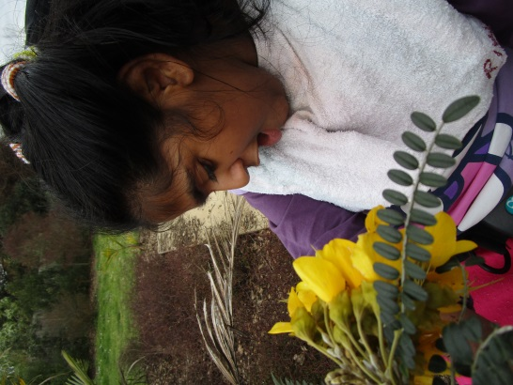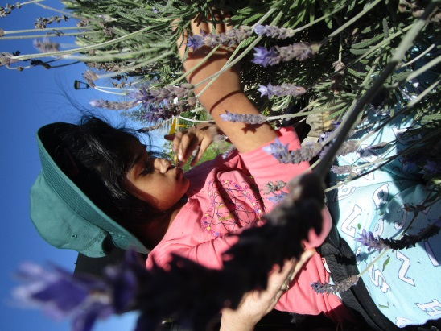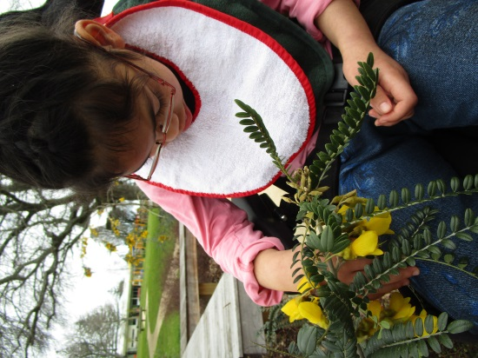

Jumpstart
This term Kahu enjoyed all of our outings with Jumpstart. He also enjoyed going to perform at rest homes – it was fun he said. Joseph liked going on the trip to Kelly Tarltons. He said the best part was visiting the penguins and they came and looked at him. All the penguins got fed by the keepers. Joseph nearly got eaten by a shark, but it was really a bus that we took a ride on back to the city. We also went sailing from the Maritime Museum and then lunch at Better Burgers, which was really tasty. Both Joseph and Kahu competed in our BLENNZ Homai Campus Olympics which was really good fun and exciting to be a part of.
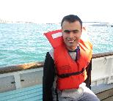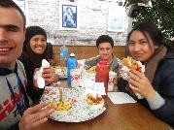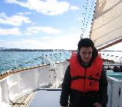
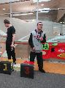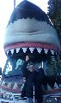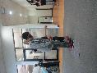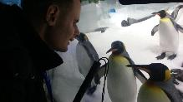

Takahe Class Olympics Theme

This term Takahe class have focused on the Olympics. We made an Olympic flame for the schools opening ceremony. The learners used hand prints to decorate the torch. Nuku used cellophane and tissue paper to represent the flames of the torch.
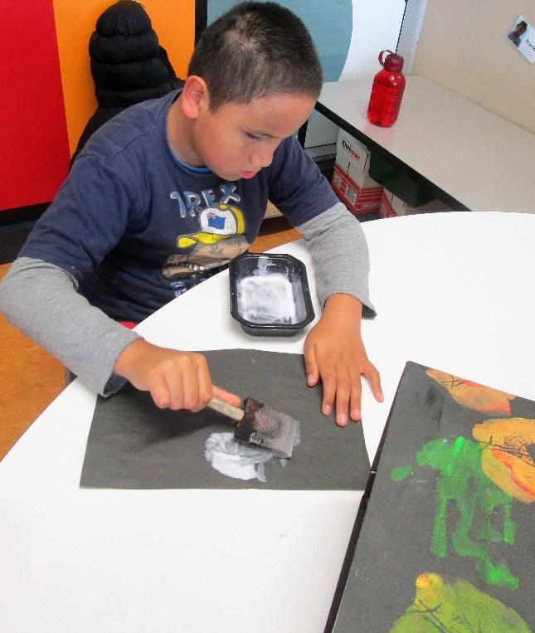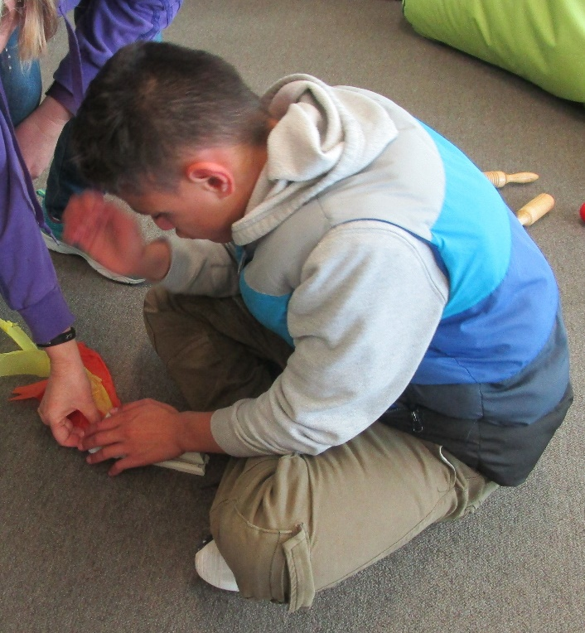
The learners then planned and made a class banner and learnt a chant for the opening ceremony.
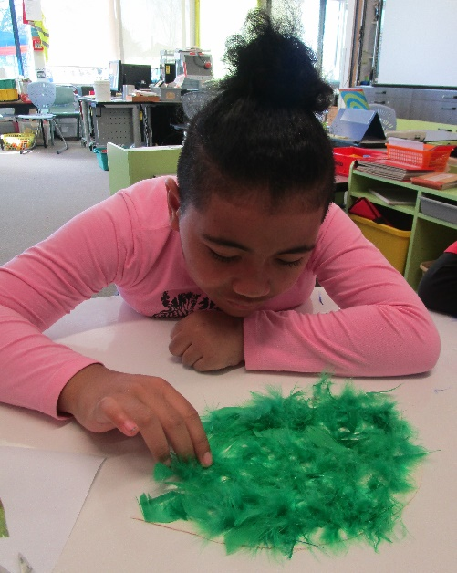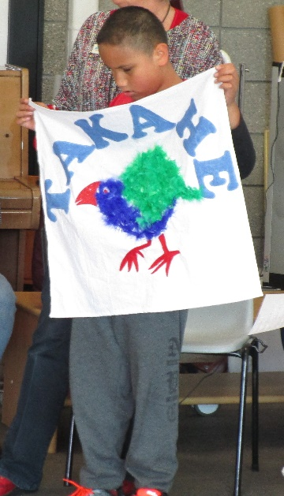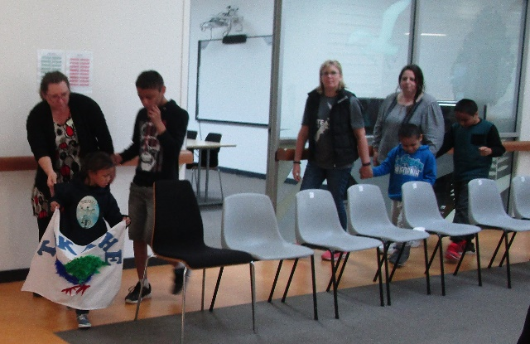
All the learners have been practicing throwing skills for shot put, rolling skills for skittles and running for the running guide race. Takahe have learnt a routine for the gymnastics event and have used apparatus such as scarves and hoops.

Pukeko
This term we have celebrated the Olympic Games and the Paralympics. Our class competed in our School Olympics as ‘Pukeko.’ We made an Olympic flag using collage and added feathers to our birds. We also painted the Olympic rings, in time to music, and glued them on in order on card. Making salt dough medals was very successful. We also made Olympic torches.
As a class we listened to many stories about the Olympics some true and some not. We answered simple questions about the stories. Some students researched on the internet for information about the Games.
In Physical Education we practised gymnastics, javelin, shotput, running and discus.
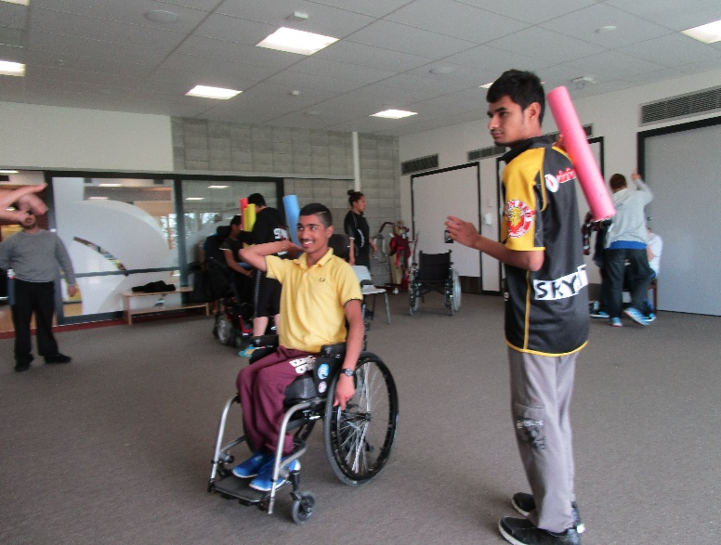
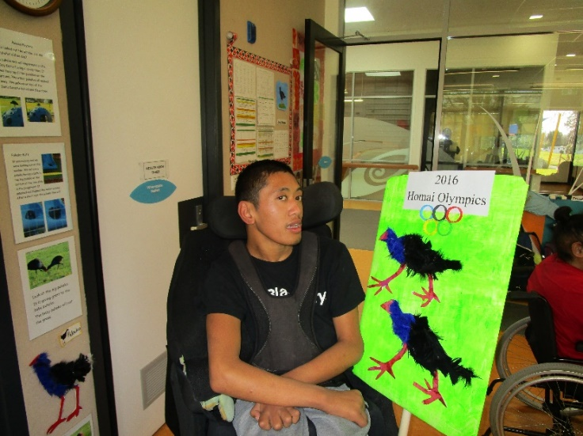

Kickstart

The Skyswing
The Kickstart three day Rotorua trip was really awesome. The trip was full of fun and exciting activities. One activity I really loved was the Skyswing. Although it was really scary it was really fun and exciting at the same time. The wind rushed passed our faces and our stomachs did flips as we flew through the air. Everyone who did it was out of their comfort zone which was nice to see. By Kassi Scarlett
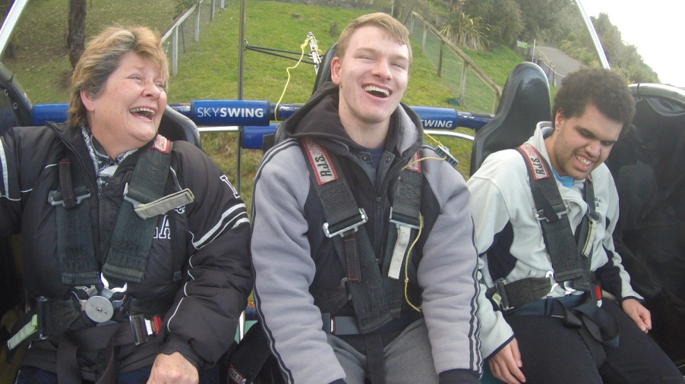
Jude Brendan and Kassi enjoying the Sky Swing
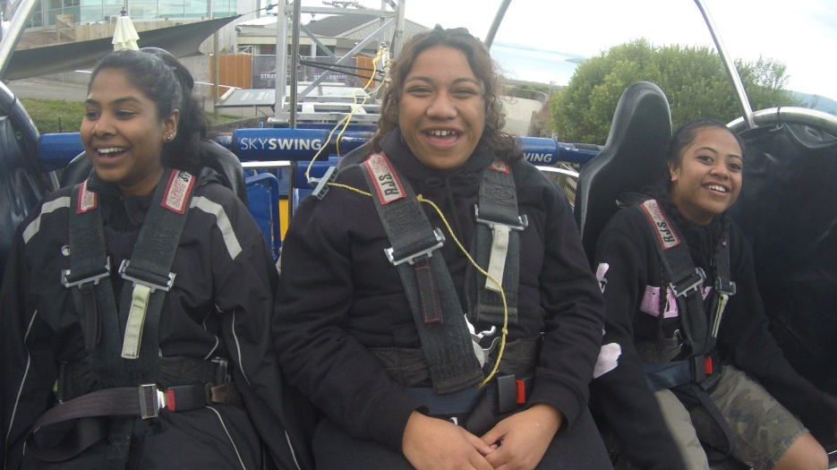

Sheena, Shay and Susana survive the Skyswing!

VIVACE RESTAURANT
At the end of Term 2, the Kickstart students were asked if they would like to be a part of the very first ‘Dine in the Dark’ experience hosted at the Vivace Restaurant on High Street in Auckland CBD. We trained for the first five weeks of Term 3, and the event itself was on Monday and Tuesday of Week 6. Everyone sat and ate in complete darkness. We, as wait staff, were also serving in the total dark. We all worked as a team and worked like we had done it before. We passed all the challenges that the two nights tried to throw at us and we knocked it on the head like it was nothing. We are very proud of ourselves and the staff of Vivace and Kickstart are very proud of us also. By Tarah Foxton-Smith
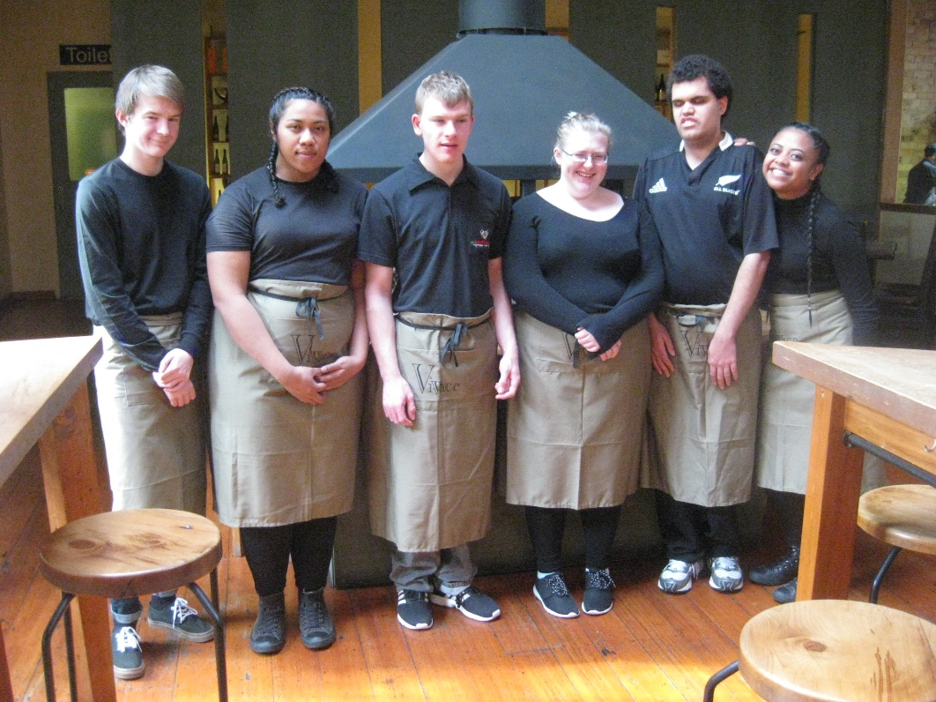

JCH Satellite Class

Tēnā koutou
As another busy term in the Satellite Class draws to a close the staff and learners have been reflecting on some memorable events during the term.
We started the term adjusting to the news that Matua Becker was leaving BLENNZ to start his retirement. He has been part of our team since 2008 and over that time his contribution across our learning programmes has been significant and far-reaching. Later in the term we honoured his contribution to the wider BLENNZ community with a Poroporoaki (a Māori farewell).
The VIP band entered the Play It Strange song writing competition and were announced as one of the 40 finalists throughout NZ. They won $750.00 towards a professional recording session and their song will be part of the Play It Strange CD.
Elizabeth and Amitoj entered their documentary about Big Biscuits to the Focus on Accessibility film competition. Thank you to all our supporters for voting online – Amitoj and Elizabeth agreed that it was a very worthwhile experience and felt they learnt about filmmaking and were proud of their film.
Our topic this term has been All Things Olympic and the Homai Olympic Day was a very special day. In Amitoj’s words “it was the best day of my whole school life”.
In the final week of term the Satellite Class along with Jumpstart and Kickstart will be competing in the Special Olympic Basketball tournament at Kohimarama. The team have spent time working out some adaptations and developing skills: dribbling, passing, communicating and shooting hoops.
Thank you to our community of learners for all the hard work, smiles and positivity. A special mention to Larissa who completed her three week nursing practicum in the class and shared her love of Te Reo and poi with us – just when we needed it.
Kia pai tō wā whakatā
Marie, Ylonda, Elizabeth, Carlton, Jack, Adrea and Amitoj
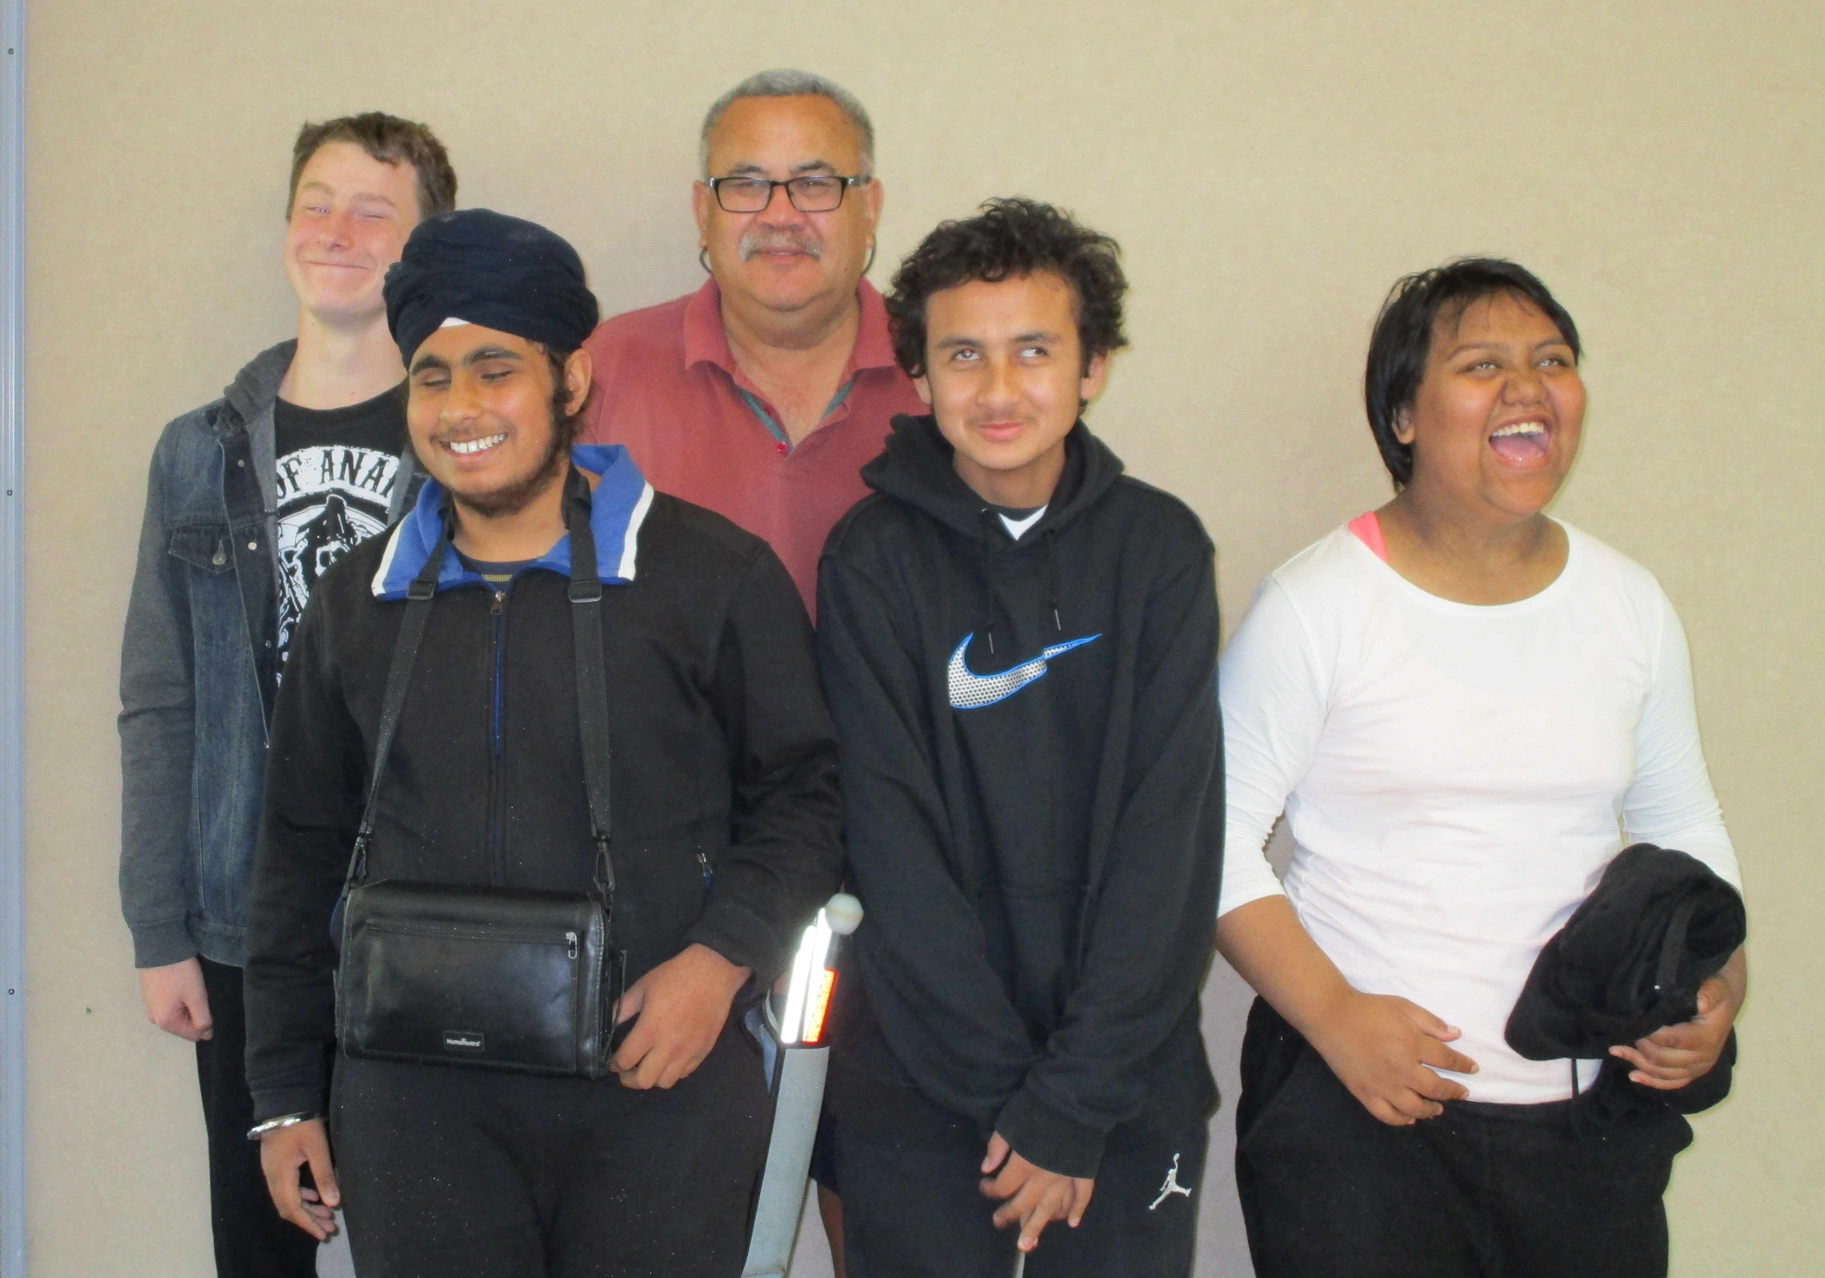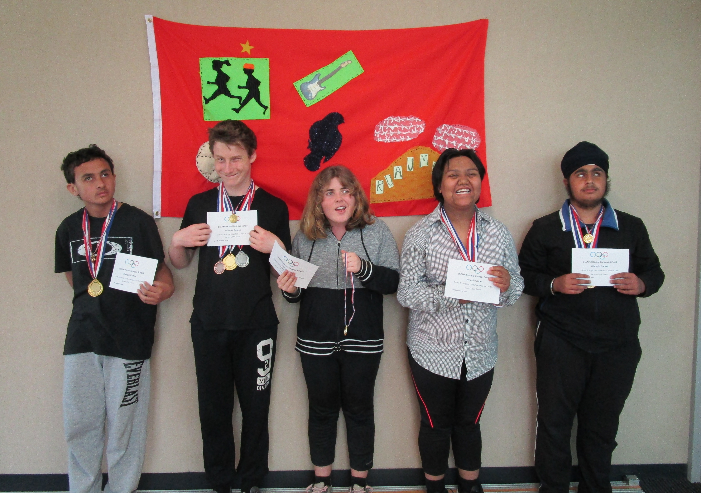
Farewell to Matua Becker Olympic Team

Nikau
Students have shared their personal highlights for this term.
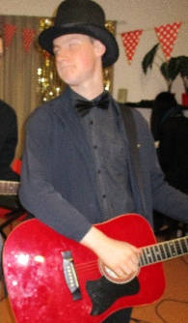
Carlton is very proud of how he has expanded his guitar playing skills and is keen to learn more.
James enjoyed his recent train trip into the city where he had a good look around the Maritime Museum, had fish and chips and took a lot of photos of the sky tower. He is also quite impressed with how he has organised his room his technology cords.
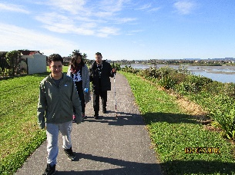
Kahurangi has enjoyed all the outings we have been on. He also enjoys the weekend cooking the students do. One of his favourite meals was the butter chicken he made last weekend.

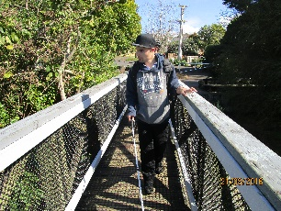
Joseph enjoys staying at Nikau Hostel. He especially enjoys the outings.
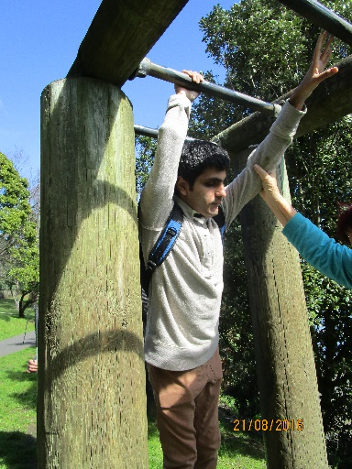
Michael has had a good term, he enjoyed attending the Poetry night and listening to all the talented performers.
Naomi’s highlight was attending the Poetry night at Clendon Library where she performed two of her original poems. Naomi also entered one of her songs in the Play it Strange competition.

Tui Class

This term we have been learning about plants, seeds and gardens. Students were involved in a variety of activities where they explored soil, seeds, leaves, plants, twigs, and flowers. We went for several walks to the school garden to look at and touch the plants and flowers. We had a look at the kowhai tree which had beautiful yellow flowers. We collected leaves, twigs and flowers to take back to the classroom for our nature box.
On 23rd August we visited the Kings Plant Barn. Students explored the plants and flowers and chose some plants to buy. All students participated with assistance to plant petunia, cineraria and marigold in our flower box outside our classroom. They have been taking turns to water the plants which are growing well and beginning to flower.
The students have their own flowering plants that they helped to pot. They are observing their plants as they grow and begin to flower.
