Panui

Term 1 2016

Homai Campus School and Residential Services

Rāranga ai te tuakiri o te tāngata kea whatu i ngā koingo o te iwi hei taupe kit e korowai o te ngākau.

Weave the identity of the people, sow the desires of a nation, thus to be adorned by the cloak of the heart

Kia Ora, Ni Hau, Talofa Lava, Kia Orana, Malo e lelei, Salam Alaikum, Namaste, Ni Sa Bula, Fakalofa Lahi Atu and Greetings.
This year we launched our new transition programme called Jumpstart. The programme began the year with Jacqui Carr as the teacher. Jacqui, unfortunately was not able to continue and we thank her for starting the programme off. We were very fortunate to employ Troy Sheppard who has extensive teaching experience in transition. He will start with us in the beginning of term 2.
The term has been busy with lots of activities outside the classroom. The students have been involved in the Inerschools Parasports at Mount Roskill Primary, the Counties Manukau Ribbon day athletic sports at Massey Park and Greater Auckland Athletics Champs at Mount Smart Stadium.

You will have received information in the mail about the Board of Trustees election that is now in process. Please consider standing for the BLENNZ Board of Trustees at the next elections. You can make a difference in the education of children who are blind, deafblind or have low vision by becoming a trustee on the BLENNZ Board. It would be wonderful to have a parent from the Homai Campus School join the Board.

Board elections for 3 parent trustee positions will be held on Friday 3rd June 2016. As a parent or caregiver of a child or young person supported by BLENNZ we would like to encourage you to stand for a parent elected trustee position on the BLENNZ Board. This is an exciting opportunity to be part of a board which governs a comprehensive and innovative network of services throughout New Zealand.

Barbara Whitley
Senior Manager
School and Residential Services

Jumpstart
Kingi for the Day By Kahurangi Groube
Each fortnight the school meets for Te Reo. One day I was asked to be Kingi for the day. This means I had to take the role of Kingi at the gathering. The schools special korowai (feathered cloak) was put around my shoulders and I was given the tokotoko (walking stick used as a staff) to hold.
I had to sit in front of the school and everyone had to greet me in Te Reo. At the end of the time I stood at the door and said farewell to everybody.
I felt very proud to be chosen for this role. Next time somebody else will have a turn.
Here is a photo of me in the korowai.
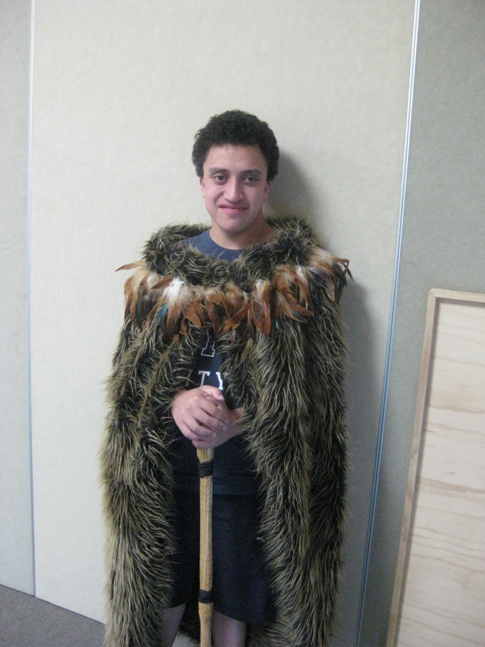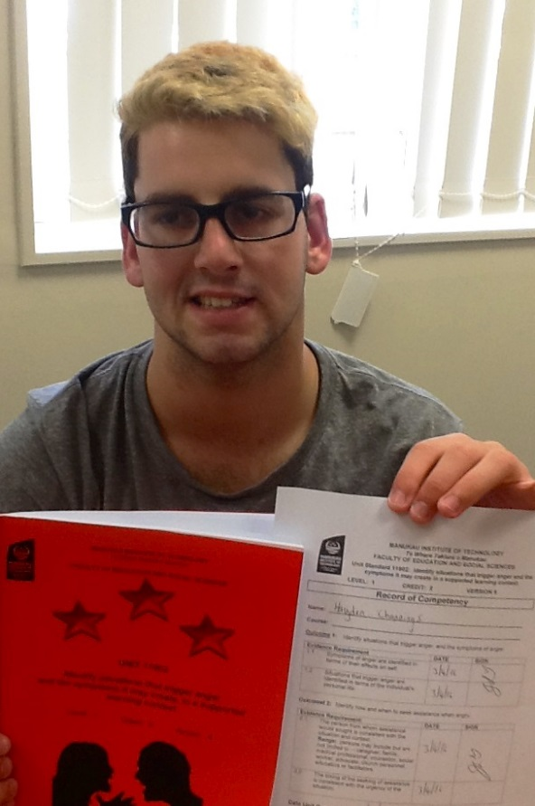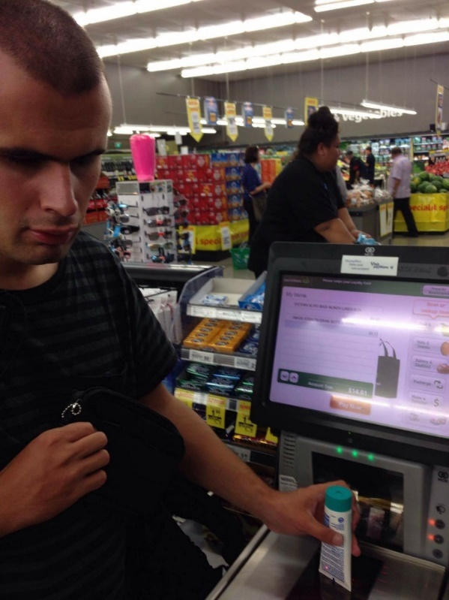
Kahurangi Groube Hayden Channings Shopping at Countdown
Kingi for the Day attending a course at MIT Joseph Taka

This term, every Friday I attended a four week course at MIT with the Jumpstart Programme. This was a STAR course. It was about learning skills that I could use in everyday life, particularly if I get a job or when I am out and about in the community.
At first the “get to know you” ball game was overwhelming but I managed to get to know the people in the class. I learnt different things at MIT like what makes me angry and some sensible things that I can do to calm myself down when I’m feeling angry and stressed. There have been other challenges that I encountered in MIT like the roleplaying because I was nervous and scared, but I kept acting by trying not to look at the audience and pretend that they’re not there.

Shopping at Countdown by Joseph Taka
We made our first trip to Countdown on the van where I slowly learnt the layout of the supermarket. I know that the first area we encounter is the fruits and vegetable section. Then we come to the shelf products on the aisle. I am still learning about where the meat section is. At the checkout, I learnt where to put the products on the counter, how to use the self-checkout with some assistance and how to pay for my personal things. I have led the Jumpstart group walking to Countdown twice showing my O & M skills. This picture shows me learning to use the scanner at Countdown.

Takahe Class
This term Takahe has been very busy. We have been visiting Totara Park weekly and practising running races for the Parasports Day. We unpacked and used the new scooters on the bike track. We went swimming each week learning how to blow bubbles and put our faces in the water. We have built sand castles in the sand pit and stomped them down with our feet when it was time to go back to class. We learnt to use lots of new technology and had lots of fun.

Photo of Takahe students swimming. Students using a daisy player
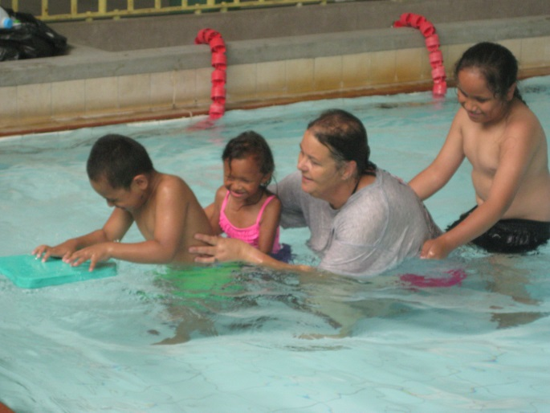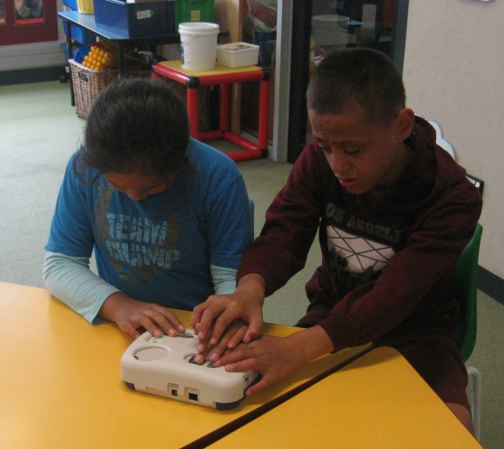

Weka Class
This term we focused on ‘Myself, My Family, My World’. The students in Weka class listened to stories and songs from the library while exploring tactile pictures. Some of our favourite titles were ‘I love my Daddy’, ‘My Mum’s the Best’ and ‘Are you my Mother?’ All the students responded with happy vocalizations and smiles as they became familiar with our new poems and songs during our language sessions.

We explored homemade play dough and made hand prints while saying our poems ‘Me’ and ‘All of Me’. We listend to the story ‘My Car’ and the students were assisted to roll, pat and shape their play dough into cars. Creating handprints with brightly painted palms while listening to the poems ‘My Two Hands’ and ‘I Am Special’ was great fun.

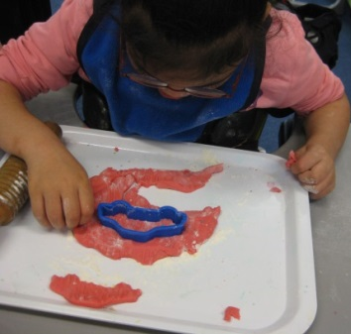
During our Sensory Art sessions each student was assisted to decorate a huge ring with shiny ribbon and we moulded and rolled out clay to create a hanging butterfly mobile. We used butterfly and fish cookie cutters and we painted our clay creations with bright colours.

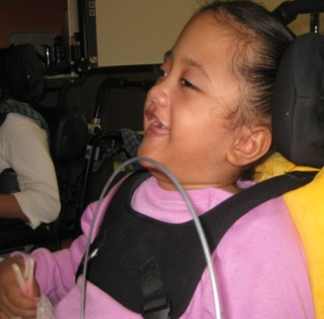
Hephzi was chatting away while decorating the ring for her butterfly mobile.

Tui Class

The Great Kumara Hunt
Last year Tui class carefully removed the eyes that had grown on a small kumara and put them in water to sprout. After a few weeks these had grown big enough to be planted in the school garden at the hub. Stones were put near them to help hold them in the ground. Soon they were growing well. When students returned to school after the summer holidays there was a lot of green. Some straw was carefully put under the plants greenery to try and stop setting more roots.
April 7th Harvest day and students involved in the gardening gathered at the hub for the dig.
Daryl had first go with a fork then everyone else got down and dirty. The biggest kumara measured
1.29 kg. Two big buckets full of huge kumara were unearthed. Now we need to find some recipes.
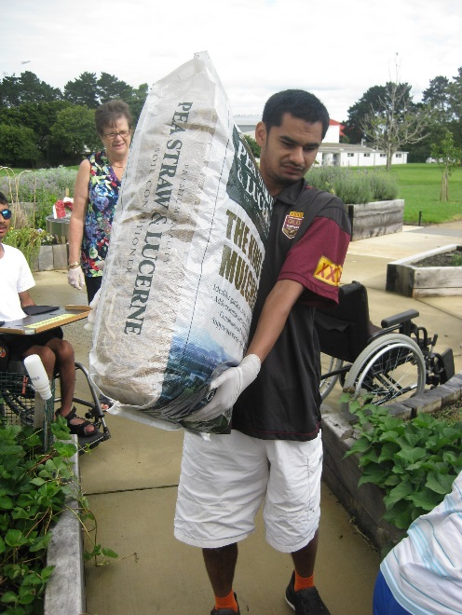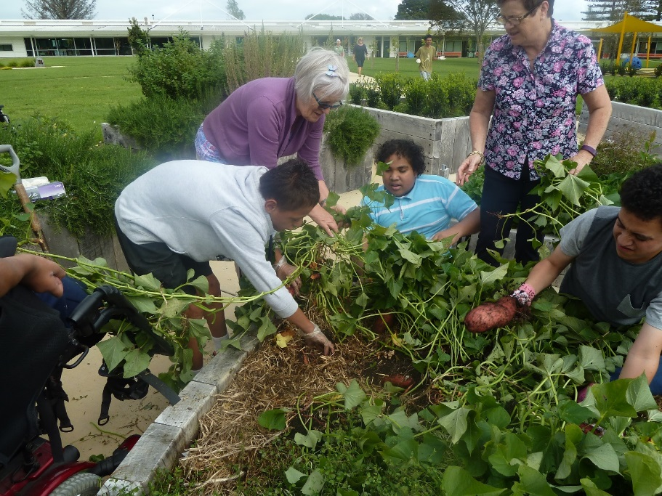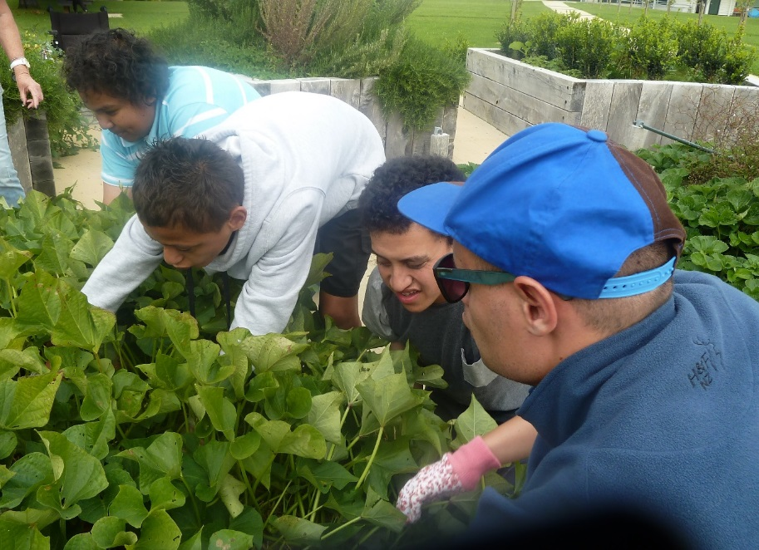
Ronald helped with Students and teachers digging Teuaki can feel a real big treasure
the mulch, he was a for kumara
champion lifter.

Kiwi Class
This term, students in Kiwi class have taken part in two separate sporting events.
On 22nd March Jesse and August went to the Counties Manukau Ribbon day athletic sports at Massey Park. Many other schools participated. There were several track events. Students also took part in field events such as long jump and soft ball throw. Jesse and August took part in the assisted 50 meter walk. They competed with students from other schools. They were assisted by staff to complete the race.

On 8th April Kerred and Iulieta attended the Interschool Parasports day at Mt Roskill Primary school. They were assisted to take part in skittles, boccia, obstacle course and wheelchair races. They were excited to receive their ribbons and rosettes.
Even though it rained everyone had lots of fun.
It was such a great opportunity for our students to be a part of these events so that they don't miss out on the health, wellness and social benefits that sport and recreation provides. Special certificates were presented to the students at the school assembly.

August participated in the assisted walk Kerred and Iulieta in the wheelchair race
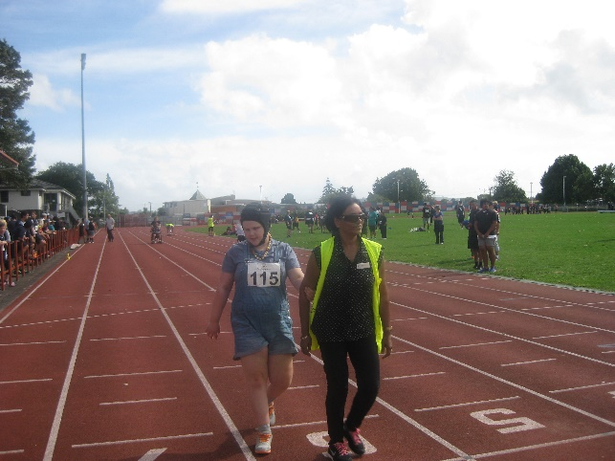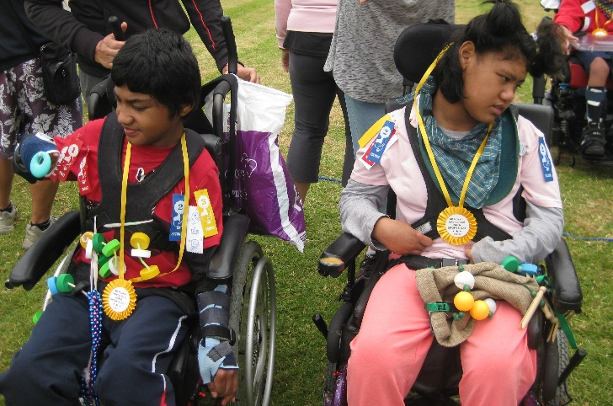
James Cook Satellite Class
Kia ora koutou katoa
We have had a healthy, fit start to our year. The students have been involved in training and competing in 3 athletic events and we are pleased to report that we are running faster, jumping longer and throwing further.

Elizabeth and Amitoj competing at the Greater Auckland Athletics Champs in the 100m AWD race at Mt Smart Stadium.
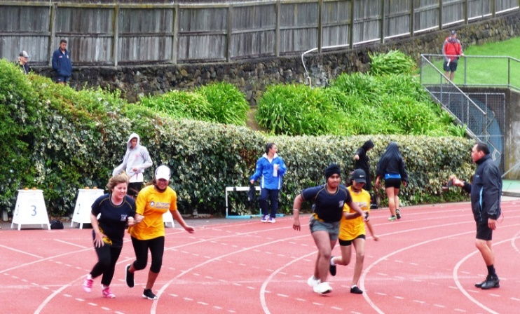

Carlton competing in the Standing Long Jump at the James Cook Athletics
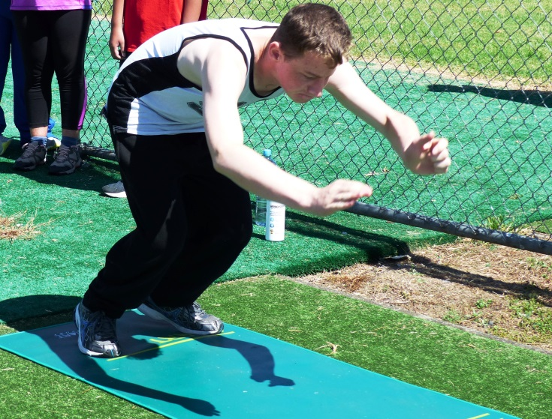

In March we went along to the Auckland Polyfest where we enjoyed watching the wonderful performances at each of the stages and being part of this busy exciting annual event.
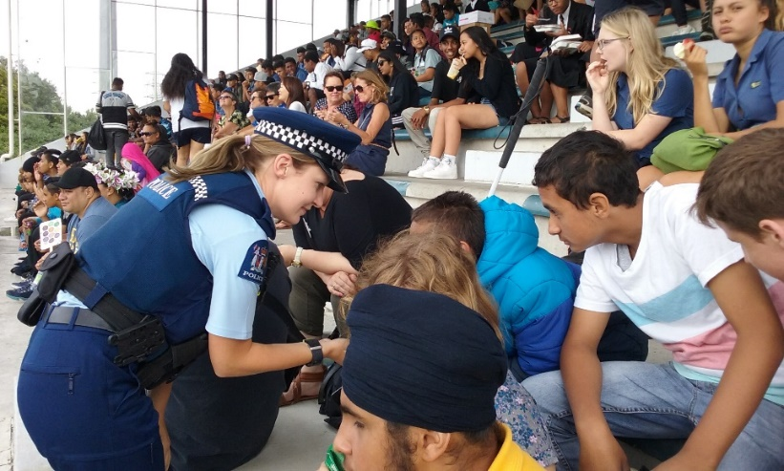
The students chatting to a police officer at the Polyfest 2016

VIP Band
Our VIP band has been super focused getting ready for the Smoke Free Rock Quest in May. Over the term they have worked solidly with Ajay to compose an original song – put the arrangement together – and now are practicing twice a week to be ready for their performance at the Telstra Event Centre. More information about this event can be found here smoke free rock quest
Homai Assemblies
This term we reintroduced our Homai Campus School Assemblies. They happen every fortnight on Wednesday afternoon at 2.00pm. The Satellite Class along with Takahe have had the opportunity to lead on two occasions. The assemblies are a great way to celebrate our learning and an opportunity to develop our public speaking skills
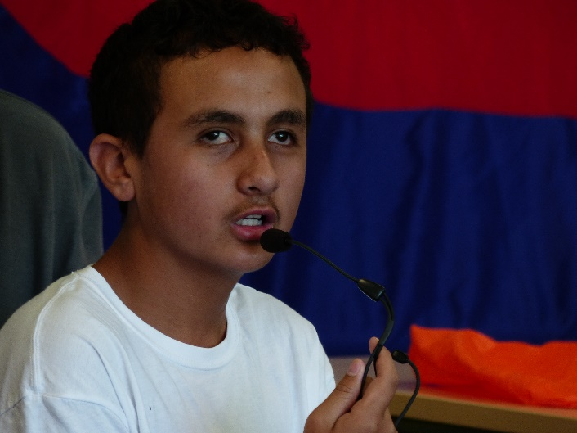
Jack was the Master of Ceremony when the Satellite Class co led the Homai Assemblies.

Kickstart’s Overnight Communication and Team Building Camp 7-8 April 2016

Comments from some of the Kickstart students:
We were all really pleased with how well we did as a team.
No one gave up and everyone gave everything a go.
We had good communication and laughed instead of getting frustrated.
We all managed to learn how to get around safely in a new environment.
It was a great team effort and everyone enjoyed the whole experience especially the walk
through the tunnel!
The Kickstart group before entering the tunnel
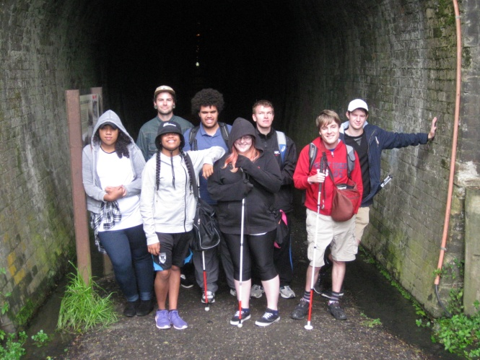
The Human Knot activity
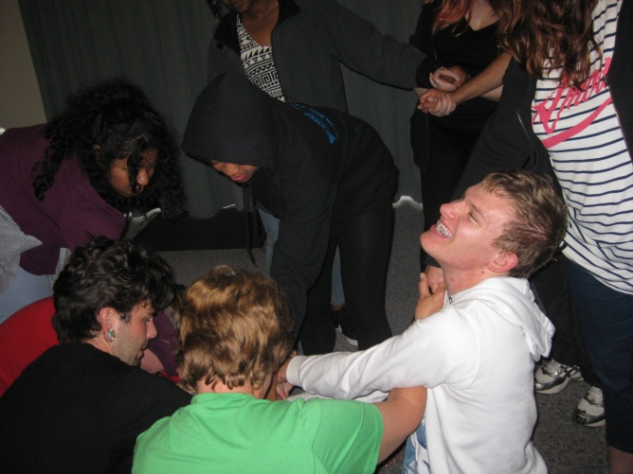
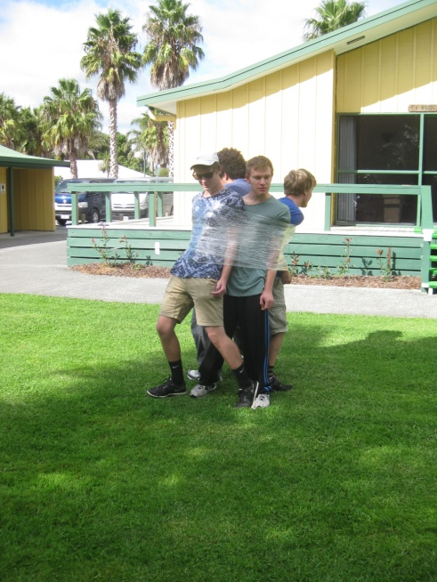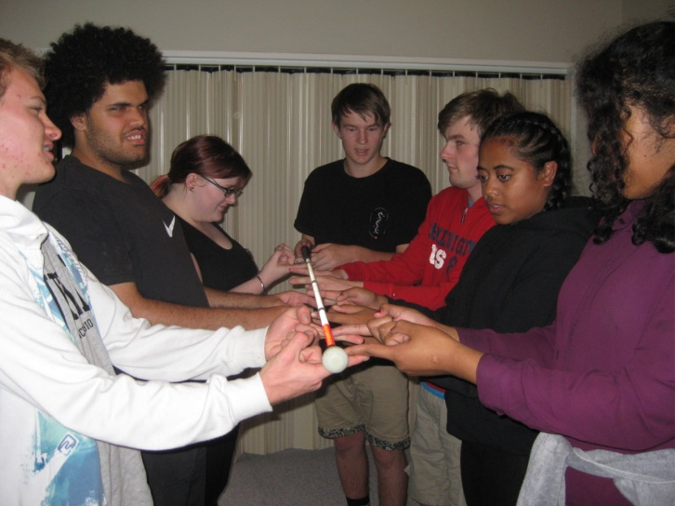
Gllad to be workin together The ‘Helium’ Stick activity facilitated by Tim

Nikau Hostel

We have had a great start to the year with a small group of 7 students. Michael, James and Carlton are our returning students. Joseph Taka from West Auckland, Kahurangi Groube from Gisborne and Hayden Channings from Christchurch reside in Nikau and attend the new BLENNZ programme “Jumpstart”. Naomi MacKinnon from Auckland is a Monday to Friday student.
The Term has gone very fast but we have managed to squeeze in a variety of activities, a favourite being the “Wild Boy Weekend”. We had read the book “Wild boy” which is the true story written by a young New Zealand lad who walked around the Coastline of New Zealand. We decided to do our own scaled down version.

James and Michael put up the tents in the courtyard so everyone could have a turn at sleeping
under the stars at Homai Campus .
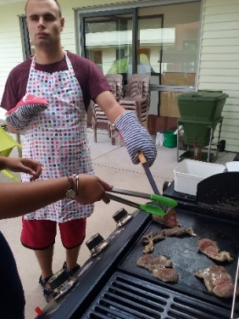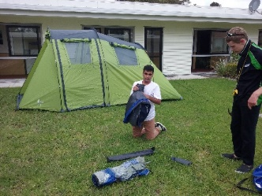

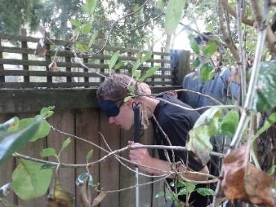
Then on the Sunday we did the BLENNZ perimeter walk, blindfolded to make the experience more memorable. Most were surprised by how big our grounds are.

