Panui

Term 2 2016
Homai Campus School and Residential Services

Rāranga ai te tuakiri o te tāngata kea whatu i ngā koingo o te iwi hei taupe kit e korowai o te ngākau.

Weave the identity of the people, sow the desires of a nation, thus to be adorned by the cloak of the heart

Kia Ora, Ni Hau, Talofa Lava, Kia Orana, Malo e lelei, Salam Alaikum, Namaste, Ni Sa Bula, Fakalofa Lahi Atu and Greetings.

Congratulations to Mitch Harris for his election on to the BLENNZ Board of Trustees. It is heartening to have a parent of the Homai Campus School on the Board.

You will see through the newsletter that term 2 has been an incredibly busy one for us. The school have been following a focus of Pasifika and have much to share.

The Life Education caravan came this term. Life Education is a charity that provides children with the knowledge to make informed choices about their health, respect others and learn to appreciate their uniqueness.
The programme was adjusted to meet the needs of all the students and was thoroughly enjoyed by everyone. Pamela Ens, the Life Education teacher did this by taking the children and young people on an adventure in the mobile classroom that is equipped with sight and sound equipment designed to capture imaginations. She took the students on this journey, along with Harold the Giraffe, their mascot. Harold, as always, was a hit with all the students. We are very fortunate to be able to access this organization.

Aku mihi nui ki a koutou

Barbara Whitley
Senior Manager
School and Residential Services

Weka Class

Under the Pacific in Weka Room
During this term, Manuae, Hephzibah, Riya and Prisha, the students in Weka, have explored many ways of creating the parts of an underwater scene. The fish were made from handprints of each student. This was not their favourite activity. The water was a collaborative block of finger painting in blues and greens to give the tropical effect. Seaweed was created with textured rollers
using greens and browns. The students enjoyed the experience, especially Prisha who thought paint might be a new kind of face paint.
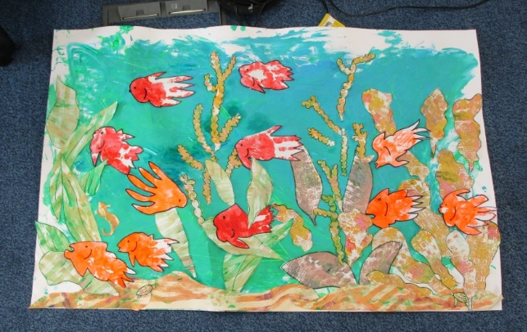
Look at our finished mural.

Tui Class
This term our theme has been ‘Pasifika’. The class have listened to many stories about Samoa and Tonga and other pacific islands. Jill from the Library came and read us a story in Samoan about Uncle Timi who was asleep at the beach and got wet when the tide came. We enjoyed this story.

We have learnt lots; especially about the coconut palm. In cooking time we have tasted milk and meat from coconuts and in art we have painted with coconut shells and on shells to make clackers to use in music. In Grooming we have used coconut soap and coconut oil for massage.
Several of the students have researched on line for additional information and have been helped to share it with the class. We read a school journal story about coconut palms called ‘The Tree of Life’ and were surprised by how many uses there are for coconut palms. Together we made a list of a few of them.

Uses of Coconut Palms
Food and drink from the coconut
Coconut oil for massage and cooking
Bowls and cups from the shell
Clackers from the coconut shells
Fiber to make string and rope
Brooms
Fans
Buildings
Leaves for weaving baskets

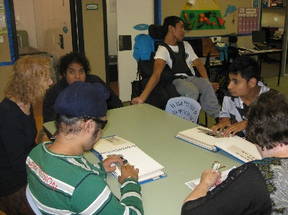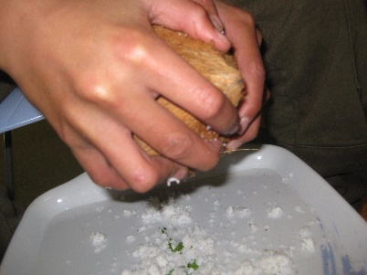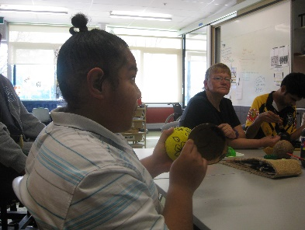
Jill reading Uncle Timi’s Scraping meat from Teuaki using coconut
Sleep coconut clackers

Kickstart
Ziplining - what an adventure! It was a confidence boosting adventure from our exciting train trip to Britomart to the calm, relaxing trip over to Waiheke Island and on to the Zipline. We then experienced a breath taking walk back through the forest and back to home to base. Ziplining had its 35 to 50 kilometre an hour, 200 metres flying over the forests treetops, giving all the confidence to try such thrill seeking activities in the future. However, the sound of native birds and the smells and sights of the trees would encourage any human being to attempt such a walk again. Overall, this was a confidence boosting and enjoyable outing had by all Kickstarters.

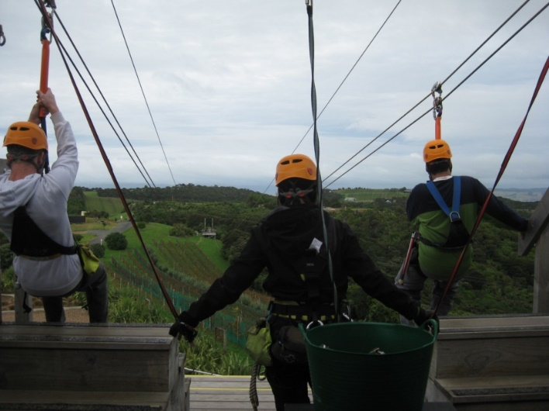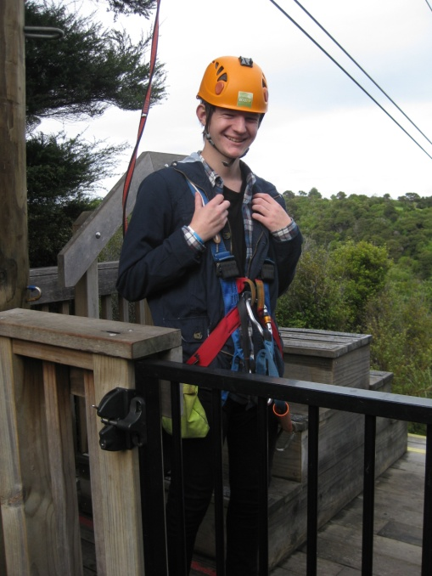
Brendan and Kassi are on their way Tim is ready to go

International Violinist Suyeon Kang Visits BLENNZ
On the 23rd of June BLENNZ had a special visitor come in and perform. The violinist was Suyeon Kang. Suyeon is the winner of the 2015 Michael Hill International Violin competition. She now travels on tour as part of her first place prize. The Australian competitor is a very successful artist and we all enjoyed her performance it was absolutely delightful. From all students that attend BLENNZ we thank you for the heart-warming performance. We wish you the very best for the future.
By Shay & Kassi

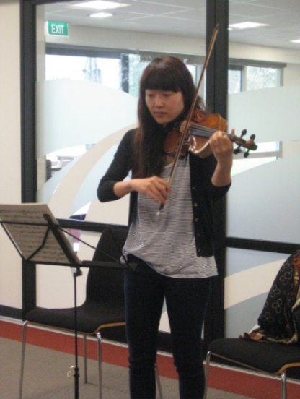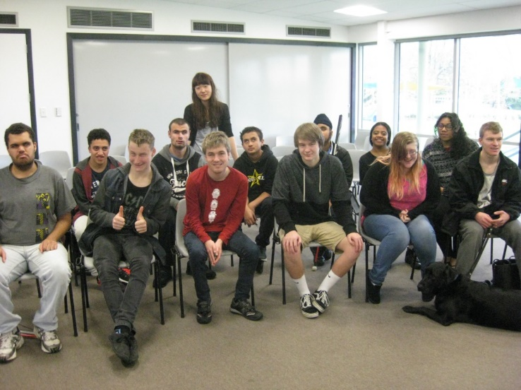
Suyeon playing the violin A photo with Suyeon and students
for the students

Kiwi Class
Kiwi class has been listening to music and songs that embraced the languages and cultures of the Cook Islands, Niue, Samoa, and Tonga. Students showed interest and enjoyment while exploring coconut shells, leis and lava-lavas. Iulieta dressed up in her traditional Samoan clothes called ‘pulatasi’ which a matching skirt and tunic with Samoan designs. Our morning greetings included Talofa Lava and Malo e lelei. We listened to the story ‘One day I saw a Taniwha’ during interactive story telling. Students explored tactile pictures of the Taniwha and used switches to fill in the words from the story. At Te Reo sessions we learned to use tapping sticks to tap the rhythm while listening to E Papa music.

Iulieta wearing her Pulatasi | August enjoying dancing to Pacifica music | Kerred enjoyed dancing to Pacifica music
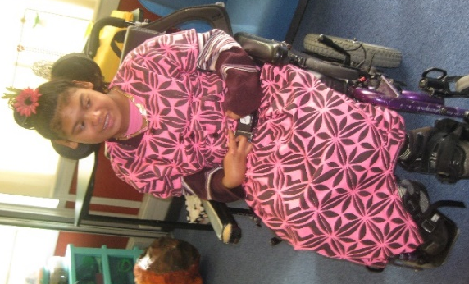 | 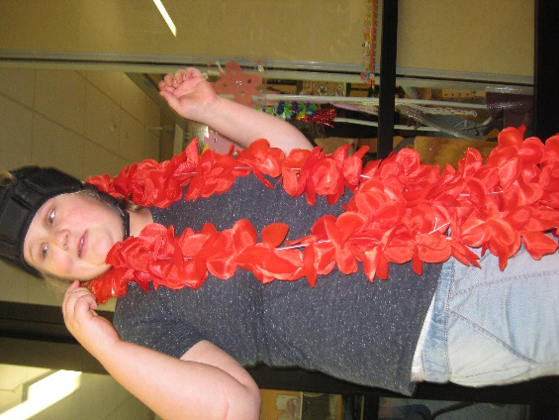 | 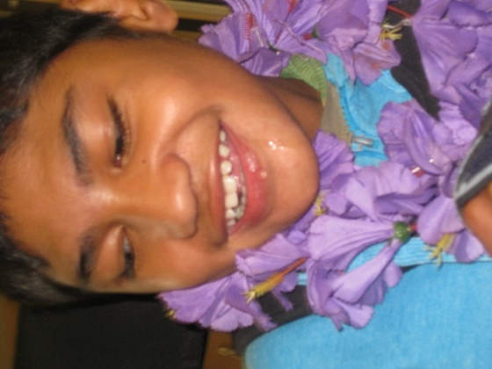

Takahe Class
This term Takahe class visited Harold in his mobile classroom. Harold told us all about having a variety of food types in our lunch boxes. After our lesson Harold gave us each a lunchbox to take home.

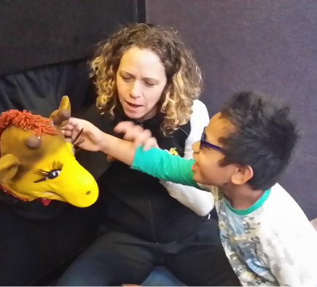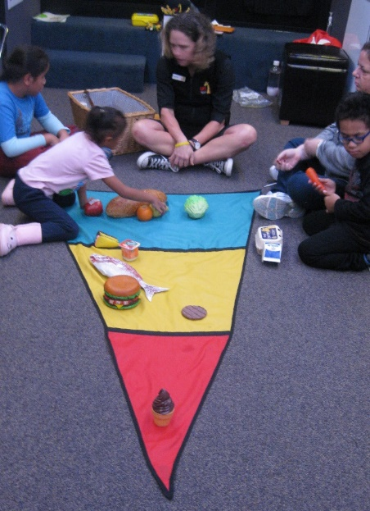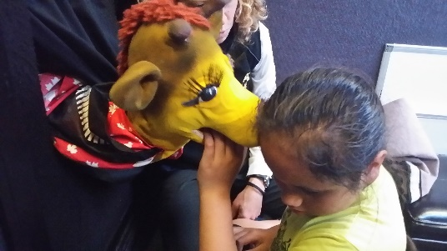
Student touching Harold’s Students sitting around Harold Giraffe whispering in
ear food triangle mat with plastic child’s ear
Food placed in correct area

Nikau House
Term 2 has been a very busy one for Nikau House.
Here we are half way through the year and the students are all wondering where the time has gone.
The most exciting event for this Term has been the concert and cocktail (non-alcoholic) evening we hosted last week.
Kahurangi took on the task of barman and photographer for the night, doing an excellent job in both roles.
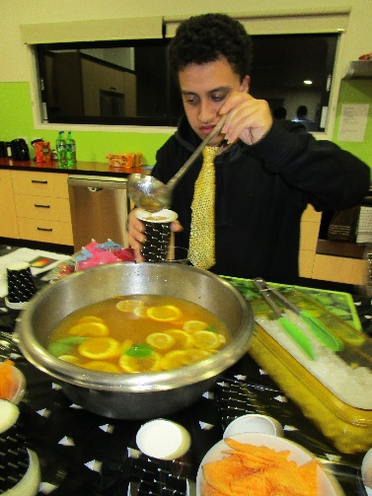
All students took a role in either the planning or managing on the night. We invited the Kickstart staff and students and all said they had a fabulous evening.
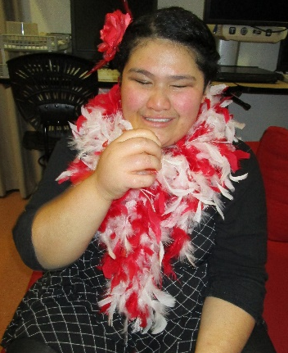
Naomi took part in the group items and did a lovely solo song.
The Kickstart students contributed with some very polished performances which spiced up the evening.
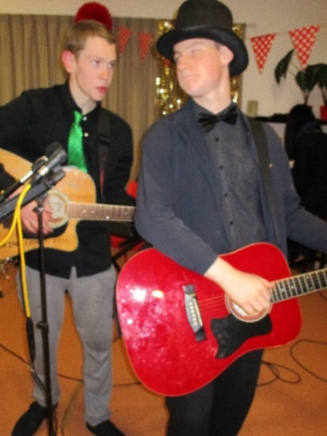
Carlton and Michael shared the M.C. responsibilities, ensuring the evening flowed along with no hitches.
Carlton and James performed a toe tapping duet.
Joseph wowed everyone with his keyboard, recorder and singing skills.
James was in charge of sound and recording. He mentioned that a D.V.D of the concert will be available early in Term 3. We look forward to it.
Have a safe and enjoyable holiday from everyone at Nikau House.

Jumpstart
Jumpstart has had an exciting term 2. We have been rock climbing at Extreme Edge in Panmure. Both Kahurangi and Joseph did well to climb the wall and improve their technique to come down safely using the automated cable. We enjoyed a number of outings including travelling by train and ferry to Devonport and visiting the local fish and chip shop. On our final outing this term we went to see the movie ‘Hunt for the Wilderpeople’ at the Event Cinema next to Aotea Centre in Auckland city. It was an entertaining New Zealand film for all of us. After that, we went to Daikoku Restaurant where a Japanese chef cooked our lunch on a hot plate in front of us.
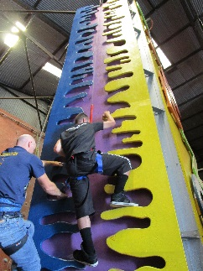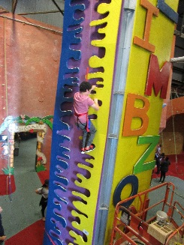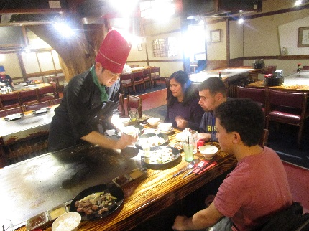
Kia ora koutou

The James Cook Satellite Class have been active and industrious this term. Early in the term they performed at the Smoke Free Rock Quest where they premiered their original song Being Me. The opportunity to participate in this secondary school music competition and to be exposed to the high level of performances and the buzz of the night was a very cool experience.
Carrying on with the rock theme – the students started a physical training programme to prepare for their full days climbing at Extreme Edge, an indoor rock climbing venue in Panmure. Over the term each student challenged themselves to climb further and to progress to more difficult walls.
Throughout the term the students have continued to run their enterprise businesses: Carjak a car wash business and Big Biscuits a baking business. The skills they are learning are preparing them for real life - job skills and every day. They used the profits form the businesses to pay for rock climbing and to have their song Being Me professionally recorded.
The Big Biscuit team made a film that they have entered into an Australian film competition and would love our BLENNZ whanau to get behind and support our entry when it goes live.

And finally, the VIP band have entered their original song Being Me into the Play It Strange song writing competition.
Thank you to all the students: Elizabeth, Carlton, Benjamin, Adrea, Amitoj and Jack for all your hard work and enthusiasm.

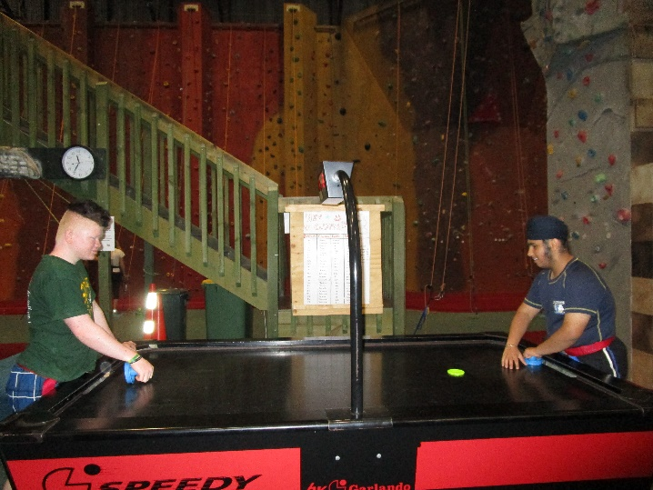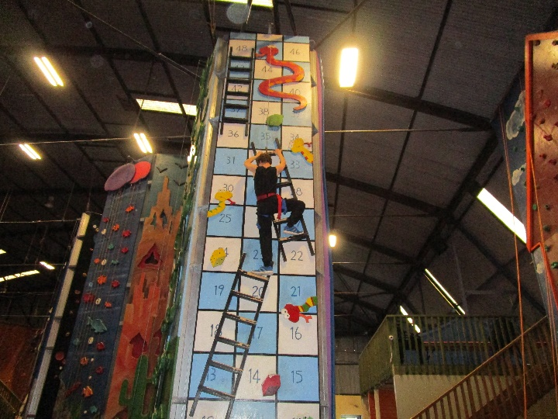
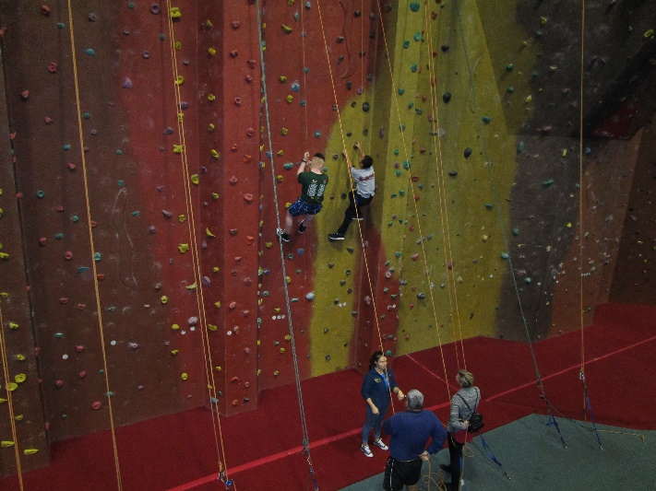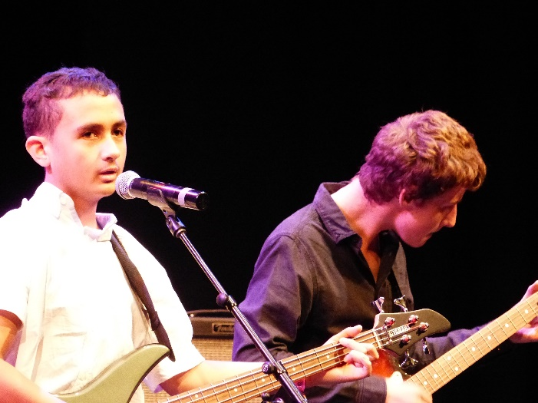
Pictures of students rock climbing and playing Air Hockey at Exteme Edge
Picture of Jack and Benjamin playing guitars and singing at The Smoke Free Rock Festival

