Blind and Low Vision Education Network NZ

Annual Report 2017

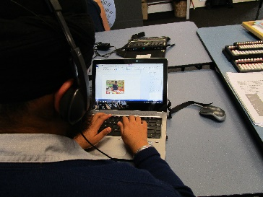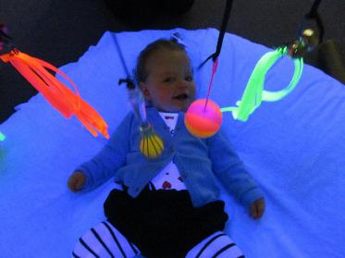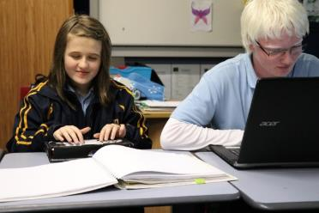
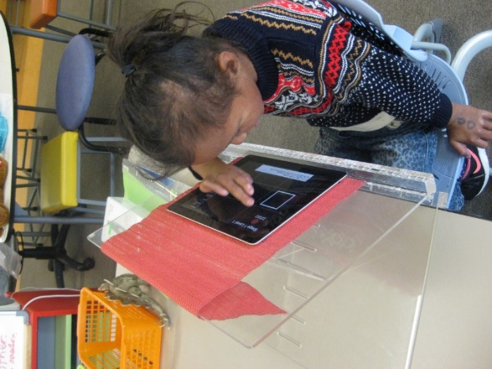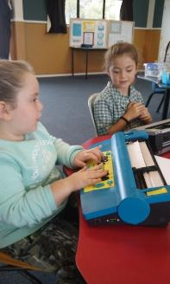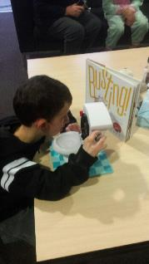
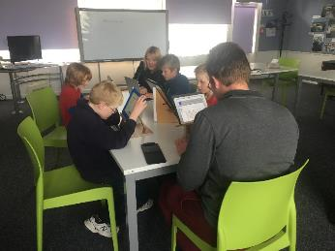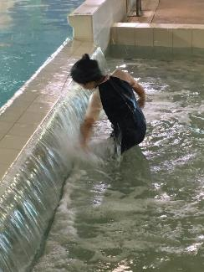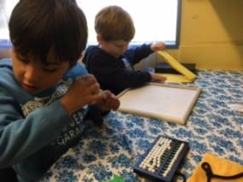
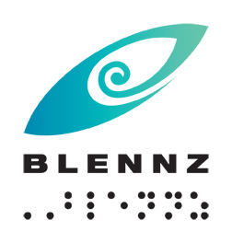

Blind and Low Vision Education Network NZ

2016 Annual Report and Financial Statements

School Address:
2 McVilly Road, Manurewa, Auckland 2012

School postal address
Private Bag 801, Manurewa, Auckland 2243

Contact details:
School Phone: (09) 2667109
School Fax: (09) 2674496
Email: Admin@blennz.school.nz
Facebook: BLENNZ Facebook
Twitter: @BLENNZOnline
BLENNZ ICT: info@blennz.school.nz

Contents
Message from the Board Chair 6
Message from the Principal 7
Introduction 8
Special Character School 8
Vision 10
Mission 10
Values 10
Organisational Culture 10
Beliefs 11
Key Facts and Figures 12
Learners attending Homai Campus School 12
Learners Receiving Services from BLENNZ Visual Resource Centres end of 2017 13
Statement of Variance – Overview 15
BLENNZ 2017 Annual Plan 15
Events from 2017 17
South Pacific Educators in Vision Impairment (SPEVI) 17
Braille Music Retreat 17
Specialist Services Review 17
Roundtable Conference 17
Vision 2017 18
9th International Council of Educators of People with Visual Impairment (ICEVI) 18
Learner Achievement 19
School and Residential Services 19
Homai Campus School 19
Nikau Hostel 25
Assessment and Teaching 26
BLENNZ Homai Early Childhood Centre 26
BLENNZ Northland Visual Resource Centre 27
BLENNZ Auckland North Visual Resource Centre 28
BLENNZ Auckland South Visual Resource Centre 30
BLENNZ Hamilton Visual Resource Centre 31
BLENNZ Tauranga Visual Resource Centre 31
BLENNZ Gisborne Visual Resource Centre 32
BLENNZ Napier Visual Resource Centre 33
BLENNZ Taranaki Visual Resource Centre 35
BLENNZ Palmerston North Visual Resource Centre 36
BLENNZ Wellington Visual Resource Centre 36
BLENNZ Nelson Visual Resource Centre 37
BLENNZ Christchurch Visual Resource Centre 38
BLENNZ Otago Visual Resource Centre 40
BLENNZ Southland Visual Resource Centre 41
BLENNZ National Assessment Service (NAS) 41
BLENNZ Immersion 43
Regional Teaching Team 44
BLENNZ DOM 44
BLENNZ VRC Coordinators 45
Homai Campus Music School 46
Individual Music Programme – Wendy Richards 46
Music School – Wendy Richards 46
Homai School Music Therapy Programme – Ajay Castelino 47
Te Whānau o Homai 47
Youth Library 48
Board of Trustees 49
Pre mid-term elections 2017 49
Post mid-term elections 2017 49
BOT members and roles – pre mid-term election 50
BOT members and roles – post mid-term election 51
Professional Development and strategy Planning Days 51
The Framework of Indicators of Learner Achievement 51
Homai Campus School 52
BLENNZ Qualifications gained and intended pathways. 57
Learner Engagement in Learning 57
Regional Network 60
Learners verified for Ongoing Resourcing Scheme (ORS), primarily for vision 63
Student Engagement in Learning 68
Caregiver Surveys 70
Professional Surveys 71
Immersion Courses 2017 72
Developmental Orientation and Mobility Services 76
2017 National Standards Reporting 78
Statement of Resources 82
Physical Resources 82
Other Resources 83
School Roll and Days Open BLENNZ 83
Administration Services 84
Health and Safety: 84
Policy Review: 86
Compliance: 87
Legislation: 87
Property: 88
Assets: 88
Appendix: BLENNZ 2017 Annual Plan Statement of Variance – Detailed 89
Goal 1: Objective 1: 89
Goal 1: Objective 2: Operational 92
Goal 1: Objective 3: 95
Goal 1: Objective 4: 96
Goal 2: Objective 1: 97
Goal 2: Objective 2: 97
Goal 2: Objective 3: 98
Goal 2: Objective 4: 99
Goal 2: Objective 5: 101
Goal 3: Objective 1: 102
Goal 3: Objective 2: 103
Goal 3: Objective 3: 104
Goal 3: Objective 4: 106
Goal 3: Objective 5: 107
Goal 3: Objective 6: 109
Goal 3: Objective 7: 110
Goal 3: Objective 8 111
Goal 3: Objective 9: 112
Goal 3: Objective 10: 113
Goal 3: Objective 11: 114
2017 Audited Financial Statement 118

Message from the Board Chair

Kia ora tātou

On behalf of the BLENNZ Board of Trustees I present the 2017 Annual Report.

2017 has been another great year for BLENNZ across the network. Progress has been made towards all of the strategic goals including:

- Evidence-based practice is being used to support learners to achieve their full potential
- Learning-centred whānau relationships are being developed and strengthened
- Learning is continually enhanced through resources, systems and organisational relationships.

In 2017 we saw the adoption of the updated school values of whanaungatanga, manaakitanga, awhinatanga, kotahitanga and ako. We want these values to be inherent across the network from the Board to the Principal, staff and ākonga. They are values which we can all embrace and demonstrate in how we conduct ourselves. Have a look at the 2018 Charter to learn more about how BLENNZ whānau demonstrate each value.

The BLENNZ website has been refreshed and is now in an accessible format that works across all devices. This will continue to be updated with new and relevant information and resources.

The Board spent a lot of time in 2017 looking at options for the Homai Campus swimming pool complex. This is a great facility but due to it’s age is in need of an upgrade. Various options were presented to a working group and to the Board. The Board has agreed to fund an upgrade, and have started the process towards getting approval and the work underway. The intention is to have the pool reopened early in 2019.

I’m excited to see what’s in store for this year. Through the very capable leadership of the Principal and Senior Managers, and through the commitment of our teachers and support staff, BLENNZ is well-positioned to continue providing an outstanding education to our children in 2018.

Ngā mihi nui
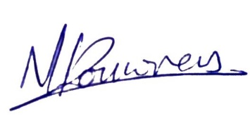
Nathaniel Louwrens
Board Chair

Message from the Principal

Tēnā tatou katoa

Once again we mark the passing of each school year with presentation of our Annual Report.

Compiling the Annual Report is always initiated with a sense of trepidation, how do you capture a year in the life of BLENNZ? How can you portray the many services and learning communities across our network? However once again as the report comes together it progresses from being a mammoth task to a wonderful documentation of the celebration of achievements of ākonga.

As you read through the various sections of the report which shares and depicts ākonga achievements you cannot help be impressed. I am very aware that there are many other similar stories of effort, commitment and success that have not made it to this report, we acknowledge each and every one of you.

I want to take this opportunity to acknowledge the commitment of whānau, our colleagues and sector partners who have walked alongside our teaching team in 2017. We learn so much from you and from each other. Thank you for being an active part of our learning community.
To our BLENNZ team I acknowledge your commitment to access and equity for tamariki and rangitahi. Thank you for your reflection and focus on continual improvement as we seek to build a learning culture which is evidenced based.

To our administration team, who quietly work behind the scenes to keep the systems operating, thank you. A special thank you to Janny Cooke, Board of Trustees Secretary, without your assistance we would not have the annual collation of BLENNZ ākonga achievements for 2017.

Karen Stobbs
Principal

Introduction
Welcome to the 2017 Annual Report for the Blind and Low Vision Education Network NZ (BLENNZ). The primary focus of the report is to provide accountability to the community, a set of accounting statements providing accountability from a financial perspective; reports on achievement and challenges from an operational perspective; and strategic planning reports from a strategic perspective.

Special Character School
The Blind and Low Vision Education Network NZ (BLENNZ) is a national school that provides a network of education services to 1565 blind, deafblind and low vision learners throughout New Zealand from birth to 21, including those who have additional special needs. BLENNZ was established as a national network of services thirteen years ago in January 2005. It is one of the special schools nationally that have been legislated to provide residential provision for learners.
The purpose of BLENNZ is to ensure that the education needs of blind, deafblind and low vision learners are identified and appropriate programmes and services are available. It aims to support the government goals for education by enhancing education opportunities for its learners, facilitating access to and participation in the regular curriculum and developing skills for independence.

Historically blindness education services were provided either by the Blind Foundation (previously The Royal New Zealand Foundation of the Blind) through the services based on Homai Campus, or by Visual and Sensory Resource Centres that were part of the state education system. In July 2000, Homai National School for the Blind and Vision Impaired became a state residential special school and in 2005, all of the services were amalgamated to form the Blind and Low Vision Education Network NZ.

This amalgamation of services was achieved through many years of combined advocacy from parents, teachers, service providers and sector organisations, who expressed a strong desire for a unified, nationally coordinated system for service provision. BLENNZ aims to achieve such co-ordination and cohesion and to reflect the special character of the school through the following objectives:

- Development of nationally consistent practice which is evidence-based
- Implementation of the principles of the National Plan
- Learning and teaching in the Expanded Core Curriculum in the context of the Key Competencies, as expressed in the BLENNZ Curriculum
- Learning and teaching based on the Expanded Core Curriculum as a means of accessing Te Whāriki
- Determination, monitoring and review of learner outcomes
- Clear mechanisms for accountability
- Staffing levels within international benchmarks
- Improved access to services for children and their families/whānau
- Equitable, cohesive and seamless services

BLENNZ is a national school with a national community, which includes children and young people, their families/whānau, Resource Teachers Vision and blindness educators, partner service providers such as the Blind Foundation and blindness education sector groups including:

- Parents of Vision Impaired NZ (PVI)
- Blind Citizens of New Zealand Inc (ABC NZ)
- Deafblind (NZ) Incorporated
- Kāpō Māori Aotearoa NZ, and Te Whānau o Homai

BLENNZ education services are provided from 14 centres. These are:
- BLENNZ Homai Campus, Manurewa, Auckland
  - Homai Campus School and satellite class at James Cook High
  - Residential Service
  - Homai Early Childhood Centre
  - Auckland South Visual Resource Centre
- Northland Visual Resource Centre, Manaia View School, Whangarei
- Auckland North Visual Resource Centre, Marlborough Primary School, Glenfield
- Hamilton Visual Resource Centre, Hamilton North School, Hamilton
- Tauranga Visual Resource Centre, 78 Carmichael Road, Tauranga
- Gisborne Visual Resource Centre, Riverdale School, Gisborne
- Napier Visual Resource Centre, Henry Hill School, Napier
- Palmerston North Visual Resource Centre, Somerset School, Palmerston North
- Taranaki Visual Resource Centre, New Plymouth Girls High School, New Plymouth
- Wellington Visual Resource Centre, Lindon School, Wellington
- Nelson Visual Resource Centre, Nelson Intermediate School, Nelson
- Christchurch Visual Resource Centre, Burnside, Christchurch with outposts at Oceanview Heights School, Timaru and Cobden School, Greymouth West Coast
- Otago Visual Resource Centre, Dunedin North Intermediate School, Dunedin
- Southland Visual Resource Centre, Ascot Community School, Invercargill.

Vision
Every BLENNZ learner is well prepared to achieve in life.

Mission
To enable learners who are blind, deafblind or have low vision to reach their full potential, BLENNZ provides quality education and specialist teaching services in partnership with whānau and the wider community.

Values
The services and programmes of BLENNZ are aligned to support the principles and intent of government priorities, goals and strategies for education; the aims of the Disability Strategy for an inclusive society and the removal of barriers; and the principles of best practice in blindness education.

The guiding principles and values of the Blind and Low Vision Education Network NZ will reflect the following documents:

- Universal Declaration of Human Rights, Article 1
- Convention on the Rights of Persons with Disabilities, Article 3 and 24
- Te Tiriti o Waitangi
- New Zealand Disability Strategy
- Ministry of Education Statement of Intent
- A National Plan for the Education of Learners who are Blind and Vision Impaired in Aotearoa / New Zealand
- Te Whāriki
- New Zealand Curriculum

Organisational Culture

As a community, BLENNZ has identified core values, which guide our organisation:
Whanaugatanga, Manaakitanga, Awhinatanga, Kotahitanga, Ako.

Our shared BLENNZ values and beliefs interweave to guide our community of learning and teaching, promoting the development of qualities that lead to engaged, confident, connected, lifelong learners. Qualities such as:

Can do attitude, Self-starters, Resourceful, Resilient, Contributing, Curious, Reflective, Explorer, Problem-Solvers, Connected, Confident, Belonging, Actively Involved, Making Choices, Confident communicators.

The services and programmes of BLENNZ are aligned to support the principles and intent of government priorities, goals and strategies for education; the aims of the Disability Strategy for an inclusive society and removal of barriers; and the principles of best practice in blindness education.

The children and young people of BLENNZ are represented across the various levels of education: early childhood, primary and secondary. While their education settings are diverse, the large majority of learners attend their local school or early childhood setting. Their means of communication and literacy include tactile material, braille, print, dual braille and print, sign, augmentative and alternative communication modes.

Beliefs
The following beliefs underpin the BLENNZ approach to learning and teaching:
- Parents and whānau are the prime educators in their child’s learning
- Education is focused on the learner within the context of whānau, community and culture
- Learning occurs through active engagement in meaningful environments
- Ākonga have unique needs requiring specialist learning and teaching approaches
- Ākonga have the right to equitable access to education
- Ākonga have a right to belong and to realize their potential as participating and contributing members of society
- Team collaboration promotes positive outcomes for ākonga

Key Facts and Figures

Learners attending Homai Campus School

On 1 July 2017 the roll of the Homai School was 32
Day Students 32
Residential Students:
- Attending Homai Campus School 01 (included in above figure)
- Attending Manurewa High School 02 (not included in above figure)
Male 19
Female 13
ORS:
- Very High needs 24
- High needs 08
Learners with moderate needs 0
Primary 16
Secondary 16

Analysis of Ethnicity
European/Pakeha 22%
Māori 25%
Samoan 16%
Tongan 6%
Cook Island Māori 9%
Indian 19%
Other 3%

75% of the students attend the BLENNZ Homai Campus School are non-European. 25% are Māori, 31% are Pasifika, 19% are Indian, 22% Pakeha and 3% other ethnicities.

Learners Receiving Services from BLENNZ Visual Resource Centres end of 2017

 | Roll No. | Early Childhood | Primary | Secondary
Northland | 44 | 8 | 18 | 18
Auckland North | 151 | 34 | 76 | 41
Auckland South | 301 | 63 | 141 | 97
Waikato / Thames / Coromandel / King Country | 142 | 28 | 83 | 31
Bay of Plenty | 103 | 20 | 53 | 30
Gisborne / East Cape | 50 | 4 | 29 | 17
Hawkes Bay | 54 | 6 | 39 | 9
Taranaki | 73 | 20 | 38 | 15
Horewhenua Manawatu | 116 | 25 | 55 | 36
Wellington | 140 | 25 | 72 | 43
Nelson / Buller / Marlborough | 50 | 8 | 33 | 9
Canterbury / West Coast | 219 | 34 | 119 | 66
Otago | 55 | 7 | 37 | 11
Southland | 31 | 3 | 17 | 11
TOTAL | 1529 | 285 | 810 | 434

Analysis of Ethnicity
European/Pakeha 56.2%
NZ Māori 22.5%
Samoan 3.9%
Indian 3.9%
Cook Island Māori 0.8%
Chinese 0.8%
Tongan 3.1%
Niuean 0.8%
Other 7.6%

Statement of Variance – Overview

BLENNZ 2017 Annual Plan
Goal 1 | All learners are supported by BLENNZ to achieve their full potential through the use of evidence-based practice. | Outcome
Objective 1 | Inquiry - Continue to define evidence-based approach for each area of the Expanded Core Curriculum. | Achieved
2 | Operational - Initiate adoption and review the use of those evidence based tools and processes, which have been identified. | Achieved
3 | Inquiry - A plan is implemented to strengthen current evidence based practice of Expanded Core Curriculum. | Achieved
4 | Inquiry - An inquiry of current practice and need is initiated in relation to access for learners to the NZ Curriculum in the area of Health and Physical Education. | In progress

Goal 2 | Learner progress and achievement is enriched through the building and strengthening of effective learning-centred relationships with each learner’s whānau. | Outcome
Objective 1 | Inquiry - The Board consultation and communication plan is reviewed, revised and implemented. | Achieved
2 | Inquiry - Establish common expectations with both service strands regarding effective engagement with parents and whānau based on inquiry in 2016 and implement changes. | Achieved
3 | Conduct an inquiry into the current effectiveness of communication between BLENNZ and whānau for a different cohort of learners i.e. moderate. | Achieved
4 | Inquiry - Website/ resources based on the findings of the 2016 a 2-year work plan will be developed to scaffold the development of the website content and hard copy resources. | In progress
5 | Operational Information pathway for parents and ākonga is developed, incorporating the findings of 2016 work, and includes a review system to support the planned sharing of key information from enrolment to withdrawal from BLENNZ. | In progress

Goal 3 | Learning is enhanced through the appropriate use of BLENNZ resources, systems and organisational relationships. | Outcome
Objective 1 | Residential Services: Implement changes based on the inquiry in 2016 for Residential Services. | Partial
2 | Services to Special Schools: Complete the final phase through a process of inquiry to inform the provision of effective service for leaners with needs which are complex and include vision. | Achieved
3 | Deafblind Services: Initiate inquiry into current needs of learners who are deafblind. | Achieved
4 | Early Childhood Services: Continue inquiry for future provision of early childhood service | Achieved
5 | Leadership Roles: Continued development of those in leadership roles. Support to develop skills and competencies of aspiring leaders is informed by responses received in 2016. Aspiring leaders’ comments being progressed with individuals to ensure that they have what they need to progress their aspirations and develop their strengths | Achieved
6 | Teaching Roles Coordinators lead professional development in assessment and teaching including:  - DOM - Achieved  - Literacy through braille - Achieved  - Early Childhood assessment and documentation – scheduled for 2018 Staff Conference  - Assessments in NZ school settings - Not at this time. In 2018 PACT professional learning with MOE  - Learners with additional needs including vision. Not at this time | Partial
7 | Induction A review of current resources is completed and work commences to establish a framework for induction and associated resources. | Partial  Restart 2018
8 | Systems for resource development, storage and access and retrieval have been reviewed based on 2016 work and changes are beginning to be implemented. | Achieved
9 | Outdoor Learning Environment Continue to develop the Outdoor Learning Environment Phase Maintenance scheduled is review and updated. | Achieved
10 | Swimming Pool A plan to upgrade the pool is developed and initiated based on evidence from 2016. | Partial
11 | Sensory Schools Capital Works Programme is progressed for the next prioritised centres and work continues with the MOE to establish s70 leases for all locations off campus. | Partial

Events from 2017

South Pacific Educators in Vision Impairment (SPEVI)
10 staff from BLENNZ attended the 2017 SPEVI Biennial Conference, which took place in Brisbane, Australia from the 8 – 12 January. The theme for the conference was ‘Shining the light on vision education’ and addressed some new ideas and technologies as well as discussion on ways to prepare students to move forward with progressive learning techniques.

Braille Music Retreat
On Friday 20 January, a group of eager music-braille readers gathered for the inaugural Braille Music Retreat. The group consisted of 17 participants, 15 New Zealand residents, including three sighted members (a braille transcriber, a BLENNZ RTV and Wendy Richards, BLENNZ Homai Campus Braille Music Teacher, and two participants from Australia.
This was a wonderful celebration for members of our wider community and one, which BLENNZ will continue to support.

Specialist Services Review
The Specialist Services Review, which is an external review of the Specialist Service Standards, took place during the week of the 29 May. This was the first time that the Developmental Orientation and Mobility Service was included in the review process with the review focusing on both professional practice and Management and Organisational Standards.

Roundtable Conference
Two staff from BLENNZ attended this conference. The theme of the conference was “Information Access – new modes, technologies and opportunities”. The conference organisers put together a very interesting programme addressing a range of current issues. The perspectives of policy makers, copyright agencies and publishers were shared. Other topics of interest to BLENNZ included technology, access now and in the future and braille workshops.
Of note was the opportunity to make a connection with Dick Lunenborg from Bartimeus. His keynote and workshop, which focused on the process for actual adaptations to technology for those who have multiple needs including blindness, were valuable.

The conference also provided a valuable opportunity to connect with representatives from the Australian, New Zealand Tactile Graphics Group of which BLENNZ will be represented through one staff member who has undertaken to address the area of curricula development for learners.

The conference generated a very welcoming collaborative atmosphere. There was a real sense that participants were engaged and open to sharing their knowledge and exploring ideas, which contributed to a very worthwhile three days.

Vision 2017
Two staff from BLENNZ attended this conference, which was held the week prior to the Roundtable Conference. The theme of the conference was “Low vision rehabilitation: A global right”. The very interesting programme included presentations on Cortical Vision Impairment; neuroplasticity; vision perception; children and vision impairment; and complex/multiple needs.

9th International Council of Educators of People with Visual Impairment (ICEVI)
Two staff from BLENNZ attended this conference with one staff member presenting her findings from her PhD research – Behavioural Change: Inclusion or Exclusion? A Dilemma for Educators.

Attendance at this conference provided BLENNZ with an opportunity to engage with educators across some of the best schools and services for children and young people who are blind, deafblind and low vision from across Europe.

Learner Achievement

School and Residential Services

Homai Campus School

The Homai Campus School has three distinct areas to meet the need of learners who are blind, deafblind and low vision.

- The Homai Campus School classrooms known as, Takahe, Pukeko, Tui, Kiwi and Weka. The learners in these classrooms may have additional barriers to their learning. They work in the New Zealand Curriculum. Teaching methods and equipment have been adapted to the unique educational needs of these students.
- The Satellite Class at James Cook High School where the students have satellite group learning activities including intensive one-to-one instruction, as well as mainstream learning experiences.
- The Kickstart Programme, which provides an opportunity for young adults to live in a supported flatting situation as they make the transition to tertiary, the workplace and/or independent living.

The Homai Campus School also provides IEP classroom immersion experiences for learners around the country.

The Residential service has one hostel, Nikau Hostel, which provides residential accommodation for blind and low vision learners who are enrolled at the Homai Campus School or at Manurewa High School. A residential placement is provided to support a learner’s access to the best educational placement at the time.

This year we have chosen to focus on technology to share.

Pukeko Class
Pukeko class has been accessing literature and information using different technologies. Logan has been practicing his braille with the alphabet using his Mountbatten brailler. It has become a daily practise, which he has really enjoyed. Teuaki has become confident using his daisy player accessing stories and music of interest. Amandeep has reached lesson 32 on his touch-typing course and enjoyed the success at each level. Dylan uses his laptop to create labels that are printed off and glued onto his posters. Using technology is a daily practise for Pukeko learners and it helps us to learn literacy in a fun and accessible way.
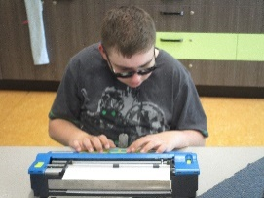

Photo - Logan is brailling using his Mounbatten brailler.

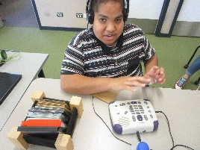
Photo - Teuaki is learning how to use his daisy player independently.

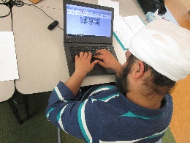
Photo - Amandeep is practicing his touch-typing on his laptop
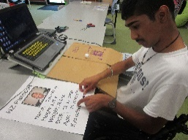
Photo - Dylan used his laptop and a printer to create labels for his poster.

Kiwi Class
The students in Tui class have been using a range of switches and voice output devices, which have enabled greater participation in communication and literacy programmes. During group language activities, students use the Big Mac and Step-by-Step switches to fill in words and phrases in poems, songs and stories.
Students have used the Big Mac switch to participate in greetings and to share news from home. Iulieta, Kerred and Prisha have been using the Jelly Bean switch to activate computer programmes. The Power link with a Jelly Bean switch has helped students to participate in a wide range of activities such as turning on the massager, radio and bubble machine. The iPad and classroom computer are used regularly to listen to stories and watch videos.
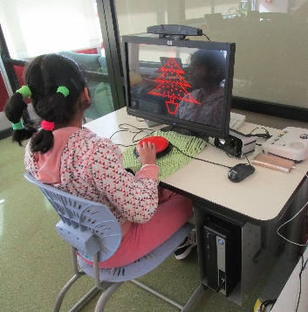
Photo - Prisha uses the Jelly Bean switch to activate cause and effect computer programmes.

Takahe Class
This year Takahe class has been using the i-pad with the different ‘Ballyland’ apps. The aim was to teach the gestures required for access to touch screen technology using voice-over. The students all found that they could play the games in the app and only once they had mastered a specific gesture could they move up to the next level and the next gesture. This program was supported by practicing the learnt gestures with other games on the i-pad and touch screen. The students engaged in a listening skills program alongside this to encourage listening and following instructions. The students were then introduced to the BookLink app from the Blind Foundation Library and were with support able to transfer the skills learnt from the ‘Ballyland’ app to the BookLink app for reading Daisy books.
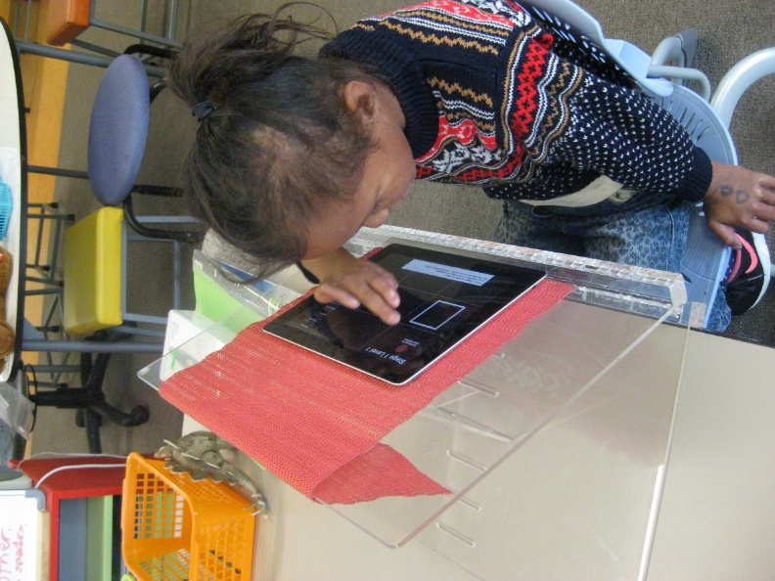
Photo - Precious using the swipe gesture from left to right to access a command in the ‘Ballyland’ app on the iPad.

Kea Class
This year one student in Kea received new technology including a laptop and dolphin guide, a printer, T4, and a Penfriend. Initially he spent considerable time in becoming familiar with the equipment and its use. He has learnt how to look after his equipment including keeping his table and drawers tidy so equipment can be readily located. One of his favourite activities is recording news, stories, poems or songs on his Penfriend. He has become more fluent with recording over the year. The piano teacher records exercises on the T4 for him to use in practice times. Other students in the class are using switches to greet and to participate in stories such as ‘The Gingerbread Man’ or the ‘Three Little Pigs.’ Two more able students have recorded on the switch, which was an enjoyable experience for them. The switch is programmed with repetitive phrases. The students are learning to press the switch at the correct place as the story is read. This encourages them to listen and focus on the story and reinforces their cause and effect understanding.
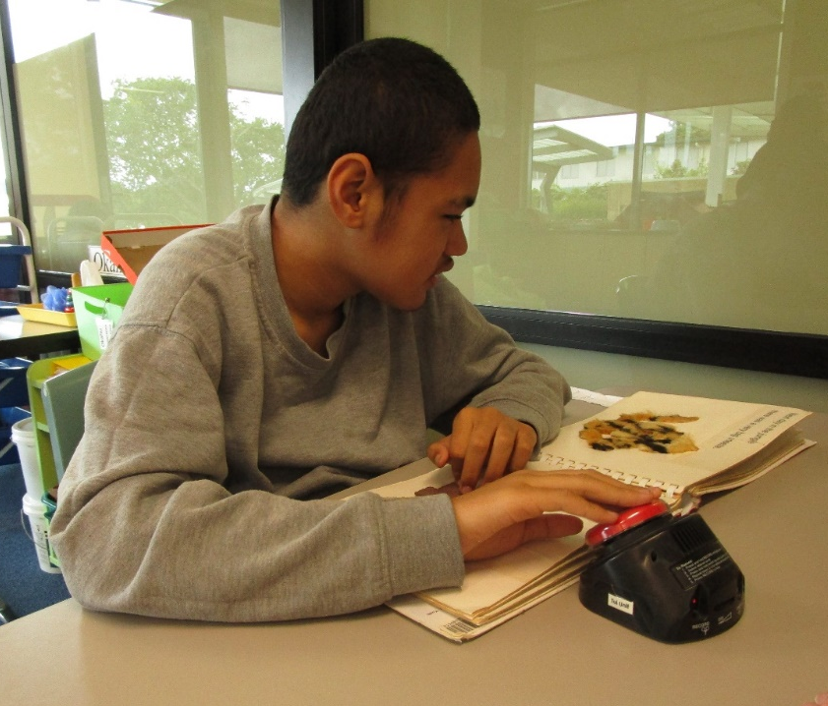
Photo - Ethen presses the switch to fill in phrases in a story.

James Cook / Homai Satellite Class
Amitoj attended the Jaws immersion course during the year. He has developed into a confident and competent Jaws user and has shared his expertise with his other classmates who are beginning to use Jaws. Jack, Amitoj, Carlton and Adrea are avid readers and have all started to use Book link on a range of devices including their iPads and iPhones. Each of the students has developed the skills to switch between an IT tool depending on the task, the place and their own preferences. These include Braillenotes, laptops with Jaws and two students’ laptops and desktop with Dolphin Guide, and three who frequently use an iPad. Each student has a personal iPhone or Android phone, which is often used throughout the day for a range of tasks.
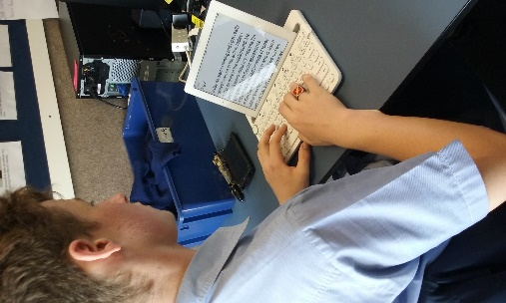
Photo - Carlton completing a journal entry about his Interact Film workshop.

Photo - Amitoj is learning the process for adding Alt Text to a picture that he later shared to his Facebook page. He is working within his Jaws program on his old laptop.

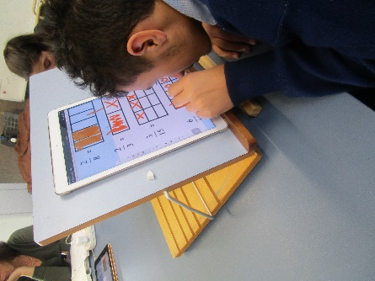
Photo - Mathematics – Jack learning about fractions. He is working on a fraction worksheet that was scanned using Scanner Pro.

Kickstart
Although we have had a small group at Kickstart this year, all the students have benefited from being in the programme. They have achieved huge personal growth and learning throughout the year.

In the third and fourth term they attended several Adapted Communication and Technology sessions at the Blind Foundation. The sessions were planned and implemented around the individual students’ needs. The students were able to access and trial a variety of screen reader and magnification programmes, apps for mobile phones and electronic Braille technology. They found these sessions extremely beneficial and enabled them to research a variety of assistive technology options. Some of them also learnt how to use the technology they already had more effectively. We hope to continue this partnership with the Blind Foundation in the future.

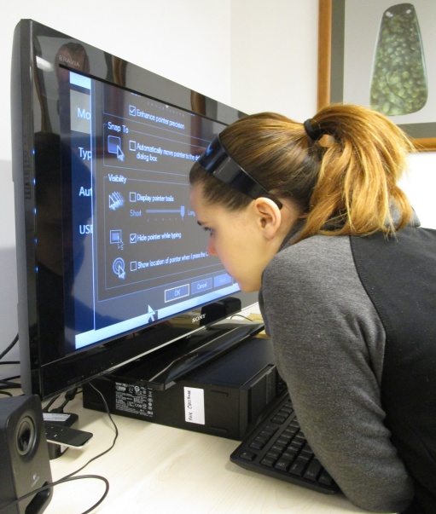

Photo - Lorna using the Zoomtext programme

Nikau Hostel

For Nikau Hostel the Education Outside the Classroom (EOTC) highlight of the year was the opportunity to explore the Tall Ship Tenacious, this was docked in Auckland for a short time in August. Tenacious is an accessible sailing ship, set up especially for people who are blind or use wheelchairs. Michael and Jayke learnt that it is one of the largest wooden sailing ships in the world, both enjoyed looking at all the features on the ship, in particular the talking compass.
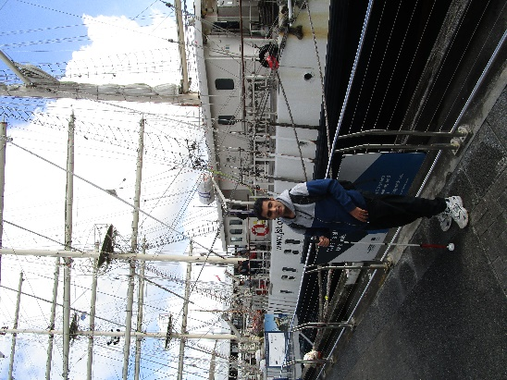
Photo - Michael standing beside the ship
Michael and Jayke enjoy being around animals so a visit to the Cat Lounge Café was an ideal way to spend a Saturday morning. The Cat Lounge café has a large area, which is set up in the form of a lounge for many friendly cats that are happy to be patted and played with. Both students enjoyed visiting the Cat Lounge and voiced they would like to visit again sometime in the future.
Towards the end of the year Michael and Jayke went to the afternoon showing of Matilda the Musical, both were amazed at the talents of the young actors and thoroughly enjoyed the show.

Assessment and Teaching

BLENNZ Homai Early Childhood Centre
The development of the darkroom has been a long term project, supported through fundraising and donations from past and present BLENNZ, HECC whānau. This year the addition of coloured LED strip lights, UV lights and a disco ball has brought new life to the space. Discos have become a regular feature of the Friday session. White and fluoro objects really pop under the UV lights and encourage looking and reaching to explore. On other occasions the large bubble column and subdued mood lighting can be calming. While every space is multi-sensory, we have tried to use lighting to create a non-cluttered and adaptable environment where all ākonga can engage in motivating experiences for learning.
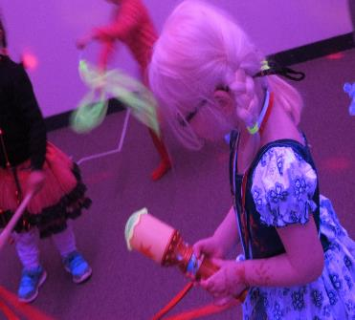
Photo - At the Friday Fun Disco, Anika uses a projector torch to make patterns.
Photo - Isabelle lies under the hanging frame surrounded by neon objects which glow under the UV light. She is active, looking and batting at the objects.

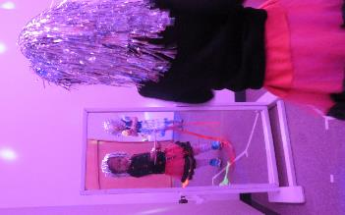
Photo - Aisha looking in the mirror as she dances in the darkroom.

BLENNZ Northland Visual Resource Centre
Each term BLENNZ Northland continues to run a braille club for our primary school students who are blind. Based on the New Zealand and Expanded Core Curricula, the activities target communication, social skills, physical skills and life skills. Term One’s theme and activities were focussed around Easter and involved a story, craft activity, card creations and cooking. At the end of the day we said goodbye to two very happy girls carrying home their Easter creations A club such as this is invaluable in supporting learners in all aspects of their education. It also provides opportunities to foster lasting friendships.
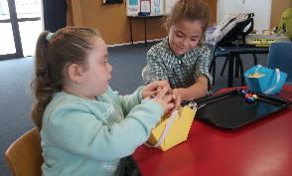
Photo - Chevarni and Zaria are problem solving together to create their basked for their Easter Eggs
Photo – Chevarni and Zaria are enjoying the sound of two Mountbatten braillers rather than just hearing their own as they write an Easter card for someone special

BLENNZ Auckland North Visual Resource Centre
St. Anne’s Book Boxes
Thanks to a generous grant from The St Anne’s Trust for the Sight Impaired North Shore, we have been able to purchase some wonderful books and resources. These will be used with our learners to support literacy development and we are currently creating accessible library boxes/kits. Our aim is for our learners to develop a love of books and to make story time fun. The kits will include:
- a picture book with clear braille overlay;
- tactile toys or objects that the learner can explore to help them understand the story;
- a tactile book which tells the story; and where possible,
- an audio recording of the book for the learner to listen to.
These resources bring the books to life and completely engage our BLENNZ learners in literacy

Photo - Jasper enjoys the Busting book and the interactive tactile object

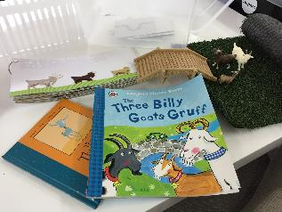
Photo - Three Billy Goat Gruff book and objects to support the story

BLENNZ Auckland South Visual Resource Centre

Low Vision Group- Homai Early Childhood
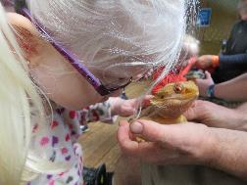
Photo - Student looking at and touching large yellow lizard

The low vision group was established in February 2017 with the Homai Early Childhood Centre for children to attend with their parents and whānau. An RTV from Auckland South VRC teaches alongside centre RTV’s during the session and together evaluate and plan for individual and group needs. We offer assistance for parents and whānau to meet and learn from each other as well as through organized workshops.
The programme has a special focus on expanded core curriculum learning outcomes, such as social interactions, developing independence in daily living skills, assistive technology and building early literacy and numeracy.

There are opportunities for one on one experiences using specific strategies and trialling resources adapted to meet vision needs. Recently the group went on an excursion to Butterfly Creek. The children had hands on encounters with farmyard animals, a bearded dragon and the largest skink we have ever seen!

BLENNZ Hamilton Visual Resource Centre
Earlier this year, two of our learners, Brianna who is blind and Brayden who has severe low vision, and their RTV Kathryn Beer were featured in an Education Gazette article. Website New Zealand Education Gazette

Their story and success illustrates what effective inclusive education looks like in practice, and how important the transition process is in contributing to this. Having two students transition to the same high school, and at the same time, required detailed planning and preparation.

Expanded core curriculum goals over the past few years have included developing skills in accessing the curriculum through a variety of media and becoming competent users of assistive technology.

With the learners’ active involvement in the transition process, professional development provided for teaching and support staff, learning support adaptations, and supportive peers, barriers to accessing the curriculum have been minimised.
Photo - Brianna and Brayden working on their BrailleSense and laptop respectively.

BLENNZ Tauranga Visual Resource Centre
On Wednesday 10th May we organised an Expanded Core Curriculum day for our Junior Primary learners with an aim of increasing their road safety skills.
We used an exciting new orientation and mobility resource called a Wise Walker. This is a set of large, high contrast boards, which can be set out to create roads and pedestrian crossings to enable learners to practice their road safety using toy vehicles and people.
The learners were very interested and engaged in creating roads and talking about how they could keep themselves safe.
The activity was then followed up with a trip outside to use the pedestrian crossing to walk to the local shops.
The day was very successful and highlighted the value of an excellent team approach, involving both RTVs and DOM specialists working together.

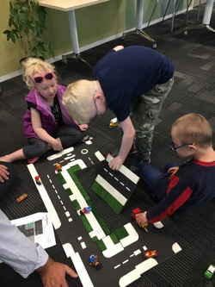
Photo - Students creating road map from high contrast boards.

BLENNZ Gisborne Visual Resource Centre
The Centre inquiry for 2017 was to research how we can develop programmes for BLENNZ learners which incorporate strategies to improve their physical abilities. In Tairāwhiti we ran weekly pool sessions focusing on confident movement in the water and water safety. A small group of learners had specific goals around physical abilities in their Individual Education Plans. This included two learners who were blind and two with low vision and additional needs. The weekly sessions were run by BLENNZ RTV Kelly Doyle, a qualified Access and Inclusion and Swimming and Water Safety Instructor, with support from VRC Manager, Bronwyn Harte-Fielder. The highlight for the learners was wearing a correctly fitted life jacket, learning to float in a survival position and how to get into a huddle. The sessions were fun and also very physical, with our learners using whole body movements.

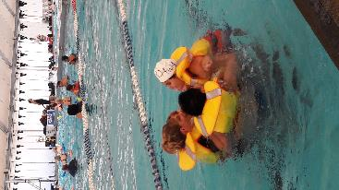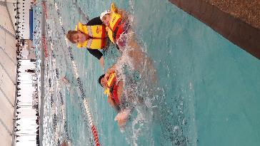
Photo 1 - Learners floating on backs wearing lifejackets
Photo 2 - Learners are making a huddle in water

BLENNZ Napier Visual Resource Centre

Positives for BLENNZ Staff
BLENNZ Napier began the year with a new look due to refurbishment. New paint, blinds, and carpet, together with revised storage areas, all contributed to a fresh, bright, working space.
Positives for BLENNZ Learners
RTVs and learners have been busy trialling and applying for assistive technology. It has been wonderful to see the learners actively engaged in using technology to independently access the curriculum. Recording learner voice has been central to the success of applications;
“It’s easy to do things for myself.”
“With the iPad I don’t have to keep walking right up the front.”
“I can sit a lot further back because the screen and the writing are lovely and big.”
“It’s the coolest brailler. When I’ve finished I can go back and just fix what I want to.”
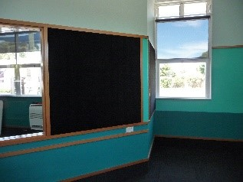
Photo - The new look BLENNZ Napier VRC
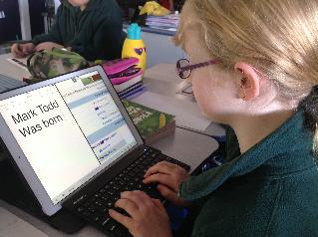
Photo - Access at a comfortable distance

BLENNZ Taranaki Visual Resource Centre
It is always exciting to get groups of BLENNZ learners together to work on BLENNZ Curriculum skills. Groups of learners came into BLENNZ Taranaki for an Art day and a Science, Art and Craft day, with a focus on social skills, life skills and communication.
The Art day was around the work of Austrian born New Zealand artist Friedrich Hundertwasser, and the learners aged between 10 - 12 years produced some wonderfully detailed art works.
Photo - An artwork produced by one of the learners
The Science, Art and Craft day at BLENNZ involved ākonga designing and painting their own Christmas pots to hold Christmas treats including a hand painted decoration for their Christmas tree. They made fruit kebabs for morning tea and had time to socialise together followed by two learners leading the group to make fluffy colourful slime. This activity appealed to all involved, including staff. There was lots of laughter and sharing of slime capabilities – some even managed interesting sounds.
This year BLENNZ is thrilled to welcome Kay Hood as the new Manager.
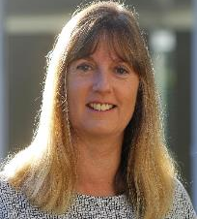
Photo - BLENNZ Taranaki new Manager, Kay Hood

BLENNZ Palmerston North Visual Resource Centre
Diamond is a 71/2 year old learner who is blind.
Diamond’s motivation to swim has been used to increase his engagement and learning outcomes. Weekly swimming sessions are fun, encourage exploration, concept and language development and physical skills. These real experiences form the base of Diamond’s literacy and numeracy programme.
The ILS coordinator attends swimming sessions to provide input into the programme around daily living skills. Clear boundaries and routines have been central to the success of the programme and Diamond’s achievements.
Tactile books depicting songs and stories reinforce learning and consolidate concepts.
Diamond’s increased communication and positivity towards learning, has been a heartfelt and special journey.

Photo - Diamond feels the rush of the waterfall in the pool cascading on his hand.

BLENNZ Wellington Visual Resource Centre

Connecting learners at an early age
We have seen over quite a number of years the value of connecting learners through attendance at Immersion Courses. Learning opportunities stand beside opportunities to make friends. This year one of the Wellington’s RTVs has used that Immersion model to link two braille learners of a similar age.
The idea to support two learners took place when the mother of a preschool expressed a desire to see a five year old braille learner working in a class setting. Devi, the RTV for both Robert 4 years of age and Tane 5 years of age organised the visit for Robert’s parents to observe Tane at school. The visit was so successful that three further return visits have already taken place. The boys enjoy each other’s company, exploring braille together and using the cane to discover school landmarks. Tane was seen to instigate a game of hide and seek with Robert. There is something very special when learners find a friend who has an understanding of living with severe visual impairment.
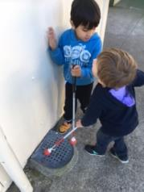
Photo - Using their canes together, Tane shows Robert where the drain is at school
Photo - Robert and Tane sitting side-by-side exploring braille.

BLENNZ Nelson Visual Resource Centre

Success for Ollie based on effective collaboration

Oliver Neill-Kilsby is an 8 year student in Nelson. This year a programme of targeted developmental orientation and mobility training was initiated by BLENNZ DOM, and carried on by his RTV and school staff.
The need for this programme was initially identified when Oliver attended the National Assessment Service (NAS) in Auckland (late 2016). An action plan to initiate support for Oliver in this area of his development was formalised at his first IEP in 2017.
Oliver’s RTV worked alongside Oliver’s teaching aide, demonstrating the activities that needed to be carried out with Oliver. This ensured that Oliver received this targeted input not just as part of his time with the RTV, but as part of his daily timetable.
Improvements in Oliver’s core strength, mobility and hand eye coordination demonstrates that Oliver has reaped the benefits of this programme. This is an example of what can be achieved when service delivery is based on the fundamentals of professional collaboration, information sharing and meaningful communication.

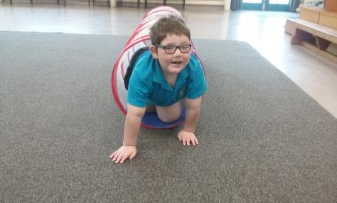
Photo - Oliver moving through a tunnel.

BLENNZ Christchurch Visual Resource Centre

Ako in action
It was identified within our centre that many of our learners, parents and RTVs struggle with keeping up-to-date with technology… that is beginning to change, as we discover the wealth of talent and knowledge of ākonga and their support team, who attend our iPad Clubs.
What started 18 months ago as a small group initiative, with ākonga sharing and learning about their assistive technology together, has now grown to three very established groups. Ākonga, parents and RTVs teach and learn from each other, in a supportive, safe and stimulating environment. Student voice determines learner outcomes. Recent outcomes have included how to “green screen” and “stop motion”. But just as importantly, iPad Club gives ākonga the opportunity to work collaboratively with like-minded others and to form friendships and develop socially.
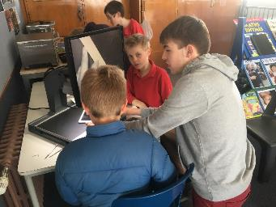
Photo - Students teaching and learning from each other
Photo - Students working collaboratively using iPads

BLENNZ Otago Visual Resource Centre
Our Curriculum Day was an opportunity for our blind and low vision ākonga to get together and practise some life skills, whilst having fun in the process. Amongst the many activities was creating your own hamburger and pouring a cold drink for yourself.
A local print-making artist, Eliza, taught ākonga the process involved in screen printing simple images onto t-shirts. The images were either created by them or researched on their technology device beforehand.
With input from the Halberg Disability Sports Adviser, Parafed Otago and the Blind Foundation, the day naturally lent itself to good opportunities for team collaboration and inter-professional practice.
A great day was had by all, with big hugs at the end, before students went their separate ways. The new friendships formed or social connections gained, was just wonderful to see.
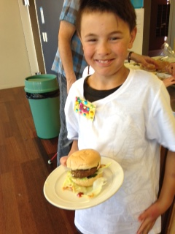
Photo - Marc with his assembled burger-Yum!!
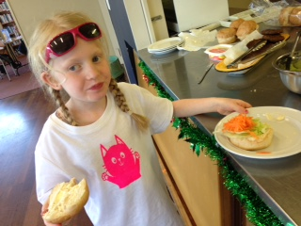
Photo - Sophia making her burger.

BLENNZ Southland Visual Resource Centre

Evolving Self Advocacy
Jessica has gained confidence in talking about her visual needs.
In Term Two her teacher and teacher aide attended a BLENNZ Southland in-service where, while under simulated vision loss, they participated in a variety of activities including sandwich making, pouring a drink, completing a worksheet and playing small ball games. A local optometrist also gave a presentation about eye conditions and vision needs. Everyone left with a greater appreciation of Jessica’s daily struggles and triumphs.
Jessica then led a similar session with her year seven class, alongside Lisa her RTV. She answered questions from her peers about a variety of topics including her eye condition, tasks she finds difficult and strategies that help. Jessica answered the questions with confidence, skill and consideration. Her class was enthralled to learn about challenges around even the simplest tasks for someone with low vision. A wonderful learning experience for everyone.
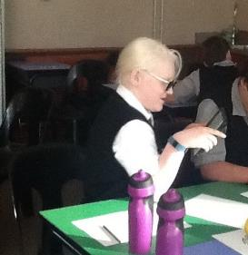
Photo - Jessica helping fellow students in class

BLENNZ National Assessment Service (NAS)

Jared at NAS
Jared has Stargardt’s Macular Dystrophy which affects his central visual field. He has difficulty with clarity of images, low levels of contrast and clutter. When a learner has such challenges within near and distant space, and also has a central field loss, other sensory channels are often reviewed. This determines what will assist the learner’s access to the environment and the materials they use. Presently, Jared predominantly uses his vision and hearing but a review of his tactile sensitivity was considered beneficial. In Jared’s case both vision, tactile awareness and discrimination were assessed.
A tactile assessment considers tactile discrimination through the sense of touch. It begins with gross discrimination and works towards finer discrimination using the finger pads with Braille. Jared, his whānau and educational team will discuss literacy access and the pathway forward is based on needs.
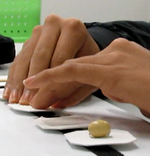
Photo - Jared is using his tactile sense to discriminate a piece of wall paper with a raised texture
Photo - Jared is reading passages from the Maclure assessment. He is viewing the passages from about 20cm.

BLENNZ Immersion
The Immersion Service has provided 14 planned courses in 2017. A total of 88 ākonga have attended 122 places on Immersion Courses this year.
The courses have covered diverse topics such as daily living skills - learning to use a knife and fork, to assistive technology skills - how to use a BrailleNote to search the internet. A highlight of many of the courses for students has been visits off campus to such places as the Aotea Centre to see the first audio described ballet performance in New Zealand or to Sylvia Park to practise assistive daily living skills including buying their own lunch. Ākonga have spoken again and again of the great pleasure they get from meeting with their peers in the residential setting and the learning that takes place from one another.
One RTV said, “It was evident that ākonga who have had Immersion experiences from a young age have a higher level of independence, plus better technology and social skills than new ākonga who first attend at an older age.”

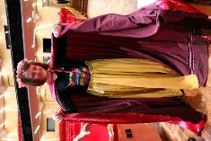
Photo - Ākonga dressed in ballet costume at the Aotea Centre

Regional Teaching Team

BLENNZ employs a number of Resource Teachers: Vision who are based at fourteen Visual Resource Centres located across New Zealand. The role of these teachers is to advise, provide guidance and direct teaching to identified learners with a vision concern, in their region.
Opportunities continue to be provided for Regional Managers of each Centre to meet and to support the implementation of the Annual Plan. These occur at a national level and facilitate a collaborative approach to enhance pedagogy and practice. Likewise, opportunities continue to be provided for the teachers across the network to meet at a regional level through Visual Resource Centre Regional Days and the biennial BLENNZ Conference.
Regional Days took place in Term 2 this year, as the BLENNZ Conference in late January 2018 will provide a forum for professional development and teaming for all. This first meeting was an opportunity for all Resource Teachers Vision, in the three regions – North, Central and South, to come together to share and engage in both initiatives from the Annual Plan and in professional learning to support their roles. Managers also had a second opportunity to come together in Term 3, on a national level, having met in March 2017.
These network opportunities are critical as BLENNZ strives towards the provision of consistent specialized programme delivery for ākonga from an informed specialist teaching team.

BLENNZ DOM

2017: A year of training successes with the Developmental Orientation and Mobility team
The beginning of 2017 saw our first two Developmental Orientation and Mobility (DOM) trainees complete their training and step up to become DOM Specialists. Ernie Belk and Melanie Harvey completed their professional competencies and core Specialist Teaching papers at the end of 2016. Abby Higgs and Rachel Irvine will complete their professional competencies and Massey papers to commence as Specialist DOMs at the end of 2017, Helen Blundell, and Julie Bowen are completing year 1 of the two-year training at the end of 2017. The team, including three registered Occupational Therapists, is currently exploring BLENNZ role in the curriculum area of Life Skills. In partnership with Massey University, to date we have successfully seen 40 Resource Teachers (Vision) achieve the Supporting DOM on campus course; 17 achieve the Supporting DOM programmes in the Community Course and 10 teaching staff achieve the ADL course.
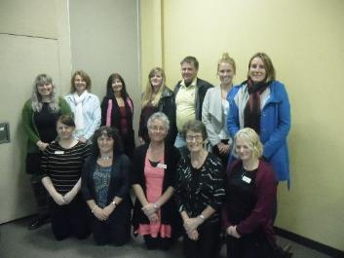
Photo - From back left: Rachel Irvine; Helen Blundell; Trish Ward; Melanie Harvey; Ernie Belk; Abby Higgs; Nicola McDowell
From front left: Jennifer Hoatten; Julie Bowen; Kay Daly; Gendy Ritzema; Marie Cooper

BLENNZ VRC Coordinators

Together BLENNZ, the Blind Foundation and NZQA are working towards developing accessible online assessments that take into account a range of learner needs and assistive technology packages. It has been a long-term goal for everyone, that online assessments are accessible for all learners. NZQA have taken on board the importance of promoting accessibility as a right of all learners, this has raised some questions around how we do this best.
There are certain technology packages that will provide a more accessible experience. When thinking about students learning in a digital world, we need to consider what skill development we need to focus on, to ensure all are prepared for online assessments. This has raised issues around accessibility versus usability and how this impacts on learner experiences. This information is essential to consider as we progress this work, particularly in helping us to understand that meeting accessibility guidelines is only one part of the equation. If digital assessments are not both accessible and usable, then they are not a valid option.
These issues help us to determine what solutions and skills are paramount for learner success.
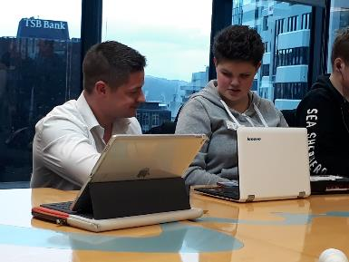
Photo - Student working on laptop

Homai Campus Music School

Individual Music Programme – Wendy Richards

Eleven students received regular one to one music tuition in 2017. Five of these students are at NCEA level so their programme focus is primarily on accessing and completing NCEA standards. One student also achieved an A grade for a grade 7 piano performance exam. 2017 also marked the start of a three-year research programme focused on exploring appropriate and effective music braille pedagogy for BLENNZ learners.

Music School – Wendy Richards
Nineteen students enrolled in the music school programme in 2017. Fifteen of these access music via braille, two use large print, one is an aural learner, and one was the sighted child of a tutor. Music school day is a busy and lively event with all students enjoying the opportunity to meet together and make music. For the first time ever, senior students collaborated on a whole group project in the afternoon. Students divided into three groups to work on different facets of a radio play, which explored themes of difference and acceptance in music. One group wrote a humorous script, one group wrote a song to reflect the story, and the third group wrote accompanying music. This year we presented our work at an afternoon ‘matinee’ concert, which included the first live performance of the radio play. I was fortunate to visit the Lighthouse school music programme in New York City during the year, which was a very affirming experience. I was impressed with their programme but it also highlighted the high quality of our BLENNZ programmes and staff. Additionally our student numbers are comparable to the New York programme, even though NYC has a far larger population base.

Homai School Music Therapy Programme – Ajay Castelino

Eight group and four individual music therapy sessions were provided every week for the Homai Campus students in 2017. The aim of the music therapy sessions was to support the ākonga emotional, social, verbal and non-verbal expression through the use of music. The music therapist also worked as part of a multi-disciplinary team alongside the other Homai therapists to deliver two motor-sensory programs. Of note, the James Cook class participated in the “Play it Strange” songwriting competition as part of their goal of personal expression and their song, “Make the Impossible Possible” made the top 100 nationally.

Te Whānau o Homai

In 2017 Te Whānau o Homai committee were involved with the following events at the Homai Campus.

21 June
Bach blessing by Matua Toi and Martin Cooper, Kaumatua from Manurewa Marae

24 June
Welcome from Blind Foundation Board visitors including three guide dogs.
Matua Becker very kindly assisted the students to prepare for the Mihi Whakatau and also assisted Sara, teacher aide in preparation for the Karanga.

14 November
Welcome to six visitors from Te Roopu Wairoa, a unique kaupapa Māori organisation founded and governed by whānau with physical, sensory and intellectual disabilities. Since it began in 2001, Te Roopu Wairoa has evolved and expanded its role of providing disability information and advice to also assisting whānau access Māori communities, providers, agencies and government.

Also welcomed were nine BLENNZ Homai staff, six Homai students, and four nursing students from the University of Auckland

Youth Library

The Youth Library is based at BLENNZ Homai Campus School and is administered by the Blind Foundation. We have two enthusiastic librarians on site who provide a point of contact for teaching staff and teacher aides throughout New Zealand to request educational items for school children.
The Blind Foundation, through funding from the Ministry of Education, is committed to producing and providing a wide range of accessible resources to fulfil the educational and recreational needs of children and youth. The Library also supports children and their families in literacy reading development and lifelong learning through the provision of a range of reading material in a variety of formats. These include:
- Collage books: sturdy, hard-covered picture books with large print and braille text and bright, bold collage illustrations.
- Early readers and School journals available in large print and e-text.
- Braille books: fiction, non-fiction, examinations, tests and textbooks.
- Twin vision picture books: with clear plastic braille over the original print or with clear plastic braille pages inserted between the original print pages. Some are also available with an accompanying CD.
- Large print books in 18 and 24-point font: mostly fiction for ages 9 to 16. We also have a growing non-fiction and textbook collection.
- Kitsets with enclosed print book with accompanying CD and braille text.
- Electronic files (E-text) available in Word, HTML and Plain text.
- Playaway pre-recorded MP3 players.
- DAISY books.
- Digital services such as Booklink and Bookshare

The library supports RTVs and educators professional development through the provision of reference material and reference services. Cathryn is available to assist with reference queries and literature searches.

The library also supports and helps with a variety of immersion courses run by BLENNZ over the course of the school year, and conducts library tours for teacher aides and other educational groups when requested. We provide weekly story times for the Early Childhood Centre, and have regular visiting sessions for all classes in the school, including the James Cook Satellite Unit and the transition programme. We also meet regularly with families visiting for assessment to let them know what resources we have that may be suitable for their child.
Opening hours: Monday to Friday, 9.00am to 4.30pm, including school holidays.
You can phone us on (09) 268-3215 or 0800 24 33 33 ask for Youth library.
Email youthlibrary@blindfoundation.org.nz

The Library Team:
Senior Librarian – Cathryn Mitchell
Senior Library Assistant – Currently recruiting

Board of Trustees

Pre mid-term elections 2017
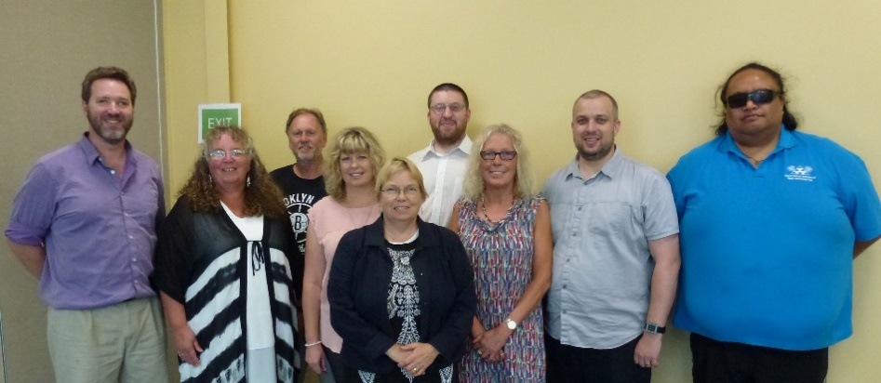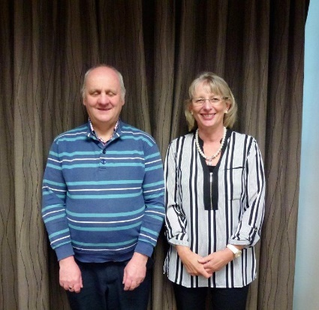
Back row – from left – Mitch Harris and Nathaniel Robson
Front row – from left – Jonathan Godfrey, Karen Stobbs, Letitia Patete, Gretchen Good, Jane Cox, Nathaniel Louwrens, Nigel Ngahiwi, Insert: Neil Jarvis, Janny Cooke
In November 2017 the School Trustee mid tern elections were held with a new Board of trustees taking office on the 8 December 2017.

Post mid-term elections 2017
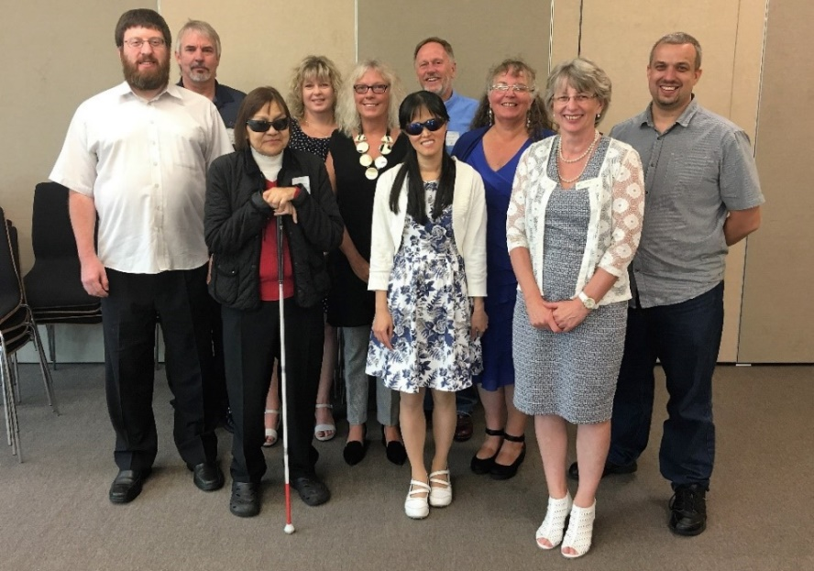
Back row from left – Graeme Hood, Letitia Patete, Mitch Harris
Middle row from left – Nathaniel Robson, Jane Cox, Karen Stobbs, Nathaniel Louwrens
Front row from left – Sarndra Tamepo, Wendy Chiang, Janny Cooke. Insert: Neil Jarvis
BLENNZ has a national board of trustees, which is representative of BLENNZ and of the wider blindness education sector.
The role of the BLENNZ Board is to govern the school, with a focus on providing an environment that fosters achievement for ākonga children and young people who are blind, deaf blind or low vision.
BLENNZ also has the Homai Early Childhood Centre on the Homai Campus. This is a licensed centre attended by young children in the Auckland region, and also serving as a national resource. Because of current legislation, this centre is governed under a separate trust and trust board, the Homai Early Childhood Centre Education Trust (HECCET) Board of Trustees. Seven members of the BLENNZ Board form the membership of the HECCET Board of Trustees.
The BLENNZ Board of Trustees meet on a Friday afternoon and in 2017 met for six meetings:
24 February, 7 April, 26 May, 25 August, 27 October, 8 December
The Board is made up of the following trustee positions:
- Four elected by parents receiving services from Visual Resource Centres
- One elected by parents of students enrolled at the Homai Campus School
- One elected by staff
- One appointed by the RNZFB now known as the Blind Foundation
- One appointed by Blind Citizens NZ
- One appointed by a panel of representatives of recognised Kāpo Māori organisations
- The Principal of BLENNZ
- Board co-opted trustees, provided that the number of parent elected and VRC elected trustees was greater than the total number of co-opted and appointed trustees.

BOT members and roles – pre mid-term election
Nathaniel Louwrens – Board Chair and Visual Resource Centre Elected Parent Trustee
Nathaniel Robson – Deputy Chair and Visual Resource Centre Elected Parent Trustee
Mitch Harris – Homai Campus School Elected Parent Trustee
Gretchen Good – Visual Resource Centre Elected Parent Trustee
Jane Cox – Staff Elected Trustee
Neil Jarvis – Appointed, Royal New Zealand Foundation of the Blind known as the Blind Foundation
Jonathan Godfrey – Appointed, Association of Blind Citizens of NZ Inc
Nigel Ngahiwi – Appointed, Kāpō Māori Aotearoa NZ
Karen Stobbs – Principal

BOT members and roles – post mid-term election
Nathaniel Louwrens – Board Chair and Visual Resource Centre Elected Parent Trustee
Nathaniel Robson – Deputy Chair and Visual Resource Centre Elected Parent Trustee
Mitch Harris – Homai Campus School Elected Parent Trustee
Graeme Hood – Visual Resource Centre Elected Parent Trustee
Jane Cox – Staff Elected Trustee
Neil Jarvis – Appointed, Royal New Zealand Foundation of the Blind known as the Blind Foundation
Wendy Chiang – Appointed, Association of Blind Citizens of NZ Inc
Sarndra Tamepo – Appointed, Tangata Whenua
Karen Stobbs – Principal

Professional Development and strategy Planning Days
7 April 2017
For the Board’s meeting on the 7th April the agenda in the morning included strategic discussion around the Homai Campus Swimming Pool and a meeting with Sally Jackson (MOE, Chief Advisor – Strategic Relationships and David Wales, MOE, National Director Special Education) who met with the Board to provide further information about the Learning Support Update

26 August 2017
This meeting focused on the following topics:
- Strategic plan for the use of accumulated funds
- Long term property development
- The Board’s communication and engagement plan and the consultation cycle for 2018

The Framework of Indicators of Learner Achievement

BLENNZ uses a network-wide approach to quantifying learner achievement using a framework of evaluation indicators. The indicators capture both direct and indirect measures to provide an overview of achievement of learners and BLENNZ services. This systematic approach is intended to enhance opportunities for evidence-based practice and to provide the data needed for the development of nationally consistent practice and for a process of continuous improvement.

The outcomes are documented in the following pages with the first section of reporting focusing on the School and Residential Service Strand followed by reporting on the Assessment and Teaching Services.

Homai Campus School

Collate IEP goal achievement data for learners attending Homai Campus School.
Targets
Learners at Homai Campus School will achieve 80% of their IEP goals during 2017
In this reporting the names Pukeko, Takahe, Tui, Kiwi, Kea and Weka refer to the different classrooms of the learners.
Reporting
The Homai Campus School has developed an IEP policy and guidelines to ensure the IEP process outlines the children and young peoples’ strengths and needs, bringing together a collaborative team that works in partnership with family and whānau to identify and prioritise learning outcomes that are based on effective assessment and teaching strategies. The IEP or ITP plans ensure learners are provided with a programme that enables them to achieve maximum educational outcomes and the goals are appropriate for the learner. Each IEP is reviewed by the Senior Teacher, Coordinator School programmes and the Senior Manager of School and Residential Services.
The learners have worked well to achieve their IEP goals. For the learners who have not achieved the target of 80% there appears to be a consistent variable relating to their attendance.

Pukeko
There was only one learner in Pukeko who did not achieve 80% in their goals. The goal was around managing his new technology and as the family had planned to move to another country and needing to leave the technology behind, the family requested that the learner did not focus on that goal.

Learner | Using language symbols and texts | Participating and contributing | Managing Self | Relating to Others | Thinking
1 | 76% | 80% | 83% | 88% | 80%
2 | 81% | 85% | 83% | 83% | 81%
3 | 85% | 82% | 82% | 80% | 85%
4 | 85% | 83% | 82% | 86% | 80%

Takahe
With the exception of one learner in one area of the key competencies, all learners achieved at or more than 80% of their goals. An educational psychologist spent time with the learner, family and teacher to develop some strategies to support learning for this learner. Goals were set prior to this intervention. New goals have been set including the information from the psychologist.
Learner | Using language symbols and texts | Participating and contributing | Managing Self | Relating to Others | Thinking
1 | 100% |  | 100% |  | 100%
2 | 83% | 80% | 95% | 93% | 93%
3 | 75% | 100% | 93% |  | 93%
4 | 100% |  | 93% | 100%

Kea
Learner 2 had erratic attendance, which impacted on the achievement of goals. Regular contact was made with the family to encourage attendance and opportunities were taken to discuss this issue and the impact on learning when the family came in to school.
Learner | Language Symbols and texts | Participating and contributing | Managing self | Relating to others | Thinking
1 | 88% | 100% | 81% |  | 100%
2 | 72% |  | 78%
3 | 84% |  | 85% | 100%
4 | 84% |  | 100% |  | 100%

Learners in Tui and Weka classes are very high needs and some with fragile health. Illness and absences have had an impact on progress.

Tui
Learners in Tui class sometime have more than one goal in a key competency. The focus of each of these goals are different – e.g. under managing self a learner is working on physical skills as well as having another goals focusing on visual efficiency skills. Learners 1 and 3 both had health issues and changes in their physical abilities, which impacted on their ability to achieve set goals. Learner 4 had a significant change in his health and physically was no longer able to achieve the goal set earlier in the year.

Learner | Using language symbols and texts | Participating and contributing | Managing Self | Relating to Others | Thinking
1 | 85% |  | 78% 64%
2 | 80% | 87% 85%
3 | 83% |  | 50% 100%
4 | 75% |  | 43% | 100%
5 | 82,5% |  | 100% 87%

Weka
Learner 3 did not achieve 80% in one area. This learner was new to school and did not have good health; therefore, there were many absences, which interfered with his learning. Learner 5 had hospital stays and many changes of medication. The medication impacted on her learning, as she was not able to focus on learning for the same period of time as she did before.

Learner | Using language symbols and texts | Participating and contributing | Managing Self | Relating to Others | Thinking
1 | 100% |  | 83% |  | 100%
2 | 85% |  | 88% |  | 100%
3 | 75% |  | 100% | 100%
4 | 85% |  | 92% | 50% | 100%
5 | 76% |  | 70% |  | 100%

Kiwi
A new class was opened in term 3 and during term 3 and 4 three 5-year-old learners started school. IEP’s were held for these learners. The reviews for these will be held in 2018.

James Cook High Satellite Class
Learner 1 transitioned back to his home community at the end of term 3 and much of term two focused on his transition. Learner 5 moved from a conventional learning programme to a more functional programme. This learner also moved from the campus school into the satellite at the beginning of the year and the change of environment may have influenced the learning outcomes. There were also significant difficulties in his home environment, which impacted on his ability to focus and learn.

Learner | Using language symbols and texts | Participating and contribution | Managing Self | Relating to Others | Thinking
1 | 70% |  | 90%
2 | 80% | 100% | 90%
3 | 100% | 77% | 95% |  | 80%
4 | 95% | 100% | 90%
5 | 65% |  | 90% | 87%

Māori and Pasifika

Māori Learners
7 of the 8 learners achieved 80% or more of their IEP goals. The one learner who did not achieve 80% due to a change in his physical condition.

Cook Island Māori Learners
All 3 learners achieved 80% or more of their IEP goals.

Samoan Learners
5 of the 6 learners achieved 80% or more of their IEP goals. The one learner who did not achieve 80% spent time in hospital and time away from school.

Tongan Learners
Both of the 2 learners achieved 80% or more of their IEP goals.

Target
Identified learners at Homai Campus School will improve their reading age by a minimum of 6 months during 2016.

Reporting
 | Term 1 | Term 1 | Term 4 | Term 4
Learner | Reading age Term 1 | Reading Level | Reading age  Term 4 | Reading Level
1 | 13.5yrs |  | 14.5 yrs
2 | 13. yrs |  | 14. yrs
3 | 11.5yrs | L29 | 12 yrs | L30
4 | 5 yrs | L4 | 5.5yrs | L8
5 | 5yrs | Emergent | Learning media assessment during the year indicated a move from print to print/ audio | L3
6 | 5yrs< | L1 | Moved from print to braille due to a change in vision.

Target
Learners at Homai Campus School participating in conventional numeracy programmes will achieve their individual targets in numeracy and progress towards National Standard expectations by the end of 2017

Learner | Numeracy Project Level / Stage | Numeracy Project Level / Stage
 | Term 1 2016 | Term 4 2016
1 | Level 1 / stage 1 | Level 1 / stage 3
2 | Level 1 / stage 1 | Level 1 / stage 2
3 | Level 2 / stage 2 | Level 2 / stage 4
4 | Level 2 stage 6 | Level 2 stage 7
5 | Level 2 stage 3 | Level 2 stage 3
6 | Level 2 stage 7 | Level 2 stage 8
7 | Level 2 stage 6 | Level 2 stage 7

The NumPA assessment is completed with each learner in a conventional numeracy programme. The assessment is adapted for low vision and braille learners. The assessment scores in various areas. The results are analysed by the teacher, areas strengths and weaknesses are identified.

Target
Learners attending the Kickstart Programme will achieve 80% of their ITP goals during 2016.

Reporting
All Kickstart learners have achieved 80% or more of their ITP goals.
Learner | Daily Living Skills | Study and  Career | Personal  Skills | Orientation  And Mobility | Recreation  And Leisure
1 | 95% | 100% | 100% | 92,5% | 100%
2 | 100% | 100% | 100% | 100% | 92.5%
3 | 100% | 100% | 95% | 100% | 92.5%
4 | 100% | 100% | 100% | 100% | 92.5%

BLENNZ Qualifications gained and intended pathways.

Kickstart learners, up to 5 years later.
31 Learners who attended Kickstart between 2012 and 2016 were identified.

Qualification pathway. 10 ex learners are attending or had attended university, 6 polytech, 2 other learning institutions and 13 who did not indicate they went on to further study.
Employment. 13 ex learners indicated that they were currently in employment, 2 were working in a voluntary capacity, and 1 was in a workshop environment.
When asked of their current living situations, 19 were in a flatting situation, 9 lived at home, and 1 in supported living, 1 boarding and 1 was in a Halls of Residence.

Learner Engagement in Learning

Kickstart Learner Survey 2016
Conduct an annual end of year survey of learners attending the Kickstart programme to determine their level of satisfaction with the programme.

Target
All of the learners evaluated the programme as appropriate in terms of support for goal achievement, overall effectiveness and preparation for independent living and work.

Reporting
The 4 learners in the programme at the end of 2016 each completed the survey. The targets were achieved.

1. I was well supported when planning and setting my goals for this year.
4 strongly agreed;

2. I was well supported to achieve my set goals this year.
4 strongly agreed;

3. I felt comfortable communicating with the staff.
2 strongly agreed; 2 agreed.

4. I feel prepared for living independently.
1 strongly agreed; 3 agreed

5. I have planned for the future and have my direction for work or study.
1 strongly agreed; 2 agreed.1 partly agreed

6. My EOTC activities have built my confidence in giving new and challenging things a go.
1 strongly agreed; 2 agreed: 1 partly agreed

7. Overall the Kickstart programme met my needs.
1 strongly agreed; 3 agreed

Homai Campus School Survey

All reporting to parents by the Homai Campus School will be against the learners’ IEPs. It will be in an agreed format which has been developed to comply with the National Standards Guidelines to ensure that all reporting is in plain language and clearly articulates to parents the next steps for their child’s learning, and how they can support the learning outcomes at home.

Targets
100% of reports to parents/caregivers from Homai Campus School use the agreed format.

100% of parents/caregivers surveyed express satisfaction (strongly agreed or agreed) with the new style and formatting of reports with regard to clarity of information and clear articulation of the next steps in the child’s learning and how they can support this learning at home.

Conduct an annual survey of parents with children attending Homai Campus School to determine the level of satisfaction with the service provided.

Target
100% of parents/caregivers evaluate the service provided as appropriate strongly agreed or agreed) in terms of the quality of classroom programmes, ease of communication with the home, child safety, assessment and feedback.

Reporting
9 out of a possible 30 families completed the survey.

1. My child is well supported by the classroom programme.
6 strongly agreed; 3 agreed.

2. There is good communication between the classroom and home.
7 strongly agreed; 2 agreed.

3. I feel welcomed into the school and comfortable contacting the staff.
6 strongly agreed; 3 agreed.

4. The health and safety of my child is well provided for.
6 strongly agreed; 3 agreed.

5. The information presented in the IEP is helpful to me.
4 strongly agreed; 5 agreed.

6. The school report is informative and easy to read.
5 strongly agreed; 4 agreed;
(6 continued) The School Report gives a clear idea of what is the next step in learning.
4 strongly agreed; 6 agreed.

(6 continued) The School Report says how learning can be supported at home.
5 strongly agreed; 4 agreed;

7. The termly newsletter provides good information on the activities at school.
4 strongly agreed; 5 agreed;

Homai Residential Services
Conduct an annual survey of all parents of learners who are in residence in the Homai Campus hostels to determine the level of satisfaction with the service provided. This will in part, demonstrate compliance with the terms of the Hostel Licence.

Target
95% of parents/caregivers evaluate the service provided as appropriate in terms of quality of communication with home, quality of recreational and cultural activities, learner wellbeing and support for their child’s educational programme.

Reporting
3 out of a possible 3 families responded. Targets were achieved.

1. The residential environment is safe and comfortable.
2 strongly agreed; 1 agreed.

2. There is good communication from the residential staff about my child’s progress, activities and appointments.
1 strongly agreed; 2 agreed;

3. The Residential staff are approachable and I feel comfortable contacting them.
2 strongly agreed; 1 partly agreed;

4. The health needs of my child are well monitored and cared for.
2strongly agreed; 1 partly agreed;

5. The residential services provide good support for my child’s educational programmes.
1 strongly agreed; 1 agreed.1 N/A

6. The information provided by the residential staff in the IEP is helpful.
1strongly agreed; 1 agreed. 1 N/A

7. The residential contributions to the school reports are informative and easy to follow.
2 strongly agreed; 1 agreed;

8. There is a good range of recreational and cultural activities as well as community outings provided for my child.
4 strongly agreed; 2 agreed.

Regional Network
BLENNZ uses a network wide approach to quantify learner achievement for all BLENNZ learners within an established framework of indicators. This systematic approach is intended to reflect evidence based practice and to provide data needed to establish nationally consistent practice together with a process of continuous improvement.

In 2017, for the fifth consecutive year, BLENNZ continued to emphasise the importance of reporting of accurate and meaningful data in order to provide a broad picture of the BLENNZ learner population. The focus was on the population of braille and print users, aged 5-12 years, who are verified for ORS primarily on their vision. This focus was further defined to those learners who participate in a conventional literacy programme. This data will be analysed across the five year period to establish trends and identify next steps for the regional network.

In December 2017, there were 1552 learners enrolled with BLENNZ whose information was held on the electronic platform of e-Tap and who were receiving their support from a Visual Resource Centre. Data in respect to all learners is continually updated throughout the year to assure accuracy.
Outcome Indicators

Literacy – Using Language, Symbols and Text
For all BLENNZ learners data for reporting on this indicator will be aggregated from the BLENNZ Literacy Profile Forms, which are completed by BLENNZ teachers for all learners and collated electronically.

Identify the proportion of the learners acquiring literacy by:
The type of literacy programme (conventional or functional)
The stage of literacy development
The level of participation in the literacy programme as defined in the BLENNZ Literacy Profile

Outcome Not Achieved

Reporting
BLENNZ teachers have completed the BLENNZ Literacy Profile and information has been collated to identify the type of literacy programme, level of participation and stage of development in literacy for the BLENNZ learner population.

- The type of literacy programme (conventional or functional) a learner is involved in.
53% (832) of learners follow a conventional literacy programme
This is a formal instructional programme of reading and writing (in print or Braille) that generally begins at Early Childhood Centres and continues throughout the school years. Learners in such programmes demonstrate continuous growth in literacy skills from year to year.

40% (625) of learners follow a functional literacy programme
These programmes have an emphasis on reading and writing for the purpose of increased independence in daily life.

6% (89) of learners’ literacy programmes are yet to be determined or identified
Learner age is the principal factor involved where the literacy programme has yet to be determined.

1% (6) of learners where no information was provided
This data has been requested so that information is complete for 2017.

- Their stage of literacy development

Literacy development for the BLENNZ learner is defined by the way the learner gains meaning of the world around them. This will start from actual objects through to visual or tactual codes and is described as: using real objects; 3 dimensional items (objects of reference); 2 dimensional picture or tactile cue (objects of reference); text symbols such as print, Moon, braille; or as dual modality meaning using meaning both print and braille. The following information outlines this data:

56% (869) use text symbols (printed or embossed)
11% (175) use 2 dimensional (pictures or cues)
5% (80) use 3 dimensional objects and
27% (421) use real objects
1% (7) of learners’ literacy development is not recorded

Of the 1% of learners whose stage of literacy development is not recorded, they are located across seven regions. These learners are new enrolments, new to the region or very young. Data has been requested to be provided as assessments/observations are carried out.

- Learners’ level of participation in their literacy programme as defined in the BLENNZ Literacy Profile

Learners may be at different levels of participation: exposure; awareness; emergent; early; or fluent. Each level reflects how the learner is engaged in literacy - for example at exposure level, the learner is presented or exposed to literacy materials and experiences, whereas at fluency level, the learner is integrating cues, thereby maintaining meaning through longer and more complex sentence structures, various kinds of prose, and poetry and adjusting the rate of reading to the purpose.

Exposure – 29% (454) of BLENNZ learners are participating in their literacy programme by being exposed to literacy materials and resources

Awareness – 14% (213) of BLENNZ learners demonstrate an awareness of the literacy materials that are shared with them by attempting all or some of the following:
- Touching or looking at the illustration;
- Attending to the language of the story being shared – may vocalise with adult;
- Turning pages;
- Touching dots

Emergent – 11% (170) of BLENNZ learners are at an emergent level, showing interest in attempting to read text unaided, considering what is read with what is already known, discussing what is happening with what is likely to happen and recognising a number of words in various contexts.

Early – 15% (236) of BLENNZ learners are at an early level of literacy drawing out meaning from text using such strategies as:
- Using their background experience
- Taking risks and making approximations
- Using text and illustrations to sample, predict and confirm
- Using letter sound associations to confirm predictions

Fluent – 30% (470) of BLENNZ learners are at a level of fluency integrating cues, maintaining meaning through longer and more complex sentence structures, various kinds of prose and poetry and adjusting the rate of reading to the purpose

1% (9) of learners’ levels of participation in a literacy programme is not recorded in the BLENNZ Literacy Profile. This data has been requested so that information is complete for 2017, where ever possible.

Learners verified for Ongoing Resourcing Scheme (ORS), primarily for vision

All Braille users from 5-12 years old who participate in conventional literacy programmes

- Identify the proportion of learners reading at their chronological age or better as at December 2017.

Outcome Not Achieved

Reporting
There were 18 learners, ORS verified vision only, aged 5-12 years who use braille and participate in a conventional literacy programme. 33% of these learners are reading at or better than their chronological age.

Reading Ages of Learners Using Braille whose Chronological Age is 5-12 Years

Year of Birth | No Data | Below | At | Above | Total
2005 |  | 1 |  | 1 | 2
2006 | 1 | 2 |  |  | 3
2007 |  | 4 |  | 1 | 5
2008 |  |  | 1 |  | 1
2009 |  |  | 1 | 2 | 3
2010 |  | 2 |  |  | 2
2011 |  | 2 |  |  | 2
Total | 1 | 11 | 2 | 4 | 18
Percent | 6% | 61% | 11% | 22% | 100%

In 2017, these 18 learners are 1% of the total number of learners on the BLENNZ roll who are receiving support from Visual Resource Centres. 22% of these learners (4) are reading above their chronological age while 11% (2) are reading at their chronological age. Of the learners, 61% (11) are reading below their chronological age with information not supplied for 1 learners (6%).

For those learners reading below their chronological age, information was provided for 7 of the learners. This information refers to a number of considerations as follows:-

- One learner is able to decode at a higher reading level than recorded, but does not comprehend material at this level
- One learner has had a recent vision loss having begun as a print reader and now moving toward braille as a medium
- One learner attends a Rudolf Steiner school where formal literacy is not taught until 7.5 years of age
- Excellent Understanding
- Can decode at a higher level but loses comprehension
- Very good development in Braille decoding skills
- Increase in pure RA does not reflect growth in skill, knowledge and independence
- Fluent and accurate reader however processing information inhibits comprehension
- First year of learning and regular attendance. Slow and steady progress
- AT Steiner where print/braille literacy is not introduced until 7 years

BLENNZ teachers have reported on gains in literacy levels for 13 students in this category, which is pleasing to report. 5 learners have increased their reading age by more than 1.5 years.

- All Low-Vision Learners from 5-12 years old who use print in conventional literacy programmes

Identify the proportion of learners reading at their chronological age or better as at December 2017.

Outcome Not Achieved

Reporting

There were 148 (9%) of the total BLENNZ recorded learners. 65% of these learners are reading at or better than their chronological age.

Reading Ages of Learners Using Print whose Chronological Age is 5-12 Years

Year of Birth | No Data | Below | At | Above | Total
2005 | 1 | 4 | 1 | 8 | 14
2006 | 1 | 3 | 2 | 14 | 20
2007 | 1 | 10 | 5 | 10 | 26
2008 | 0 | 11 | 4 | 7 | 22
2009 | 0 | 7 | 12 | 4 | 23
2010 | 0 | 6 | 7 | 4 | 17
2011 | 2 | 4 | 4 | 2 | 12
2012 | 1 | 0 | 11 | 2 | 14
Total | 6 | 45 | 46 | 51 | 148
Percent | 5% | 30% | 31% | 34% | 100%

34% (51) of learners in this age group who use print as their medium are reading above their chronological age, while 31% (46) are reading at their chronological age. 30% (45) of the group are reading below their chronological age with no age related information provided for 5% (6) of the learners.
Where no information was detailed, the following narrative was provided:

- Not done, homeschooled
- Starting School in 2018
- Only just received ORS at end of 2017
- Home Schooled and out of the country until recently

For those learners reading below their chronological age, further information was provided for 5 of the group:
- Learner was home schooled (1)
- Poor attendance at school this year (1)
- Inference & applied knowledge poor, struggling with vision loss (1)
- Learner is still below National Standards despite adaptions in place (2)
- Just started school
- 2016 reading age cannot have been correct
- Class Teacher Comments: Although he passed his 8.5-9 running record and will be tested at 9-10 the next time I kept him at 8.5-9 for my OTJ as I would like him to improve his e-asttle score up to #b, so it provides a more all-round picture of his reading ability.
- He is not meeting National Standards despite adaptations in place
- Incorrectly coded by RTV as Conventional not functional literacy
- Just started Montessori School and a reading programme wasn’t in place
A number of gains have been reported for this cohort, with 18 learners improving their reading ages by at least 2 years.

Process Indicators
Student Achievement

1. Quality of teaching
What is being measured? Teacher assessment skills in literacy
BLENNZ Braille learners 5 – 12 years who are participating in a conventional literacy programme and acquiring literacy through touch

- BLENNZ teachers working with learners acquiring literacy through touch 5 – 12 years who are participating in conventional literacy programmes, will demonstrate the required skills in carrying out a Running Record assessment.

Targets
1. All braille users from 5 – 12 years old participating in conventional literacy programmes will have their reading age assessed and documented by their BLENNZ teacher using the Running Records diagnostic assessment.
Target not achieved
2. All teachers undertaking this assessment have demonstrated their competency.
Target achieved
Reporting
The first target was not achieved as incomplete data was provided within the cohort. This is a concern to report as considerable communication was provided to the network about the need to ensure these assessments were undertaken by RTV. BLENNZ will continue to seek assessment for braille users to be undertaken by RTVs or in partnership with classroom teacher.

BLENNZ ORS verified learners with low vision who are 5 – 12 years and participating in a conventional literacy programme
- BLENNZ teachers working with ORS verified learners who have low vision from 5 – 12 years old who are participating in conventional literacy programmes, will demonstrate the required skills in carrying out a Running Record assessment

Targets
1. All ORS verified learners with low vision from 5 to 12 years old participating in conventional literacy programmes will have their reading age assessed and documented by their BLENNZ teachers using the Running Records diagnostic assessment.
Target not achieved
2. All teachers undertaking this assessment have demonstrated their competency
Target achieved

Reporting
All BLENNZ ORS verified learners with low vision aged 5 – 12 years participating in a conventional literacy programme assessed in 2017 have had their reading ages assessed, and documented using Running Records diagnostic assessment, however these assessments were either undertaken by the RTV or the classroom teacher.
Ongoing professional development continues across the BLENNZ network to improve the confidence and competency of all BLENNZ teachers in carrying out a Running Record assessment. Further information will be sought as to how these assessments were taken. Where these are in partnership with the RTV, there is not a concern.

What is being measured? Teacher skills in assessing and accessing appropriate technology for learners
Secondary School Learners
- Report on success rate for assistive technology applications to the Ministry of Education in support of curricula access for BLENNZ learners

Target
A 100% success rate with assistive technology applications for 2017.
Target achieved
Reporting
The assessment and procurement of assistive technology for BLENNZ learners remains an essential undertaking to ensure learners have access to their 21st century learning environments. A range of technology has been approved including iPads, laptops, Mountbattens, Tablets, Braillesense, Braillenote and a range of relevant software. The emphasis remains on promoting inclusive environments for all learners.

The number of BLENNZ learners using assistive technology continues to increase. In Term One 28 applications were lodged, in Term Two there were 58 applications, in Term Three there were 67 applications and in Term Four there were 71 applications made. The total number of applications made for 2017 was 224 which includes new technology and replacements. Therefore this latter group made up a component of the total number of assistive technology applications. In Term 1 there was 8, Term 2 there was 7, Term 3 there was 4, and Term 4 there was 12. The total number of applications in this category was 31.
Hardware included:-
- MacBook – 19
- Ipad – 25
- Mountbatten – 4
- Braille Device – 10
- Laptop – 15
- Surface Pro – 6
- Scanner Pro/PDF Expert – 17
- Slant Board – 4
- Printer - 2
Software included:-
- Typing Programme – 5
- Clicker – 5
- Voice Dream Suite/Writer – 24
- JAWS – 13
As most BLENNZ learners require technology that includes both hardware and software, a more refined reporting system is currently being considered that identifies clearly the individual learning needs as opposed to an accumulative record of all that has been approved. This will assist the network in identifying relevant updated information and in identifying professional development requirements for RTV.

Student Engagement in Learning

Quality of Teaching

Visual Resource Centres
- Conduct an annual national survey of a 10% representative sample of parents with children receiving services from Visual Resource Centres to determine the level of satisfaction with the Resource Teacher Vision service provided.
Target achieved

95% of parents/caregivers evaluate the service provided as appropriate in terms of effectiveness, communication with home and support for their child’s educational programme.
Target not achieved

Reporting
231 surveys were sent out to parents/whānau and 51 were returned – a return rate of 22% with a decrease of 3.8% from responses in 2016.

The following satisfaction rates were obtained when parents/caregivers were asked if:

1. Their child was well supported by the Visual Resource Centre:
72% Strongly agreed; 22% Agreed; and 6% Partly agreed
94% Target achieved

2. There was good communication between the Resource Teacher Vision and home:
73% Strongly agreed; 21% Agreed; and 6% Partly agreed
94% Target achieved

3. They felt comfortable contacting the Resource Teacher Vision:
78% Strongly agreed; 16% Agreed; and 6% Partly agreed
94% Target achieved

4. The input of the Resource Teacher Vision makes a positive difference to my child’s learning:
65% Strongly agreed; and 35% Agreed
100% Target achieved

5. The information provided by the Resource Teacher Vision is informative and easy to read:
71% Strongly agreed; 25% Agreed; and 4% Partly agreed
96% Target achieved

6. It is easy to access support from the Visual Resource Centre
45% Strongly agreed; 47% agreed; and 8% Partly agreed
92% Target not achieved.
This reporting is not providing sufficient information as to what is required to support families. Change in what is collected is planned to provide more opportunities for explanations and requests.

Linking Home with School

Visual Resource Centres
- Conduct a national survey of a 10% representative sample of early childhood centres and schools to determine the level of satisfaction with the Resource Teacher Vision service provided.
Target achieved

95% of early childhood centres and schools evaluate the service provided as appropriate in terms of effectiveness, accessibility and the quality of information and advice provided.
Target not achieved

Reporting

195 surveys were sent out to early childhood centres and schools, 115 were returned which equates to a 58.9% return rate. This is a decreased response rate of 8.4% from responses in 2016.

The following data refers to the 2017 returned information.

1. 98% of schools or early childhood centres surveyed believed the BLENNZ Resource Teacher Vision’s availability in providing advice and support to the child who is blind or low vision was satisfactory or better.
64% Excellent; 29% Very good; 5% Satisfactory; and 2% Poor
98% Target achieved

2. 99% of schools or early childhood centres surveyed believed the information and advice provided by the Resource Teacher Vision in supporting her child who is blind or low vision was satisfactory or better.
60% Excellent; 32% Very good; 7% Satisfactory; and 1% Poor
99% Target achieved

3. 99% of schools or early childhood centres surveyed believed the Resource Teacher Vision’s effectiveness in meeting the vision related needs of the child who is blind or low vision was satisfactory or better.
65% Excellent; 27% Very Good, 7% Satisfactory; and 1% Poor
99% Target achieved

4. 98% of schools or early childhood centres surveyed believed the contribution the Resource Teacher Vision’s input had made in enhancing the learner outcomes of the child who is blind or low vision was satisfactory or better.
58% Excellent; 30% Very good, 10% Satisfactory; and 2% Poor
98% Target achieved

This is outcome is exemplary, however contact with the educational settings that were dissatisfied indicates increased service delivery would be welcome as what is received is outstanding. Further refinement of this reporting is in process.

National Assessment Service (NAS)
There are two surveys distributed by NAS. The caregiver survey which is filled out at the completion of the National Assessment week, and the Professional Survey completed by the RTV approximately 6-8 weeks after receiving the NAS assessment report. Therefore, the caregiver data reflects the calendar year (all four terms) and the RTV surveys cover Term 4 2016 to Term 3, 2017. The number of returns equates to 90% (previously 70%) of the caregiver surveys and 70% (previously 32%) of the professional surveys.
The outcome is based on a 95% result required, responses receiving a score 3 or higher, based on the service being appropriate, effective, timely and culturally relevant.

Caregiver Surveys

Questions:

- How appropriate and relevant were our assessments and verbal suggestions?
- How effective was our communication throughout the assessment process?
- How timely was this assessment, in respect to the referral and the learner’s needs?
- How well did we meet your individual and cultural needs? Did you feel listened to and respected?

- = Excellent, 2 = Very Good, 3 = Satisfactory, 4 = Poor, 5 = Very Poor

Caregiver Surveys | Excellent | Very Good | Satisfactory | Poor | Very Poor | Target is 95% and is rated by a score of 1-3
Question 1 | 31 | 5 | 0 | 0 | 0 | 100% of target
Question 2 | 31 | 5 | 0 | 0 | 0 | 100% of target
Question 3 | 33 | 3 | 0 | 0 | 0 | 100% of target
Question 4 | 35 | 1 | 0 | 0 | 0 | 100% of target

Professional Surveys

Questions:
- How appropriate and relevant were our suggestions to support this learner (in your role as RTV)?
- How effective was the communication throughout the assessment process?
- How timely was the assessment in respect to the referral and the learners needs?
- How well did we meet the individual and cultural needs of the learner and their family? Did they feel listened to and respected?

Professional Surveys | Excellent | Very Good | Satisfactory | Poor | Very  Poor | No Comment | Target (95%) is achieved from grade 1-3
Question 1 | 26 | 4 | 1 | 0 | 0 | 0 | 100% of target
Question 2 | 24 | 5 | 2 | 0 | 0 | 1 | 100% of target
Question 3 | 28 | 3 | 0 | 0 | 0 | 0 | 100% of target
Question 4 | 24 | 5 | 0 | 2 | 0 | 0 | 94% of target

The two ‘poor’ scores relate to the following issues:

- A parent wanted to make changes to the timetable e.g. cancelling or moving sessions so they could eat their lunch at home, but this was not discussed with either the RTV or Coordinator prior to the assessment week, so was unable to be actioned. Mum had difficulty finding the venue each day. Two suggestions were made by the RTV, firstly to consider timing of sessions for Auckland families travelling in daily, and secondly to provide a map to families.

Action:
The timetable is discussed with the family prior to the assessment and any difficulties are addressed at that time. If early starts are difficult because of travel/traffic, families are offered accommodation onsite to manage this. Lunch (with the special dietary requirements for the mum and child being met) was offered on the day the parent brought this to our attention. The Coordinator/Executive Assistant ensures maps are provided for families who need them.

- The written NAS communication states travel for one adult and one child is paid for and confusion arose as this was different from the verbal communication where the parent was told they could bring other siblings (the RTV passed this message on to the family after discussing it with the Coordinator). However, the parent made arrangements for her other children to be cared for based on the written communication, rather than what the RTV said.

Action:
The Coordinator and Executive Assistant work with the RTV and family to determine which family members are likely to attend the assessment (others are welcome to attend if the travel is funded by themselves. Food and accommodation is available for those who attend at no extra cost to the family). This is then followed up with the family confirming attendees on the written documentation that they are asked to return to NAS.

Immersion Courses 2017

Target: Provide 20 Immersion Courses in 2017.

Target not met
- 19 immersion courses were delivered in 2017
- One ECE sector course was cancelled
- One compulsory sector course was cancelled due to low numbers
- One extra compulsory sector course was held
- Parents participated in 12 courses
- 139 ākonga have been engaged in immersion courses with 36 of these attending more than one course.
- 6 immersion courses were held partially over a weekend

Overview of all courses:
Term | Ākonga | Staff | Parents
Term 1  5 courses were provided | A total of 39 ākonga attended. | 27 BLENNZ RTV have attended immersion courses.  Five specialist tutors have been involved in four of the courses. | 11 parents participated in two courses
Term 2  4 courses were provided  (ECE Course Cancelled) | A total of 23 ākonga attended. | 35 BLENNZ RTV have attended Immersion courses with two Braille Music Specialists on one course.  1 x ADL specialist tutor was involved in one course.  1 x Teacher Aide was involved in one course. | 8 parents participated in 3 courses.
Term 3  6 courses were provided | A total of 56 ākonga attended. | 51 BLENNZ staff have attended Immersion courses  2 x DOM specialists were involved in two courses.  2 x ADL specialists were involved in two courses.  1 x Specialist Tutor was involved in one course. | 31 parents were involved in four courses.
Term 4  3 courses were provided | A total of 21 ākonga attended. | 23 BLENNZ staff have attended Immersion courses  4 x Sports facilitators attended one course.  1 x Specialist Teacher attended one course. | 13 parents participated in three courses.

Compulsory and Early Childhood courses
- Conduct ākonga and/or parent surveys of Immersion Course participants to determine the level of satisfaction with the programme.
Target
90% of ākonga and parents surveyed evaluate the programme as appropriate in terms of course content and the positive learning outcomes experienced.

Target met
In 2017 surveys were received from 127 ākonga at the end of each course they attended. Feedback was as follows:
- The course was valuable to me

 | Strongly agreed or agreed | Partly agree | Disagree
Ākonga | 109

- The course was appropriate in terms of course content and the positive learning outcomes experienced

 | Strongly agreed or agreed | Partly agree | Disagree | Strongly disagree
Ākonga | 105 | 4

Surveys were received from 33 parents at the end of each course they attended. Feedback was as follows:

- The course was valuable for me in terms of course content and with positive learning outcomes experienced.

 | Strongly agree | Agree | Partly agree | Disagree | Strongly disagree
Parents | 30 | 3

- The course was valuable for my child in terms of course content and with positive learning outcomes experienced.

 | Strongly agree | Agree | Partly agree | Disagree | Strongly disagree
Parents | 30 | 3

Conduct a follow-up survey of a sample of ākonga, parents and teachers (class or RTV) to determine levels of usefulness of resources that accompanied the immersion course.

Target
95% of ākonga, parents and teachers surveyed evaluate the resources as appropriate and the content has been useful following the course.

Target met

Annual follow up surveys are completed each year.

Parent survey of Early Childhood immersion course 3-5th Nov (7 parents)
1. The information and resources provided and the content of the course have continued to of value to them and their child following the completion of the course.
 | Strongly agreed or agreed | Partly agree | Disagree or strongly disagree
Parents | 7

Parent reflections were:

- It has been invaluable for us. We really appreciate the whole experience.
- Feeling inspired and learned more strategies for Tanya. Grateful for her RTV.
- Course exceeded our expectations, thoroughly enjoyed attending.
- It was so wonderful to meet parents who have kids with the same conditions.
- The evening talk with Keiran was so valuable as he has the same condition as Jackson.

Resource Teacher Vision survey of the two immersion courses delivered to the Blind ākonga 11-15 years old group held in March and August.
6 RTVs responded with feedback on behalf of the 8 ākonga both courses.
1. The resources used and the content of the course has been useful to my ākonga following the course
 | Strongly agree | Agree | Partly agree | Disagree | Strongly disagree
Staff | 5 | 1

Some staff reflections were:
- Having the computer work in the morning worked well as the students were fresher. The tutorials were well planned, gave clear directions and will support ongoing work with my student. Skype YouTube lessons went particularly well and it was good having two support people. There needs to be more work in using an amanuensis, line graphs and problem solving without RTV guidance. I think the 1:1 work with each student and RTV was particularly valuable, but having unsupported students makes it more difficult for the students to work at their own pace. It’s also hard on the RTV of a student if they are facilitating and supporting the group (as RTVs were using this course for their own PD) as well as trying to work with their own student.
- A lovely course with awesome students and great bunch of RTVs and other staff. Some super opportunities for promoting independence and giving students a chance to work collaboratively with peers who face similar challenges. I was impressed with the food and the effort that had gone into catering for those with dietary needs. Lovely to work with Natalie, appreciate her inclusive, collaborative and professional approach. Sad to say goodbye to Ruth. Exhausted by the end but worth every minute.

Ākonga survey of the two immersion courses delivered to the Blind ākonga 11-15 years old group held in March and August.
Seven ākonga responded with feedback.

1. The resources used and the content of the course has helped me with my learning following the course
 | Strongly agree | Agree | Partly agree | Disagree | Strongly disagree
Ākonga | 5 | 2

Reflection on feedback:
- I really liked learning about my eye condition and I was able to take this information back to school to share with my teachers. I liked that I could hear the others in the group talking about their eye condition and hearing that others had the same one as me.
- Ballet wasn’t really my thing but it was cool going up on the stage to have feel of all the props and costumes. I don’t think I’ll go again though.

Developmental Orientation and Mobility Services
Surveys to parents/whānau, ākonga and team members were undertaken in 2017 in order to provide feedback in respect to measures of communication, service style and the impact of the DOM service.
Target 90% Positive Response.
The surveys were sent out in the first half and then again in the second half of the year.
Survey One
In total 82 surveys were distributed in the first half of the year with a response from 30, indicating a 36% response rate. All responses were positive.
Response 100 % - Target Achieved
Survey Two
In the second half of the year, 87 surveys were distributed, with a response from 18, indicating a 20% response rate, none of whom were ākonga. Of these, two of the responses indicated that a follow up was required. This occurred by the local BLENNZ Managers and both were considered unfounded concerns, however there remains a commitment to ensure communication and service are exemplary for all.
Response 89% - Target Not Achieved

2017 National Standards Reporting
School Number | Name | Report name | Excluded >= 1 March | Excluded: No OTJ
4156 | BLENNZ Homai Campus | March annual charter update | 4 | 18

Reading all levels | Well below | Well below | Below | Below | At | At | Above | Above | Total
 | Number | % | Number | % | Number | % | Number | % | No.
All students | 14 | 87.5% | 2 | 12.5% |  |  |  |  | 16
Maori | 3 | 75% | 1 | 25% |  |  |  |  | 4
Pasifika | 8 | 88.9% | 1 | 11.1% |  |  |  |  | 9
Asian | 3 | 100% |  |  |  |  |  |  | 3
NZ European/Pakeha/Other European | 1 | 100% |  |  |  |  |  |  | 1

Male | 6 | 75% | 2 | 25% | 0 | 0 | 0 | 0 | 8
Female | 8 | 100% | 0 | 0 | 0 | 0 | 0 | 0 | 8

School Number | Name | Report name | Excluded >= 1 March | Excluded: No OTJ
4156 | BLENNZ Homai Campus | March annual charter update | 4 | 18

Reading by levels | Well Below | Well Below | Below | Below | At | At | Above | Above | Total
 | Number | % | Number | % | Number | % | Number | % | No.
After 1 year at school |  |  | 2 | 100% |  |  |  |  | 2
After 2 years at school | 2 | 100% |  |  |  |  |  |  | 2
After 3 years at school | 3 | 100% |  |  |  |  |  |  | 3
End of year 4
End of Year 5 | 4 | 100% |  |  |  |  |  |  | 4
End of Year 6 | 1 | 100% |  |  |  |  |  |  | 1
End of Year 7 | 2 | 100% |  |  |  |  |  |  | 2
End of Year 8 | 2 | 100% |  |  |  |  |  |  | 2

School Number | Name | Report name | Excluded >= 1 March | Excluded: No OTJ
4156 | BLENNZ Homai Campus | March annual charter update | 4 | 18

Writing all levels | Well Below | Well Below | Below | Below | At | At | Above | Above | Total
 | Number | % | Number | % | Number | % | Number | % | No.
All students | 14 | 87.5% | 2 | 12.5% |  |  |  |  | 16
Māori | 3 | 75% | 1 | 25% |  |  |  |  | 4
Pasifika | 8 | 88.9% | 1 | 11.1% |  |  |  |  | 9
Asian | 3 | 100% |  |  |  |  |  |  | 3
NZ European/Pakeha/Other European |  |  |  |  |  |  |  |  | 1

Male | 6 | 75% | 2 | 25% | 0 | 0 | 0 | 0 | 8
Female | 8 | 100% | 0 | 0 | 0 | 0 | 0 | 0 | 8

School Number | Name | Report name | Excluded >= 1 March | Excluded: No OTJ
4156 | BLENNZ Homai Campus | March annual charter update | 4 | 18

Writing all levels | Well Below | Well Below | Below | Below | At | At | Above | Above | Total
 | Number | % | Number | % | Number | % | Number | % | No.
After 1 year at school |  |  | 2 | 100% |  |  |  |  | 2
After 2 years at school | 2 | 100% |  |  |  |  |  |  | 2
After 3 years at school | 3 | 100% |  |  |  |  |  |  | 3
End of year 4
End of Year 5 | 4 | 100% |  |  |  |  |  |  | 4
End of Year 6 | 1 | 100% |  |  |  |  |  |  | 1
End of Year 7 | 2 | 100% |  |  |  |  |  |  | 2
End of Year 8 | 2 | 100% |  |  |  |  |  |  | 2

School Number | Name | Report name | Excluded >= 1 March | Excluded: No OTJ
4156 | BLENNZ Homai Campus | March annual charter update | 4 | 18

Mathematics all levels | Well Below | Well Below | Below | Below | At | At | Above | Above | Total

 | Number | % | Number | % | Number | % | Number | % | No.
All students | 14 | 87.4% | 2 | 12.5 |  |  |  |  | 16
Māori | 3 | 75% | 1 | 25% |  |  |  |  | 4
Pasifika | 8 | 88.9% | 1 | 11.1% |  |  |  |  | 9
Asian | 3 | 100% |  |  |  |  |  |  | 3
NZ European/Pakeha/Other European | 1 | 100% |  |  |  |  |  |  | 1

Male | 6 | 75% | 2 | 25% | 0 | 0 | 0 | 0 | 8
Female | 8 | 100% | 0 | 0 | 0 | 0 | 0 | 0 | 8

School Number | Name | Report name | Excluded >= 1 March | Excluded: No OTJ
4156 | BLENNZ Homai Campus | March annual charter update | 4 | 18

Mathematics by levels | Well Below | Well Below | Below | Below | At | At | Above | Above | Total

Mathematics by levels | Well Below | Well Below | Below | Below | At | At | Above | Above | Total
 | Number | % | Number | % | Number | % | Number | % | No.
After 1 year at school |  |  | 2 | 100% |  |  |  |  | 2
After 2 years at school | 2 | 100% |  |  |  |  |  |  | 2
After 3 years at school | 3 | 100% |  |  |  |  |  |  | 3
End of year 4
End of Year 5 | 4 | 100% |  |  |  |  |  |  | 4
End of Year 6 | 1 | 100% |  |  |  |  |  |  | 1
End of Year 7 | 2 | 100% |  |  |  |  |  |  | 2
End of Year 8 | 2 | 100% |  |  |  |  |  |  | 2

Statement of Resources

Physical Resources
The BLENNZ Homai campus is sited on 55 acres of crown land. Also situated on this site is the Blind Foundation’s Guide Dog Centre and Fale Kotuku (Pacific Island Services). Some of the land is currently leased through the Ministry of Education to a farmer; however, the leased land is expected in time to become the site of the new Secondary School for Te Wharekura o Manurewa.

The property redevelopment was completed in 2012. Some work on the grounds was undertaken in 2013. Plans were drawn up and work commenced at the end of 2014, on the Outdoor Learning Environment. Stage 1 was completed in 2015.

School buildings comprise:
- The main building:
* Homai Campus School
* National Assessment Service
* National Special Formats Library (BLINK)
* Auckland Visual Resource Centre
* National Administration
* Early Childhood Centre
- Residential building:
* Long stay residential students
* National Assessment Service accommodation for visiting families
* Immersion course accommodation
* Main kitchen
- Residential Transition Programme building (used for Kickstart in 2017)

Remaining facilities include:
- School House (Ministry of Education has given permission for this building to be used for visiting staff and parent accommodation). Renovations to this building were completed in 2012.
- Swimming Pool. A building review was undertaken in 2017, and project planning commenced, for a total refurbishment of the swimming pool building. It is expected that this work will be completed in 2018.

The on-site national special formats library is partially funded by the MOE but continues to be governed and operated by the Blind Foundation.

Section 70: Property Occupancy Documents for Visual Resource Centres are being established with the local schools where each VRC is based. Maintenance of VRC buildings is the responsibility of the local school Board of Trustees. The rebuild/refurbishment of Visual Resource Centres is part of the Sensory Resource Centre Capital Works Programme.
During 2016, the Tauranga Sensory Resource Centre build was completed, with staff moving into the new premises on the 20 September 2016. Visual Resource Centre building redevelopment priorities in 2017 were Wellington, Palmerston North, Northland, Otago and the potential development of a resource centre and satellites in the north of Auckland and Pukekohe. The redevelopment of these bases will continue into 2018.

As at 31 December 2017, contract staff included the services of a speech language therapist, physiotherapist, occupational therapist, Paediatrician, Ophthalmologist and Optometrist.

Other Resources
The Homai Early Childhood Centre Education Trust is located on the BLENNZ Homai Campus. Formerly part of BLENNZ, at the direction of the Ministry of Education it became a separate entity during 2006 with its own Board of Trustees, referred to as the Homai Early Childhood Centre Trust (HECCT).

School Roll and Days Open BLENNZ
The RS32 1 July roll of the BLENNZ Homai Campus School was 35, however the school roll fluctuated during the year with a number of ākonga enrolling as the year progressed, as well as some ākonga being withdrawn from the roll through either leaving or being transitioned to their local school.
The school was open for the whole school year.

Administration Services
Administration Services provide support to each of the education services within BLENNZ. It includes administration, personnel (including Novopay support), finance and property.

Health and Safety:

2017 Health and Safety Achievements under parts of the 11 Key Components of an effective health and safety system.
Number of meetings held by the National Health and Safety Committee - 8
Leadership
Raise awareness of the implications of the changes of the Health and Safety at Work Act 2015 in terms of the work place.
- Achieved: Health and Safety is placed on the agenda for each team meeting. Managers have the responsibility for ensuring H&S is on the agenda and that it is an open forum, which is minutes.

Development of a Health and Safety Work Plan for the National H&S Committee
- Achieved: Plan developed which is referred to in respect to agenda content for each meeting of the National H&S Committee.

Worker Participation
Promote Staff Engagement
- Achieved: Actioned through staff meetings held across the region. Staff can go to their manager or their H&S Representative if they have any H&S Concerns.

Engagement with the BLENNZ H&S Policies
- Achieved: Through the engagement of H&S policies at team meetings.

Engagement with Emergency Plans
- Achieved: Emergency plans updated and plans for visual resource centres received.

Establish a staff-training plan for 2017
- Achieved: Completed staff training plan and records received for 2017.

Risk Identification, Assessment and Management
Conduct a Risk Identification Audit
- Achieved: National Risk Assessment audit carried out across the organisation. Risk Assessment Registers available for all teams to update and keep current.

Workplace Management
Installation of a sign in sign out system for the management of visitors onto the BLENNZ Homai Campus

- Achieved: VisTab system installed. Visitors are required to sign in on arrival and sign out on departure. From the commencement of 2018, all BLENNZ staff are now required to use the VisTab system.

Establish a national communication system in the event of emergencies – lockdowns.
- Achieved: Entered into the School Links online software that helps schools communicate with staff in the event of emergencies. PD undertaken by the H&S Coordinator and Senior Manager, Administration. System is used when carrying out lockdown exercises.

Health and Wellbeing Programmes
Establish a BLENNZ National Staff Wellbeing Committee
- Achieved: BLENNZ National Staff Wellbeing Committee established. First face-to-face meeting taking place end of term 1, 2018.

Professional Development
H&S Representatives attend training course
- Achieved: Training course attended by the Visual Resource Centre H&S Representative in term 1, 2017.

Homai Campus Grounds staff attend appropriate training in the use of chemicals
- Achieved: Chemical Handling and Spill Management course undertaken in Term 1 by the Homai Campus Site Manager and Groundsman.

Annual Goals:
- Termly fire drills carried out for the Homai Campus School. Drills were also carried out throughout the year at the Visual Resource Centres located in host schools and the stand-alone centres.
- One lockdown exercise was carried out in term 4 for the Homai Campus. Drills were also carried out across the network.
- Resource Teachers Vision were involved in Earthquake Drills while visiting schools across the network.
- Full first aid and refresher courses were completed by staff needing to renew their certificates.

Policy Review:
All policies and procedures were regularly reviewed and updated in line with the 2016-2017 Policy Review Schedule. The policy review committee, which comprises the Senior Management Team and all Coordinator positions, met throughout the year. The following operational policies were reviewed and signed off:
- Travel
- Theft & Fraud Prevention
- Use of BLENNZ Facilities
- Sensitive Expenditure
- Reimbursement of Expenses to Families
- Swimming Pool
- Safe Driving
- Cybersafety and Digital Citizenship
- Staff Wellbeing
- Intimate Care
- Admissions, Transfers and Withdrawals (and Criteria for BLENNZ Services)
- Privacy (and Procedures)

The Board of Trustees reviewed the following policies:
- Delegations
- Finance and Property
- Asset Capitalisation
- Cash Management
- Financial Management
- Principal’s Professional Expenses
- Trustee Remuneration
- Child Protection
- Staff Trustee Role Description

Compliance:
The following compliance requirements were undertaken in 2017:
- All staff appointments follow processes as outlined in the Delegation and Staff Appointment and Recruitment policies. All staff appointed to positions are being safety checked prior to commencing employment. Under the new regulations safety checking involves identity verification, information requirements, risk assessment and periodic re-assessment every three years. Current non-teaching staff are police vetted on a three yearly cycle. As each review falls due, staff are also being identity checked to ensure we meet compliance under the Vulnerable Children’s Act 2014.
- Police vetting of teaching staff occurs during their teacher registration process. As registration falls due, teachers are also identity checked.
- Police vet checks of volunteers is also undertaken.
- The Blind Foundation ensures police vetting of Library staff is undertaken.
- Contract staff are also police vetted e.g. Paediatric Therapy (Physiotherapists, Occupational Therapists, Speech Language Therapists) and Clinicians (Paediatrician, Optometrist, Ophthalmologist).
- A database is kept, and regularly reviewed, to ensure all teachers are registered in accordance with the requirements of the Teacher Registration Board and the Education Act.
- Teacher salary increments are linked to the requirement to meet professional standards as outlined in the performance appraisal cycle.

Legislation:
- BLENNZ continues to comply with both the Privacy Act and the Public Records Act in all matters relating to the collection, storage, use and disclosure of personal information as they affect both ākonga and staff. Staff continue to be requested to review their own electronic file management to streamline storage for ease of access and to ensure files, photographs and videos are not permanently kept if the purpose for which they were originally created no longer exists and there is no legal requirement to retain such material. This is an ongoing process given the large amounts of electronic and photographic storage currently on file.
- BLENNZ complies with the Copyright Act 1994. Copyright licensing for books and other printed materials has been renewed for the period 1 July 2017 – 30 June 2018. A review of the storage and destruction of electronic information, including photographs and videos is continuing.
- All procedures in terms of guidelines for enrolment and stand down procedures are followed in accordance with Section 20 of the Education Act 1989. This includes receipt of Section 9 Agreements from Ministry of Education for all students enrolled at the Homai Campus School.

Property:
- Monthly checks for building Warrant of Fitness requirements continue to be undertaken. In accordance with audit requirements, the long-term maintenance plan (LTMP) has been updated.
- Building compliance for Visual Resource Centres based in schools is the responsibility of the base schools.
- Building compliance for the Christchurch Visual Resource Centre is the responsibility of the Ministry of Education.
- Building compliance for stand-alone centres (Tauranga Visual Resource Centre) is the joint responsibility of BLENNZ and Kelston Deaf Education Centre.

Assets:
- The fixed asset schedule continues to be reviewed on a two yearly cyclical basis with the Homai Campus one year followed by national bases in the second year.

Appendix: BLENNZ 2017 Annual Plan Statement of Variance – Detailed

Key: A = Target achieved N = Target not achieved P = progressing towards target

Goal 1: Objective 1:
Inquiry Continue to define evidence based approach for each area of the Expanded Core Curriculum.
Responsible | Action | Target
Principal and Senior Managers | Inquiry Process  Projects and inquiries that have emerged from the 2016 work are confirmed and initial background work commences to progress these areas of evidence-based practice in: Life skills; Literacy; Family focussed practice; Cultural competency; Career and Future Planning; and aspects of assessment and sensory efficiency.  Each lead researcher will develop a detailed action plan, which has 4 phases one for each term. | - Each lead researcher has, in collaboration with the team and informed by others, clearly defined the project / inquiry.  - Goal defined (22nd Feb)  - Areas of inquiry shared with service team leaders on 15/16th March and at a staff meeting for the school and HECCET.  - Detailed action plan submitted to respective line manager at the latest by end of week 7, term 1.  - Initial reconnaissance completed by end of term and placed on shared space.  - The steps and timeframes to achieve the 2017 outcomes have been developed in collaboration and are clearly identified across the team for 2017.
Outcome: (A)
- Lead researchers identified project with the support and collaboration of inquiry team.
- Termly meetings were planned each term to enable colleagues to inform and support the inquiry process.
- The inquiries were also shared with others as identified in the target.
- Line managers were provided action plans and these were reviewed as part of both performance appraisal, regular and inquiry team meetings.

Goal 1: Objective 1: - Continued
Continue to define evidence-based approach for each area of the Expanded Core Curriculum.
Responsible | Action | Target
Senior Managers | Each lead researcher will oversee the implementation and completion of their action plan. | The work is:  - being shared across the research team to inform the evolution of the work being undertaken 4th & 5th May.  - drawing in/on a range of teachers from across the network.  - being shared across both campus based and regional teams.  Plans fully implemented and completed.
Principal and Senior Managers | The outcomes of each inquiry are evaluated and findings shared. | A report including a full evaluation is completed and shared with the research team.  Reports include recommendations to inform next steps in adoption of developed / confirmed tools and processes.  The need for the development or acquisition of any new tools or processes have been identified.
Outcome: (A)
- Lead researchers drew in others to inform the development of their inquiries as well as the range of voices and data.
- Individuals worked at a range of paces however, all completed their inquiries.
- All reports were shared over two days in the final inquiry meeting in November. Individuals and the team drew on the evaluation and collective knowledge to identify future goals and tasks for:
- individual
- the area of practice
- the actual inquiry.
- Each lead inquirer will present their work and facilitate a focus group in the curricula or area of practice during the 2 day BLENNZ Staff Conference scheduled for January 2018.

The following Inquiry Goals were undertaken and achieved in:
- To develop a shared understanding of how RTV’s ensure accessibility, interpret and Report on achievement for BLENNZ learners against
- What is the understanding of values and their Māori translations in the BLENNZ context, and is there a link to cultural competency across the network given the fact that the BLENNZ BOT have added Māori values to the Network’s Vision?

- By end 2017, I will have investigated BLENNZ different roles in living skills and created a proposal, using evidence based approach, for desired training, responsibilities and model of service delivery that will inform BLENNZ next steps in living skills

- To identify effective tools and practice in learning and teaching in the Sensory Efficiency area of the Expanded Core Curriculum.

- To develop a mutually constructed definition to determine who are our dual sensory learners in BLENNZ

- What is effective practice for BLENNZ students in a Special School?

- How does what we are doing in the Kickstart ‘Career and Future Planning’ compare to what is going on in other similar programmes around the world and what strategies can we take from other programmes to improve our programme to best meet the needs of the BLENNZ learners as they transition from school into the community.

- By November 2017, I have analysed the survey data in respect to BLENNZ RTVs employed in the period 2015-2017. I will have established their current levels of confidence and competence then provided guidelines to support new learning.

- BLENNZ will have a beginning structure to support RTV in the provision of the most effective practice for working with ākonga within the context of whānau, thereby supporting the BLENNZ philosophy and values relating to families, and to support the employment and professional learning and development of RTVs working with early childhood ākonga and their whānau.

- By the end of 2017, I will have consulted with specific learning group(s) within BLENNZ. So that BLENNZ learners who are ORS funded can begin to develop problem solving and self-advocacy skills when faced with issues to online learning, and be able to work more efficiently in the classroom to improve their outcomes.

- By the middle of Term 4, I will have investigated and trialled a pilot online program for the delivery of the BLENNZ curriculum via distance learning to facilitate the engagement of RTVs and through this improve the outcomes for early Braille Literacy Learners.

- To revisit and refine the Tactile Graphics Pedagogy and expand the tactile graphic plan of skills development for Level 1.

Goal 1: Objective 2: Operational
Initiate adoption and review the use of those evidence based tools and processes, which have been identified.
Responsible | Action | Target
Principal and Senior Managers | Operational  Evidence based practice that has emerged from the 2016 work are confirmed and initial background work commences to operationalise these areas of evidence-based practice across the network: Literacy - braille pedagogy; Assessment of Social Skills; documentation in Early Childhood; and aspects of Assessment / Sensory Efficiency.  Each lead practitioner will develop a detailed action plan, which clearly articulates how this will be achieved. | - Each lead researcher has, in collaboration with the team and informed by others, clearly defined the process for operationalising practice.  - Areas of work to be shared with senior 11th March and service team leaders on 15/16th March and at a staff meeting for the school and HECCET.  - Detailed action plan submitted to respective line manager at the latest by end of week 7, term 1.  - The steps and timeframes to achieve the 2017 outcomes have been developed in collaboration and are clearly identified across the team for 2017.  - Implementation process is initiated.

Outcome: (A)
- Lead researchers developed work plans to take aspects of work identified in 2016 into practice in 2017.

Goal 1: Objective 2: Operational - continued
Initiate adoption and review the use of those evidence based tools and processes, which have been identified.
Responsible | Action | Target
Senior Managers | Each lead practitioner will oversee the implementation and completion of their respective action plan. | The work is:  - being shared with the senior leadership team 4th & 5th May.  - professional learning and development is being provided to a range of teachers from across the network prioritised by the relevance to the curricula area.  - what is occurring is being shared across both campus based and regional teams.  Plans fully implemented and completed by the end of term 3.
Principal and Senior Managers | The outcomes of the implementation are evaluated and findings shared. | A report including a full evaluation is completed and shared with the research team.  Reports include recommendations to inform next steps in adoption of developed / confirmed tools and processes.  The need for the development or acquisition of any new tools or processes have been identified.
Outcome: (A)
- The work was progressed as planned and completed during the year and shared either in regional meetings or at the January 2018 BLENNZ Staff Conference, whichever was more appropriate.
- Each leader provided up dates at both inquiry or leadership meetings during the year and shared the final report at the two day inquiry meeting held in November.
- Any further work was identified by each researcher as part of the final inquiry report and discussed at the 2 day workshop in November.

The following resources, which included tools and processes were developed and achieved:
Orientation and Mobility: At the end of term 2 both DOM Supporter: On Campus course and DOM Supporter: In the Community course RTV courses were successfully completed. All evaluations were very good or excellent.
In term 3 / 4: A DOM Supporter: On Campus course was held for Resource Teachers Vision 14th – 18th August 2017 and in term 4 an RTV Adaptive Daily Living course is 16th – 19th October 2017.
Early Childhood: Recording and reporting template guidelines have been developed. These are non-prescriptive and allow for the individuality of each family and each RTV. The documents paint a picture of recording and reporting that is expected to be collected when working with ākonga and whānau. An emphasis this year has been on developing forms that are accessible. Three adults who are blind have, over the course of the year checked the documents for accessibility issues. Provision of this information required a complete restart of the formatting of the documents earlier this year. A further focus has been on weaving principles of effective family centred practice into the documents, ensuring the voice of the child, family and professionals are all heard. The documents have been trialled by RTV on the planning team and are currently being reviewed by an RTV who has not been involved in the process, giving a fresh perspective. The Guiding Documents will be shared with staff at the BLENNZ Conference 2018.
Literacy:
The workshop was held over two days. The first day there were five workstations facilitated by a BLENNZ staff member. These were, Accessibility – Documents, Accessibility – Devices, Touch Typing – Programmes & Practice, Access to Literacy, Apps for Low Vision. RTVs chose the station that best met their and their student’s current needs and rotated through the others throughout the day. A wider educational perspective was provided by Helen Prescott a teacher from a mainstream school very involved in technological innovations in the education sector in a presentation after lunch, along with a presentation by Naomi Meltzer a supplier of Low Vision Aides. The second day included a cybersafety discussion, case studies where RTVs were encouraged to apply their new learning to actual students and then time for each RTV to prepare a presentation for their centre around their learning from the course. Student voice was incorporated by a student panel with two senior students who use technology providing insights into what worked best for them from a technological perspective.

Sensory Efficiency:
The next steps and outcomes from 2017 have been documented and shared with the Senior Leadership team through inquiry presentations. A framework will continue to be established which will integrate other curriculum elements of assessment and practice.

Goal 1: Objective 3:
A plan is implemented to strengthen current evidence based practice of Expanded Core Curriculum.
Responsible | Action | Target
Senior Managers | Findings of the 2016 inquiry are shared with professional leaders of both the school and regional services. | Professional leaders across the school and regional services have a clear idea of BLENNZ current practice.
 | Guidelines are developed to inform practice based on findings. | A group is formed to develop the guidelines.  A draft set of guidelines is completed.
 | Draft guidelines are shared with teachers and feedback sought. | Feedback informs the final set of guidelines.
 | Implement revised guidelines within one or two VRCs and one classroom. | Guidelines are implemented  Feedback is received.
 | Evaluate a sample of IPs based on new guidelines. | Changes are becoming evident in practice.

Outcome: (A)
- An analysis of IEPs indicated a number of changes and, or additions could be trialled to strengthen evidence based practice in respect to the Expanded Core Curriculum.
- Guidelines have been drafted, then revised and emailed to the RTVs of the previously identified cohort – 5-12 year old learners ORS VH and to BLENNZ Wellington as a centre.
- Information and feedback from both the cohort and the centre will support future changes in practice.
- The subsequent analysis in Term 4 indicated that student voice was not captured in all IEPs; detailed information in respect to the assessment tools and adaptations was inconsistent, although this evidence was more apparent.
- The way forward is to consider professional learning and development or part of the Induction Programme for RTVs, to include how to document evidence of teaching and learning in IEPs.

Goal 1: Objective 4:
An inquiry of current practice and need is initiated in relation to access for learners to the NZ Curriculum in the area of Health and Physical Education.
Responsible | Action | Target
Principal | Identify person to lead this work and develop a framework for the inquiry.  Develop a framework for the inquiry and from this a detailed action plan. | A framework has been developed with input from the coordinators and senior managers.
 | Implement plan.  Gather information from a range of sources including teachers working in a range of settings and levels; ākonga and parents. | Findings are gathered and analysed.
 | Evaluate findings and make recommendations. | A report is developed which includes methodology, findings, and recommendations.

Outcome: (P)
The strategy to achieve this outcome was reviewed during the year. Following a meeting, mid-year, between BLENNZ and the Practice Advisor Child and Family social Worker, Blind Foundation it was agreed that BLENNZ, Coordinator VRC) Alison Prskawetz, would work with Gary Veenstra (BF) to progress this strand. A cohort was identified which included BLENNZ ākonga who had left the service; this was on the basis that their reflections beyond leaving school may be helpful in informing practice. An interview schedule was developed and trialled at the end of 2017. This will be utilised in a survey and focus group in term 1 2018.

Goal 2: Objective 1:
The Board consultation and communication plan is reviewed, revised and implemented
Responsible | Action | Target
Principal | The Board develop a three-year consultation and communication plan as part of the Board work plan. | A consultation and communication plan is developed and is being implemented.
Principal and Board chair | The board confirm the consultation and communication plan. | Plan is agreed ready for implementation in 2017 is underway and review date set.

Outcome (A)
The Board discussed this plan and process at a number of meetings including the Board Strategy Day. A list of stakeholders was developed a plan for Board communication has been scoped and is being implemented. A three-year consultation cycle has been agreed with the first round scheduled to take place in 2019. The latter will inform the development of BLENNZ Strategic Plan.

Goal 2: Objective 2:
Establish common expectations with both service strands regarding effective engagement with parents and whānau based on inquiry in 2016 and implement changes.
Responsible | Action | Target
Principal | Share findings of the 2016 inquiry with Managers and Coordinators.  Seek feedback on how we may improve engagement  with parents.  Small group identified to progress this work. | Parent perspectives shared.  Strengths identified.  Gaps and areas for further improvement identified.  Terms of reference in place for group.
Senior Managers | Group progress a document which outlines BLENNZ expectations for parent engagement. | Future expectations document has been drafted and is ready to share.
Principal | Draft document is shared and feedback gathered to inform final version.  Some centres are trying new approaches. | A common view is forming of the range of possible strategies for engagement.
Principal | Expectations for 2018 are shared in preparation for planning for and implementation in 2018. | Staff and parents have access to the findings informing this work.  Expectations, based on the findings, and discussion are clearly articulated and known by staff.  Teams are planning to integrate ideas into 2018.

Outcome: (A)
- A survey of all centres was undertaken with 100% response rate. The findings of which were presented at the September Managers meeting. They demonstrated a wide range of initiatives. Time was spent in that meeting seeking consensus on commitment for 2018. This will entail a minimum of one event and a twice yearly newsletter to all parents. A commitment has been made to set up a G drive folder in which Managers will place examples of planning, and events, newsletters that have been successful.

Goal 2: Objective 3:
Conduct an inquiry into the current effectiveness of communication between BLENNZ and whānau for a different cohort of learners i.e. moderate.
Responsible | Action | Target
Principal | Develop a framework for this inquiry and identify key contributors. | Plan for inquiry developed and shared.
Principal and Senior Managers | Information is gathered from a sector of the learning community i.e. learners with moderate needs. | Parents have been surveyed.
Principal | Data is collated and analysed. | Common themes are identified and documented.
Principal | Findings are shared in preparation for planning to implement any changes in 2018 | Findings shared with leadership team and board.
Outcome: (A)
This work was undertaken as a phone survey of parents, the interviewer being an administrator who is also a parent of a child on the role. The same questions were used as those in last year’s survey. A sample of 30 parents was used approximately 10% of this cohort. Phone surveys while rich in narrative are challenging in time. The trends were similar to that of the parents of braille users with exceptions emerging based on frequency of BLENNZ input. The latter was to be anticipated given the diverse range of needs of this cohort and the random sampling of parents. It may be worth considering a narrower cohort based on level of service provision if this was to be repeated in the future. The data needs to be shared in detail with the senior manager to enable her to reflect on the consistency of practice.

Goal 2: Objective 4:
Website/ resources, based on the findings of the 2016 a 2-year work plan will be developed to scaffold the development of the website content and hard copy resources.
Responsible | Action | Target
Principal  Senior Manager S&R | E-learning facilitator will develop a draft work plan for 2017 / 18 which outlines the:  - Staged development of the website content  - Introduction of intranet system Share the draft with the senior leadership team.  Share with sector groups seeking feedback and identifying opportunities to collaborate in relation to content; groups include but are not limited to PVI; Ngāti Kāpo; Blind Citizens.  Finalise work plan and share with managers. | SMT agree work plan 2017 /18  Scope is shared with coordinators and managers  Any immediate changes that can be made are.  Information from all groups informs work plan for the online environment.
Principal | Elearning facilitator:  - reports progress to line manager and updates senior leaders at each meeting.  - keeps teachers across the network up to date, as new content is available. | The work plan drives the development of information in the online space and informs changes to processes to ensure parents have easy access to information.

Outcome: (P)
- Our new intranet is now being used by a small number of staff across the country and we expect to roll this out to all centres soon. Integration with Office 365 is not yet working correctly so nationwide use is being held off until sorted. Staff currently using this pace find it easy to use and very responsive.
- Part of our ongoing website planning involves looking to our community to see which voices we can capture to provide relevant content across our community. This will involve capturing ākonga, whānau, staff and community voices.
- The website has now been launched and has a space for resources/information for parents/whānau that is continuing to evolve and grow. We have looked at a few different options to provide online content that is specific to learners, including work on the new BLENNZ website to develop this further. We are planning to make contact with centres to see what hard copy resources are currently being used around the country to ensure there is consistent information sharing with ākonga and whānau.
A workplan for ongoing development will remain as part of the 2018 annual plan to ensure the content development is sustainable. This work sits alongside the introduction of a new intranet, which is intended to be the collaborative platform, which as one of its functions, host the development of content, led by practice leaders and developed in partnership with skilled professionals across the network.

Goal 2: Objective 5:
An information pathway for parents and ākonga is developed, incorporating the findings of 2016 work, and includes a review system to support the planned sharing of key information from enrolment to withdrawal from BLENNZ.
Responsible | Action | Target
Principal | The findings of 2016 focus groups (AP / KG) are reviewed by the senior leadership team | Information is developed to share with managers in March meeting
 | Key information and milestones are mapped as part of a senior leadership team meeting. | Feedback is identified
 | SMT revise material based on feedback. | Revised pathway document and processes
 | Changes to etap system based on pathway are explored and costed. | Clear understanding of systems changes and associated timeframes and costs.
Senior Manager A&T / S&R | Pathway document shared with teaching teams at regional days and school and centre staff meetings | Feedback is received.
 | Final document / process is confirmed at managers meetings. | Process and information agreed
 | Changes are made to database as appropriate.  Documents associated with process finalised and disseminated for implementation 2018. | Database changes in place.  Flow diagram describing information pathway completed and introduced to all teams at team meetings.

Outcome: (A)
A number of meetings took place to progress this. The creation of an individual child’s portfolio was discussed. Several platforms were considered and advice sought discussed with colleagues at Texas School For the Blind and the Royal Institute for Deaf and Blind Children in Australia who are investigating this as well. They have come up against the same issues as BLENNZ has in trying to find an accessible platform. Like us they have come to the conclusion that BLENNZ will have a build our own. We are waiting for the launch of the new BLENNZ intranet and website with hopes that this can be utilised to meet this goal.

In 2018 we need to establish some interim procedures in our existing eTap system until our longer term ambition can be achieved.

Goal 3: Objective 1:
Residential Services: Implement changes based on the inquiry in 2016 for Residential services.
Responsible | Action | Target
Principal and Senior Manager School and Residential | Initial report on 2016 Inquiry presented to the Board | Presentation at February BOT meeting.
Senior Manager S&R Services | Develop a draft proposal for discussion with the Board on any proposed changes to future service and delivery. | Draft proposal developed.
Principal & Senior Manager S&R Services | Board consultation and discussion takes place. | Board consultation takes place.
Principal & Senior Manager S&R Services | Consultation and discussion with newly appointed SMT S&R Services on any proposed changes to future service and delivery.  Consultation with appropriate staff. | Consultation takes place.
Principal & Senior Manager S&R Services | Strategic Plan presented to the Board for approval. | Present at October BOT meeting.
Principal & Senior Manager S&R Services | Implementation plan for any approved changes developed to take effect from the start of the 2018 school year. | Implementation Plan completed.

Outcome: (A)
- The outcomes of the 2016 research were presented to the Board of Trustees in term 1, 2017 when the recommendations of the research were outlined. Of note was to consider the needs of BLENNZ learners creatively and flexibly in regards to the programme. Visits were made to the Deaf Residential Schools, Van Asch and Kelston to focus on the functioning and planning that sits behind their transition programmes.
- Following expressions of interest being sought across the country for a residential service for either a Kickstart, Jumpstart or Nikau Hostel Programme each learner and family were followed up and met with to ascertain their needs and goals. Through the review of the needs of each of ākonga, a direction for the Transition Programme moved to a Transition Pathway concept. The applications were all approved at the recent Admissions and Withdrawals Committee. Rather than specifying criteria to admission into the Kickstart Programme all programmes will be supervised 24/7 and goals established to meet the individual needs. It was therefore evident that any strategic direction developed for the residential transition programme was to be learner led. Throughout 2017 many of the recommendations from the 2016 inquiry have been put in place. Through this time BLENNZ has undergone a Managing National Assessment (MNA) review and advice sought to instigate NZQA Framework Unit Standards to be included in the programme in 2018. Collaboration with the Sensory Schools’ residential services has identified shared issues and solutions. The Positive Behaviour for Learning has continued to be developed to ensure a framework of behaviour management that is based on consistent language and practise supports the residential programmes. The workforce of Residential Youth Workers is being built, induction planned and professional learning put in place with the collaboration of Massey University. A boarding management software system has been trialled throughout 2017 in Nikau Hostel to manage the leave processes in 2018.

Goal 3: Objective 2:
Special Schools: Complete the final phase a process of inquiry to inform the provision of effective service for learners with needs which are complex and include vision.
Responsible | Action | Target
Principal | Organise consultation process through SEPANZ.  Undertake consultation to gather the perspectives of the potential role of BLENNZ in support of improved outcomes for learner attending Special Schools. | Special Schools are consulted.  Data gathered informs the process of review.
Principal & Coord S&R | Undertake a second round of consultation through survey monkey. | Special schools are consulted. Data gathered informs process of review.
Principal & Coord S&R | Collate and analyse the data. | Information informs the provision of services to learners.
Coord S&R | Develop a discussion paper highlighting a framework for future provision and practice. | Leadership team have the opportunity to consider findings and dialogue re draft framework.
Principal & Coord S&R | Share findings with the Board as appropriate. | Board have the opportunity to consider findings.
Coord S&R | Senior leadership team reflect on implications of work to date and determine impact on practice and provision. | Leadership team have the opportunity to develop an approach for consultation with the wider team.
Principal & Coord S&R | Meet with relevant parties to share findings and proposed next steps. | Findings are shared within BLENNZ and feedback sought and considered prior to discussion with Special Schools and MoE, which informs planning / provision.
Outcome: (A)
- Information from the Special Schools survey has been collated and shared with the reference group. The themes have been finalized with all of the data collected and BLENNZ values merged with the theme diagram. The reference group brainstormed PLD to support both BLENNZ staff and Special Schools staff working with our learners with additional needs. A workshop at the conference will ask for staff for input on the elements of best practice for learners with additional needs and as well as the areas of PLD needed to support staff working with our learners.
- Information gathered from the conference will be collated with the rest of the data to complete a document which could be included in induction on best practice for RTV’s and BLENNZ staff and a matrix developed on resources we have already developed and where staff can access these.
- A staff member has been identified to progress this work in partnership with a fundholder school in 2018.

Goal 3: Objective 3:
Deafblind Services: Initiate inquiry into current needs of learners who are deafblind.
Responsible | Action | Target
Principal | Identify staff member to lead inquiry who develops a draft inquiry plan. | A plan is developed which includes:  - Development of definition  - Identification of learners  - Initial scoping of learner need
 | The draft plan is shared with others and findings inform final plan for inquiry.  Plan is initiated. | Plan is finalised.  Background information is gathered to inform definition and data.
 | Work is progressed to develop a draft definition based on internal and external perspectives.  Initial data is gathered informed by BLENNZ data. | Draft definition is developed ready for consultation.  Report outlining current data re learners is developed.  Learners identified are reflected in the definitions that have been developed
 | Consultation takes place internally and externally to inform the definition and an understanding of the strengths and weaknesses of current data. | Consultation has taken place through focus groups and has involved sensory schools and other specialists who may be working with deafblind.
 | Analyse the findings from term 3 and compile a report, which reflects an agreed definition and makes recommendations to enhance data and any emerging themes from the work to date. | Report is presented to the senior leadership team.  Work informs immediate changes and steps to be taken in the 2018 annual plan.

Outcome: (P)
- A working group, which included BLENNZ, Ministry of Education and Deaf Education Centre staff, came together for a day to progress the development of a draft following the circulation of readings and online communication between group members.
- A draft has now been agreed and the group members may seek feedback from their respective communities before finalising. This phase of the work is nearing completion and will place us in a position to clarify data requirements in 2018. Once we are able to clarify who the learners are we will then be able to reflect on and refine the resource and service requirements of the group.

Goal 3: Objective 4:
Early Childhood Services: Continue Inquiry for future provision early childhood.
Responsible | Action | Target
Principal | Share initial strategic thinking with: HECC staff, Immersion Coord, Senior team and Managers. | Initial strategic thinking shared.  Perspectives and feedback are gathered, understood and inform thinking.
Principal | Review existing documentation associated with functions, roles and responsibilities of HECC.  Seek external advice from eg. MoE, NZSTA as appropriate. | An understanding of current wording ad impact of any potential change is identified and understood.
Principal | Meet with Ministry of Education to explore the flexibility in current funding.  Principal, SMAT and Coordinator EC work to identify appropriate sessional funding avenues, this will include ‘playgroup’ funding. | Ministry of Education agree to progressing strategic thinking into action.  Alternative funding avenues are identified.  Strategic document is finalised.
Senior Manager  Assessment &  Teaching | Advertise Early Childhood immersion position | Immersion Teacher EC appointed and progressing provision and planning.
Senior Manager  Assessment &  Teaching | Share the concept of the strategic direction with teachers across the network. | Information is shared at regional team meetings and school staff meeting.
Coordinator EC Senior Teacher | Initiate inquiry into effective models of distance learning / provision. | Findings inform EC strategic planning and implementation.
 | Initiate the implementation of the strategic direction through: survey of the Early Childhood PLD requirements, which informs a resource development plan.  EC staff continue to gather photos, videos. | An initial scope for PLD is documented and prioritised; this work is informed by a core reference group.  A resource development plan is established.  Photos and videos are to be integrated into resources for EC.
Principal | Continue to work with MoE to ensure BLENNZ has the appropriate staffing aligned with learner need. | Ministry have a clear understanding of the current strengths and weaknesses of our current resourcing.  Discussion is underway to address any gaps.

Outcome: (A)
- An initial early childhood services strategic concept plan has been scoped and shared with all teaching staff across the country. An appointment has been made to the newly created early childhood immersion position (0.6) with the successful applicant commencing mid-October. A new Job Description has been created for this position. RTVs across the country have been surveyed to determine their priorities for PLD requirements.
- Job descriptions for the current HECC teaching and administration positions are currently being reviewed. We await advice from MoE regarding an appropriate liaison person to support BLENNZ in determining funding options and appropriate staffing aligned with learner need.
- Sharon - Job descriptions for the current HECC teaching and administration positions are currently being reviewed. We await advice from MoE regarding an appropriate liaison person to support BLENNZ in determining funding options and appropriate staffing aligned with learner need.
- Further development of the EC Strategic Plan has been shared with Auckland VRC Managers, HECC staff and Auckland EC-RTV. Senior RTV and RTV job descriptions and a Letter of Delegation are in process of being developed. Tentative plans have been discussed regarding proposed changes to HECC sessions, reducing or relinquishing current programmes. Discussions have taken place regarding the utilisation of the space for local RTV to run ākonga and whānau groups as needed. Information gathered through the Child and Whānau-Centred inquiry are being shared with HECC teaching staff to incorporate into their planning

Goal 3: Objective 5:
Professional development takes place to support the development of leadership skills of those already in leadership / management roles. Leadership roles
Responsible | Action | Target
Senior Management Team | Resources  A small working group is established on 7th Feb to lead the collation and posting of BLENNZ leadership resources online. This will include resources related to the leadership PLD conducted in 2017.  The group will set a work plan and this will be shared with senior leadership team March 7th. | Members identified.  Work plan developed and meetings set.
 | Material is posted in the online space.  Material is shared with senior leadership team on 13th June. | Resource has been shared with management team.  Resources available for use.
Senior Managers Assessment & Teaching and School and Residential | The Senior Management Team will plan for continued development of those in leadership roles through PLD including: OTL workshop 17th March. | Centre of Leadership AU
 | Those involved in OTL plan for and commit to continued learning and practice of the skills and strategies. | Reflection informs how OTL work is kept at the forefront.  Coordinators touch base with participants to reflect on ongoing learning.
Senior Managers Assessment & Teaching and School and Residential | The feedback from aspiring leaders informs provision of PLD by coordinators and others. PLD will be focussed on that provided for Senior Teachers in 2016 including DiSC and Lenconi. | PLD provided by BLENNZ Coordinators as appropriate.  Course uses resources collated by BLENNZ.

Outcome: (A)
- Feedback from the documentation in respect to Aspiring Leaders has been actioned. No specific PLD was requested that involved outside facilitation, however the Coordinators are providing what has been requested. This is an ongoing process.
- Professional Learning and Development continues for those in leadership positions. Ongoing training for two identified staff re the tool referred to as the DISC (which supports the development of profiles that in turn contribute to leadership skills) occurs in November 2017. This will provide the leadership competency and registration for BLENNZ to undertake this aspect of training across the network independently.
- The existing material in respect to leadership has been collated and will be available online in the new BITRIX system as a shared resource for developing leadership skills.

Goal 3: Objective 6:
Teaching roles: Coordinators lead professional development in assessment and teaching for teachers across the network.
Responsible | Action | Target
Senior Manager Assessment & Teaching  Senior Manager School & Residential | Coordinator plan the provision of workshops including:  - DOM  - Literacy through braille  - Early Childhood assessment and documentation  - Assessments in NZ school settings  - Learners with additional needs including vision. | A plan is developed collaboratively to ensure provision of PLD has maximum impact for targeted audience and provision is coordinated.
 | Workshops are provided. | Professional development results in improved practice informing learning.
 | Decisions are made based on 2017 PLD, inquiries and projects which informs planning for 2018. | Recommendations are considered and reflected in 2018 annual plan.
Principal | Continue to work with MoE to ensure BLENNZ has the appropriate staffing aligned with learner need. | Ministry have a clear understanding of the current strengths and weaknesses of our current resourcing.  Discussion is underway to address any gaps.

Outcome (A)
Professional Learning and Development has occurred at network Regional Days with workshops confirmed in January 2018 at the BLENNZ Conference. Review of Inquiries and planning for the Annual Plan 2018 continues with the Senior Management Team and Leadership Team. This will occur in November 2017 as an outcome of the feedback from the team.
Examples of workshops that have occurred include 2 DOM supporter courses and 1 ADL supporter course completed in partnership with Massey. All evaluations for these were positive. Sensory diet workshops have been provided in Christchurch, Dunedin and Southland teams by Rachel (DOM) based in Timaru.

This matter has been raised in a number of face to face meetings and information supplied including modelling of formula to generate staffing, based on MOE formula being promoted in 2007 -9 (when the last significant MOE increase occurred, prior to ORS aggregation. Thorough data and modelling of the MOE formula has been supplied to MOE and MOE staff have advised that they are aware of the significant short fall and need for review. Ministry staff are working to progress this matter.

Goal 3: Objective 7:
Induction: A review of current resources is completed and work commences to establish a framework for induction and associated resources.
Responsible | Action | Target
Senior Manager Assessment & Teaching  Senior Manager School & Residential | Collate any suggestions about induction that may have been provided to date.  Undertake a review of existing induction material within respective service teams. | There is a shared understanding of any earlier work including recommendations.  A report is developed reflecting the content and audience for existing material.
Senior Managers Assessment & Teaching and School and Residential | In consultation with respective service teams and based on the findings of the review develop a framework for induction at the time of and post-employment.  Some obligatory elements may be identified for development and work initiated. | A plan is developed collaboratively to ensure provision of PLD has maximum impact for targeted audience and provision is coordinated.  Work is progressed for some components of induction packages.
Senior Managers Assessment & Teaching and School and Residential | Draft Induction Plan is shared and feedback sought. | Final Induction Plan is informed through consultation process.
Senior Managers Assessment & Teaching and School and Residential | Decisions are made based on 2017 work and induction for 2018 planned as well as priority pieces of work. | Recommendations are considered and reflected in 2018 annual plan.

Outcome (P)
Resources are available online for Induction to BLENNZ. These include resources for the Network, School and Residential Services, Centres, Role of RTV, Role of DOM. This material includes Health and Safety / Policies and Procedures. Further development of these resources is planned in 2018, and is to be documented in the 2018 Annual Plan

Goal 3: Objective 8
Systems for resource development, storage and access and retrieval have been reviewed based on 2016 work and changes are beginning to be implemented.
Responsible | Action | Target
Principal & SM Administration | Process to employ a librarian to lead the next phase of this initiative is initiated. | Librarian to lead this project is employed on a fixed term basis.
Principal & SMT | Appointment is made.  Orientation for the new staff member to BLENNZ and the project. | Librarian is appointed and has a clear sense of BLENNZ and the role they are employed to fulfil.
Principal & Librarian | A plan of work is developed and shared with SMT. | Report supplied and face-to-face briefing takes place.
Librarian  Principal & SMT | Librarian works through the agreed plan of work. | Plan of work is initiated and regular review takes place.  Software system purchased.  Cataloguing and systems developed and centre content is coming into database in a systematic way.  Plan for implementing library system across all centres and teams is developed and shared.  Plan is beginning to be implemented.  Key staff are receiving PLD as software is rolled out.
Outcome: (A)
A librarian, Debra Walker, has been appointed for an 18-month period to undertake the development and implementation of an online cataloguing system for our network resources. These resources include toys, games, books, files, poetry card and games. Debra has extensive cataloguing experience and was formerly employed with Auckland City Council. She started work on 25th October and has completed an induction process. She has a clear sense of the role she is employed to fulfil and is now well orientated to both the organisation and the project. She is working very effectively to scope a plan and is reporting through one note and is also complementing this with face to face briefings.

Goal 3: Objective 9:
Continue to develop Phase 2 of the Outdoor Learning Environment (OLE)
Responsible | Action | Target
Senior Managers Administration and S&R | Work is undertaken to complete the grid. | Grid is ready for use in term 1.
SM Administration | Maintenance scheduled is reviewed and updated once work is completed. | OLE is well maintained.
Principal & SMT | Convene a meeting of the SMT to identify and prioritise remaining elements of the OLE.  Plan is circulated to leadership team for feedback. | All elements known and priorities listed.
Principal & SM Administration | Plan developed scoping completion over next two – three years. | Plan presented to Senior Management team for approval and Board as appropriate.
SM Administration | Work is progressed on the next identified priority within the resourcing available. | Contractors identified and work initiated.  Approved elements are completed.

Outcome: (A)
Grid has been completed. The astro turf sports field has also been completed (this is an addition to the original OLE concept plan)
Maintenance Plan is available for the OLE.
Documentation has been received from Tiger Turf for maintenance of the Sports Field
The priority at this time is the area in front of the classrooms. This was to be in the first phase however was set to one side and placed as top priority as soon as work was revisited.
The outdoor furniture has been purchased for the inner courtyard.
The items are all listed and priorities change overtime, each year these will continue to be reviewed in preparation for the following year’s budget prioritization.

Goal 3: Objective 10:
A plan to upgrade the pool is developed and initiated based on evidence from 2016.
Responsible | Action | Target
Principal & SM Administration | Following approval from the Board, quotes are obtained to commence prioritised repairs and maintenance. | Quotes are obtained and work progressed.
Principal | The Board as part of the April meeting have all information at hand to consider the future development, use and sustainability of the pool facilities. | The Board are well informed and able to determine a strategic direction.
Principal | A draft strategic plan for the redevelopment of the pool is developed. | Draft plan developed.
Principal & Board Chair | Strategic plan is presented to the Board for their consideration. | A decision is made for the future of the pool to inform BLENNZ strategic planning.
Principal | Based on the decision of the Board a project team may be convened to progress any future development.  This team will develop both strategic and detailed planning for the future development of the pool. | Team identified if required.  Work commences after clarifying terms of reference for the project team.  Plan of work is developed.

Water main to swimming pool replaced.
Boiler heat exchanger replaced
Pipe leak within pool complex repairs
The Board have been well informed
Outcome: (P)
- The water main to the swimming pool has been replaced along with the boiler heat exchanger.
- The pipe leak within the pool complex has been repaired
- The Board have been well informed and were able to determine the strategic direction.
- A draft strategic plan for the redevelopment of the pool was completed.
- The Swimming Pool Committee was established.
- A Seismic building report was received and concept design completed.
- BLENNZ is currently seeking costings on the design brief and approval from the Ministry of Education.

In parallel to this process Deon Davies, BLENNZ Site Manager, has been grappling with a number of matters that have impacted on the functioning of the pool. We had a significant leak in the pipes leading to the pool and repair of this led to a subsequent leak in the pool complex. This has now been resolved.

Given the uncertainty that existed at the end of the term Bridget Lamphee and I met with Sandra Blewett as we had no guarantee when the repairs might take place nor could we ensure that we would be able to keep the pool open . It was agreed that her contract for this year was no longer viable and at this stage, we could give her no assurance that the pool will be available in 2018.

Goal 3: Objective 11:
Sensory Schools Capital Works Programme is progressed for the next prioritised centres and work continues with the MoE to establish s70 leases for all locations off campus.
Responsible | Action | Target
Principal | The Principal continues to:  - Liaise with Ministry of Education to progress the Sensory Schools Capital Works Programme.  - Sensory Schools Principals work with MoE to progress the implementation for the s70 lease agreements. | BLENNZ works effectively with the Sensory Schools and Ministry of Education to establish quality-learning environments across the BLENNZ network.  S70s are increasingly in place.
Principal | The Principal with the support of the Senior Management team undertake to lead and manage the work plan for 2016. | Sensory Schools Capital Works Programme is progressed for:  - Wellington  - Palmerston North  - Dunedin  - Gisborne  - Auckland North (including a satellite) and  - Northland
Principal | The Principal and team work with MoE to explore opportunities as they arise. | Opportunities are explored and may include but not be limited to:  - Auckland region  - Christchurch

Outcome: (P)
Wellington
BLENNZ Wellington have now been relocated for a year, to Linden School. Although this location, as a temporary base remains suitable, it is increasingly difficult to operate successfully in all requirements of a VRC. The refurbishment of the Kelburn site remains on hold due to unforeseen issues with existing framework which resulted in a further application to Council with amended plans. Assurances have been provided that once the plans are approved, the build will commence, with completion now suggested as late August.

Palmerston North
Plans have now gone to tender for this refurbishment with the outcome yet to be confirmed. This is expected on March 01 with a building plan then to go into place and a timeline for the building process to be provided.

Northland
BLENNZ has been in communication with the project manager of this refurbishment as there was a delay at the end of 2017 due to the sudden death of a student at Tikipunga High School. There is no further progress to date. The project manager has undertaken to work with the Principal of the school to progress to a meeting to view the planned location of the centre within the school. BLENNZ Northland have expressed their concern with the centre location in this school due to adverse publicity about vandalism and arson at the school recently. These concerns have been raised with the project manager.
Otago
A process is underway, led by Ministry of Education, to identify a long term solution for the Resource Teachers Vision and Deaf in Dunedin. Initial meetings have been held, a possible location identified and initial concept plans drafted. The site is in South Dunedin, Riselaw Road, if this comes to fruition, it will be a refurbishment. The space could work very well and will enable co-location of both teams. The building is big enough to accommodate others and the Ministry are working with other groups as they progress this option. It is anticipated that a meeting early in 2018 will enable all parties to finalise these concept plans.

Auckland North / Auckland South / South-Pukekohe
The proposals for both of these new builds remain with the MoE. Both are locations within new schools – Scott Point and Belmont. It is understood that establishment Boards are likely to be the next steps in this process. Liaison with Christine Miller (MoE) continues.

Rotorua
Initial discussions with the MoE in Rotorua and liaison with Kelston Deaf Education Centre have not progressed further than has previously been reported. This involved a base for RTV within the RTD Centre, as BLENNZ Rotorua is an outpost of Hamilton, not a standalone centre. In order to provide collegial support, service delivery for this area is now undertaken from BLENNZ Tauranga due to improved travel time as opposed to the support from BLENNZ Hamilton. Ongoing liaison will occur to ensure future proofing this location.

Gisborne
BLENNZ Gisborne are increasingly keen to relocate, however as yet, this possibility has not progressed to discussions with the MoE as in it is not necessarily seen as a high priority for the moment.

S70s
Discussion with the MoE in respect to s70s remains a priority for BLENNZ. These are currently in place at the following schools Henry Hill, Kelburn, Kendal, Ascot, Dunedin North, Tiaho, Marlborough, Mania View, Riverdale, and Somerset. No S70s are in place for Nelson Intermediate, Hamilton North, and New Plymouth Girls.

2017 Audited Financial Statement

