**Blind and Low Vision Education Network NZ - Annual Report 2018**

Xavier and NJ playing alongside each other
 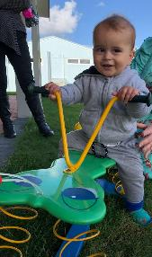 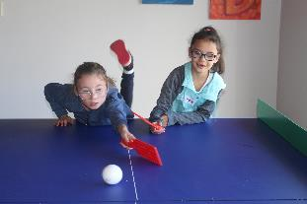

Students enjoying making music together.
 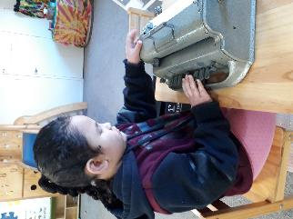 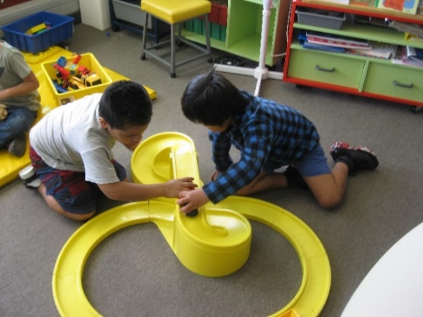

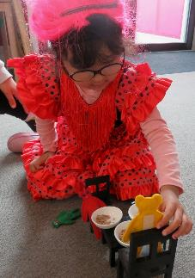 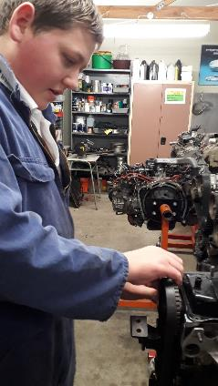 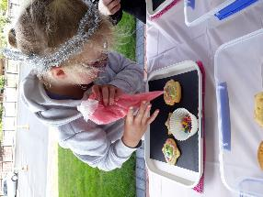

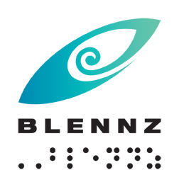

**Blind and Low Vision Education Network NZ**

**2018 Annual Report and Financial Statements**

School Address:

2 McVilly Road, Manurewa, Auckland 2012

School postal address

Private Bag 801, Manurewa, Auckland 2243

Contact details:

School Phone: (09) 2667109

School Fax: (09) 2674496

Email: [Admin@blennz.school.nz](mailto:Admin@blennz.school.nz)

Facebook: [BLENNZ Facebook](https://www.facebook.com/blindandlowvisioneducationnetworknz/)

Twitter: @BLENNZOnline

BLENNZ ICT: [info@blennz.school.nz](mailto:info@blennz.school.nz)



Contents

Message from the Board Chair 8

Message from the Principal 9

Introduction 10

Special Character School 10

Vision 12

Mission 12

Values 12

Organisational Culture 12

Beliefs 13

Key Facts and Figures 14

Learners attending Homai Campus School 14

Learners Receiving Services from BLENNZ Visual Resource Centres end of 2018 15

Statement of Variance – Overview 17

Events from 2018 20

BLENNZ Staff Conference 20

Prescribed Body 20

The Hon. Louisa Wall 20

The Hon. Tracey Martin 20

Kāpō Māori o Aotearoa 20

Disability Rights Commissioner Paula Tesoriero 20

CVI Workshop 21

Papua New Guinea Study Tour 21

Learner Achievement 2018 22

School and Residential Services 22

Homai Campus School 22

Transition Pathways Programme 28

Assessment and Teaching 29

BLENNZ Homai Early Childhood Centre 29

BLENNZ Northland Visual Resource Centre 30

BLENNZ Auckland North Visual Resource Centre 31

BLENNZ Auckland South Visual Resource Centre 33

BLENNZ Hamilton Visual Resource Centre 34

BLENNZ Tauranga Visual Resource Centre 35

BLENNZ Gisborne Visual Resource Centre 36

BLENNZ Napier Visual Resource Centre 37

BLENNZ Taranaki Visual Resource Centre 37

BLENNZ Palmerston North Visual Resource Centre 39

BLENNZ Wellington Visual Resource Centre 40

Curriculum Day: MasterChef 40

BLENNZ Nelson Visual Resource Centre 41

A learner’s voice…..an extract from her school speech 41

BLENNZ Christchurch Visual Resource Centre 42

Music at Christchurch BLENNZ 42

BLENNZ Otago Visual Resource Centre 43

BLENNZ Southland Visual Resource Centre 44

Cool Cane Kids 44

BLENNZ National Assessment Service (NAS) 45

BLENNZ Immersion 46

Regional Teaching Team 46

BLENNZ DOM 47

BLENNZ Developmental Orientation and Mobility Service: team sharing and learning together. 47

BLENNZ VRC Coordinators 48

Homai Campus Music School 48

Individual Music Programme – Wendy Richards 48

Music School – Wendy Richards 48

Homai School Music Therapy Programme – Ajay Castelino 49

Te Whānau o Homai 49

January 23/24 49

March 22 49

March 26 49

September 17 49

October 15 50

November 11 50

Following is a Whakataukī (whaka-to cause/tau-to be settled/kī-a saying) 50

Youth Library 50

Board of Trustees 52

Board Members: 52

BOT members and roles as at 31 December 2018 53

Professional Development and strategy Planning Days 53

6 April 2018 53

25 August 2018 53

The Framework of Indicators of Learner Achievement 55

The Framework of Indicators of Learner Achievement 55

Homai Campus School - 2018 55

Targets 55

Reporting 55

Māori and Pasifika 59

Target 60

Reporting 60

Reporting 60

Learner Engagement in Learning 61

Transition Pathway Programme Learner Survey 2018 61

Homai Campus School Survey 62

Homai Campus School 62

Reporting 62

Homai Residential Services 63

Target 63

Reporting 63

Regional Network - Elaine to check 64

Outcome Indicators 64

Literacy – Using Language, Symbols and Text 64

Identify the proportion of the learners acquiring literacy by: 64

Reporting 65

Learners verified for Ongoing Resourcing Scheme (ORS), primarily for vision 67

Reporting 67

Reporting 68

Process Indicators 69

Student Achievement 69

Teacher assessment skills in literacy 69

Targets 69

Reporting 69

Targets 70

Teacher Skills in Assessing and Accessing Appropriate Technology for Learners 70

Target 70

Reporting 70

Student Engagement in Learning 71

Quality of Teaching 71

Visual Resource Centres 71

Reporting 72

Linking Home with School 76

Reporting 76

Statement of Resources 79

Physical Resources 79

Other Resources 80

School Roll and Days Open BLENNZ 80

Administration Services 81

Health and Safety: 81

2018 Summary 81

2018 Goals in full 82

Key Components 1: Leadership and 11 Monitoring Reporting and Assurance 82

Key Component 9: Health and Wellbeing Programmes 83

Key Component 5: Workplace Management 83

Key Component 2: Worker Participation 83

Key Component 5: Workplace Management 84

Annual Ongoing Goals: 84

Key Component 5: Workplace Management 84

Key Component 10: Professional Development 85

Policy Review: 85

Compliance: 87

Legislation: 87

Property: 88

Assets: 88

Goal 1 89

Goal 2 92

Goal 3 94

Ongoing advocacy for dialogue with relevant personnel is imperative. 99

A joint approach between the three Sensory Schools is required. Ongoing advocacy for dialogue with relevant personnel is imperative. 100

2018 Audited Financial Statement 101

# Message from the Board Chair

Kia ora tātou

On behalf of the BLENNZ Board of Trustees I present the 2018 Annual report.

This report provides a detailed overview of what has occurred over the past year right across the BLENNZ network. It shows that progress has been made towards all of the strategic goals:

* All learners are supported by BLENNZ to achieve their full potential through the use of evidenced-based practice.
* Learner progress and achievement is enriched through the building and strengthening of effective learning-centred relationships with each learner’s whānau.
* Learning is enhanced through the appropriate use of BLENNZ resources, systems and organisational relationships.

It is exciting to hear of the successes of our ākonga. This is testament to the dedication of those ākonga, their parents and whānau, as well as BLENNZ teachers, support staff and management. Thank you all for your ongoing commitment.

* Ehara taku toa i te toa takitahi, engari he toa takitini  
  My success is not my own, but that of many

BLENNZ is committed to a continual partnership with parents and whānau as the prime educators in their child’s learning. This is a key factor in achieving our vision that ‘Every BLENNZ learner is well prepared to achieve in life’.

We are also committed to partnering with our sector partners as this helps us to inform how to continue to best support our ākonga. In 2018 the Blind and Low Vision Education Sector Forum focused on how modern or innovative learning environments and digital technologies can further support our ākonga. While this work is ongoing, in 2019 the sector forum is also exploring how to better support ākonga to transition from BLENNZ into their next stage in life, whatever that might look like for each individual.

I look forward to see what’s in store for BLENNZ in 2019 and beyond.

Ngā mihi nui

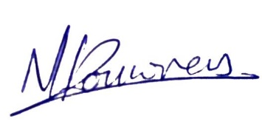

Nathaniel Louwrens

**Board Chair**

# Message from the Principal

Tēnā tatou katoa

When I look through this report what speaks most strongly to me is the wonderful learning that occurs when people come together ākonga, whānau, members of the blindness community and staff.

Learning from each other and making connections is such a strong component of learning and teaching across the BLENNZ network.

We have a wonderful community of learning and I would like to take this opportunity to thank everyone who directly works within BLENNZ and those who walk alongside us to enable us to do the work we do in the interest of ākonga and whānau.

To ākonga past and present who contribute so much to events and curriculum days thank you!

To everyone that contributed to and engaged in the learning that is documented within the pages of this report, and the huge volume that occurs and didn’t make it to these pages, a very big thank you. It is your openness to learning and sharing, to making a difference, that makes this such a fabulous story to share.

To the wonderful ākonga whose learning and achievements are celebrated throughout this report well done you are all stars!

The Strategic Goals set for us by the BLENNZ Board for 2016 – 2018, have been reviewed and from 2019 on the previous goals will form the basis of expectations of the board who have confidence that we will be:

* Evidence based
* Partnership focused and
* Effective and responsible users of the resources we are entrusted with.

I take this opportunity to thank the Board who volunteer as governors of our network. They are seldom to the fore and yet contribute their time and energy on behalf of our community.



Karen Stobbs

**Principal**

# Introduction

Welcome to the 2018 Annual Report for the Blind and Low Vision Education Network NZ (BLENNZ). The primary focus of the report is to provide accountability to the community, a set of accounting statements providing accountability from a financial perspective; reports on achievement and challenges from an operational perspective; and strategic planning reports from a strategic perspective.

## Special Character School

The Blind and Low Vision Education Network NZ (BLENNZ) is a national school that provides a network of education services to 1585 blind, deafblind and low vision learners throughout New Zealand from birth to 21, including those who have additional special needs. BLENNZ was established as a national network of services fourteen years ago in January 2005. It is one of the special schools nationally that have been legislated to provide residential provision for learners.

The purpose of BLENNZ is to ensure that the education needs of blind, deafblind and low vision learners are identified and appropriate programmes and services are available. It aims to support the government goals for education by enhancing education opportunities for its learners, facilitating access to and participation in the regular curriculum and developing skills for independence.

Historically blindness education services were provided either by the Blind Foundation, through the services based on Homai Campus, or by Visual and Sensory Resource Centres that were part of the state education system. In July 2000, Homai National School for the Blind and Vision Impaired became a state residential special school and in 2005, all of the services were amalgamated to form the Blind and Low Vision Education Network NZ.

This amalgamation of services was achieved through many years of combined advocacy from parents, teachers, service providers and sector organisations, who expressed a strong desire for a unified, nationally coordinated system for service provision. BLENNZ aims to achieve such co-ordination and cohesion and to reflect the special character of the school through the following objectives:

* Development of nationally consistent practice which is evidence-based
* Implementation of the principles of the National Plan
* Learning and teaching in the Expanded Core Curriculum in the context of the Key Competencies, as expressed in the BLENNZ Curriculum
* Learning and teaching based on the Expanded Core Curriculum as a means of accessing Te Whāriki
* Determination, monitoring and review of learner outcomes
* Clear mechanisms for accountability
* Staffing levels within international benchmarks
* Improved access to services for children and their families/whānau
* Equitable, cohesive and seamless services

BLENNZ is a national school with a national community, which includes children and young people, their families/whānau, Resource Teachers Vision and blindness educators, partner service providers such as the Blind Foundation and blindness education sector groups including:

* Parents of Vision Impaired NZ (PVI)
* Blind Citizens of New Zealand Inc (ABC NZ)
* Deafblind (NZ) Incorporated
* Kāpō Māori Aotearoa NZ, and Te Whānau o Homai

BLENNZ education services are provided from 14 centres. These are:

* BLENNZ Homai Campus, Manurewa, Auckland
  + Homai Campus School and satellite class at James Cook High
  + Residential Service
  + Homai Early Childhood Centre
  + Auckland South Visual Resource Centre
* Northland Visual Resource Centre, Manaia View School, Whangarei
* Auckland North Visual Resource Centre, Marlborough Primary School, Glenfield
* Hamilton Visual Resource Centre, Hamilton North School, Hamilton
* Tauranga Visual Resource Centre, 78 Carmichael Road, Tauranga
* Gisborne Visual Resource Centre, Riverdale School, Gisborne

With an outpost at Wairoa

* Napier Visual Resource Centre, Henry Hill School, Napier
* Palmerston North Visual Resource Centre, Somerset School, Palmerston North

With an outpost at Wanganui

* Taranaki Visual Resource Centre, New Plymouth Girls High School, New Plymouth
* Wellington Visual Resource Centre, Lindon School, Wellington
* Nelson Visual Resource Centre, Nelson Intermediate School, Nelson
* Christchurch Visual Resource Centre, Burnside, Christchurch with outposts at Oceanview Heights School, Timaru and Cobden School, Greymouth West Coast
* Otago Visual Resource Centre, Dunedin North Intermediate School, Dunedin
* Southland Visual Resource Centre, Ascot Community School, Invercargill.

## Vision

Every BLENNZ learner is well prepared to achieve in life.

## Mission

To enable learners who are blind, deafblind or have low vision to reach their full potential, BLENNZ provides quality education and specialist teaching services in partnership with whānau and the wider community.

## Values

The services and programmes of BLENNZ are aligned to support the principles and intent of government priorities, goals and strategies for education; the aims of the Disability Strategy for an inclusive society and the removal of barriers; and the principles of best practice in blindness education.

The guiding principles and values of the Blind and Low Vision Education Network NZ will reflect the following documents:

* Universal Declaration of Human Rights, Article 1
* Convention on the Rights of Persons with Disabilities, Article 3 and 24
* Te Tiriti o Waitangi
* New Zealand Disability Strategy
* Ministry of Education Statement of Intent
* A National Plan for the Education of Learners who are Blind and Vision Impaired in Aotearoa / New Zealand
* Te Whāriki
* New Zealand Curriculum

## Organisational Culture

As a community, BLENNZ has identified core values, which guide our organisation:

Whanaugatanga, Manaakitanga, Awhinatanga, Kotahitanga, Ako.

Our shared BLENNZ values and beliefs interweave to guide our community of learning and teaching, promoting the development of qualities that lead to engaged, confident, connected, lifelong learners. Qualities such as:

Can do attitude, Self-starters, Resourceful, Resilient, Contributing, Curious, Reflective, Explorer, Problem-Solvers, Connected, Confident, Belonging, Actively Involved, Making Choices, Confident communicators.

The services and programmes of BLENNZ are aligned to support the principles and intent of government priorities, goals and strategies for education; the aims of the Disability Strategy for an inclusive society and removal of barriers; and the principles of best practice in blindness education.

The children and young people of BLENNZ are represented across the various levels of education: early childhood, primary and secondary. While their education settings are diverse, the large majority of learners attend their local school or early childhood setting. Their means of communication and literacy include tactile material, braille, print, dual braille and print, sign, augmentative and alternative communication modes.

## Beliefs

The following beliefs underpin the BLENNZ approach to learning and teaching:

* Parents and whānau are the prime educators in their child’s learning
* Education is focused on the learner within the context of whānau, community and culture
* Learning occurs through active engagement in meaningful environments
* Ākonga have unique needs requiring specialist learning and teaching approaches
* Ākonga have the right to equitable access to education
* Ākonga have a right to belong and to realize their potential as participating and contributing members of society
* Team collaboration promotes positive outcomes for ākonga

# Key Facts and Figures

## Learners attending Homai Campus School

**On 1 July 2018 the roll of the Homai School was 42**

Day Students 42

Residential Students:

* Attending Homai Campus School 01 (included in above figure)
* Attending Manurewa High School 02 (not included in above figure)

Male 27

Female 15

ORS:

* Very High needs 33
* High needs 08

Learners with moderate needs 1

Primary 21

Secondary 21

**Analysis of Ethnicity**

European/Pakeha 19%

Māori 26%

Samoan 14%

Tongan 5%

Cook Island Māori 12%

Indian 17%

Other 7%

81% of the students attend the BLENNZ Homai Campus School are non-European.

## Learners Receiving Services from BLENNZ Visual Resource Centres end of 2018

|  | **Roll No.** | **Early Childhood** | **Primary** | **Secondary** |
| --- | --- | --- | --- | --- |
| Northland | 43 | 3 | 24 | 16 |
| Auckland North | 161 | 35 | 83 | 43 |
| Auckland South | 305 | 66 | 127 | 112 |
| Waikato / Thames / Coromandel / King Country | 127 | 24 | 70 | 33 |
| Bay of Plenty | 119 | 23 | 71 | 25 |
| Gisborne / East Cape | 59 | 8 | 31 | 20 |
| Hawkes Bay | 48 | 7 | 31 | 10 |
| Taranaki | 72 | 16 | 41 | 15 |
| Horewhenua Manawatu | 120 | 23 | 58 | 39 |
| Wellington | 144 | 24 | 81 | 39 |
| Nelson / Buller / Marlborough | 51 | 8 | 32 | 11 |
| Canterbury / West Coast | 206 | 31 | 114 | 61 |
| Otago | 59 | 5 | 37 | 17 |
| Southland | 29 | 3 | 18 | 8 |
| **TOTAL** | **1543** | **276** | **818** | **449** |

**Analysis of Ethnicity**

European/Pakeha 55.2%

NZ Māori 22.9%

Samoan 3.7%

Indian 3.0%

Cook Island Māori 2.0%

Chinese 2.1%

Tongan 1.6%

Niuean 0.7%

Other 8.7%

# 

# Statement of Variance – Overview

**2018 Annual Plan**

| **Goal 1** | **All learners are supported by BLENNZ to achieve their full potential through the use of evidenced-based practice** | **Outcome** |
| --- | --- | --- |
| Objective 1 | Undertake professional learning to strengthen the skills of curricula leaders in the inquiry process to:   * lead and mentor others in inquiry * complete the development of a guideline to support inquiry within BLENNZ   to enable improved teaching and learning outcomes that are evidenced based | Achieved |
| Objective 2 | Focus on numeracy achievement of ākonga by:   * identifying the achievement outcomes in numeracy for a **cohort** of ākonga * collating resources and   providing professional development | Not achieved |
| Objective 2 | Continuation of Tactile graphics | Achieved |
| Objective 3 | Implement the:  online hubs which become the repository of curricula/pedagogical resources and base for learning communities | Achieved |
| Objective 4 | Homai Early Childhood Centre strategic path through a teacher led inquiry model | Partially Achieved |
| Objective 5 | Residential programme pathways for transitionusing an evidence based approach. | Partially Achieved |

| **Goal 2** | **Learner progress and achievement is enriched through the building and strengthening of effective learning-centred relationships with each learner’s whānau.** | **Outcome** |
| --- | --- | --- |
| Objective 1 | **Communication:**   * The Board will initiate regional consultation with a view to hearing the voice of whānau. To gather feedback from BLENNZ community to inform strategic thinking and engagement process. | Achieved |
| Objective 2 | * All team leaders will embed the provision of a biannual team newsletter and an annual regional whānau event in practice. * Enhancing relationships through effective communication and activities. | Newsletters achieved  Annual Events – Partially Achieved |
| Objective 3 | * Establish and initiate an online content development work plan reflecting the needs of whānau | Not achieved |
| Objective 4 | **Capability Building:**   * To raise awareness of and increase the cultural competency of the BLENNZ teaching team.   To provide the BLENNZ teaching team with the tools, experiences and resources to raise awareness and increase cultural competency through data gathering. | Achieved |
| Objective 5 | * Collaborate with education and health teams in an initiative to inform the development of parent leadership in visioning and goal setting – Now and Next. | Partially Achieved |
| Objective 6 | A teaching team will engage in the ‘My Working World’ work programme to enhance their reflective practice resulting in stronger professional and parent relationships. | Achieved |

| **Goal 3** | **Learning is enhanced through the appropriate use of BLENNZ resources, systems and organisational relationships.** | **Outcome** |
| --- | --- | --- |
| 1. Partnerships | Initiate work, with Blind Foundation, to inform a collaborative approach to transition. | Not achieved |
| 2. Partnerships | Work with fundholders to develop and trial an approach to enhance outcomes of ākonga who have learning needs which are complex in nature. | Achieved |
| 3. Partnerships | Organise and facilitate a Sector workshop to inform practice in modern learning environments. | Achieved |
| 4. Partnerships | Collaborate with international & national partners to inform effective practice for assessment and intervention with ākonga who have CVI. | Achieved |
| 5. Staff | Further develop induction resources | Partially Achieved |
| 6. Staff | Develop a PLD framework to support policy | Achieved. |
| 7. Staff | Develop recommendations for VI Post Grad course. | Achieved |
| 8. Systems | Establish a resource cataloguing system | Achieved |
| 9. Systems | Establish a resource cataloguing system | Achieved |
| 10. Systems | Develop a database of ākonga who are deafblind. | Partially achieved |
| 11. Systems | Property  Implement property agreements with MOE | Not achieved |
| 12. Systems | Progress the sensory schools capital works program. | Partially achieved |
| 13. Systems | Refurbish the BLENNZ Homai Campus swimming pool | Not achieved |

# 

# Events from 2018

## BLENNZ Staff Conference

The 2018 BLENNZ Staff Conference took place on the 24th and 25th January. 200 staff registered for the conference from across the network.

Keynote speakers Megan Ellis – What it Takes – speaking on My Working World Nathan Mikaere-Wallis – Brainwave Trust – The developing Brain and PB4L team presentations.

### Prescribed Body

On the 5th April 2018 BLENNZ became a prescribed body for the purposes of section 69 of the Copyright Act 1994.

### The Hon. Louisa Wall

28th May - Member of Parliament for Manurewa, Louisa Wall, met with the Principal and members of the leadership team Homai Campus School. This was as part of a commitment to visit each of the education centres in her electorate. Of particular focus on this visit were an employment initiative she has been working on in the area of transition, which will include employment of young people with disabilities. Louisa considered it important that ākonga from BLENNZ be involved in this.

### 

### The Hon. Tracey Martin

27th July - Associate Minister of Education, Tracey Martin, met the principal and members of the leadership team Homai Campus School. The meeting involved sharing of the presentation about BLENNZ, a tour of the campus and engagement with ākonga on site. It was a fairly informal engagement in which the dialogue was supportive and inquiring.

### Kāpō Māori o Aotearoa

17th September - a Powhiri took place to welcome whānau who were attending an immersion course at Homai for some of our Rumaki Reo learners.  This was the start of a week long course and was a great opportunity to connect whānau with Kāpō Māori o Aotearoa.

### Disability Rights Commissioner Paula Tesoriero

24 September - Paula Tesoriero, Disability Rights Commission and Douglas Hancock visited BLENNZ Homai Campus. BLENNZ was able to provide an opportunity for them to engage with regional managers of the Visual Resource Centres and ākonga from the school who provided a tour of the campus. We then met with them to share an overview of the range of the services we provide nationally and regionally and the partnerships we are working to achieve in the interest of effective service provision and positive outcomes for ākonga.

### CVI Workshop

On the 15 and 16 October BLENNZ hosted a Cerebral Visual Impairment (CVI) Workshop for ophthalmologists, orthoptists, paediatricians and neuropsychologists. The two days provided an opportunity for BLENNZ staff to undertake PLD and for people in the field of CVI to advance their understanding of CVI and build national and international networks with our current partners in education and health. Guests included: Florine Pilon-Kamsteeg - Orthoptist, Bartimeus, Netherlands, Kerry Tait – Deputy Principal, Narbethong State Special School, Brisbane, Australia and Karen Neilson – Statewide Adviser, Visually Impaired Statewide Services, Queensland, Australia.

### Papua New Guinea Study Tour

A group of eleven team members from Papua New Guinea visited the BLENNZ Homai Campus during the week of the 12 November.

A range of information was provided in the areas of: early learning; acquisition of braille and literacy through braille; vision assessment and assessment tools; functional vision assessments; environments for access and learning; inclusive practice and partnerships; and teacher training.

On Tuesday 19th November the principal accompanied a small group who met with Ministry of Education and Ministry of Foreign Affairs and Trade. These meetings were also attended by cbm NZ’s Chief Executive. The group spoke highly of the work that had been undertaken during the week, the learning that has occurred, and the reflection on what this means for how they might take services forward in their plan to develop the first two schools in Goroka and Wewak which will be models of inclusive practice.

# Learner Achievement 2018

## School and Residential Services

### Homai Campus School

The Homai Campus School has three distinct areas to meet the need of learners who are blind, deaf/blind and low vision.

* The Homai Campus School classrooms known as Weka, Kiwi, Tui, Pukeko, Takehe and Kea. The learners in these classrooms may have additional barriers to their learning. They work in the New Zealand Curriculum. Teaching methods and equipment have been adapted to the unique educational needs of these students.
* The Satellite Class at James Cook High school where the students have satellite group learning activities including intensive one-to-one instruction as well as mainstream learning experiences.
* The Transition Pathways Programme is a programme for students as they make the transition to tertiary, the work place and/or independent living.
* The Homai Campus School also provides IEP classroom immersion experiences for learners around the country.
* The Residential service has one hostel, Nikau Hostel, which provides residential accommodation for blind and low vision learners who are enrolled at the Homai Campus School, Manurewa High School and the students attending the Transition Pathways programme.

This year our focus for reporting is on social skills.

#### Weka Room

Two children in wheelchairs playing with a foil blanket.


Opportunities for learning together are built into the programme for all students in the Weka group. The students use switches as they share home/school news or their favourite poems with others. Some use a switch to put in the repeated section of a familiar story. Opportunities are given for the students to move independently using the classroom hoist system and some students use this time to seek out a classmate and interact with them. A favourite activity is the sharing of a very shiny and noisy foil survival blanket. The noise amuses all the students as two students each try to claim the whole blanket.

#### Kiwi Class

Xavier and NJ playing alongside each other


Kiwi Class students have all been working on IEP goals based on the Key Competency of Relating to Others. For each student specific learning outcomes will be different. Xavier is now greeting other students and staff members by name and will sit at break times in the company of older more verbal students. NJ is greeted and farewelled, and supported to play on the rocker during break times by Takahe Class students. N J. anticipates his turn during greetings and will offer a response by vocalizing. Zara is enjoying communication and turn taking during Intensive Interaction. She predicts her turn as it approaches and shows anticipation and excitement with attentiveness and body language, and by looking at the speaker. All Kiwi Class students show a strong sense of belonging within their class group and are able to remain focused on independent activities at the same table.

#### Tui Class

Tui class students waiting for their turn to share their news.


Students liestening to a story together


In Tui Class we enjoyed our time together. The highlight activities of the day are the morning greetings and story time.

During the morning greetings, we sit at our desks and wait eagerly for our turn to say “morning” and share our news with everyone. We enjoy this time, as we all get to have an equal opportunity to listen and share. This term we are gathering around in a circle, in the middle of the classroom, for story time. This way, everyone gets a turn to read the story, and no one is left out. We enjoyed this terms theme story about our “Living World”. Our focus was on the jungle. We got to listen to recorded sounds of the jungle with all the noises and sounds made by growly animals.

#### Takahe class

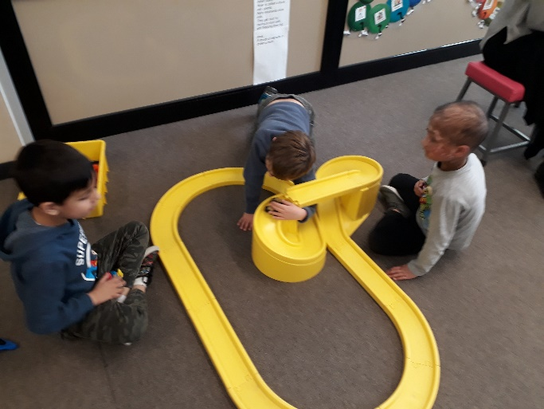 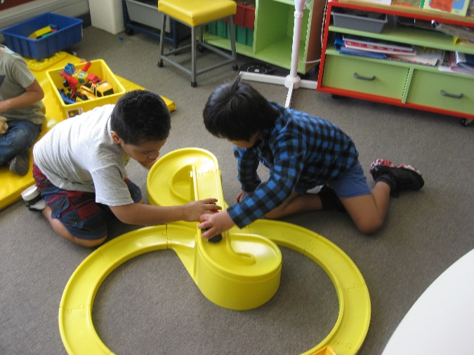

In the past year Takahe class learners have had many opportunities to practice and develop their social skills. From visiting the Zoo and interacting with the staff and general public to interacting with visiting students for IEP Immersion weeks. Harold from the Life Education Trust visited and focused on being a good friend and treating people with respect. The learners have referred back to Harold’s wise words on many occasions. The learners have all grown in their maturity and how they relate to one another and to those visiting their classroom. They include them in games and guide and show them around the school giving their new friends an opportunity to take turns.

#### Pukeko Class

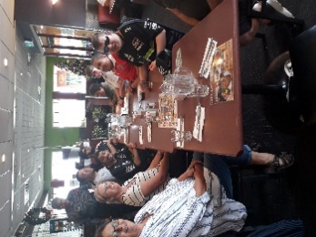

Pukeko class have been practicing their social skills at school and in the community. We visited Denny’s Restaurant in Manukau for our ‘End of Year Outing’. Raising funds at BLENNZ Homai Campus School was fun. Staff communicated with Pukeko learners in a social manner answering surveys, purchasing food, plants and car washing services. Pukeko learners ordered their own food at Denny’s Restaurant in Manukau and paid for their meal at the counter. Great conversation took place with staff and waiters in a restaurant setting. Each learner managed their food while conversing with staff and waiters. Learners enjoyed the access and choice of ordering and paying for their meal at a restaurant.

#### Kea Class

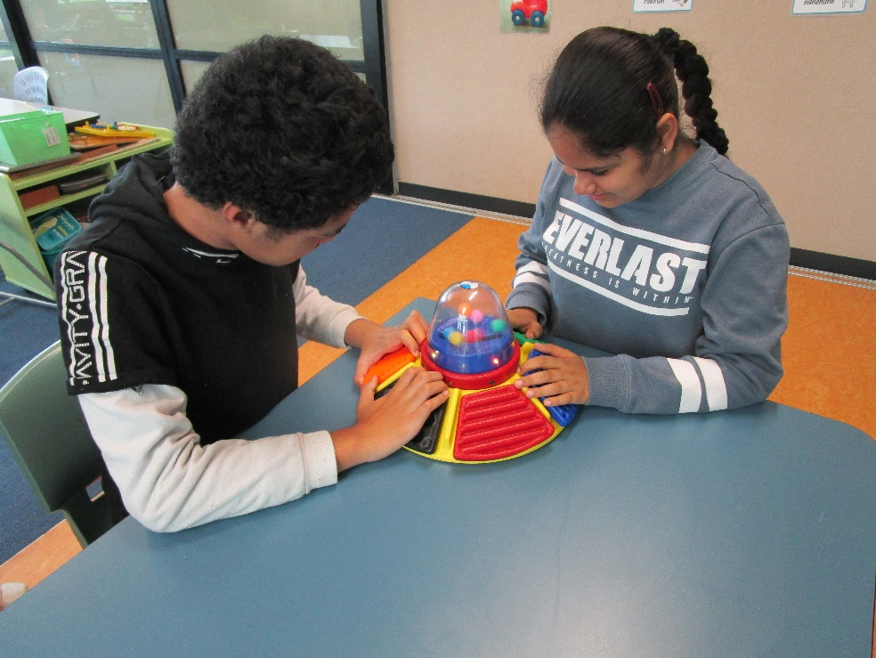

Kea class have been practicing skills which require them to sit next to another person and share items of interest and books. While the students are very good at sitting near to each other, they can still be reluctant to share. An item of high interest for all the students is this spaceship sensory activity. Each panel produces a different sound, light or movement response. Riya and Ethen were having fun seeing who could get the most reaction from pressing their panels.

#### James Cook High School Satellite Class

Students listening to instructions for a game.


We are all delighted that we have had many opportunities to practise our social skills throughout the year. Some of the opportunities were in the classroom and others outside. Nuku has made a significant progress in working with and interacting with others appropriately. He can now play a variety of games with his peers and follows basic rules without much prompting. Amitoj is able to express his opinions and accept group decisions. Jack has been such help in helping and supporting his classmates during outings. He ensured that they knew where to go, took turns appropriately as required and communicated maturely with staff if he was not sure what to do. Adrea is making her opinions known in discussions and decision-making. Maide-Pearl, the class’ newest member has managed to use her respectful and practical nature to encourage her classmates to reconsider their views when they have not made very good choices. All the above has helped the team to work better and happily during most group situations.

Students enjoying making music together.


Transition Pathways Programme

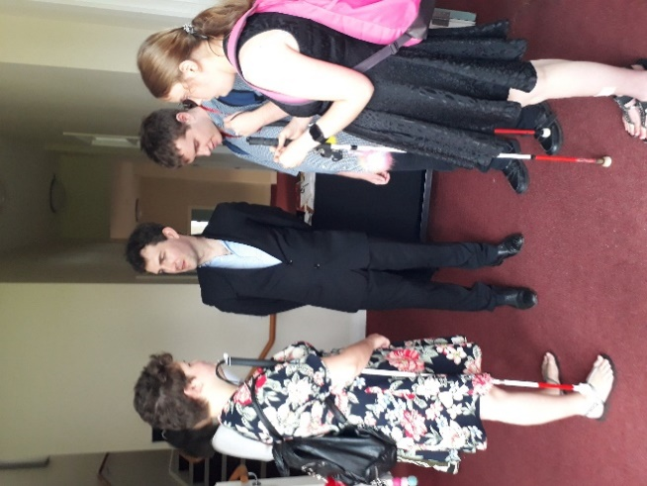 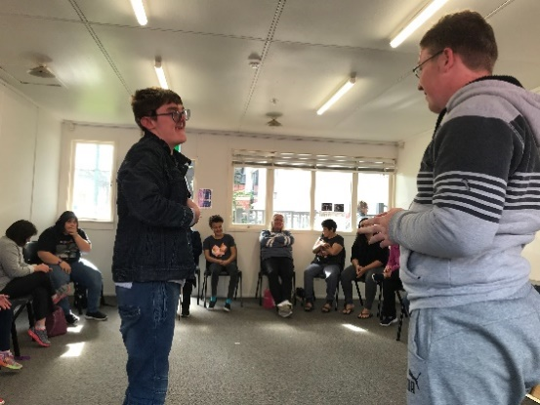 Transition students participating in First Aid Defibrilator training


In 2018 Ākonga were involved in a range of social groups and activities where they had the opportunity to develop their social skills including advocacy and assertiveness, clear communication for informal and formal situations, an understanding about themselves within a social context, and awareness and empathy with others.

They participated in various community clubs and programmes including; the Interact Drama and Film workshops, hip hop dance lessons, and a community choir.

They strengthened their connections with other young people from the blind community attending the Blind Foundation youth group Cube meetings, and a range of social and recreation events,  and day courses where they pursued areas of  personal interest including;  self-defence  classes,  movie club, and ice skating.

There were various opportunities where individual Ākonga participated in presentations and forums where they advocated and represented the view point of young people with a vision impairment. They prepared short video presentations for BLENNZ - sharing information about themselves and the Transition Programme.

Throughout the year they hosted visitors and groups to the programme – developing and demonstrating the values of Manakitanga and Awhinatanga at formal and informal occasions.

# Assessment and Teaching

## BLENNZ Homai Early Childhood Centre

Homai Early Childhood Centre has a termly booking with Ambulance Officer Sue to learn more about the people who help us in our community. She brings ‘Amby’ a model ambulance and real equipment to explore. In August, a real St Johns Ambulance came too. We had direct contact with the first aid equipment we are familiar with and used all our senses to explore, both inside and outside the Ambulance, comparing it with Amby and our small models.

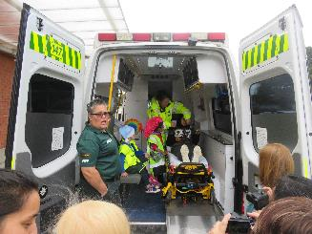

Ākonga experience the real ambulance

We have been utilising our 3D printer to create models to support learning and storytelling throughout our programme, e.g., the 3 bears story was enhanced with chairs, beds and a table, all produced on the 3D printer. Aisha and her mother played together, creatively retelling the story. The printer assists us to create unique resources to enable ākonga to access the curriculum.

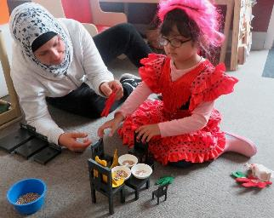

Aisha and her mother play together



Aisha sits on the floor with the storytelling models and other props

## **BLENNZ Northland Visual Resource** Centre

In 2018 BLENNZ Northland have been running three curriculum days each term.

These consist of a Low Vision Group (primary and intermediate), Braille Club (primary) and a Braille Secondary Schools Group. Our learners are collaboratively deciding on their group names, so watch this space.

Our tamariki gather together with their Resource Teachers of Vision from all areas across Northland including Taipa, Kaitaia, Dargaville, Kaikohe, Kerikeri, Ngunguru and Whangarei.

These days are based on the New Zealand and Expanded Core Curricula and particularly focus on social skills, independent daily living skills and assistive technology. Student voice is recorded and the groups identify their own goals and areas of focus.

The engagement, discussions, problem solving and friendships that are fostered make our expanded core curriculum days a termly highlight for our tamariki.

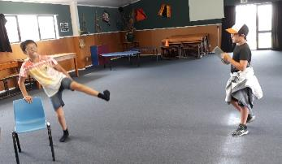

Figure 1 Creating a friendship strip: one person acting, the other being the cameraman.

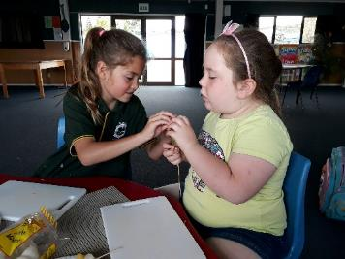

Figure 2 Working together to make fruit kebabs

## BLENNZ Auckland North Visual Resource Centre

On May 7th, we held a Sports day for BLENNZ primary and intermediate aged learners. 18 learners attended. It was held at the PHAB Building in Takapuna. Out on the field, Rhys and James from Halberg, and Matt and Parveen from Blind Sport provided coaching sessions in soccer and cricket. We discovered that we have some budding bowlers and batsmen.

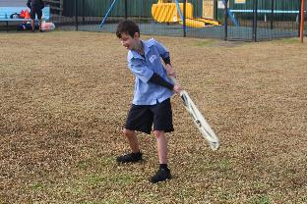

Budding batsman strikes the ball.

Inside, Pops Games provided some amazing wooden games and puzzles. They were all large and colourful, excellent for our students to use. Many were really challenging providing an opportunity for learners to test their problem solving skills. The polybats (table tennis) game in which the adults were blindfolded was the scene of laughter and hilarity.



Two girls enjoying the challenge of playing polybats.

All in all, a wonderful day which encouraged lots of physical and social opportunities for all who took part.

## BLENNZ Auckland South Visual Resource Centre

David, a Year 13 student, displayed a desire to become more independent. He set a goal to transition from school into a work environment by the end of the year. His RTV and DOM specialist, set out to make this happen. Initially, David lacked confidence. He had never ventured out into the community alone. He dragged his fingers along shop fronts to gain tactile clues and to keep himself safe so a long cane was suggested.

The trio undertook weekly visits to various shopping malls, train stations and Auckland CBD. Elgrete and Ernie saw David’s confidence grow drastically with each session. David is now capable of getting himself to a specific location using multiple trains. He uses the strategies taught with confidence and can navigate himself safely in a crowded environment.

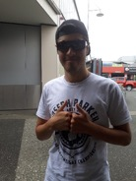

A photograph of a smiling David wearing sunglasses, T-shirt and cap and giving a two thumbs up hand signal.

BLENNZ Hamilton Visual Resource Centre  
Hamilton VRC held a family Xmas Event to give families and BLENNZ staff an opportunity to engage on a more informal basis.

Eleven families attended alongside 2 staff members of the Blind Foundation.

The event was held on December 5th. We hired an animal farm, which was one of the highlights for all the children. The animal farm owner was incredibly supportive of the children and took special care with the babies, toddlers, and older children alike, ensuring their safety and happiness. A sausage sizzle was held and everyone enjoyed a snack as they wandered around, playing games, drawing over the carpark with chalk and decorating cookies.

 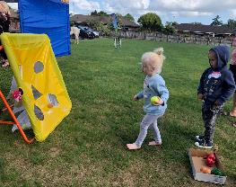

Fig 1 Icing Cookies; Fig 2 The games were a hit with all ages

Families engaged with each other and staff they had not met before. It was a successful evening that families enjoyed and hopefully this will be the start of yearly events that encourage families to be a bigger part of the BLENNZ whanau.

 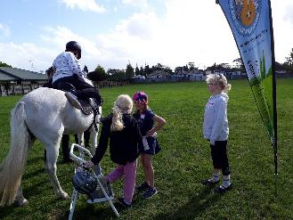

Fig 3 Enjoying the bouncy caterpillar; Fig 4 The girls chat to each other while they wait their turn for a pony ride

## BLENNZ Tauranga Visual Resource Centre

Tauranga VRC ran an Expanded Core Curriculum day for our senior Primary and Intermediate learners on 15th June. We invited our local Community Constable, Paul Wrigley to talk to our learners about personal safety and the role of the police. Paul also brought some new recruits to meet us.

The learners had the opportunity to explore a police car and try on the specialist equipment including armored vests, batons and hats. The learners then used their devices to write about the experience. A favourite was setting off the sirens on the car.

It was a great opportunity for the learners to meet a community role model and have hands on activities.

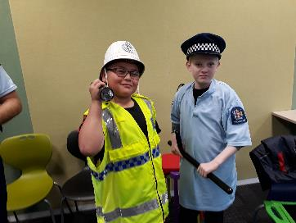

Two learners trying on police uniform and equipment.

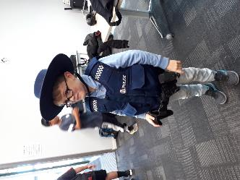

Figure Learner trying on the armoured vest and utility belt.

## BLENNZ Gisborne Visual Resource Centre

After a very successful whānau disco in 2017 we carried this on as a yearly event to promote and celebrate physical skills**,** whānaungatanga and collaboration with our Blind Foundation colleagues. This year we had a great attendance of BLENNZ whānau and ākonga, (including grandparents and great grandparents). Everyone came dressed up in costumes around our Stars theme and had a fantastic time, with many adults and children dancing the night away.

We were very lucky to have the best sound and music from a BLENNZ father, DJ Ash Andrews and we provided a variety of kai, including a sausage sizzle and vegetarian options.

It was wonderful to see everyone dancing, interacting, making connections and having fun! Ākonga and whānau commented that this event is a highlight of the year for them.

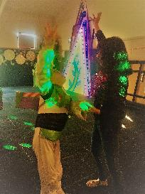

Kobe is dancing with Dolina at the disco.

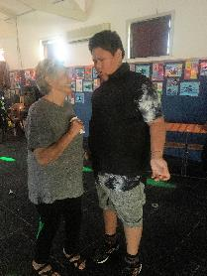

Shayden dancing with his great grandmother at the disco.

## **BLENNZ Napier Visual Resource** Centre

During the Term 2 holidays, a group of nine learners attended a Blind Foundation Activity Day, which included a visit to the Historical Napier Prison. They were surprised to see first-hand the tiny cells the prisoners were once housed in and the prison’s stark surroundings. Some amazing stories of daring escapes captured their imagination. Back at the Foundation, the children were fully involved in making lunch together and participating in a variety of team games.

BLENNZ Napier learners are continuing to learn new skills. Four year old Piper enjoys taking time during RTV visits to explore and ‘write’ on the Perkins Brailler. Piper names members of her whānau as she makes dots for each one.



Piper enjoying the Perkins Brailler

## BLENNZ Taranaki Visual Resource Centre

A focus this year at BLENNZ Taranaki was to provide rich learning experiences for groups of ākonga where there were opportunities to connect, collaborate and learn together.

A highlight was group visits to Access Radio Taranaki, where ākonga planned and presented their own show. Their podcasts were available to listeners on the station’s website. This experience will be ongoing as ākonga who display a passion for radio will have the opportunity of learning the skills of broadcasting. Student voice included *“This was my dream to be on the radio”* and *“You actually get to be yourself on the radio.”*

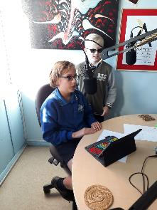

Tipene on Air at Access Radio Taranaki with Jack listening and observing

Another highlight was the ‘Sailability’ experience where small groups of ākonga were introduced to sailing. They had turns sailing with an experienced volunteer while steering the yacht and then practicing their Expanded Core Curriculum skills of identifying the correct money and ordering a hot drink from the local café.

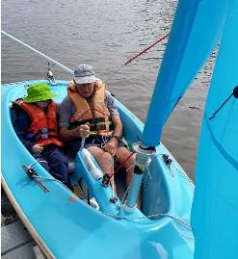

Zach’s first experience in a yacht

## BLENNZ Palmerston North Visual Resource Centre

At BLENNZ Palmerston North we are all about supporting ākonga to follow their dreams and interests – even when that involves thinking well outside the square.

Darcy, a Year 13 student at Whanganui High School, is taking Automotive Engineering. He is learning how engines work, through dismantling and re –assembling one using entirely non-visual techniques.

Darcy has his own tool-kit, made accessible with a tactile map. The iPhone app, ‘Tap-Tap-See’ has proven very useful for reading digital displays on tools like Vernier callipers.

Having a teacher aide with a can-do attitude, and support from a retired blind mechanic, along with Darcy’s passion for the subject, is enabling him to gain skills and NCEA and trade credits.

Self-advocacy skills have proven to be essential as Darcy surprises those who are used to relying on sight to perform tasks, that he can perform them safely, and just as well, using auditory and tactile skills.



Darcy is attaching a timing-belt to an engine on a stand in the Automotive workshop.

## BLENNZ Wellington Visual Resource Centre

### Curriculum Day: MasterChef

A morning of teaching, learning, eating and having fun for both parents and children.

In a collaboration between BLENNZ Wellington and ADL instructors from the Blind Foundation, parents and their children attended the Curriculum Day together to learn about techniques for cook.

While the children were busily creating chefs hats and decorating pizza boxes, Elsje and Nicole from the Blind Foundation gave the parents the opportunity to learn the how’s and why’s of safe cooking techniques to use with their children.

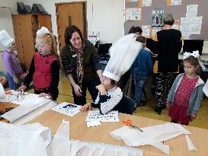

Chef's hat in full production

The parents were then joined by their children to put theory into practice by chopping fruit to make kebabs, toasting crumpets and spreading margarine and then chopping, spreading and grating items for pizzas. Once the pizzas were cooked the cleaning up was done and dishes were washed. All good ADL skills.

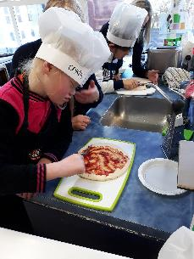

Full concentration is needed to get the tomato paste spread correctly on the pizza base

At the conclusion of a very busy, successfu**l** morning, the children got to take their pizza home - if there was any left, and the parents were given handouts as a reminder of all the skills taught during the sessions.

## BLENNZ Nelson Visual Resource Centre

### A learner’s voice…..an extract from her school speech

I’ve been told that my eyes twitch a lot, but I don’t notice it. This causes headaches and visual fatigue.

I sit with my friends in class now because I have a laptop and iPad. My laptop has accessibility features to make stuff bigger and easier for me to see.

I have gone on immersion courses where I meet other people my age going through the same or similar situations. They’re so much fun! I have the chance to make amazing friends that live all over New Zealand. Some of the friends I’ve made also have nystagmus and it helps my confidence a lot. I’m always reassured that even though it feels like I’m the only one that’s different, I am not alone.

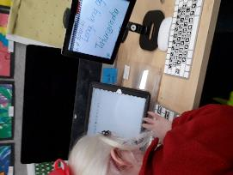

Learners making the most of technology to support their learning

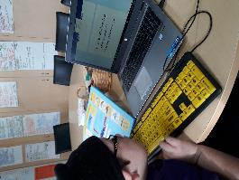

Learners making the most of technology to support their learning

## BLENNZ Christchurch Visual Resource Centre

### Music at Christchurch BLENNZ

This year a third music class was started, catering to ORS Vision Only students. The main drive behind this group was to learn the marimba and ukulele repertoire so to participate in the Christchurch *Strum Strike Blow 2018 Festival.*

After two and a half terms of music classes with RTV Virginia Simmons, they joined with over 1200 primary school students from 42 primary schools from Christchurch in the fifth Strum Strike Blow Festival.

Four students met weekly to learn six marimba pieces ranging from a Japanese song to the theme to Mission Impossible were learned. On the ukuleles, starting with playing only one chord in Term 1 by the festival date were able to follow their music and play the entire song… all while wearing lai’s.

They developed into a strong confident team. One student summed it up, rushing to their parent exclaiming, “I learnt to follow the conductor!”

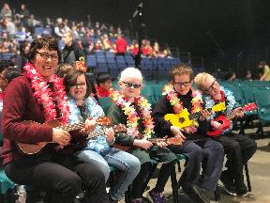

Students playing ukuleles

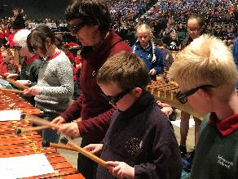

Students playing marimbas

## BLENNZ Otago Visual Resource Centre

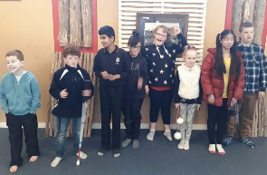

Group photo of ākonga

Curriculum Day has become an event that our blind and low vision ākonga look forward to each year as it gives them a special time to be together and many friendships have been made. Following feedback from the ākonga last year, we decided to go for a trip out together and visited the local Marae.

Careful preparation before the visit meant that everyone was ready to present their mihimihi and knew the waiata that we would sing. Two of our ākonga are Maori and took leadership roles on the day, helping with pronunciation and saying a karakia.

The staff at the Marae were very welcoming and had designed cultural activities that took the needs of our group into consideration. The ākonga had fun making poi, working with clay and listening to Maori stories of the local area.

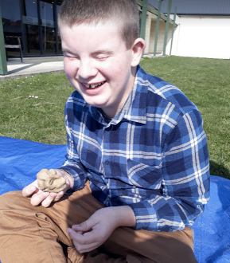

Nathaniel making a clay pot

## BLENNZ Southland Visual Resource Centre

### Cool Cane Kids

Kay Daly has been sharing cane tips and skills with staff and students.

Each student has a different emphasis in his or her cane work.

One has learnt how to negotiate his way around the town centre that he lives and into cafes and shops. He has learnt strategies to aid his independence with both mobility and life skills, while at the same time finding the best hot chocolate in town.

Another young man has learnt cane skills for his safety when travelling on footpaths and crossing roads.

The third person pictured was working on using her cane to help her navigate steps and unknown spaces to help when she travelled to Japan on a school trip.

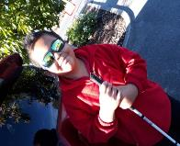 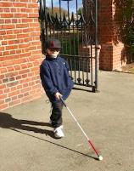

Fig 1: Dimetrez Mason with his new cane. Fig 2: Kayden Ashby out and about doing cane work

Jessica walking down steps using her cane


Fig 3: Jessica Barnes practicing her cane usage

## BLENNZ National Assessment Service (NAS)

Ela and her whānau live in Te Upoko-o-te-ika-a-Māui or the Wellington area. Ela experiences congenital dual sensory loss or congenital deafblindness. She uses a combination of vision and hearing strategies and devices to assist the compounding and multiplying effect that her dual sensory status has on access and learning. Ela has recently transitioned to primary school.

In Term 3, Ela attended a comprehensive assessment on the BLENNZ Homai campus with her mother and Resource Teacher Vision. The educational and health professionals of the NAS team alongside Ela and her mother shared ideas, suggestions and strategies specific to Ela’s sensory and health needs in her preparation as a new entrant.

Ela’s mother recently shared that Ela feels very welcomed at school.

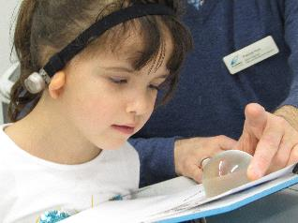

Ela views an illustration with a dome magnifier

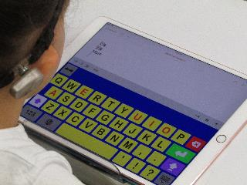

Ela views the iPad after typing on the Keedogo Plus internal keyboard

## BLENNZ Immersion

The Immersion Service has started the year well. Five of six courses were successfully completed, one ECE course was not undertaken because of staff changes.   
The courses included Braille Maths for High School Learners, Career and Future Planning and Planning for Tertiary (also for High School Learners), JAWS for Beginners and the Early Childhood course. All compulsory sector courses maintained a balance between covering the NZ Curriculum and the inclusion of areas of the Expanded Core Curriculum. Students have focussed particularly on Orientation and Mobility and Daily Living skills during their time at Homai.

Immersion welcomes a new member to the team. Nic Holloway from Hamilton has become the new Immersion Facilitator replacing Lesley Wear.

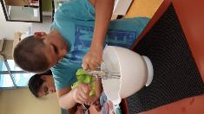

Ākonga using a hand mixer

## Regional Teaching Team

BLENNZ employs a number of Resource Teachers:Vision and Developmental Orientation and Mobility Specialists who are based at fourteen Visual Resource Centres and four outposts located across New Zealand. The role of the teachers is to advise, provide guidance and direct teaching to identified learners with a vision concern, in their region while the role of the DOM is to work collaboratively in the provision of specialist services.

Opportunities continue to be provided for Managers of each Centre to meet and to support the implementation of the Strategic and Annual Plans. These meetings occur at a national level and facilitate a collaborative approach to enhance pedagogy and practice. They took place in Terms 1 and 3 in 2018. Likewise, opportunities continue to be provided for the teaching team located across the network to meet at a regional level through Visual Resource Centre Regional Days Regional Days took place in Term 2 and 3 in 2018.

These network opportunities are critical as BLENNZ strives towards the provision of consistent specialized programme delivery for ākonga from an informed specialist teaching team.

### 

## BLENNZ DOM

### BLENNZ Developmental Orientation and Mobility Service: team sharing and learning together.

The BLENNZ DOM team continues to grow and learn together throughout 2018. The team meets 4 times a year for professional and service stream development.

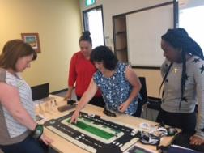

Members of the BLENNZ DOM team review the Wise Walker Kit. A kit developed in NZ, to the team’s specifications, with the aim of supporting blind and low vision learners to learn concepts and strategies associated with community travel.

Members of the DOM team also presented on the BLENNZ DOM Model and philosophies at the April conference of Orientation and Mobility Association of Australasia.

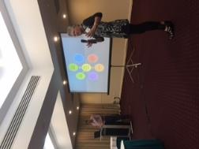

Members of the BLENNZ DOM team presenting at the Orientation and Mobility Association of Australasia Conference

The presentation was well received at the conference and the conference content and resources were shared with the BLENNZ DOM team at the team meeting.

## BLENNZ VRC Coordinators

BLENNZ ākonga participated in the NCEA review. Chrissie Butler from CORE Education gathered the voice of BLENNZ ākonga from a group of senior students meeting at Homai Campus. They shared their experiences and offered suggestions to support engagement and involvement in the NCEA process.

Focus material was used to support and guide conversations around what works well, good and not so good experiences, and ideas to change and improve the NCEA process. Voices gathered will be analysed and included an NZCER report to the Ministry of Education to refine NCEA and strengthen its design and implementation.

The focus group was a great success with everyone sharing their experiences and offering suggestions about what was going well, how things might be changed and what might be improved.

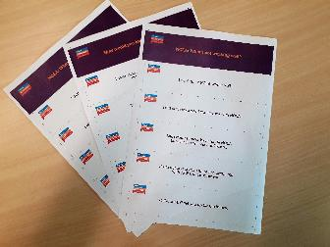

Focus material used to support and guide ākonga conversations.

# Homai Campus Music School

## Individual Music Programme – Wendy Richards

Eleven students received regular one to one music tuition in 2018. Four students completed NCEA standards from levels 1 – 3, and three others accessed music braille lessons via skype in preparation for NCEA within the next two years. Two learners are at Homai Campus school and two learners are currently in primary school placements.

## Music School – Wendy Richards

Twenty-two students enrolled in the music school programme in 2018. Sixteen of these access music via braille, five use large print, one is an aural learner, Music school day is a busy and lively event with all students enjoying the opportunity to meet together and make music. This year we trialed a slightly different approach to the afternoon programme, with learners actively involved in making decisions about what they wanted to learn and how they were going to achieve this. Teachers were encouraged to step back and allow peer-to-peer teaching and learning to happen naturally, only stepping forward to offer support when required. This encouraged the students to take ownership of their own learning and support each other in the learning process.

## Homai School Music Therapy Programme – Ajay Castelino

Eight group and five individual music therapy sessions were provided every week for the Homai Campus students in 2018. The aim of the music therapy sessions was to support the ākonga’s emotional, social, verbal and non-verbal expression through the use of music. The music therapist also worked as part of a multi-disciplinary team alongside the other Homai therapists to deliver a weekly motor-sensory program.

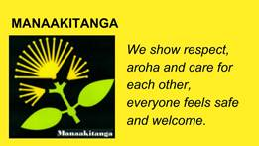

# Te Whānau o Homai

In 2018 Te Whānau o Homai committee were involved with the following events at the Homai Campus.

## January 23/24

BLENNZ conference-involved behind the scenes where needed.

## March 22

Powhiri to welcome new staff and students followd by afternoon tea.

## March 26

Farewell to Barbara Whitley, Manager of School and Residential Services.

## September 17

Powhiri to welcome bilingual ākonga and Whānau from around Te Ika A Māui (the North Island) were here for an Immersion week. Motuhake Te Reo Māori bilingual learners were joined by Ngāti Kāpo. Matua Becker along with students and their kaiako/kaiawhina made the welcome possible.

## October 15

Powhiri/Whakatau to welcome visitors from The Netherlands and Australia who attended a Cortical vision Impairment workshop.

## November 11

Mihi/Whakatau for Papua New Guinea visitors. A whakatau (less formal than a powhiri) is a speech to welcome a visiting group.

## Following is a Whakataukī (whaka-to cause/tau-to be settled/kī-a saying)

Very important within Māori culture with underlying messages which are extremely influential in Māori society.

He tangata takahi manuhiri, he Marae puehu

A person who mistreats his guest has a dusty Marae or someone who disregards their visitors will soon find they have no visitors at all.

This accentuates the importance of manaakitanga or hospitality.

# Youth Library

The Youth Library is based at BLENNZ Homai Campus School and is administered by the Blind Foundation.  We have two enthusiastic librarians on site who provide a point of contact for teaching staff and teacher aides throughout New Zealand to request educational items for school children.

The Blind Foundation, through funding from the Ministry of Education, is committed to producing and providing a wide range of accessible resources to fulfil the educational and recreational needs of children and youth.  The Library also supports children and their families in literacy reading development and lifelong learning through the provision of a range of reading material in a variety of formats. These include:

* Collage books: sturdy, hard-covered picture books with large print and braille text and bright, bold collage illustrations.
* Early readers and School journals available in large print and e-text.
* Braille books: fiction, non-fiction, examinations, tests and textbooks.
* Twin vision picture books: with clear plastic braille over the original print or with clear plastic braille pages inserted between the original print pages. Some are also available with an accompanying CD.
* Large print books in 18 and 24-point font: mostly fiction for ages 9 to 16. We also have a growing non-fiction and textbook collection.
* Kitsets with enclosed print book with accompanying CD and braille text.
* Electronic files (E-text) available in Word, HTML and Plain text.
* Playaway pre-recorded MP3 players.
* DAISY books.
* Digital services such as Booklink and Bookshare

The library supports RTVs and educators professional development through the provision of reference material and reference services.  Cathryn is available to assist with reference queries and literature searches.

The library also supports and helps with a variety of immersion courses run by BLENNZ over the course of the school year, and conducts library tours for teacher aides and other educational groups when requested.   We have regular visiting sessions for all classes in the school and meet regularly with families visiting for needs assessment.

Opening hours: Monday to Friday, 9.00am to 4.30pm, including school holidays.

You can phone us on (09) 268-3215 or 0800 24 33 33 ask for Youth library.  
Email [youthlibrary@blindfoundation.org.nz](mailto:youthlibrary@blindfoundation.org.nz)

The Library Team:

Senior Librarian – Cathryn Mitchell

Senior Library Assistant – Gordon Dickson

# Board of Trustees

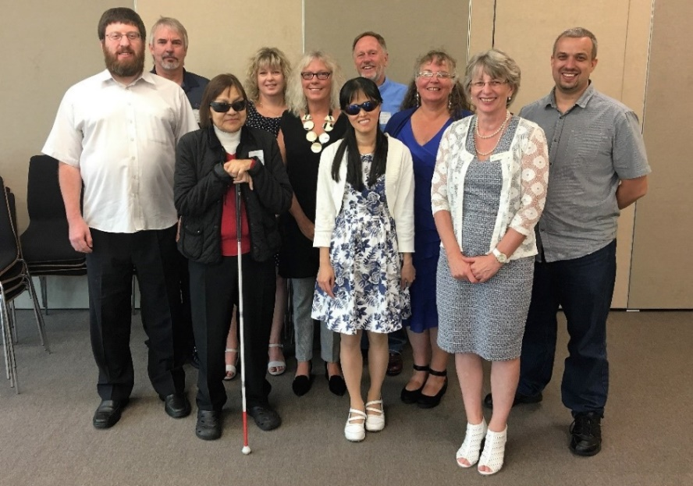

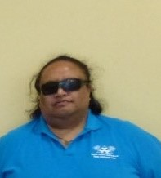 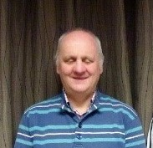 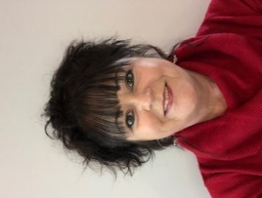

## **Board Members**:

Top photo back row from left: Graeme Hood, Letitia Patete, (left December 2018) Mitch Harris

Middle row from left: Nathaniel Robson, Jane Cox, Karen Stobbs, Nathaniel Louwrens

Front row from left: Sarndra Tamepo, (left July 2018) replaced by Nigel Ngahiwi (lower left)

Wendy Chiang, Janny Cooke (BOT Secretary), Neil Jarvis (lower centre) left April 2018 replaced by Catherine Rae (lower right)

BLENNZ has a national board of trustees, which is representative of BLENNZ and of the wider blindness education sector.

The role of the BLENNZ Board is to govern the school, with a focus on providing an environment that fosters achievement for ākonga and young people who are blind, deaf blind or low vision.

BLENNZ also has the Homai Early Childhood Centre on the Homai Campus. This is a licensed centre attended by young children in the Auckland region, and also serving as a national resource. Because of current legislation, this centre is governed under a separate trust and trust board, the Homai Early Childhood Centre Education Trust (HECCET) Board of Trustees. Seven members of the BLENNZ Board form the membership of the HECCET Board of Trustees. These are: Mitch Harris, Nigel Ngahiwi, Nathaniel Louwrens, Wendy Chiang, Catherine Rae, Jane Cox, and Karen Stobbs

The BLENNZ Board of Trustees meet on a Friday afternoon and in 2018 met for six meetings:

23 February, 6 April, 20 June, 24 August, 26 October, 7 December

The Board is made up of the following trustee positions:

* Four elected by parents receiving services from Visual Resource Centres
* One elected by parents of students enrolled at the Homai Campus School
* One elected by staff
* One appointed by the RNZFB now known as the Blind Foundation
* One appointed by Blind Citizens NZ
* One appointed by a panel of representatives of recognised Kāpo Māori organisations
* The Principal of BLENNZ

Board co-opted trustees, provided that the number of parent elected and VRC elected trustees was greater than the total number of co-opted and appointed trustees.

## BOT members and roles as at 31 December 2018

Nathaniel Louwrens – Board Chair and Visual Resource Centre Parent Trustee

Nathaniel Robson – Deputy Chair and Visual Resource Centre Parent Trustee

Mitch Harris – Homai Campus School Parent Trustee

Graeme Hood – Visual Resource Centre Parent Trustee

Jane Cox – Staff Elected Trustee

Catherine Rae – Appointed, Royal New Zealand Foundation of the Blind known as the Blind Foundation

Wendy Chiang – Appointed, Association of Blind Citizens of NZ Inc

Nigel Ngahiwi – Appointed, Tangata Whenua

Karen Stobbs – Principal

## Professional Development and strategy Planning Days

### 6 April 2018

For the first half of the Board’s meeting on the 6th April the agenda in the morning included strategic discussion around the development of the Board’s Communication and Engagement Plan which informed the consultation questions. For the second part of the morning the Board met with David Wales, MOE National Director Learning Support and Coll O’Connor Senior Adviser, Provider Services, Learning Support who shared with the Board further information about the Learning Support Update.

### 25 August 2018

This meeting focused on the following topics:

* 2018 Consultations looking at feedback, what the board might take forward and reflections on the process.
* Board engagement within the community – how the Board might engage
* Further strategic thinking around strategic goals

# The Framework of Indicators of Learner Achievement

BLENNZ uses a network-wide approach to quantifying learner achievement using a framework of evaluation indicators. The indicators capture both direct and indirect measures to provide an overview of achievement of learners and BLENNZ services. This systematic approach is intended to enhance opportunities for evidence-based practice and to provide the data needed for the development of nationally consistent practice and for a process of continuous improvement.

The outcomes are documented in the following pages with the first section of reporting focusing on the School and Residential Service Strand followed by reporting on the Assessment and Teaching Services.

# The Framework of Indicators of Learner Achievement

## Homai Campus School - 2018

**Collate IEP goal achievement data for learners attending Homai Campus School.**

### Targets

**Learners at Homai Campus School will achieve 80% of their IEP goals during 2018**

In this reporting the names Pukeko, Takahe, Tui, Kiwi, Kea and Weka - the different classrooms of the learners on campus. It also includes the satellite class at James Cook Satellite.

When learners achieve their goals new goals are set. The aim is 100% but achievement of the goal is at the pace of the learner.

### Reporting

The Homai Campus School has developed an IEP policy and guidelines to ensure the IEP process outlines the children and young peoples’ strengths and needs, bringing together a collaborative team that works in partnership with family and whānau to identify and prioritise learning outcomes that are based on effective assessment and teaching strategies. The IEP or ITP plans ensure learners are provided with a programme that enables them to achieve maximum educational outcomes and the goals are appropriate for the learner. Each IEP is reviewed by the Senior Teacher, Co-coordinator School Programmes and the Senior Manager of School and Residential Services.

The learners have worked well to achieve their IEP goals. For the learners who have not achieved the target of 80% there appears to be a consistent variable relating to their attendance due to illness and in some cases changes in their physical condition and / or changes in medication which has impacted on their learning.

#### Pukeko

Learners in Pukeko are secondary aged and focusing on life skills. Most achieved their goals. Learners 3 and 4 made decisions not to continue with touch typing. They may reconsider their decision at their next IEP meeting. Learner 4 needs more time to consolidate his goals as his attendance has been erratic.

| **Learner** | **Using language symbols and texts** | **Participating and contributing** | **Managing Self** | **Relating to Others** | **Thinking** |
| --- | --- | --- | --- | --- | --- |
| 1 | 100% | 100% | 80% |  | 80% |
| 2 | 90% | 100% | 85% |  |  |
| 3 | 70% | 100% |  |  | 70% |
| 4 | 80% | 100% | 75% | 100% | 75% |
| 5 | 75% |  | 90% |  | 80% |

#### Takahe

With the exception of one learner, all learners achieved at least 80% of their goals. This learner had serious ill health issues last year and attended only 60% throughout the year. Even when he was attending school, he often felt unwell and this impacted on his achievement. These goals will be retained in 2019 as they are still relevant.

| **Learner** | **Using language symbols and texts** | **Participating and contributing** | **Managing Self** | **Relating to Others** | **Thinking** |
| --- | --- | --- | --- | --- | --- |
| 1 | 95% |  | 92% |  | 100% |
| 2 | 93% |  | 90% | 83.3% | 94% |
| 3 |  |  | 88% | 88% |  |
| 4 | 73% |  | 64% | 75% |  |
| 5 | 97% |  | 80% |  | 96% |

#### Kea

The learners in this class are widely varied in their needs and abilities. There are two learners under ACC funding who each had a teacher aide assigned to them. A new learner with very complex needs and behaviour challenges meant much time was given in settling him into his new environment and getting to know him and understanding strategies to support his learning and behaviour. Learner 4 has not made the anticipated progress and goals have been adjusted to better meet his needs. Learner 5 is receiving continued support from therapists to assist her in achieving the goals.

| **Learner** | **Language Symbols and texts** | **Participating and contributing** | **Managing self** | **Relating to others** | **Thinking** |
| --- | --- | --- | --- | --- | --- |
| **1** | 90% | 80% | 88% | 75% |  |
| **2** | 66% | 100% |  | 100% |  |
| **3** | 80% |  | 64% | 100% | 88% |
| **4** | 64% |  | 100% |  | 87.5% |
| **5** | 100% | 75% | 66.6% |  |  |

Learners in Tui and Weka classes are very high needs and some with fragile health. Illness and absences have had an impact on the progress of some learners.

#### Tui

Due to staff illness, there were many relievers in this class in the first part off the year. Mid year, a long-term reliever was employed for this class. During the second half of the year, the learners made pleasing progress. For learner 2, 3 and 4, health issues and changes of medication impacted on their attendance and achievement. For learner 5 staff worked closely with the Manukau Children’s Team to support the family and whānau during some difficult times.

| **Learner** | **Using language symbols and texts** | **Participating and contributing** | **Managing Self** | **Relating to Others** | **Thinking** |
| --- | --- | --- | --- | --- | --- |
| 1 | 83% |  | 66% | 100% |  |
| 2 | 81% |  | 83% |  |  |
| 3 | 71% | 100% | 75% |  |  |
| 4 | 66% |  | 66% |  |  |
| 5 | 50% |  | 75% |  |  |

#### Weka

Most learners in Weka achieved more than 80%. However, learner 1 was very unwell with numerous admissions to hospital during the year. Her family agreed that her learning outcomes will continue until March 2019. Learner 6 transitioned into school during the year. He travels from West Auckland and SESTA transport declined his application due the distance and his age. Family transport him to school, however his attendance has not been consistent. We are hoping that now he is 6 the application can be reviewed more positively.

| **Learner** | **Using language symbols and texts** | **Participating and contributing** | **Managing Self** | **Relating to Others** | **Thinking** |
| --- | --- | --- | --- | --- | --- |
| 1 | 60% |  | 80% |  | 66% |
| 2 | 95% |  | 75% | 100% |  |
| 3 | 85% |  | 100% |  | 100% |
| 4 | 100% |  | 88% |  | 100% |
| 5 | 80% |  | 87% |  | 100% |
| 6 |  | 50% |  |  |  |

#### Kiwi

Kiwi class began with two learners and throughout the year two more transitioned into the class.

| **Learner** | **Using language symbols and texts** | **Participating and contributing** | **Managing Self** | **Relating to Others** | **Thinking** |
| --- | --- | --- | --- | --- | --- |
| 1 | 100% | 100% | 100% | 100% | 100% |
| 2 | 100% | 100% | 100% | 100% | 100% |

Learners 3 and 4 transitioned into the class during terms 3 and 4. The goals set in their initial IEP will be reviewed in 2019.

#### James Cook High Satellite Class

Learners in James Cook satellite achieved most of their goals. Learners attend classes in the mainstream at James Cook, the satellite class and on Homai Campus.

Learner 3 was reluctant to join in the mainstream. However, by later in the year when he felt confident enough to join in the mainstream classes, it was too late for him to attend the classes. He will begin in the mainstream in 2019. Learner 4 had ongoing challenges. BLENNZ staff continue to work closely with Oranga Tamariki, family and whānau to support the significant needs of this learner.

| **Learner** | **Using language symbols and texts** | **Participating and contribution** | **Managing \Self** | **Relating to Others** | **Thinking** |
| --- | --- | --- | --- | --- | --- |
| 1 | 100% | 80% |  | 100% |  |
| 2 | 91% | 82% | 91% |  |  |
| 3 | 86% | 57% | 100% | 100% |  |
| 4 | 50% |  | 80% | 75% |  |

A fifth learner joined the class during term 3. Her IEP goals were set at a meeting early in term 4 and will be reviewed in 2019.

### Māori and Pasifika

#### Māori Learners

3 learners achieved 80% or more of their IEP goals. Two learners did not achieve 80%. Staff are working closely with these two families. One learner has not been here long enough to have her goals reviewed.

#### Cook Island Māori Learners

4 learners achieved 80% or more of their IEP goals. The learner who did not achieve 80% had significant health issues resulting in time in hospital and a change of medication, which impacted on learning.

#### Samoan Learners

5 of the 7 learners achieved 80% or more of their IEP goals. One learner who did not achieve 80% spent time in hospital and time away from school. The other has not been at school long enough to have her goals reviewed.

#### Tongan Learners

Both learners achieved 80% or more of their IEP goals.

### Target

Identified learners at Homai Campus School will improve their reading age by a minimum of 6 months during 2016.

Learners at James Cook are attending Mainstream English classes working on NCEA Level 1.

### Reporting

|  | **Term 1** | **Term 1** | **Term 4** | **Term 4** |
| --- | --- | --- | --- | --- |
| **Learner** | **Reading age Term 1** | **Reading Level** | **Reading age**  **Term 4** | **Reading Level** |
| 1 | 5 yrs | L3 | 5.5yrs | L7 |
| 2 | 5.5yrs | L8 |  | L9 |

#### Target

Learners at Homai Campus School participating in conventional numeracy programmes will achieve their individual targets in numeracy and progress towards National Standard expectations by the end of 2018. The learners at James Cook are working within the James Cook Mainstream programme, NCEA Level 1.

| **Learner** | **Numeracy Project Level / Stage** | **Numeracy Project Level / Stage** |
| --- | --- | --- |
|  | **Term 1 2016** | **Term 4 2016** |
| 1 | Level 1 / stage 2 | Level 1 / stage 3 |
| 2 | Level 1 / stage 3 | Level 2 / stage 4 |

The NumPA assessment is completed with each learner in a conventional numeracy programme. The assessment is adapted for low vision and braille learners. The assessment scores in various areas. The results are analysed by the teacher, areas strengths and weaknesses are identified.

#### Target

Learners attending the Transition Pathway Programme will achieve 80% of their ITP goals during 2018**.**

### Reporting

9 learners began the year in the Transition Pathways Programme. One learner left at the end of term 2 and another at the end of term 3 to prepare for transition to University. Meetings were held for these learners in their home cities and a handover to the Blind Foundation Adult Services.

All learners achieved at least 80% of their goals. Learner 9 was the learner who left at the end of term 2. Some learners had more than one goal in a Key Competency. These were averaged out for the percentage.

| **Learner** | **Using Language symbols and texts** | **Participating and contributing** | **Managing self** | **Relating to others** | **Thinking** |
| --- | --- | --- | --- | --- | --- |
| 1 | 100% | 100% | 100% |  | 100% |
| 2 | 100% | 100% | 100% | 80% | 90% |
| 3 | 100% | 100% | 100% |  | 100% |
| 4 | 100% | 100% | 100% | 100% | 100% |
| 5 | 100% | 100% | 100% | 90% | 100% |
| 6 | 90% |  |  | 100% | 100% |
| 7 |  | 85% |  | 100% | 100% |
| 8 | 100% |  | 96% | 100% | 90% |
| 9 |  | 80% | 90% | 80% | 80% |

## Learner Engagement in Learning

### Transition Pathway Programme Learner Survey 2018

As the Transition Pathway Programme was a pilot programmed or 2018, feedback was requested by families, staff and learners throughout the year. This was done by email, written surveys, face to face and phone conversations. The team working with the Transition Pathway Programme discussed the options for surveying the learners at the end of their time in the programme. They decided that it would be more helpful to wait until the learners had returned home and moved into the next phase of their lives – University, living in supported living or away from home and into programme or work in their local communities. This way it was felt that the learners could reflect on what was useful within the programme and also give feedback on what may have been more useful to focus on to support their move to post school life.

This information will be collected at the end of term 1 2019.

## Homai Campus School Survey

### Homai Campus School

All reporting to parents by the Homai Campus School will be against the learners’ IEPs. It will be in an agreed format that has been developed to comply with the National Standards Guidelines to ensure that all reporting is in plain language and clearly articulates to parents the next steps for their child’s learning, and how they can support the learning outcomes at home.

#### Targets

100% of reports to parents/caregivers from Homai Campus School use the agreed format.

100% of parents/caregivers surveyed express satisfaction (strongly agreed or agreed) with the new style and formatting of reports with regard to clarity of information and clear articulation of the next steps in the child’s learning and how they can support this learning at home.

Conduct an annual survey of parents with children attending Homai Campus School to determine the level of satisfaction with the service provided.

#### Target

100% of parents/caregivers evaluate the service provided as appropriate Strongly agreed or agreed in terms of the quality of classroom programmes, ease of communication with the home, child safety, assessment and feedback.

## Reporting

19 out of a possible 34 families completed the survey.

1. My child is well supported by the classroom programme.

12 strongly agreed; 6 agreed. 1 strongly disagree

2. There is good communication between the classroom and home.

12 strongly agreed; 5 agreed. 2 disagree

3. I feel welcomed into the school and comfortable contacting the staff.

12 strongly agreed; 5 agreed. 1 disagree 1 strongly disagree

4. The health and safety of my child is well provided for.

13 strongly agreed; 6 agreed.

5. The information presented in the IEP is helpful to me.

10 strongly agreed; 9 agreed.

6. The school report is informative and easy to read.

12 strongly agreed; 5 agreed; 1 disagree 1 N/A

(6 continued) The School Report gives a clear idea of what is the next step in learning.

12 strongly agreed; 5 agreed. 1 disagree 1 N/A

7. The termly newsletter provides good information on the activities at school.

12 strongly agreed; 4 agreed; 1 disagree 1 N/A how we can improve our support

It was identified that two of the families who responded should have had the survey in their own language or been given the survey with an interpreter present. An interpreter will be invited to meet with these families to ensure their comments are a real indication of their views. A discussion on how we can better meet the needs of these families will be had with the families. An invitation into the school or a home visit will be offered to the other family to discuss their comments. Contact has been extremely difficult with this family. However, we are continuing to try to make contact through the home school notebook.

## Homai Residential Services

Conduct an annual survey of all parents of learners who are in residence in the Homai Campus hostels to determine the level of satisfaction with the service provided. This will in part, demonstrate compliance with the terms of the Hostel Licence.

### Target

95% of parents/caregivers evaluate the service provided as appropriate in terms of quality of communication with home, quality of recreational and cultural activities, learner wellbeing and support for their child’s educational programme.

## Reporting

1 out of a possible 3 families responded.

1. The residential environment is safe and comfortable.

1 strongly agreed;

2. There is good communication from the residential staff about my child’s progress, activities and appointments.

1 strongly agreed;

3. The Residential staff are approachable and I feel comfortable contacting them.

1 agreed;

4. The health needs of my child are well monitored and cared for.

1strongly agreed

5. The residential services provide good support for my child’s educational programmes.

1 strongly agreed;

6. The information provided by the residential staff in the IEP is helpful.

1strongly agreed

7. The residential contributions to the school reports are informative and easy to follow.

1 strongly agreed

8. There is a good range of recreational and cultural activities as well as community outings provided for my child.

1 strongly agreed

## Regional Network

BLENNZ continues to use a network wide approach to quantify learner achievement for all BLENNZ learners within an established framework of indicators. This systematic approach reflects evidence based practice and provides data needed to confirm nationally consistent practice.

In 2018, for the sixth consecutive year, BLENNZ continued to emphasise the importance of reporting of accurate and meaningful data in order to provide a broad picture of the BLENNZ learner population. The focus was on the population of braille and print users, aged 5-12 years, who are verified for ORS primarily on their vision. This focus was further defined to those learners who participate in a conventional literacy programme. This data will be analysed further from the six year period to reflect on known trends and to consider forward planning.

In December 2018, there were 1582 learners enrolled with BLENNZ whose information was held on the electronic platform of eTAP and who were receiving their support from a Visual Resource Centre. Data in respect to all learners is continually updated throughout the year to ensure accuracy.

## Outcome Indicators

### Literacy – Using Language, Symbols and Text

For all BLENNZ learners, data for reporting on this indicator will be aggregated from the BLENNZ Literacy Profile Forms, which are completed by BLENNZ teachers for all learners and collated electronically.

### Identify the proportion of the learners acquiring literacy by:

The type of literacy programme (conventional or functional)

The stage of literacy development

The level of participation in the literacy programme as defined in the BLENNZ Literacy Profile

**Outcome Achieved for 99% of the learner population**

### Reporting

BLENNZ teachers have completed the BLENNZ Literacy Profile and information has been collated to identify the type of literacy programme, level of participation and stage of development in literacy for the BLENNZ learner population.

1. **The type of literacy programme (conventional or functional) a learner is involved in.**

**54.7% (865) of learners follow a conventional literacy programme**

This is a formal instructional programme of reading and writing (in print or Braille) that generally begins at Early Childhood Centres and continues throughout the school years. Learners in such programmes demonstrate continuous growth in literacy skills from year to year.

**38.7% (613) of learners follow a functional literacy programme**

These programmes have an emphasis on reading and writing for the purpose of increased independence in daily life.

**5.6% (89) of learners’ literacy programmes are yet to be determined or identified**

Learner age is the principal factor involved where the literacy programme has yet to be determined.

**1.0% (15) of learners where no information was provided**

This data has been requested to inform the profile.

1. **Their stage of literacy development**

Literacy development for the BLENNZ learner is defined by the way the learner gains meaning of the world around them. This will start from actual objects through to visual or tactual codes and is described as: using real objects; 3 dimensional items (objects of reference); 2 dimensional picture or tactile cue (objects of reference); text symbols such as print, braille; or as dual modality meaning using both print and braille. The following information outlines this data:

**56.7% (897) use text symbols (printed or embossed)**

**10.7% (171) use 2 dimensional (pictures or cues)**

**4.2% (66) use 3 dimensional objects and**

**27.4% (433) use real objects**

**1.0% (15) of learners’ literacy development is not recorded**

NB - Of the 1% of learners whose stage of literacy development is not recorded, they are located across eight regions. These learners are new enrolments or very young, therefore, their stage of literacy development is unknown, but most are likely to be ‘using real objects’.

1. **Learners’ level of participation in their literacy programme as defined in the BLENNZ Literacy Profile**

Learners may be at different levels of participation: exposure; awareness; emergent; early; or fluent. Each level reflects how the learner is engaged in literacy - for example at exposure level, the learner is presented or exposed to literacy materials and experiences, whereas at fluency level, the learner is integrating cues, thereby maintaining meaning through longer and more complex sentence structures, various kinds of prose, and poetry and adjusting the rate of reading to the purpose.

**Exposure – 29.6%** (469) of BLENNZ learners are participating in their literacy programme by being exposed to literacy materials and resources. A further 1.0% (15) are likely to be at this stage of participation as they are very young children or infants.

**Awareness – 12.7%** (202) of BLENNZ learners demonstrate an awareness of the literacy materials that are shared with them by attempting all or some of the following:

* Touching or looking at the illustration;
* Attending to the language of the story being shared – may vocalise with adult;
* Turning pages;
* Touching dots

**Emergent – 10.7%** (169) of BLENNZ learners are at an emergent level, showing interest in attempting to read text unaided, considering what is read with what is already known, discussing what is happening with what is likely to happen and recognising a number of words in various contexts.

**Early – 13.7%** (216) of BLENNZ learners are at an early level of literacy drawing out meaning from text using such strategies as:

* Using their background experience
* Taking risks and making approximations
* Using text and illustrations to sample, predict and confirm
* Using letter sound associations to confirm predictions

**Fluent – 32.3%** (511) of BLENNZ learners are at a level of fluency integrating cues, maintaining meaning through longer and more complex sentence structures, various kinds of prose and poetry and adjusting the rate of reading to the purpose

## Learners verified for Ongoing Resourcing Scheme (ORS), primarily for vision

**All Braille users from 5-12 years old who participate in conventional literacy programmes**

* Identify the proportion of learners reading at their chronological age or better as at December 2018.

**Outcome Achieved**

### Reporting

There were 19 learners, ORS verified vision only, aged 5-12 years who use braille and participate in a conventional literacy programme. 31.6% of these learners are reading at or better than their chronological age.

**Reading Ages of Learners Using Braille who’s Chronological Age is 5-12 Years**

| **Year of Birth** | **No Data** | **Below** | **At** | **Above** | **Total** |
| --- | --- | --- | --- | --- | --- |
| 2006 |  | 2 |  |  | 2 |
| 2007 |  | 4 |  | 1 | 5 |
| 2008 |  |  |  | 1 | 1 |
| 2009 |  | 1 |  | 3 | 4 |
| 2010 |  | 2 |  |  | 2 |
| 2011 |  | 2 |  |  | 2 |
| 2012 |  | 1 | 1 |  | 2 |
| 2013 |  |  |  |  | 1 |
| **Total** |  | 13 | 1 | 5 | 19 |
| **Percent** |  | 68.4% | 5.3% | 26.3% | 100% |

In 2018, these 19 learners were 1.2% of the total number of learners on the BLENNZ roll who are receiving support from Visual Resource Centres. 26.3% (5) of these learners are reading above their chronological age while 5.3% (1) are reading at their chronological age. Of the learners, 68.4% (13) are reading below their chronological age.

For those learners reading below their chronological age, information was provided for 9 of the learners. This information refers to a number of considerations as follows:-

* Learner had been refusing to read for most of the year. T4 has seen a dramatic change in motivation. So pleased with this result.
* Excellent decoding, improved comprehension – good with facts, working on inference re: comprehension.
* New to roll T3, 2018.
* New to Braille.
* Learner had extremely poor school attendance.
* Working on reading for meaning, vocabulary and fluency.
* Initially reading was halting, lacking in fluency and little work attack skills evident. Reviewed program, went back to L10 worked back up to L15. Now reading with fluency and comprehension at this level.
* Can read single words, but struggles with sentences.
* Attends Steiner School, reading not taught until 7 years.

**All Low-Vision Learners from 5-12 years old who use print in conventional literacy programmes**

* Identify the proportion of learners reading at their chronological age or better as at December 2018.

**Outcome Achieved**

### Reporting

There were 160 (10.1%) BLENNZ learners in this category. 66.9% of these learners are reading at or better than their chronological age.

**Reading Ages of Learners Using Print who’s Chronological Age is 5-12 Years**

| **Year of Birth** | **No Data** | **Below** | **At** | **Above** | **Total** |
| --- | --- | --- | --- | --- | --- |
| 2006 | 1 | 4 | 2 | 13 | 20 |
| 2007 |  | 11 | 4 | 11 | 26 |
| 2008 |  | 8 | 6 | 10 | 24 |
| 2009 | 1 | 7 | 7 | 10 | 25 |
| 2010 |  | 7 | 8 | 4 | 19 |
| 2011 | 1 | 8 | 4 | 3 | 16 |
| 2012 | 1 | 4 | 8 | 6 | 19 |
| 2013 |  |  | 9 | 2 | 11 |
| **Total** | **4** | **49** | **48** | **59** | **160** |
| **Percent** | **2.5%** | **30.6%** | **30.0%** | **36.9%** | **100%** |

36.9% (59) of learners in this age group who use print as their medium, are reading above their chronological age, while 30% (48) are reading at their chronological age. 30.6% (49) of the group are reading below their chronological age with no age related information provided for 2.5% (4) of the learners.

Where no information was detailed, the following narrative was provided:

* Two learners were not assessed due to Resource Teacher Vision absence, one learner had been enrolled for a month, and another attended a Kura.

For those learners reading below their chronological age, further information was provided for all of the group:

The following information was documented:

* Poor student attendance
* ESOL
* Developmental delay
* Change / new vision diagnosis
* Accessibility to print
* General ill health
* New enrolment
* Home-schooled
* Developing skills
* Progressing well
* Transferred ORS

# Process Indicators

## Student Achievement

### Teacher assessment skills in literacy

**BLENNZ Braille learners 5 – 12 years who are participating in a conventional literacy programme and acquiring literacy through touch**

* BLENNZ teachers working with learners acquiring literacy through touch 5 – 12 years who are participating in conventional literacy programmes, will demonstrate the required skills in carrying out a Running Record assessment.

### Targets

1. All braille users from 5 – 12 years old participating in conventional literacy programmes will have their reading age assessed and documented by their BLENNZ teacher using the Running Records diagnostic assessment.

**Target achieved**

2. All teachers undertaking this assessment have demonstrated their competency.

**Target achieved**

### Reporting

Both targets were achieved as complete data was provided for the cohort.

**BLENNZ ORS verified learners with low vision who are 5 – 12 years and participating in a conventional literacy programme**

* BLENNZ teachers working with ORS verified learners who have low vision from 5 – 12 years old who are participating in conventional literacy programmes, will demonstrate the required skills in carrying out a Running Record assessment

### Targets

1. All ORS verified learners with low vision from 5 to 12 years old participating in conventional literacy programmes will have their reading age assessed and documented by their BLENNZ teachers, or in partnership with the classroom teacher / SENCO, using the Running Records diagnostic assessment.

**Target achieved**

1. All teachers undertaking this assessment have demonstrated their competency

**Target achieved**

## Teacher Skills in Assessing and Accessing Appropriate Technology for Learners

**School Learners across all age bands**

* Report on success rate for assistive technology applications to the Ministry of Education in support of curricula access for BLENNZ learners

### Target

A 100% success rate with assistive technology applications for 2018.

**Target achieved**

### Reporting

The assessment and procurement of assistive technology for BLENNZ learners remains an essential undertaking to ensure learners have access to their 21st century learning environments. A range of technology and software has been approved. The emphasis remains on promoting inclusive environments for all learners.

The number of BLENNZ learners using assistive technology continues to increase. In 2018, 161 new applications, and 31 applications for replacement equipment were made.

**Assistive Technology Applications 2018**

| **Term** | **New Application** | **Replacement** | **Total** |
| --- | --- | --- | --- |
| 1 | 28 | 8 | 36 |
| 2 | 31 | 7 | 38 |
| 3 | 56 | 4 | 60 |
| 4 | 46 | 12 | 58 |
| **Total** | **161** | **31** | **192** |

**Hardware included:**

* MacBook
* IPad
* Mountbatten
* Braille Note / Braille Sense
* Laptop
* Slope Board
* Printer
* Orbit

**Software included:**

* Typing Programmes
* Zoom Text
* JAWS

## Student Engagement in Learning

### Quality of Teaching

### Visual Resource Centres

* Conduct an annual national survey of a 10% representative sample of parents with children receiving services from Visual Resource Centres to determine the level of satisfaction with the Resource Teacher Vision service provided.

**Target achieved**

* 95% of parents/caregivers evaluate the service provided as appropriate in terms of effectiveness, communication with home and support for their child’s educational programme.

**Target achieved**

### Reporting

228 surveys were sent out to parents/whanau and 54 were returned. This is a return rate of 23.6%, a return rate of 22% occurred in 2017.

The following satisfaction rates were obtained when parents/caregivers were asked if:

1. My child is well supported by the Visual Resource Centre:

76% Strongly agree; 22% Agree; 2% Partly agree; 0% Disagree

**100% Target achieved**

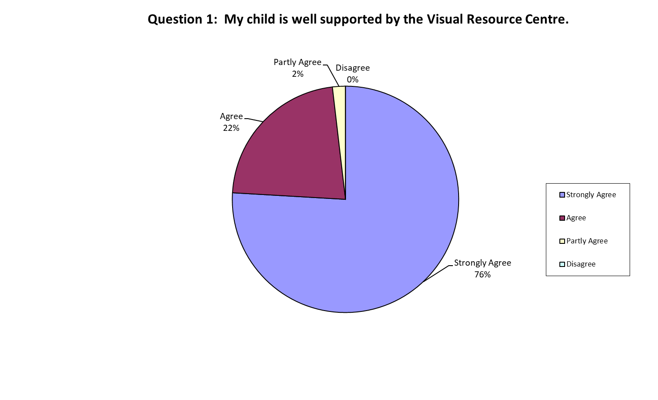

2. There is good communication between the Resource Teacher Vision and home:

74% Strongly agree; 22% Agree; 2% Partly agree; 2% Disagree

**98% Target achieved**

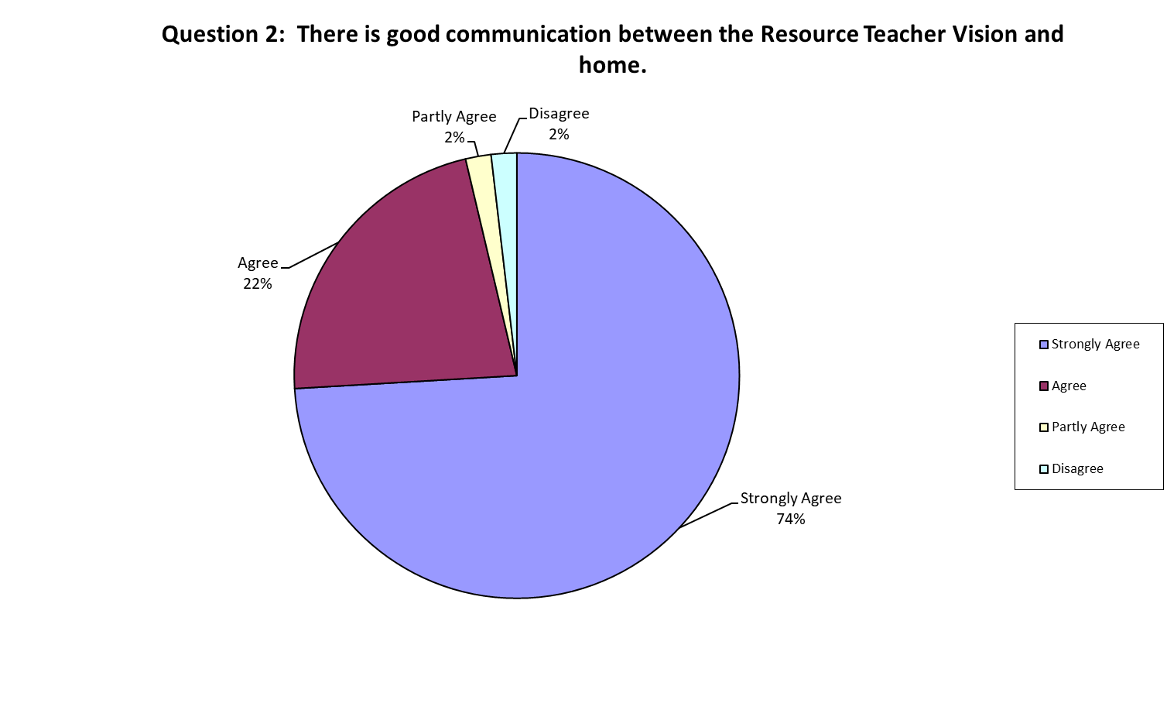

3. I feel comfortable contacting the Resource Teacher Vision:

81% Strongly agree; 19% Agree; 0% Partly agree; 0% Disagree

**100% Target achieved**

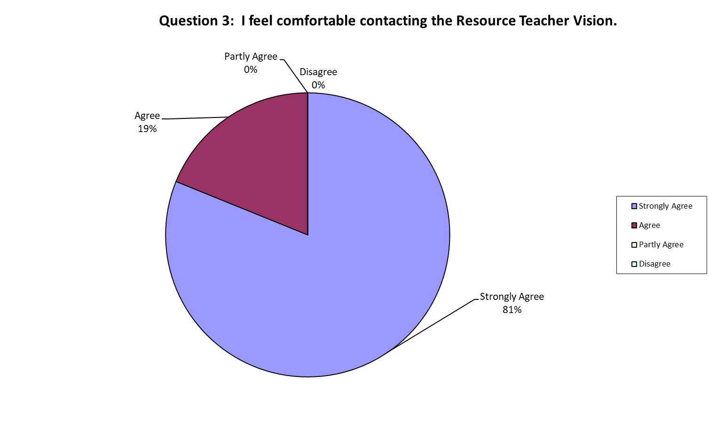

4. The input of the Resource Teacher Vision makes a positive difference to my child’s learning:

76% Strongly agree; 20% Agree; 4% Partly agree; 0% Disagree

**100% Target achieved**

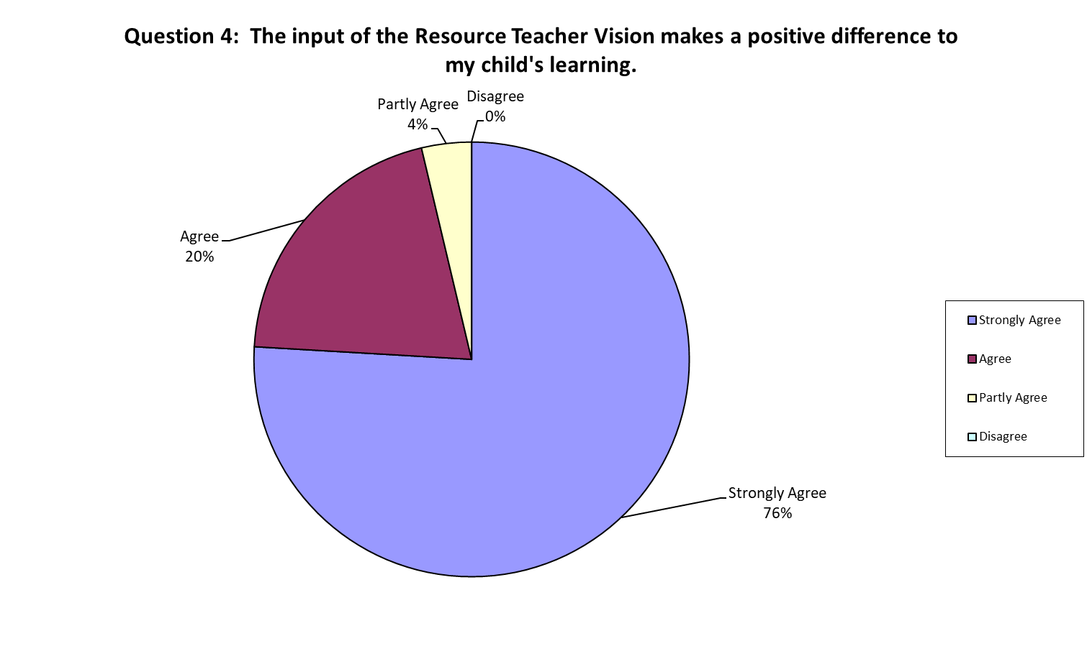

5. The information provided by the Resource Teacher Vision is informative and easy to read:

76% Strongly agree; 20% Agree; 4% Partly agree; 0% Disagree

**100% Target achieved**

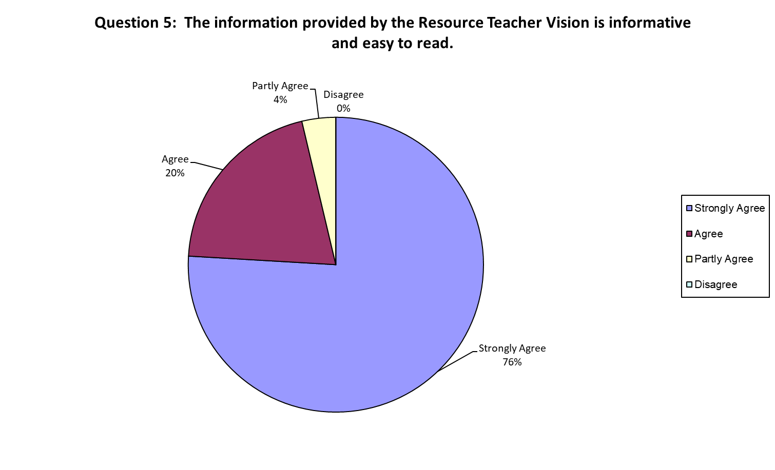

6. It is easy to access support from the Visual Resource Centre

51% Strongly agree; 42% agree; 7% Partly agree; 0% Disagree

**100% Target achieved.**

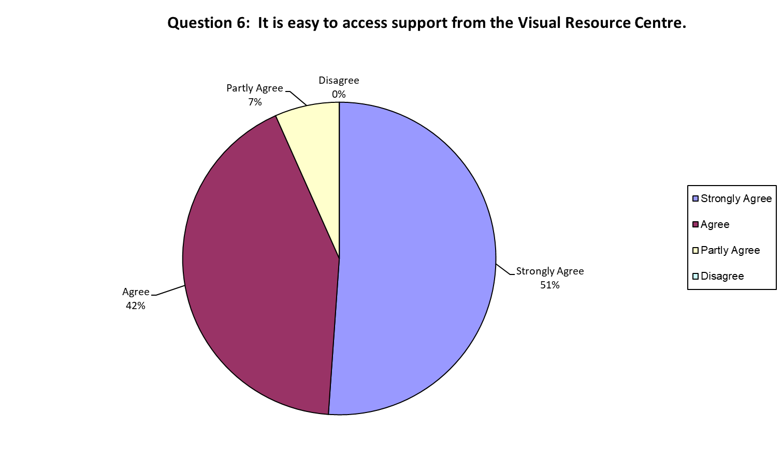

* In general, parent dissatisfaction related to support to ‘moderate needs’ learners in respect to communication with family and frequency of visits

## Linking Home with School

**Visual Resource Centres**

* Conduct a national survey of a 10% representative sample of early childhood centres and schools to determine the level of satisfaction with the Resource Teacher Vision service provided.

**Target achieved**

95% of early childhood centres and schools evaluate the service provided as appropriate in terms of effectiveness, accessibility and the quality of information and advice provided.

**Target achieved**

### Reporting

196 surveys were sent out to early childhood centres and schools, with 122 returned. This is a return rate of 62.2%, a return rate of 58.9% occurred in 2017.

The following data refers to the 2018 returned information.

1. 98% of schools or early childhood centres surveyed believed the BLENNZ Resource Teacher Vision’s availability in providing advice and support to the child who is blind or low vision was satisfactory or better.

68% Excellent; 20% Very good; 10% Satisfactory; and 2% Unsatisfactory

**98% Target achieved**

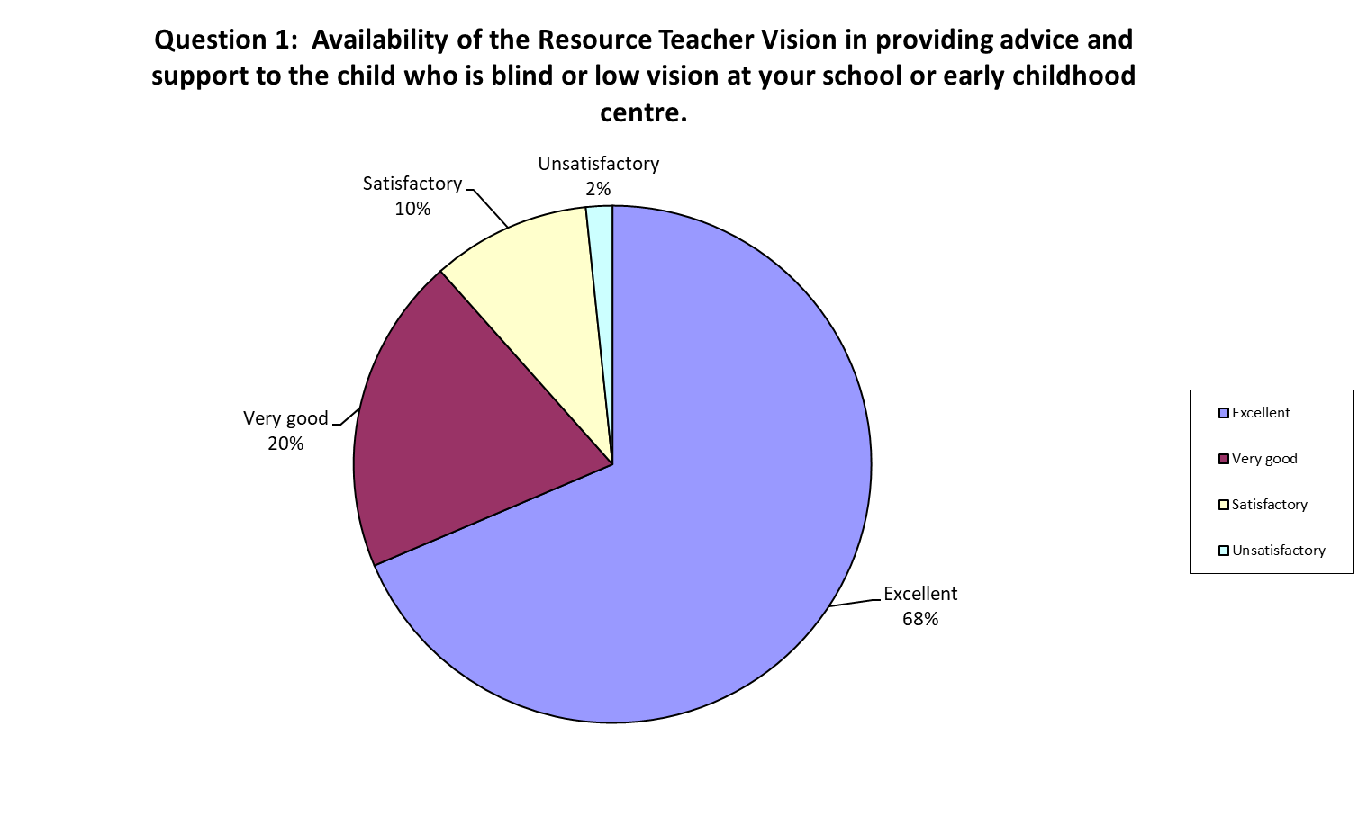

2. 97% of schools or early childhood centres surveyed believed the information and advice provided by the Resource Teacher Vision in supporting the child who is blind or low vision was satisfactory or better.

66% Excellent; 26% Very good; 5% Satisfactory; and 3% Unsatisfactory

**97% Target achieved**

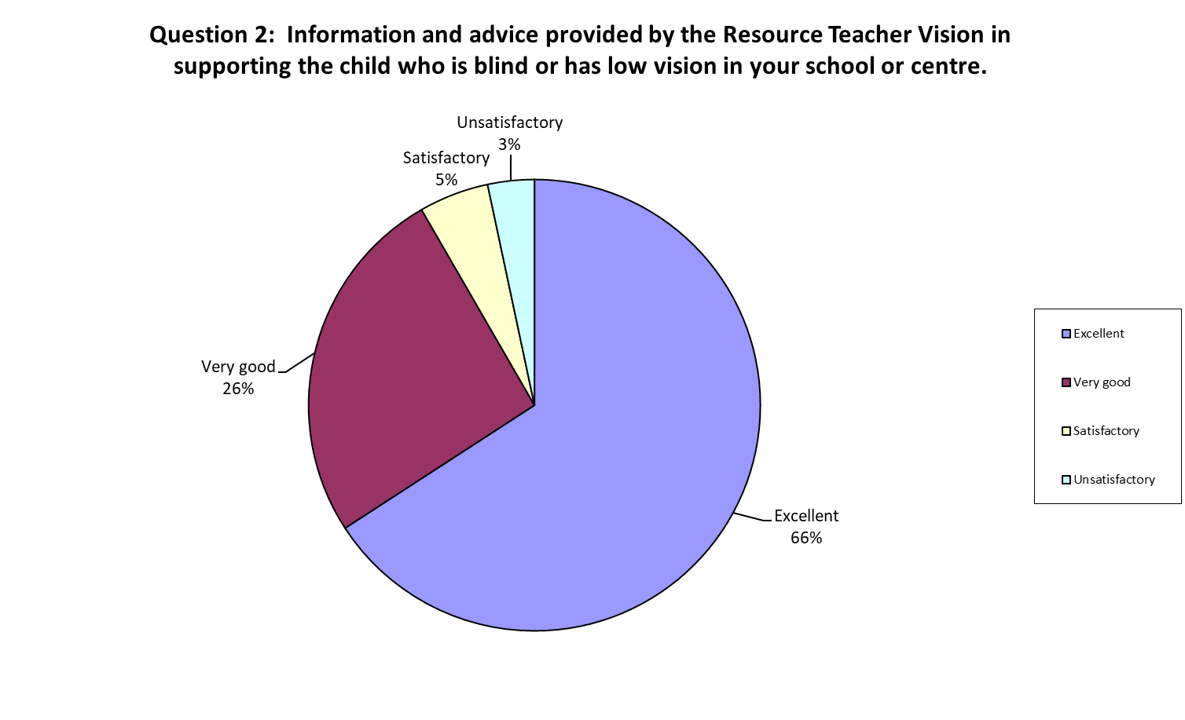

3. 97% of schools or early childhood centres surveyed believed the Resource Teacher Vision’s effectiveness in meeting the vision related needs of the child who is blind or low vision was satisfactory or better.

61% Excellent; 29% Very Good, 7% Satisfactory; and 3% Unsatisfactory

**97% Target achieved**

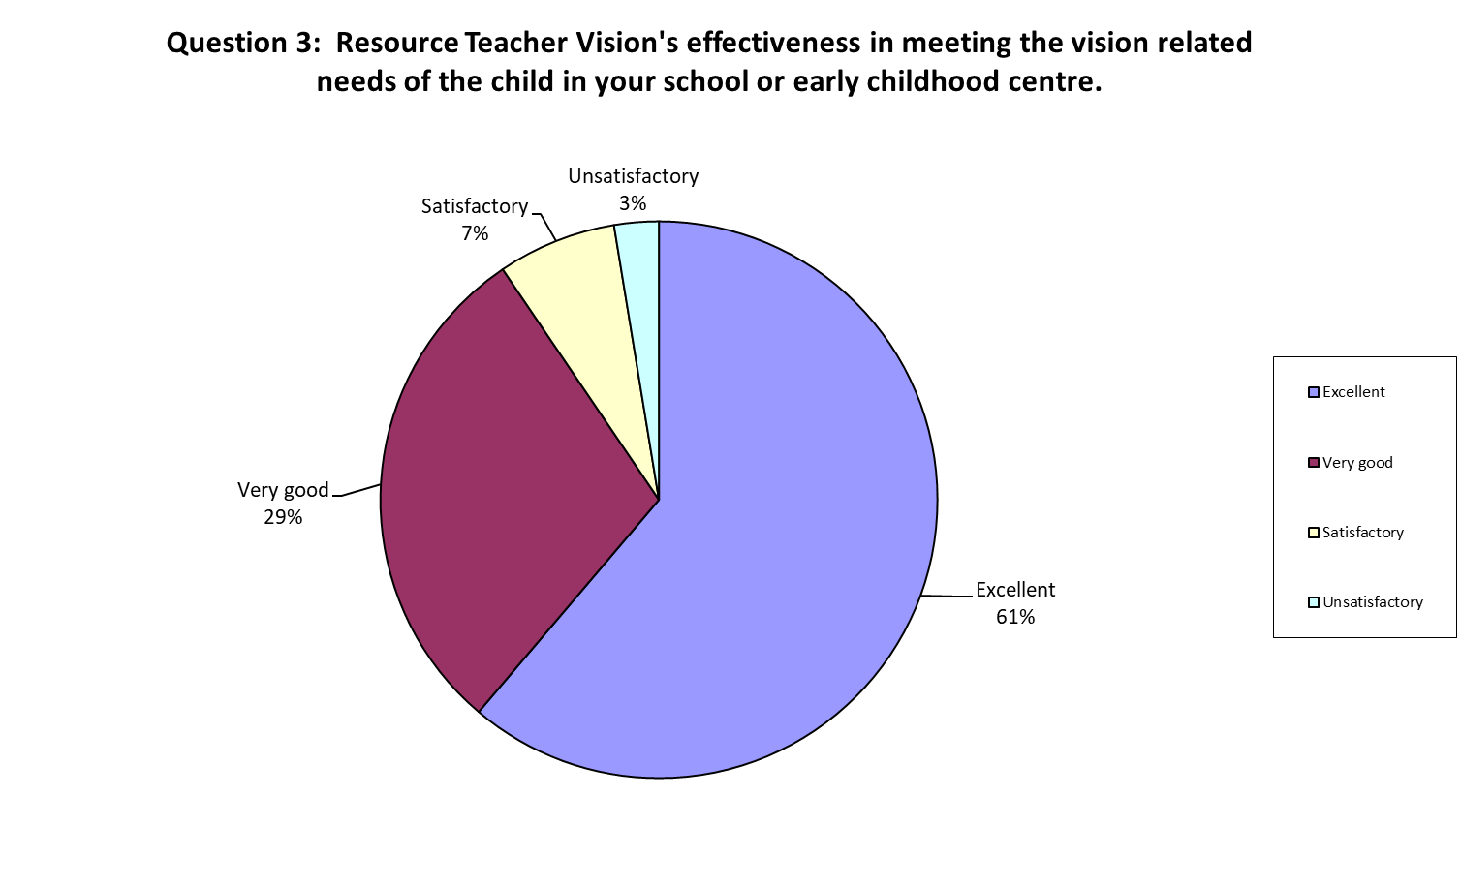

4. 96% of schools or early childhood centres surveyed believed the contribution the Resource Teacher Vision’s input had made in enhancing the learner outcomes of the child who is blind or low vision was satisfactory or better.

59% Excellent; 28% Very good, 9% Satisfactory; and 4% Unsatisfactory

**96% Target achieved**

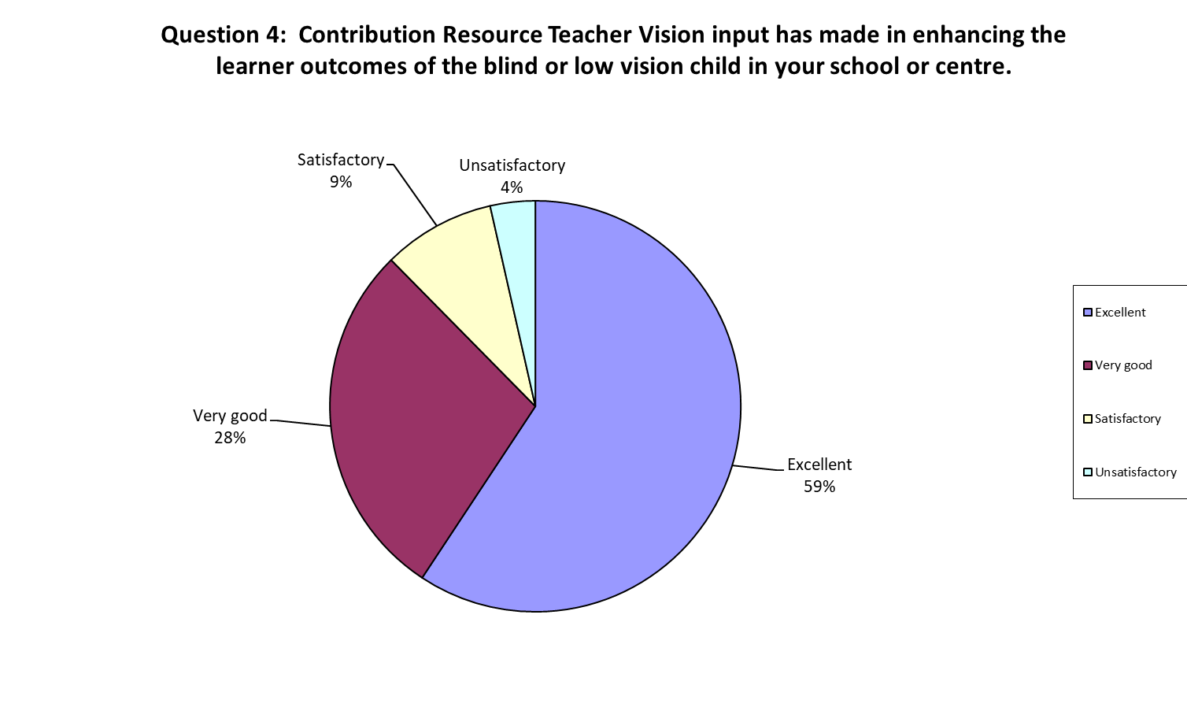

* Contact with the educational setting rating BLENNZ as providing unsatisfactory services was made. The reporting was considered an error as the RTV and BLENNZ were seen as separate entities.

# Statement of Resources

## Physical Resources

The BLENNZ Homai campus is sited on 55 acres of crown land.  Also situated on this site is the Blind Foundation’s Guide Dog Centre and Fale Kotuku (Pacific Island Services).  Some of the land is currently leased through the Ministry of Education to a farmer; however, the leased land is expected in time to become the site of the new Secondary School for Te Wharekura o Manurewa.

The property redevelopment was completed in 2012. Some work on the grounds was undertaken in 2013. Plans were drawn up and work commenced at the end of 2014, on the Outdoor Learning Environment. Stage 1 was completed in 2015.

School buildings comprise:

* The main building:

* Homai Campus School

* National Assessment Service

* National Special Formats Library (BLINK)

* Auckland Visual Resource Centre

* National Administration

* Early Childhood Centre

* Residential building:

* Long stay residential students

* National Assessment Service accommodation for visiting families

* Immersion course accommodation

* Main kitchen

* Whare Titoki (Residential Transition Programme building).

Remaining facilities include:

* School House (Ministry of Education has given permission for this building to be used for visiting staff and parent accommodation). Renovations to this building were completed in 2012.
* Swimming Pool. A building review was undertaken in 2017, and project planning commenced, for a total refurbishment and/or rebuild of the swimming pool building. Initial designs and costs were completed in 2018, however it is not now expected to be authorized and completed until 2019.

The on-site national special formats library is partially funded by the MOE but continues to be governed and operated by the Blind Foundation.

Section 70: Property Occupancy Documents for Visual Resource Centres are being established with the local schools where each VRC is based. Maintenance of VRC buildings is the responsibility of the local school Board of Trustees. The rebuild/refurbishment of Visual Resource Centres is part of the Sensory Resource Centre Capital Works Programme.

The Taranaki Visual Resource Centre was upgraded in 2014, the Hamilton Senory Resource Centre rebuilt in 2015, and the Tauranga Sensory Resource Centre rebuilt in 2016. Since 2017 Visual Resource Centre building redevelopment priorities have been Wellington, Palmerston North, Northland and Otago. These priorities continued into 2018. However all of these building projects have been further delayed and are now expected to be completed in 2019. The development of a resource centre and satellites in the north of Auckland and Pukekohe (Belmont) is ongoing. At the end of 2018 establishment Boards for the two new schools had been set up by Ministry of Education, with a representative from BLENNZ on both boards. The redevelopment of these bases will continue into 2019, with the likely completion date of 2021.

As at 31 December 2018, contract staff included the services of a speech language therapist, physiotherapist, occupational therapist, Paediatrician, Ophthalmologist and Optometrist.

## Other Resources

The Homai Early Childhood Centre Education Trust is located on the BLENNZ Homai Campus. Formerly part of BLENNZ, at the direction of the Ministry of Education it became a separate entity during 2006 with its own Board of Trustees, referred to as the Homai Early Childhood Centre Trust (HECCT).

## School Roll and Days Open BLENNZ

The RS32 1 July roll of the BLENNZ Homai Campus School was 42, however the school roll fluctuated during the year with a number of ākonga enrolling as the year progressed, as well as some ākonga being withdrawn from the roll through either leaving or being transitioned to their local school.

The school was open for the whole school year.

# Administration Services

Administration Services provide support to each of the education services within BLENNZ. It includes administration, personnel (including Novopay support), finance and property.

## Health and Safety:

### 2018 Summary

* Number of meetings held by the National Health and Safety Committee – 8
* 2018 Health & Safety Goals established with mid year and end of year reviews.
* Health and Safety is placed on team meeting agendas throughout the organisation.
* Review of Emergency Procedures - Homai Campus Fire Evacuation Procedures and planning of drills for inside and outside of school hours.
* Review and update of ¾ of the BLENNZ Pandemic Plan.
* From the National Risk Assessment Register, two Risk Assessment registers were reviewed at each National H&S Committee Meeting and follow-up actioned accordingly.
* Staff Wellbeing Committee confirmed with planning throughout the year in terms of meetings, goals and budget
* Additional representation on the National Health and Safety Committee with representation from Education Outside the Classroom Committee and Staff Wellbeing Committee.
* Implementation of Safety Announcements in terms of Severe Weather Events has been seen as a positive action and welcomed by staff.
* Trialling of and eventual sign up to Safety Monitor NZ – a cloud based software to effectively manage and monitor health and safety activities
* Accidents and Incidents are reported at each H&S Committee meeting with queries followed-up with those concerned. A summary of accidents and incidents reported in 2018 will be prepared for tabling and discussion at the first meeting of the National H&S Committee in February 2019.
* Completion of Fire Emergency evacuation drills for the Homai Campus and in the regions.
* Contractors Health and Safety Policies/Statements updated.
* Participation in the New Zealand Shakeout exercise, 18 October.
* Review and updating of:
  + BLENNZ Worker’s Health and Safety Training Plan and Record and Guidelines
  + An introduction to Health and Safety
  + Induction, Training and information

The 2018 Staff PD around H&S will be inputted into Safety Monitor in January with summary of PD provided to the National Committee in February 2019

* Development of an On-line Induction Programme to be implemented in 2019
* Child Matters training undertaken nationally, with staff from the Homai Campus School and Residential undertaking their training in January 2019
* A report on National Health and Safety is reported to the Board of Trustees at each Board meeting

### 2018 Goals in full

2018 Health and Safety Achievements under areas of the 11 Key Components of an effective health and safety system.

### Key Components 1: Leadership and 11 Monitoring Reporting and Assurance

Set the direction of health and safety management in your workplace.

#### **Goal 1:**

**Identification and trialling of a cloud based tool for real time H&S Management and Monitoring.**

**Progress Review:**

* Term 2 - Safety Monitor – cloud-based tool for the real time management, monitoring and reporting programme identified and trialled.
* Term 3 – BLENNZ signed up to Safety Monitor with the H&S committee accessing and navigating the website on the 13 August in order to familiarize themselves with content and to identify areas of priority in terms of data input.

Priority areas:

* + Incident register
  + First aid certificates
  + First aid kits
  + Hazard/Risk Assessment Register
  + Hazardous substances
  + Vehicles checks in term of BLENNZ own vehicles – WOF, registration

**Outcome: Achieved**

### Key Component 9: Health and Wellbeing Programmes

#### Goal 2:

**Establishment of the BLENNZ National Wellbeing Committee**

**Progress:**

* Committee established with first face-to-face meeting held on the 11 April with meetings held throughout the year in June, August and November.

**Outcome: Achieved**

### Key Component 5: Workplace Management

#### **Goal 3:**

**EOTC Committee – review of EOTC process**

**Progress:**

* Meeting held of EOTC team who have set their meeting dates for 2019. Membership includes representation from Development Orientation and Mobility and Resource Teachers Vision.
* 2019 plans include sharing updated information nationally.

**Outcome: Partially Achieved**

### Key Component 2: Worker Participation

#### **Goal 4:**

Reviewing of Emergency Plans

**Progress:**

* Fire Evacuation – procedures reviewed and updated.
* Earthquake – not reviewed
* Lockdown – Partially reviewed
* Pandemic – under review ¾ completed

**Outcome: Partially Achieved**

### Key Component 5: Workplace Management

#### **Goal 5:**

**Review of Policies and what PD is required particularly around H&S Policies**

**Progress:**

* Plan done which has been reviewed by the leadership team in terms of professional development requirements. Will be available for people to review.

**Outcome: Achieved**

## Annual Ongoing Goals:

### Key Component 5: Workplace Management

#### **Goal 1:**

**Drills are carried out throughout the year and staff understand their responsibility for:**

* Fire
* Earthquake
* Lockdown

**Progress:**

* Homai Campus – termly fire drills carried out ‘during school hours’. Two drills carried out for ‘out of school hours’.
* Ministry of Defence - NZ Shakeout drill carried out on the 18 October. This is the national earthquake and tsunami hikoi event.

Lockdown drill for 2018 has not taken place. The PD that was to have been provided by Harrison Tew did not occur, as their representative was unavailable due to hospitalization. Staff professional development and drill for the Homai campus will occur on the 29 January 2019.

**Outcome: Partially Achieved**

### Key Component 10: Professional Development

#### **Goal 2:**

**Staff professional development is provided for:**

* Child protection

**Progress:**

Workers attended professional development on Child Matters during full one-day courses held on:

* Regional Days: Christchurch – 15 May, Wellington – 18 May, Auckland 22 May, Tauranga 24 May with an extra course held in Auckland on the 31 May.
* Child Protection Champions – to be progressed for the next steps.
* Analysis report received from Child Matters.
* January 24, 2019 – course date for Homai Campus School and Residential and newly appointed staff.

**Outcome: Achieved**

## Policy Review:

All policies and procedures were regularly reviewed and updated in line with the 2018-2020 Policy Review Schedule. The policy review committee, which comprises the Senior Management Team and all Coordinator positions, met throughout the year. The following operational policies were reviewed and signed off:

* Digital Technologies
* Concerns and Complaints
* Code of Conduct
* Teaching Staff Leave
* Non Teaching Staff Leave
* Working from Home and Staff Ākonga in the Workplace
* Payments by Parents of Ākonga
* Purchasing
* Use of Credit Cards
* Conflicts of Interest
* BLENNZ Vehicles
* Use of BLENNZ Accommodation
* Restraint and Seclusion
* Health and Safety: Visitors
* Support for Ākonga in Cases of Physical Illness
* Infectious Diseases
* Safe Lifting of Goods and Equipment
* Sexual Harassment
* Readiness for Emergencies
* Traumatic Incidents
* Staff Alcohol
* Student Alcohol
* Drug Free
* Workplace Bullying and Harassment
* Food Safety
* Food Allergies
* School Hours and Term Dates
* Non Custodial Parents Access to Ākonga and their Records

The main focus for Board policy review in 2018 was the Child Protection Policy and supporting documentation. With the assistance of Child Matters, this was completed and approved by the Board in October. Additional policies reviewed were:

* Curriculum
* Research Ethics
* Roles and Responsibilities of the Principal
* Personnel Management
* Concerns and Complaints
* Board of Trustees Roles and Responsibilities
* Board Chair Role Description
* Relationship between the Chair and the Principal
* Code of Ethics.

## Compliance:

The following compliance requirements were undertaken in 2018:

* All staff appointments follow processes as outlined in the Delegation and Staff Appointment and Recruitment policies. All staff appointed to positions are being safety checked prior to commencing employment. Under the new regulations safety checking involves identity verification, information requirements, risk assessment and periodic re-assessment every three years. Current non-teaching staff are police vetted on a three yearly cycle. As each review falls due, staff are also being identity checked to ensure we meet compliance under the Vulnerable Children’s Act 2014.
* Police vetting of teaching staff occurs during their teacher registration process. As registration falls due, teachers are also identity checked.
* Police vet checks of volunteers is also undertaken.
* The Blind Foundation ensures police vetting of Library staff is undertaken.
* Contract staff are also police vetted e.g. Paediatric Therapy (Physiotherapists, Occupational Therapists, Speech Language Therapists) and Clinicians (Paediatrician, Optometrist, Ophthalmologist).
* A database is kept, and regularly reviewed, to ensure all teachers are registered in accordance with the requirements of the Teacher Registration Board and the Education Act.
* Teacher salary increments are linked to the requirement to meet professional standards as outlined in the performance appraisal cycle.

## Legislation:

* BLENNZ continues to comply with both the Privacy Act and the Public Records Act in all matters relating to the collection, storage, use and disclosure of personal information as they affect both ākonga and staff. Privacy Procedures were updated and are reviewed each year to ensure compliance. Staff continue to be requested to review their own electronic file management to streamline storage for ease of access and to ensure files, photographs and videos are not permanently kept if the purpose for which they were originally created no longer exists and there is no legal requirement to retain such material. This continues to be an ongoing process given the large amounts of electronic and photographic storage currently on file.
* BLENNZ complies with the Copyright Act 1994. Copyright licensing for books and other printed materials has been renewed for the period 1 July 2018 – 30 June 2019.
* All procedures in terms of guidelines for enrolment and stand down procedures are followed in accordance with Section 20 of the Education Act 1989. This includes receipt of Section 9 Agreements from Ministry of Education for all students enrolled at the Homai Campus School.

## Property:

* Monthly checks for building Warrant of Fitness requirements continue to be undertaken. In accordance with audit requirements, the long-term maintenance plan (LTMP) has been updated.
* Building compliance for Visual Resource Centres based in schools is the responsibility of the base schools.
* Building compliance for the Christchurch Visual Resource Centre is the responsibility of the Ministry of Education.
* Building compliance for the stand-alone Tauranga Visual Resource Centre is the joint responsibility of BLENNZ and Kelston Deaf Education Centre.
* Building compliance for the Christchurch Visual Resource Centre is the responsibility of the Ministry of Education.

## Assets:

* The fixed asset schedule continues to be reviewed on a two yearly cyclical basis with the Homai Campus one year followed by national bases in the second year. In addition to this a full review of IT equipment was undertaken in 2018 and an updated IT Equipment Replacement Plan completed.

**2018 BLENNZ Full Variance Report on the** Annual Plan Goals and Objectives

Goal 1 **– All learners are supported by BLENNZ to achieve their full potential through the use of evidence-based practice.**

| **Objective** | **Who** | **Objective** | **Progress** | **Outcome** |
| --- | --- | --- | --- | --- |
| 1 | Principal | Undertake professional learning to strengthen the skills of curricula leaders in the inquiry process to:   * lead and mentor others in inquiry * complete the development of a guideline to support inquiry within BLENNZ   to enable improved teaching and learning outcomes that are evidenced based. | Achieved | Work with Core completed, revised vision developed and shared for feedback, inquiry document will be revised for 2019.  Curricula leaders initiating communities of practice related to inquiry focus 2019. |
| 2 | Coordinator  Alison | Focus on numeracy achievement of ākonga by:   * identifying the achievement outcomes in numeracy for a **cohort** of ākonga * collating resources and * providing professional development. | Braille Maths Pedagogy   * Outcomes - Achieved * Resources - Achieved * PLD – Not achieved | Findings of a survey of ākonga and their RTV informed Braille Maths resource review and development, which is completed.  PLD has been planned and will be provided in 2019.  The GLOSS and JAM tests in large print have been developed for each Centre. These are being adapted for braille learners and files for these will be available on G-Drive.  Work in the area of Tactile Graphics has been integrated and informed further development of math resources.  Further PLD planned for both general mathematics and maths through braille in 2019. |
| 2 | Coordinator  Alison | Continuation of Tactile graphics. | Achieved | Tactile Graphics level 1 literacy resources available and will be placed on hub.  Tactile Graphics (TG)   * TG image library created; images are filed in categories, and tagged for easy search. * Instructions to make sequence, alphabet books and instructional readers have been created to ensure consistency on a national basis. * The use of the images in instructional readers has been trialled with feedback provided by RTV that reflect positive learning outcomes. * Tactile Graphic Assessment tool for Level 1, created in Part 1 for assessment of early skills, and Part 2 for Numeracy. * Pedagogy of Tactile Graphics document has been reviewed and refined. * BLENNZ Language of Lines tactile program has been revised and used   PLD planned for January 2019 for members of teaching team and the respective AFM producers. |
| 3 | Curricula leaders | Implement the:   * online hubs which become the repository of curricula/pedagogical resources and base for learning communities. | Achieved implementation | Examples on line and varying levels of progress re content at this time. |
| 4 | Sharon Duncan  SM A&T | Homai Early Childhood Centre strategic path through a teacher led inquiry model. | Partially achieved | HECC sessions restructured now 2 centre run sessions and one RTV faciliated session.  Inquiry into PLD requirements and provision undertaken and completed, which will inform work plan and approach in 2019. This included:   * Identification of range of delivery models for EC PLD. * Identification of current provision of national PLD across the following teams: NAS; EC Immersion; DOM; HECC; BLENNZ Induction. * Review of current best practice in provision of PLD in Aotearoa, New Zealand.   PLD content requests mainly for practical exemplars and information rather than deeper pedagogy and practice: the ‘what’ rather than the ‘why’.  The Hub utilised to attract early childhood engagement.  PLD content is in process of being developed.  Discussions have occurred with some Managers VRC, to elicit fresh ideas from a regional perspective.  Internally staffing has been amended to form ‘National Early Learning Service’. |
| 5 | SM S&R | Residential programme pathways for transitionusing an evidence based approach. | Partially achieved | While individual ākonga may have achieved the interface of staff has not worked effectively.  Although staff in both settings expressed a commitment to the vision of holistic 24/7 approach, there have been some challenges in implementing such a seamless programme and for staff to learn to work in this new way.  Currently the team are working with and preparing for five ākonga who are returning to progress their transition on 2019.  There is also further working to identify the wider needs for all BLENNZ ākonga and think creative ways in which these needs may be met. We are working with ‘What it Takes’ to support us in progressing this, and will enter a sprint co-design process in term 1. |

Goal 2 **- Learner progress and achievement is enriched through the building and strengthening of effective learning-centred relationships with each learner’s whānau.**

| **Objective** | **Who** | **Objective** | **Progress** | **Outcome** |
| --- | --- | --- | --- | --- |
| 1 | Principal & BOT Chair | **Communication:**   * The Board will initiate regional consultation with a view to hearing the voice of whānau. To gather feedback from BLENNZ community to inform strategic thinking and engagement process. | Achieved | Process achieved however limited input.  Review of how consultation is undertaken required.  Board will consider their consultation questions and may seek external researcher to undertake on their behalf. Focussing their time on meeting with staff and community. |
| 2 | SM A&T  SM S&R | * All team leaders will embed the provision of a biannual team newsletter and an annual regional whānau event in practice. * Enhancing relationships through effective communication and activities. | Newsletters – Achieved  Annual events – Partially achieved | Homai Campus School (HCS) and Residential write and send out a termly newsletter with contributions from each area.  All centres are producing a biannual newsletter and are progressing towards an annual event. |
| 3 | Co-ord DAE | * Establish and initiate an online content development work plan reflecting the needs of whānau. | Not achieved | A plan was created to collate videos that capture voices from four areas of BLENNZ: Ākonga; Families/whanau; Staff; and Community. The leadership team each made suggestions about who would be good to capture.  This proved problematic from an organisation perspective and in consultation with the Senior Management Team it was decided to follow a similar approach to collecting voices as we use for annual plan contribution. This means VRCs, BLENNZ service strands, HECC and Homai Campus School will each take responsibility for capturing voices within their own contexts. A contribution schedule has been prepared and will be shared at Managers Meeting early in 2019, as content exists within teams however process to share is ineffective. |
| 4 | SMT  Kelly Doyle | **Capability Building:**   * To raise awareness of and increase the cultural competency of the BLENNZ teaching team. * To provide the BLENNZ teaching team with the tools, experiences and resources to raise awareness and increase cultural competency through data gathering. | Achieved | Initial data gathered showed that work needed to be done in this area. The following are examples of tools and resources:   * BLENNZ Values Introduced * Pōwhiri for new staff and students * Bilingual Immersion Course * Relationships established with Māori Agencies (Ngāti Kāpo) * Resource bank with regard to Māori language and traditions established on G Drive for all BLENNZ staff to access. * They are familiar with and enacting values and express them clearly in action. * They are familiar with the MOE resource ‘He Piringa Whanau’ , understand it’s purpose and articulate how it can be used in the BLENNZ setting.   We have evidence that progress has been made, however there is still work to be done to continue to increase awareness, understanding and upskill BLENNZ teaching team to learn and use the Māori language in everyday situations. |
| 5 | Principal & Coordinator VRC (SD) | * Collaborate with education and health teams in an initiative to inform the development of parent leadership in visioning and goal setting – Now and Next. | Partially achieved | Initial workshop, first of two, held.  Tools trialled and feedback sought from 4 participants, mixed response re usefulness and confidence in using tool.  Feedback from the one external centre that has utilised the process. Major concerns regarding the financial sustainability of process.  Second workshop not progressed at this time until issues re financial sustainability can be resolved. Also further thinking required around how this is woven into service provision and that of others. |
| 6 | Principal | A teaching team will engage in the ‘My Working World’ work programme to enhance their reflective practice resulting in stronger professional and parent relationships. | Achieved | Transition team have been involved in this work as have the members of the leadership team and the Nelson team. Preparation is underway currently to plan the initial work for 2019, with ‘whatittakes’ contracted to provide this support. Work will continue to be progressed and initiated with a number of teams in 2019 -20. |

Goal 3 **– Learning is enhanced through the appropriate use of BLENNZ resources, systems and organisational relationships.**

| **Objective** | **Who** | **Objective** | **Progress** | **Outcome** |
| --- | --- | --- | --- | --- |
| 1 **Partnerships** | Principal  SMT | Initiate work, with Blind Foundation, to inform a collaborative approach to transition. | Not achieved | An initial meeting has been held and there is a possibility to progress this work in 2019. |
| 2 **Partnerships** | SMT  RTV CVRC | Work with fundholders to develop and trial an approach to enhance outcomes of ākonga who have learning needs which are complex in nature. | Achieved | Partnerships established with ophthalmologists at the Eye Clinic, at Christchurch Hospital for referrals, John Veale optometrist screened students at Waitaha Special School. 30 ākonga assessed and referrals made to ophthalmic team.  Initial information shared with parents and staff and follow up planned. |
| 3 **Partnerships** | Coord DAE | Organise and facilitate a Sector workshop to inform practice in modern learning environments. | Achieved | The two day workshop was achieved and the information gathered is informing priority work for BLENNZ including: Assistive Technology Applications  * Ongoing work to promote application process that results in each ākonga being prepared with appropriate technologies as they move through school. * Working towards all ākonga having a laptop as they move into secondary education.  Online Platforms A number of these have been prioritised and work progressed as follows:   * e-asTTle are in the process of doing a feasibility study around the way the platform currently operates and what is involved in making this accessible. They are interested in making improvements and are currently seeking funding to make this a reality. There is currently no indication about when this funding will be in place. * Study Ladder, A brief check was done which found significant accessibility issues, even on the sign up page. Contact was made earlier in the year asking for clarification and further discussion but no response. Further communication in planned. * Mathletics, contact was made and we were hoping to progress dialogue to resolve the accessibility issues with this product, however they have informed us that they have no plan to offer support for screen readers. * Education Perfect, is next on the list to make contact with. * G Suite - This continues to be a challenge. We are exploring Grackle Docs and other Grackle products but these are aimed at creators not users.  Software Developers  * NZCER – progress being made re how we can work together to enable them to create accessible resources/testing for use in the classroom. They now have planned to create a login to begin testing and work together towards accessible online resources. This is a long term piece of work. * e-asTTle- As explained in point above and * JAM and Linc Ed will be progressed in 2019  Prescribed Body/Authorised Entity  * Since our ILE workshop in April BLENNZ has become a Prescribed Body under the Copyright Act 1994. * We are working internally to lay down processes by which we will produce accessible materials as a prescribed body. * This is an ongoing piece of work that will continue into 2019 and beyond. * We will also use this process to inform the way in which BLENNZ becomes an Authorised Entity once the Marrakesh Treaty is implemented in New Zealand. |
| 4 **Partnerships** | Coord NAS | Collaborate with international & national partners to inform effective practice for assessment and intervention with ākonga who have CVI. | Achieved | Two BLENNZ staff – Sue Arrojado and Patrick Pink – travelled to Narbethong for a 3-day workshop with two optometrists from Kuala Lumpur Hospital and the optometrist who works in the Narbethong team. Florine Pilon (Bartimeus) was one of the guest presenters during these three days. This occurred during the second week of the October term break.  This was followed in Week 1, Term 4 with a 3-day workshop at Homai with presenters include colleagues from: Bartimeus; Narbethong State Special School and State Wide Education, Queensland) having key presenting roles alongside a number of BLENNZ staff, representing key services and strands within our network. This provided significant opportunities for attendees to network, share ideas and make future plans for further development including:   * Continue to network with international colleagues to share resources and ideas. * Communication via email has continued with Florine, Karen and Kerry. * The videos/information to share has been put in a shared space with those who attended are being invited to access this. Wider sharing will take place as work progresses. * To collate and theme the information and ideas taken from the panel and group discussions.   This work definitely established connections nationally and internationally and will be progressed in 2019. |
| 5 **Staff** | SMT &  Contractor | Further develop induction resources. | Partially Achieved | The initial section has been completed which is for all BLENNZ staff. The second sections have been outlined but need to be done face to face with other staff because they are site specific.  By the end of the term all of the information that has been gathered will be in the Induction Folder on “G”Drive. This is to make the information available to new staff starting now and at the beginning of next year.  The sections on “G”Drive will be the one for all staff, the section for RTVs and Homai teachers and some professional development packages for teachers.  The professional information for teachers is around BLENNZ Key Services, assessment, the Expanded Core Curriculum, and some information that may be useful to RTVs starting out.  Coordinator DAE, is developing an online space for the Induction package to slot into and this will be available for content to be added next year. |
| 6 **Staff** | SM Admin | Develop a PLD framework to support policy. | Achieved. | All PLD requirements identified for 2019 planning and implementation.  PLD Review document has been produced. This has been reviewed by the collective Leadership Team.  Discussions have been held on PLD requirements that need to be actioned. PLD not currently being provided will be reviewed in terms of the 2019 PLD Plan and budget. |
| 7 **Staff** | SM A&T | Develop recommendations for VI Post Grad course. | Achieved | Consultation has occurred across the network and has been collated to inform the recommendations. The findings will be shared with MOE on 14th December.  Some progress has been made with Massey University re the instigation of a mentoring programme |
| 8 **Systems** | Librarian | Establish a resource cataloguing system. | Achieved | The BLENNZ Accessit cataloguing system has been established and introduced in six centres:   * Christchurch * Dunedin * Southland * Nelson * Taranaki * Hamilton   Centres now online and cataloguing into Accessit include: Homai, Christchurch, Taranaki, Nelson and Southland.  The cataloguing at Homai is underway. Everyone has been asked to weed their collections.  Cataloguing of Auckland South has also started.  Taranaki’s existing database transfer is complete.  Auckland South is about to get underway.  The manual is completed and the standards for each type of resource are currently being created. |
| 9 **Systems** | Coord VRC | Initiate a national AFM system of support. | Partially achieved | Initiated in support of production of tactile graphics work, which has been an effective process.  The BLENNZ AFM Strategy Group have developed a plan of work for 2019 to establish a system that meets the Prescribed Body requirements. |
| 10 **Systems** | Principal   * NAS | Develop a database of ākonga who are deafblind. | Partially achieved | Definition identified, centres beginning to work with NAS to identify ākonga.  BLENNZ, MoE and DECs jointly created criteria to determine which learners on the BLENNZ roll have deafblindness.  Current database (etap) categories for hearing and deafblindness and their effectiveness for documentation and retrieval are currently being reviewed.  Correspondence with e.g. Taranaki Visual Resource Centre has taken place to determine who has a diagnosed bilateral or unilateral sensorineural and/or permanent conductive hearing loss and/or auditory neuropathy spectrum disorder with MoE or DEC support is currently underway.  Correspondence with MoE and the DECs about their systems for documentation, archiving and retrieval with the possible inclusion of similar categories and groupings for BLENNZ database to foster a ‘common’ language when sharing information about deafblind learners is currently being undertaken. |
| 11 **Systems** | Principal  SM A&T | Property  Implement property agreements with MOE. | Not achieved | Ongoing advocacy for dialogue with relevant personnel is imperative. Collation of current information re S70s and their contractual time frames has occurred.  A series of meetings and email exchanges have occurred between BLENNZ Principal, MOE Property team and Principals Deaf Education Centres (they have similar concerns). To date no progress made. A joint approach between the three Sensory Schools is required. Ongoing advocacy for dialogue with relevant personnel is imperative. |
| 12 **Systems** | SM A&T | Progress the sensory schools capital works program. | Partially achieved | Slow progress has been made with Wellington, Palmerston North and Otago centres.  Reporting continues on a regular basis to the Board.  Projects underway are in Otago, Wellington, Palmerston North, Auckland South, Auckland North and Northland. BLENNZ has identified other centres where refurbishment is required.  A joint approach between the three Sensory Schools is required.  Ongoing liaison with the MOE Property Advisors remains important as does continued advocacy within each project |
| 13 **Systems** | SM Admin | Refurbish the BLENNZ Homai Campus swimming pool. | Not achieved | Project Manager appointed.  Architect and Quantity Surveyor appointed.  Draft concept plans produced.  Draft costings produced.  Budget limits have been set.  Seismic building report has been updated.  Final decision regarding approach refurbish or rebuild confirmed by the Board.  Decision regarding use of heritage architect to be made following final update at December meeting. |

# 2018 Audited Financial Statement

(Refer to separate audited Financials)