**Blind and Low Vision Education Network NZ - Annual Report 2019**

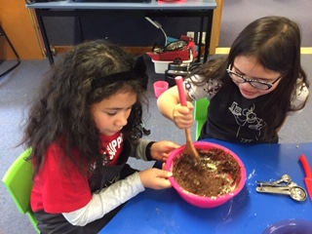 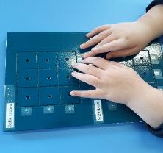 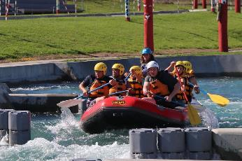

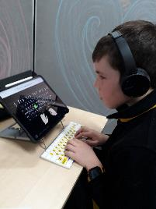 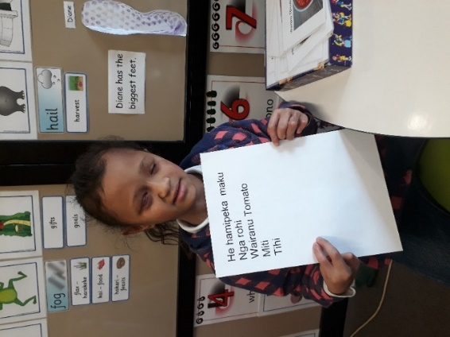 ~~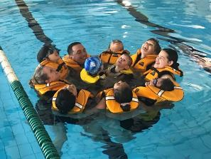~~

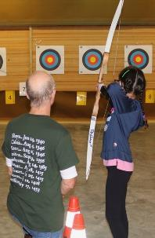 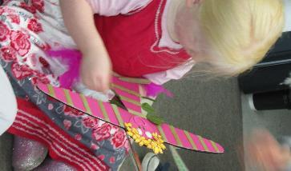 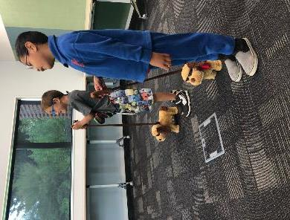

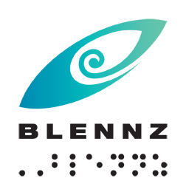

**Blind and Low Vision Education Network NZ**

**2019 Annual Report and Financial Statements**

School Address:

2 McVilly Road, Manurewa, Auckland 2012

School postal address

Private Bag 801, Manurewa, Auckland 2243

Contact details:

School Phone: (09) 2667109

School Fax: (09) 2674496

Email: [Admin@blennz.school.nz](mailto:Admin@blennz.school.nz)

Facebook: [BLENNZ Facebook](https://www.facebook.com/blindandlowvisioneducationnetworknz/)

Twitter: @BLENNZOnline

BLENNZ ICT: [info@blennz.school.nz](mailto:info@blennz.school.nz)



**Contents**

Message from the Board Chair 8

Message from the Principal 9

Introduction 10

Special Character School 10

Vision 11

Mission 11

Values 12

Organisational Culture 12

Beliefs 13

Key Facts and Figures 14

Learners attending Homai Campus School 14

Learners Receiving Services from BLENNZ Visual Resource Centres end of 2019 15

Statement of Variance – Overview 2019 Annual Plan 17

Strategic Goals: 17

Transition - Ākonga from the start of secondary through to the end of compulsory schooling. 17

Wellbeing - Ākonga for whom BLENNZ is the primary provider. 17

Succession 18

Operational Goals 19

Partnerships/Organisational Relationships 19

Workforce Development 20

Systems / Resources 21

Property 21

Events from 2019 23

Braille Retreat 23

Visit by Minister Carmel Sepuloni 23

Kuia and the Spider 23

Matariki 23

Te wiki o te Reo Māori 23

BLENNZ Early Learning Services (BELS) 23

Trans-Tasman Certificate of Proficiency in Unified English Braille 23

Learner Achievement 2019 24

Homai Campus School 24

Weka Class - Matariki Celebrations 24

Kiwi Class 25

Tui Class - Te Reo: 25

Takahe class - TeReo 25

Kea Class are on a te reo journey. 26

JCHS Satellite Class Māori Language Week Celebrations 27

Transition Pathways Programme 28

Assessment and Teaching 29

BLENNZ Homai Early Childhood Centre 29

BLENNZ Northland Visual Resource Centre 30

BLENNZ Auckland North Visual Resource Centre 30

BLENNZ Auckland South Visual Resource Centre 31

BLENNZ Hamilton Visual Resource Centre 32

BLENNZ Tauranga Visual Resource Centre 33

BLENNZ Gisborne Visual Resource Centre 34

BLENNZ Napier Visual Resource Centre 35

BLENNZ Taranaki Visual Resource Centre 36

BLENNZ Palmerston North Visual Resource Centre 37

BLENNZ Wellington Visual Resource Centre 37

BLENNZ Nelson Visual Resource Centre 38

BLENNZ Christchurch Visual Resource Centre 39

BLENNZ Otago Visual Resource Centre 40

BLENNZ Southland Visual Resource Centre 40

BLENNZ National Assessment Service (NAS) 41

BLENNZ Immersion 42

Regional Teaching Team 43

BLENNZ Developmental Orientation and Mobility Service (DOM) 44

BLENNZ VRC Coordinators 45

Homai Campus Music School 45

Individual Music Programme – Wendy Richards 45

Music School – Wendy Richards 45

Homai School Music Therapy Programme – Ajay Castelino 46

Te Whānau o Homai 46

February 2019 46

March 2019 46

June 2019 46

August 2019 47

September 2019 47

Youth Library 47

Board of Trustees 48

Board Members – June 2019: 48

BOT members and roles as at 31 December 2019 49

Professional Development and strategy Planning Days 50

21 June 2019 50

24 August 2019 – Strategy Day 50

The Framework of Indicators of Learner Achievement 50

The Framework of Indicators of Learner Achievement 50

Homai Campus School - 2019 50

Targets 50

Reporting 50

Takahe 51

Kea 51

Tui 52

Weka 52

Kiwi 53

James Cook Satellite Classes 53

James Cook 2 (formerly Pukeko class) 54

Māori and Pasifika 54

Target (Literacy) 55

Target (Numeracy) 55

Homai Campus School Survey 55

Regional Network 57

Outcome Indicators 57

A Literacy – Using Language, Symbols and Text 57

Identify the proportion of the learners acquiring literacy by: 57

Reporting 58

Learners verified for Ongoing Resourcing Scheme (ORS), primarily for vision 60

Reporting 60

Reporting 61

Reporting 61

B. Mathematics 62

Approach used to collect data 63

Summary data table and graphs – Number Achievement Years 0 – 8 ORS Vision Learners 63

Number Achievement Years 0 – 8 ORS Vision Learners 63

Process Indicators 65

Student Achievement 65

Teacher assessment skills in literacy 65

Targets 65

Targets 65

Target 66

Reporting 66

Assistive Technology Applications 2019 66

Hardware includes: 66

Software includes: 66

Student Engagement in Learning 67

Quality of Teaching 67

Other Educational Settings 81

Immersion Courses 2019 – Compulsory Sector 81

Target 81

Reporting 81

Overview of all courses: 81

Compulsory courses 82

Target 82

Immersion Courses for Early Childhood 83

Knowledge, Skills and Values 83

Process Indicators 83

Overview of all courses: 84

Early Childhood courses 84

National Assessment Service (NAS) 85

Background 85

Cumulative Data - 2019 Referrals 86

Caregiver Surveys 86

Questions: Sample Responses 86

How appropriate and relevant were our assessments and verbal suggestions? 86

How effective was our communication throughout the assessment process? 87

How timely was this assessment, in respect to the referral and the learner’s needs? 87

How well did we meet your individual and cultural needs? Did you feel listened to and respected? 87

Is there anything else you would have liked covered in the assessment? 88

Please add any further comments, including suggestions to improve our assessment process 88

Professional Surveys 89

Questions: 89

Developmental Orientation and Mobility 94

Statement of Resources 97

Physical Resources 97

Other Resources 98

School Roll and Days Open BLENNZ 98

Administration Services 99

Health and Safety: 99

2019 Summary 99

Policies: 100

Compliance: 101

Legislation: 102

Property: 102

Assets: 103

BLENNZ Full 2019 Variance Report on the Annual Plan Goals and Objectives 104

Strategic Goals: 104

Transition - Ākonga from the start of secondary through to the end of compulsory schooling. 104

Wellbeing - Ākonga for whom BLENNZ is the primary provider. 107

Succession 109

Operational Goals 113

Partnerships/Organisational Relationships 113

Workforce Development 115

Systems / Resources 127

Property 128

2019 Audited Financial Statement 131

# Message from the Board Chair

Kia ora tatou to all of our BLENNZ community,

It is my pleasure, on behalf of the BLENNZ Board of Trustees to present the 2019 Annual Report.

This report provides a detailed overview of what has occurred over the past year within BLENNZ and the progress toward our strategic goals.

The main focus of 2019 was transition and we were delighted to welcome Blind and Low Vision NZ CEO, John Mulka, to the BLENNZ Board to help ensure both parties are on the same page.

We are committed to working with our sector partners to provide more help to our ākonga as they move from school into the wider world, wherever that may be. The work on transition continues.

For 2020 we are concentrating on the wellbeing of our ākonga.

BLENNZ already takes a holistic approach to our children's education. But by focusing on wellbeing in 2020 we can make sure that we are taking into account all our student's individual needs.

This also supports our vision that “every BLENNZ learner is well prepared to achieve in life”.

It gives us a renewed commitment to work closely with our sector partners helping with both transition and wellbeing. Part of that work includes innovative learning environments and digital technology, the value of which has been highlighted by the COVID-19 lockdown.

Clearly, 2020 has been a year without precedent. As I write this, we have entered the sixth week of the COVID-19 lockdown and re-opening our school still looks to be some time away. We are acutely aware of the unique pressures this has placed upon our community and we look forward to life returning to some normality.

I would like to congratulate and thank our staff for the calm and professional way they have worked through and continue to work through this pandemic.

Like everyone else, we have had to adapt. Board meetings are now conducted remotely and it has certainly awakened us to the efficiencies that can be made in time and travel costs as well as the reduction of our carbon footprint.

I know that for many people in the BLENNZ orbit the COVID-19 pandemic has made life even more complicated and difficult. Our hearts are with you and we remain committed to supporting you and your children.

Warmest regards,

Mitch Harris.

# Message from the Principal

In looking back over 2019, it seems a distant memory, however as I reflect on the content of the report which captures slices of what occurred, I reflect on how busy the year was with so many new initiatives taking place on top of the core business of BLENNZ.

The core business, is the as usual aspect of our work, it is the everyday work of the BLENNZ teaching team and all who support them to make their work possible. It may take place in the early learning centre, the classrooms and residences on campus or in the many learning environments across Aotearoa. It is the work that is central to our values and beliefs, ensuring that each and every ākonga has the access they require, to learn and develop in the learning environment of choice, alongside their peers. We have a highly committed team who use their creativity to meet individual needs on a daily basis. Their work makes a difference every day. I applaud them for their commitment to their work and to their ongoing development of their practice in the interest of tamariki, rangatahi.and whānau throughout 2019 and beyond.

In 2019 there was a focus on developing our Te Reo. This involved many making a personal commitment to learn and grow. It also included two magical opportunities to gather together. Kāpō Māori o Aotearoa, enabled the audio translation of a performance which took place on campus the first a performance in Te Reo of the Kuia and the Spider. We were delighted to include others in our local and specialist school community to join us for this performance. The second being the wonderful feast we had on campus where, if we wanted to eat, we needed to use our Te Reo Māori. Everyone embraced the opportunity and I suspect we will have more such events in 2020. Neither of these events happen without the wonderful behind the scenes work of Te Whānau o Homai, our fabulous catering staff, and many others behind the scenes who work quietly to ensure smooth running of such enjoyable days.

Innovation was also seeded in the emerging Early Learning Services which will have a national reach, facilitating and supporting effective practice across the network. The residential team who focus on those in transition from school have also embarked on a major rethink, with input from those in transition to ascertain how BLENNZ might best facilitate successful transition for life beyond school in partnership with allied agencies.

In closing, yes, 2019 seems a distant memory, but it was a year full of moments that make memories for many, steps towards achieving our goals, which you will get a glimpse of when you review the content of this report.

Karen Stobbs

Principal

# Introduction

Welcome to the 2019 Annual Report for the Blind and Low Vision Education Network NZ (BLENNZ). The primary focus of the report is to provide accountability to the community, a set of accounting statements providing accountability from a financial perspective; reports on achievement and challenges from an operational perspective; and strategic planning reports from a strategic perspective.

## Special Character School

The Blind and Low Vision Education Network NZ (BLENNZ) is a national school that provides a network of education services to 1580 blind, deafblind and low vision learners throughout New Zealand from birth to 21, including those who have additional special needs. BLENNZ was established as a national network of services fifteen years ago in January 2005. It is one of the special schools nationally that have been legislated to provide residential provision for learners.

The purpose of BLENNZ is to ensure that the education needs of blind, deafblind and low vision learners are identified and appropriate programmes and services are available. It aims to support the government goals for education by enhancing education opportunities for its learners, facilitating access to and participation in the regular curriculum and developing skills for independence.

Historically blindness education services were provided either by the Blind and Low Vision NZ, (RNZFB) through the services based on Homai Campus, or by Visual and Sensory Resource Centres that were part of the state education system. In July 2000, Homai National School for the Blind and Vision Impaired became a state residential special school and in 2005, all of the services were amalgamated to form the Blind and Low Vision Education Network NZ.

This amalgamation of services was achieved through many years of combined advocacy from parents, teachers, service providers and sector organisations, who expressed a strong desire for a unified, nationally coordinated system for service provision. BLENNZ aims to achieve such co-ordination and cohesion and to reflect the special character of the school through the following objectives:

* Development of nationally consistent practice which is evidence-based
* Implementation of the principles of the National Plan
* Learning and teaching in the Expanded Core Curriculum in the context of the Key Competencies, as expressed in the BLENNZ Curriculum
* Learning and teaching based on the Expanded Core Curriculum as a means of accessing Te Whāriki
* Determination, monitoring and review of learner outcomes
* Clear mechanisms for accountability
* Staffing levels within international benchmarks
* Improved access to services for children and their families/whānau
* Equitable, cohesive and seamless services

BLENNZ is a national school with a national community, which includes children and young people, their families/whānau, Resource Teachers Vision and blindness educators, partner service providers such as the Blind and Low Vision NZ and blindness education sector groups including:

* Parents of Vision Impaired NZ (PVI)
* Blind Citizens of New Zealand Inc (ABC NZ)
* Deafblind (NZ) Incorporated
* Kāpō Māori Aotearoa NZ, and Te Whānau o Homai

BLENNZ education services are provided from 14 centres. These are:

* BLENNZ Homai Campus, Manurewa, Auckland
  + Homai Campus School and satellite class at James Cook High
  + Residential Service
  + Homai Early Childhood Centre
  + Auckland South Visual Resource Centre
* Northland Visual Resource Centre, Manaia View School, Whangarei
* Auckland North Visual Resource Centre, Wairau Intermediate School
* Hamilton Visual Resource Centre, Hamilton North School, Hamilton
* Tauranga Visual Resource Centre, Bethlehem, Tauranga
* Gisborne Visual Resource Centre, Riverdale School, Gisborne

With an outpost at Wairoa

* Napier Visual Resource Centre, Henry Hill School, Napier
* Palmerston North Visual Resource Centre, Rochester Street, Awapuni, Palmerston North

With an outpost at Wanganui

* Taranaki Visual Resource Centre, New Plymouth Girls High School, New Plymouth
* Wellington Visual Resource Centre, Kelburn Normal School, Wellington
* Nelson Visual Resource Centre, Nelson Intermediate School, Nelson
* Christchurch Visual Resource Centre, Burnside, Christchurch with outposts at Oceanview Heights School, Timaru and Cobden School, Greymouth West Coast
* Otago Visual Resource Centre, Dunedin North Intermediate School, Dunedin
* Southland Visual Resource Centre, Ascot Community School, Invercargill.

## Vision

Every BLENNZ learner is well prepared to achieve in life.

## Mission

To enable learners who are blind, deafblind or have low vision to reach their full potential, BLENNZ provides quality education and specialist teaching services in partnership with whānau and the wider community.

## Values

The services and programmes of BLENNZ are aligned to support the principles and intent of government priorities, goals and strategies for education; the aims of the Disability Strategy for an inclusive society and the removal of barriers; and the principles of best practice in blindness education.

The guiding principles and values of the Blind and Low Vision Education Network NZ will reflect the following documents:

* Universal Declaration of Human Rights, Article 1
* Convention on the Rights of Persons with Disabilities, Article 3 and 24
* Te Tiriti o Waitangi
* New Zealand Disability Strategy
* Ministry of Education Statement of Intent
* A National Plan for the Education of Learners who are Blind and Vision Impaired in Aotearoa / New Zealand
* Te Whāriki
* New Zealand Curriculum

## Organisational Culture

As a community, BLENNZ has identified core values, which guide our organisation:

Whanaungatanga, Manaakitanga, Awhinatanga, Kotahitanga, Ako.

Our shared BLENNZ values and beliefs interweave to guide our community of learning and teaching, promoting the development of qualities that lead to engaged, confident, connected, lifelong learners. Qualities such as:

Can do attitude, Self-starters, Resourceful, Resilient, Contributing, Curious, Reflective, Explorer, Problem-Solvers, Connected, Confident, Belonging, Actively Involved, Making Choices, Confident communicators.

The services and programmes of BLENNZ are aligned to support the principles and intent of government priorities, goals and strategies for education; the aims of the Disability Strategy for an inclusive society and removal of barriers; and the principles of best practice in blindness education.

The children and young people of BLENNZ are represented across the various levels of education: early childhood, primary and secondary. While their education settings are diverse, the large majority of learners attend their local school or early childhood setting. Their means of communication and literacy include tactile material, braille, print, dual braille and print, sign, augmentative and alternative communication modes.

## Beliefs

The following beliefs underpin the BLENNZ approach to learning and teaching:

* Parents and whānau are the prime educators in their child’s learning
* Education is focused on the learner within the context of whānau, community and culture
* Learning occurs through active engagement in meaningful environments
* Ākonga have unique needs requiring specialist learning and teaching approaches
* Ākonga have the right to equitable access to education
* Ākonga have a right to belong and to realize their potential as participating and contributing members of society
* Team collaboration promotes positive outcomes for ākonga

# Key Facts and Figures

## Learners attending Homai Campus School

**On 1 July 2019 the roll of the Homai School was 46**

Day Students 46

Residential Students:

* Attending Homai Campus School 0 (included in above figure)
* Attending Manurewa High School 2 (not included in above figure)

Male 30

Female 16

ORS:

* Very High needs 34
* High needs 10

Learners with moderate needs 2

Primary 22

Secondary 24

**Analysis of Ethnicity**

NZ European 15%

Māori 19%

Samoan 15%

Tongan 7%

Cook Island Māori 17%

Indian 17%

Other Asian 2%

Fijian 2%

Japanese 2%

Other European 2%

Other South East Asian 2%

85% of the students attend the BLENNZ Homai Campus School are non-European.

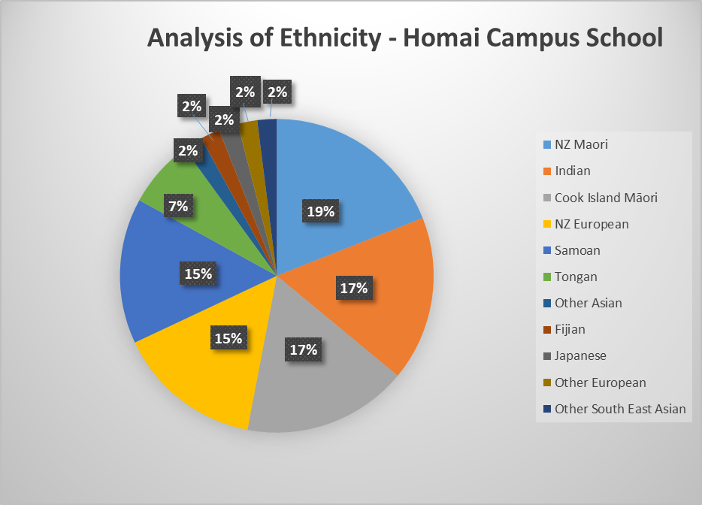

## Learners Receiving Services from BLENNZ Visual Resource Centres end of 2019

| **Visual Resource Centre** | **Early Childhood** | **Primary** | **Secondary** | **Total** |
| --- | --- | --- | --- | --- |
| Northland | 4 | 24 | 12 | 40 |
| Auckland North | 36 | 85 | 44 | 165 |
| Auckland South | 72 | 146 | 98 | 316 |
| Hamilton | 23 | 63 | 39 | 125 |
| Tauranga | 17 | 72 | 28 | 117 |
| Gisborne | 7 | 31 | 18 | 56 |
| Napier | 7 | 27 | 13 | 47 |
| Taranaki | 10 | 51 | 16 | 77 |
| Palmerston North | 22 | 51 | 39 | 112 |
| Wellington | 22 | 79 | 49 | 150 |
| Nelson | 8 | 29 | 14 | 51 |
| Christchurch | 32 | 115 | 63 | 210 |
| Otago | 4 | 37 | 16 | 57 |
| Southland | 3 | 19 | 8 | 30 |
| **Total** |  |  |  | **1553** |

**Analysis of Ethnicity**

European/Pakeha 54.9%

NZ Māori 23.0%

Samoan 3.5%

Indian 3.5%

Cook Island Māori 1.9%

Chinese 2.0%

Tongan 2.0%

Niuean 0.6%

Other 8.6%

# 

# Statement of Variance – Overview 2019 Annual Plan

## Strategic Goals:

### Transition - Ākonga from the start of secondary through to the end of compulsory schooling.

| **Objective** | **Who** | **Objective** | **Progress / Outcome** |
| --- | --- | --- | --- |
| 1. | Senior Manager  School and Residential | Conduct an inquiry, which will engage with a cross section of ākonga (past and present), parents, members of the teaching team and sector partners. | **Achieved** |
| 2. | SM School & Residential / Coordinator Immersion | Through a co-design process, develop BLENNZ long and short-term transition, immersion and residential programs to effectively meet ākonga need. | **Achieved** |
| 3. | SM School & Residential / Coordinator Immersion | Develop a shared and agreed process for ākonga transition, from the start of secondary to the end of compulsory schooling. This will be achieved through BLENNZ leading a working group, which will be informed by the gathering of data from those ākonga who have left the school system and the voice of sector partners. | **Achieved** |

### Wellbeing - Ākonga for whom BLENNZ is the primary provider.

| **Objective** | **Who** | **Objective** | **Progress / Outcome** |
| --- | --- | --- | --- |
| 1. | Senior Manager School and Residential | To initiate the self-review process at BLENNZ Homai Campus School. | **Achieved** |
| 2. | PrincipalSenior Manager Assessment and Teaching | To inform our practice by liaising with and learning from:Ministry of Education AdvisorsSensory School practitionersSpecial School practitionersEducational researchers and other schools for the blind who are working in this area.Readings and research relevant to the work. | **In progress** |
| 3. | Principal | To gather the perspectives of a range of voices to assist us in developing a shared and collective understanding of wellbeing for this cohort. | **In progress** |
| 4. | Principal | To identify potential pilots of enhanced practice for 2020, which have the potential to be trialled through individual and collaborative inquiry process. | **Partially Achieved** |

### Succession

| **Objective** | **Who** | **Objective** | **Progress / Outcome** |
| --- | --- | --- | --- |
| 1. | Principal and Senior Managers | To understand our current situation anddevelop a plan to reduce risk in thisperiod of change. | **Achieved** |
| 2. | Senior Managers | To ensure all new staff complete an induction process, which is reviewed annually and revised for the following year. | **Achieved** |
| 3. | Senior Managers | To embed a process which annually plans to document and share practice through:SecondmentSharing of inquiries  * Teams and curricula leaders documenting and capturing material for the hub. * Teams sharing of success stories. | **Achieved** |
| 4. | Principal | To enhance the culture of our organisation by making explicit the way in which we partner with ākonga, whānau and our colleagues internally and externally. | **Achieved** |

## Operational Goals

### Partnerships/Organisational Relationships

| **Objective** | **Who** | **Objective** | **Progress / Outcome** |
| --- | --- | --- | --- |
| 1. | Principal & Senior Management  Team | To work in partnership with MOE Learning Support leaders to ensure BLENNZ and MOE maintain a clear and shared understanding of our respective roles and responsibilities. | **Partially Achieved** |
| 2. | Principal Coordinator Kaupapa | To improve the interface between Kāpō Māori Aotearoa (KMA) and BLENNZ. | **Achieved** |
| 3. | Principal | To establish a regular interface with Sector Partners to enhance the flow of information on a no surprises basis. | **Achieved** |
| 4. |  | To facilitate partnerships with DECs that develop pedagogy and practice in deafblindness. | **Partially Achieved** |

### Workforce Development

| **Objective** | **Who** | **Objective** | **Progress / Outcome** |
| --- | --- | --- | --- |
| 1. | Coordinators | To continually develop resources which clearly articulate and curate effective practice in blindness education pedagogy and practice. | **Achieved**   * Sensory Efficiency * Communication * Deafblind * Early Learning   **Partially Achieved**   * Access * Transition * DOM |
| 2. | Curricula Leaders | Curricula leaders will identify who is undertaking inquiry and / or leading practice in the curricula area and establish mechanisms for sharing and partnerships. | **Achieved:**   * Sensory Efficiency * Communication   + Tactile Graphics   + Mathematics * Access * Deafblind – Saul Taylor * DOM – group inquiry   **Partially Achieved**   * Social skills   **Initiated**   * Transition |
| 3. | Coordinator  Early Childhood | To establish an outreach service to enhance practice in early learning to strengthen effective practice across the network. | **Achieved** |
| 4. | Coordinator National Assessment Service (NAS) | To develop our practice in identification and assessment with a focus on cerebral vision impairment. | **Achieved** |
| 5. | Coordinator NAS and Christchurch VRC | To complete assessment process for ākonga and work collaboratively with Waitaha to develop a process to build confidence and competence of their teaching team. | **Achieved** |
| 6. | ST NAS & Coord VRCs | To be able to clearly and accurately identify BLENNZ ākonga who are deafblind. | **Achieved** |

### Systems / Resources

| **Objective** | **Who** | **Objective** | **Progress / Outcome** |
| --- | --- | --- | --- |
| 1. | Coordinator VRC | To establish and maintain a comprehensive catalogue of all BLENNZ learning resources. | **Partially Achieved** |
| 2. | SM  Administration | To incorporate all of BLENNZ IT / AT resources into the catalogue. | **Partially Achieved** |
| 3. | Coordinator VRC | To fully implement the roles and responsibilities of a Prescribed Body. | **Partially Achieved** |

### Property

| **Objective** | **Who** | **Objective** | **Progress / Outcome** |
| --- | --- | --- | --- |
| 1. | Principals  DEC & MOE | To have a mutually agreed process (between MOE, DEC and BLENNZ) confirmed to implement the appropriate agreements for all Centres and Satellites. This will be achieved by a MOE Property person taking responsibility to lead the implementation or updating of agreements nationwide. | **Achieved** |
| 2. | Principals  DEC & MOE | To have a mutually agreed process (between MOE, DEC and BLENNZ) confirmed to review, action and complete the Sensory Schools Capital Works Plan. | **Achieved** |

# 

# Events from 2019

## Braille Retreat

BLENNZ facilitated the second Braille Retreat at the Homai Campus which took place from the 17-20 January. This retreat engages the adult community in a weekend focused around Braille Music, sharing, creating and performing. This is a wonderful collaboration with the adult music community.

## Visit by Minister Carmel Sepuloni

The Hon. Carmel Sepuloni visited the Homai Campus on the 8 March. During her visit the Minister engaged with the Senior Managers’ had a brief tour of the school and an opportunity to engage with ākonga.

## Kuia and the Spider

On the 21 March the BLENNZ Homai Campus hosted the first performance of Kuia and the Spider in Te Reo Māori. Sector partners Kāpō Māori Aotearoa New Zealand Inc provided the links to enable the translation of the performance, which was enjoyed by a large cross section of akonga from across the Auckland Specialist School community. Many stayed on to picnic in the grounds before heading home.

## Matariki

On the 26 June the Homai Campus School celebrated Matariki. Whānau were invited to share the day and we were delighted that the tamariki from the local Kōhanga Reo were able to join us. Everyone was welcomed with a whakatau by the campus school ākonga. It was lovely to have whānau and visitors enjoying the celebrations with us.

## Te wiki o te Reo Māori

A fabulous week for BLENNZ the highlight of which was a burger feast for ākonga and staff alike at the Homai campus. Everyone was fully engaged ordering their burger, including each of the fillings they wanted, in Te Reo.

## BLENNZ Early Learning Services (BELS)

In 2019 staff were introduced to the new BLENNZ Early Learning Services. Staff programmes focused on early childhood pedagogy and practice with a focus on empathically guided partnerships with whānau. The latter is part of an extensive programme we are introducing across the network, with our colleagues from What it Takes.

## Trans-Tasman Certificate of Proficiency in Unified English Braille

A number of staff from the BLENNZ teaching team undertook the braille proficiency exam with all passing.

# Learner Achievement 2019

## Homai Campus School

The Homai Campus School has two distinct areas to meet the need of learners who are blind, deaf/blind and low vision.

* The Homai Campus School classrooms known as Weka, Kiwi, Tui, Pukeko, Takehe and Kea. The learners in these classrooms may have additional barriers to their learning. They work in the New Zealand Curriculum. Teaching methods and equipment have been adapted to the unique educational needs of these students.
* The Satellite Classes at James Cook High school where the students have satellite group learning activities including intensive one-to-one instruction as well as mainstream learning experiences.
* The Homai Campus School also provides IEP classroom immersion experiences for learners around the country.

This year our focus for reporting is on Te Reo

## Weka Class - Matariki Celebrations

On the 26th of June Weka Class kaiako and ākonga hosted a group activity for the Matariki visit by tamariki from a Manurewa Kohanga Reo. Our part in the day included the sharing of stories, songs and action. We shared the story ‘The Seven Fish of Matariki, the story and song ‘Tawhirimatea – A song For Matariki’ and also a small action activity which gave everyone the opportunity to move after sitting for a short while. The ākonga in Weka enjoyed watching the reactions and activity of the visiting students, and older students within the Homai Campus School were able to see how we included our students in Te Reo activities.

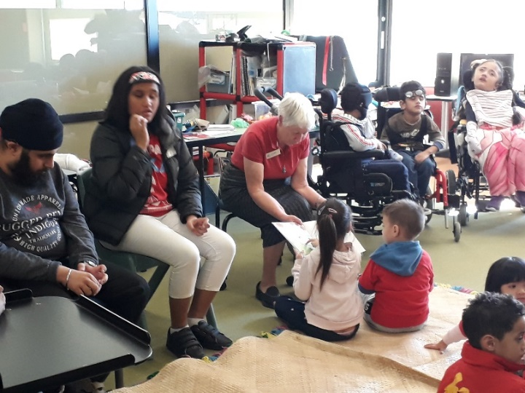

## Kiwi Class

Kiwi Class students have extended their chewing programme to include Te Reo naming words for familiar food. We have a collection of lunchboxes stored in a flax kete. The lunchboxes have plastic food and real potato sticks in them. For students who don’t eat orally they tactually explore plastic foods. Other students are learning to bite, crunch and chew using real potato sticks. Here is our introductory song: He aha kei roto te kete, he aha kei roto te kete, he aha kei roto te kete ahi ahi tenei. The song asks ‘What is in the bag, what is in the bag, what is in the bag today? Students are supported to reach into the bag and pull out a lunchbox. Inside the lunchboxes are plastic nga kotokota riwai, nga rohi, nga hotiti (chips, bread and sausages) and real potato sticks.

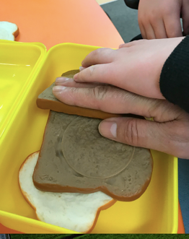 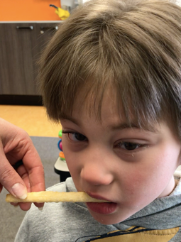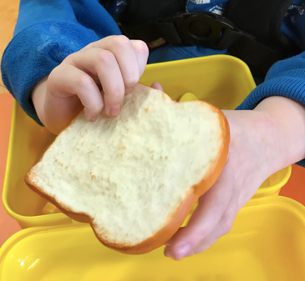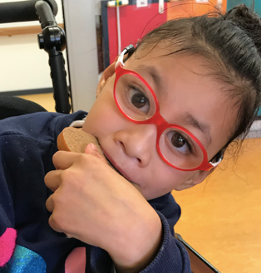

## Tui Class - Te Reo:

In Tui class we create many opportunities to use Te Reo. Each morning, we start our day with a karakia: Ete atua, Aroha mai, Ete atua, Manaaki mai, Ete atua, Awhina mai, Ake ake tonu e, Amine. Meaning – O God love us, forever and ever, Amen. O God help us, forever and ever, Amen. We sing this karakia and listen to it sung on you tube. We sing and listen to other Māori songs during our morning greetings. We also use Māori words for different activities in the class such as kai time (eating time), wharepaku for toileting, e tu, e noho. We are fortunate that one of our staff members (TA) is Māori and uses Te Reo words with the learners all the time in the class.

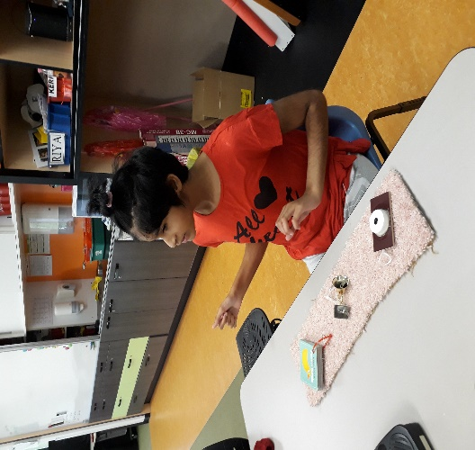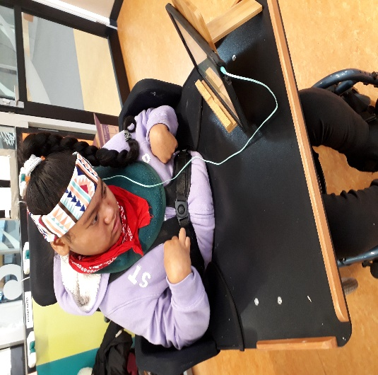

## Takahe class - TeReo

In the past year Takahe class learners have had many opportunities to practice and develop their TeReo. Kelly Doyle Co-ordinator Kaupapa has visited the class two to three times a term to lead the morning communication in TeReo. She has shared the school waiata and taught the students a number of action songs. Kelly used different teaching strategies to encourage the development and use of TeReo in the classroom. The students were able to practice these waiata and the new phrases learnt during daily communication. The students were confident to use these phrases in conversation at different school functions such as He Hamipēka, Matariki Festival, Kuia and the Spider and when welcoming visitors to the school in Whakatau and Powhiri.

group of learners sitting around a table holding two wooden sticks. teacher with a guitar leading a stick action song
 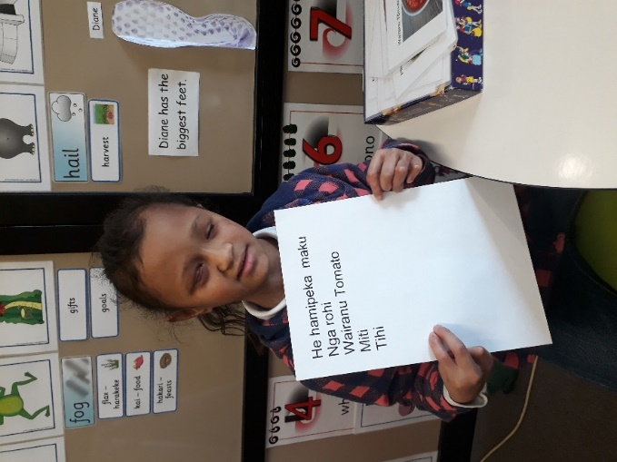

## Kea Class are on a te reo journey.

In Kea class we teach and speak te reo in various ways. We greet each other in the morning, and students who are able will say Morena and name the staff member they are greeting. Te reo is used functionally to name everyday objects in class, and to voice basic instructions. Kea students enjoy te reo stories during language time and reading. Our new favourite book and cd is Row, Row, Row Your Waka, by Rebecca Lawson, a NZ writer of children’s books in te reo and English. Our class iPad is a very valuable tool for te reo language acquisition and for listening to, and learning to sing, te reo songs and rhymes.

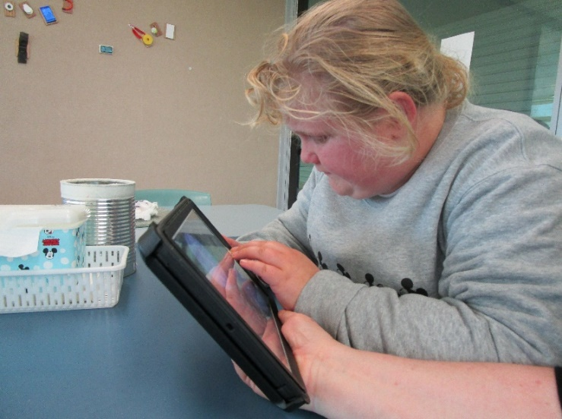

## JCHS Satellite Class Māori Language Week Celebrations

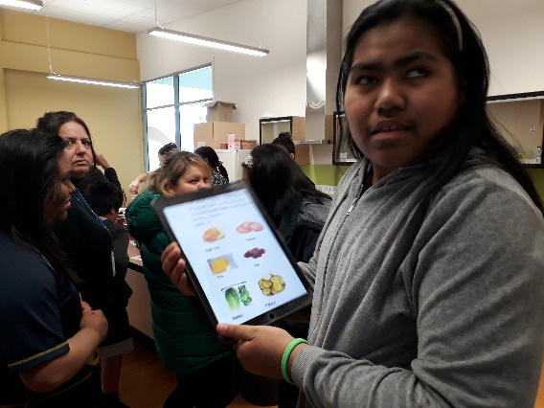

Tina doing her final Māori practice placing her order.

Māori Language week was celebrated country wide between the 9th and 16th of September. We made sure we were not left out in the celebrations. We listened to Māori stories narrated by Kelly throughout the week. On Wednesday, 11September, we all had a wonderful time at Homai Campus School ordering burgers for lunch in Te Reo Māori.  There was a wonderful array of ingredients such as tīhi [cheese], tōmato, rētihi [lettuce], pīti [beetroot] to name a few that our ākonga were able to choose from for their veggie burgers or hamburgers. We had to order every item using Te Reo Māori.  It was wonderful to see everyone develop his or her confidence and have a proper conversation going back and forth in Te Reo. All of us in JCHS Satellite Class agreed that their hamipēka was kakato - delicious, tino kino te pai- quite the best!  This year, we enjoyed participating in many Māori activities such as powhiri, whakatau, the story of Kuia and the spider not forgetting the Matariki celebrations!

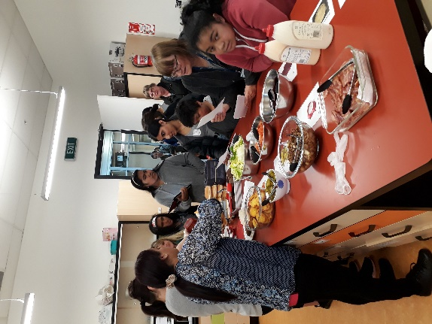

Ākonga gathering in the Homai Campus ADL Room to order their burgers

Transition Pathways Programme

Ben and David stand with two members of Blind Sport and Halberg Foundation during a break time at cycling at the netball courts
 Ben is at the wicket and holding the cricket ball after knocking off the stumps


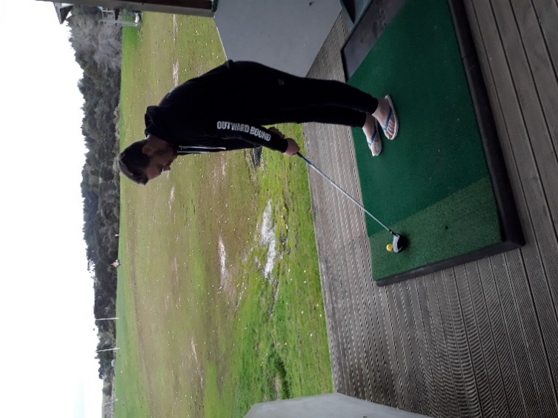 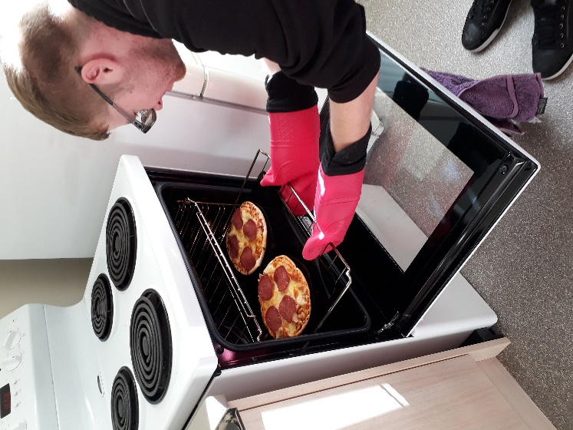

In 2019 Ākonga were involved in a range of sporting groups and activities where they had the opportunity to develop their skills and an understanding about themselves within a sporting context.

They participated in various community clubs and programmes including; maintaining and developing their skills in Tia Chi, attending Halberg’s sporting activities such as group golfing, an international Blind Sports cricket game and the Blind Sports award. They were able to practice their networking skills and had the opportunity to meet some inspirational athletes in the blind and low vision community.

Some ākonga had the opportunity to experience an independent living situation. These ākonga lived in the flat in Titoki and gained insight into what it means to be independent.

At the end of 2019, ākonga moved onto a variety of different settings. Some returned to their home setting, some moved onto community living, and some moved onto university and the halls of residence.

# Assessment and Teaching

## BLENNZ Homai Early Childhood Centre

Homai Early Childhood Centre is producing interactive story boxes for ākonga, accommodating varying levels of vision skills. We use cultural, natural and classical early childhood stories currently of interest to ākonga and whānau, adding tactile materials and real objects for ākonga to explore. One of the examples includes tactile kites for the storybook: The Seven Kites of Matariki. The visual and tactile elements supported ākonga understanding and interaction with the story. While reading the story and describing the individual kites, ākonga had a chance to experience the tactile differences between varying kites. Ākonga also held on to the handles of the kites and acted out the story, helping the kites glide into the pre-dawn sky.

 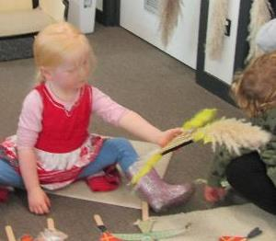

Figure 1 & 2 Four year old girl compares the visual and tactile components of two kites

## **BLENNZ Northland Visual Resource** Centre

Each term in 2019 Braille Club Curriculum Day has been held for Zaria and Chevarni who work hard on their Expanded Core Curriculum Goals. These goals focus on Independent Daily Living, Braille Literacy and Social Skills. They get the opportunity to practise social interactions, telling jokes and playing reciprocal games. The girls played ‘Battleships’; based on the traditional game and designed especially for tactile learners. They enjoy making their own food and pouring their own drinks as well as sharing their technology and building on their Braille literacy.

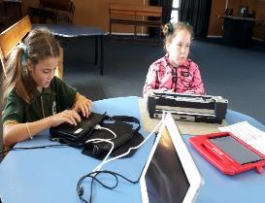

Figure 1 Zaria and Chevy using their Braille devices to write letters and emails



Figure 2 A 'tactile' battle ships board

## BLENNZ Auckland North Visual Resource Centre

Due to roll growth at Marlborough Primary School the room that we had been based in for 27 years was redesignated as a classroom. At the end of term 2 we sadly packed up the centre and moved to a temporary base at Wairau Intermediate. Our new host school has been very welcoming and we are delighted that there is plenty of car parking.

In September, Robyn Black and Jenny McFadden attended the dawn blessing of the Scott Point School site where our new purpose built centre is to be based. We look forward to moving there in 2021.

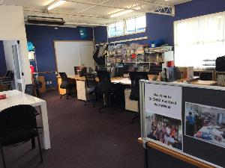

Figure 1 Our new office at Wairau intermediate

## BLENNZ Auckland South Visual Resource Centre

**Building sports and recreation opportunities outside of school**

A need to offer a wider range of local sporting opportunities during the weekend for South Auckland youths with visual impairments, led to the founding of the Matariki South Youth Sports Program. The free program, created by Casey Flint (BlindSport), Kerry Blackmoore (Halberg Foundation) and Aimee Peterken (BLENNZ) was spread over eight Saturday afternoons and open to students aged 5-21.

The intention was to offer taster sessions of a wide variety of sports, provide an opportunity for whānau to actively engage with their children during these activities and create ongoing connections with local sporting organisations. Students participated in archery, goalball, self-defence, swimming, rock climbing, sailing, cycling, football, tennis and golf.

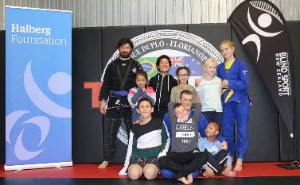

Figure 1: The students with their self defense instructors – including Brazilian Jiu Jitsu champion Clinton Davies known as “the blind grappler”.



Figure 2 Aiming for success!

BLENNZ Hamilton Visual Resource Centre  
Hamilton VRC have recently started a new Transition Immersion Group for children on our caseloads that are attending school from Year 9 to Year 13.

Kathryn Leonida is using this as part of her 2019 Inquiry:

**“Skills and attributes, mentors and making connections”** is the theme. It includes:

* Living independently (eg. self-care, food prep, chores, budgeting, planning, shopping)
* Travelling independently (eg. transport, road crossings, reading maps, using technology – all of which includes DOM skills)
* Working independently (eg. skills and attributes, exploring voluntary work, exploring career choices, exploring study choices)
* Social skills (eg. friendships, networking, mentoring)
* Leisure activities (eg. exploring options, making connections with people who can assist)

Lejihn and Ryan are talking with a lecturer from WINTEC Hamilton about courses they are interested in.


Figure 1 Boys talking to a tutor at Hamilton Career's EXP

Brayden, Ryan, Briana, Dylan and Lejihn are dressed up in different costumes to show that there are a variety of careers to consider at the Expo.


Figure 2 Transition Group photo at the Hamilton Careers EXPO

## BLENNZ Tauranga Visual Resource Centre

Tauranga VRC were very fortunate to have the Immersion team arrive to complete an immersion course for Braille users aged 5-8 years at our centre on 25th March. Natalie Stewart and Trish Bishop travelled down to our centre with a raft of resources and activities.

Tauranga has a number of learners who fit the criteria for this immersion course who due to family situations cannot travel. After discussions with Natalie, we decided to run the course at our centre. This was the first time the Immersion team have travelled and Tauranga were very excited about it.

The group of boys joined in activities to support concept development, assistive technology, and tactile graphics. They were able to work together to develop positional concepts and “the language of lines’ using toy dogs. The two days were a great success. The feedback from the learners, their whānau and teachers’ aide were very positive.



Figure 1 Learners using toy dogs to practise positional language.

## BLENNZ Gisborne Visual Resource Centre

This year the BLENNZ Gisborne and Napier teams collaborated with our BLVNZ colleague, Erin Leonard to organise a very successful Curriculum Day at the Wairoa Community Centre Pool which focused on our ākonga developing Swim Safety and confidence skills. Five AUSTSwim instructors (two provisional) led by Denice Gasson were in the pool, supporting six ākonga from Napier, Gisborne and Wairoa. We all had a wonderful day of learning and fun with ākonga and RTVs learning skills such as how to fit and put on a lifejacket correctly, how to float, jump from a boat and keep warm and safe by making a huddle.

A delicious morning tea and lunch was provided and there was time for ākonga to relax and play on the equipment at the Community Playground outside.

~~~~

Figure 3 Ākonga wearing lifejackets are practicing getting into a safety huddle with their AUSTSwim teachers.

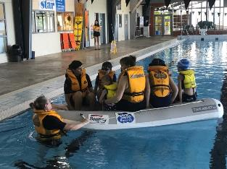

Figure 4 Ākonga lifejackets in an inflatable boat getting ready to jump out backwards, with support from their AUSTSwim instructor Denice Gasson

## **BLENNZ Napier Visual Resource** Centre

Kahn is learning to use the iPad Pro 12.9” to enable him to access the curriculum. He particularly enjoys the independence gained through being able to capture information and produce work digitally without support. The portable stand and Bluetooth keyboard enable him to work anywhere within the modern learning environment. This has been a very inclusive option for Kahn.



Figure 1 Kahn learning to touch type

Learning Braille has widened the world of literacy for Jesse. He enjoys brailling his classwork, SPEC ideas and projects. Selected work is overwritten for access and displayed with that of his peers. It has been positive for Jesse to have his contributions available for discussion or viewing by some of his peers, staff, family and visitors to the Centre. In this way Jesse has achieved his goal of sharing his ideas with others.

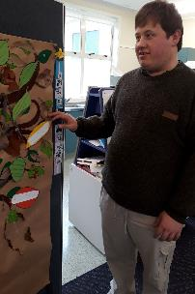

Figure 2 Jesse points out his contribution to the display

## BLENNZ Taranaki Visual Resource Centre

At BLENNZ Taranaki this year, a group of RTVs have focused their inquiry topic around tactile graphics and early braille skills. This also included a trip to the Palmerston North VRC to observe their Dot 3 club and to spend time with Trish Bishop sharing her knowledge of tactile graphics and early braille pedagogy.

Another highlight of the year was a small group of whānau and ākonga making connections together with trips to the zoo and coffee and cake at the VRC.

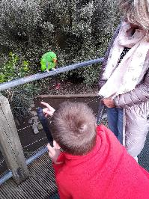

Figure 1 Learner looking closely at a parakeet perched on a handrail.

A recent highlight was a transition day for a group of learners transitioning to secondary school. The focus was on learning how to use technology effectively to access learning in a secondary school environment. This was followed by an afternoon of tennis skills with a Parafed Taranaki sport development advisor.

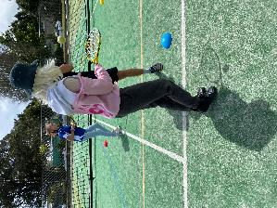

Figure 2 Girl bouncing a tennis ball off her racquet.

## BLENNZ Palmerston North Visual Resource Centre

**RTV’s ‘Brush up’ on DOM skills**

In term 1 2019 four experienced RTVs from BLENNZ Palmerston North attended the DOM ‘On Campus’ course at Homai. Over a five day period there was attendance at workshops and plenty of time to refine skills in guiding, being guided and basic cane travel. Each evening the ‘team’ of Amanda Gough, Darrell Lee, Trish Bishop and Meredith Pitcher worked on the set assignments for the course. Upon returning home the fun part began; working with a learner, documenting the work in pictures and in words, and lastly reflecting on the programme.

We felt that this course was valuable in aiding each of us to ‘brush up’ on the more technical components of guiding and cane travel. We enjoyed the work with each of our learners and took pleasure in the outcomes. Completing this course together was the ‘icing on the cake’!

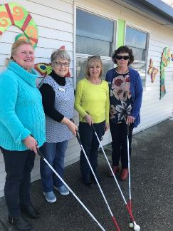

Figure 1 Palmerston North RTV team members stand with their canes; Amanda Gough, Darrell Lee, Trish Bishop, Meredith Pitcher.

## BLENNZ Wellington Visual Resource Centre

In May 2019, three BLENNZ Wellington Resource Teachers Vision, brought together a group of teacher aides working with our academic primary braille learners - an opportunity for sharing, support and professional development for a group of teacher aides who hadn’t met prior to this workshop. The workshop provided an excellent opportunity for much discussion, sharing and upskilling as well as relationship-building between RTVs and teacher aides and our intention is to facilitate regular professional development days for this group. In the future, we intend to focus on other areas of the Expanded Core Curriculum and to invite our other partners in the field including colleagues from the Blind and Now Vision NZ.

We are delighted that two of these teacher aides are currently working towards the Trans-Tasman Certificate of Proficiency in Unified English Braille.  
 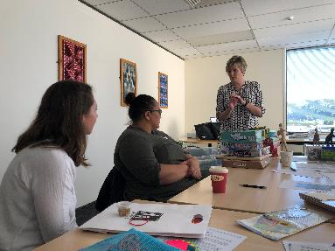

Figure 1 Two Devi and Olivia in discussion with one of the three participating teacher aides

## BLENNZ Nelson Visual Resource Centre

Shared cooking sessions are perfect opportunities for learners to acquire a range of Curriculum and independent living skills. Here at the Nelson VRC we have been facilitating cooking experiences for learners who are transitioning to Intermediate Schools. These experiences, co-hosted by the RTV and Blind Found ILS specialist, provide learners with advance practice of the skills they will encounter in Food Tech classes.

During these highly motivating experiences, learners practise a range of Expanded Core Curriculum skills (personal care/hygiene, organizational skills, interpersonal skills, etiquette, independent living skills, decision making), as well as the Curriculum skills of math (budgeting, time, measurement, addition, subtraction, fractions) and literacy (listening, reading and writing step-by-step instructions).

Teachers report that learners have integrated these out-of-class experiences into their classroom-based literacy programmes. It is rewarding to witness that these fun-filled learning experiences have taught a host of new skills to support life-long learner independence.

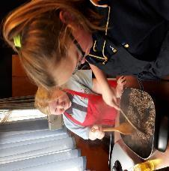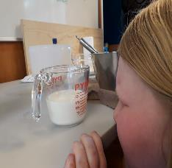 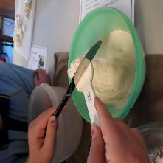

Figure 1 Cooperative cooking fun

Figure 2 Careful looking to ensure measurements are accurate

Figure 3 Learning new skills to keep amounts consistent

## BLENNZ Christchurch Visual Resource Centre

“Fun Friday” continues to be popular with our 6 to 10 age group. The students particularly enjoy learning daily living skills while cooking and our “Master Chef” group challenge was hotly contested. They also have fun learning recreational skills and social skills, and many lovely friendships have developed within the group. This year’s group of Peer Support students (Marama, Luca, Zahina, Te Roma and Zack) have shown great leadership skills and have been a great help and role models for the others.



Figure1 Marama and Taylah-Jade stirring the baking mixture

The “Intelligent In Be Tweens” are a new group of Year 7 and 8 students who come together once a term to practice skills from the Expanded Core Curriculum. The group get out and about having fun while focusing on Orientation and Mobility for pedestrians and using the bus; Daily Living Skills; using technology to help problem solving to overcome issues caused by their vision; social skills and recreation skills.

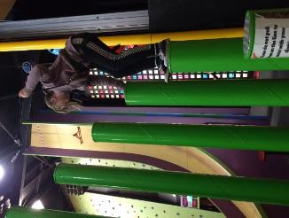

Figure 2 The Leap of Faith at Clip and Climb

## BLENNZ Otago Visual Resource Centre

At the end of Term one, two learners from Otago, attended the “Power Up!” Immersion course at Homai for learners who have experienced a recent vision loss. Over the course of the week, the students learned about their eye conditions, participated in orientation and mobility activities and practised their independent living skills.

In pairs, they shopped at a local supermarket for items needed to make meals during their stay. An impressive range of visually impaired speakers and adult mentors present throughout the course provided inspiration and guidance.

The course culminated in a white water rafting trip which was great fun and challenging for students and staff alike. This course was a wonderful opportunity for the students to meet others with a recent vision loss.



Figure 1 White Water Rafting

## BLENNZ Southland Visual Resource Centre

**Learning for Life**

The first part of the year has been about new learning for staff and ākonga. This includes attendance at the DOM Supporters on Campus Course and professional development for teachers and school staff, as well as involvement with Immersion course planning and attendance.

We are informing and empowering others by spreading knowledge about BLENNZ, BLENNZ services, the role of the RTV, and how best we can provide for our learners specific vision focussed needs. School staff have been eager to learn and felt they better appreciated their ākonga’s needs after our input.

Ākonga and RTV’s have grown after inclusion in Immersion. The confidence, networking, relationship building with whānau and fellow professionals has been immense.

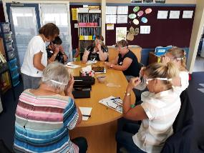

Figure 1 In-Service training day

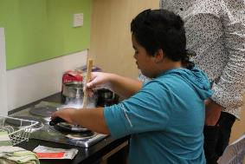

Figure 2 Cooking at Immersion

## BLENNZ National Assessment Service (NAS)

**Music Therapy**

Dimetruz is a tactile and auditory learner who loves listening to music. During his National Assessment, Dimetruz attended a music therapy session to see how he can engage in music listening and playing alongside his peers.

He explored a range of instruments and chose to play the drum kit, guitar, piano and beat-box on a microphone. He started with free exploration of each instrument and then was guided to try specific technical ideas. By the end of the session Dimetruz was able to hold a steady beat on a drum, play a C and G major chord on the guitar and play the melody to the first line of “Mary had a Little Lamb.” The music therapy session showed Dimetruz and his family that he has good innate musical abilities.

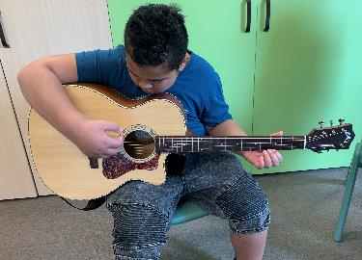

Figure 1 Dimetruz playing the guitar

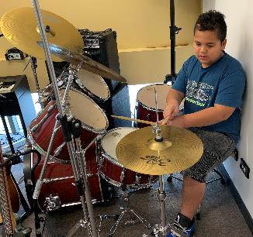

Figure 2 Dimetruz playing the drums

## BLENNZ Immersion

On the 20th and 21st of March 2109, an Immersion group of six bilingual ākonga and six supporters/whānau stayed in te whare Titoki on the Homai Campus. The purpose of this Immersion was to coincide with a performance of The Kuia and the Spider and to continue building on whanaungatanga and connections made at the Motuhake bilingual immersion in 2018. This was the first Te Reo Māori audio described performance in the world and was held in conjunction with the Auckland Arts Festival.

The ākonga were part of hosting and showing manaakitanga to the Kāpō Māori CEO, actors from the Takirua Company, audio describers and Auckland Arts Festival organisers. They helped welcome manuhiri to the Homai Campus and being the first students to attend a performance with Te Reo Māori audio description. Nic Holloway facilitated this Immersion and Kelly Doyle supported. Papa Gavin Reedy was also a vital part of this Immersion.

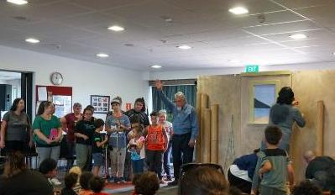

Figure 1 BLENNZ Students Welcoming Guests to Homai Campus

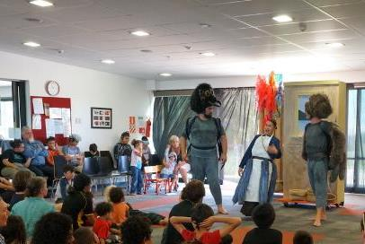

Figure 2 The Kuia and The Spider Performance

## Regional Teaching Team

BLENNZ employs a number of Resource Teachers: Vision and Developmental Orientation and Mobility Specialists who are based at fourteen Visual Resource Centres and eight outposts located across New Zealand. The role of these specialist teachers is to advise, provide guidance and direct teaching to identified learners with a vision concern, in order that they are able to access the curriculum while developing skills needed to reach their potential in life. The role of the DOM is to work collaboratively with Resource Teachers: Vision in the provision of specialist services.

Each Centre is led by a manager who is in turn closely supported by a Centre Coordinator. Pedagogy and Practice is framed by the Mission, Beliefs and Values of the organization and is guided by the Strategic and Annual Plans with a clear focus on working collaboratively to meet the needs of all BLENNZ learners. Opportunities are provided for individuals and teams to meet regionally and nationally for professional development and to facilitate an approach that aspires to equitable informed service delivery and evidence based learner outcomes.

The Regional Teaching Team also work in partnership with the National Assessment Service, Immersion/Residential Services and the Early Learning Service. These strands are based at the campus and are pivotal in supporting the regional teams.

BLENNZ continues to strive towards the provision of consistent specialized assessment and programme delivery for ākonga from an informed teaching team.

## BLENNZ Developmental Orientation and Mobility Service (DOM)

This year BLENNZ has prioritised achieving 50% of all Resource Teachers Vision to have completed at least one of the Developmental Orientation and Mobility (DOM) supporter courses, run as a collaboration between Massey University and the BLENNZ DOM Specialist team.  This year that meant running five of the week long courses at Homai campus.

The courses are run as two parts.  The first is the “supporting DOM programmes on school campus” and the second is “supporting DOM programmes in the community”.  Both courses enskill team members to continue supporting DOM programmes on a regular basis, with the oversight of the Specialist, in a risk managed way.

The courses are delivered under the premise that learners move and travel all the time, so the more people consistently supporting the learner to develop skills and strategies in DOM the better the potential outcomes.

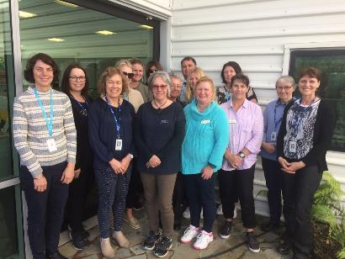

Figure 1 RTVs and the Massey/DOM Specialist tutors at a recent Community course.

## BLENNZ VRC Coordinators

This is the new Visual Resource Centre Co-ordinator Team.  We welcome Saul Taylor back to BLENNZ from Deaf Education sector, he brings a wealth of knowledge with him with a particular focus on Deafblindness. Saul is based with the Napier team.

Fiona Hansen has also joined the team this year.  She has been in the Vision Education field in different roles across the Network, including working at the Campus School over the last 20 years.  Fiona was most recently the Manager of Tauranga, she has a particular focus on Induction.

Alison Prskawetz remains based in Wellington and is excited to have two fabulous new team members working with her.  Alison’s focus is on Communication in the Expanded Core Curriculum.

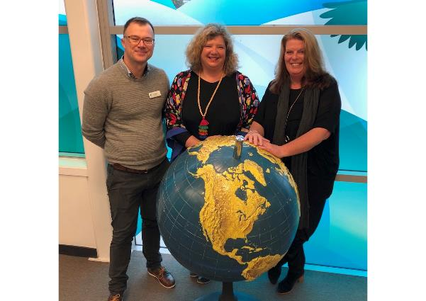

Figure 1 VRC Coordinators, left to right, Saul Taylor, Ali Prskawetz, Fiona Hansen

# Homai Campus Music School

## Individual Music Programme – Wendy Richards

Ten students received regular one to one music tuition in 2019. Of these, five learners achieved great success at NCEA Music, levels 1 - 3. Five external NCEA papers were prepared in braille, including both aural and score reading papers at level 1 and 2, and the harmonic analysis paper at level 3. Of note, is one learner who attempted and passed both level 2 papers, and another learner who passed the level 3 paper. This is the first time in 20 years this level 3 examination has been undertaken in a braille format.

## Music School – Wendy Richards

Twenty-two students enrolled in the music school programme in 2019. The programme consisted of a full day of musical activities ranging from a physical warm-up, music appreciation, musicianship class, vocal ensemble, dance classes, band and a capella group. This year also included a “Super-Junior” trial for a small group of learners who had not yet started school. The well supported end-of-year concert included performances from the super juniors, solo items, band, a capella, and the full choir.

## Homai School Music Therapy Programme – Ajay Castelino

Eight group and five individual music therapy sessions were provided every week for the Homai Campus students in 2019. The aim of the music therapy sessions was to support the ākonga’s emotional, social, verbal and non-verbal expression through the use of music. The music therapist also worked as part of a multi-disciplinary team alongside the other Homai therapists to deliver a weekly motor-sensory program. Two of the classes also performed at the Interact Music Festival.

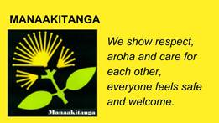

# Te Whānau o Homai

In 2019 Te Whānau o Homai committee were involved with the following events at the Homai Campus.

## February 2019

Whakatau to welcome new staff/ākonga to Homai Campus.

## March 2019

Kuia and the Spider performance in Te Reo performed here on Campus.

## June 2019

Matariki Celebration

Everybody involved working together as a Whānau-whakawhanaungatanga.  Sharing sessions such as art/waiata/kai.

Whānau, staff, local Kohanga Reo were hosted to showcase our BLENNZ values and practise Te Reo in a social setting.

A time to shine bright like the stars of Matariki.

## August 2019

Welcome to new Residential staff one of whom was officially handed over to us by a contingency of approximately twenty people from that person’s previous employer.

## September 2019

Māori Language Week-acknowledged by making hamburgers for staff and students to purchase.  The idea was to order in Te Reo.

BLENNZ vision board-collated by one of the staff who liaised with Te Whanau o Homai members and included BLENNZ’s vision, mission, beliefs and values.

# Youth Library

The Youth Library is based at BLENNZ Homai Campus School and is administered by the Blind and Low Vision New Zealand.  We have two enthusiastic librarians on site who provide a point of contact for teaching staff, teacher aides, parents, children and young adults throughout New Zealand to request educational items for blind and low vision learners.

The Blind and Low Vision New Zealand, through funding from the Ministry of Education, is committed to producing and providing a wide range of accessible resources to fulfil the educational and recreational needs of children and youth.  The Library also supports children and their families in literacy reading development and lifelong learning through the provision of a range of reading material in a variety of formats. These include:

* Collage books: sturdy, hard-covered picture books with large print and braille text and bright, bold collage illustrations.
* Board books for CVI readers.
* Early readers and School journals available in large print, braille and e-text.
* Braille books in hardcopy and ebraille format for fiction, non-fiction, examinations, tests, handouts and textbooks.
* Twin vision picture books: with clear plastic braille over the original print or with clear plastic braille pages inserted between the original print pages. Some are also available with an accompanying CD.
* Large print books in 18 and 24-point font: mostly fiction for ages 9 to 16. We also have a growing non-fiction and textbook collection. Also available as adapted pdf.
* Kitsets with enclosed print book with accompanying CD and braille text.
* Electronic files (E-text) available in Word, HTML and Plain text.
* Playaways that are pre-recorded MP3 players.
* DAISY books which is produced in-house and also requested from international blindness agencies through ABC (Accessible Books Consortium) and purchased from commercial vendors.
* Digital services such as Booklink, Alexa and Bookshare.

The library supports RTVs and educators professional development through the provision of reference material and reference services.  Nazreen is available to assist with reference queries and literature searches.

The library also supports and helps with a variety of immersion courses run by BLENNZ over the course of the school year, and conducts library tours for teacher aides, parents and other educational groups when requested.   We have regular visiting sessions for all classes in the school and story times for Early Childhood Centre and meet regularly with families visiting for needs assessment.

Opening hours: Monday to Friday, 9.00am to 4.30pm, including school holidays.

You can phone us on (09) 268-3215 or 0800 24 33 33 ask for Youth library.  
Email [youthlibrary2@blindfoundation.org.nz](mailto:youthlibrary2@blindfoundation.org.nz)

The Library Team:

Senior Librarian – Nazreen Shaban

Senior Library Assistant – Gordon Dickson

# Board of Trustees

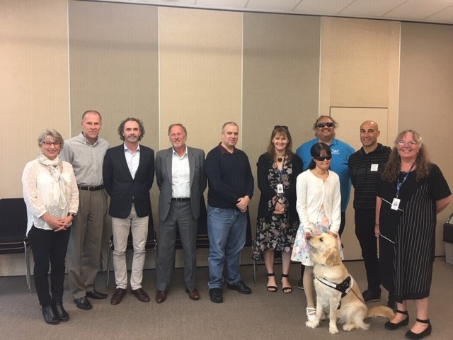

## **Board Members – June 2019**:

From left:

Janny Cooke (Board Secretary), John Mulka (BLVNZ appointed Trustee), David Cullen (VRC Parent Elected Trustee), Mitch Harris (Homai Campus Parent Elected Trustee), Nathaniel Louwrens (VRC Parent Elected Trustee), Kelly Doyle (Staff Elected Trustee), Nigel Ngahiwi (Tangata Whenua appointed Trustee), Christopher Gunn (VRC Parent Elected Trustee), Karen Stobbs (Principal), Wendy Chiang (Blind Citizens NZ appointed Trustee) with Guide Dog Yaron.

BLENNZ has a national board of trustees, which is representative of BLENNZ and of the wider blindness education sector.

The role of the BLENNZ Board is to govern the school, with a focus on providing an environment that fosters achievement for ākonga and young people who are blind, deaf blind or low vision.

BLENNZ also has the Homai Early Childhood Centre on the Homai Campus. This is a licensed centre attended by young children in the Auckland region, and also serving as a national resource. Because of current legislation, this centre is governed under a separate trust and trust board, the Homai Early Childhood Centre Education Trust (HECCET) Board of Trustees. Seven members of the BLENNZ Board form the membership of the HECCET Board of Trustees. These are: Mitch Harris, Nigel Ngahiwi, Nathaniel Louwrens, Wendy Chiang, John Mulka Kelly Doyle, and Karen Stobbs

In 2019 the BLENNZ Board met for six meetings and one strategy day:

22 February, 29 March, 21 June, 23 August, 24 August (Strategy Day), 1 November, 6 December

The Board is made up of the following trustee positions:

* Four trustees elected by parents receiving services from Visual Resource Centres
* One trustee elected by parents of students enrolled at the Homai Campus School
* One trustee elected by staff
* One trustee appointed by the RNZFB now known as the Blind and Low Vision NZ
* One trustee appointed by Blind Citizens NZ
* One trustee appointed by a panel of representatives of recognised Kāpo Māori organisations
* The Principal of BLENNZ

Board co-opted trustees, provided that the number of parent elected and VRC elected trustees is greater than the total number of co-opted and appointed trustees.

## BOT members and roles as at 31 December 2019

Visual Resource Centres parent elected trustees:

* Nathaniel Louwrens, Graeme Hood, David Cullen, Christopher Gunn

Homai Campus School parent elected trustee:

* Mitch Harris

BLENNZ staff elected trustee:

* Kelly Doyle

Appointed Trustees:

* John Mulka – Blind and Low Vision NZ
* Wendy Chiang – Blind Citizens NZ
* Nigel Ngahiwi – Tangata Whenua

The Principal of BLENNZ

* Karen Stobbs

## Professional Development and strategy Planning Days

### 21 June 2019

Chris France, NZSTA Governance Adviser facilitated a professional development workshop on Effective Governance with the newly appointed Board.

### 24 August 2019 – Strategy Day

This day focused on the following

* Continuation of the 21st August Board PD on Effective Governance
* Workshop facilitated by John Easby on Working in Partnership

# The Framework of Indicators of Learner Achievement

BLENNZ uses a network-wide approach to quantifying learner achievement using a framework of evaluation indicators. The indicators capture both direct and indirect measures to provide an overview of achievement of learners and BLENNZ services. This systematic approach is intended to enhance opportunities for evidence-based practice and to provide the data needed for the development of nationally consistent practice and for a process of continuous improvement.

The outcomes are documented in the following pages with the first section of reporting focusing on the School and Residential Service Strand followed by reporting on the Assessment and Teaching Services.

# The Framework of Indicators of Learner Achievement

## Homai Campus School - 2019

**Collate IEP goal achievement data for learners attending Homai Campus School.**

## Targets

**Learners at Homai Campus School will achieve 80% of their IEP goals during 2019**

In this reporting the names Pukeko, Takahe, Tui, Kiwi, Kea and Weka are the different classrooms of the learners on campus. There are also two satellite classes at James Cook High school.

When learners achieve their goals, new goals are set. The aim is 100% but achievement of the goal is at the pace of the learner.

## Reporting

The Homai Campus School has developed an IEP policy and guidelines to ensure the IEP process outlines the children and young peoples’ strengths and needs, bringing together a collaborative team that works in partnership with family and whānau to identify and prioritise learning outcomes that are based on effective assessment and teaching strategies. The IEP or ITP plans ensure learners are provided with a programme that enables them to achieve maximum educational outcomes and the goals are appropriate for the learner. Each IEP is reviewed by the Senior Teacher, Co-ordinator School Programmes and the Senior Manager of School.

The learners have worked well to achieve their IEP goals. For the learners who have not achieved the target of 80% there appears to be a consistent variable relating to their attendance due to illness and in some cases changes in their physical condition and / or changes in medication which has impacted on their learning.

### Takahe

All learners achieved at least 80% of their goals. When learners achieve 100% of their goals, new goals are set to extend their learning.

| **Learner** | **Using language symbols and texts** | **Participating and contributing** | **Managing Self** | **Relating to Others** | **Thinking** |
| --- | --- | --- | --- | --- | --- |
| 1 | 94% |  | 83% |  | 100% |
| 2 | 90% | 100% | 89% |  | 90% |
| 3 | 100% |  | 100% | 88% | 100% |
| 4 | 85% | 100% | 95% |  | 100% |
| 5 | 95% | 100% | 100% | 100% |  |
| 6 | 86% | 100% | 100% | 100% |  |

### Kea

The learners in this class are widely varied in their needs and abilities. There are two learners with ACC funding who each had a teacher aide assigned to them. One student transitioned from school to post school life during the year. Student 3 had new goals set in term 3.

| **Learner** | **Language Symbols and texts** | **Participating and contributing** | **Managing self** | **Relating to others** | **Thinking** |
| --- | --- | --- | --- | --- | --- |
| **1** | 60% |  | 58% |  | 50% |
| **2** | 100% | 60% | 53% |  |  |
| **3** | 87.5 |  | 92% / 50% | 100% | 88% |
| **4** | 64% |  | 100% |  | 87.5% |
| **5** | 100% | 75% | 66.6% |  |  |

### Tui

Learners in Tui class have very high needs and some with fragile health. Illness and the resulting absences from school have had an impact on the progress of some learners.

Learner no. 1, had changes in seizures medications which impacted on their ability to learn and focus in class. Learner no. 5 changed classes due to an increase in students mid-year. The time taken to transition and settle into a new routine impacted on their learning and they also had frequent absences due to a sibling bereavement.

Due to resignation of the class teacher mid-year, a long-term reliever was employed for this class. Unanticipated changes of staffing did impact initially on ākonga learning. Learner no. 4 was particularly affected by the change in staffing, taking a while to settle.

| **Learner** | **Using language symbols and texts** | **Participating and contributing** | **Managing Self** | **Relating to Others** | **Thinking** |
| --- | --- | --- | --- | --- | --- |
| 1 | 40% |  | 75% |  |  |
| 2 | 100% | 100% | 80% |  |  |
| 3 | 66% | 100% | 100% |  | 100% |
| 4 | 50% |  | 100%  100% |  |  |
| 5 | 73% | 65% | 84% |  |  |
| 6 | 80% |  | 100% |  | 100% |

### Weka

The students in Weka all have considerable health needs which impacts on their attendance and their ability to engage consistently during the school day.

No. 2 physical condition has deteriorated significantly during the year – on palliative care track.

No. 3 and 4 transitioned into this class from BLENNZ ECE. To begin with they did not attend regularly. Attendance increased over the term. Goals had been pre-set from ECE transition.

No. 5 had numerous hospital appointments and absences due to ill health.

| **Learner** | **Using language symbols and texts** | **Participating and contributing** | **Managing Self** | **Relating to Others** | **Thinking** |
| --- | --- | --- | --- | --- | --- |
| 1 | 92.8% |  | 91.6% | 83% |  |
| 2 | 75% | 80% | 75% |  |  |
| 3 | 59% |  | 33% | 100% |  |
| 4 | 50% |  | 50% | 100% |  |
| 5 | 80% |  | 78% |  | 75% |

### Kiwi

Kiwi class began with two learners and throughout the year two more transitioned into the class, altering the class dynamics.

| **Learner** | **Using language symbols and texts** | **Participating and contributing** | **Managing Self** | **Relating to Others** | **Thinking** |
| --- | --- | --- | --- | --- | --- |
| 1 | 100% | 100% | 85% | 100% | 100% |
| 2 | 100% | 100% | 100% | 100% | 100% |
| 3 | 100% | 100% | 70% | 75% | 100% |
| 4 | 100% | 100% | 100% | 75% | 100% |

### James Cook Satellite Classes

Class 1 at the James Cook Satellite started the year with six learners. One studentmoved to another school during the year to support his needs.

| **Learner** | **Using language symbols and texts** | **Participating and contribution** | **Managing \Self** | **Relating to Others** |
| --- | --- | --- | --- | --- |
| 1 | 75% | 80% | 80% | 100% |
| 2 | 83% | 80% | 83% | 89% |
| 3 | 80% | 80% | 100% | 100% |
| 4 | 83% | 83% | 100% | 100% |
| 5 | 80% | 75% | 80% | 100% |

Mid-year a second class (formerly Pukeko) joined the Satellite campus as James Cook 2.

Both classes often worked together on the Managing Self and Relating to Others aspects of the Key Competencies Curriculum.

### James Cook 2 (formerly Pukeko class)

Learners in James Cook 2 are secondary aged and focusing on life skills. Some achieved their goals.

Learner 3 had considerable health issues, due to his deteriorating condition, ill health and hospital appointments all impacting on his school programme.

Learner 6 transitioned to the school towards the end of 2019 and took some time to settle into the new environment and classroom learning.

| **Learner** | **Using language symbols and texts** | **Participating and contributing** | **Managing Self** | **Relating to Others** | **Thinking** |
| --- | --- | --- | --- | --- | --- |
| 1 | 80% | - | 83% | - | 83% |
| 2 | 83% | - | 87.5% | 70% | 80% |
| 3 | 70% | 78% | 75% | 78% | 70% |
| 4 | 88% | 83% | 83% | 88% | 83% |
| 5 | 85% | - | 70% | - | 85% |
| 6 | 68% | - | 60% | - | 70% |

### Māori and Pasifika

#### Māori Learners

There are 7 learners enrolled at the school who identify as Māori.

2 of these learners achieved 80% or more of their IEP goals. Staff are working closely with these families.

#### Cook Island Māori Learners

There are 6 learners who identify as Cook Island Māori. 2 of the 6 achieved 80% or more of their IEP goals.

#### Samoan Learners

2 of the 6 learners who identify as Samoan achieved 80% or more of their IEP goals. A combination of ill health and family circumstances contributed to the other 4 learners’ performance.

#### Tongan Learners

3 learners identify as Tongan. One of these learners achieved 80% or more of their IEP goals.

### Target (Literacy)

Learners at Homai Campus school participating in a conventional literacy programme are predominantly in Takahe classroom. These learners are working towards achieving their individual targets in reading and comprehension using a variety of media e.g. Braille, large print, auditory. All students have made progress throughout the year.

Learners attending James Cook High School satellite are working towards NCEA Level 1 English within their classroom programme.

### Target (Numeracy)

Learners at Homai Campus school participating in a conventional numeracy programme will achieve their individual targets in numeracy.

14 learners at Homai Campus School participate in conventional numeracy programme.

#### Learners: Senior students (12years +)

7 of the 14 are in the senior school.

The learners at James Cook High School are working within the mainstream programme at NCEA Level 1. Other senior students who attend the campus school are working within Level 1 of the NZ Curriculum.

#### Learners: Junior students (5 - 12years)

The NumPA or JAM assessments are completed with each learner who is working within a conventional numeracy programme. The assessment is adapted for low vision and braille learners. The assessment scores in various areas. The results are analysed by the teacher, with areas of strength and weaknesses are identified.

### Homai Campus School Survey

#### Homai Campus School

All reporting to parents by the Homai Campus School will be against the learners’ IEPs. It will be in an agreed format that has been developed to comply with the National Standards Guidelines to ensure that all reporting is in plain language and clearly articulates to parents the next steps for their child’s learning, and how they can support the learning outcomes at home.

#### Targets

100% of reports to parents/caregivers from Homai Campus School use the agreed format.

100% of parents/caregivers surveyed express satisfaction (strongly agreed or agreed) with the new style and formatting of reports with regard to clarity of information and clear articulation of the next steps in the child’s learning and how they can support this learning at home.

Conduct an annual survey of parents with children attending Homai Campus School to determine the level of satisfaction with the service provided.

#### Target

100% of parents/caregivers evaluate the service provided as appropriate Strongly agreed or agreed in terms of the quality of classroom programmes, ease of communication with the home, child safety, assessment and feedback.

#### Reporting

11 out of a possible 44 families completed the survey. Two more will be done at IEP meeting this year when an interpreter will be present to support whanau in providing information.

**1. My child is well supported by the classroom programme**.

6 strongly agreed; 5 agreed. 0 strongly disagree

**2. There is good communication between the classroom and home.**

5 strongly agreed; 6 agreed. 0 disagree

**3. I feel welcomed into the school and comfortable contacting the staff.**

7 strongly agreed; 4 agreed. 0 disagree

**4. The health and safety of my child is well provided for.**

6 strongly agreed; 5 agreed.

**5. The information presented in the IEP is helpful to me.**

7 strongly agreed; 4 agreed. 0 disagreed

**6. The school report is informative and easy to read.**

4 strongly agreed; 7 agreed; 0 disagree

(6 continued) **The School Report gives a clear idea of what is the next step in learning.**

4 strongly agreed; 5 agreed. 1 disagree

**7. The termly newsletter provides good information on the activities at school.**

4 strongly agreed; 6 agreed; 0 disagree 1 N/A not at school long enough to get

school newsletter

#### Further Parent Comments from Survey:

* BLENNZ / Homai do really well, provide a great service to learners with vision impairment/blind learners.
* Is it possible to use hand santisers in the classroom for personal hygiene before giving feeds and medications to the students?
* We send a notebook in the bag with comments but it seems like it is not checked most of the times. It would be nice to get some comments back as to what happened at school.
* No further comments other than knowing A enjoys her school programme, always comes back home from a happy day. Loves doing homework. Strongly agree to everything.
* I would like to say thank you to all the teachers that work with A. He is learning a lot . he says lots of words and he answers my questions every time when I ask him. He understands everything. Thank you very much.
* This is the best school for my son. The teachers make you feel comfortable and very welcoming.They even go that extra mile just to make your child feel comfortable. These teachers are irreplaceable. Very happy parent.
* Listen to the student, tuning in to verbal and no verbal cues re requests for care and wellbeing, empathy in regards to medically fragile and complex needs/life expectancy, approaching students with a positive attitude.
* The writing in the notebook is not that clear. Please write clearly.
* It is good to get an introduction to the teacher and a bit about their background. It is a total surprise to meet the new teacher but not knowing about them.
* I would like to thank all the teachers, support workers at school for everything they have done to help all the children at Homai Campus.

## Regional Network

BLENNZ continues to use a network wide approach to quantify learner achievement for all BLENNZ learners within an established framework of indicators. This systematic approach reflects evidence based practice and provides data needed to confirm nationally consistent practice.

In 2019, BLENNZ continued to emphasise the importance of reporting of accurate, complete and meaningful data in order to provide a broad picture of the BLENNZ learner population. The focus was predominantly on the population of braille and print users, aged 5-12 years, who are verified for ORS primarily on their vision, and are following conventional programmes.

In December 2019, there were 1532 learners enrolled with BLENNZ whose information was held on the electronic platform of eTAP and who were receiving their support from a Visual Resource Centre. Data in respect to all learners is continually updated throughout the year to ensure accuracy.

## Outcome Indicators

### A Literacy – Using Language, Symbols and Text

For all BLENNZ learners, data for reporting on this indicator will be aggregated from the BLENNZ Literacy Profile Forms, which are completed by BLENNZ teachers for all learners and collated electronically.

### Identify the proportion of the learners acquiring literacy by:

The type of literacy programme (conventional or functional).

The stage of literacy development.

The level of participation in the literacy programme as defined in the BLENNZ Literacy Profile

**Outcome Achieved for 99.5% of the learner population**

### Reporting

BLENNZ teachers have completed the BLENNZ Literacy Profile and information has been collated to identify the type of literacy programme, level of participation and stage of development in literacy for the BLENNZ learner population.

1. **The type of literacy programme (conventional or functional) a learner is involved in.**

**55.5% (850) of learners follow a conventional literacy programme**

This is a formal instructional programme of reading and writing (in print or Braille) that generally begins at Early Childhood Centres and continues throughout the school years. Learners in such programmes demonstrate continuous growth in literacy skills from year to year.

**37.9% (581) of learners follow a functional literacy programme**

These programmes have an emphasis on reading and writing for the purpose of increased independence in daily life.

**6.1% (93) of learners’ literacy programmes are yet to be determined or identified**

Learner age is the principal factor involved where the literacy programme has yet to be determined.

**0.5% (8) of learners where no information was provided**

This data has been requested to inform the profile.

1. **Their stage of literacy development**

Literacy development for the BLENNZ learner is defined by the way the learner gains meaning of the world around them. This will start from actual objects through to visual or tactual codes and is described as: using real objects; 3 dimensional items (objects of reference); 2 dimensional picture or tactile cue (objects of reference); text symbols such as print, braille; or as dual modality meaning using both print and braille. The following information outlines this data:

**57.8% (886) use text symbols (printed or embossed)**

**12.7% (194) use 2 dimensional (pictures or cues)**

**3.6% (55) use 3 dimensional objects and**

**25.4% (390) use real objects**

**0.5% (7) of learners’ literacy development is not recorded**

NB: Of the 0.5% of learners whose stage of literacy development is not recorded, they are located across eight regions. These learners are new enrolments or very young, therefore, their stage of literacy development is unknown, but most are likely to be ‘using real objects’.

1. **Learners’ level of participation in their literacy programme as defined in the BLENNZ Literacy Profile**

Learners may be at different levels of participation: exposure; awareness; emergent; early; or fluent. Each level reflects how the learner is engaged in literacy - for example at exposure level, the learner is presented or exposed to literacy materials and experiences, whereas at fluency level, the learner is integrating cues, thereby maintaining meaning through longer and more complex sentence structures, various kinds of prose, and poetry and adjusting the rate of reading to the purpose.

**Exposure – 29.8%** (456) of BLENNZ learners are participating in their literacy programme by being exposed to literacy materials and resources. A further 0.8% (12) are likely to be at this stage of participation as they are very young children or infants.

**Awareness – 12.5%** (191) of BLENNZ learners demonstrate an awareness of the literacy materials that are shared with them by attempting all or some of the following:

* Touching or looking at the illustration;
* Attending to the language of the story being shared – may vocalise with adult
* Turning pages
* Touching dots

**Emergent – 10.5%** (161) of BLENNZ learners are at an emergent level, showing interest in attempting to read text unaided, considering what is read with what is already known, discussing what is happening with what is likely to happen and recognising a number of words in various contexts.

**Early – 14.2%** (218) of BLENNZ learners are at an early level of literacy drawing out meaning from text using such strategies as:

* Using their background experience
* Taking risks and making approximations
* Using text and illustrations to sample, predict and confirm
* Using letter sound associations to confirm predictions

**Fluent – 32.2%** (494) of BLENNZ learners are at a level of fluency integrating cues, maintaining meaning through longer and more complex sentence structures, various kinds of prose and poetry and adjusting the rate of reading to the purpose

## Learners verified for Ongoing Resourcing Scheme (ORS), primarily for vision

**All Braille users from 5-12 years old who participate in conventional literacy programmes**

* Identify the proportion of learners reading at their chronological age or better as at December 2019.

**Outcome Achieved for 27.3%**

### Reporting

There were 22 learners, ORS verified vision only, aged 5-12 years who use braille and participate in a conventional literacy programme. 27.3% of these learners are reading at or better than their chronological age.

**Reading Ages of Learners Using Braille whose Chronological Age is 5-12 Years**

| **Year of Birth** | **No Data** | **Below** | **At** | **Above** | **Total** |
| --- | --- | --- | --- | --- | --- |
| 2007 |  | 6 |  |  | 6 |
| 2008 |  | 2 |  | 1 | 3 |
| 2009 |  |  |  | 3 | 3 |
| 2010 |  | 1 |  |  | 1 |
| 2011 | 1 | 2 |  | 1 | 4 |
| 2012 |  | 1 |  |  | 1 |
| 2013 |  | 1 |  | 1 | 2 |
| 2014 | 1 | 1 |  |  | 2 |
| **Total** | 2 | 14 | 0 | 6 | 22 |
| **Percent** | 9.1% | 63.6% | 0% | 27.3% | 100% |

In 2019, these 22 learners were 1.4% of the total number of learners on the BLENNZ roll who are receiving support from Visual Resource Centres. 27.3% (6) of these learners are reading above their chronological age while 0% (0) are reading at their chronological age. Of the learners, 63.6% (14) are reading below their chronological age. The 9.1% (2) learners who have had no data provided, were both new to braille, with no reading age yet determined.

For those learners reading below their chronological age, information was provided for 7 of the learners. This information refers to a number of considerations as follows:-

* Swapped from print to Braille this year, learning to decode grade 2UEB, working on punctuation
* Very slow and laboured
* Such poor attendance that formal Braille reading has not yet begun
* Reading age increased by 2.5 years. Continuing to work on fluency and reading for meaning
* HHHas had 12 weeks away from Braille with a broken arm and overseas travel this year
* Learner is on the autistic spectrum and resistant to change. Decoding is a lot higher than 7.5yrs; but comprehension is not
* Alphabet - recently started Braille due to brain tumour

**All Dual Print Braille Learners from 5-12 years old who participate in conventional literacy programmes**

* Identify the proportion of learners reading at their chronological age or better as at December 2019.

**Outcome Achieved for 41.9%**

### Reporting

There were 12 (0.8%) BLENNZ learners in this category. 41.9% of these learners are reading at or better than their chronological age.

**Reading Ages of Learners Using Print/Braille whose Chronological Age is 5-12 Years**

| **Year of Birth** | **No Data** | **Below** | **At** | **Above** | **Total** |
| --- | --- | --- | --- | --- | --- |
| 2007 |  | 1 |  |  | 1 |
| 2008 |  |  |  |  | 0 |
| 2009 |  | 1 |  | 1 | 2 |
| 2010 |  | 2 |  |  | 2 |
| 2011 |  |  |  | 1 | 1 |
| 2012 |  | 2 |  | 1 | 3 |
| 2013 |  | 1 |  |  | 1 |
| 2014 |  |  | 2 |  | 2 |
| **Total** | **0** | **7** | **2** | **3** | **12** |
| **Percent** | **0.0%** | **58.4%** | **16.7%** | **25%** | **100%** |

25% (3) of learners in this age group who use print/braille (dual) as their medium, are reading above their chronological age, while 16.7% (2) are reading at their chronological age. 58.4 (7) of the group are reading below their chronological age.

For those learners reading below their chronological age, information was provided for 5 of the learners. This information refers to a number of considerations as follows:

* New to braille/print (4 learners)
* Last year’s results came from comprehension when the text was read to him. This was not an accurate assessment of reading when reading independently.

**All Low-Vision Learners from 5-12 years old who use print in conventional literacy programmes**

* Identify the proportion of learners reading at their chronological age or better as at December 2019.

**Outcome Achieved for 44.2%**

### Reporting

There were 145 (9.5%) BLENNZ learners in this category. 44.2% of these learners are reading at or better than their chronological age.

**Reading Ages of Learners Using Print whose Chronological Age is 5-12 Years**

| **Year of Birth** | **No Data** | **Below** | **At** | **Above** | **Total** |
| --- | --- | --- | --- | --- | --- |
| 2007 |  | 13 | 2 | 12 | 27 |
| 2008 |  | 13 | 1 | 10 | 24 |
| 2009 |  | 9 | 5 | 11 | 25 |
| 2010 |  | 13 | 2 | 3 | 18 |
| 2011 |  | 12 | 1 | 2 | 15 |
| 2012 | 1 | 7 | 1 | 9 | 18 |
| 2013 |  | 8 | 1 | 3 | 12 |
| 2014 |  | 5 |  | 1 | 6 |
| **Total** | **1** | **80** | **13** | **51** | **145** |
| **Percent** | **0.7%** | **55.2%** | **9.0%** | **35.2%** | **100%** |

35.2% (51) of learners in this age group who use print as their medium, are reading above their chronological age, while 9.0% (13) are reading at their chronological age. 55.2% (80) of the group are reading below their chronological age with no age related information provided for 0.7% (1) of the learners. The 0.7% (1) learner who had no data provided, is in a Kura environment where Running Record testing is not undertaken.

For those learners reading below their chronological age, further information was provided for all of the group:

The following information was documented:

* Developmental delay
* Change / new vision diagnosis
* Accessibility to print
* General ill health
* New enrolment
* Developing skills
* Progressing well
* Lack of home support

### B. Mathematics

**Learners being supported by RTVs itinerating from Visual Resource Centres.**

* Report on each learner’s achievement (ORS Vision Only Years 1-8) of individual numeracy targets.

All ORS Vision Only learners Year 0 – Year 8 who are following a conventional numeracy programme, will have their mathematics levels identified using the required assessment material.

**Outcome Achieved for 100%**

Reporting

In 2019 we worked with Julie Roberts from New Zealand Council for Educational Research to upskill our RTV’s across the network in assessing learners in Mathematics. This is our first round of data collection.

### Approach used to collect data

* Assessment was completed on each learner using Junior Assessment in Mathematics (JAM) or GloSS
* All judgments were moderated in each regional centre.
* The data was then ‘cleaned’ for consistency. Regional Maths Ninjas were consulted if any clarification or changes were required.

### Summary data table and graphs – Number Achievement Years 0 – 8 ORS Vision Learners

* Summary table and graphs presented as achieving within curriculum expectations
* Graphs include medium comparison – all learners, print and braille

### Number Achievement Years 0 – 8 ORS Vision Learners

Table below summaries the number of learners and percentage of learners achieving within curriculum expectations. Note one curriculum level covers approximately two years of learning so the classification is a broad band approach rather than specific year level expectations.

|  | **All Learners** | **All**  **%** | **Print**  **Learners** | **Print**  **%** | **Braille**  **Learners** | **Braille**  **%** |
| --- | --- | --- | --- | --- | --- | --- |
| **Towards** | 73 | 40% | 67 | 43% | 6 | 22% |
| **Within** | 87 | 48% | 70 | 46% | 17 | 63% |
| **Above** | 21 | 12% | 17 | 11% | 4 | 15% |
| **Total** | 181 | 100% | 154 | 100% | 27 | 100% |

This graph shows the data of the identified learners. We have noticed that all learners were achieving within and above expected levels in Number in the first two years of school.

This indicates readiness to work towards testing in the next area of multiplicative and fractions testing. This is an area we will be looking into in 2020.

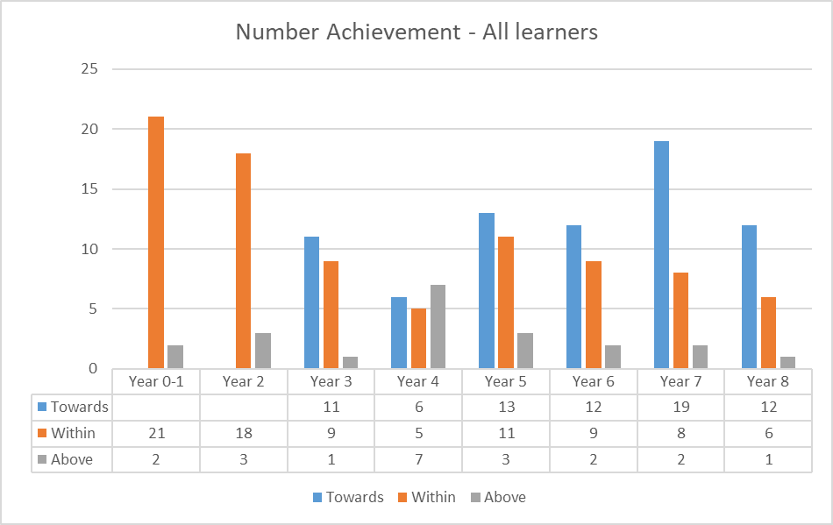

This graph shows the comparison between BLENNZ print and braille learners.

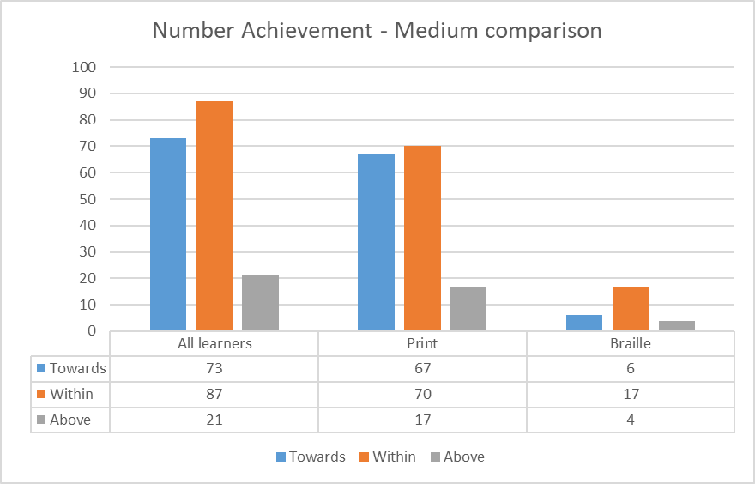

This graph breaks down the year levels of the braille learners. We are exploring two areas coming out of the data. What is are access issues for learners and what learning needs to pre-taught with tactile graphics.

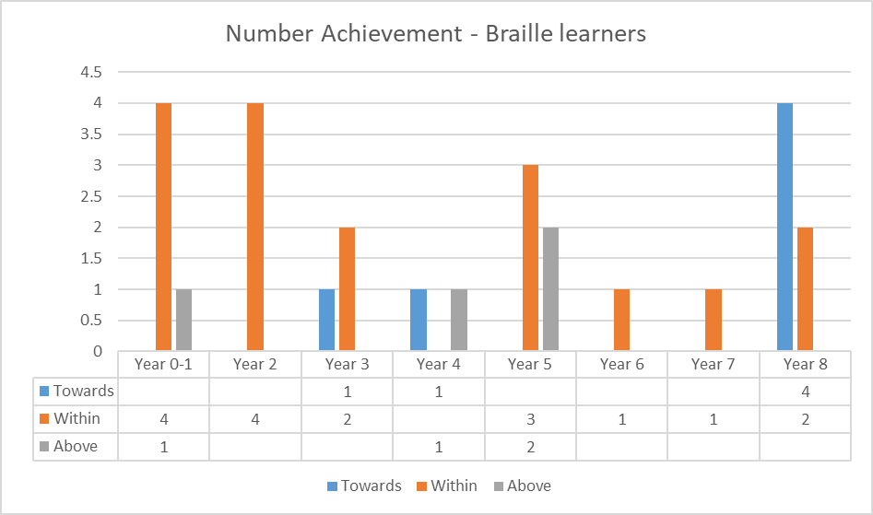

# Process Indicators

## Student Achievement

### Teacher assessment skills in literacy

**BLENNZ Braille learners 5 – 12 years who are participating in a conventional literacy programme and acquiring literacy through touch**

* BLENNZ teachers working with learners acquiring literacy through touch 5 – 12 years who are participating in conventional literacy programmes, will demonstrate the required skills in carrying out a Running Record assessment.

### Targets

1. All braille users from 5 – 12 years old participating in conventional literacy programmes will have their reading age assessed and documented by their BLENNZ teacher using the Running Records diagnostic assessment.

**Target achieved for 90.9%**

1. All teachers undertaking this assessment have demonstrated their competency.

**Target achieved**

**BLENNZ ORS verified learners with low vision who are 5 – 12 years and participating in a conventional literacy programme**

* BLENNZ teachers working with ORS verified learners who have low vision from 5 – 12 years old who are participating in conventional literacy programmes, will demonstrate the required skills in carrying out a Running Record assessment

### Targets

1. All ORS verified learners with low vision from 5 to 12 years old participating in conventional literacy programmes will have their reading age assessed and documented by their BLENNZ teachers, or in partnership with the classroom teacher / SENCO, using the Running Records diagnostic assessment.

**Target achieved for 99.3%**

1. All teachers undertaking this assessment have demonstrated their competency

**Target achieved**

**Teacher Skills in Assessing and Accessing Appropriate Technology for Learners**

**School Learners across all age bands**

* Report on success rate for assistive technology applications to the Ministry of Education in support of curricula access for BLENNZ learners

### Target

1. A 100% success rate with assistive technology applications for 2019.

**Target achieved**

### Reporting

The assessment and procurement of assistive technology for BLENNZ learners remains an essential undertaking to ensure learners have access to their 21st century learning environments. A range of technology and software has been approved. The emphasis remains on promoting inclusive environments for all learners.

# Assistive Technology Applications 2019

| **Term** | **New Equipment** | **Replacement** | **Total** |
| --- | --- | --- | --- |
| 1 | 15 | 3 | 18 |
| 2 | 27 | 8 | 35 |
| 3 | 19 | 11 | 30 |
| 4 | 36 | 7 | 43 |
| Total | 97 | 29 | 126 |

## Hardware includes:

A range of technology was applied for which included the following:

* iPads in a range of sizes
* MacBook
* Polaris Braillenote
* BrailleSense U2
* Windows laptop

A wide range of accessories were applied for. They included:

* Noise cancelling headphones
* Carry cases
* Bluetooth keyboards
* Personal printers

## Software includes:

A range of software was applied for to support the hardware. These included:

* Dolphin guide
* JAWS
* TypeAbility
* Zoomtext

A range of applications were also applied for to support access on iPads. These included:

* Voice Dream reader suite
* Clicker 4
* Scanner pro
* PDF expert

## Student Engagement in Learning

Quality of Teaching – An on line survey approach was used in 2019 to gather the responses to service delivery as perceived by EC centres, schools, parents and caregivers. The following tables provide an analyses of these responses.

### Quality of Teaching

#### BLENNZ Surveys to Schools / Centres – Early Childhood – 9 Responses

**The chart shows column scales in percentages on the survey response to BLENNZ Visual Resource Centres endeavour to respond promptly to requests for support to blind or low vision children.
Excellent 44.44%, Very Good 11.11%, Unsatisfactory 11.11%, Comment 33.33%.**

BLENNZ RTV provide information to families, schools and centres in the form of visits, advisory/teaching reports and in-service training.
Column scales in percentages:  Excellent 55.56%, Very Good 11.11%, Satisfactory 22.22%, Unsatisfactory 11.11%

Overall Comments – service delivery was seen as very positive however greater frequency of visits was requested.

#### BLENNZ Surveys to Schools / Centres – Moderate – 29 Responses

Overall Comments – more support is requested at the beginning of a school year as is increased access to resources.

#### BLENNZ Survey to Schools / Centre – Vision Only – 31 Responses

Overall Comments – Greater support was noted in respect to adaptations and resources.

#### BLENNZ Survey to Parents / Caregivers – Early Childhood – 7 Responses

Overall Comments – Service delivery was seen as positive.

#### BLENNZ Survey to Parents / Caregivers – Moderate – 20 Responses

Overall comments – Service delivery was appreciated and seen as positive.

#### BLENNZ Survey to Parents / Caregivers – Vision Only – 12 Responses

Overall Comments – a concern was noted when there was a change in RTV which was considered difficult for all.

# Other Educational Settings

This includes Immersion Courses, National Assessment Service and Developmental Orientation and Mobility. The following information related to all BLENNZ learners involved in these programmes.

## Immersion Courses 2019 – Compulsory Sector

### Target

1. Provide 16 Immersion Courses in 2019.

**Target achieved**

### Reporting

* 16 Immersion courses were delivered in 2019
* 26 Parents participated in 5 courses
* 118 ākonga have been engaged in immersion courses with 30 of these attending more than one course.

### Overview of all courses:

| **Term** | **Ākonga** | **Staff** | **Parents** |
| --- | --- | --- | --- |
| **Term 1**  **4 courses were provided** | A total of 28 ākonga attended. | 21 BLENNZ RTV have attended immersion courses.  9 x specialist tutors have been involved in 3 of the courses. | 3 parents participated in 1 course. |
| **Term 2**  **4 courses were provided** | A total of 41 ākonga attended. | 29 BLENNZ RTV have attended immersion courses.  11 x specialist tutors have been involved in 2 of the courses. | 9 parents participated in 2 courses |
| **Term 3**  **3 courses were provided**  **(measles outbreak)** | A total of 22 ākonga attended. | 22 BLENNZ RTV have attended immersion courses.  7 x specialist tutors have been involved in 4 of the courses. | 7 parents participated in 1 course |
| **Term 4**  **5 courses were provided** | A total of 27 ākonga attended. | 26 BLENNZ RTV have attended immersion courses.  6 x specialist tutors have been involved in 0 of the courses. | 7 parents participated in 2 course |

### Compulsory courses

* Conduct ākonga and/or parent surveys of Immersion Course participants to determine the level of satisfaction with the programme.

### Target

1. 90% of ākonga and parents surveyed evaluate the programme as appropriate in terms of course content and the positive learning outcomes experienced.

**Target achieved**

In 2019 surveys were received from 118 ākonga at the end of each course they attended. Feedback was as follows:

1. The course was valuable to me

|  | Strongly agreed or agreed |
| --- | --- |
| Ākonga | 100% |

1. The course was appropriate in terms of course content and the positive learning outcomes experienced

|  | Strongly agreed or agreed |
| --- | --- |
| Ākonga | 100% |

Surveys were received from all parents at the end of the courses they attended. Feedback was as follows:

1. The course was valuable for me in terms of course content and with positive learning outcomes experienced.

* 100% found the course very worthwhile
* 100% recommended that this course be held for other families in the future
* 100% liked the pace of the course.

|  | Strongly agree | Agree | Partly agree | Disagree | Strongly disagree |
| --- | --- | --- | --- | --- | --- |
| Parents | 100% |  |  |  |  |

1. The course was valuable for my child in terms of course content and with positive learning outcomes experienced.

|  | Strongly agree | Agree | Partly agree | Disagree | Strongly disagree |
| --- | --- | --- | --- | --- | --- |
| Parents | 100% |  |  |  |  |

Conduct a follow-up survey of a sample of ākonga, parents and teachers (class or RTV) to determine levels of usefulness of resources that accompanied the immersion course.

Target

1. **100%** of ākonga, parents and teachers surveyed evaluate the resources as appropriate and the content has been useful following the course.

**Target achieved**

# Immersion Courses for Early Childhood

## Knowledge, Skills and Values

### Process Indicators

#### Target:

Provide 4 Immersion Courses in 2019.

**Target met**

* 3 Early Childhood Immersion courses were delivered in 2019
* 28 Parents / Caregivers participated in these 3 courses
* 17 ākonga have been engaged in Early Childhood Immersion courses

### Overview of all courses:

| **Term** | **Ākonga** | **Staff** | **Parents** |
| --- | --- | --- | --- |
| **Term 1**  **1 course was provided** | A total of 4 ākonga attended | 7 BLENNZ Staff attended this course  3 x guest speakers were involved in this course | 7 parents / caregivers participated in this course |
| **Term 2**  **1 course was provided** | A total of 8 ākonga attended | 8 BLENNZ Staff attended this course  2 x guest speakers were involved in this course | 15 parents / caregivers participated in this course |
| **Term 4**  **1 course was provided**  **(instead of 2 due to the measles outbreak)** | A total of 5 ākonga attended | 3 BLENNZ Staff attended this course  3 x guest speakers were involved in this course | 6 parents / caregivers participated in this course |

### Early Childhood courses

* Conduct ākonga and/or parent surveys of Early Childhood Immersion Course participants to determine the level of satisfaction with the programme.

**Target**

100% of ākonga and parents surveyed evaluate the programme as appropriate in terms of course content and the positive learning outcomes experienced.

**Target met**

Surveys were received from all parents at the end of the courses they attended.  Feedback was as follows:

**February**

1. The course was valuable for myself and my child in terms of course content and with positive learning outcomes experienced:

* 100% found the course worthwhile
* 100% recommended that this course be held for other families in the future
* 75% liked the pace of the course.

**Target met**

**June**

2. The course was valuable for myself and my child in terms of course content and with positive learning outcomes experienced:

* 100% found the course worthwhile
* 100% recommended that this course be held for other families in the future
* 100% liked the pace of the course.

Conduct a follow-up survey of parents / caregivers to determine levels of ongoing value of the immersion course.

**Target**

Of the follow-up surveys received, 100%of parents gave positive feedback on the value of the immersion course.

**Target met**

**November / December**

1. The course was valuable for myself and my child in terms of course content and with positive learning outcomes experienced:

* 100% found the course worthwhile for their child
* 100% found the course worthwhile for themselves as a parent / caregiver
* 100% found the information received during the course worthwhile

A follow-up survey is yet to be conducted of parents / caregivers to determine levels of ongoing value of the immersion course.

# National Assessment Service (NAS)

## Background

The purpose of National Assessment Service is to provide professional assessment of learners based on a transdisciplinary model involving a team of educators, clinicians and therapists who bring their skills and knowledge to a collaborative assessment process in areas of the regular and expanded core curriculum.  They also focus on the goals of parents to support improved outcomes for learners.  In addition, the National Assessment Service provides professional development for Resource Teachers of Vision and learners’ wider teaching teams.

## Cumulative Data - 2019 Referrals

| **2019** | **Term 1** | **Term 2** | **Term 3** | **Term 4** | **Total** |
| --- | --- | --- | --- | --- | --- |
| 73 – 75 complex assessments (range of specialists) | 19 | 14 | 19 | 12 | 64 |
| 300 – 315  Clinic assessments (not including full) | 22 | 32 | 17 | 29 | 100 |
| Other assessments (one off)-one or two NAS areas | 22 | 13 | 19 | 22 | 76 |
| Total | 63 | 59 | 55 | 63 | **240** |

## Caregiver Surveys

In 2019, 42 caregiver surveys were returned**.**  The rating is as follows:

1= Excellent, 2 = Very Good, 3 = Satisfactory, 4 = Poor, 5 = Very Poor

Target is 95% and is rated by a score of 1-3 therefore 100% of target was achieved

| **Caregiver Surveys** | **Excellent** | **Very Good** | **Satisfactory** | **Poor** | **Very Poor** | **Target is 95% and is rated by a score of 1-3** |
| --- | --- | --- | --- | --- | --- | --- |
| Question 1 | 39 | 3 | 0 | 0 | 0 | 100% of target |
| Question 2 | 39 | 2 | 1 | 0 | 0 | 100% of target |
| Question 3 | 37 | 3 | 2 | 0 | 0 | 100% of target |
| Question 4 | 41 | 1 | 0 | 0 | 0 | 100% of target |

Some of the comments made in the Caregiver surveys follows:

## Questions: Sample Responses

### How appropriate and relevant were our assessments and verbal suggestions?

* Very well communicated and adapted to T’s individual needs and requirements.
* Everything was explained really clearly and solutions that we were not aware of.
* Assessments and verbal suggestions were well organised, thoughtful and respectful towards myself and L. Very supportive, thank you
* Assessments were thorough and directed to the areas we had identified. Verbal suggestions were enough to understand without being overwhelming.
* All assessments and suggestions were very good. Some suggestions were expansions of what we were always practicing, always work towards exploring new thoughts and ideas for our progression assessment return
* The assessments and subsequent advice has been invaluable and of great assistance for us going forward.

### How effective was our communication throughout the assessment process?

* Great clear communication right through the whole process. Every effort was made to meet the needs of the whanau.
* Communication was excellent, we felt listened to and not talked down to. Beautiful staff.
* Everyone who L and I came in contact with was respectful and communicated well with L, altering communication techniques to captivate and maintain L’s attention.
* Great, really good to have a sample timetable well in advance and a wealth of information provided in various forms-written, website, video link etc. Very good communication at the start of each session. Open communication. Clear and easy to understand.
* Couldn’t fault the communication. The organization was amazing and the telephone call before the visit was really useful.

### How timely was this assessment, in respect to the referral and the learner’s needs?

* It was great that R had a very quick acceptance for referral and managed it well with him.
* Was fine, gave us lots of time to plan around our family, teacher aide, timing was perfect.
* We found it a better option to complete assessment after T had started school as we had some experience o base questions on.
* Referral process was prompt and a smooth process since the time of referral.
* Timing was good-especially as D was just about to enter his teenage years and prepare for transition to college.
* Assessment was earlier than expected (within a couple of months of the referral) this made timing even better for both A (child) and R (mum).
* Impressed by how soon we were given an appointment once A’s referral was accepted.
* Very fast. We so appreciate S’s RTV initiating the NAS assessment and BLENNZ making this happen so quickly.

### How well did we meet your individual and cultural needs? Did you feel listened to and respected?

* I felt it was a great idea to do this NAS so that we could benefit and have a good understanding what we need to do for R from the young age. Everything was culturally appropriate.
* The staff have been amazing, both informative, caring, not once have they made us uncomfortable to talk or express ourselves.
* Each assessment was great. I was asked at each session if I found/needed or was concerned about anything.
* Both L and I felt our individual needs were respected. I myself was very impressed with how staff and fellow students interacted with L
* Staff were approachable and friendly. It was good to have A’s RTV attend as a local support person.
* Yes, I was very impressed by the empathy, patience and kindness by all professional staff.
* Very well. Some staff used Te Reo which was awesome and some even used sign language.

### Is there anything else you would have liked covered in the assessment?

* Fantastic, everything was well looked at.
* All covered and much appreciated
* A little longer session for ADL. A paediatrician session.
* No very happy with all aspects of the assessments coverage.
* No. There were more professionals present than expected. Very impressed by how the whole experience worked so well.
* Could sessions be split across the 3 days more to have less on day one
* I can’t think of anything but the thoroughness of the sessions has been outstanding.

### Please add any further comments, including suggestions to improve our assessment process

* I think personally it was very excellent/appropriate/well communicated and to me felt very comfortable/relaxed and included in. Thanks everyone involved in the assessment process. They have been informative, providing support, answer to questions. We have been able to relax be open and honest with the staff and gain reassurance and things to implement to help H. Also it has been amazing to have the support of S, which has made this experience stress free.
* Thanking you all for the excellent service, assessment and all what you do for my boy and all.
* Loved being here, the teachers/assessors were so kind. We found it so insightful. The support and resources are amazing.
* L and I would like to thank all of the staff for making this process and experience enjoyable. Even more so due to new environments being overwhelming for L. Everyone including the library, kitchen, reception, immersion and assessment staff and students have created an experience we will never forget.
* Absolutely Fantastic! Gained so much information, ideas. Brilliant service. Thank you, thank you, thank you!
* We would like to come back yearly to further learning not only for A but for ourselves. Continue to practice Awhinatanga, Kotahitanga, Whanaungatanga, Ako me te aroha hoki. Nga mihi nui kia koutou katoa nga Kaimahi o Nga Uara o BLENNZ
* Incredibly grateful to have had this invaluable experience. It has been very worthwhile. A great place with wonderful people. Really enjoyed making friends with kids that are blind as well. A real privilege. We will miss this place. Thank you so much for the opportunity
* This course has been very reassuring actually learning about what M is facing physically and really pleased with the attention given.
* Very consistent messages and valid differences between the disciplines

## Professional Surveys

In 2019, 35 professional surveys were returned**.**  The rating is as follows:

1= Excellent, 2 = Very Good, 3 = Satisfactory, 4 = Poor, 5 = Very Poor

Target is 95% and is rated by a score of 1-3 therefore 100% of target was achieved

| **Professional Surveys** | **Excellent** | **Very Good** | **Satisfactory** | **Poor** | **Very Poor** | **No Comment** |
| --- | --- | --- | --- | --- | --- | --- |
| Question 1 | 27 | 8 | 0 | 0 | 0 | 0 |
| Question 2 | 30 | 5 | 0 | 0 | 0 | 0 |
| Question 3 | 31 | 3 | 1 | 0 | 0 | 0 |
| Question 4 | 28 | 6 | 0 | 0 | 0 | 1 |

Some of the comments made in the Professional Surveys follow:

### Questions:

#### 1. How appropriate and relevant were our suggestions to support this learner (in your role as RTV)?

* These were very helpful in terms of knowing where to from here in being able to best support L and his family. I will be able to refer back to them throughout the year and make any changes to my programme as needed.
* Working together on the formulation of suggestions really allowed the NAS team to provide realistic and accurate suggestions. I felt well supported by all concerned, especially knowing that I have worked with H for many years.
* The suggestions were helpful in relation to my learner’s physical and mental health (and there were concerns around these that needed addressing). In my role as RTV I had been concerned about my learner’s ability to get around his school and community safely, due to his visual condition. The NAS assessment allowed W to spend time with a qualified DOM who discussed strategies he could use to safely cross roads (this had been a concern of W and his Mother).
* Both mum and I were thrilled to have some really practical ideas “of where to next”. The ideas were practical and very relevant as we were concerned about how to get him over the self-harm stage when he doesn’t want to do something
* The final report had detailed, specific strategies, ideas and recommendations that were also shared during the assessment. These are relevant and ongoing to ensure activities and experiences support the learner
* I think as RTVs we need to be very aware of the implications of gross motor development and the links to all developmental areas especially if the ākonga are going to be tactile/auditory learners. RTVs need to understand why we have to begin very early and put the emphasis on these key milestones, when intervention /referrals should happen, know how to help facilitate, work through resistance and be able to explain to families what the implications of these key gross motor steps will have on future development and learning.
* Comments were both appropriate and relevant and supported an IP meeting where they were shared with the Kindy and W’s Early Intervention Teacher and ESW

#### 2. How effective was the communication throughout the assessment process?

* I appreciated the time before the Assessment to share thoughts and throughout. At one stage P and I took time to share a video of D and this was helpful in sharing information on a child who was very difficult to assess due to closing down in assessments.
* Everyone explained what they were doing and why before and during each session. We were given a brief summary at the end of each session about what they had observed with a more comprehensive one in the final report.
* Wonderful, lots of information shared at the time it was happening and in conversation towards the end of each session.
* Questions, queries and comments were encouraged and opened up further dialogue relevant to the learner.
* During each session specialists would provide verbal feedback either directed at RTV, Parent or student depending on the content. The finial meeting with Sue is very well constructed and enables families to process and consolidate what was covered over the 3 days. It was a positive conversation with a focus on K’s strengths, likes and next steps for the future
* I found communication was excellent with the team involved through the week, but I have to admit at the start, because I had never been to Homai before and I was not given direction when I arrived, it would have been good to have a person (perhaps the office lady) to show me to my accommodation, or give me some guidance.
* I knew what was happening the whole way through, and, all communication is friendly, approachable and supportive. Communication was great from start to finish, from everything including receiving the timetable in advance to regular updates when we were there. Someone checked in with mum throughout each day which was very helpful. I was totally impressed and I know that mum has been so appreciative with the service that they are getting through BLENNZ and the NAS team. Communication was fantastic with a father who wasn’t that sure about coming but really enjoyed the whole process.

#### 3. How timely was the assessment in respect to the referral and the learner’s needs?

* Just after ORS verification and great preparation/information for sharing with the school team. Physio timing great as at a point where there needed to be some changes made re orthotics.
* There have been many communications with D’s school regarding his difficulties and questioning whether this was indeed a visual concern. NAS was a final resort to try and address this question.
* It was excellent timing as L transitions to high school 2019.
* The assessment was able to happen in the term following the referral which was great as my learner did not have to wait too long to go to NAS
* L has not been making progress and I was running out of ideas, so very timely. Especially around technology and O&M.
* Because M does not have any early intervention support between her visits to NZ this referral was very relevant particularly at such a critical stage in her physical development. Her parents needed to have the big picture to truly understand the importance of developing M’s core strength, hand strength, crawling, getting in and out of sitting, before she walks.

#### 4. How well did we meet the individual and cultural needs of the learner and their family?

**Did they feel listened to and respected?**

* Very respectful in every way, listened to a long and detailed ‘story’ and responded in a caring way.
* I know that the family were very appreciative of the warm welcome that they received and with how each of the specialists dealt with them. Questions etc. were directed to Nan and L and occasionally when needed to me so the majority of the information being given to the assessment team was coming from the family.
* K fed back to both RTV and myself how impressed and grateful she was for the way that her and T’s needs were considered and embraced.
* I observed mum getting more and more comfortable on day one. I’m not sure any parent is really knowledgeable about what an organisation is like until they are immersed but I know she loved the experience and the wrap around service for S and herself.
* One question the family did ask was “how do you get other family members on board who don’t necessarily understand the importance of developing independence?’ This has made me reflect on needing to talk more with the family about this and who is in M’s daily life, what they do with her and how culture may impact on this.
* In terms of the actual report K said the sections with photos were better because she could show her partner who wasn’t able to attend, what A did over the 3 days and explain better some of the suggestions given. She said the photos also reminded her about what A had done, as there was a lot to take in over a short time and it becomes a bit of a blur.
* The NAS team accommodated the family well and meet them at their level. There is a lot of wide family conflict going on and to have a supportive environment was really great for the family. I think a lot of things shared by the family had probably not been discussed before.

#### Is there anything else you would have liked covered in the assessment

* I think at the time what was covered was what was needed in terms of where L is with his vision.
* As mentioned previously more joint assessments. I also think it would be valuable to do some sessions in the HECC. Gendy did her session there and it felt more natural and relaxed for both M and her parents. They spoke and asked more questions in this session, though this may have been because they were mid-way through the assessment and generally feeling more relaxed. My observation was that it seemed easier in this environment to get more active involvement/engagement from the family and it was more in context. M had some play sessions during down times in the HECC and I think it would be useful to have videoed some of these, so skills not seen in previous sessions could be observed.
* If we were able to get glasses as part of the assessment or confirm what will be funded through Enable that would be great. I know this is a whole different area.
* No, very comprehensive. It makes such a difference to have a whole team working together for the assessments
* Being able to have visual fields mapped would be very useful. There are a number of learners with a reduced visual field and often this not looked a locally. For some learners, not this one, they appear to meet the ORS criteria under this area but it is challenging for an RTV to accurately assess this and many medical professionals do not assess this area.

#### Has the report confirmed or extended your knowledge of the learner

* Certainly (as always) a fantastic opportunity to have so many assessments completed in a short timeframe, and to have the record of assessment results and suggestions from the team. This gives opportunity for the impact of various aspects of the learners’ visual needs to be considered in a different way to what is possible in an RTV’s infrequent visits to an advisory learner.
* It has given me a great document to refer to and share with other professionals working with S.
* It was reassuring to find out that L has a complex array of issues which needed a number of professionals to help and support to move forward.
* The report has done a bit of both. It has confirmed what was identified in terms movement and vision. I came away with extended knowledge of how these two factors are impacting on each other for L. Not having his new glasses meant we were unable to identify the extent to which they would improve his vision. However, hopefully the family have a better understanding that they will make some improvement to his vision.
* Extended my knowledge of C considerably. I didn’t realize he had such high visual needs, as he appears so capable, and it is fantastic having so much precise information now in all areas, and plenty of things I can work on with him. Also I can now feel more confident sharing my knowledge about C’s needs with teachers, TAs, other agencies etc.
* From the assessment process, it has been decided that W will start by learning print, his tactile skills will continue to be explored and extended in the event that he will be a braille user in the future. He will learn to touch type. His core strength has been reviewed, a physio has returned to work with W. Games have implemented to improve core strength and tactile development.

#### Please note any changes made as a result of the assessment process

* At H’s IEP this term, I was able to recommend a change in approach in our planning and adaptions of her program, because I had the support of NAS report.
* As a result of the assessment process we strongly recommended a referral to CAMHS upon the learner’s return to school and this was discussed in the learners IEP meeting that was held within a short time after NAS.
* Yes in many ways. We have an opportunity to see the learner outside the school setting. I now have a better understanding of K’s strengths, skills and challenges. I also have a clear picture of what tools are needed so that K can assess the curriculum independently. Observing the FVA provided greater insight into K’s posture when using his near vision. Importance of using a stand with his iPad and also how additional lighter improved his visual reach. Information about dome magnification options proved extremely helpful also. The important aspects contained in the NAS report have proved very informative and useful when completing his recent ORS report and Assistive Technology application.
* A has a gesture dictionary and all those working with her are much more ‘on board’ with using tactile signs or the objects of reference before they change activities.
* Being part of this assessment and seeing how much more confident and inspired it made those caring for A and the changes this has led to has been one of my favourite experiences this year. I also learnt so much that I could use with A as well as with many other learners.
* Print size, use of glasses, bifocal glasses, balancing near and distance activities, ways to support A with behaviour and understandings about his learning during the school day, physical programme followed.

# Developmental Orientation and Mobility

Survey results summary: (Survey raw data needed manual review due to some unanswered questions skewing analysis).

Format: Survey monkey questions with comment space emailed to all VRCs with request for 3 learners’ cases to be surveyed for each centre. Surveys to be offered to parent, learner, team members (i.e. RTV, teacher, TA etc)

Respondents: 23 total. 7 parents; 6 learners; 6 RTV; 4 teaching support.  NB: sample is not considered sufficient to inform.

| **Question** | **Responses summary** | **FOI requirement** | **Question purpose** |
| --- | --- | --- | --- |
| The BLENNZ DOM Service emphasizes enskilling as many people as possible to support learners. Do you feel this will improve DOM programmes? | 21 responded:  81% said yes; 19% not sure;  2 did not answer (disregarded) | 90% feel positive  Not met | Monitor feelings toward moving to collaborative model |
| From your knowledge who has been involved in the provision of Developmental Orientation and Mobility (DOM) with you or the learner? | 22 responded:  81% family; 95% Specialist; 86% RTV; teacher 18%;  TA 50%; other 18% | 90% note not just specialist  Indicates yes met | Monitor shift to more than specialist provision of service.  A range of people involved is noted here indicating more toward collaborative programming |
| Please rate, and below comment on, how timely contact and support was provided to you by those involved with your DOM Programming | 22 responded:  91% noted very good or excellent; no poor ratings. | 90% satisfactory or better  Met (100%) | Monitor perceptions of BLENNZ DOM service provision timeliness. |
| Please rate, and comment below on how useful the forms of communication from those providing your DOM Programme were | 22 responded:  77% noted very good or excellent; 1 poor rating (anonymous parent-no comment given). | 90% satisfactory or better  Met | Monitor perceptions of how useful the BLENNZ DOM service’s communication was to programming |
| list the forms of communication you received to share information and strategies (tick as many as needed) | 21 responded:  ftf; specialist report, learning story; RTV reporting/sharing specialist report; phone; email; other | 90% report more than 1 form of communication  Indicates met | Monitor that BLENNZ DOM Services uses a range of formats and avenues to communicate |
| Please rate, and comment below on, the consistency and quality of communication from those providing your DOM Programme | 22 respondents:  91% very good or excellent | 90% satisfactory or better  Met (100%) | Monitor consistency and quality of communication across the BLENNZ DOM Service |
| How well do you feel those involved in your DOM programme understood and endeavored to meet the agreed DOM Goals? | 22 responded:  91% very good or excellent | 90% satisfactory or better  Met (100%) | Monitor perceptions of team understanding and work toward goals |
| Please rate and comment below on the usefulness of the programme. | 22 responded  86% very good or excellent;  1 did not answer (disregarded) | 90% satisfactory or better  Met (100%) | Perceived usefulness of programming |
| Do you feel the BLENNZ Development Orientation and Mobility Service has made a difference? | 21 responded:  93% very good or excellent;  2 did not answer (disregarded) | 90% satisfactory or better  Met (100%) |  |

**Sample comments:**

RTVs:

“Specialist validated that we were on target”

“Specialist listened, is professional and knowledgeable”

Enskilling others works “if everyone is involved and understands the programme it has to help the implementation.”

Parents:

“Specialists need to provide the programme”

“To my knowledge this service has been very helpful and informative for the schools.”

Enskilling others “It will become easier for learners to gain more knowledge and skills. It will become easier for learners to gain more knowledge and skills.”

“I think when trying to establish a relationship with a new family it is a good to either meet face to face or spend some time talking on the phone until a shared understanding of the families’ values are present.”

“I remain unconvinced by the model of service delivery”

Learners:

“I learnt new strategies that I would not have known of if I hadn’t done the programme.”

“Yes it was useful. Otherwise I wouldn't be able to get anywhere else like the new playground”

Teaching Support:

“Email communication excellent. In person everything explained well.”

# Statement of Resources

## Physical Resources

The BLENNZ Homai campus is sited on 55 acres of crown land.  Also situated on this site is the Blind Foundation’s Guide Dog Centre and Fale Kotuku (Pacific Island Services).  Some of the land is currently leased through the Ministry of Education to a farmer; however, the leased land is expected in time to become the site of the new Secondary School for Te Wharekura o Manurewa.

The property redevelopment was completed in 2012. Some work on the grounds was undertaken in 2013. Plans were drawn up and work commenced at the end of 2014, on the Outdoor Learning Environment. Stage 1 was completed in 2015.

School buildings comprise:

* The main building:

* Homai Campus School

* National Assessment Service

* National Special Formats Library (BLINK)

* Auckland Visual Resource Centre

* National Administration

* Early Childhood Centre

* Residential building:

* Long stay residential students

* National Assessment Service accommodation for visiting families

* Immersion course accommodation

* Main kitchen

* Whare Titoki (Residential Transition Programme building).

Remaining facilities include:

* School House (Ministry of Education has given permission for this building to be used for visiting staff and parent accommodation). Renovations to this building were completed in 2012.
* Swimming Poll. A building review as undertaken in 2017, and project planning commenced, for a total refurbishment and/or rebuild of the swimming pool building. Initial designs and costs were completed in 2018. During 2019 detailed plans were completed and council consent initiated, with the intention that building would be completed by the end of 2020.

The on-site national special formats library is partially funded by the MOE but continues to be governed and operated by the Blind Foundation.

Section 70: Property Occupancy Documents for Visual Resource Centres are being established with the local schools where each VRC is based. Maintenance of VRC buildings is the responsibility of the local school Board of Trustees. The rebuild/refurbishment of Visual Resource Centres is part of the Sensory Resource Centre Capital Works Programme.

The Taranaki Visual Resource Centre was upgraded in 2014, the Hamilton Sensory Resource Centre rebuilt in 2015, and the Tauranga Sensory Resource Centre rebuilt in 2016. Since 2017 Visual Resource Centre building redevelopment priorities have been Wellington, Palmerston North, Northland and Otago. Wellington was completed early 2019. The Palmerston North base was also completed in 2019 but will not be utilised as a base until the start of 2020. Work on the Northland and Otago bases continued during 2019, with expected completion dates in 2020. The development of a resource centre and satellites in the north of Auckland (Scott Point) and Pukekohe (Belmont) commenced, as part of the new builds in 2019. It is expected these will be open early in 2021.

As at 31 December 2019, contract staff included the services of a braille music teacher, speech language therapist, physiotherapist, occupational therapist, Paediatrician, Ophthalmologist and Optometrist.

## Other Resources

The Homai Early Childhood Centre Education Trust is located on the BLENNZ Homai Campus. Formerly part of BLENNZ, at the direction of the Ministry of Education it became a separate entity during 2006 with its own Board of Trustees, referred to as the Homai Early Childhood Centre Trust (HECCT).

## School Roll and Days Open BLENNZ

The RS32 1 July roll of the BLENNZ Homai Campus School was 42, however the school roll fluctuated during the year with a number of ākonga enrolling as the year progressed, as well as some ākonga being withdrawn from the roll through either leaving or being transitioned to their local school.

The school was open for the whole school year.

# Administration Services

Administration Services provide support to each of the education services within BLENNZ. It includes administration, personnel (including Novopay support), finance and property.

## Health and Safety:

### 2019 Summary

* 2019 Health & Safety Goals established with a mid-year review carried out in July and end of year review carried out in November.
* Health and Safety is placed on team meeting agendas throughout the BLENNZ Network.
* Review of Emergency Procedures – Homai Campus Fire Evacuation in respect to Out of Hours Procedures and the establishment of Severe Weather Events for the national network.
* A national hazard audit was carried out mid year in respect to the Risk Assessment Registers and review of randomly selected registers by the committee during meetings of the National Health and Safety Committee.
* Annual audit carried out by Harrison Tew, Emergency Planning specialists in respect to Senior Leadership Training (including the ongoing revision of the Lockdown Procedures and Pack, annual updates to the Emergency Plan and updated information provided to emergency services.
* The BLENNZ Wellbeing Committee met termly during the year and are now well established in terms of being the forum for wellbeing consultative processes and lead direction for managing wellbeing issues as well as addressing operational matters where appropriate.
* Workers are now recording their Health and Safety professional development by completing their own Health and Safety Training Plan and Record. The information from these Plans is then transferred to the Training and Certification section within Safety Monitor.
* Notifications sent nationally or regionally to staff by email or through the School Links Emergency Messaging system around emergency events continues to be greatly valued.
* During the termly fire drills at the Homai Campus reference to the Sign In, Sign Out tablet has been valuable in terms accounting for everyone on the campus.
* Accidents and Incidents are reported at each H&S Committee meeting with queries followed-up with those concerned. A summary of accidents and incidents reported in 2019 will be prepared for tabling and discussion at the first meeting of the National H&S Committee in February 2020.
* Participation in the New Zealand Shakeout exercise on the 17 October.
* Child Matters course held on the 8th November for new employees and as a mop up course for those workers that had missed attending and completing a previous course.
* Staff participations in the On-line Induction Programme throughout 2019.
* Reporting on National Health and Safety is provided to the BLENNZ Board of Trustees at each board meeting.

**Health and Safety Goals 2019**

| **Key Component 1: Leadership** | **Outcome** |
| --- | --- |
| **Goal 1:**  Continue to raise the profile of Health and Safety by providing opportunities to BLENNZ staff to become aware of their responsibilities under the Act. | **Partially actioned**   * Survey actioned around induction in general wherein people had to state whether they were in the process of induction or it had been completed. * The transfer of Health and Safety information from the Generic Drive (G Drive) to the BLENNZ Hub is in progress and will be completed by the end of the year. * Health and Safety has been woven into the Induction Process. |
| **Goal 2:**  Review of Emergency Procedures in relation to Severe Weather Events. | **Achieved**   * Procedures for Severe Weather Events have been established for the BLENNZ Network and have been distributed to Managers for presentation at team meetings and feedback. |
| **Key Component 10: Professional Development** |  |
| **Goal 3**  Staff encouraged to participate in and complete the BLENNZ Health and Safety Induction as evidenced in the completion of their Health and Safety Training Plans | **Achieved**   * As Health and Safety Training Plans from across the network are received they are inputting into Safety Monitor. |
| **Annual Ongoing Goals**  **Key Component 5: Workplace Management** |  |
| **Goal 4:** Emergency Drills are carried out throughout the year with staff understanding their responsibilities for:   * Fire * Earthquake * Lockdown | **Achieved**  Emergency drills have been carried out through the year for the Homai Campus and regions. |

## Policies:

The Board reviewed and approved the following policies in 2019:

* Board Review
* Principal’s Performance management
* Disciplinary Process in Relation to the Principal
* Conflict of Interest
* Health and Safety
* Reporting to the Board
* Board Induction
* Board Meeting Processes and Procedures
* Relationship between the Board and the Principal
* School Policy Framework

All policies listed for review in 2019 on the Board Policy Review Schedule were completed.

The BLENNZ Policy Review Committee has met regularly during the year to review operational policies and procedures in line with the 2018-2020 Operational Policy Review Schedule. Operational policies reviewed and approved (including some that commenced in 2018) are:

* Succession Planning
* Payments by Parents of Ākonga
* Reimbursement of Expenses
* Handling and Transfer of Ākonga
* Ākonga Mental Health and Wellbeing
* Managing Ākonga attending BLENNZ Programmes
* Simulated Vision Loss
* Administration of Medication
* Ākonga Mental Health and Wellbeing
* Intimate Care
* Staff Alcohol
* Ākonga Alcohol
* Drug Free
* Infectious Diseases
* Support for Ākonga in Cases of Physical Illness
* Traumatic Incidents
* Communication and Social Media
* Transportation of Ākonga in BLENNZ Vehicles
* Lone Worker and Personal Safety
* Te Tiriti o Waitangi
* Informed Consent for Specialist Service Provision
* Environmental Best Practice

The following are awaiting final review and sign off:

* First Aid
* Surrender and Retention of Property and Searches (and Procedures)
* Homai Campus Specialist/Therapist Workload Management

Due to the large number of operational policies requiring review (currently 87 in total), it is likely the 3 year review cycle will be extended to a 4 year cycle, with policies pertaining to Government legislation being reviewed every four years, the exception being when Acts of Parliament are updated. This should help to make the schedule more manageable.

## Compliance:

The following compliance requirements were undertaken in 2019:

* All staff appointments follow processes as outlined in the Delegation and Staff Appointment and Recruitment policies. All staff appointed to positions are being safety checked prior to commencing employment. Under the new regulations safety checking involves identity verification, information requirements, risk assessment and periodic re-assessment every three years. Current non-teaching staff are police vetted on a three yearly cycle. As each review falls due, staff are also being identity checked to ensure we meet compliance under the Vulnerable Children’s Act 2014.
* Police vetting of teaching staff occurs during their teacher registration process. As registration falls due, teachers are also identity checked.
* Police vet checks of volunteers is also undertaken.
* The Blind Foundation ensures police vetting of Library staff is undertaken.
* Contract staff are also police vetted e.g. Paediatric Therapy (Physiotherapists, Occupational Therapists, Speech Language Therapists) and Clinicians (Paediatrician, Optometrist, Ophthalmologist).
* A database is kept, and regularly reviewed, to ensure all teachers are registered in accordance with the requirements of the Teacher Registration Board and the Education Act.
* Teacher salary increments are linked to the requirement to meet professional standards as outlined in the performance appraisal cycle.

## Legislation:

BLENNZ complies with both the Privacy Act and the Public Records Act in all matters relating to the collection, storage, use and disclosure of personal information as they affect both ākonga and staff. The Privacy Committee has met twice in 2019 and reviewed the policy and procedures. The procedures now include a declaration that must be signed by staff to acknowledge that they have read and are aware of their obligations and responsibilities. We are continuing the process of getting all current staff to complete this. The policy and procedures are also now included in documentation that is provided to all new staff prior to them commencing employment.

BLENNZ complies with the Copyright Act 1994. Copyright licensing for print, music, television and radio is current for the compliance period under review and has recently been renewed for the period 1 July 2019 – 30 June 2020.

All procedures in terms of guidelines for enrolment and stand down procedures are followed in accordance with Section 20 of the Education Act 1989. This includes receipt of Section 9 Agreements from Ministry of Education for all ākonga enrolled at the Homai Campus school.

## Property:

Monthly checks for building Warrant of Fitness requirements continue to be undertaken for the Homai Campus and the stand-alone Visual Resource Centre in Tauranga. In accordance with audit requirements the long term maintenance plan (LTMP) has been updated. Safety checking of electrical goods on the Homai Campus takes place annually, with equipment checked on a cyclic basis. The Regional Network has also commenced this process.

Building WOF for Visual Resource Centres located in local schools is the responsibility of the school.

## Assets:

The fixed asset schedule continues to be reviewed on a two yearly cyclical basis with the Homai Campus one year followed by national bases in the second year. To meet audit requirements copies of invoices for all fixed asset purchases are kept for checking off against the accounting service provider (Education Services) asset schedule for depreciation purposes. Any assets that are stolen, lost or beyond repair are notified to Education Services at year end so that the schedule can be updated in time for the annual audit that takes place between March-May each year. A separate IT replacement cycle has been created to create a more streamlined system for BLENNZ nationally. Work commenced in 2019 of an additional IT replacement plan for assets related to national infrastructure requirements.

# BLENNZ Full 2019 Variance Report on the Annual Plan Goals and Objectives

## Strategic Goals:

### Transition - Ākonga from the start of secondary through to the end of compulsory schooling.

| **Objective** | **Who** | **Objective** | **Progress / Outcome** |
| --- | --- | --- | --- |
| 1. | Senior Manager  School and Residential | Conduct an inquiry, which will engage with a cross section of ākonga (past and present), parents, members of the teaching team and sector partners. | **Achieved**  Information/voices was gathered from a cross section of akonga, parents, teachers and sector forum members. The information was themed and taken forward to form part of the of the Sprint Process.  The Sprint took place in Wellington in April formally faciliated by What it Takes (WiT) and comprised members from across the national network with an outcome of five areas to focus on for transtion nationally.  The voices continue to be gathered of ākonga present and past and parents through focus groups and interviews. This information will continue to inform the process. |
| 2. | Senior Manager School & Residential and Coordinator Immersion | Through a co-design process, develop BLENNZ long and short-term transition, immersion and residential programs to effectively meet ākonga need. | **Achieved**  Four ideas were developed from the themed feedback of a cross section of voices and the outcomes of the SPRINT process were consulted on and revised. These areas are: protoypes for a transition framework which includes a range of options for access, an initial conversation, mentoring and online information. Following the initial design process the focus moved to further developing the concepts and planning how they may be further developed.  The four ideas that emerged and were consulted on were:   * An initial conversation followed by annual review from point of transition to secondary * Transition Framework - curricula * Online content * Mentors.   They will be introduced in a step by step process throughout 2020, 2021.  Planning is well underway for 2020 to introduce some of the initiatives that came out of the Sprint. In alignment with the outcomes of the sprint process, the cohort of learners for the short term Future Planning Immersion for 2020 course has shifted from years 12 and 13 to years 9 and 10 where the initial conversation around transition was identified as needing to take place. This will be taken to the wider network next year after it has been trialled in term 1 with the immersion course. |
| 3. | Senior Manager School & Residential and Coordinator Immersion | Develop a shared and agreed process for ākonga transition, from the start of secondary to the end of compulsory schooling. This will be achieved through BLENNZ leading a working group, which will be informed by the gathering of data from those ākonga who have left the school system and the voice of sector partners.  . | **Achieved**  The initial phase of this work has been achieved in 2019. Significant progress has been made in this area. This objective is still in progress as this is now seen as the first of a three year plan.  This year has focussed on developing a framework for the transition process. Planning is well underway for the year long residential programme on the Homai campus. A reference group of Resource Teachers Vision from around the country came to Homai Campus where a workshop was held to further develop the year long programme. This has also been shared with secotr partners and with BF staff leading transition. Specific programme content focus for each term has been developed with the input of RTV in light of the themed feedback from the many voices thathave been gathered.  Term 1 – Lets think about you and your future  Term 2 – Lets get you out and about  Term 3 – Lets develop your ADL skills  Term 4 – Lets develop your ADL skills.  Week long immersion courses are also proposed. The content for these courses will complement the year long programme.  The initial conversations will begin to be introduced in 2020 and existing initiatives developed in 2020 by a range of centres will continue to be provided based on ākonga need and demand.  The appointment of a National Transition Manager from the Blind and Low Vision NZ was made in the third quarter. Meetings with the National Transition Manager have occurred to discuss roles and to identify ideas where both organisations can work in collaboration. He is also taking the opportunity to engage in existing courses. The meetings are ongoing with planning underway for collaboration in relation to working in partnership with aspects of the year-long transition programs and immersion programs.  There have also been some discussion around mentoring for some ākonga and how Blind and Low Vision NZ may be able to contribute to this work. |

### Wellbeing - Ākonga for whom BLENNZ is the primary provider.

| **Objective** | **Who** | **Objective** | **Progress / Outcome** |
| --- | --- | --- | --- |
| 1. | Senior Manager School and Residential | To initiate the self-review process at BLENNZ Homai Campus School. | **Achieved**  During term 3 a third year social work student had a placement at Homai Campus School. During this time she surveyed 16 ākonga from the school and residential. Questions included whether they felt safe at school and whether school provided them the strategies and resources to support their wellbeing physically and emotionally. The ages of the ākonga ranged from 5 to 21 years. The surveys were done individually with the student asking the questions and then writing down the ākonga response.  14 students commented that they felt safe while two felt uncomfortable due to raised aggression and arguments (ākonga). The counsellor was noted as a positive contact while others noted a staff member. Most said they managed their emotions through music or ignoring them.  Since the interviews there have been some group work on emotions and social skills. Those in Nikau have an identified Youth Worker allocated to them individually.  The survey is to be retaken at the end of the year to identify if interventions taken have made a difference. |
| 2. | Principal Senior Manager Assessment and Teaching | To inform our practice by liaising with and learning from:Ministry of Education AdvisorsSensory School practitionersSpecial School practitionersEducational researchers and other schools for the blind who are working in this area.Readings and research relevant to the work. | **In progress** Given emerging material from the Ministry of Education and new initiatives from the UK have not progressed to final stage and recommendations. Likely to continue into 2020 building on what is shared / seeded at the BLENNZ staff conference.   * Readings and research have been collated and will be located on the Hub (BLENNZ intranet). * We have been in liaison with a range of parties, gathering resources, to inform this work including: * Ministry of Education – including the latest online links and resources * Sensory Schools Principal who has identified and linked key practitioners in regular settings and residential leading this work. * Participation at Wellbeing Conference in September by two senior staff who will present at staff conference. * We have also been in liaison with Barry Coughlan, University of Limerick and Barry Carpenter, Professor in Mental Health, Oxford Brookes University. * Wellbeing is the primary focus of the BLENNZ staff Conference January 22 & 23.   Ministry of Education have released further information in support of this work in the second half of 2019. |
| 3. | Principal | To gather the perspectives of a range of voices to assist us in developing a shared and collective understanding of wellbeing for this cohort. | **In progress** There are many voices to gather. In 2019 the voices of 16 ākonga within Homai Campus School were captured along with 45 ākonga attending secondary. The latter group provided their reflections in response to:   * What does wellbeing mean to you? * What does wellbeing as a vision impaired person mean to you?   Their responses have been analysed and the aggregated findings will be shared with the wider leadership.  Across the network teams are initiating activities and strategies to promote wellbeing these need to be collated and shared in the new year to raise awareness of strategies that are positively making a difference.  At the recent Sector Forum the community representatives supported a focus on unpacking ‘Wellbeing’ to be the focus of the Blindness Education Forum in 2020. The emphasis being on unpacking wellbeing from a range of perspectives. This will inform BLENNZ about the role it may play in promoting wellbeing of ākonga. |
| 4. | Principal | To identify potential pilots of enhanced practice for 2020, which have the potential to be trialled through individual and collaborative inquiry process. | **Partially Achieved** This term the current initiatives that centres have already initiated are being gathered and shared with a view to promoting wider adoption of those activities that have had a positive impact. Pilot has been identified and committed to for 2020.  Barry Carpenter has invited us to be part of a UK study which is piloting an app to support Student Emotional and Mental Health (SEMH) promotion and data gathering. Jane Thistlethwaite will be the lead facilitator for this. It can be used to focus on areas such as:   * Being kind to others (SDQ) * Having fun (SBA) * Feeling proud (Resilience, flourishing) * Building strong relationships (Attachment theory). |

### Succession

| **Objective** | **Who** | **Objective** | **Progress / Outcome** |
| --- | --- | --- | --- |
| 1. | Principal and SMT | To understand our current situation anddevelop a plan to reduce risk in thisperiod of change. | **Achieved**  This is the first phase of an ongoing plan to regularly review and actively manage risk generated by succession.  Senior Manager Administration provided an overview of all staff across BLENNZ and the potential risk in relation to entitlement to retire. The potential areas and degree of risk was shared with the Senior Managers. Employment processes were then considered and implemented to minimise that risk resulting in positive change for the four teams identified as having high or high to medium risk. |
| 2. | Senior Managers | To ensure all new staff complete an induction process, which is reviewed annually and revised for the following year. | **Achieved** Induction content for the package was revised following a review last year and dialogue with new RTV / DOM staff providing feedback at regional meetings. Online content includes text, PowerPoints, talking heads, quizzes and links to documentation and material across the network systems.  Access is now provided to an online induction workshop which is now up and running for all new staff. Staff are now completing an online induction process, the online content is complemented by face to face dialogue with their line managers and delegated team members.  The data to track that every new staff member is undertaking this and where they are in the process is being gathered by one of our national administrators. Once we are assured that this is tracking all staff effectively we will then embed this as an automatic part of the process following appointment.  Feedback has been very positive. |
| 3. | Senior Managers | To embed a process which annually plans to document and share practice through:SecondmentSharing of inquiries  * Teams and curricula leaders documenting and capturing material for the hub.   Teams sharing of success stories. | **Achieved**  This is an ongoing process which will continue to be strengthened overtime.Processes are in place to ensure practice is documented and shared on the BLENNZ intranet. This has included the secondment of two RTVs in the area of communication plus liaison with outgoing staff members for the purpose of informing induction programmes. In 2019, they have developed and written content for the Hub that is available for all teachers in the BLENNZ network regarding the teaching and implementation of tactile graphics and mathematics. This has included PLD across the network.  BLENNZ National Assessment Service have provided professional learning for 20 RTVs in Functional Vision Assessment and Observation.  Further information about Septo Optic Hypoplasia, Albinism is currently under development.  DOM team provided 5 courses for the teaching team raising the number of staff who have successfully undertaken the supporters course to 50%.  Content has been provided in the area of Deafblind and professional learning focussed on raising awareness of who may have access issues related to being deafblind, this included raising awareness of the agreed definition.  The AT application process was actively shared across the team and ongoing support is provided as requested. Information was also provided to the MOE assessors to support them to understand the needs and range of solutions that may be considered when evaluating an AT application.  Documenting practice is occurring through regular use of the Hub.  Curriculum leaders liaise with teams to encourage sharing of inquiries locally (which is detailed in centre minutes) and regionally which occurred at Regional Days across the country.  Celebrations of success are evidenced in newsletters, centre minutes and at IEPs. Success stories are also available on the website and included in newsletters and in the Annual Report. |
| 4. | Principal | To enhance the culture of our organisation by making explicit the way in which we partner with ākonga, whānau and our colleagues internally and externally. | **Achieved**This year’s objectives are near completion, themes from end of year workshop anticipated by end of term. This is the first year of a three year process. What it Takes has been contracted and a three year workplan developed. The first phase of this has progressed well during 2019 and a review has occurred to set the program for 2020.  In the first year work has focussed on:   * Finalising the transition work initiated last year, this culminated also in the SPRINT – facilitated by WiT. * DOM team who are nearing completion of a program to continue to enhance partnership within their team and the interface with other teams. * Work with the Early Learning Service to develop a program that can be used internally for professional capability building on – empathetic partnerships with purpose. * WiT have been working with the Wellington, Nelson and Palmerston North teams. * Work has continued with members of the senior leadership team on both a 1:1 and team basis.   The final meeting with the wider leadership team took place on 11th November where we captured our learning to date, this feedback is being themed to draw out:   * where we are in our development of this practice and * the key learning and components that will become the BLENNZ guide to working in empathetic partnerships with purpose. |

## Operational Goals

### Partnerships/Organisational Relationships

| **Objective** | **Who** | **Objective** | **Progress / Outcome** |
| --- | --- | --- | --- |
| 1. | Principal & Senior Management  Team | To work in partnership with MOE Learning Support leaders to ensure BLENNZ and MOE maintain a clear and shared understanding of our respective roles and responsibilities. | **Partially Achieved**   * We have met with MOE Learning Support (LS) senior staff in Early learning and agreed the need for this work. * MOE and BLENNZ have mapped the BLENNZ Early Learning strategy with the MOE LS framework. * A Sensory School meeting took place in September where the interface of LS and ourselves was discussed. The initial points of contact at a local level were recommended as these are at very early, and different phases across the country. * Further conversations are planned for 2020 as the changes in Learning Support continue to develop and new roles such as Learning Support Coordinators and Facilitators begin to take effect. |
| 2. | Principal Coordinator Kaupapa | To improve the interface between Kāpō Māori Aotearoa (KMA) and BLENNZ. | **Achieved**  There has been significant improvements in this area in 2019. Some of the evidence of these improvements are listed below:   * Attendance of KMA CEO at bilingual immersion Te Kuia me te Pūngawerewere. * KMA accessing Te Reo Māori audio description for use by BLENNZ ākonga. * Meeting with Kelly and Karen both at Homai and in Heretaunga. * Invitation from KMA to run an art session and hold a static display at biannual conference. Both these were successful. * Working with KMA CEO to co-construct how we share information about the roles and responsibilities of BLENNZ and KMA. * Referrals from KMA for BLENNZ services for three ākonga. * KMA CEO would like to work on the 2020 Te Reo Māori and audio described production with support from BLENNZ.   Next steps - With support from KMA, work to develop successful relationships with iwi connected to BLENNZ Visual Resource Centres. |
| 3. | Principal | To establish a regular interface with Sector Partners to enhance the flow of information on a no surprises basis. | **Achieved**  Although slow to get underway have held meetings with:  Regular meetings are taking place with ākonga/ whānau focussed groups:   * Kāpō Māori Aotearoa, CEO Chrissie Cowan (also with Coordinator Kaupapa) * PVI, CEO David Heather (have included Senior Manager Assessment & Teaching Services).   Contact with others is less frequent, however working relationship is effective:   * Blind Citizens NZ, CEO Rose Wilkinson (Phone dialogue and face to face meeting) * Deafblind Aotearoa – no meeting at this time. Interface has been directly related to work around deafblind. * Liaison has also occurred with Albinism Trust. |
| 4. |  | To facilitate partnerships with DECs that develop pedagogy and practice in deafblindness. | **Partially Achieved**  Offers made to both MOE learning Support including Advisor of Deaf Children (AODC) and Sensory Schools have been accepted.  Mark Douglas (AODC head at MOE) closely communicated with by Patrick to begin to line up term 4 meeting to present to Learning Support key personnel, this has not occurred at this time.  Presentation was made to the Principals of The DECs who have requested engagement with their team in 2020 to raise awareness of this community of ākonga. |

### Workforce Development

| **Objective** | **Who** | **Objective** | **Progress / Outcome** |
| --- | --- | --- | --- |
| 1. | Coordinators | To continually develop resources which clearly articulate and curate effective practice in blindness education pedagogy and practice. | **Achieved targets for 2019**  **Sensory Efficiency – Sue Arrojado**  A definition has been established by Steve Bellamy as part of his inquiry work over previous years. This along with a mind map and link to the eye conditions work is in the process of being put on the Hub.  Assessment and Resources for Teaching and Learning are also being developed with much of the work on G Drive, it is now just moving it from G Drive to the Hub. Modules for Assessment of Learners who are able to use formal tests have been completed. These are currently on the G Drive available to all staff but also will be put on the Hub.  **Achieved targets for 2019**  **Communication – Ali Prskawetz**  We have looked closely at three areas of the communication strand this year. Tactile. Graphics, Mathematics and Augmentative communication. Mathematics and Tactile Graphics have been worked on for a the last 2 years and this year we focused on completing and pulling together all of the resources that we have developed. These areas developed an online space for materials to be collated and stored a living repository for online resources. This has included updating existing materials and developing new materials. The maths supplementary. Guide. Has been revised and updated. Tactile graphics the Kiwi lines tactual program Part 1 and 2 have been developed alongside the BLENNZ Pedagogy of Tactile graphics and has been completed. A mind map has been developed and completed as the platform for the online spaces. All three of these areas have an online space on The Hub which has been completed ready to be shared across the Network. Some of these areas will also be shared on the BLENNZ Website. This is a living space that be added to a developed further.  **Partially Achieved**  **Access – Karen Gilligan**  This area continues to be developed with The Hub being the main space for resources and support. The main focus has been ongoing work around accessible documentation with a mixture of professional development for staff – individual, small groups and large groups. It has been very heartening to see staff development continue within this area and I believe this is key to impacting wider change within education.  Work continues around the move towards digital assessments within school. We are partnering with NZQA and NZCER to do testing in this area to ensure a shared understanding of what is necessary for accessible digital assessments. We are specifically focusing on the needs of ākonga – in terms of technology solutions and skill development, and the procurement and design of digital assessments – ensuring decisions are made with access in mind. This journey is being shared within The Hub so that all staff are aware of what is happening in this area.  **Achieved targets for 2019**  **Deafblind – Saul Taylor**  To better inform the development of PLD and resources specific to learners with deafblindness, it was necessary to capture a national picture of learners with a combined vision and hearing status. Internal processes and systems on how we collect, and curate hearing data were required. The Learner Profile and the categories in eTAP were reviewed (clinically approved by educational audiologist PP) and changed to include clinical hearing information and status, hearing supports and services, devices for hearing access, receptive and expressive communication modes and sensory channels for learning. This data will assist in collecting, curating and utilising the information to inform and create targeted PLD and resources. Hopefully, the data will also influence a review of the BLAF system and national consistency of service delivery for learners with deafblindness.  A shared understanding about hearing, hearing reports, hearing devices for access and hearing supports and services continue to be shared via the Hub. At this stage, resources this year have leaned towards general hearing information. During the BLENNZ conference January 2020, 3 workshops will be run about the diversity of deafblindness, research on tactile communication, and understanding hearing devices, this will provide a snapshot of deafblind learners across the network and the key professional learning needs for RTVs at this time. As visibility and awareness about hearing status continues to develop, more specific and targeted PLD and resources on the compounding nature of deafblindness can begin to occur in 2020.  **Partially Achieved for 2019**  **Transition – Jenny Ayden**  The focus this year has been looking at the transition curriculum and developing a structured 4 term programme which can be differentiated to meet ākonga needs. The programme will be used in both long term and short term transition courses. Future planning is for modules to be developed for ako on line to allow ākonga to connect with the structured programme and transition curriculum.  A mind map has been developed for transition from school on the Hub and this is currently being populated with resources and links to related support agencies and resources as well as research findings related to blindness education in the area of career and future planning, transition from school.  **Partially Achieved**  DOM content for the hub has been collated within Gdrive and will be uploaded.  **Achieved - Early Learning**  Early childhood pedagogy and practice extends across all areas of the curricula. 2019 has seen a focus on developing and collating early childhood resources that will benefit new RTV, and having a centralised system for all RTV to be able to locate significant resources. Documents have been reviewed, rewritten and aligned to meet BLENNZ values and beliefs, and the philosophy and pedagogy of BELS.  A mind map provides a visual representation of the areas of early childhood pedagogy and practice populated to date on The Hub. |
| 2. | Curricula Leaders | Curricula leaders will identify who is undertaking inquiry and / or leading practice in the curricula area and establish mechanisms for sharing and partnerships. | **Achieved targets for 2019**  Sensory Efficiency – Sue Arrojado  Senior Teacher NAS has developed modules which have been shared with RTVs attending Functional Vision Assessment PLD and are currently available on G Drive, soon to be on the Hub also. Further links to others undertaking inquiry in this area are happening, a Manager who has done her inquiry on Keratoconus is sharing outcomes with Coordinator NAS and our ophthalmologist and optometrist on 25 November. Further sharing of information will take place at the BLENNZ conference. CVI inquiry including Waitaha project CVI definition are mentioned in objective 4 & 5 below.  **Achieved targets for 2019**  Communication – Ali Prskawetz  Tactile graphics has been led by Trish Bishop she has already implemented a two day workshop at the beginning of year she is also presenting at the BLENNZ and SPEVI conference on Tactile graphics to support emergent literacy the BLENNZ way. A tactile library of 145 of levelled instruction readers, sequence books for each letter of the alphabet and alphabet books have been developed this will continue to grow.  Mathematics has been led by Diane Glynan and myself we have worked with Julie Roberts from NZCER. We have delivered National and target PLD across the Network to upskill Teachers in the implementation of Gloss And Jam assessments for the priority learners. We have developed Large print and tactile versions of these assessments. We are gathering our first round of data from this work this month. In 2020 we will be rolling out more PLD for the Base school and the selected Maths Leaders across the network. This will be looking at the data we have collated and developing next steps in assessing our learners developing a consistent tactile assessment to compliment the GLOSS and JAM resources  **Achieved targets for 2019**  Access – Karen Gilligan  I have worked during 2019 with the leadership team to develop resources for staff leading inquiry areas around the network. This has involved working alongside staff leading curricula/pedagogical areas as well as the staff they have identified as undertaking inquiries in these specific areas.    This work has seen the development of curricula and pedagogical areas with content to support staff at all levels across BLENNZ. BLENNZ is rich in knowledge and content around the country, across many areas of curricula and pedagogy and this work has brought much of this into a shared space for everyone to access.    The Hub is also developing as a space where people can share their Inquiries across the network. These are quick and easy to set up and provide an opportunity for people to share and test their ideas, while developing content for a range of audiences.  **Partially Achieved targets for 2019**  Social skills have been embedded into every Immersion course this year with a lot of work being done around the building of groups and maintaining the connections for students who have attended Immersion courses. The Youth Working Team from Whare Nikau have worked on a number of courses focussing on team building and social skills and this will be expanded on in 2020. This has had a positive impact on whanaunatanga for ākonga and whanau who attend these courses. The focus on The Hub has been the sharing of research articles and trying to develop a national conversation regarding the importance of social skills for our ākonga. In 2020 we will be looking to form a social skills inquiry group to be headed by an RTV with a particular focus in this area. The Social Skills curriculum area of The Hub now has the Social Skills chapter from Stepping Stones as the first landing point for the pedagogy section of the mind map which details the proposed population of the area and during 2020 more information will be added to flesh out the other areas.  **Achieved targets for 2019**  **Deafblind** – Saul Taylor  Learners with deafblindness make up the third community alongside blind and low vision ākonga, who BLENNZ supports and serves. Working alongside learners with deafblindness and whānau requires targeted, evidence-based ways of practice that acknowledge the uniqueness and diversity of the community. Pedagogy for deafblindness stretches across all of the curricula areas and is a significant aspect in the key areas that the leadership team have been developing: sensory efficiency, communication, social skills, transition, access and early learning. For example, what does transition look like for a learner with deafblindness who includes sign language as his/her communication system? Or what are the specific learning needs for a two-year old with deafblindness who uses touch and proximity as their primary learning channel and how do we support his/her family? Or how do we best communicate and work alongside Deaf and Hard of Hearing services with a eleven-year old BLENNZ learner who uses bilateral hearing aids and a remote mic as he/she moves to another school?  Building national capacity and consistency involves the creation of a network of Resource Teachers Vision who currently work or have a passion for working with learners with deafblindness. Currently, a group of BLENNZ staff who attended the 17th Deaflbind International World Conference in Australia on the 12-16 August, 2019 continue to provide deafblind input in their respective positions across the network. These include members who represent Homai school, VRC manager, BELS, VRC coordinator, NAS and RTV. Widening the circle of representation to involve VRCs and RTVs across the country is one of the next steps in establishing partnerships and information sharing. This has connections to the annual plan goal and objectives and the action steps for deafblind PLD/resources for 2020.  During 2019, presentations on BLENNZ deafblind inquiry, the resulting demographics and next steps have been shared internally with the DOM department and externally with the two principals of the DECs and head of Advisors on Deaf Children/MOE. In addition, the Hub contains sections for deafblind content: Deafblind Pedagogy and the workgroup, Deafblind Learners. These will be two spaces online where BLENNZ staff can access current ideas and research as well as ways of working that have been proven throughout the history of deafblind education.  **Initiated**  **Transition** – Jenny Ayden  The transition co-design process and outcomes were shared at each of the Regional Days. After which a request for expressions of interest for staff to be part of a reference group as we progress through the initiatives in the National Transition Proposal. A workshop was held at Homai Campus where 10 staff contributed in further developing the transition curriculum. This is to be a 4 term structured programme which can be differentiated to meet ākonga need those This will be trialled in the year long programme and the four short term transition focused immersion courses during 2020. There will be continued reflection and input from members of the reference team as the year progresses. Consultation and collaboration will also take place with sector partners.  **Achieved**  **DOM**  DOM - group inquiry, led by Kay, with the theme reflecting on the service to move forward has included: WIT theming what’s going well and what we can reflect on to move forward interviews from the DOM Specialist team; how we are prioritising learners and next steps; our experiences with training; comparisons of time specialists spend in various activities; assessment tools and how we can evolve these; bitrix use by DOM team; review of Homai campus DOM service and how it fits with network team; where we are at with leading motor development and next steps with RTV courses.  The DOM team are presenting their various aspects in January DOM meeting and co-ord bringing group inquiry together for end term 1 2020.  **Achieved - Early Learning**  A significant focus of the development of BELS has been the shift toward early childhood focused RTV. Over the course of 2019 centres have moved from many of their RTV “dipping their toes” into early childhood, to employing or selecting one, or a small number of RTV to be the centre’s key RTV for early childhood. This has enabled these kaiako to engage in early learning pedagogy and practice, thus benefiting ākonga and whānau. Literature has unequivocally shown that the employment of early childhood focused staff is paramount to effective services.  All early childhood focused staff have this year participated in a BELS Staff Programme, involving 3-days of participatory, active learning. This has been followed-up with ongoing learning and sharing through monthly Zoom meetings between each of the BELS Staff Programmes participants and the BELS team.  Two RTVs relatively new to BLENNZ were recognised for their pedagogical knowledge of early childhood practice and engaged to each support one aspect of the BELS Staff Programmes. Two other experienced RTVs also supported the delivery of the programmes. Engaging an ex-RTV through contract work has had significant benefit for the newly developing BELS team.  Collaboration between Auckland EC RTV and BELS resulted in strengthening of relationships and development of an initial PATH.  A survey of EC focused staff identified areas of knowledge of individual RTV, as well as gaps in early childhood pedagogy and practice. Having this knowledge enables us to provide contacts between RTV seeking information or support.  A survey of early childhood inquiries was undertaken this year and RTV undertaking these inquiries encouraged to present their findings at the BLENNZ Conference.  A further outcome of the work across the network this year has been an understanding of the need to develop strategies to engage the leadership team in early childhood pedagogy and practice – to believe in, to advocate and to support the initiatives of BELS. |
| 3. | Coordinator  Early Childhood | To establish an outreach service to enhance practice in early learning to strengthen effective practice across the network. | **Achieved**  Planned outcomes have led to the establishment of BELS services. Progress has been made toward shared philosophical understandings of whānau centred participatory practice, BELS Principles and related outcomes of effective practice for early childhood kaiako. This has occurred through three BELS Staff Programmes occurring over 2019, with ongoing monthly Zoom meetings between participants and BELS staff, and encouragement to engage in three dedicated BELS Workgroups. While not yet universal across all early childhood kaiako within BLENNZ, the pedagogy and philosophy of BELS has been well socialised and continues to evolve and be understood, which will result in better outcomes for ākonga and whānau. Evaluation of the outcomes of the programmes will occur in 2020.  BELS have trailed a variety of communication options including Zoom, Hub Workgroups, BELS newsletter, phone connections, and a dedicated BELS email helpline to engage EC RTV. Zoom meetings have drawn the highest involvement. |
| 4. | Coordinator  National Assessment Service | To develop our practice in identification and assessment with a focus on cerebral vision impairment. | **Achieved – first phase of this work**  A definition has been developed and shared with BLENNZ staff at regional days. The PowerPoint for this is available on the Hub. A resource on CVI has been developed and includes current international classifications of CVI. It was completed and shared in May 2019. The definition was also shared at the meeting with MOE on 6 June.  A review of current international knowledge and practice relating to assessment and interventions for ākonga with CVI and no additional challenges (CVI Classification 3) has been completed and shared, May 2019.  Regular meetings have taken place throughout the year to document progress and review the scope and direction of the project.  The information available to date is now with Coordinator Digital Access eLearning to be put on the Hub under CVI. Next steps are currently being documented. |
| 5. | Coordinator National Assessment Service and Christchurch Visual Resource Centre | To complete assessment process for ākonga and work collaboratively with Waitaha to develop a process to build confidence and competence of their teaching team. | **Achieved targets for 2019**  A review of what is currently happening at special schools in the Auckland Region re: vision screenings, to support and inform the Waitaha school project took place in February and NAS.  Waitaha Specialist School’s professional learning and development sessions have been completed with positive feedback from staff and the Principal. 16 surveys were completed. Results were extremely positive and comments about what the staff found helpful included;   * case studies of a number of Waitaha children; * resources that can be used; * how to engage students who use tactile and aural strategies to engage and make sense of the world; higher understanding of learner need; * different visual impairments and ways to engage students who are auditory and tactile learners.   Suggestions for further learning included:   * visiting the satellite classes to provide insight on students outside base school; * creating tactile/auditory learning environments and programmes; * how to accommodate movement disorder when teaching through tactile channels, some electronic pictures of resources.   Communication with an ophthalmologist’s PA has been taking place to clarify outcomes for the 8 children referred as part of the Inquiry process last year (The optometrist referred these learners for further follow up). One child is still to be seen as parent cancelled the appointment.  A discussion with the RTV who is delivering service to Waitaha has given feedback on how this PLD has influenced practice within the school and outcomes are very positive with referrals being made and several new learners identified as meeting criteria for the BLENNZ roll. Teachers and therapists in the school are asking great questions and implementing ideas from PLD as well as creating their own resources and ideas.  A meeting with Principal of Waitaha, Principal of BLENNZ and Coordinator NAS will take place on Monday 2 December at BLENNZ Christchurch to look at next steps.  The RTV who supports Waitaha school and Coordinator NAS will be presenting at the BLENNZ Conference outcomes of this project to inform future work with specialist schools. |
| 6. | Senior Teacher  National Assessment Service & Coord VRCs | To be able to clearly and accurately identify BLENNZ ākonga who are deafblind. | **Achieved targets for 2019**  **Saul Taylor – liaising with Patrick Pink**  Senior Teacher NAS and Coordinator VRCs have obtained a national picture of learners with deafblindness. 10% of the BLENNZ roll have a permanent hearing status in combination with their vision status. We now also know that 50% of BLENNZ deafblind learners are in regular school settings, and a further third are in special schools. The Learner Profile and eTAP have been reviewed and changed to include clinical hearing information and status, hearing supports and services, devices for hearing access, receptive and expressive communication modes and sensory channels for learning. This will assist in collecting, archiving and selecting data to inform future PLD, resources, funding and service delivery. |

### Systems / Resources

| **Objective** | **Who** | **Objective** | **Progress / Outcome** |
| --- | --- | --- | --- |
| 1. | Coordinators | To establish and maintain a comprehensive catalogue of all BLENNZ learning resources. | **Partially Achieved**  **Ali Prskawetz**  A considerable amount of progress has occurred during 2019. The Resource Catalogue Librarian has worked with staff nationally to set up systems and provide PD. 12 of the 14 VRCs have been trained in the use of the system, as well as staff in the Homai Campus School, with more than 5000 items currently catalogued.  This year 11 of 13 centres have been visited and training given. (Not including Homai). Well over 5000 items have been added to Accessit. This maintenance work ensures we are maintaining a high standard of cataloguing that benefits all staff using the catalogue. New collections added include kits, FVA, musical instruments and poetry cards. This means staff can now add their own items to these existing records, which saves time. This work is important to our online catalogue as it provides an easy search tool for staff. This ensures the same, updated information is being accessed by all staff who work in centres, to help guide them when cataloguing.  The establishment of the initial catalogue of curriculum resources is time consuming so this will be an ongoing piece of work in 2020. |
| 2. | Senior Manager  Administration | To incorporate all of BLENNZ IT / AT resources into the catalogue. | **Partially Achieved**  **Bridget**  The focus for 2020 has been to ensure we have captured all IT/ AT / ICT infrastructure items on the asset register with all relevant information documented to enable effective planning to inform replacement cycles.  The intention in 2020 is to also catalogue and bar code all BLENNZ IT resources, integrating this into the Accessit system used for curricula material. |
| 3. | Senior Manager  Coordinator Communication | To fully implement the roles and responsibilities of a Prescribed Body. | **Partially Achieved**  **Ali Prskawetz**   * BLENNZ is working towards all requirements under the Prescribed Body status which has now changed to an Authorised Entity now the Marrakesh Treaty is signed off by government. * A new copyright Bill has been passed through parliament in the last month. With this in mind we are developing a national system. * We have developed a BLENNZ work flow matrix and registry system and are currently working through a national process. This is supported by guidelines to inform staff of their respective responsibilities in complying to Authorised Entity status. * Once this is developed we will work through this with support from our affiliated partners. |

### Property

| **Objective** | **Who** | **Objective** | **Progress / Outcome** |
| --- | --- | --- | --- |
| 1. | Principals Deaf Education Centre and LSM | To have a mutually agreed process (between MOE, DEC and BLENNZ) confirmed to implement the appropriate agreements for all Centres and Satellites.  This will be achieved by a MOE Property person taking responsibility to lead the implementation or updating of agreements nationwide. | **Achieved targets for 2019**  Points of contact from the three parties have been identified:   * DEC – Principal and EO * BLENNZ – Principal and SM Admin or SM Admin drawn in as required dependent on agenda. * MOE have identified a senior person within the property team whose role is to oversee this work nationally– Stephen Cross:   + Stephen draws in others to inform the work as appropriate.   Face to face meetings have occurred to clarify the existing situation and these are now scheduled as monthly meetings, with plans of action developed around specific areas of need e.g. ICT, Property Occupancy, Capital Works.  Property Occupancy Agreements have been prioritised, with a view to confirm a process and work on agreements for Awapuni; Kelburn; Riselaw; and Northland are underway. These will inform process for remaining sites.  MOE are recognising some of the internal barriers and aim to have new process minimise these by providing increased guidance to regional property teams and initiating process in partnership with Sensory Schools.  The Sensory Schools provide information at various times throughout the year to a number of different groups within MOE. A request by us for MOE to maintain a national spreadsheet tracking all elements of work has been agreed to. This has been populated by Sensory Schools and will be updated on a regular basis. |
| 2. | Principals Deaf Education Centre and LSM | To have a mutually agreed process (between MOE, DEC and BLENNZ) confirmed to review, action and complete the Sensory Schools Capital Works Plan. | **Achieved**  As above, points of contact from the three parties:   * DEC – Principal and EO * BLENNZ – Principal and SMAT * MOE – Stephen Cross   Recently completed - Wellington VRC and Palmerston North Sensory Centre at Awapuni School.  Current projects include:   * Tikipunga, Northland Sensory Resource Centre * Scott Point Satellites/Visual Resource Centre * Belmont Satellites/ Visual Resource Centre * Riselaw, Otago Sensory Resource Centre * Awapuni, Palmerston North Sensory Resource Centre   The entire national spreadsheet for all sensory school property has been reviewed twice during the year. With ongoing progress of prioritised projects and emerging priorities discussed at the National Sensory School Property meeting, convened monthly by MOE. Follow up in relation to matters raised has been undertaken by MOE effecting some positive change re communication. Prioritised projects for 2020 have been identified.  Further review required in the near future to prioritise for 2020. |

# 2019 Audited Financial Statement

(Refer to separate audited Financials)