Board of Trustees Policy: Delegations (NAG 3)

Blind & Low Vision Education Network NZ

Statement of Intent:
The Board of Trustees is ultimately responsible for all the activities and outcomes within the Blind & Low Vision Education Network NZ (BLENNZ).
The Schedule of Delegations sets out those responsibilities that can only be exercised by the Board, the responsibilities delegated to the Principal, and those responsibilities that the Principal can delegate to specified staff positions.
The purpose of the Schedule is to ensure that the effectiveness of the governance and management of BLENNZ is maintained, to provide an agreed basis by which BLENNZ’s executive management can exercise its responsibilities, and to enable the responsibilities delegated to be monitored. It is the Board’s expectation that delegations made will be properly exercised and the persons who hold such delegations will be held accountable. If these principles are observed then the Board can be certain its responsibilities in terms of the Education Act 1989, the Crown Entities Act 2004 and the Financial Reporting Act 1993 (or any of their amendments) will have been properly fulfilled.

Policy Requirements:
1. The Schedule of Delegations does not in itself provide the right to executive management and staff to exercise the responsibilities delegated. The right to exercise these responsibilities will be set out in a Letter of Delegation which is signed by the parties involved.
2. The Principal shall ensure that a copy of each Letter of Delegation is safely retained and shall be made available to the Board, BLENNZ auditors and officers of any Court hearing a case related to BLENNZ finances.
3. No variations to the Schedule of Delegations can be made except by the majority approval of those trustees present at the Board meeting where a quorum is achieved.
4. As part of its approval the Board requires the Principal to make this Schedule available to all staff and for a copy to be included in the BLENNZ Policy Manual. The Board requests that the Principal arrange for all new staff to be made familiar with this Policy and other policies approved by the Board.
5. Under section 66 of the Education Act 1989 the Board can delegate its powers/functions to committees consisting of non-trustees. Committees must have a minimum number of two persons, at least one of whom must be a trustee.

6. Board delegations to committees must be made by way of resolution and written notice to the person or persons. The delegate must not sub-delegate the power or function without the written consent of the Board. The Board is not able to delegate the general power of delegation. The delegation can be revoked at any time by resolution and written notice to the delegate(s) or by any other method provided for in the delegation. Explicit written delegation minimises the risk of any legal action being brought against the Board or committee for acting without authority.
7. Delegations continue in force until they are revoked. This is the case even if the membership of the Board changes. The BLENNZ Board of Trustees will however table at their first meeting of the Board each year or following an election, the schedule of all delegations made by the Board so that all trustees are aware of them and any changes, if felt necessary, can be discussed.

Supporting Documentaton:
MOE Website - Crown Entities Act 2204 - Governance
Board Schedule of Delegations
NZ School Trustees Association Website
Ratified by the Board: 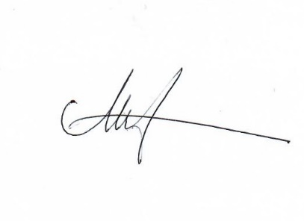 Date: 26 June 2020
Next Review: 2023

