Blind and Low Vision Education Network NZ - Annual Report 2020

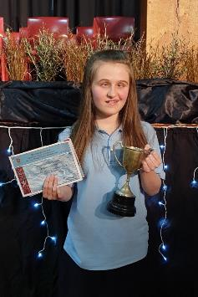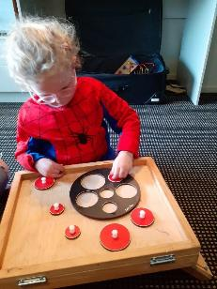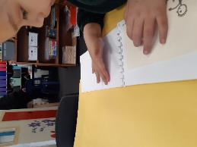
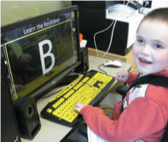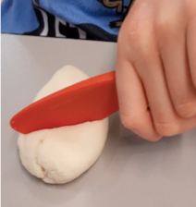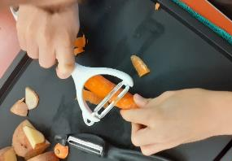
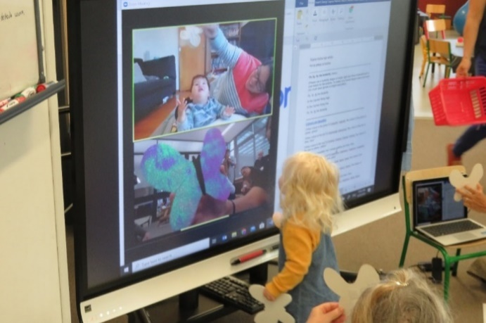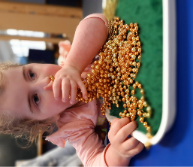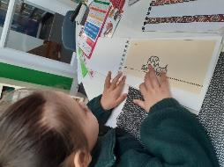
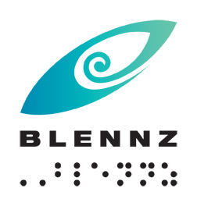

Blind and Low Vision Education Network NZ

2020 Annual Report and Financial Statements

School Address:
2 McVilly Road, Manurewa, Auckland 2012

School postal address
Private Bag 801, Manurewa, Auckland 2243

Contact details:
School Phone: (09) 2667109
School Fax: (09) 2674496
Email: Admin@blennz.school.nz
Facebook: BLENNZ Facebook
Twitter: @BLENNZOnline
BLENNZ ICT: info@blennz.school.nz

Table of Contents
Message from the Board Chair 8
Message from the Principal 9
Introduction 10
Special Character School 10
Vision 12
Mission 12
Values 12
Organisational Culture 12
Beliefs 13
Key Facts and Figures 14
Learners attending Homai Campus School 14
Learners Receiving Services from BLENNZ Visual Resource Centres end of 2020 15
Statement of Variance – Abridged 2020 Annual Plan 17
Strategic Goals: 17
Operational Goals 18
Events from 2020 20
BLENNZ Conference – 22-23 January 20
Year Start – Transition Whānau 20
Learner Achievement 2020 21
Homai Campus School 21
Tahi Syndicate 22
Weka Class 22
Tui Class 23
Pukeko Class 23
Takahe class 24
Kiwi Class 24
Rua Syndicate: Intermediate and Senior School 25
Kea Class 25
Senior Classes James Cook 26
Senior 2 26
Senior 3 27
2020 Residential Transition Report 27
Assessment and Teaching 30
Homai Early Childhood Centre 30
Whangarei Visual Resource Centre 30
Auckland North Visual Resource Centre 31
Auckland South Visual Resource Centre 33
Hamilton Visual Resource Centre 34
Tauranga Visual Resource Centre 34
Gisborne Visual Resource Centre 35
Napier Visual Resource Centre 36
BLENNZ Taranaki Visual Resource Centre 37
Staffing – Problem Solving Approach 37
Palmerston North Visual Resource Centre 38
Wellington Visual Resource Centre 40
Nelson Visual Resource Centre 41
Christchurch Visual Resource Centre 42
BLENNZ Parent Support Group 42
Dunedin Visual Resource Centre 43
BLENNZ Southland Visual Resource Centre 44
Being Prepared for Change 44
BLENNZ National Assessment Service (NAS) 44
Adaptive Daily Living (ADL) 44
BLENNZ Immersion 45
Regional Teaching Team 46
Developmental Orientation and Mobility Service (DOM) 47
Positive Steps 47
BLENNZ VRC Coordinators 48
Homai Campus Music School 49
Individual Music Programme – Wendy Richards 49
Music School – Wendy Richards 49
Homai School Music Therapy Programme 49
Te Whānau o Homai 51
Homai Early Childhood Centre 51
BLENNZ staff conference 51
Māori language week from September 14, 2020 51
BLENNZ Matariki 51
Welcoming new staff/students 51
Youth Library 52
Board of Trustees 53
Board Members – November 2020 53
BOT members and roles as at 31 December 2020 54
Strategy Planning 54
The Framework of Indicators of Learner Achievement 55
Homai Campus School 55
Targets 55
Reporting 56
Takahe 56
Kea 57
Tui 57
Weka 58
Pukeko 58
Kiwi 59
James Cook Satellite Classes 59
Māori and Pasifika 60
Target (Literacy) 61
Target (Numeracy) 61
Homai Campus School IEP Survey 62
Summary: 65
Regional Network 66
Outcome Indicators 66
A Literacy – Using Language, Symbols and Text 66
Identify the proportion of the learners acquiring literacy by: 66
Reporting 66
Learners verified for Ongoing Resourcing Scheme (ORS), primarily for vision 68
Reporting 69
Reporting 70
Reporting 71
B. Mathematics 72
Approach used to collect data 72
Number Achievement Years 0 – 8 ORS Vision Learners 72
Number Achievement Years 0 – 8 ORS Vision Learners 72
Process Indicators 73
Student Achievement 73
Teacher assessment skills in literacy 73
Targets 73
Reporting 74
Assistive Technology Applications 2020 74
Hardware includes: 75
Software includes: 75
Other Educational Settings 75
Immersion Courses 2020 – Compulsory Sector 75
Target 75
Reporting 76
Overview of all courses: 76
Compulsory courses 76
Immersion Courses for Early Childhood 78
Knowledge, Skills and Values 78
Process Indicators 78
Overview of all courses: 78
Early Childhood courses 79
National Assessment Service (NAS) 80
Background 80
Cumulative Data - 2020 Referrals 81
Caregiver Surveys 81
Questions: Sample Responses 81
Professional Surveys 82
Questions: 83
Developmental Orientation and Mobility 84
Sample/themed comments from DOM FOI survey: 86
Statement of Resources Bridget 89
Physical Resources 89
School Roll and Days Open BLENNZ 90
Administration Services - Bridget 90
Health and Safety: 90
2020 Summary 90
Policies: 92
Personnel: 93
Legislation: 93
Property: 94
Assets: 94
BLENNZ Full 2020 Variance Report on the Annual Plan Goals and Objectives 95
Strategic Objectives 95
Making a difference: Evidence-based 95
Transition Ākonga from the start of secondary through to the end of compulsory schooling 96
Wellbeing - Ākonga for whom BLENNZ is the primary provider. 99
Succession 100
Operational Goals 104
Partnerships/Organisational Relationships 104
Staff Capability Building 107
Systems / Resources 113
Property 113
2020Audited Financial Statement 115

Message from the Board Chair
Kia ora tātou to all of our BLENNZ community,
It is my pleasure, on behalf of the BLENNZ Board of Trustees to present the 2020 Annual report.
This report provides a detailed overview of what has occurred over the past year within BLENNZ and the progress toward our strategic goals.
The main focus of 2019 was transition and we were delighted to welcome Blind Foundation CEO, John Mulka, to the BLENNZ Board to help ensure both parties were on the same page.
We are committed to working with our sector partners to provide more help to our ākonga as they move from school into the wider world, wherever that may be. The work on transition continues.
Covid-19 both highlighted and hindered our work in 2020 as we concentrated on the wellbeing of our ākonga.
BLENNZ already takes a holistic approach to our children's education. But by focusing on wellbeing we hope to ensure that we are taking into account all our student's individual needs.
This also supports our vision that “every BLENNZ learner is well prepared to achieve in life”.
It gives us a renewed commitment to work closely with our sector partners helping with both transition and wellbeing. Part of that work includes innovative learning environments and digital technology, the value of which has been highlighted by the lockdown.
Clearly, 2020 was a year without precedent. We are acutely aware of the unique pressures this has placed upon our community and we look forward to life returning to normal.
I would like to congratulate and thank our staff for the calm and professional way they have worked through and continue to work through this pandemic.
Like everyone else, we have had to adapt. Board meetings are now conducted remotely and it has certainly awakened us to the efficiencies that can be made in time and travel costs as well as the reduction of our carbon footprint.
I know that for many people in the BLENNZ orbit the Covid-19 pandemic has made life even more complicated and difficult. Our hearts are with you and we remain committed to supporting you and your children.
Nga mihi mahana
Mitch Harris

Message from the Principal

2020 will go down in history for many reasons, this report may not find its way into historical records but it does capture some of the wonderful moments that form part of BLENNZ history as it records learning that occurred despite all that was going on around us.

Compared to the rest of the world New Zealand has done well to come through 2020 and continue to operate in the way we have. The report for 2020 is a wonderful celebration of learning and teaching and shows how agile people have been across one of the most challenging of years.

Our values truly shone as we connected with ākonga, whānau and colleagues across many settings. The disruption caused by changing levels was met with a degree of frustration and yet this was far outweighed by the levels of creativity that went into exploring how we might do things differently with and for ākonga.

Many teams can share great examples of innovation and from this we have learnt new ways of reaching out, of connecting. The immersion team and residential led the way in this area, providing distant learning options with great speed, when face to face residential had been planned. It has changed the range of ways in which they might engage, as many of their ideas will continue as part of how courses can be provided.

On reflection there appear to have been two very distinct insights we have all had. One being the amazing possibilities that technology provides and the other the importance the simple things in life. Technology and our use of it increased significantly in 2020, as it became the main way of connecting. My thanks go to the BLENNZ team who took creativity to a next level and to the ākonga and whānau who embraced change and remained connected, such as the rangatahi in residential and those working on their NCEA. To all those whānau and staff who used the opportunity to focus on life skills while in lock down and took the opportunity to enjoy being together as whānau, well done! Making the most of teachable moments in everyday life is so important.

As we sign off for 2020, we continue to be in this state of flux, agility is the catch word of the times. May 2021 bring us calmer times and let us not lose the many insights that we have had. Insights into what we are capable of and what is important to us as a learning community. There is a saying ’hunt for the good’ there are good things that have emerged from our 2020 experience let’s take them forward.

Take care, stay safe and enjoy each moment!

Karen Stobbs
Principal

Introduction
Welcome to the 2020 Annual Report for the Blind and Low Vision Education Network NZ (BLENNZ). The primary focus of the report is to provide accountability to the community, a set of accounting statements providing accountability from a financial perspective; reports on achievement and challenges from an operational perspective; and strategic planning reports from a strategic perspective.

Special Character School
The Blind and Low Vision Education Network NZ (BLENNZ) is a national school that provides a network of education services to 1608 blind, deafblind and low vision learners throughout New Zealand from birth to 21, including those who have additional special needs. BLENNZ was established as a national network of services sixteen years ago in January 2005. It is one of the special schools nationally that have been legislated to provide residential provision for learners.
The purpose of BLENNZ is to ensure that the education needs of blind, deafblind and low vision learners are identified and appropriate programmes and services are available. It aims to support the government goals for education by enhancing education opportunities for its learners, facilitating access to and participation in the regular curriculum and developing skills for independence.

Historically blindness education services were provided either by Blind Low Vision NZ, (RNZFB) through the services based on Homai Campus, or by Visual and Sensory Resource Centres that were part of the state education system. In July 2000, Homai National School for the Blind and Vision Impaired became a state residential special school and in 2005, all of the services were amalgamated to form the Blind and Low Vision Education Network NZ.

This amalgamation of services was achieved through many years of combined advocacy from parents, teachers, service providers and sector organisations, who expressed a strong desire for a unified, nationally coordinated system for service provision. BLENNZ aims to achieve such co-ordination and cohesion and to reflect the special character of the school through the following objectives:

- Development of nationally consistent practice which is evidence-based
- Implementation of the principles of the National Plan
- Learning and teaching in the Expanded Core Curriculum in the context of the Key Competencies, as expressed in the BLENNZ Curriculum
- Learning and teaching based on the Expanded Core Curriculum as a means of accessing Te Whāriki
- Determination, monitoring and review of learner outcomes
- Clear mechanisms for accountability
- Staffing levels within international benchmarks
- Improved access to services for children and their families/whānau
- Equitable, cohesive and seamless services
BLENNZ is a national school with a national community, which includes children and young people, their families/whānau, Resource Teachers Vision and blindness educators, partner service providers such as the Blind Low Vision NZ and blindness education sector groups including:

- Parents of Vision Impaired NZ (PVI)
- Blind Citizens of New Zealand Inc (ABC NZ)
- Deafblind (NZ) Incorporated
- Kāpō Māori Aotearoa NZ, and Te Whānau o Homai

BLENNZ education services are provided from 15 centres. These are:
- BLENNZ Homai Campus, Manurewa, Auckland
  - Homai Campus School and satellite class at:
    - James Cook High
    - Tamaoho School
  - Residential Services, short and long term courses and residential
  - Early Learning Services
  - National Assessment Services
  - Auckland South Visual Resource Centre
- Whangarei Visual Resource Centre, Tikipunga High School, Whangarei
- Auckland North Visual Resource Centre, temporarily located at Wairau Intermediate School, Forrest Hill, Auckland until BLENNZ Scott Point School development is completed.
- Pukekohe Visual Resource Centre, Tamaoho School, Pukekohe
- Hamilton Visual Resource Centre, Hamilton North School, Hamilton with outposts in Thames and Taupo
- Tauranga Visual Resource Centre, Bethlehem, Tauranga with an outpost in Whakatane and Rotorua
- Gisborne Visual Resource Centre, Riverdale School, Gisborne with an outpost in Wairoa
- Napier Visual Resource Centre, Henry Hill School, Napier
- Palmerston North Visual Resource Centre, Awapuni School, Palmerston North with an outpost at Keith Street School, Whanganui
- New Plymouth Visual Resource Centre, New Plymouth Girls High School, New Plymouth
- Wellington Visual Resource Centre, 27 Kowhai Road, Kelburn, Wellington
- Nelson Visual Resource Centre, Salisbury School, Nelson; with an outpost in Blenheim
- Christchurch Visual Resource Centre, Burnside, Christchurch with outposts at Oceanview Heights School, Timaru; and Cobden School, Greymouth West Coast
- Dunedin Visual Resource Centre, Dunedin North Intermediate School, Dunedin (Moving to Riselaw Road in 2020)
- Invercargill Visual Resource Centre, Ascot Community School, Invercargill.

Vision
Every BLENNZ learner is well prepared to achieve in life.

Mission
To enable ākonga who are blind, deafblind or have low vision to reach their full potential, BLENNZ provides quality education and specialist teaching services in partnership with whānau and the wider community.

Values
The services and programmes of BLENNZ are aligned to support the principles and intent of government priorities, goals and strategies for education; the aims of the Disability Strategy for an inclusive society and the removal of barriers; and the principles of best practice in blindness education.

The guiding principles and values of the Blind and Low Vision Education Network NZ will reflect the following documents:
- Universal Declaration of Human Rights, Article 1
- Convention on the Rights of Persons with Disabilities, Article 3 and 24
- Te Tiriti o Waitangi
- New Zealand Disability Strategy
- Ministry of Education Statement of Intent
- A National Plan for the Education of Learners who are Blind and Vision Impaired in Aotearoa / New Zealand
- Te Whāriki
- New Zealand Curriculum

Organisational Culture

As a community, BLENNZ has identified core values, which guide our organisation:
Whanaungatanga, Manaakitanga, Awhinatanga, Kotahitanga, Ako.

Our shared BLENNZ values and beliefs interweave to guide our community of learning and teaching, promoting the development of qualities that lead to engaged, confident, connected, lifelong learners. Qualities such as:

Can do attitude, Self-starters, Resourceful, Resilient, Contributing, Curious, Reflective, Explorer, Problem-Solvers, Connected, Confident, Belonging, Actively Involved, Making Choices, Confident communicators.

The services and programmes of BLENNZ are aligned to support the principles and intent of government priorities, goals and strategies for education; the aims of the Disability Strategy for an inclusive society and removal of barriers; and the principles of best practice in blindness education.

The children and young people of BLENNZ are represented across the various levels of education: early childhood, primary and secondary. While their education settings are diverse, the large majority of learners attend their local school or early childhood setting. Their means of communication and literacy include tactile material, braille, print, dual braille and print, sign, augmentative and alternative communication modes.

Beliefs
The following beliefs underpin the BLENNZ approach to learning and teaching:
- Parents and whānau are the prime educators in their child’s learning
- Education is focused on the learner within the context of whānau, community and culture
- Learning occurs through active engagement in meaningful environments
- Ākonga have unique needs requiring specialist learning and teaching approaches
- Ākonga have the right to equitable access to education
- Ākonga have a right to belong and to realize their potential as participating and contributing members of society
- Team collaboration promotes positive outcomes for ākonga.

Key Facts and Figures

Learners attending Homai Campus School

On 1 July 2020 the roll of the Homai School was 41
Day Students 36
Residential Students:
- Attending Homai Campus School 36 (included in above figure)
- Attending Manurewa High School 3 (not included in above figure)
Male 28
Female 13
ORS:
- Very High needs 34
- High needs 10
Learners with moderate needs 4
Primary 20
Secondary 18 (does not include transition students)

Analysis of Ethnicity
NZ European 17%
Māori 17%
Samoan 15%
Tongan 8%
Cook Island Māori 15%
Indian 20%
Other Asian 2%
Fijian 2%
Japanese 2%
Other European 2%
Other South East Asian 2%

83% of the students attend the BLENNZ Homai Campus School are non-European.

Learners Receiving Services from BLENNZ Visual Resource Centres end of 2020

Visual Resource Centre | Early Childhood | Primary | Secondary | Total
Northland | 8 | 26 | 12 | 46
Auckland North | 34 | 81 | 49 | 164
Auckland South | 76 | 155 | 100 | 331
Hamilton | 22 | 69 | 54 | 145
Tauranga | 16 | 65 | 35 | 116
Gisborne | 6 | 33 | 19 | 58
Napier | 4 | 28 | 16 | 48
New Plymouth | 13 | 51 | 18 | 82
Palmerston North | 19 | 52 | 38 | 109
Wellington | 26 | 58 | 46 | 130
Nelson | 4 | 31 | 16 | 51
Christchurch | 32 | 117 | 70 | 219
Otago | 1 | 41 | 19 | 61
Invercargill | 2 | 18 | 7 | 27
Total |  |  |  | 1587

Analysis of Ethnicity
European/Pakeha 54.1%
NZ Māori 22.9%
Samoan 3.6%
Indian 3.7%
Cook Island Māori 1.9%
Chinese 2.0%
Tongan 2.0%
Niuean 0.6%
Other 9.2%

Statement of Variance – Abridged 2020 Annual Plan

Strategic Goals:
Focus | Objective | December 2020
Making a  difference | To gather a comprehensive understanding of our current evidence based practices in relation to our services provided through the: School; National; and Regional teams to ensure evidence focusses on the difference we are making. | In progress
Transition | To prepare the foundation documents that will underpin the integration of Immersion and Residential Services providing clarity of roles, responsibilities for individuals and as a licensed Hostel. | Achieved
 | To implement the first year of the revised programme that emerged from the 2019 SPRINT which includes a termly focus for rangatahi in the transition process. | Achieved
 | To trial a short term course “Future Planning” based on the long term transition programme. | Achieved
 | To establish online content for transition including: The Hub, Ako Online transition modules in alignment with the long-term transition course, the inclusion of transition on the BLENNZ Website. | Not Achieved
 | To initiate work with Blind and Low Vision NZ and other sector partners to further the creation of a mentoring network. | Initiated
 | To create an initial conversation guide around transition for all year 9 ākonga for implementation during 2021. | Initiated
Wellbeing | To participate in a UK study which is piloting an app to support Student Emotional and Mental Health (SEMH) promotion and data gathering. | In progress
 | To investigate the use of the Meke Meter for well-being assessment. | Not Achieved
 | To trial a range of activities/programs, that have an evidence base that enhance wellbeing of ākonga. This will be informed by pre and post programme surveys. | In progress
Succession | To establish a staffing review process to monitor succession for staffing. | Achieved
 | To identify employment strategies that increase the number of strong candidates attracted to Auckland based positions. | Partially Achieved
 | To further develop BLENNZ online induction programmes focussing specifically on content for RTVs and DOM specialists starting work at BLENNZ. | Achieved
 | To continue to review and update information on the general induction workshop ensuring information is up to date and remains relevant. | Achieved
 | To share practice across the network through the presentation of curricula inquiries on the Hub. | Achieved
 | To enhance the culture of our organisation by making explicit the way in which we partner with ākonga, whānau and our colleagues internally and externally. | Achieved

Operational Goals
Focus | Objective | December 2020
Organisational Relationships | To work in partnership with MOE Learning Support leaders to ensure BLENNZ and MOE maintain a clear and shared understanding of our respective roles and responsibilities. | Initiated
Relationships | To maintain the positive interface between Kāpō Māori Aotearoa NZ and BLENNZ while establishing relationships with MOE and iwi. | In progress
Relationships | To sustain 2-4 meetings with each of our sector partners: Blind Citizens NZ; Kāpō Māori Aotearoa NZ; and PVI enhance the flow of information on a no surprises basis. | Achieved
Relationships | To develop a partnership with Vision Impairment Education Workforce (VIEW) for the purpose of enhancing pedagogy and practice that is informed by published international research. | Achieved
Staff Capability Building | In 2020 focus will be on building staff competency and confidence in specific areas relating to:  - Accessibility – creating documents born accessible. | Achieved
Staff Capability | - Assessment / Practice - Functional Vision Assessment in Te Reo Maori; | Achieved
Staff Capability | - Assessment / Practice - Cerebral Vision Impairment | Achieved
Staff Capability | - Assessment / Practice - Ākonga who are deafblind | Achieved
Staff Capability | - Assessment / Practice - Leadership/capability Ākonga with complex learning needs. | Partially Achieved
Staff Capability | - Assessment / Practice - Ākonga with complex learning needs. | In progress
Staff Capability | - Mathematics – assessment and reporting; accessibility of learning materials | Achieved
Staff Capability | - Mathematics – Homai Campus School assessment and reporting: | In progress
Staff Capability | Literacy: Accessibility of learning materials - tactile graphics library >20 readers at each PM level | Achieved
Staff Capability | Literacy: Develop shared understanding of progressions re tactile graphics @ early learning levels | Achieved
Staff Capability | Literacy: Distance Course To trial ‘Teaching Literacy Through Braille’ as an on line distance course | Achieved
Systems & Resources | To establish and maintain a comprehensive catalogue of all BLENNZ learning resources | In progress
Systems &  Resources | To commence to incorporate BLENNZ IT / AT resources into the catalogue of BLENNZ learning resources. | In progress
Systems &  Resources | To begin implementation of the roles and responsibilities associated with being an Authorized Entity under the new copyright act 2019. | Achieved
Property | To establish a clearly articulated process for establishment and review of Property Occupancy Documents (POD) resulting in all POD agreements for BLENNZ resource centres and satellites established or reviewed. | In progress
Property | To maintain a regular review process (between MOE, DEC and BLENNZ) for the portfolio of property encompassed within the Sensory Schools Capital Works Plan. | In progress

Events from 2020

BLENNZ Conference – 22-23 January
The BLENNZ Staff Conference went very well with wonderful keynote presentations by Lucy Hone, Director of the New Zealand Institute of Wellbeing and Resilience and Valerie Stordardi, PhD in Educational Psychology University of Canterbury. The programme was very comprehensive with 184 participants accessing 47 presenters

Year Start – Transition Whānau
The Residential and School welcomed the whānau of ākonga onto campus at the start of term. This was a wonderfully warm welcome from ākonga and staff followed by a weekend of coming together. All residential staff including night staff and teaching team were able to meet with whānau. The whanaungatanga that took place over their time together meant that the relationships are on a stronger footing than they have been in the past.
This message sent by Kelly Doyle captures the tenor:
“So proud today to see the BLENNZ values in action today. Beautiful Pōwhiri. I love the way the Kaumatua are so behind our efforts. The way the school stepped up to tautoko and use their experience was priceless. My heart is glad that this was an expectation for ākonga me ngā kaiako hou. Well done Whānau xx. Our waka is moving along very nicely with gathering speed as we all keep pace together... and it's course is very straight.
Just proud as!“
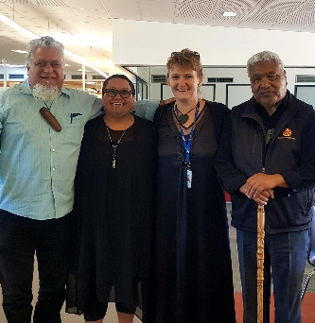
From left: Gavin Reedy (papa Gav), Kuia Mere Komeme, Kelly Doyle and Matua Toi Katipa Snr

Learner Achievement 2020

Homai Campus School
The Homai Campus School has two distinct areas to meet the need of learners who are blind, deaf/blind and low vision.
- In 2020 we have aligned the school into two syndicates: Tahi – junior school – years 1 – 6 and Rua years 7 – 13.
- The Homai Campus School classes; Weka, Kiwi, Tui, Pukeko, Takahe and Kea. The learners in these classrooms may have additional barriers to their vision impairment which impact on their physical and intellectual capacity.
- These learners are referred to as having complex learning needs. They work on the Key Competencies Framework an adapted curriculum, which is a more equitable measure of their achievements. Teaching strategies and equipment have been adapted to the unique educational needs of these ākonga.
- During 2020 Tahi Syndicate (Satellite Classes at James Cook High school) had to be relocated on site at BLENNZ due to a delay in building modifications of their classrooms.
- Some ākonga continued where possible accessing satellite learning activities for James Cook for part of the year, but the majority continued classes with two newly appointed secondary trained teachers who facilitated individual and classroom learning on site instead of the BLENNZ Homai Campus School, in two of the Immersion spaces.
- This has added much challenge and complexity for both ākonga learning in an inclusive setting meaning development of independence, extension of orientation and mobility, and access to both elective and NCEA classes on site at James Cook became untenable in the latter part of the year. The logistics of moving ākonga to / from James Cook with the present staffing and logistics of high school timetables, resulted in the majority remaining on site at BLENNZ for the majority of 2020. The Tahi staff team have done a magnificent job in ensuring ākonga have had secondary type contexts to support their learning though still within the BLENNZ Homai Campus School environment. Staff set up a secondary type timetable with individuals moving across the classes which for this time and purpose were split into three with a third teacher managing one cohort who were more dependent.
- It is hoped that the staff and ākonga will be able to return to James Cook in the near future so ākonga can get a true sense of developing their learning in an inclusive context where there are real expectations of managing their own independence, developing further as young autonomous individuals, who are starting to manage meaningful relationships with peers, learning time management and the responsibilities of accountability and work deadlines in a secondary school context.
- The Homai Campus School also provides IEP classroom immersion experiences for learners around the country. Sadly due to Covid, only one IEP Immersion took place and that was aborted after day 2, when Covid levels changed quickly.
- This year our focus was reporting on a school wide IEP review, which included feedback from a parent survey. We also joined an International project on gauging ākonga SEMH (Social Emotional Mental Health / Wellbeing) involving using an encrypted iPad App where ākonga could feedback their learning to whānau at home. Again Covid hindered this getting fully off the ground with the initial focus being very successful with one senior ākonga. We will roll this out further during 2021.
- We continued the facilitated Maths Initiative and look forward to commencing a MoE funded Literacy initiative in 2021.

Tahi Syndicate

Weka Class

Sports Time in Weka Class
The students in Weka really look forward to seeing Rochelle each Tuesday. She comes from Counties Manukau Sports Group and organises sport activities for the students. Each class has a turn.

We have been working on using our hands to push the ball into a small basketball hoop or into a large mesh bag. Sometimes the balls miss and roll away. Then the teachers have to chase them. We work with different activities each time.
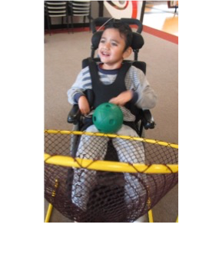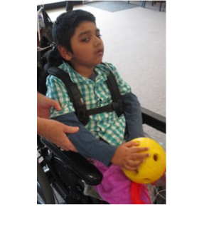

Tui Class

Tui class had a fun-filled year learning about Patterns and Decorations. The ākonga studied Patterns in Literacy and Patterns in Numeracy. The class also learnt about the religious festival Diwali, watched performers at the assembly, read the book about the celebration, and made and coloured pictures of Diya lamps. They also sang Guy Fawkes Night and coloured photos of Guy Fawkes. In Art, the children created a variety of artworks – a collage of a tui bird, painting using coloured pens, gloop, playdough moulding and weaving using coloured papers to mention a few. Tui class also visited places around the school, such as the playground, the hall and the office, the library and the kitchen and were applauded when they performed E Rere Taku Poi during the End of Year Concert and enjoyed making a variety of Christmas decorations to finish off the year.
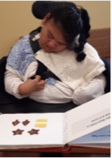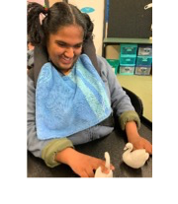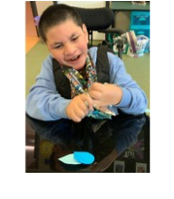

Pukeko Class

Play is a vital part of development for ākonga in Pukeko Class– it helps them to learn, to understand and to grow. Being imaginative and creative with play is particularly important for children with sensory impairments. It is not about specialist play; it is about making all types of play accessible and supporting our students to interact. Our Theme during Term 4 has been patterns and decoration and has held a focus on the curriculum areas of Mathematics and Literacy. Through the vehicle of play with dough, the students have been supported to read books, songs and rhymes about shape and number. Braille, large print and audio literacy has been offered. Ākonga have been supported to engage in many dough experiences. Sometimes students in Pukeko Class can be ‘tactile sensitive’ – unwilling to touch or be touched. Consistent and repeated exposure to dough is a fun way to overcome tactile sensitivity.
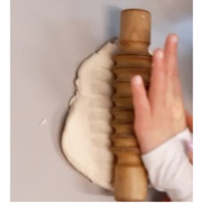

Takahe class

Takahe class have been very busy. The students all worked hard, learning to read, using computer typing programmes and Dolphin Guide Connect, and all the things that an active classroom of students can do.

For the technology theme the students used their thinking skills and worked together to form a plan of what to make and what to buy in order to create a decorated frame. It was a very interesting topic for them, and they are proud of their finished work.

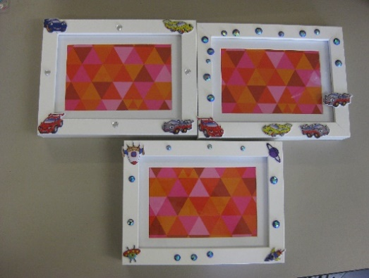

Kiwi Class

Kiwi class had the opportunity to explore a range of patterns in Tactile and Sensory activities in Reading, Music and Gardening. They also explored shapes in maths, and looked at patterns in cultural activities such as Diwali. The students had a wonderful experience with St John Ambulance coming to visit the campus. They experienced wearing the protective fire clothes, helmets and bandages.
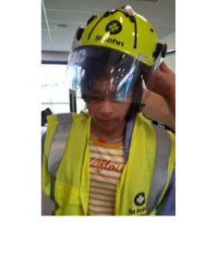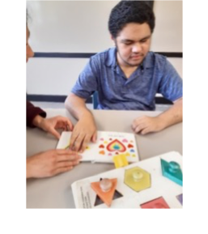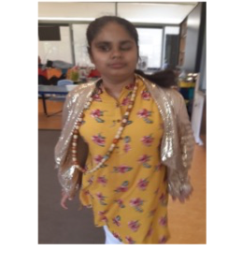

Rua Syndicate: Intermediate and Senior School

Kea Class

Ākonga from Kea class worked with patterns and decorations. They were given the opportunity to explore a range of patterns in Literature, Music, Plants and Animals. They explored patterns using numbers and shapes in Mathematics. They started swimming and enjoyed swimming in the school pool on Thursdays. St John Ambulance came to visit and ākonga learned how to keep themselves safe from fires and injuries. Ākonga experienced wearing the protective fire clothes, helmets and bandages.

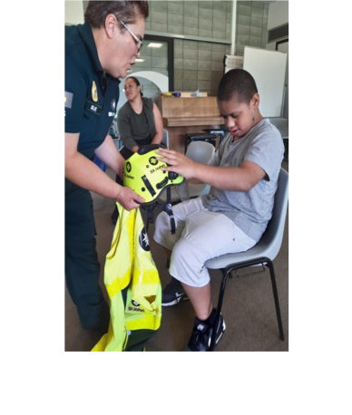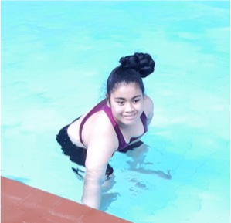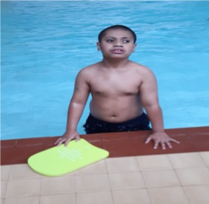

Senior Classes James Cook
Senior 1
One highlight for the year was the ‘Mystery of the Golden Pen’. This was an Immersion activity and involved groups of BLENNZ detectives solving the clues to decide who stole the pen and how? Everyone used their problem solving skills to analyse clues and hints to piece the crime together and announce Sue Suspicious as the culprit!
In term four ākonga were busy with swimming, hockey and trips to the Gardens to put our mathematics into action. They measured distances, perimeter and directions.
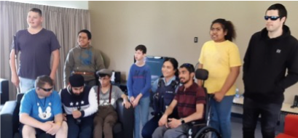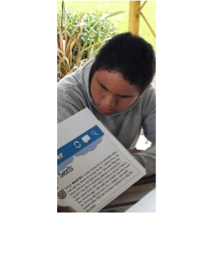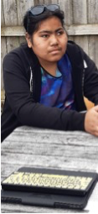

Senior 2
Senior 2 had a very productive year. They enjoyed outings to the Botanic Gardens. They also enjoyed ‘the Mystery of The Golden Pen’ Immersion early in term 4. The students worked with another senior class, and the transition students to solve a mystery.
Blind Sport organised for Manukau Hockey to run a few hockey sessions. The students had a lot of fun and enjoyed working with others and learning a new skill. They learnt how to hold the hockey stick, dribble the ball, score goals, and even had a few games.
Senior 2 worked hard in numeracy and literary in particular, gaining NCEA credits along the way. Two ākonga sat another internal math assessment on probability and both passed.
The whole class continued to work on preparing for a formal interview in the literacy programme. The class learnt much about how to communicate appropriately, both verbally (tone and clarity) and non-verbally (using body language correctly).
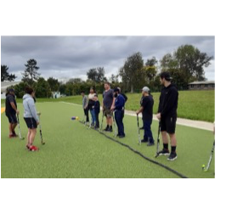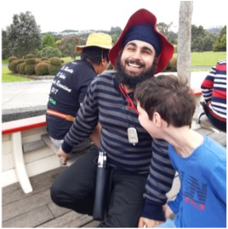

Senior 3
Senior 3 ākonga were excited to return to school following the returns to alert level 1 which meant they could do a lot more things. One highlight was the Greedy Cat performance at the Mangere Arts Centre. The students were also delighted to reconnect with their swimming coach.
In cooking the students made quiche, smoothies and cookies apart from learning how to measure ingredients, following recipes and cleaning up. One week at ‘The Mystery of The Golden Pen’, Immersion course gave the students all the skills about solving problems, analysing clues and working with learners from other classes. They discovered how competitive they could be.
In class the students happily carried out their individual and class programmes.
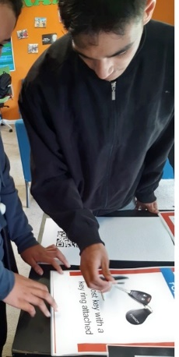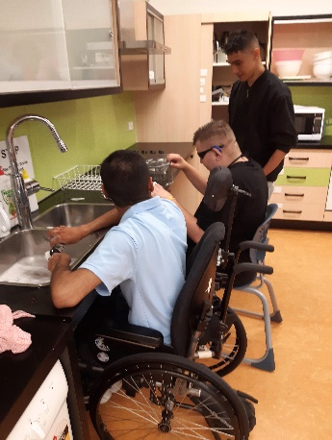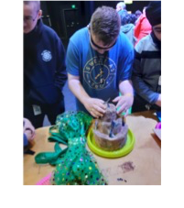

2020 Residential Transition Report
This year, the revised residential transition programme that emerged from the 2019 SPRINT was implemented. The Whānau Hui was an amazing start to the year with an opportunity to further our Whanaugatanga with all residential students and their Whānau.
Term 1 began with a 4 day high ropes course at Adventure Works as a lead in to the term focus “Let’s think about you and your future.” This course supported confidence building, self-esteem and developing a can do attitude along with getting to know the team and working together.
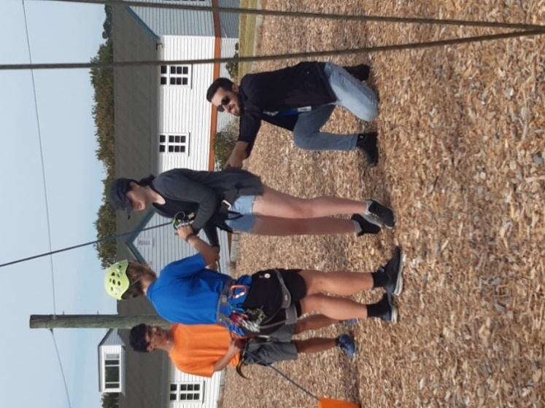
Figure 1: A high ropes instructor and staff member testing a student's harness prior to engaging in a high ropes activity
In Term 2, the theme “Let’s get you out and about” was replaced with “Coping and learning during Covid” as New Zealand had gone into lockdown and the residential transition programme was conducted via distance learning. This was a time to concentrate on using technology effectively to communicate and participate in an online community. The learners explored strategies for keeping yourself and others well – mentally, emotionally and physically during these times of change. Routine, fun and variety kept the group connected.
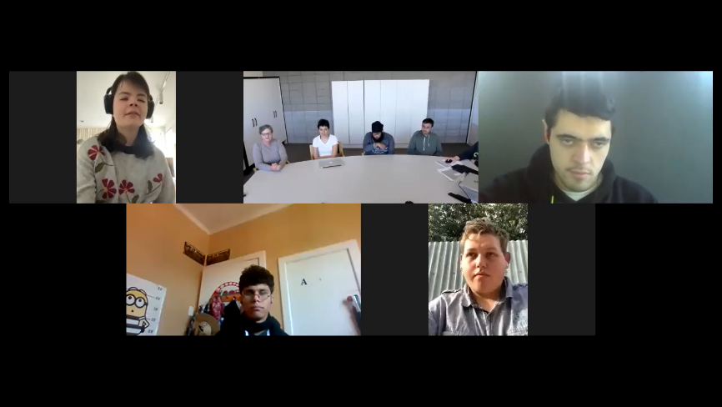
Figure 2: Screenshot of a Zoom call between staff and students
Back on campus in term 3, the team re-focussed on “Let’s develop your Independent Living Skills” – a time for food preparation, budgeting and household management.
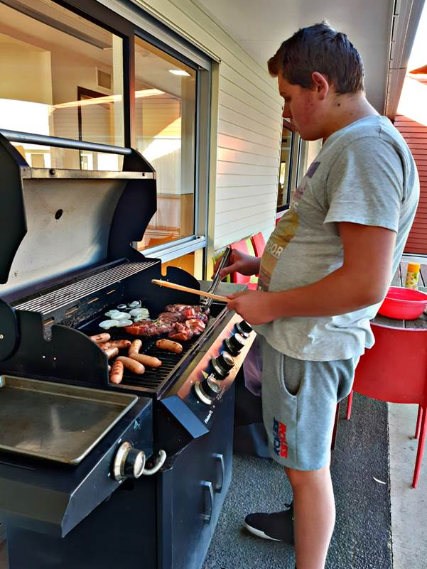
Figure 3: A student practising adaptive skills while tending to a BBQ for all residential students
In term 4, the focus was “Let’s look at life after BLENNZ”. Two of our learners worked with Transition Coordinators on their individual plans for their future; including preparing to live out of Auckland and to attend an animal care course at Unitec. Two learners identified that they would like to return to the programme in 2021 as the COVID-19 Pandemic had meant some of the planned activities did not go ahead.
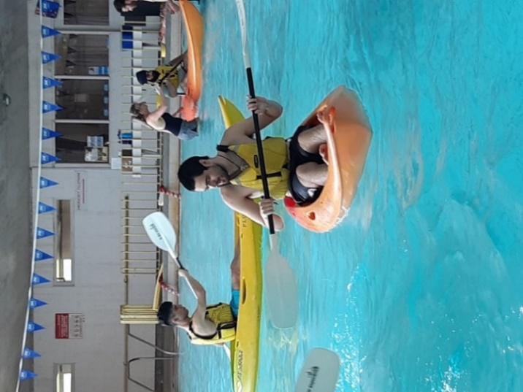
Figure 4: Students engaging in a kayaking activity in the BLENNZ swimming pool to further their understanding of water safety

Assessment and Teaching

Homai Early Childhood Centre
Homai Early Childhood Centre is hosting Zoom group music sessions during COVID-19 lockdowns to keep whānau who attend the centre connected with one another and with centre staff.
The Zoom sessions are a great opportunity for ākonga and whānau to continue their relationships with other families during the lockdown periods. The experience boosts the technological confidence of whānau, many of whom have never previously used video conferencing tools. During the Zoom sessions, we include a whānau discussion and information sharing time, where resources and news is confidently shared.
Post lockdown, we have families from across the water join the music sessions via Zoom - with families currently from Waiheke Island and Samoa. We are planning to keep this practice alive in our service.
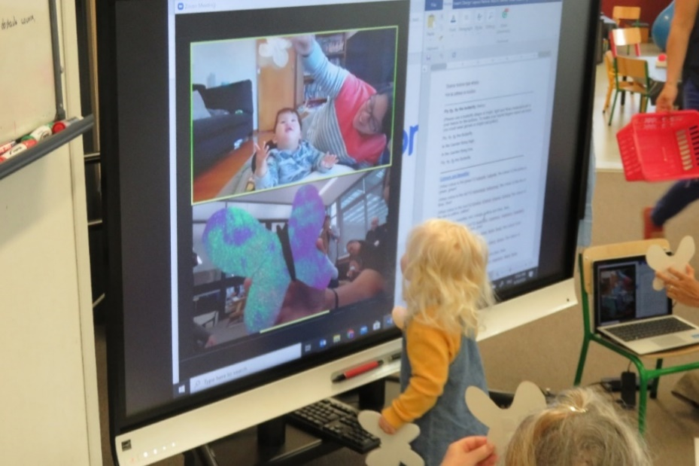

Whangarei Visual Resource Centre

After being located in the old dental clinic at Manaia View School for the past nine years, BLENNZ Northland Visual Resource Centre moved into our very own purpose built Sensory Resource Centre located on campus at Tikipunga High School.
The fabulous new space is shared with Resource Teachers Deaf from Ko Taku Reo Deaf Education Northland. The building consists of four spaces with a shared adapted kitchen and staffroom, hui room, multi-purpose space and toilet facilities.
We were honored to have Joby Hopa ‘Community Engagement Manager’ for Tikipunga bless our centre prior to us moving in.
Having a purpose built facility will enable us to deliver professional learning development in-services as well as our termly expanded core curriculum days and whānau events on site.
We are excited to share this incredible space with ākonga and whānau.
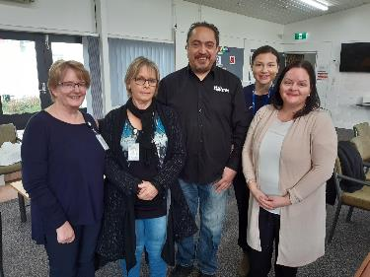
Figure 5 Joby Hopa (Community Engagement Manager) blessed the centre
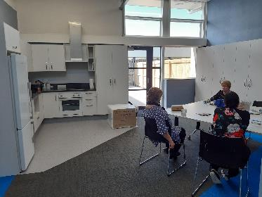
Figure 6 Sensory Resource Centre shared Kitchen and kai area

Auckland North Visual Resource Centre
In the last week of term 2, two BLENNZ learners and their classes from Glen Eden Intermediate experienced a goalball session facilitated by Casey from Blind Sport NZ. Both classes prepared for the session by watching goalball videos on YouTube and at the start of their session they learnt defence and attack strategies.
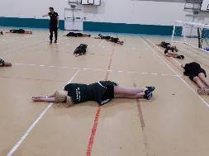
Figure 1 Learners practice defence techniques
Wearing blindfolds and in teams of three they participated in the game. Initially cautious they soon became familiar with the game and became more competitive.
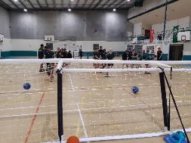
Figure 2 Learners practice attack strategies
It was a positive experience for all! One class asked lots of questions around blindness, eye conditions and low vision, which gave the BLENNZ learner the opportunity to tell them about albinism and how it affected her.

Auckland South Visual Resource Centre

The Tactile Map Reading Programme was originally developed by Jane Wells in the 1980s. In 2019, Jan Thorburn and Lyndsey Starkey decided they were keen to update the resource and invited Jane to be part of the updating process.

Fourteen edits of the original text and many hours spent by Blind Low Vision NZ updating the tactile diagrams have resulted in a wonderful resource. The resource comprises a student braille manual; a teacher handbook giving the background to the teaching involved; and a print copy of the student braille manual. The three books have been packaged into durable red bags and should last for many years to come. The resource will be distributed to each Vision Resource Centre at the Term 4 Managers Meeting.
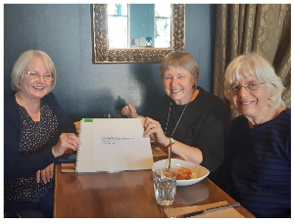
Figure 1: The Map Reading Programme Team celebrates finishing the update with lunch in a cafe
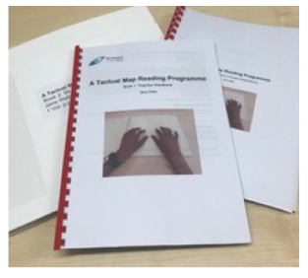
Figure 2 The Tactile Map Reading Programme comprises three books: the braille map book; the teacher manual and a print copy of the student braille book
Hamilton Visual Resource Centre
There have been lots of celebrations at HVRC. Sue Cooke, Lisa Halsall, Debbie Barker and Alannah Orr have successfully passed the braille transcribers exam with distinctions or high distinctions. Alannah Orr, Debbie Barker and I have successfully completed our postgraduate diploma in specialist teaching.
We have six BLENNZ learners at Otorohanga College. At Senior prize giving the BLENNZ students were prominently featured. Te Wai Martin received first prize in Hospitality and the Principals award for consistently demonstrating the school's values. Brayden Guilford was first equal in music as well almost having achieved his Excellence endorsement for NCEA Level 2. Brianna Houston was first in History, first equal in music and second in English, Maths and Biology. She has already achieved her Excellence endorsement for NCEA Level 2. We are all very proud of their achievements but none more so than their RTV Kathryn Leonida.
Figure 1 Brianna holding her certificates and cup from the Senior Prize giving at Otorohanga College

Tauranga Visual Resource Centre
This year in Tauranga we have had a big push on our braille skills and teaching braille literacy. We have four staff members who have completed the BANZAT Transcribers exam over the October holidays. They have spent a whole week working hard while the rest of the team offered tea, sympathy, biscuits and moral support.
The whole team underwent professional development on supporting our braille learners with literacy from RTV, Cloe Jones, who kindly came in from maternity leave to share her skills and knowledge. We have been reviewing our braille resources and Reka Nemedi (Resource Production) and our volunteers group have been reproducing our braille readers with the new tactile graphics.
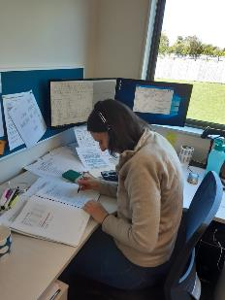
Figure 1: Reka Nemedi working hard on her braille exam
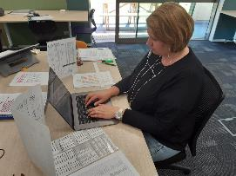
Figure 2: Nynske Westenbroek working hard on her braille exam

Gisborne Visual Resource Centre
During the Lockdown and across Term 2, our team thought of innovative ways to communicate with schools, ākonga, whānau and each other, improving our digital skills along the way. Some examples of what we provided for BLENNZ ākonga and their whānau were Assistive Technology and resources, regular individual Zoom sessions, recorded video sessions, Group Zoom music sessions and information and links via email to learning opportunities and support. A huge thank you to PVI for the support and resources they provided, to Dr Lucy Hone & Dr Denise Quinlan for the invaluable information around well-being and resilience and to our BLENNZ colleagues and leadership team for their ongoing awhinatanga.
He waka eke noa…
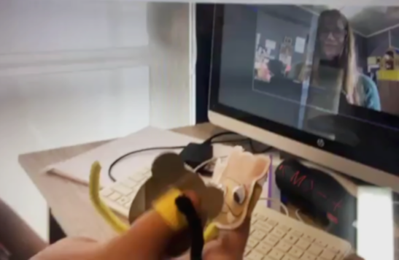
Figure 1: A BLENNZ ākonga holding up her monkey finger puppets to act out a poem during a Zoom session with her RTV
Figure 2: The tactile pictures made by whānau for a story a BLENNZ ākonga wrote in braille during Lockdown called “Hurry Up Butterfly.”

Napier Visual Resource Centre
The National Assessment Service came to Napier in early September 2019. This was particularly timely, as four early childhood ākonga were transitioning to school. It has been lovely to see many of the recommendations followed up and implemented by whānau and schools throughout this school year.
COVID-19-19 has been an unexpected disruption to the year. Despite this, positive outcomes were achieved, the individual needs of each learner was considered and catered for where possible within their home environment. Many students used their technology skills to adapt to new ways of learning. They had transferable skills which enabled them to use new platforms. This was a pleasing outcome from a difficult situation.
Figure 1: Evie explores the wooden puzzle

BLENNZ Taranaki Visual Resource Centre

Staffing – Problem Solving Approach
Tara Lisney was appointed as a full-time fixed term RTV and quickly settled into her role developing warm, professional relationships with her ākonga and whānau.
In Term 3, we regretfully said goodbye to Helen Wiseman as she had planned to go overseas. Tracey McCook was appointed and she brings a fresh classroom teacher perspective.
The COVID-19 lockdown created a need for the Taranaki team to connect with learners and families in a variety of digital and online platforms to suit the needs of the family. A strength of the team was to collaboratively problem solve challenges that arose and we have continued to add this ‘problem solving’ component into our weekly meetings.
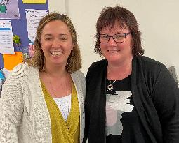
Figure 1 Our new RTVs, Tracey McCook on the left and Tara Lisney on the right.
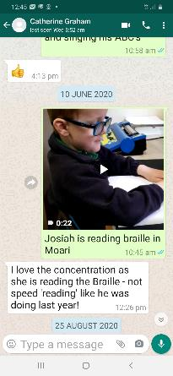
Figure 2: WhatsApp screenshot by the RTV of a learner reading braille

Palmerston North Visual Resource Centre
The BLENNZ Pedagogy of Tactile Graphics has been implemented with Amiria from a very young age. Our aim has been to scaffold her learning so that she is be able to interpret and understand graphics, to support her learning, as she moves through the mainstream curriculum. The ability to manipulate and explore meaningful models and objects, as well as use actual experiences to facilitate her understanding of concepts has resulted in positive learning outcomes.
Amiria started school this year, and is our first learner whose RTV has been able to access the tactually illustrated instructional readers as a new entrant. Amiria is using the ‘sequence books’ that help to reduce the complexity of the graphics, that lead on to the alphabet books with graphics representing the focus letter being taught.
We will watch her progress with interest!
Figure 1: Amiria reading from an emergent instructional reader.
Figure 2: Amiria using an alphabet book about “c”.
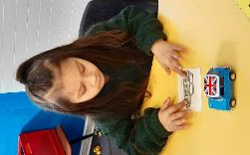
Figure 3: Amiria matching the graphic of a car to the model of the car.

Wellington Visual Resource Centre
This year, main team focuses included: receiving WIT Professional Development; developing capability through coaching; and the continuance of developing a culture that enhances the engagement, productivity and growth of our people
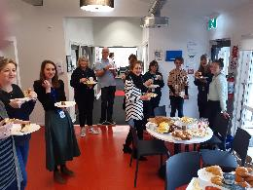
Figure 1: A photo of ‘WIT Graduates’ sharing breakfast together before our final session.
WIT PLD - has been completed and applied in a sustained way – it’s guided us through conversations and communication with professionals and families, and helped our planning together.
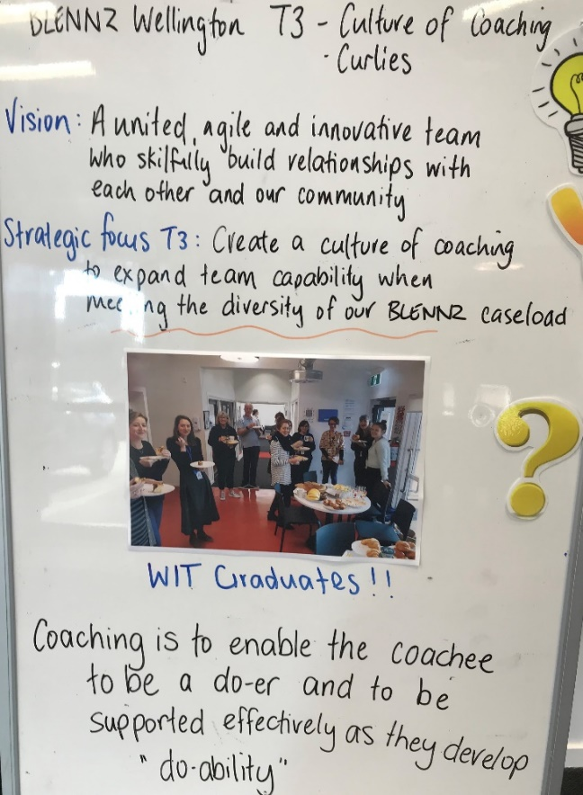
Figure 2: The WVRC team noticeboard in Term 3, showing the focus to develop a culture of Coaching
Coaching – we have strong, but siloed, knowledge bases in the team – we’re using coaching to expand team capability and competently meet the diversity of our Ākonga.
Culture – the way we do things – continues to be a focus in the Wellington team and is creating a team who are easy to work with, support each other, are keen to grow, and where every person is valued. We will continue this journey into 2021.

Nelson Visual Resource Centre
RTV supported the DOM initiated programme by implementing and practising the use of strategies for safe navigation of the school environment with the learner using all of his sensory skills. The learning goal for this student is for the development of purposeful and confident movement through a range of different environmental spaces. This is beginning with the area proximal to his class room. From there the skills learnt can be generalised to other environments. As well as RTV input, ongoing support from the other members of the learner’s team is required for the learner to safely use pedestrian crossing.
As well as challenges with peripheral vision, the learner also has a deficiency of rods in his retina, he is visually challenged in low light and in changing levels of illumination.
BLENNZ DOM have also initiated the use of a cane at home for night use.
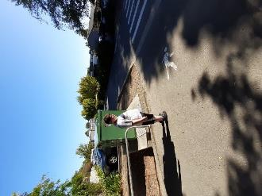
Figure 1 Skills for safe navigation

Christchurch Visual Resource Centre

BLENNZ Parent Support Group
Over the year our preschool Parent Support Group has been well attended. Many new families have made connections with others and enjoy the opportunity to meet together and join RTVs fortnightly at BLENNZ Christchurch VRC as well as offsite activities. During Covid-19 restrictions and home learning, ākonga and whanau remained connected through weekly Zoom sessions.
The aim of the BLENNZ Preschool Parent Support Group is to provide a fun and engaging environment where whanau and ākonga feel supported, comfortable and welcome. We use music, lightboxes and sensory games to engage children from an early age. Although the group is informal and mixed ability, the activities are based on Te Whāriki (Early Childhood Curriculum) and promote visual skills, early communication and social interaction.
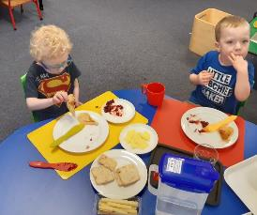
Figure 1: Social interaction between peers
Figure 2 Actively exploring the beads on tray

Dunedin Visual Resource Centre
Transition from secondary school to post-school life has been a focus for some of our ākonga in Otago this year. As part of our transition programme for a learner with additional needs we worked with the secondary school to access support. Once the transition provider was chosen by our learner and her whanau a Path Plan with goals embedded in mainstream education and community settings was developed in partnership with the school and other agencies (BLVNZ). The goals were determined by our learner and she participated in community based activities including cooking and sewing classes as well as Studio 2 where she was able to create artwork to be exhibited at the studio.

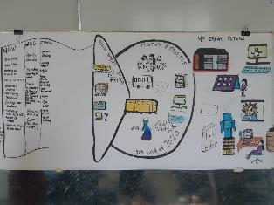
Figure 1: Learner’s Path Plan
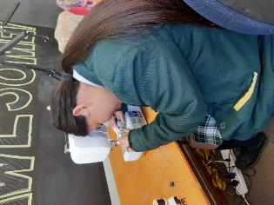
Figure 2 Sewing a scrunchie.

BLENNZ Southland Visual Resource Centre

Being Prepared for Change
Our work load changed in the year of Covid -19 and our delivery evolved. Remote learning provision became a priority. Making connections via Zoom and messaging become the order of the day. Appropriate devices and parental help have been paramount. Post lockdown rescheduling activities, better promoting digital access and learning PD have been valuable.
A delayed visit to Otago University and Otago Polytechnic in Dunedin took place at the end of term 3. Three ākonga and their parents looked at available opportunities for post school options.
The group met with the Blind Low Vision transition manager, the institutes’ disability support managers and subject tutors.
Ākonga navigated the unknown environment using individual strategies while viewing the campus’s and accommodation options.
This was a highly valued by ākonga and parents for the connections made and possible options

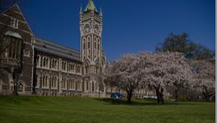
Figure 1: The large clock tower and buildings of the University of Otago, sitting on the grass bank.

BLENNZ National Assessment Service (NAS)

Adaptive Daily Living (ADL)
Joshua, his parents, and RTV attended an ADL session as part of his National Assessment. He has low vision and sensory loss in both upper and lower limbs. Joshua participated in a series of daily living tasks in this session which he and his family had said were priorities for them. The work space was set up to maximise his use of vision, and appropriate equipment, strategies and methods were demonstrated. Observation of his skills in these activities informed suggestions that will support his success and ensure his safety in other daily tasks that were discussed.

Figure 1: Joshua is using a vegetable peeler with a bigger handle grip to peel a carrot held against the tray surface.
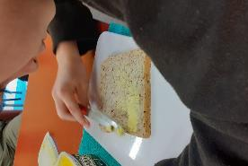
Figure 2: Joshua is using his right hand to spread margarine on to a slice of bread with a knife with bigger grip handle, on a sandwich spreading board placed on non-slip matting

BLENNZ Immersion

This year has been challenging for the Immersion team as we responded to the difficulties presented by the pandemic and subsequent lockdowns (nationally and Auckland-wide). We have seen these challenges as an opportunity to grow and develop Immersion courses; trying new formats for delivery and bringing together ākonga, some of whom have never experienced BLENNZ Immersion before.

The online ZoomPals Hui, planned and delivered by Kelly Doyle, Coordinator Kaupapa, was a huge success; the course focus was on Māori traditional games for ākonga to enjoy learning in the Immersion environment and be able to participate/share in their class programme.
Accessible, inclusive Kaupapa Māori activities included karakia, waiata, simple Te Reo, Poi, Rākau and storytelling, and provided an opportunity to re-connect with friends.

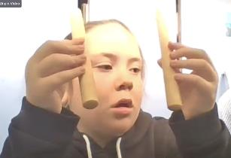
Figure 1 Chevarni practising rākau on the ZoomPals Hui course
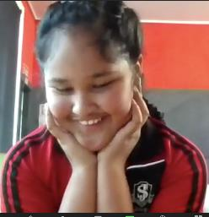
Figure 2 Ana enjoying the online music course

Regional Teaching Team
BLENNZ employs a number of Resource Teachers: Vision and Developmental Orientation and Mobility Specialists who are based at fourteen Visual Resource Centres and eight outposts located across New Zealand. The role of these specialist teachers is to advise, provide guidance and direct teaching to identified learners with a vision concern, in order that they are able to access the curriculum while developing skills needed to reach their potential in life. The role of the DOM is to work collaboratively with Resource Teachers: Vision in the provision of specialist services.
Each Centre is led by a manager who is in turn closely supported by a Centre Coordinator. Pedagogy and Practice is framed by the Mission, Beliefs and Values of the organization and is guided by the Strategic and Annual Plans with a clear focus on working collaboratively to meet the needs of all BLENNZ learners. Opportunities are provided for individuals and teams to meet regionally and nationally for professional development and to facilitate an approach that aspires to equitable informed service delivery and evidence based learner outcomes.
The Regional Teaching Team also work in partnership with the National Assessment Service, Immersion/Residential Services and the Early Learning Service. These strands are based at the campus and are pivotal in supporting the regional teams.
BLENNZ continues to strive towards the provision of consistent specialized assessment and programme delivery for ākonga from an informed teaching team.

Developmental Orientation and Mobility Service (DOM)

Positive Steps
A highlight for BLENNZ DOM in 2020, was the inclusion of the service in the Lower North Island MOE Property Team meeting in May. Members of the BLENNZ team, Central Region Managers from Taranaki and Palmerston North and the National Coordinator for DOM attended the meeting. The presentation was led by Julie Bowen (DOM Specialist) who overviewed the role of BLENNZ DOM Specialists and RTVs as relates to school, to school transitions and to environmental advice.
Outcomes of this discussion were very positive including:
- Strengthening relationships through shared and open dialogue with members of the local MOE property team.
- Sharing the BLENNZ DOM Service Goal around safety and equitable access focusing on that:
- We assess the learner, implementing a transition plan that includes environmental advice
- We value consistency through collaboration across the wider team including Ministry, school, community and home to support learners.
- BLENNZ DOM Service supports learners to become as independent as they wish to be in their schools and communities.
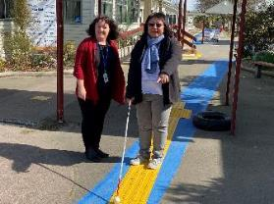
Figure 1 Julie & Crystal discuss the positioning of directional tiles at a local school
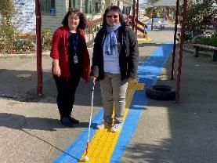
Figure 2 Julie & Crystal practice walking along directional tiles at a local school

BLENNZ VRC Coordinators
An incredible year in respect of BLENNZ’s response to Covid 19. As VRC Coordinators the ‘contactability, connectedness, and caring’ aspects of our roles came to the fore this year. Also, as part of our ‘how are we making a difference’ inquiry line, we discovered the threads of our work key people value most highly are; information sharing, approachability, and connectedness. Our WiT journey has evolved, as we have taken on more facilitative aspects of the work, continuing our own journey but also taking more leadership in sessions with VRC managers and with entire VRC teams as they come alongside WiT processes for the first time. Now entering our third year as a VRC Coord trio, we look forward to 2021, each of us now supporting 5 centres each.
Alison, Fiona, & Saul

Homai Campus Music School

Individual Music Programme – Wendy Richards
Twelve ākonga received regular one to one music tuition in 2020. Three ākonga successfully completed four external NCEA papers including both aural and score reading papers at levels 2 and 3. Another learner based at Homai Campus was able to achieve 6 Level 1 performance credits through his BLENNZ music programme. Six ākonga accessed their music lesson via zoom or FaceTime which proved invaluable during lockdown.

Music School – Wendy Richards
Music school experienced several challenges and changes in 2020 as it moved to a completely online programme, then back to a hybrid format of delivery, with ākonga both on campus and online. Though the online format proved challenging for some ākonga, it provided an opportunity to explore new technologies and engage learners previously unable to attend due to geographical location. We started with 18 participants and grew to 22. We were also able to have special guests join us, one of whom (Dr Dalia Sakas) runs a similar programme in New York City. She was delighted to see how we had managed to maintain our sense of community through the online platform, and was determined to follow our lead with her own students. A new “virtual classroom” was also created using google slides so that ākonga could access practice material independently. A hybrid “family day” was held at the end of the year where ākonga shared their music learnings with their families – both on campus and on the big screen.

Homai School Music Therapy Programme
Helen Dowthwaite, joined BLENNZ Homai School term 3, 2020. We had been without a music therapist since week 4, term 1, 2020.

Once with us from Term 3, post Covid, Helen provided an enriching music therapy programme Thursdays and Fridays to a range of ākonga across the school, with facilitating individual and small group sessions.

One particular area of focus on Thursday afternoons was Helen’s facilitation of individual input into group music therapy sessions for James Cook ākonga. Her focus here involved working on specific goals for each ākonga. One significant focus was around further enhancing the work around Social Emotional Mental Health and wellbeing and how this can be supported through music, in particular following the return to school, post Covid.

This was quickly identified as a priority across the school, especially for James Cook ākonga who became part of a set Thursday afternoon group music therapy programme with Helen. The social work student, on placement at the time also worked alongside Helen to trial the SEMH App with one ākonga who was involved in the group music therapy session.

This student by the end of the year, was confident to share her learning and speak about how she felt about it via the SEMH App to her Mum at home. This was very powerful, as this young person previously had been a follower more so than a leader and held back sharing any reflections of her input.

As a result of this tailored input resulted in individual performances by the ākonga noted above along with peers sharing in group performances. Ākonga were able to share their learning at the End of School Christmas Concert, 2020.

The pride shown by individual ākonga was obvious, as was the sense of achievement in having developed more confidence, music skills, confidence and self-esteem demonstrated through their musical performance.

Ākonga played a range of instruments including the drums, guitar, keyboard and some also lead vocals. This was a very motivating and positive opportunity for the ākonga involved to share their learning. Whanau who attended the end of year concert, also had an opportunity to see and hear their tamariki involved in individual and group performances.

Te Whānau o Homai

Homai Early Childhood Centre

Consultation was held with a kaumatua from Manurewa Marae with regards to having a carving in the centre outdoor area adjacent to the playground. Once installed the carving would be interactive and accessible for all tamariki.

BLENNZ staff conference
January 22 and 23, 2020 was held here on campus with Te Whānau o Homai committee being responsible for workshops teaching poi, waiata, rākau, harakeke putiputi in a fun environment.

Māori language week from September 14, 2020
Because of the pandemic, to raise public awareness for Māori language revitalisation whereby we all come together to celebrate Te Reo was done a little differently. So at 12:00pm on September 14, 2020 people who had signed up took part in the celebration of the Māori language moment via zoom. The time and day are significant as this marked the hour in 1972 when a group of Māori presented a petition of 30k signatures to Parliament calling for Te Reo to be taught in our schools.

BLENNZ Matariki
This was planned with various activites to take place on campus whereby Te Whānau o Homai would have taken an active part. So because of what everyone was experiencing at the time due to to the pandemic Matariki was not celebrated in the normal way. Traditionally Matariki was celebrated by gathering with Whānau and reflecting on the past and also by attending local activities. Instead, Te Reo phrases were placed at reception where people sign in.

Welcoming new staff/students
A whakatau was held on two occasions to welcome new staff and students to BLENNZ.

Youth Library
Youth Library based at BLENNZ Homai Campus School, is administered by Blind Low Vision New Zealand. We have two enthusiastic librarians on site who offer a point of contact for teaching staff, teacher aides, parents, children and young adults throughout New Zealand and provide educational as well as recreational resources for blind and low vision learners.
Blind Low Vision New Zealand, through funding from the Ministry of Education, is committed to producing and providing a wide range of accessible resources to fulfil the educational and recreational needs of children and young adults. The library also supports children and their families in literacy reading development and lifelong learning through the provision of a range of reading materials in a variety of formats. These include:
- Collage books: sturdy, hard-covered picture books with large print and braille text and bright, bold collage illustrations.
- Board books for CVI readers.
- Readers and School journals available in large print, braille and e-text.
- Braille books in hardcopy and e-braille format for fiction, non-fiction, examinations, tests, handouts and textbooks.
- Twin vision picture books: with clear plastic braille over original print or with clear plastic braille pages inserted between the original print pages. Some are also available with an accompanying CD.
- Large print books in 18 and 24-point font: mostly fiction for ages 9 to 16. We also have a growing non-fiction and textbook collection. Also available as adapted pdf.
- Kitsets with enclosed print book with accompanying CD or online daisy audio access and braille text.
- Electronic files (E-text) available in Word, HTML and Plain text.
- Playaways that are pre-recorded MP3 players.
- DAISY books which is produced in-house, requested from international blindness agencies through ABC (Accessible Books Consortium) and purchased from commercial vendors. These are sent to clients as Bookdrives which can contain 50 titles at any one time.
- Digital services such as Booklink, Alexa and EasyReader.

The library supports RTVs and educators professional development through the provision of reference material and reference services. Nazreen is available to assist with reference queries and literature searches.

The library also supports and helps with a variety of immersion courses run by BLENNZ over the course of the school year, and conducts library tours for teacher aides, parents and other educational groups when requested. We have regular visiting sessions for all classes in the school. We also deliver story times for Early Childhood Centre and meet regularly with families visiting for needs assessment.

Opening hours: Monday to Friday, 9.00am to 4.30pm, including school holidays.
You can phone us on (09) 268-3215 or 0800 24 33 33 ask for Youth library.
Email youthlibrary2@blindfoundation.org.nz

The Library Team:
Senior Librarian – Nazreen Shaban
Senior Library Assistant – Gordon Dickson

Board of Trustees
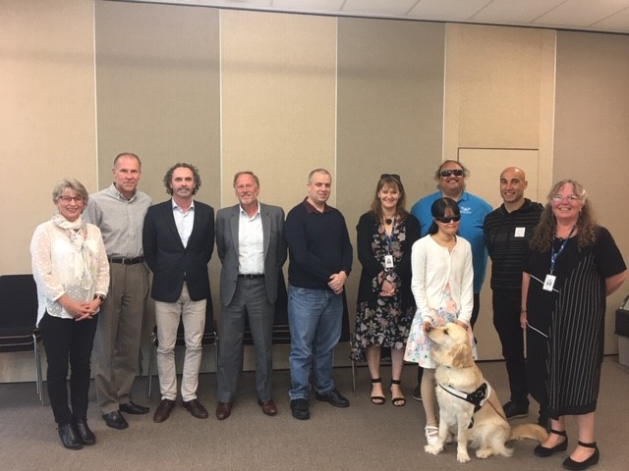

Board Members – November 2020
From left:
Janny Cooke (Board Secretary), John Mulka (BLVNZ appointed Trustee), David Cullen (VRC Parent Elected Trustee), Mitch Harris (Homai Campus Parent Elected Trustee), Nathaniel Louwrens (VRC Parent Elected Trustee), Kelly Doyle (Staff Elected Trustee), Nigel Ngahiwi (Tangata Whenua appointed Trustee), Christopher Gunn (VRC Parent Elected Trustee), Karen Stobbs (Principal), Wendy Chiang (Blind Citizens NZ appointed Trustee) with Guide Dog Yaron.
Missing from the photo is VRC Parent Elected Trustee Graeme Hood.
BLENNZ has a national board of trustees, which is representative of BLENNZ and of the wider blindness education sector.
The role of the BLENNZ Board is to govern the school, with a focus on providing an environment that fosters achievement for ākonga and young people who are blind, deaf blind or low vision.
In 2020 the BLENNZ Board met for seven meetings inclusive of one strategy planning morning.
28 February, 27 March, 24 April, 26 June, 14 August, 16 October, 4 December
The Board is made up of the following trustee positions:
- Four trustees elected by parents receiving services from Visual Resource Centres
- One trustee elected by parents of students enrolled at the Homai Campus School
- One trustee elected by staff
- One trustee appointed by the RNZFB now known as the Blind and Low Vision NZ
- One trustee appointed by Blind Citizens NZ
- One trustee appointed by a panel of representatives of recognised Kāpo Māori organisations
- The Principal of BLENNZ

Board co-opted trustees, provided that the number of parent elected and VRC elected trustees is greater than the total number of co-opted and appointed trustees.

A mid-term elections for school boards of trustees took place early December 2020. This resulted in two Visual Resource Centre parent elected trustees not wishing to seek re-election. These were Nathaniel Louwrens and Graeme Hood. The Board welcomed Ross Meikle as one of the Visual Resource Centre Parent Elected Trustees. Wendy Chiang, Blind Citizens NZ appointed trustee did not seek a reappointment and was replaced by Martine-Abel-Williamson.

BOT members and roles as at 31 December 2020
Visual Resource Centres parent elected trustees:
- David Cullen, Christopher Gunn, Ross Meikle
Homai Campus School parent elected trustee:
- Mitch Harris
BLENNZ staff elected trustee:
- Kelly Doyle
Appointed Trustees:
- John Mulka – Blind and Low Vision NZ
- Martine Abel-Williamson – Blind Citizens NZ
- Nigel Ngahiwi – Tangata Whenua
The Principal of BLENNZ
- Karen Stobbs

Strategy Planning
The Board held their strategic planning on the 16 October. The purpose of the day was to:
- Explore how BLENNZ might, more effectively, fulfil our monitoring role to answer the question: How do we know we are making a difference?
- BLENNZ has a range of context including itinerant (regional); school; and national service strands.
- The focus was the service which has the greatest scope, the itinerant teaching provision.
- The scene was set from the Coordinator and RTV perspective. All BLENNZ services aim to positively impact:
  - Access to Learning
  - Learning to Access
  - Inclusion

- The board invited three experienced team members to share their perspectives about the role of the RTV and how it makes a difference to the overall development of ākonga. Each team member shared their perspectives from the perspective of provision to the three cohorts of ākonga:
- an ākonga with low vision
- an ākonga who is blind
- an ākonga who is deafblind
The coordinator provided an update to the board on the area of wellbeing and community voice.
The presentations would enable the board to reflect in their strategic focus entering into 2021.

The Framework of Indicators of Learner Achievement

BLENNZ uses a network-wide approach to quantifying learner achievement using a framework of evaluation indicators. The indicators capture both direct and indirect measures to provide an overview of achievement of learners and BLENNZ services. This systematic approach is intended to enhance opportunities for evidence-based practice and to provide the data needed for the development of nationally consistent practice and for a process of continuous improvement.

The outcomes are documented in the following pages with the first section of reporting focusing on the School and Residential Service Strand followed by reporting on the Assessment and Teaching Services.

Homai Campus School

Targets
Learners at Homai Campus School will achieve 80% of their IEP goals during 2020

In this reporting the names Pukeko, Takahe, Tui, Kiwi, Kea and Weka are the different classrooms of the learners on campus. There are also three classes normally based at James Cook High school who were based on Campus for 2020, Senior 1,2,3.

When learners achieve their goals, new goals are set. The aim is 100% but achievement of the goal is at the pace of the learner.

Learners at Homai Campus School are working either within the Key Competencies Framework (Adapted Curriculum) or the New Zealand Curriculum, dependent on their functional skills, their vision impairment and additional disabilities. Conventional curriculum learning and targets therefore are not always realistic or relevant for some ākonga in the school. Teachers are very skilled at working to establish the functional learning level of each ākonga and provide the appropriate curriculum goals in line with their IEP.

Reporting
The Homai Campus School has developed an IEP policy and guidelines to ensure the IEP process outlines the children and young peoples’ strengths and needs, bringing together a collaborative team that works in partnership with family and whānau to identify and prioritise learning outcomes that are based on effective assessment and teaching strategies. The IEP or ITP plans ensure learners are provided with a programme that enables them to achieve maximum educational outcomes and the goals are appropriate for the learner. Each IEP is reviewed by the Senior Teacher, Coordinator School Programmes and the Senior Manager of School. During 2020, due to Covid 19, the usual cycle of two IEPs was not always possible, due to Lockdown, ākonga absence or parent’s capacity to attend IEPs in person, or access IEP meetings on line. Cultural and language supports are also a consideration when supporting parents / whanau attending IEPs.

The learners have worked well to achieve their IEP goals. For the learners who have not achieved the target of 80% there appears to be a consistent variable relating to their attendance due to illness and in some cases changes in their physical condition and / or changes in medication which has impacted on their learning. Covid 19 and the associated Lockdowns have through 2020 impacted significantly for many ākonga, with attendance and return to school being spasmodic.

Takahe
The aim is that all learners achieve at least 80% of their goals. When learners achieve 100% of their goals, new goals are set to extend their learning. Learner 2 had on going issues with his AT so he was not able to achieve his language goal. Covid also lead to him returning to school not speaking for many weeks, with a very fragile disposition. His anxiety affects him physically when moving / interacting when at school. Student 3 Learner 4 moved to a new class in term 3 and was also impacted by Covid – SEMH so all learning was effected so only managed two IEP goals. Learner 5 had cardiac surgeries term one and was absent for the majority of the school year with just small interludes at school. She fatigues easily so any learning at school is still compromised by her cardiac condition.

Student 6 is reading at level 15 but resists testing due to his autism. He is a dual language learner with 1.5 days home school per week in his home language. On return to school has resisted engaging in any written language or math work. We continue to work with the family.

Learner | Using language symbols and texts | Participating and contributing | Managing Self | Relating to Others | Thinking
1 | 89% |  | 90% |  | 86%
2 | 66.6% |  | 100% | 100% | 83%
3 | 79% | 50% | 88%
4 | 57% |  | 75%
5 | 40.5% |  |  |  | 64%
6 |  | 69% | 82%

Kea
The learners in this class are widely varied in their needs and abilities. Student 1 had only 1 IEP in 2020 due to Covid and Lockdown which impacted on his ability to progress in his learning especially literacy. Learner 2 was absent the majority of the year post Covid as family / whanau chose to keep her safe at home therefore she only had one IEP. Learner 3 had excellent attendance and works very hard with great home / school support. Learner 4 transitioned from Kiwi Class in term 3 after Lockdown 1. Learner 5 transitioned form Takahe also in term 3, 2020. Learner 4 behaviour due to a preexisting brain injury has difficulty settling to tasks and achieving his goals. The Covid lockdowns really impacted on his return to school after each lockdown – it took him some time to settle.
Learner 5 received his devices near the end of Term 4, with the delay in AT due to Covid. This impacted on his independent learning.
Learner | Language Symbols and texts | Participating and contributing | Managing self | Relating to others | Thinking
1 | 60% |  | 80% |  | 80%
2 | 66% |  | 50% |  | 40%
3 | 100% |  | 100% |  | 100%
4 | 66% |  | 50% |  | 60%
5 | 50% |  | 79% |  | 80%

Tui
Learners in Tui class have very high needs and some with fragile health. Illness and the resulting absences from school have had an impact on the progress of some learners significantly during 2020 and Covid.
Learner | Using language symbols and texts | Participating and contributing | Managing Self | Relating to Others | Thinking
1 | 87% |  | 83% |  | 100%
2 | 83% |  | 83% | 100%
3 | 87% |  | 100% | 83%
4 | 80% |  | 80% |  | 100%
5 | 100% |  | 87% | 75%

Weka
The students in Weka all have considerable health needs which impacts on their attendance and their ability to engage consistently during the school day.
No. 2 physical condition has deteriorated significantly during the year – on palliative care track.
No. 3 and 4 transitioned into this class from BLENNZ ECE. To begin with they did not attend regularly. Attendance increased over the term. Goals had been pre-set from ECE transition.
No. 5 had numerous hospital appointments and absences due to ill health.

Learner | Using language symbols and texts | Participating and contributing | Managing Self | Relating to Others | Thinking
1 | 92.8% |  | 91.6% | 83%
2 | 75% | 80% | 75%
3 | 59% |  | 33% | 100%
4 | 50% |  | 50% | 100%
5 | 80% |  | 78% |  | 75%

Pukeko
The students in Pukeko all have had an unusual amount of absences during 2020. This has been followed by two Covid Lockdowns and returning to a new normal. For students who are dependent on routine and consistency, and repetition in their learning environment any change impacts on their attendance and their ability to engage consistently during the school day. Across all students progress has been less than usual.

Learner 1 has had limited progress towards goals due to frequent illness, surgery and recovery, and lockdowns. Consistent implementation has not been possible. Her surgery has only been done on one leg hence moving with support is not yet possible.

Learner 2 has needed to become familiar with new team members, He doesn’t learn well with unfamiliar staff. Attendance has been infrequent.

Learner 3 Reintegration into school from frequent absence has been challenging for him. Progress is influenced by his behaviour.

Learner 4 Non achievement of goals has been influenced by lack of attendance due to lockdowns and reintegration into school routines and poor attendance.

Learner 5 Infrequent attendance until Term 4 (less than a month Full time equivalent FTE over her first year) has influenced progress. Poor attendance has meant this learner has not developed full familiarity with classroom people, places or routines.

Learner 6 Non achievement in has been influenced by truancy, lockdowns, and family inability to attend IEP meetings. SWISS and truancy have been engaged.
Learner | Using language symbols and texts | Participating and contributing | Managing Self | Relating to Others | Thinking
1 | 25% |  | 10% | 10% | 20%
2 | 75% | 80% |  | 30% | 60%
3 | 85% | 5% | 75% | 40% | 55%
4 | 80% | 70% | 60% | 50% | 60%
5 | 50% | 60% | 50% | 60% | 40%
6 |  |  | 40% | 40% | 30%

Kiwi
Kiwi class began with two learners and throughout the year two more transitioned into the class, altering the class dynamics. Learner 1 had intermittent absences due to re engaging into school after Covid then Auckland Lockdown. Took some time to settle back into routines on return to school each time. Learner 4 was away the majority of the year in Indian and due to Covid could not get back into NZ. Learner 5 has made remarkable progress in Self Managing-especially standing sitting, stepping, turning and walking.

Learner | Using language symbols and texts | Participating and contributing | Managing Self / Relating to Others | Thinking
1 | 66% |  | 75% | 50%
2 | 100% | 75% | 83%
3 | 80% |  | 87% | 83%
4 | 60% |  | 70% | 67%
5 | 83% |  | 83%

James Cook Satellite Classes

Senior 1
Senior 1 Class from James Cook Satellite started the year with three learners. All students in the class only managed one IEP for 2020 due to Covid lock downs, time restraints and Staff changes. Learner 1 from their first IEP gain 100% in both music sound Arts L4 and Mathematics Number L2 with 84% in English speaking writing and presenting L2. Learner 2 achieved 80% in KCI 5 Engaging in a variety of social skills to develop positive relationships. This learner also became more confident in the use of Braille as a communication form.

Learner | Using language symbols and texts | Participating and contribution | Managing \Self | Relating to Others
1 | 100%
2 | 75% |  | 100% | 80%
3 | 40% | 80% | 80% | 80%

All Senior classes often worked together on the Managing Self and relating to others aspects of the Key Competencies Curriculum.

Senior 2
Learners in Senior 2 are secondary aged and focusing on accessing NCEA. Two of the students gained credits with Endorsements in maths. With regards to Participating and Contributing, Learner 1 and 3 due to interruptions with Covid were unable to meet their IEP goals as these were based around James Cook classes. Inability to secure work experience post Covid resulted in Learner 3 not meeting Relating to Others to the optimal level.

Learner | Using language symbols and texts | Participating and contributing | Managing Self | Relating to Others | Thinking
1 | 90% | 50% | 90%
2 | 89% |  | 80% |  | 94%
3 | 89% | 50% | 89% | 71% | 100%

Senior 3
Learners in Senior 3 are secondary aged and focusing on life skills. Learner 1 previous literacy goal was not met due to intermittent absence from ill health, taking time to re-engage when at school. Learner three started with us at the beginning of Term 3. His IEP is scheduled for Term 1, 2021.

Learner | Using language symbols and texts | Participating and contributing | Managing Self | Relating to Others | Thinking
1 | 40% | 90% | 100% |  | 67%
2 | 80% |  | 75% |  | 100%
3 | 0% | 0% | 0% | 0% | 0%

Māori and Pasifika

Māori Learners
There are 9 learners enrolled at the school who identify as Māori.
IEP Goals for the year were disrupted due to Covid lock downs so all learners are still working on their goals. Staff are working closely with these families.

Cook Island Māori Learners
There are 6 learners who identify as Cook Island Māori. 3 of the 6 achieved 80% or more of their IEP goals.

Samoan Learners
1 of the 7 learners who identify as Samoan achieved 80% or more of their IEP goals. A combination of Covid lock downs, ill health and family circumstances contributed to the other 6 learners’ performance.

Tongan Learners
3 learners identify as Tongan. One of these learners achieved 80% or more of their IEP goals.

Target (Literacy)
Learners at Homai Campus school participating in a conventional literacy programme are predominantly in Takahe classroom. These learners are working towards achieving their individual targets in reading and comprehension using a variety of media e.g. Braille, large print, auditory. All students have made progress throughout the year.

Learners attending James Cook classes on site at BLENNZ during 2020, were developing the skills required to access NCEA subjects.

Target (Numeracy)
Learners at Homai Campus school participating in a conventional numeracy programme will achieve their individual targets in numeracy.

7/9 senior learners at Homai Campus School (Senior 1, 2, and 3 classes) participated in conventional numeracy programme. Two ākonga accessed NCEA Level 1 Maths.

Learners: Senior students (12years +)
9 of the 17 are in the senior school. Three of the learners at James Cook (Senior 1 – 3 for 2020), were working within the mainstream programme at NCEA Level 1 and 3 were working Levels 1 – 3 in the NZ Curriculum. Other senior students who attend the campus school are working within Level 1 of the NZ Curriculum.

Learners: Junior students (5- 12years)
The NumPA or JAM assessments are completed with each learner who is working within a conventional numeracy programme. The assessment is adapted for low vision and braille learners. The assessment scores in various areas. The results are analyzed by the teacher, with areas of strength and weaknesses are identified.

Homai Campus School IEP Survey

Homai Campus School
All reporting to parents by the Homai Campus School will be against the learners’ IEPs. It will be in an agreed format that has been developed to comply with the National Standards Guidelines to ensure that all reporting is in plain language and clearly articulates to parents the next steps for their child’s learning, and how they can support the learning outcomes at home. Below are our findings from this survey:

2020 IEP Survey:
How do you like to be contacted about IEP meetings?
- Home school book 4
- Txt 8
- Phone 2
- Letter 1
Where would you prefer to hold your young person’s IEP meeting?
- At BLENNZ / Satellite 9
- At home 2
- On a Marae? If so which one? (since survey, one verbal request).
- Another place – where? No feedback
- Zoom No feedback
What is your preferred language for IEP meetings?
- English 9
- Thai 1
Would you like to bring or have an interpreter available?
- Yes 2
- No 8

How else can we support you to be fully involved at your young person’s IEP?
- Sending out the previous/ current IEP goals before the meeting to remind parents so they can think about next steps
- Nothing really very supportive teachers/specialists
- To discuss with me everything you involve with my daughter at school
- Keeping in touch from time to time
- He needs help with Maths, spelling and reading, Transitioning my son.

How often do you feel IEP meetings should be held?
- Twice a year – Term one / term three 5
- Twice a year - Term two / term four 6
- One in Term One or Two and a parent teacher meeting by phone Term Three to update on progress.
- Would you like to receive information about your young person’s learning goals prior to the IEP?
Yes 8
No 1

What are the most important Goal areas you want covered in your tamariki’s IEP meeting?
Curriculum Goals: The average of 9 surveys was:
Literacy- listenting to / reading books, poems, rhymes,
7 Making marks on paper, writing, Braille, symbols,
6 Maths counting, adding subtracting, using money, measuring.
7 Learning Braille / using Assistive Technology
7 Learning about their world, science, social
7 Life skills cooking, using money, working with others

Would you like your Tamariki’s teacher / therapy team to keep you updated about IEP goals between IEPs?
- Home school book 4
- Email 6
- Text 2
- Phone 1
- WhatsApp 2
- Meeting in person

At the IEP Meeting:
Do you feel included?
Yes 10
No 1

Do you get a chance to say what you want to happen?
Yes 10
No 1

Are you kept informed of progress at school between IEPs?
Yes 9
No 2

Where and how would you like to meet for IEP meetings?

- At BLENNZ? 8
- At your home? 2
- On your Marae?

How you feel about attending IEP meetings?
- Good would like to see Logan more involved with the discussion and setting goals
- Feel good
- Good at times, with working in retail it’s hard to make sure I’m available, best time would be Monday.
- I enjoy IEP meetings as it keep me updated on my child progress and what he is learning and doing well in
- Fine its important
- Not happy
- Good
- I prefer meeting in person at BLENNZ
- Eager

What would make it easier?
- As long as the time suits attending the IEP meetings is not difficult
- More time in a day
- To listen to me
- Face to face
- zoom
Is transport / timing a barrier?
- Both, but school are always able to organise IEPs at a date and time to suit
- Just time to organise work schedule
- Prefer Mornings
- There is no transport barrier – just timing – I would prefer the first time I the morning
- No
- No only weather transports normally by train but trains are only running as far as Manukau due to upgrades
- Transport

What format would you like to have the IEP presented in?
- Possibly a little more structured so that everyone present is able to contribute in a timely manner and to keep the IEP on track
- Paper form
- Any form suits
- Letter
- All in writing
- English
- Paper A4 normal print
- Would like to hear more from the therapists

What would you like to see included / taken out?
- Included: Brief review of current goals and progress
- Setting new goals
- Therapists contribution of current goals and progress
- Parental input into any changes, in our case, medical and any other issues.
- Student to be brought into discussion at each stage, by preparing them a week or so in advance with a short list of what areas will be discussed thus giving them a chance to thin about anything they may wish to add or include or discuss at the IEP meeting
- No
- Nothing at this point
- For my child to get out from wheelchair, she can walk and run around but she need help to stand up.
- IEP goals to be included
- Would like regular feedback (progress reports from teacher and therapists) between IEP’s
- We would like to discuss all the learning of our child

Summary:
Of all the parents/ whanau who completed the survey we have established their desired priorities for future IEP facilitation and reporting. We have identified areas that inform parents / whanau well and other aspects that need further development.
The findings of this survey will contribute to the next phase of the School IEP Review which is being implemented from Term 1, 2021. (Refer Annual Plan Strategic Goals and Making a Difference documents).
At the end of 2021 we plan to conduct a Parent Survey which will also include a follow up review of the new IEP process for BLENNZ Homai Campus School ākonga.

Regional Network

BLENNZ continues to use a network wide approach to quantify learner achievement for all BLENNZ learners within an established framework of indicators. This systematic approach reflects evidence based practice and provides data needed to confirm nationally consistent practice.

In 2020, BLENNZ continued to emphasise the importance of reporting of accurate, complete and meaningful data in order to provide a broad picture of the BLENNZ learner population. The focus was predominantly on the population of braille and print users, aged 5-12 years, who are verified for ORS primarily on their vision, and are following conventional programmes.

In December 2020, there were 1592 learners enrolled with BLENNZ whose information was held on the electronic platform of eTAP and who were receiving their support from a Visual Resource Centre. Data in respect to all learners is continually updated throughout the year to ensure accuracy.

Outcome Indicators

A Literacy – Using Language, Symbols and Text
For all BLENNZ learners, data for reporting on this indicator will be aggregated from the BLENNZ Literacy Profile Forms, which are completed by BLENNZ teachers for all learners and collated electronically.

Identify the proportion of the learners acquiring literacy by:
The type of literacy programme (conventional or functional)
The stage of literacy development
The level of participation in the literacy programme as defined in the BLENNZ Literacy Profile

Outcome Achieved for 99.9% of the learner population

Reporting
BLENNZ teachers have completed the BLENNZ Literacy Profile and information has been collated to identify the type of literacy programme, level of participation and stage of development in literacy for the BLENNZ learner population.

- The type of literacy programme (conventional or functional) a learner is involved in.

54.8% (872) of learners follow a conventional literacy programme
This is a formal instructional programme of reading and writing (in print or Braille) that generally begins at Early Childhood Centres and continues throughout the school years. Learners in such programmes demonstrate continuous growth in literacy skills from year to year.

39.5% (629) of learners follow a functional literacy programme
These programmes have an emphasis on reading and writing for the purpose of increased independence in daily life.

5.7% (91) of learners’ literacy programmes are yet to be determined or identified
Learner age is the principal factor involved where the literacy programme has yet to be determined. This relates to infants under 18 months of age. Where this is not the case updated information has been requested,

- Their stage of literacy development

Literacy development for the BLENNZ learner is defined by the way the learner gains meaning of the world around them. This will start from actual objects through to visual or tactual codes and is described as: using real objects; 3 dimensional items (objects of reference); 2 dimensional picture or tactile cue (objects of reference); text symbols such as print, braille; or as dual modality meaning using both print and braille. The following information outlines this data:
- 58.4% (930) use text symbols (printed or embossed)
- 12.7% (202) use 2 dimensional (pictures or cues)
- 3.3% (53) use 3 dimensional objects
- 25.4% (405) use real objects
- 0.1% (2) of learners’ literacy development is not recorded
NB: Of the 0.1% of learners whose stage of literacy development is not recorded, they are new enrolments or very young, therefore, their stage of literacy development is unknown, but are most likely to be ‘using real objects’.

- Learners’ level of participation in their literacy programme as defined in the BLENNZ Literacy Profile

Learners may be at different levels of participation: exposure; awareness; emergent; early; or fluent. Each level reflects how the learner is engaged in literacy - for example at exposure level, the learner is presented or exposed to literacy materials and experiences, whereas at fluency level, the learner is integrating cues, thereby maintaining meaning through longer and more complex sentence structures, various kinds of prose, and poetry and adjusting the rate of reading to the purpose.

Exposure – 28.5% (453) of BLENNZ learners are participating in their literacy programme by being exposed to literacy materials and resources. A further 0.4% (7) are likely to be at this stage of participation as they are very young children or infants.

Awareness – 12.8% (204) of BLENNZ learners demonstrate an awareness of the literacy materials that are shared with them by attempting all or some of the following:
- Touching or looking at the illustration;
- Attending to the language of the story being shared – may vocalise with adult
- Turning pages
- Touching dots

Emergent – 10.9% (173) of BLENNZ learners are at an emergent level, showing interest in attempting to read text unaided, considering what is read with what is already known, discussing what is happening with what is likely to happen and recognising a number of words in various contexts.

Early – 15.2% (242) of BLENNZ learners are at an early level of literacy drawing out meaning from text using such strategies as:
- Using their background experience
- Taking risks and making approximations
- Using text and illustrations to sample, predict and confirm
- Using letter sound associations to confirm predictions

Fluent – 32.2% (513) of BLENNZ learners are at a level of fluency integrating cues, maintaining meaning through longer and more complex sentence structures, various kinds of prose and poetry and adjusting the rate of reading to the purpose

Learners verified for Ongoing Resourcing Scheme (ORS), primarily for vision

All Braille users from 5-12 years old who participate in conventional literacy programmes
- Identify the proportion of learners reading at their chronological age or better as at December 2020.
Outcome Achieved for 81.8%

Reporting
There were 22 learners, ORS verified vision only, aged 5-12 years who use braille and participate in a conventional literacy programme. 46.4% of these learners are reading at or better than their chronological age.

Reading Ages of Learners Using Braille whose Chronological Age is 5-12 Years

Year of Birth | No Data | Below | At | Above | Total
2008 |  | 3 |  |  | 3
2009 |  |  |  | 4 | 4
2010 |  |  | 1 |  | 1
2011 | 1 | 2 | 1 | 1 | 5
2012 |  | 3 |  |  | 3
2013 | 2 |  | 1 | 1 | 4
2014 |  |  | 1 |  | 1
2015 | 1 |  |  |  | 1
Total | 4 | 8 | 4 | 6 | 22
Percent | 18.2% | 36.4% | 18.2% | 27.2% | 100%

In 2020, these 22 learners were 1.4% of the total number of learners on the BLENNZ roll who are receiving support from Visual Resource Centres. 27.2% (6) of these learners are reading above their chronological age while 18.2% (4) are reading at their chronological age. Of the learners, 36.4% (8) are reading below their chronological age.

For those reading below their chronological age, information was provided for all of the learners. This information refers to a number of considerations as follows:-

- COVID 19 lockdowns have affected reading progression (3)
- Poor health has impacted on attendance
- A reluctant participant in any reading activity
- Reading comprehension for stories read aloud is higher
- Learners have increased their reading age by 1 year (2)

For those learners where no data was provided (4), the following explanations are noted
- Learner still at pre- braille level (2)
- Learner in hospital and not assessed
- Learner moving towards functional literacy through braille

All Dual Print Braille Learners from 5-12 years old who participate in conventional literacy programmes
- Identify the proportion of learners reading at their chronological age or better as at December 2020.
Outcome Achieved for 91.7%

Reporting
There were 12 (0.8%) BLENNZ learners in this category. 75% of these learners are reading at or better than their chronological age.

Reading Ages of Learners Using Print/Braille whose Chronological Age is 5-12 Years
Year of Birth | No Data | Below | At | Above | Total
2008 |  |  |  | 1 | 1
2009 |  | 1 |  |  | 1
2010 |  |  |  |  | 0
2011 |  |  |  | 1 | 1
2012 |  | 1 |  | 1 | 2
2013 |  | 0 |  |  | 0
2014 | 1 |  | 2 |  | 3
2015 |  |  | 4 |  | 4
Total | 1 | 2 | 6 | 3 | 12
Percent | 8.3% | 16.7% | 50% | 25% | 100%

25% (3) of learners in this age group who use print/braille (dual) as their medium, are reading above their chronological age, while 50% (6) are reading at their chronological age. 16.7% (2) of the group are reading below their chronological age with no age related information provided for 8.3% (1) of the learners.
For those learners reading below their chronological age, information was provided for both of the learners. This information refers to a number of considerations as follows:
- Has moved up 6 levels
- Recent adjustment to programme following dyslexia diagnosis

For the 1 learner where no assessment had occurred, the following statement was made:
- Learner not attending school due to ongoing family concerns with Covid

All Low-Vision Learners from 5-12 years old who use print in conventional literacy programmes
- Identify the proportion of learners reading at their chronological age or better as at December 2020.
Outcome Achieved for 97.9%

Reporting
There were 141 (8.9%) BLENNZ learners in this category. 45.4% of these learners are reading at or better than their chronological age.

Reading Ages of Learners Using Print whose Chronological Age is 5-12 Years

Year of Birth | No Data | Below | At | Above | Total
2008 | 1 | 12 | 1 | 10 | 24
2009 |  | 11 | 8 | 8 | 27
2010 |  | 12 | 2 | 5 | 19
2011 |  | 9 | 1 | 4 | 14
2012 | 1 | 9 | 1 | 10 | 21
2013 | 1 | 9 | 3 | 2 | 15
2014 |  | 11 | 3 |  | 14
2015 |  | 1 | 5 | 1 | 7
Total | 3 | 74 | 24 | 40 | 141
Percent | 2.1% | 52.5% | 17.0% | 28.4% | 100%

28.4% (40) of learners in this age group, who use print as their medium, are reading above their chronological age, while 17% (24) are reading at their chronological age. 52.5% (74) of the group are reading below their chronological age with no age related information provided for 2.1% (3) of the learners.

For those learners reading below their chronological age, further information was provided for all of the group:
The following information was documented:
- COVID 19 lockdowns
- Developmental delay
- Change / new vision diagnosis
- Other health diagnosis
- General ill health
- New enrolment
- Developing skills
- Progressing well
- Lack of home support

For the 3 learners where no assessment data was provided, the following information was stated
- Learner has just started school and assessment is not appropriate
- Learner is unwell as in palliative care
- Assessments of this type are not considered appropriate by the school

B. Mathematics
Learners being supported by RTVs itinerating from Visual Resource Centres.
- Report on each learner’s achievement (ORS Vision Only Years 1-8) of individual numeracy targets.

All ORS Vision Only learners Year 0 – Year 8 who are following a conventional numeracy programme, will have their mathematics levels identified using the required assessment material.
Outcome Achieved for 100%

Reporting
In 2020 we continued our work with Julie Roberts from New Zealand Council for Educational Research to upskill our RTV across the network in assessing learners in Mathematics. This is our second round of data collection. We are working with eTAP to be able to break down our data into print, braille and dual users. This is our second year of data collation once we have the data analysed, we will be able to provide more information and be able to draw conclusions on this for next steps.

Approach used to collect data
- Assessment was completed on each learner using Junior Assessment in Mathematics (JAM) or GloSS
- All judgments were moderated in each regional centre.
- The data was then ‘cleaned’ for consistency. Regional Maths Ninjas were consulted if any clarification or changes were required. This is still in process and we are working with eTAP to develop our reporting guidelines so we can do this in a cyclic basis.

Number Achievement Years 0 – 8 ORS Vision Learners
- Summary table and graphs presented as achieving within curriculum expectations

Number Achievement Years 0 – 8 ORS Vision Learners
Table below summaries the number of learners and percentage of learners achieving within curriculum expectations. Note that one curriculum level covers approximately two years of learning so the classification is a broadband approach rather than specific year level expectations.

 | All Learners | All  %
Towards | 96 | 61.9%
Within | 38 | 24.5%
Above | 21 | 13.5%
Total | 155 | 100%

As stated, we are working with eTAP to develop our data information sharing and at this time we are yet to fully analyse the break down between print and braille learners. This data reflects the learners in the regions only. We are also looking at comparing 2019 and 2020 data to understand any trends that may be emerging across the network. This will be compared with what is occurring in schools nationally and pertains to Vision Only ORS learners. This information will inform next steps in our approach to Mathematics.

Process Indicators

Student Achievement

Teacher assessment skills in literacy

BLENNZ Braille learners 5 – 12 years who are participating in a conventional literacy programme and acquiring literacy through touch
- BLENNZ teachers working with learners acquiring literacy through touch 5 – 12 years who are participating in conventional literacy programmes, will demonstrate the required skills in carrying out a Running Record assessment.

Targets
- All braille users from 5 – 12 years old participating in conventional literacy programmes will have their reading age assessed and documented by their BLENNZ teacher using the Running Records diagnostic assessment.
Target not achieved

- All teachers undertaking this assessment have demonstrated their competency.
Target achieved

BLENNZ ORS verified learners with low vision who are 5 – 12 years and participating in a conventional literacy programme
- BLENNZ teachers working with ORS verified learners who have low vision from 5 – 12 years old who are participating in conventional literacy programmes, will demonstrate the required skills in carrying out a Running Record assessment

Targets
- All ORS verified learners with low vision from 5 to 12 years old participating in conventional literacy programmes will have their reading age assessed and documented by their BLENNZ teachers, or in partnership with the classroom teacher / SENCO, using the Running Records diagnostic assessment.
Target not achieved

- All teachers undertaking this assessment have demonstrated their competency
Target achieved

Teacher Skills in Assessing and Accessing Appropriate Technology for Learners
School Learners across all age bands
- Report on success rate for assistive technology applications to the Ministry of Education in support of curricula access for BLENNZ learners
Target
- A 100% success rate with assistive technology applications for 2020.
Target achieved

Reporting
The assessment and procurement of assistive technology for BLENNZ learners remains an essential undertaking to ensure learners have access to their 21st century learning environments. A range of technology and software has been approved. The emphasis remains on promoting inclusive environments for all learners. There were some difficulties in 2020 getting the equipment into the country. There was a backlog of equipment, which shows in the large number of applications approved in term 4. We have 100% success rate in acquiring the equipment needed for learners. The ministry of education was supportive of trial technology going home during level 4 and 3 lockdowns and worked with local teams to ensure this happened. There were 2 other technology applications completed through ACC and funded by them that is not part of this data.

Assistive Technology Applications 2020

Term | Allocated for trial | Approved | Replaced and repaired
1 | 13 | 7 | 5
2 | 11 | 26 | 3
3 | 14 | 18 | 2
4 | 4 | 40 | 5
Total | 42 | 91 | 15

Hardware includes:
A range of technology was applied for which included the following:
- iPads in a range of sizes
- MacBook
- Polaris Braillenote
- BrailleSense U2
- Windows laptop
- Mountbatten Whisper
A wide range of accessories were applied for. They included:
- Noise cancelling headphones
- Carry cases
- Bluetooth keyboards
- Protective cases
- Apple pencil

Software includes:
A range of software was applied for to support the hardware. These included:
- Dolphin guide
- JAWS
- TypeAbility
- Zoomtext
A range of applications were also applied for to support access on iPads. These included:
- Voice Dream reader suite
- Clicker 4
- Scanner pro
- PDF expert

Other Educational Settings
This includes Immersion Courses, National Assessment Service and Developmental Orientation and Mobility. The following information related to all BLENNZ learners involved in these programmes.

Immersion Courses 2020 – Compulsory Sector

Target
- Provide 20 Immersion Courses in 2020.
Target not achieved because of COVID-19

Reporting
- 14 Immersion courses were delivered in 2020
- 8 courses delivered by distance
- 6 courses delivered on-campus
- 10 Parents participated in 3 courses
- 92 ākonga have been engaged in immersion courses with 14 of these attending more than one course.

Overview of all courses:

Term | Ākonga | Staff | Parents
Term 1  3 courses were provided | A total of 26 ākonga attended. | 18 BLENNZ RTV have attended immersion courses.  10 x specialist tutors have been involved in 3 of the courses. | 0 parents
Term 2  1 Online course was provided  COVID-19 | A total of 5 ākonga attended | 8 BLENNZ RTV participated in an immersion course | 0
Term 3  5 courses were provided  3 Online  2 On Campus | A total of 30 ākonga attended. | 28 BLENNZ RTV participated in immersion courses.  4 x specialist tutors have been involved in 4 of the courses. | 10 parents participated in 3 courses
Term 4  5 courses were provided  4 Online  1 On Campus | A total of 31 ākonga attended. | 31 BLENNZ RTV or supported staff have participated courses.  3 x specialist tutors have been involved in 3 of the courses. | 0

Compulsory courses
- Conduct ākonga and/or parent surveys of Immersion Course participants to determine the level of satisfaction with the programme.

Target
- 100% of ākonga and parents surveyed evaluate the programme as appropriate in terms of course content and the positive learning outcomes experienced.
Target achieved

In 2020 surveys were received from 92 ākonga at the end of each course they attended.

Feedback was as follows:
The course was valuable to me: 99% of Ākonga strongly agreed or agreed with this statement.
The course was appropriate in terms of course content and the positive learning outcomes experienced: 99% of Ākonga strongly agreed or agreed with this statement.

Surveys were received from all parents at the end of the courses they participated in. Feedback was as follows:

- The course was valuable for me in terms of course content and with positive learning outcomes experienced.

- 100% found the course very worthwhile
- 100% recommended that this course be held for other families in the future
- 100% liked the pace of the course.

 | Strongly agree | Agree | Partly agree | Disagree | Strongly disagree
Parents | 100%

- The course was valuable for my child in terms of course content and with positive learning outcomes experienced.

 | Strongly agree | Agree | Partly agree | Disagree | Strongly disagree
Parents | 100%

Conduct a follow-up survey of a sample of ākonga, parents and teachers (class or RTV) to determine levels of usefulness of resources that accompanied the immersion course.

Target
- 100% of ākonga, parents and teachers surveyed evaluate the resources as appropriate and the content has been useful following the course.
Target achieved

Immersion Courses for Early Childhood

Knowledge, Skills and Values

Process Indicators

Target:
Provide 6 Immersion Courses in 2020

Target met
- 4 Early Childhood Immersion courses were delivered in 2020 due to Covid-19 restrictions, one of which was an online course
- 24 Parents / Caregivers participated in these 4 courses
- 9 ākonga have been engaged in Early Childhood Immersion courses face-to-face and 4 ākonga online

Overview of all courses:

Term | Ākonga | Staff | Parents
Term 1  2 courses were provided | A total of 4 ākonga attended the first course (1 had to withdraw due to illness) | 5 BLENNZ Staff attended this course  3 x guest speakers were involved in this course | 7 parents / caregivers participated in this course
 | A total of 3 ākonga attended the second course (the fourth child returned home as unwell) | 5 BLENNZ Staff attended this course  2 x guest speakers were involved in this course | 6 parents / caregivers participated in this course
Term 2
The Early Childhood Immersion Course scheduled for May had to be postponed to August (Term 3) due to Covid-19

Term 3  1 course was provided (postponed from May)  1 other course scheduled for September was postponed to October/November (Term 4) due to Covid-19 | A total of 2 ākonga attended this course (the parent of another ākonga due to attend fell ill during the week of the course so was unable to attend) | 3 BLENNZ Staff attended this course  3 x guest speakers were involved in this course | 4 parents / caregivers participated in this course
Term 4  1 course was provided via Zoom (postponed from September) | Online Zoom sessions were held for parents / caregivers of 6 ākonga for this course | 2 BLENNZ Staff attended this course  2 x guest speakers were involved in this course | 7 parents / caregivers participated in this online course

Early Childhood courses
Conduct ākonga and/or parent surveys of Early Childhood Immersion Course participants to determine the level of satisfaction with the programme.

Target
100% of ākonga and parents surveyed evaluate the programme as appropriate in terms of course content and the positive learning outcomes experienced.
Target met
Surveys were received from parents at the end of the courses they attended. Feedback was as follows:

February
The course was valuable for myself and my child in terms of course content and with positive learning outcomes experienced:

- 100% found the course very worthwhile for their child and family
- 100% liked the opportunities to make connections with others during the course
- 100% liked the opportunity to ask questions of staff and guests during the course
- 100% found the information received during the course very worthwhile
March
The course was valuable for myself and my child in terms of course content and with positive learning outcomes experienced:

- 100% found the course very worthwhile for their child and family
- 100% liked the opportunities to make connections with others during the course
- 100% liked the opportunity to ask questions of staff and guests during the course
- 100% found the information received during the course very worthwhile
August
The course was valuable for myself and my child in terms of course content and with positive learning outcomes experienced:

- 100% found the course worthwhile for their child
- 100% found the course worthwhile for themselves as a parent / caregiver
- 100% found the information received during the course worthwhile
- 100% liked the opportunity to ask questions of staff and guests during the course

Target
Conduct a follow-up survey of parents / caregivers to determine levels of ongoing value of the immersion course.
Target met
Of the Early Childhood Immersion courses held onsite, 100% of parents in the follow-up survey gave positive feedback on the value of the Immersion course. However, it needs to be noted that very few responses were received.

October/November
Some comments from parents / caregivers following the online zoom sessions:
- Good to hear other thoughts
- All of my questions were answered
- Listening to the parent of an older child really helpful
- Good to know there is support
- Would have loved to attend face to face course at Homai but this has been really informative
- Immersion is fantastic in person, I think it’s great to meet people, talk and make connections. This zoom call was a great additional way of getting information out to people and was the next best thing to meeting in person

National Assessment Service (NAS)

Background
The purpose of National Assessment Service is to provide professional assessment of learners based on a transdisciplinary model involving a team of educators, clinicians and therapists who bring their skills and knowledge to a collaborative assessment process in areas of the regular and expanded core curriculum. They also focus on the goals of parents to support improved outcomes for learners. In addition, the National Assessment Service provides professional development for Resource Teachers of Vision and learners’ wider teaching teams.

Cumulative Data - 2020 Referrals

2020 | Term 1 | Term 2  (Lockdown  Term) | Term 3  (AKL  Lockdown) | Term 4 | Total
73 – 75 complex assessments (range of specialists) | 11 | 3 | 2 | 12 | 28
300 – 315 Clinic assessments (not including full) | 24 | 19 | 25 | 37 | 105
Other assessments (one off)-one or two NAS areas | 5 | 11 | 11 | 10 | 37
Total | 40 | 33 | 38 | 59 | 170

Caregiver Surveys
In 2020, 27 caregiver surveys were returned. The rating is as follows:
1= Excellent, 2 = Very Good, 3 = Satisfactory, 4 = Poor, 5 = Very Poor
Target is 95% and is rated by a score of 1-3 therefore 100% of target was achieved

Caregiver Surveys | Excellent | Very Good | Satisfactory | Poor | Very Poor | Target is 95% and is rated by a score of 1-3
Question 1 | 23 | 4 | 0 | 0 | 0 | 100% of target
Question 2 | 24 | 3 | 0 | 0 | 0 | 100% of target
Question 3 | 22 | 3 | 2 | 0 | 0 | 100% of target
Question 4 | 23 | 4 | 0 | 0 | 0 | 100% of target
Some of the comments made in the Caregiver surveys follows:

Questions: Sample Responses
How appropriate and relevant were our assessments and verbal suggestions?
- They were awesome, we learned so much about how to grow with our child. Looking forward to putting everything into action.
- Very relevant thanks to pre assessment conversation around the key areas of concern but also got plenty of opportunity and time to discuss other things that came to mind at the time.

How effective was our communication throughout the assessment process?
- Communication has been clear throughout the assessments. Explained nice and simply for parents to understand.
- I enjoyed talking with every single specialist we worked with, they were very patient and understanding and very informative.

How timely was this assessment, in respect to the referral and the learner’s needs?
- Would have loved to have come down earlier but grateful for how quickly it happened as COVID has been an issue.
- We had reached a plateau so this has given me fresh ideas and motivation to do more.

How well did we meet your individual and cultural needs? Did you feel listened to and respected?
- Yes most definitely everyone here at BLENNZ is amazing and so kind and caring. I am so grateful for all your time and the amazing support. Overwhelmed by all your Aroha.
- ‘D’ answered that he felt listened too, understood and respected and I have to agree with him. Has been a pleasure and gained a lot.

Is there anything else you would have liked covered in the assessment?
- Just more time with Patrick and Sue as we embark on our braille journey!
- The assessment was amazing, I learnt so much and it was great meeting everyone and hearing so many suggestions, my only wish (very unrealistic!!) is that everyone who works with ‘L’ could attend and learn as much as I did. I would have loved more time with ‘L’ in the music therapy, unfortunately by the time we got to music ‘L’ had reached the end of his patience, but feel this is an area that would have greatly benefitted him as music very much calms him and he responds the best to music out of any aspect.

Please add any further comments, including suggestions to improve our assessment process
- Excellent service. Nothing to add. Was better than expected. Everyone was definitely friendly and helpful.
- Nothing really needs to be improved. Maybe some improvisations on where the sessions may be held e.g. music room in a bigger space.

Professional Surveys
In 2020, 21 professional surveys were returned. The rating is as follows:
1= Excellent, 2 = Very Good, 3 = Satisfactory, 4 = Poor, 5 = Very Poor
Target is 95% and is rated by a score of 1-3 therefore 100% of target was achieved

Professional Surveys | Excellent | Very Good | Satisfactory | Poor | Very Poor | No Comment
Question 1 | 20 | 1 | 0 | 0 | 0 | 0
Question 2 | 17 | 4 | 0 | 0 | 0 | 0
Question 3 | 21 | 0 | 0 | 0 | 0 | 0
Question 4 | 17 | 4 | 0 | 0 | 0 | 0

Some of the comments made in the Professional Surveys follow:

Questions:
1. How appropriate and relevant were our suggestions to support this learner (in your role as RTV)?
- Good range of options and things to try. Had a much more cohesive understanding of his abilities in non-academic areas.
- The suggestions were appropriate and relevant to my learner.

2. How effective was the communication throughout the assessment process?
- Lots of communication which was excellent. As a new RTV it was great to be part of that. I especially enjoyed the tagging in on emails.
- I didn’t seem to get all the email updates throughout the assessment, the ones I had were really helpful. It’s really useful to feed in with other specialists and if parents have missed some of the key recommendations.

3. How timely was the assessment in respect to the referral and the learner’s needs?
- Able to get the assessment really quickly after the referral and the extent of the vision loss was realised. Really appreciated this being considered while working through the process of coming onto the roll.
- Timing was perfect, in fact a lot quicker than we had thought.
.

4. How well did we meet the individual and cultural needs of the learner and their family?

Did they feel listened to and respected?
- From my point of view yes. Having time away from Campus also helped. Sue’s final catch up was also beautifully presented to the family.
- The whānau commented that prior to the assessment they were extremely anxious about their visit. They said this was in relation to their culture and the unknown. They appreciated that NAS video and mentioned that perhaps having more whānau voice at the end could help to reassure families, there is no Māori representative in the video. They would be happy to be part of this. They went away feeling so well supported and cared for. As I said earlier from Paula and Gloria through to Mark, your NAS team have created a homely atmosphere where they felt comfortable. All specialists listened to their goals and could not have more respectful to them. A special thank you for letting C’s mum stay as that meant so much to him and his mum.

Is there anything else you would have liked covered in the assessment
- If there was the option for the student to have a session with a psychologist, particularly with an older academic student. Some time for the student to talk through things might add in some useful ideas for the report and help them come to terms with what is on top for them.
- The whole experience was invaluable to me as an RTV and extremely timely. I am amazed at the continued excellence of delivery in the fields of expertise and the suggestions they make which includes warm language they use. I am very appreciative of the ongoing liaison that happens both pre and post assessment. I am blown away with the hospitality received at Homai. This also includes Paula McKendrick’s lovely way with both the families and RTV. Thank you. No email is ever silly when asking the most trivial questions.

Has the report confirmed or extended your knowledge of the learner
- Both confirmed and extended
- Confirmed in areas (for the family perhaps too) and also made me look at options in a different light.

Please note any changes made as a result of the assessment process:
- We were working towards many of the recommendations, however since the learner regained some vision the focus has changed to include print.
- Included more talk to text into his learning. Listening to spelling pattern rhymes has helped him in retaining spellings. Listening to more reading. Front loading aspects before the class learn. Using tactiles to remember parts of his learning. This is only just the beginning!

Developmental Orientation and Mobility

Format: survey monkey questions with comment space emailed to all VRCs with request for 2-3 learners cases to be surveyed for each centre. Surveys to be offered to parent, learner, team members (ie RTV, teacher, TA etc) and Dom Specialist; 38 learners who had Dom programmes were identified nationally.

Respondents: total: 77 surveys were completed (compared with 22 last year). This is the highest number we have had to date. 14 from parents; 9 from learners; 29 from RTV; 9 from teacher/teaching support and 17 from DOM Specialists.

The teams were asked to identify who they asked to respond so we had a total surveys requested. However less than half of the teams responded to this request so we are unable to identify the total people asked to fill in the survey. We will work on this next year with a possible national strand, ‘more personal’ approach being floated. As well as the survey analysis a sample and themes of comments made on survey have been included for qualitative indications.

Question | Responses summary | FOI requirement | Question purpose
The BLENNZ DOM Service emphasizes enskilling as many people as possible to support learners. Do you feel this will improve DOM programmes? (Q3) | 77 responded:  94.8% said yes;  5.2 not sure. | 90% of people responding feel positive-met requirement from information we have received | The purpose of this question is to monitor feelings toward moving to collaborative model
From your knowledge who has been involved in the provision of Developmental Orientation and Mobility (DOM) with you or the learner? (Q4) | 77 responded:  59.7%family;  97.4%Specialist;  87% RTV; teacher  24.7%;  TA 50.6%; other 13% | 90% note not just specialist  Indicates yes met. A range of people are perceived as involved in the DOM programme-indicating collaboration | This question was designed to monitor shift to more than specialist provision of service. A range of people involved is noted here indicating more toward collaborative programming
Please rate, and below comment on, how timely contact and support was provided to you by those involved with your DOM Programming (Q5) | 77 responded:  79.22% noted very good or excellent;  19.48 responded satisfactory or good;  1 (1.3%) poor rating (anonymous parent-comment was “great help to my child but just no communication to me”). | 90% satisfactory or better  Indicates Met  The DOM specialist team is refining its communications with families as more Specialists are on board (see comments in appendix 3) | This question monitors perceptions of BLENNZ DOM service provision timeliness.
Please rate, and comment below on how useful the forms of communication from those providing your DOM Programme were (Q6) | 77 responded:  89.71 responded very good or excellent;  11.69 responded satisfactory or good;  2 (2.6%) poor rating  (1=anonymous parent- no comment;  2= commented “didn’t understand question”). | 90% satisfactory or better  Indicates Met | This question monitors perceptions of how useful the BLENNZ DOM service’s communication was to programming
List the forms of communication you received to share information and strategies (tick as many as needed) (Q7) | 77 responded: ftf with spec (87.01%); specialist report (84.42%), learning story (36.36%); RTV reporting (54.55%)/sharing specialist report  (54.55%); phone  (49%); email  (71.43%);other | 90% report more than 1 form of communication  Indicates met  The service is using a variety of communication formats | This questions monitors that BLENNZ DOM Services uses a range of formats and avenues to communicate
Please rate, and comment below on, the consistency and quality of communication from those providing your DOM Programme (Q8) | 77 respondents:  81.82% very good or excellent;  16.89% satisfactory or good;  1 (1.3%) poor parent-comment: “programme has been good just no involvement from me” | 90% satisfactory or better  Indicates Met | This question monitors consistency and quality of communication across the BLENNZ DOM Service
How well do you feel those involved in your DOM programme understood and endeavored to meet the agreed DOM Goals? (Q9) | 77 responded:  80.5% very good or excellent; 19.5% satisfactory or good. | 90% satisfactory or better  Indicates Met | This question monitors perceptions of team understanding and work toward goals
Please rate and comment below on the usefulness of the programme. (Q10) | 77 responded:  93.5 % very good or excellent; 6.5 good | 90% satisfactory or better  indicates  Met | This question asks about perceived usefulness of programming
Do you feel the BLENNZ Development Orientation and Mobility Service has made a difference? (Q10) | 77 responded:  88.31% very good or excellent;  11.69% good or satisfactory | 90% satisfactory or better  Indicates  Met

Sample/themed comments from DOM FOI survey:

Major themes:
- “The more people understand the process and DOM programme, the better the outcome will be”
- “By enskilling others they can better support the DOM programmes”

DOM Specialist
- Teaming and relationship building skills are high- “fabulous”
- Very professional
- They make a difference and are useful
- More time with DOM (all busy so theme is about not just DOM availability)
- Working closer with family

RTVs comments samples/themes:
- “respected by ākonga, whanau and RTVs”
- “practical and achievable suggestions without being overwhelming”
- “Dom has given…confidence”
- “providing great progress and supports for RTVs”
- “the expertise of the DOM is invaluable in upskilling the RTV, informing team and then the ākonga and his team”
- “team feel empowered”
- “communication and reports –clear and easy to access”
- “it made a huge difference as being confident and moving around was a huge barrier”
- “fabulous service”
- “the language and strategies the DOM used encouraged one of my learners to be a proud young adult”
- “more frequent visits”
- “parent buy in/connection needed”
- Theme from RTVs: incredibly positive about their DOM provider - more

Parents:
- “I am very happy with the services provided”
- “team feel empowered”
- “thanks for your help”
- “BLENNZ has taught not only my son but our family as a whole new ways to include, engage and educate through mobility without sight. It is a very useful resource for all involved”
- “the support has been superb. Thank you”
- “great service, my daughter is becoming more confident”
- “we receive the best support from RTV and DOM”
- “great programme just has not involved me”
- Reports directly from DOM would be better
- Theme: very positive but more connection with family

Teacher/Teaching support:
- “made a difference”
- ‘followed advice given”
- “great service for the students and aides. It has been an invaluable resource”
- “team work makes dream work”
- “very lucky to have so much support around her. she gets all her needs met”
- “DOM made the programme enjoyable, was great at being able to read when the student was tired, was a pleasure to work with”
- “the programme is essential and a vital component.”
- “very helpful for me to get feedback from the DOM”
- Finding time to implement
- Theme: very positive. more time across all

Ākonga:
- “it was good but a lot to handle”
- “I like my DOM programme. It makes me feel good”
- “learning is still happening”
- “more often”
- “when I use my cane, I know how to use it well”
- “has challenged me by letting me work through, think for myself”
- “I felt confident moving in the community”
- Theme: positive…bit much sometimes?

DOM Comments:

Themes:
- Where sharing across team occurs, there are improved outcomes
- Communication is key
- More connection with families this year-would like to connect more as if parents available we are more able to make a difference
- Comments show here is an evident ‘joy’/’passion /high engagement with the learners and teams across the DOM team
- Comments indicate a flexibility with service options and expectations - sometimes specialist sometimes collaborative and a willingness to grow with that-but still work to do over time

Statement of Resources Bridget

Physical Resources
The BLENNZ Homai campus is sited on 55 acres of crown land. Also situated on this site is the Blind Foundation’s Guide Dog Centre and Fale Kotuku (Pacific Island Services). Some of the land is currently leased through the Ministry of Education to a farmer; however, the leased land is expected in time to become the site of the new Secondary School for Te Wharekura o Manurewa.

The property redevelopment was completed in 2012. Some work on the grounds was undertaken in 2013. Plans were drawn up and work commenced at the end of 2014, on the Outdoor Learning Environment. Stage 1 was completed in 2015.

School buildings comprise:
- The main building:
* Homai Campus School
* National Assessment Service
* National Special Formats Library (BLINK)
* Auckland Visual Resource Centre
* National Administration
* Early Childhood Centre
- Residential building:
* Long stay residential students
* National Assessment Service accommodation for visiting families
* Immersion course accommodation
* Main kitchen
- Whare Titoki (Residential Transition Programme building).

Remaining facilities include:
- School House (Ministry of Education has given permission for this building to be used for visiting staff and parent accommodation). Renovations to this building were completed in 2012.
- Swimming Pool. A building review as undertaken in 2017, and project planning commenced, for a total refurbishment and/or rebuild of the swimming pool building. Initial designs and costs were completed in 2018. During 2019 detailed plans were completed and council consent initiated, with the intention that building would be completed by the end of 2020. Due to the 2020 COVID-19 situation building site works did not commence until the end of 2020. The expected timeframe for completion is now the end of 2021.

The on-site national special formats library is partially funded by the MOE but continues to be governed and operated by the Blind Foundation.
Section 70: Property Occupancy Documents for Visual Resource Centres are being established with the local schools where each VRC is based. Maintenance of VRC buildings is the responsibility of the local school Board of Trustees. The rebuild/refurbishment of Visual Resource Centres is part of the Sensory Resource Centre Capital Works Programme. Taranaki (2014), Hamilton (2015), Tauranga (2016), Wellington (2019), Palmerston North (2020), Northland (2020) and Otago (2020) Visual Resource Centres have all be either upgraded or rebuilt. The Visual Resource Centre and Homai Campus School satellite class base at Tamaoho School in Pukekohe was completed at the end of 2020 and opened at the start of 2021. The VRC and Satellite development at Scott Point (Auckland North) is now expected to be completed by the end of 2022.

As at 31 December 2020, contract staff included the services of a braille music teacher, speech language therapist, physiotherapist, occupational therapist, Pediatrician, Ophthalmologist and Optometrist.

School Roll and Days Open BLENNZ
The RS32 1 July roll of the BLENNZ Homai Campus School was 41, however the school roll fluctuated during the year with a number of ākonga enrolling as the year progressed, as well as some ākonga being withdrawn from the roll through either leaving or being transitioned to their local school.
The school was open for the whole school year with services provided remotely during COVID-19 lockdown periods.

Administration Services - Bridget
Administration Services provide support to each of the education services within BLENNZ. It includes administration, personnel (including Novopay support), finance and property.

Health and Safety:

2020 Summary

- Priority from March 2020 was to ensure that communications were sent out to the BLENNZ network in relation to COVID-19 Ministry of Education updates and to ensure that staff received updates on process and procedures.
- From the key elements of a Health and Safety System BLENNZ set the 2020 Health & Safety Goals which were reviewed on the 23 November 2020.
- Health and Safety is placed on team meeting agendas throughout the BLENNZ Network.
- Emergency procedures reviewed:
  - Lockdown PLD and Theory and Management Risks
  - The BLENNZ Pandemic Plan
- Health and Safety documentation:
  - Risk Identification, Assessment and Management
  - Injury and Illness Managers
were reviewed and updated
- A national hazard audit was carried out in Term 3 in respect to the Risk Assessment Registers. Registers are reviewed and monitored by the National H&S Committee with feedback provided to the department/area concerned.
- The BLENNZ Senior Managers’ received PLD from Harrison Tew in respect to carrying out a lockdown drill. Lockdown PLD will be made available throughout 2021 for BLENNZ staff to increase their knowledge of lockdown procedures in the event of a drill or real event.
- The BLENNZ Wellbeing Committee met termly during the year and are well established in terms of being the forum for wellbeing consultative processes and lead direction for managing wellbeing issues as well as addressing operational matters where appropriate. This has been a very important committee in 2020 particularly in relation to COVID-19 and the promotion of wellbeing for staff.
- Workers continue to record their Health and Safety professional development by completing their own Health and Safety Training Plan and Record. The information from these plans is then transferred to the Training and Certification section within Safety Monitor, a cloud-based tool for managing, monitoring and reporting Health and Safety activities.
- Fire drills were carried out at the Homai Campus and around the network for Visual Resource Centres based in host schools and those in stand-alone situations.
- Accidents and Incidents are reported at each H&S Committee meeting with queries followed-up with those concerned. A summary of accidents and incidents reported in 2020 will be prepared for tabling and discussion at the first meeting of the National H&S Committee in February 2020.
- Participation in the New Zealand Shakeout exercise on the 15 October.
- Staff participations in the On-line Induction Programme throughout 2020.
- Reporting on National Health and Safety is provided to the BLENNZ Board of Trustees at each board meeting.

Health and Safety Goals 2020

Key Component | Outcome
Goal 1:  Key Component 10: Professional Development  Lockdown PLD and Theory and Management of Risks  - Senior Managers’ undertake PLD around what needs to occur in the event of a lockdown drill and/or real event.  - Lockdown drills are carried out. | Partially Achieved  - PLD undertaken with Harrison Tew on the 9th September.  - Lockdown drills were not achieved.  - PLD for the Homai Campus staff is scheduled for the Teacher Only Day on the 2 February 2021 in preparation for a lockdown drill in term 1.  - PLD for the Visual Resource Centres is scheduled for the regional days throughout 2021 and will be tailored for centres in host schools and standalone centres.
Goal 2:  Key Component 9: Health and Wellbeing Programmes  - A proactive approach to ensure that workers and volunteers can actively manage their own health and wellbeing. | Achieved  - BLENNZ 2 Day Conference held in January with the theme of Health and Wellbeing for everyone with a number of workshop session provided on wellbeing.  - The 2020 year has been very challenging in terms of the COVID-19 lockdowns and restrictions. National messages of support were circulated by Senior Management. The Board sent out their Gift Bag of Appreciation which was so well received nationally. In addition to this the Auckland team received messages of support and a Forget Me Not gift from their colleagues across the network following the Level 3 Lockdown.  - BLENNZ Management continue to take a proactive approach to the wellbeing of workers and volunteers.
Goal 3:  Key Component 5: Workplace Management  Review and updating of the BLENNZ Pandemic Plan. | Achieved.  - This will be an ongoing task in 2021 in terms of COVID-19.
Goal 4: Part 1:  Key Component 4: Risk Identification, Assessment and Management  - Updating of the processes to follow in identifying a Hazard and a Risk. | Achieved  - Documentation reviewed and updated by H&S Committee  - Presented to Regional Managers’ on the 5th November.  - Documentation placed on the BLENNZ Group drive – Health and Safety.
Goal 4: Part 2:  Injury and Illness Management  - All BLENNZ workers fully understand the requirements around Risk Identification and Accident Reporting. | Achieved  - Documentation reviewed and updated by H&S Committee  - Presented to Regional Managers’ on the 5th November.  - Documentation placed on the BLENNZ Group drive – Health and Safety.
Annual Goals  Emergency Drills:  - Fire Drills  - Earthquake | Achieved  - Apart from term 1, termly fire drills are carried out for the Homai campus.  - Fire drills are also carried out across the network.  - The National Shakeout Drill took place at the Homai Campus on 15 October 2020.

Policies:
The Board reviewed and approved the following policies in 2020:
- Asset Capitalisation
- Financial Management
- Cash Management
- Trustee Remuneration and Expenses
- Delegations
- Principal’s Professional Expenses
- Finance and Property
The BLENNZ Policy Review Committee has met regularly during the year to review operational policies and procedures in line with the 2020-2022 Operational Policy Review Schedule. Operational policies reviewed and approved are:
- Theft and Fraud Prevention
- Use of BLENNZ Facilities
- Homai Campus Outdoor Learning Environment
- Staff Wellbeing
- Sun Safe
- First Aid
- Surrender and Retention of Property and Searches
- Health & Safety: Worker Engagement and Participation
- Health & Safety: Risk Management
- Infectious Diseases
- Homai Campus Specialist/Therapist Workload Management
- Copyright
- Copyright in the Classroom
- Admissions, Transfers and Withdrawals
- Privacy

Personnel:
All staff appointments follow processes as outlined in the Delegation and Staff Appointment and Recruitment policies. As per the requirements of the Vulnerable Children’s Act 2015, all staff appointed as both core and non-core children’s workers are being safety checked prior to commencing employment. This includes identification checking.
The non-teaching staff Police Vet Database is reviewed each term to ensure those staff needing to be re-assessed (3 yearly process) are processed accordingly. The process undertaken is based on compliance requirements of the NZ Police Agency Agreement.
Whilst not a legal requirement, BLENNZ continues to undertake identity and police vet checks of volunteers on the same basis as employed staff.
A database is kept, and regularly reviewed, to ensure all teachers are registered in accordance with the requirements of the Teacher Registration Board and the Education Act. This now also involves identification checking.
Teacher salary increments are linked to the requirement to meet professional standards as outlined in the performance appraisal cycle

Legislation:
BLENNZ complies with both the Privacy Act and the Public Records Act in all matters relating to the collection, storage, use and disclosure of personal information as they affect both ākonga and staff. The Privacy Committee has met twice in 2020 and reviewed the policy and procedures. At the November meeting the Committee also reviewed the Privacy Policy in terms of changes required from 1 December due to the updated Privacy Act Amendments taking effect from this date.
BLENNZ complies with the Copyright Act 1994. Copyright licensing for print, music, television and radio is current for the compliance period under review and has recently been renewed for the period 1 July 2020 – 30 June 2021. The generic Copyright policy now include references to the Marrakesh Treaty and BLENNZ as an “Authorised Entity”.
All procedures in terms of guidelines for enrolment and stand down procedures are followed in accordance with Section 20 of the Education Act 1989. This includes receipt of Section 9 Agreements from Ministry of Education for all ākonga enrolled at the Homai Campus school.

Property:
Monthly checks for building Warrant of Fitness requirements continue to be undertaken for the Homai Campus and the stand-alone Visual Resource Centre in Tauranga. In accordance with audit requirements the long term maintenance plan (LTMP) has been updated. Safety checking of electrical goods on the Homai Campus takes place annually, with equipment checked on a cyclic basis. The Regional Network has also commenced this process.
Building WOF for Visual Resource Centres located in local schools is the responsibility of the school.

Assets:
The fixed asset schedule continues to be reviewed on a two yearly cyclical basis with the Homai Campus one year followed by national bases in the second year. To meet audit requirements copies of invoices for all fixed asset purchases are kept for checking off against the accounting service provider (Education Services) asset schedule for depreciation purposes. Any assets that are stolen, lost or beyond repair are notified to Education Services at year end so that the schedule can be updated in time for the annual audit that takes place between March-May each year. There is a separate national IT replacement cycle which allows for streamlining of purchases. In addition all BLENNZ IT capital expenditure assets are now being inputted into the Accessit Library Cataloguing system.

BLENNZ Full 2020 Variance Report on the Annual Plan Goals and Objectives

Strategic Objectives

Making a difference: Evidence-based
Objective | Who | Objective | Progress / Outcome
1. | Senior Manager  School and Residential | To gather a comprehensive understanding of our current evidence based practices in relation to our services provided through our: School; National; and Regional teams to ensure evidence focusses on the difference we are making. | In progress  During 2020 each team undertook to collate information across their service strand with a view to developing a a framework for reporting across the network. This has surfaced a number of matters that need further work before arriving at a solution.  For the school the IEP and process has surfaced as a central starting point to lift āakonga and whānau engagement and voice; the national services identified barriers to engagement and the need to refine their strategies; and the regional team have surfaced a number of themes that may be useful to unpack further if we are to capture ‘are we making a difference and if so for whom?  A summary of their progress is captured below.  School Services  The IEP is a central point for documenting goals, identifying the evidence and monitoring change. The school is in the final stages of collating feedback from parents and whānau regarding the IEP process and how beneficial they feel it is for their tamariki. The intent is to use this feedback to rework a more reflective and accessible IEP document guidelines and process that parents and whānau can more actively engage in, be it onsite at Homai, at their own home, or another place of their choosing such as their local Marae. Initial feedback is indicating that parents and whānau are signalling that having a choice for IEP meetings is a positive move. The revised process and guidelines will be ready for trial in term 1 2021.  National Services  Throughout this process the National Strand Coordinators identified issues in their approaches to gaining feedback. Lack of Engagement and potential over-surveying were identified as concerns. For 2021 a combined National Service Survey as follow-up will be progressed to simply the process and the experience for the end user. This will be constructed in term 1 2021 for trialling.  Regional  The data gathered from the Centre Coordinators has been shared with the Leadership Team. This collaborative approach has led to clarification of some of the theme analyses in order to better inform next steps. Consistencies of approach and findings were very evident and will lead to a shared understanding of the approach for 2021.  A review of the four main themes following the analysis will occur. This relates to the understanding of managers in defining themes – are we measuring the same things. A structure is to be established throughout 2021 that identifies both the purpose and processes of evidence.

Transition Ākonga from the start of secondary through to the end of compulsory schooling
Objective | Who | Objective | Progress / Outcome
1. | Coordinator Immersion Residential | To prepare the foundation documents that will underpin the integration of Immersion and Residential Services providing clarity of roles, responsibilities for individuals and as a licensed Hostel | Achieved  - The enrolment process for ākonga coming into residential services has been documented for both ākonga attending residential services and attending high school and ākonga coming into the Transition programme.  - The Residential Hostel Regulations and current procedures for Immersion and Residential have been integrated into one set of procedures.  - The Transition Taster Weekend has taken place with four potential students for 2021 identified, and three for 2022  - Documentation and information has been collated and submitted a new Hostel Licence has been issued and is valid until 25th June 2023.  - All Residential Job Descriptions have been reviewed – substanstial changes were made to the Youth Worker Job Description to align these to both the Youth Worker Principals and the BLENNZ Values.  - Whᾱnau Booklet has been finalised and is ready for distribution to families at the whānau hui at the start of 2021.  - All outcomes for Transitions Objective One have been met;  - Residential Philosophy is known and understood by all team members.
2. | Coordinator Immersion Residential | To implement the first year of the revised residential transition programme that emerged from the 2019 SPRINT which includes a termly focus for rangatahi in the transition process.  . | Achieved  All outcomes this objective have been met.  - Residential Philosophy of care is evident in interactions and learning.  - Partnerships with sector forum partners is beginning to be woven through the transition programme.  - Detailed planning undertaken for 2020 is being used as a framework for 2021.  - Transition Programme is taking place across a number of spaces on the Homai Campus including Whare Nikau and Titoki.  - Residential Team is actively involved in planning and delivery of the Transition Programme.
3. | Coordinator Immersion Residential | To trial a short term course “Future Planning” based on the long term transition programme | Achieved  - Course planned and delivered in Term 1 Term 3 Initial Conversation” planned and delivered.  - Due to COVID-19 the Initial Transition Conversation course was unable to be completed so this objective has not been met. The initial transition conversation is a priority for 2021
4. | Coordinator Immersion Residential | To establish online content for transition including: The Hub, Ako Online transition modules in alignment with the long-term transition course, the inclusion of transition on the BLENNZ Website. | Not Achieved  - The information for whānau has been collated via the whānau handbook and will go up into the online space by the end of 2021. Transition modules have been created and were delivered via Zoom during COVID. In 2021 the learning from this online delivery will be implemented in the Transition programme. The Transition ākonga will return home two weeks prior to the end of each term and participate in Transition at a distance via online learning. This will enable the generalisation of skills learnt on in the Transition programme at Homai into their local area. This will be done in conjuction with the primary service providers from Blind Low Vision NZ in their local area.  - The development of online modules has not progressed but as the Transition programmes continue to develop across the various settings the modules will be prioritised at a later time. Ākonga have been trialling a proprietary on-line Transition programme called “Work Ready”. If suitable those ākonga who are interested will enrol in this in 2021.
5. | Coordinator Immersion Residential | To initiate work with Blind and Low Vision NZ and other sector partners to further the creation of a mentoring network. | Initiated  Blind Low Vision have agreed that they will connect the ākonga who are coming into the Residential Transition programme in 2021 with peer support and mentoring.
6. | Coordinator Immersion Residential SM AT SMS | To create an initial conversation guide around transition for all year 9 ākonga for implementation during 2021 | Initiated  There was another lockdown in Term Three which meant that the Initial Conversation Immersion did not take place. The impacts of COVID-19 with the resignation of four of the Youth Workers meant that the focus of the Residential Senior Team had to go towards the employment of new Youth Workers and the rebuilding of the Residential Team in Term Four. There is a commitment in 2021 for the Initial Transition Conversation to be implemented in three key areas; Immersion, Regional Centres, Homai Campus School.

Wellbeing - Ākonga for whom BLENNZ is the primary provider.
Objective | Who | Objective | Progress / Outcome
1. | Senior Manager School | To participate in a UK study which is piloting an app to support Student Emotional and Mental Health (SEMH) promotion and date gathering. | In progress  Impacted by COVID 19 and leave this work did not progress as planned.  - Senior Manager School engaged with the UK team re this project and provided updates to the team. In line with UK Schools resumed collection of student voice late in year.  - Decision made to trial with senior ākonga, gathering voice using SEMH App during Term 4. Senior School teachers alongside social work student (previously trained in using the SEMH App) initiated this.  - Ākonga voice across range of curriculum learning / experiences has been captured via the App.  - Ākonga have expressed positive reflections on reviewing their learning with teachers.  - October 2020, Senior Manager, met with teachers, social work student and two ākonga involved who selected favourite learning activity reflection. Very powerful reflections. Ākonga will select video reflections to be sent home for whānau to view.  - This process will grow further and continue into Term 1 2021, where it is anticipated these reflections will become part of IEP feedback for these ākonga to then include reciprocal feedback from parents / whānau.
2. | ST A&T Coords Immersion Residential | To investigate the use of the Meke Meter for well-being assessment. | Not Achieved  - All Immersion courses in Term Four have been moved online due to COVID which effectively has meant that the trial of the Meke Meter was not able to be undertaken in Term Four. We will reassess the tool’s suitability in Term Four. In light of Fiona Hansen’s work around student wellbeing we will investigate a range of other tools including the EPOCH Measure of Adolescent Well-being (PDF) and other’s recommended by the Ministry of Education (NZ).
3. | SM A&T | To trial a range of activities/programs, that have an evidence base that enhance wellbeing of ākonga. This will be informed by pre and post programme surveys | In progress  - Feedback from the Coordinators has suggested that initiatives whereby Curriculum activities would provide the forum for this work have not been possible due to distance working relationships as a result of Covid.  - Wellbeing has been a focus for all individual communications as part of the IEP, but not as part of group activities as these have not occurred.  - Next steps will be to reconsider the way forward for 2021 and how this could work in a range of contexts be these as a shared approach or not.

Succession
Objective | Who | Objective | Progress / Outcome
1. | Principal SMT | To establish a staffing review process to monitor succession for staging. | Achieved  - The updating of succession planning document was commenced based on information available from end of year staffing. It will be completed early 2021 for ongoing review by the Senior Management Team.
2. | SMAT SMSS | To identify employment strategies that increase the number of strong candidates attracted to Auckland based positions | Partially Achieved  - The Assessment and Teaching Team has largely remained fully staffed recently especially where positions are permanent or full time. Some difficulties remain with changes in funding as part positions, or positions available at the end of the school year have not necessarily always attracted a lot of applicants. Staff who require leave as a result of ACC or illness impacts on service delivery as it is evident that the length of time for cover is not always known. BLENNZ is not employing staff from abroad however the current interest in working across the network is heartening.  - The School has consolidated the new school team, with appointments into the Senior School area during 2020. We have focussed on building up our Teacher Aide capacity, streamlining skill sets for staff including initiating regular training for Teacher Aides as a new process within the school.  - In July we appointed a Music Therapist 0.4 for the remainder of the term who worked with ākonga throughout the school. In term 4 we started processes to consider building our own in house therapy team. From 2021 we anticipate employing our own speech language and occupational therapist.  - In 2021 two teachers will be starting their two year post graduate qualifications in vision impairment through Massey. Two teachers completed and passed the Braille Transcribers course in term 4. At the end of the school year we appointed a further RTV who has qualifications in vision impairment and braille who will be joining the school in March 2021.
3. | VRC Coordinator | To further develop BLENNZ online induction programmes focussing specifically on content for RTVs and DOM specialists starting work at BLENNZ | Achieved  - An additional team member has been added to the two working groups to address accessibility and to check for and correct any errors or continuity anomalies. During term 4 access was given to 1 DOM and 2 RTVs to work through and give feedback.  - Evaluation remains in progress with feedback analyses and recommendations for change to occur in readiness for Term 1, 2021.  - Additional information continues to be identified and added as required ensuring content is approved by strand lead practitioners.  - All VRC managers have been given access in order to support induction within their centres.  - New workshops identified for 2021 are Teacher Aides, Youth Workers, VRC administration, and volunteers.
4. | VRC Coordinator | To continue to review and update information on the general induction workshop ensuring information is up to date and remain relevant. | Achieved  Changes in staffing have been updated. New PowerPoints continue to be developed as services evolve and information is provided by strand leads to ensure content is appropriate and correct. This will continue to be a termly ongoing process.
5. | SMT | To share practice across the network through the presentation of curricula inquires on the Hub. | Achieved  - This forum continues to be well populated and was in use prolifically during Lockdown. This was a positive outcome as staff could explore areas of interest and enhance their own learning. Ongoing updating and refinement is helpful and provides an innovative space for all.  - Curriculum sites have made a significant leap forward this year with the leadership of the Coordinators.
6. | Principal | To enhance the culture of our organisation by making explicit the way in which we partner with ākonga, whānau and our colleagues internally and externally. | Achieved – Year 2 programme  This is the second year of a three year contract with What it Takes. Given the context a high level of agility was required.  - As 2020 has progressed the constant change, increased workload and multiple relationships have come into focus, the leadership team have remained on their developmental edge. They have been invitational and generous to new members of their teams and have looked for ways to support the learning and culture shift across their teams and network. Effective relationship building skills and communication are interdependent, it is impossible to learn to truly partner and engage with people from books or online courses.  - This year has offered opportunities to combine technology with learning and behavioural change. We have all encountered unprecedented situations, context and environment changes – this has required new responses and dialling up empathic action, meeting crises and changes in working practices and team culture, all have required refreshed and new responses.  - Developing relationship expertise and the associated communication skills requires leaders -formal and informal- to be open to ongoing learning. We have started to implement key and foundational principles of partnering and have provided a variety of tools to support skill acquisition in relational expertise across 4 VRC’s this year.  - Our aim is to further distil the essence of this and move from a lead facilitator and tuakana teina relationship, with key influencers, to a coach and practical support role, to ensure partnering practices are modelled and supported across the VRCs and VRCs and network.  Our focus for 2021 is to grow and strengthen relationships across BLENNZ, led by the SMT, and with key influencers , support them to develop processes collaboratively that travel across and into BLENNZ. BLENNZ’s empathically guided partnership framework will be articulated, socialised and integrated further embedding it in the culture (‘This is how we do things around here’). The BLENNZ kaupapa will be experienced across each staff members working world – with ākonga, their whānau, their colleagues, their community partners and stakeholders, with key artefacts to sustain and concretise the relational expertise integrated and expressed across Aotearoa.

Operational Goals

Partnerships/Organisational Relationships

Objective | Who | Objective | Progress / Outcome
1. | Principal & Senior Management  Team | To work in partnership with MOE Learning Support leaders to ensure BLENNZ and MOE maintain a clear and shared understanding of our respective roles and responsibilities. | Initiated  Regional  Re-establishing relationships with the MOE and Learning Support Networks nationally remains important. These government departments are experiencing a significant change with both staff and organisational structure. All Managers are encouraged to connect with relevant personnel in their area to initiate some partnering. This is very much ongoing as service delivery returns to normal for BLENNZ personnel but equally so as the MOE establishes new positions and new responsibilities. It has become increasingly clear that connecting with the right person is pivotal in establishing processes for such work as environmental audits, specialist services, assistive technology, teacher aide moderations and property matters.  School  We are continuing to develop and establish connections with local Learning Support MoE. There have been some recent staffing changes locally. The aim is to build new strong links in 2021.  MOE Learning Support National  Dialogue has occurred around matters as they arise. MOE had signalled a meeting with both Sensory Schools but this has not been convened. No formal meeting has been planned at this stage will hold over now until 2021.
2. | Principal Coordinator Kaupapa | To maintain the positive interface between Kāpō Māori Aotearoa NZ (KMA) and BLENNZ while establishing relationships with MOE and iwi. | In progress  - Co-ordinator Kaupapa has kept in regular contact via phone and email with KMA CEO. There have been discussions about new referrals to the KMA roll, the role of KMA in the study being undertaken by Post Grad students, a joint planning exercise with regard to a te reo Māori audio described play (Covid 19 disrupted this). There was also communication with regard to services needed by a grieving ākonga over the rāhui.  - Te whānau o Homai and Co-ordinator kaupapa keep in regular contact with Manurewa Marae whānaunga.  - There was not much advance in MOE iwi contacts and this remains a work in progress. This will be reactivated through MOE National Office before the end of term 2 to identify who we might be able to engage with at a national level to pave the way for this work.
3. | Principal | To sustain 2-4 meetings with each of our sector partners: Blind Citizens NZ; Kāpō Māori Aotearoa NZ; and PVI, to enhance the flow of information on a no surprises basis. | Achieved  Kāpō Māori o Aotearoa  - The interface for this partnership has been enhanced through the Coordinator Kaupapa, this will continue for a day-to-day matters, and is informed by need of both parties. The CEO and Coordinator draw the Principal in as and when appropriate, with our next meeting proposed to inform the further development of the direction of BLENNZ work in support of specialist learning and teaching across our network, and our colleagues in Kohanga reo and Kura.  - Regular contact is kept with KMA CEO. The Post Grad students were part of a virtual on-line hui that enabled them to learn all about KMA from the CEO and ask any questions that arose.  CEO of PVI  - Rebekah Graham commenced her new role in January of this year. She met with our Senior Team at the start of term 1 by way of introduction to the senior leaders, who might be her points of contact. It was also an opportunity to visit BLENNZ Homai Campus and have an overview of the services we provide. During Level 3 – 4 we had contact on email and phone, ensuring that Rebekah had a point of contact should any specific matters require follow up. Rebekah also informed us of some specific MSD financial support to whānau, due to COVID-19 isolation, Rebekah acted as a conduit for us to ensure that connections could be made for whānau who were struggling financially to meet immediate learner needs. Contact was then made via ZOOM.  - In October the Principal and Senior Managers attended the PVI Conference and facilitated a session with parents to gather their insights on transition.  - During term 3 and 4 Rebekah has also been in contacted by Coordinators Visual Resource Centres and Digital Access and E-Learning in relation to webinars and consultation processes with Parents.  CEO BLVNZ  - COVID 19 had a significant impact on workloads and we have been in contact via phone and ZOOM we are now working to re-establish regular meetings albeit in different ways. In October the Principal attended the AGM and conference via ZOOM.
4. | Senior Manager Assessment and Teaching | To develop a partnership with Vision Impairment Education Workforce (VIEW) for the purpose of enhancing pedagogy and practice that is informed by published international research. | Achieved  - The partnership with View is proactive and positive. Communications are now occurring regarding the possible purchase of the trialled PLD. Feedback and discussion with SMT suggests this course, adapted to the New Zealand context is likely to enhance pedagogy and practice for the majority of RTVs. How this is practically developed is a work in progress but the partnership with Massey University may contribute to this course development in 2021-2022. This partnership with VIEW has been positive and informative. It is likely that this initial work lays the foundation for ongoing opportunities to enhance practice though this international connection.

Staff Capability Building
In 2020 focus will be on building staff competency and confidence in specific areas relating to Accessibility, Assessment, Numeracy, Literacy, Early Learning
Objective | Who | Objective | Progress / Outcome
1. | Coordinator DAEL | Accessibility  To develop basic accessibility standards which are used by all staff in documentation around the network. | Achieved  - Like many things in 2020, the plan for Accessibility work across the network has not gone entirely as expected. Two of the main actions to be achieved was to determine the confidence of staff around the network and to determine staff within strands, services and teams who were able to lead and provide support. It has been determined through survey feedback that before we look at confidence levels, BLENNZ needs to make sure that everyone understands why we are committed to Accessibility.  - Lockdown provided rich opportunities to begin using webinars for professional development across the network. A webinar for all staff around creating accessible documents was held with over 90 staff registering. Those staff not able to attend at the time were able to watch the webinar later through the new Vimeo Professional Learning and Development space. There are several spaces where staff can access content including The Hub, Ako Online (for new staff) and professional development opportunities are available as needed.
2. | Coordinator Kaupapa and Senior Teacher NAS | Functional Vision Assessment (FVA) in Te Reo Māori | Achieved  - The Te Whatakakitenga Māori (FVA) was introduced across the BLENNZ Network.  - A highlight was an FVA Māori being carried out by National Assessment Services at a full assessment which was also reported in Te Reo Māori.  - A new referral was assessed in te reo Māori at Te Kura o Waikaremoana by the Kaupapa Co-ordinator  - Feedback was acquired from VRC Managers as to how the resource is being used across the network.  - Full complementary functional tactile and auditory assessments with the appropriate assessment materials/tools and accompanying scripts in te reo Māori are the next steps in developing, trialling and gathering feedback on the range of sensory assessments for children, young people and their whānau, whose choice is to be assessed in te reo Māori.
3. | Coordinator National Assessment Service | Cerebral Vision Impairment  To continue to develop our practice in identification and assessment with a focus on cerebral vision impairment (CVI) | Achieved  - CVI Definition is on the Hub. CVI diagnosis information has been shared and will be added to the Hub before end of 2020.  - CVI resources continue to be added to, with some overlap in the complex needs work being developed.  - Assessment for this group of learners will be included in the complex needs work in 2021 with the BLENNZ AAA document already available as support/guidance.  - Relationships with our partners in Australia and Bartemeus continue and the involvement of MOH and MOE means collaboration is possible in this work at a level beyond BLENNZ.  - The audit of BLENNZ files has begun (Christchurch information has been gathered and letters to Christchurch and Tauranga ophthalmologists have been sent and optometrist will continue this work in 2021).
4. | Coordinator  VRC and Snr Teacher NAS | Ākonga who are deafblind  To create and implement systematic professional development opportunities and continue to compile online resources to upskill identified RTVs so they are more equipped to work with learners with deafblindness and their whānau. The purpose of this is to enhance learner outcomes for the identified 10% of BLENNZ learners | Achieved  - PD material was migrated over to the new BLENNZ Intranet on Sharepoint which has provided an exciting new platform for greater engagement with staff in terms of PD opportunities.  - Current data on BLENNZ learners on the Deafblind roll has been updated to include information on sensory channels use for access/learning/communication, types of hearing devices and any other details around types/degree of hearing status/loss which is referred to PD opportunities for RTVs.  Awareness Raising – Deafbind  - A deafblind hui was held in Palmerston North on the 4 December that provided region-specific data and inform next steps for relevant PLD and resources based on the ākonga in each region alongside the continuation of partnering with local deafblind and hard of hearing colleagues.  BLENNZ Leadership – Deafblind  - Through Massey University BLENNZ offered PLD on Deafblindness to the year one students on the post graduate course (Blind and Low Vision endorsement) and also year 1 students from the Deaf and Hard of Hearing endorsement.  - BLENNZ has commenced working with Massey University to create a 20 hour 2 credit module in deafblindness for the Massey University Specialist Teacher Programme (Vision).  - Internally BLENNZ has provided PD to a number of DOMS on specific adaptations needed to most effectively work alongside deafblind learners in regards to their orientation and mobility.  - Support is being provided to BLENNZ staff nationally in terms of raising awareness of deafblindness through Assessment referrals, learner profile discussions and Admissions and Withdrawal Committee meetings.
5. | Coordinator National Assessment Service | Ākonga with complex learning needs  To grow leadership and raise teacher capacity/sustainability in respect to sensory needs of ākonga. | Partially Achieved  - A plan to develop resources was developed in term 1.  - A CVI PowerPoint is now available to access.  - The development of a resource package on CVI has commenced.
6. | Coordinator National Assessment Service | Assessment of ākonga with complex learning needs  To create a PLD programme to support RTVs in assessment of ākonga with complex needs that will include resources to use and how to interpret observations and findings and implement a suitable programme for these learners. | In progress  - Lockdowns as a result of COVID 19 have impacted on the timeframe for this goal/objective. The material that everyone requires as a baseline for what will be presented at Regional Days will be made available on the Hub in Term 1, 2021. Delivery of pertinent information for all will be presented at Regional days in term 2. Further work in this area will be developed over the year and it is likely that PLD opportunities for those who would like to be ‘ninjas’ (ideally one or two in each centre) will take place over 2021 in sessions using the format of the FVA PLD.
7. | Coordinator Communication | Mathematics – assessment and reporting; accessibility of learning material  To develop competence in assessment and reporting in Maths in the New Zealand context in all areas for 5-12 year olds.  To develop the skillset required so that all RTV’s ensure that the NZC Mathematics is accessible for the VO ORS learners in the 5-12 year old cohort. | Achieved  - Zoom workshop held with Maths Ninjas on looking and understanding multiplicative thinking.  - PLD has begun with the Homai Campus School around assessment of level 1 in mathematics.  - Face to face session has occurred for the northern region to develop teachers understanding of multiplicative thinking.
8. | Coordinator Communication | Mathematics – Homai Campus School assessment and reporting.  To develop their understanding of the mathematical progressions and assessments for level 1 using rich tasks. | In progress  - Due to COVID-19, the campus teaching team did not receive as much input as was planned from NZCER. In 2021, the majority of the funded hours will be allocated to the school.
9. | Coordinator Communication | Literacy: Accessibility of learning materials  To continue to grow and develop the tactile graphics library to ensure that there are 20 readers at each PM level until level 15. | Achieved  - For the most part this goal has been achieved, with only four reading levels short of two books each.
10. | Coordinator Communication | Literacy: Professional Learning and Development  Through targeted PLD and immersion courses to develop and share the collective understanding of tactile graphics progressions for early braille learners | Achieved – Graphics PLD  - Tactile Graphics have been shared in January at the SPEVI and BLENNZ conferences.  - The tactile pedagogy has been referenced.  - Additional PLD was held for resource producers and RTVs in the Southern area and Wellington.  - No input has occurred to date re the Early Learning content due to the priority being placed on sequence books, alphabetic books and instructional readers.
11. | SM A&T | Literacy: Distance Course  To trial ‘Teaching Literacy Through Braille’ as an on line distance course provided by VIEW to ascertain its suitability within NZ context. | Achieved  - Two RTVs completed this course. Reflections and feedback on the course has been received. As a result of this BLENNZ has ascertained that the course is suitable with some modifications for the NZ context. BLENNZ is now negotiating with VIEW to purchase appropriate sections of the teaching of literacy through braille course.

Systems / Resources
Objective | Who | Objective | Progress / Outcome
1. | Coordinator VRC Communication | To establish and maintain a comprehensive catalogue of all BLENNZ learning resources | In progress  - 16 administration/resource production staff nationally received cataloguing training in 2020.  - 3 PD follow-up visits were made.  - Homai campus admin staff received introduction to Accessit training.  - By the end of 2020 over 11,000 items have been added to Accessit.
2. | SM Administration | To commence to incorporate BLENNZ IT / AT resources into the catalogue of BLENNZ learning | In progress  - Training of relevant administration staff is nearing completion.  - Cataloguing of resources for the School has commenced.  - Cataloguing of the leadership team management resources is complete.  - Cataloguing of IT resources nationally has commenced.  - Cataloguing will continue in 2021
3. | SMT Coordinator VRC Communication & DAEL | To begin implementation of the roles and responsibilities associated with being an Authorized Entity under the new Copyright Act 2019. | Achieved  - A series of definitions have been developed and shared with the leadership team to gain a shared understanding about what being an Authorised Entity means.  - Documentation and policies have been shared with the leadership team, AFM group and the Managers to ensure everyone understands the rights and responsibilities or copyright and therefore what it means to being part of a prescribed body.

Property
Objective | Who | Objective | Progress / Outcome
1. | Principal with Senior Manager A&T and School | Property Occupancy Documents  To establish a clearly articulated process for establishment and review of Property Occupancy Documents (POD) resulting in all POD agreements for BLENNZ resource centres and satellites established or reviewed | In progress  - BLENNZ has initiated POD agreements for sites that have come to completion in 2020. Some of these may be in process as the year draws to a close as we await sign off from:  - host school or  - revised name changes and requirements of our sensory partners Ko Taku Reo.  We continued to liaise with the MOE at a national level to progress a systematic way forward for all property matters.
2. | Principal & Senior Managers | Property  To maintain a regular review process (between MOE, DEC, and BLENNZ) for the portfolio of property encompassed within the Sensory Schools Capital Works Plan | In progress  - Progress has occurred for a number of property matters including:  - Riselaw Road facility, Dunedin  - Whangarei facility, Northland  - Awapuni facility, Palmerston North and next centres have been prioritised for development.  - Anticipated completion in early 2021 are:  - Tamaoho Satellite and VRC, Pukekohe, new build  - James Cook Satellite refurbishment  - Not initiated at this time Scott Point Satellite and VRC, where we await MOE advice on progress.  - Overall good progress has been made in 2020, the in progress status refers to the remaining facilities that have yet to be refurbished or rebuilt.

2020 Audited Financial Statement
(Refer to separate audited Financials)

