Board of Trustees Policy: The Role and Responsibilities of the Principal (NAG 3)

Blind and Low Vision Education Network NZ

The Principal is the professional leader of the school and the Board’s chief executive working in partnership with the Board of trustees. The Principal shall not cause or allow any practice, activity or decision that is unethical, unlawful, and imprudent or which violates the Board’s Charter or expressed values or commonly held professional ethic.

Alongside their professional role, the Principal’s key contribution to day-to-day management of the school is as per the management definition in the NZSTA Governance Handbook.

The Principal is responsible for overseeing the implementation of Board policy including the Charter. Reference in documentation to the school, management and staff is to be read as “Principal” for responsibility for implementation. From time to time the Chair of the Board acting within delegated authority may issue discretions in policies of the school, in minutes of the Board, or by written delegation.

The responsibilities of the Principal are to:
- Meet the requirements of the current job description
- Meet the requirements of their employment agreement including the areas of practice from the Professional Standards for Primary Principals (PPCA) and the Code of Professional Responsibility and Standards for the teaching profession (Education Council).
- Act as the educational leader and day to day manager of the school within the law and in line with all Board policies
- Participate in the development and implementation of their annual performance agreement, and participate in their annual review process
- Develop, seek Board approval of, and implement an annual plan that is aligned with the Board’s strategic plan, meets legislative requirements and gives priority to improved student progress and achievement
- Use resources efficiently and effectively and preserve assets (financial and property)
- Put good employer policies into effect and ensure there are effective procedures/guidelines in place
- Allocate teaching units for appropriate positions
- Ensure effect and robust performance management systems are in place for all staff which include performance management reviews, attestations for salary increases and staff professional development
- Employ, deploy and terminate relieving and non-teaching staff positions
- Employ teaching staff as per the appointments policy

- Communicate with the community on operational matters where appropriate
- Refrain from unauthorised public statements about the official position of the Board on controversial social, political, and/or educational issues
- Keep the Board informed of information important to its role
- Report to the Board as per the Board’s reporting policy requirements
- Act as an Officer of the PCBU (person conducting a business or undertaking) in terms of the Health & Safety at Work Act 2015 and appoint a Health & Safety Co-ordinator to assist in fulfilling the requirements of the Act.
- Act as Protected Disclosures Officer and ensure procedures are in place to meet the requirements of the Protected Disclosures Act 2000
- Appoint, on behalf of the Board, the Privacy Officer.

Only decisions made by the Board acting as a Board are binding on the Principal unless specific delegations are in place. Decisions or instructions by individual Board members, committee Chairpersons, or committees are not binding on the Principal except in rare circumstances when the Board has specifically authorised it.

The relationship is one of trust and support with expectations documented in the relationship policy. All parties work to ensure “no-surprises”.

The Principal is not restricted from using the expert knowledge of individual Board members acting as community experts.

Supporting Documents
Link to State Services Commission - Protected Disclosures Act
Link to Education Council website
Link to MOE Website: Collective Agreements
Link to NZ School Trustees Association Website

BOT Policy: Reporting to the Board
BOT Policy: Relationship between the Chair and the Principal
BOT Policy: Relationship between the Board and the Principal
BOT Policy: Board Roles and Responsibilities
BOT Policy: Disciplinary Process in Relation to the Principal
BOT Policy: Principal’s Performance Management
BOT Policy: Delegations
Ratified by the Board 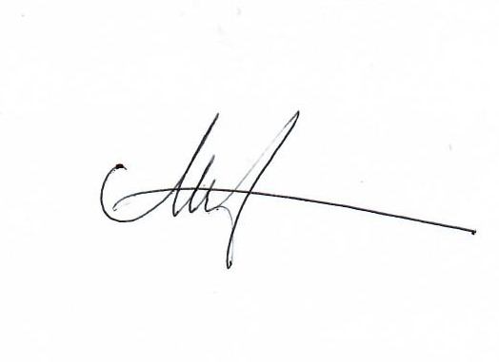
Date: 28 May 2021
Next Review Date: May 2024

