Board of Trustees Policy: Personnel Management (NAG 3)

Blind & Low Vision Education Network NZ

Statement of Intent:
The Board of Trustees of the Blind & Low Vision Education Network NZ (BLENNZ) will act as a good employer according to all relevant legislation and amendments, including but not limited to:
- Education Act 1989
- Employment Relations Act 2000
- State Sector Act 1988 and State Sector Amendment Act 1989 s77A 2c 2(h)
- Human Rights Act 1993 and other relevant legislation
- Privacy Act 1993
- Protected Disclosures Act 2000
- NZ Bill of Rights Act 1990
- Employment Relations Act 2000
- Vulnerable Children’s Act 2014.
The Board of Trustees will discharge its personnel management responsibilities in part by delegation to the Principal and others as appropriate or nominated, and in part by its own consultations and deliberations, and from time to time by those of its delegated personnel sub committee.

Policy Requirements:
The Principal will be delegated the tasks of:
- Developing and implementing personnel and industrial policies, within policy and procedural frameworks set by the Government from time to time, which promote high levels of staff performance, use educational resources effectively and recognises the needs of ākonga. These include but are not limited to:
- Concerns and Complaints
- Code of Conduct
- Leave for Teaching and Non Teaching Staff
- Equal Employment Opportunities
- Management Unit Allocation
- Induction
- Staff Recruitment and Appointment
- Working from Home and Staff Ākonga in the Workplace
- Succession Planning
- Performance Appraisal
- Classroom Release Time.

- Complying with the conditions contained in collective employment agreements for both teaching and non teaching staff.
- Complying with Ministry of Education promulgated Individual Employment Agreements for those staff not covered by collective agreements (i.e. staff who have chosen not to belong to their respective unions).
- Ensuring BLENNZ complies with:
- NZ Education Council requirements
- Education Act vetting requirements
- Vulnerable Children’s Act 2014.

Supporting Documentation:
Education Council website
Education Act 1989
2017 Amendment to Education Act
Ministry of Business Innovation and Employment Website
Government Legislation Website
Ministry of Education Website: Collective Agreements
Ministry of Education Website: Guide to Vulnerable Children's Act

Approved: 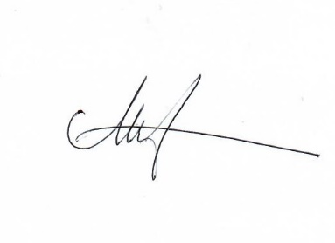
Date: 28 May 2021
Next Review Date: May 2024

