Board of Trustees: Code of Ethics Policy

Blind and Low Vision Education Network NZ
The Board of Trustees is committed to ethical conduct in all areas of its responsibilities and authority.
Trustees shall:
- Maintain and understand the values and goals of the school.
- Ensure the needs of all ākonga and their achievement is paramount.
- Be loyal to the organisation and its mission.
- Respect the integrity of the Principal and staff.
- Observe the confidentiality of non-public information acquired in their role as a trustee and not disclose to any other persons such information that might be harmful to the school.
- Be diligent and attend Board meetings prepared for full and appropriate participation in decision making.
- Ensure that individual trustees do not act independently of the Board's decision.
- Speak with one voice through its adopted policies and ensure that any disagreements with the Board's stance are resolved within the Board.
- Avoid any conflicts of interest with respect to their fiduciary responsibility.
- Recognise the lack of authority in any individual trustee or subgroup of the Board in any interaction with the principal or staff.
- Continually self-monitor their individual performance as trustees against policies and any other current Board evaluation tools.
- Recognise that only the Chairperson can speak for the Board.
- Undertake appropriate professional development

I, ……………………………………….have read and understood this Code of Ethics Policy and agree to abide by it to the best of my ability.

Signature: 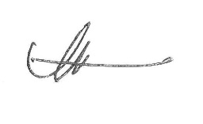

Date: 29 October 2021 Next Review: 2024

