Board of Trustees Policy: Chair’s Role Description (NAG 6)

Blind and Low Vision Education Network NZ

The Chair of the Blind and Low Vision Education Network NZ (BLENNZ) safeguards the integrity of the Board’s processes and represents the Board of trustees to the broader community. The Chair ensures that each trustee has a full and fair opportunity to be heard and understood by the other members of the Board in order that collective opinion can be developed and a Board decision reached. The Board’s ability to meet its obligations and the plans and targets it has set and enhanced by the leadership and guidance provided by the Chair.

The Chair:
1. Is elected at the first Board meeting of the year or as required except in a triennial trustee election year where it shall be the first meeting of the Board.*
2. Welcomes new members, ensures that the conflict of interest disclosure is made and the code of ethics is understood and signed, and delegates new trustee induction to the Board Secretary (through the Principal).
3. Assists Board members’ understanding of their role, responsibilities and accountability including the need to comply with the Trustees’ Code of Ethics policy, Board processes and meeting proceedings.
4. Leads the Board members and develops them as a cohesive and effective team.
5. Leads the Board towards completion of its work.
6. Ensures they act within Board policy and delegations at all times and do not act independently of the Board
7. The Chair is responsible for setting the agenda and that all Board members have the required information for informed discussion of the agenda items.
8. Ensures the meeting agenda content is only about those issues which according to Board policy clearly belong to the Board to decide.
9. Effectively organises and presides over Board meetings ensuring that such meetings are conducted in accordance with The Education (Update) Amendment Act 2017 (the Act), the relevant sections of the Local Government Official Information and Meetings Act 1987 and any relevant Board policies.*
10. Facilitate interactive participation by all Board members.
11. Represents the Board to external parties as an official spokesperson for the school except for those matters where this has been delegated to another person/s and is the official signatory for the annual accounts.*
12. Is responsible for promoting effective communication between the Board and wider community including communicating appropriate Board decisions.
13. Establishes and maintains a productive working relationship with the Principal.
14. Ensures the Board completes the Principal’s performance agreement and review are completed on an annual basis.
15. Ensures concerns and complaints are dealt with according to the school’s concerns and complaints procedures on behalf of the Board.
16. The outgoing Board Chair provides induction for the incoming Board Chair if possible.

* Legislative Requirement

Approved: 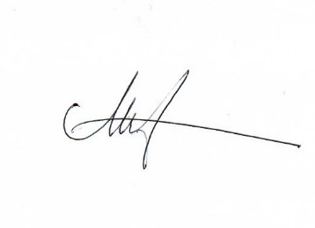
Date: 29 October 2021
Next Review: 2024

