Board of Trustees Policy – Roles and Responsibilities (NAG 6)

Blind and Low Vision Education Network NZ

Statement of Intent
1. The Board acknowledges its responsibilities to ensure that governance policies provide an outline on how the Board will operate and set standards and performance expectations that create the basis for the Board to monitor and evaluate performance as part of its ongoing monitoring and review cycle.

2. The Board’s key areas of contribution are – Representation, Leadership, Accountability and Employer Role.

The Board | Standard
1. Sets the strategic direction and long-term plans and monitors the Board’s progress against them. | - The Board leads the Charter review process  - The Board sets the strategic aims and approves the annual plan and targets and ensures the Charter is submitted to the Ministry of Education (MOE) by 1 March each year  - Regular Board meetings include a report on progress towards achieving strategic aims  - The Charter is the basis for all Board decision making
2. Monitors and evaluates student progress and achievement. | - The Board approves an annual review schedule covering curriculum and student progress and achievement reports  - Reports at each regular Board meeting, from principal, on progress against annual plan, highlight risk/success  - Targets in the annual plan are met, the curriculum policy is implemented and there is satisfactory performance of curriculum priorities
3. Protects the special character of the school | - Special character is obviously considered in all Board decisions  - Special character report is included at every Board meeting as part of the principal’s report
4. Appoints, assesses the performance of and supports the principal | - Principal’s performance management system in place and implemented
5. Approves the budget and monitors financial management of the school | - Budget approved by the first meeting each year  - Satisfactory performance of school against budget
6. Effectively manages risk | - The Board has an effective governance model in place  - The Board remains briefed on internal/external risk environments and takes action where necessary  - The Board identifies ‘trouble spots’ in statements of audit and takes action if necessary  - The Board ensures the principal reports on all potential and real risks when appropriate and takes appropriate action
7. Ensures compliance with legal requirements | - New members have read and understood the governance framework including policies, the school charter, Board induction pack and requirements and expectations of Board members  - New and continuing members are kept aware of any changes in legal and reporting requirements for the school. Board has sought appropriate advice when necessary  - Accurate minutes of all Board meetings, approved by the Board and signed by the chair  - Individual staff/student matters are always discussed in public excluded session  - Board meetings have a quorum
8. Ensures trustees attend Board meetings and take an active role | - Board meetings are effectively run  - Trustees attend Board meetings having read Board papers and reports and are ready to discuss them  - Attendance at 80% of meetings (min)  - No unexplained absences at Board meetings (3 consecutive absences without prior leave result in immediate step down (Refer Education Act 1989, S104 (1) (c)
9. Approves major policies and programme initiatives | - Approve programme initiatives as per policies  - The Board monitors implementation of programme initiatives
10. Fulfils the intent of Te Tiriti o Waitangi by valuing and reflecting New Zealand’s dual cultural heritage | - Te Tiriti o Waitangi is considered in Board decisions  - The Board, principal and staff are culturally responsive and inclusive
11. Approves and monitors human resource policy/procedures which ensures effective practice and contribute to its responsibilities as a good employer | - Becomes and remains familiar with the Board employment conditions which cover employees (i.e. Staff employment agreements and arrangements)  - Ensures there are personnel policies in place and that they are adhered to e.g. Code of Ethics  - Ensures there is ongoing monitoring and review of all personnel policies
12. Deals with disputes and conflicts referred to the Board as per the school’s concerns and complaints procedures | - Successful resolution of any disputes and conflicts referred
13. Represents the school in a positive, professional manner | - Code of Ethics adhered to
14. Oversees, conserves and enhances the resource base | - Property/resources meet the needs of the student achievement aims
15. Effectively hands over governance to new Board/trustees at election time | - New trustees provided with governance manual  - New trustees fully briefed and able to participate following attendance at an orientation programme  - Appropriate delegations are in place as per s66 Education Act  - Board of trustees participate in appropriate professional development
16. Ensures continuity of governance following BOT elections | - Considers the skill set of the Board and if the Board identifies any shortfall the Board will follow the NZSTA procedure to co-opt as appropriate.

The above policy is to be read in conjunction with the Guidelines to Support the Effective Working of the Board of Trustees and the Board of Trustees Code of Ethics Policy.

Approved: 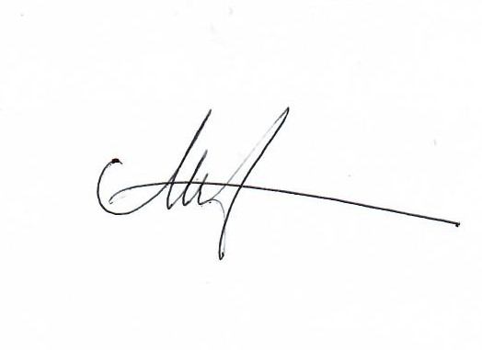

Date: 5 October 2021

Next Review: 2024

