Board of Trustees Policy: Principal’s Performance Management Policy (NAG 3)

Blind & Low Vision Education Network NZ

It is the policy of the Blind & Low Vision Education Network NZ (BLENNZ) Board of Trustees to establish a performance agreement with the principal each year* and review the principal’s performance on an annual basis with the objective of ensuring that every student on the BLENNZ roll is able to attain his or her highest possible standard in educational achievement.

- The review process will occur annually, providing a written record of how the principal has performed as per the terms of the performance agreement and identifying professional development needs.
- The principal’s performance will be formally reviewed by duly delegated member(s) of the board and optionally, at the board’s choice, an independent consultant who specialises in education.
- Those delegated or contracted to perform the review process shall have written formalised instructions specifying the responsibilities of the role.
- There will be three interim reviews, one per term preceding the annual formal review, between the principal and chair or delegate(s) to discuss progress.
- The principal will be reviewed on the criteria set forth in the performance agreement: performance objectives, professional standards, learning and development objectives and fulfilment of additional duties which require concurrence payment.
- If the principal and the board disagree on the performance objectives, the board, after considering the principal’s input, will amend the disputed objectives or confirm the unchanged objectives. The board’s decision will be final.
- The board chair, delegate(s) or consultant may gather information from staff, parents, or any other relevant members of the BLENNZ community who can provide feedback on how the principal has performed. Evidence may include surveys, self-review, interviews, focus groups or documentary evidence.
- The principal and delegate(s) will meet for a formal interview to discuss whether the performance agreement has been satisfied with the principal given the opportunity to discuss and comment on each criterion before a rating is given. The results will then be drafted into a report by the delegate(s) and sent to the principal. The principal can accept the report or dispute the report. If the report is disputed, the delegate(s) will consider the principal’s views before deciding to either amend the report, in accordance with the principal’s views, or let the report stand, with the principal’s comments attached.
- The chair/delegate(s)/consultant will report back to the board the result of the review. The principal may be present at the presentation and will have the opportunity to address the board. The principal will then exit and further discussion may continue among the board.
- The principal will be informed personally and in writing of the final outcome following discussion of the report.
- The performance agreement and results of the review are confidential to the principal, the board and their agents unless both parties agree to wider distribution.

* Legal requirement

Approved: 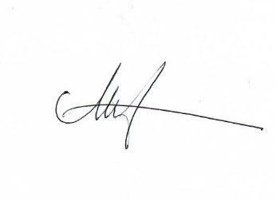

Date: 27 May 2022

Next Review: Triennially (2025)

Principal
I, …………………., have been informed of the performance review policy and procedures of BLENNZ Board.

Signature___________________________________

Date___________________________

