Board of Trustees Policy: Disciplinary Process in Relation to the Principal (NAG 3)

Blind & Low Vision Education Network

Purpose
This policy outlines the process the board will take in the event of receiving a complaint regarding the principal or if policy violations have occurred.

Requirements
If the board receives a complaint regarding the principal or determines that policy violation(s) may have occurred, the following steps will be taken:

- The board will, in the first instance, consider whether this may be dealt with in an informal manner (as per the employment agreement provisions that apply to the principal).
- Where the board considers the degree and seriousness of the concern of violation(s) sufficient to warrant initiating a disciplinary or competency process, the board shall seek the support and advice of a suitably qualified expert (eg. an NZSTA adviser) to ensure due process is followed.

Approved: 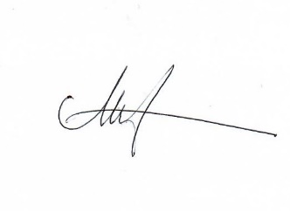

Date: 27 May 2022

Next Review: Triennially (2025)

