This EOTC safety management plan sits under the school-wide health and safety management system and alongside safety management plans for other areas within the school.

This guidance should be read in conjunction with the Ministry of Education EOTC Guidelines, 2016, Ministry of Education Health and Safety at Work Act 2015. A practical guide for boards of trustees and school leaders, 2016, and BLENNZ School’s Health and Safety policy and procedures.

BLENNZ EOTC Safety Management Plan

Board Approval
The BLENNZ Board of Trustees support and endorse EOTC at all levels in the school and approves this Safety Management Plan (SMP).

Approved by:
 |  |  | Chairperson, Board of Trustees
 |  |  | Principal
Signature | Name | Date | Position
Version Number: | 1.0
Last amended: | 02/03/21 NS
Document number: | Master

This work is licensed under the Creative Commons Attribution-Non Commercial 4.0 International License. To view a copy of this license, visit Creative Commons website

Table of Contents

Table of Contents 2
1. Background Context 5
2. EOTC Annual Safety Improvement Plan 7
3. EOTC Roles and Responsibilities 9
4. EOTC – Event Procedures 16
4.1. Overview of Process 17
4.2. Proposal and Approval 19
4.3. Plan 22
4.4. Prepare 34
4.5. Implement 35
4.6. Post Event 39

Document History
Version | Amendments Made | Approved / Date
1.0 | Initial development. | N.Stewart 02/03/21
1.1 | [outline what has changed]

Document and Version Control
- Only the current version of this document is accessible on G Drive in National Documents.
- Once printed, this document is uncontrolled.

All Safety Management System (SMS) documents:
- Include a footer that identifies the version number, the page number and the number of pages.
- Are password protected to limit unauthorised changes or deletion.
- Are backed up via the main server.
- Are archived once obsolete, and are clearly marked as such and retained in a designated folder on G drive. Archived copies and other safety related records are kept for 7 years.

This EOTC Safety Management Plan is the property of BLENNZ, a hard copy is kept at:
SMT Office
BLENNZ School
2 McVilly Ave
Manurewa
Auckland

These documents are available to all staff, contractors, students and other stakeholders.

Relevant Policy Links
Policy | Version | Reference | Link
Health & Safety | May 2016 | OP05-00 2016 | G:\Policies\BLENNZ Policies-Current\BLENNZ Operational Policies\NAG 5 - Health and Safety
EOTC | May 2016 | OP05-03 2016 | G:\Policies\BLENNZ Policies-Current\BLENNZ Operational Policies\NAG 5 - Health and Safety
First Aid | May 2016 | OP05-05 2016 | G:\Policies\BLENNZ Policies-Current\BLENNZ Operational Policies\NAG 5 - Health and Safety
Sun Safe Policy | August 2020 | OP05-09 2020 | G:\Policies\BLENNZ Policies-Current\BLENNZ Operational Policies\NAG 5 - Health and Safety
Managing Ākonga attending BLENNZ Programmes | May 2019 | OP05-14 2019 | G:\Policies\BLENNZ Policies-Current\BLENNZ Operational Policies\NAG 5 - Health and Safety
Transportation of Ākonga | Sept 2019 | OP05-38 2019 | G:\Policies\BLENNZ Policies-Current\BLENNZ Operational Policies\NAG 5 - Health and Safety
Safe Driving | Draft | OPO5-01 2020 | G:\Policies\BLENNZ Policies-Current\BLENNZ Operational Policies\NAG 5 - Health and Safety
Handling and Transferring of Ākonga | Sept 2019 | OPO7-34 2019 | G:\Policies\BLENNZ Policies-Current\BLENNZ Operational Policies\NAG 5 - Health and Safety
Swimming Pool | Aug  2017 | OPO5-34 2017 | G:\Policies\BLENNZ Policies-Current\BLENNZ Operational Policies\NAG 5 - Health and Safety
Child Protection Policies  - Appendix Six Safe Working Practices  - Appendix Nine Non-Employee Safety Check | Oct 2018 | PN5-1 | G:\Policies\BLENNZ Policies-Current\2018 Child Protection Policy
Traumatic Incidents | Feb 2019 | OPO5-31 2018 | G:\Policies\BLENNZ Policies-Current\BLENNZ Operational Policies\NAG 5 - Health and Safety

1. Background Context

Description of Organisation
The Blind and Low Vision Education Network NZ (BLENNZ) (hereafter referred to as BLENNZ) is a school that is made up of a national network of educational services for children and young people who are blind, deafblind or have low vision in New Zealand.

Refer https://www.blennz.school.nz for further information.

Education outside the Classroom (EOTC)

What is EOTC?
Education outside the classroom is curriculum-based teaching and learning activities that go beyond the walls of the classroom. EOTC includes any curriculum-based activity that takes place outside the school ranging from a museum or Marae visit, to a sports trip, field trip, or outdoor education camp.

Scope at BLENNZ
At BLENNZ EOTC includes all:
- Day trips/activities
  - i.e. Manurewa Botanic Gardens, RDA, MIT
- Expanded Core Curriculum Days
- Immersion Courses
- Developmental Orientation and Mobility
- Overnight School Camps

Rationale
Experiences outside the classroom reinforce learning by enabling students to make connections between what they have learnt in the classroom and the world beyond the classroom. EOTC experiences give students opportunities to demonstrate the essential knowledge, skills, values, attitudes and key competencies identified in the National Curriculum (New Zealand Curriculum and Te Maratanga O Aotearoa).

The EOTC programme supports the BLENNZ (expanded core) curriculum, and aims to provide:
- Opportunities beyond the classroom to support learning in all areas of the curriculum
- Opportunities for students to discover, enjoy, learn and develop in outdoor, leisure and recreational contexts
- Safe learning experiences across a variety of contexts and environments.

BLENNZ recognises the potential benefits to staff and students through experiencing acceptable risks. The school’s EOTC programme will aim to strike the right balance, so that the real risks are managed and learning opportunities are experienced to the full.

Explanation of the EOTC Safety Management Plan
The EOTC Safety Management Plan fits within the BLENNZ Safety Management System and comprises:

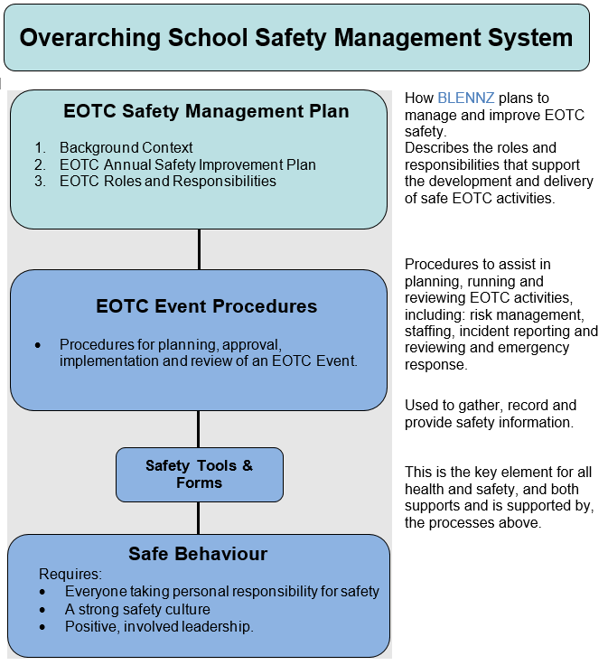

2. EOTC Annual Safety Improvement Plan

BLENNZ wide EOTC Safety Goal
To take all steps to ensure their own safety and the safety of other staff, contractors, volunteers, and students during EOTC activities and ensure that no action or inaction on their part causes harm to any other person.

Safety Objectives for EOTC
Target | Measured by
- Develop and implement a new EOTC Safety Management Plan | a. New EOTC Safety Management Plan completed by end Term 3 2021
- All staff trained in, and engaged with, new EOTC Safety Management Plan (including EOTC processes) | a. EOTC Safety Management Plan Professional Learning for all staff during Term 3 2021  b. Staff engagement at 80% by end Term 4 2021

Planning for Safety

Annual Safety Calendar
The EOTC Coordinator will plan for the following safety actions each year:
- Staff induction – for all new school staff
- Staff training – new and returning staff as required
- Regular safety communication
- Emergency response practice
- Facility and equipment checks
- Safety reviews, including of the EOTC Safety Management Plan (as below)
- The development of an Annual Safety Improvement Plan.

Maintenance and Review of EOTC Safety Management Plan
BLENNZ recognises the need to continually improve health and safety systems, and performance. The following processes will support this focus on continual improvement:

- A review of each EOTC event by the Person in Charge of the event, with findings reported to their line manager who will forward any issues to the corresponding coordinator;
  - VRC EOTC Regional Coordinator
  - School EOTC Coordinator
  - Residential Coordinator
- The overarching EOTC Coordinator Role will rotate between the three EOTC Coordinators yearly in order to facilitate a better National perspective.
- Ongoing monitoring of EOTC delivery by the EOTC Coordinators / senior school staff to ensure compliance to, and/or identify opportunities to improve safety management.
  - Working Group
    - DOM RTV
    - School
    - Residential (Long & Short)
    - VI Adult
- Annual review of the safety management system by the EOTC Coordinators including:
  - Updating an inventory of EOTC events on MS Teams throughout the year
  - Checking for ongoing compliance to new and changing legislation, standards, codes of practice, good practice guidelines and similar
  - Checking for changes in current good practice
  - Reviewing the effectiveness of risk management processes
  - Identifying professional learning opportunities for staff
  - Analyzing incidents and any incident trends
  - Reviewing emergency procedures
  - Reviewing health and safety goals and targets, developing action plans to support improved safety performance (Annual Safety Improvement Plan) and keeping records of progress.
- External review of safety management systems on a regular basis 3 yearly and/or following a serious incident.
- The EOTC Coordinators will ensure that:
    - Reviews are conducted by people with current competence in the activity
    - Opportunities for improvement are identified
    - Outcomes are communicated to staff and other relevant parties
    - Actions arising from reviews are implemented.

3. EOTC Roles and Responsibilities
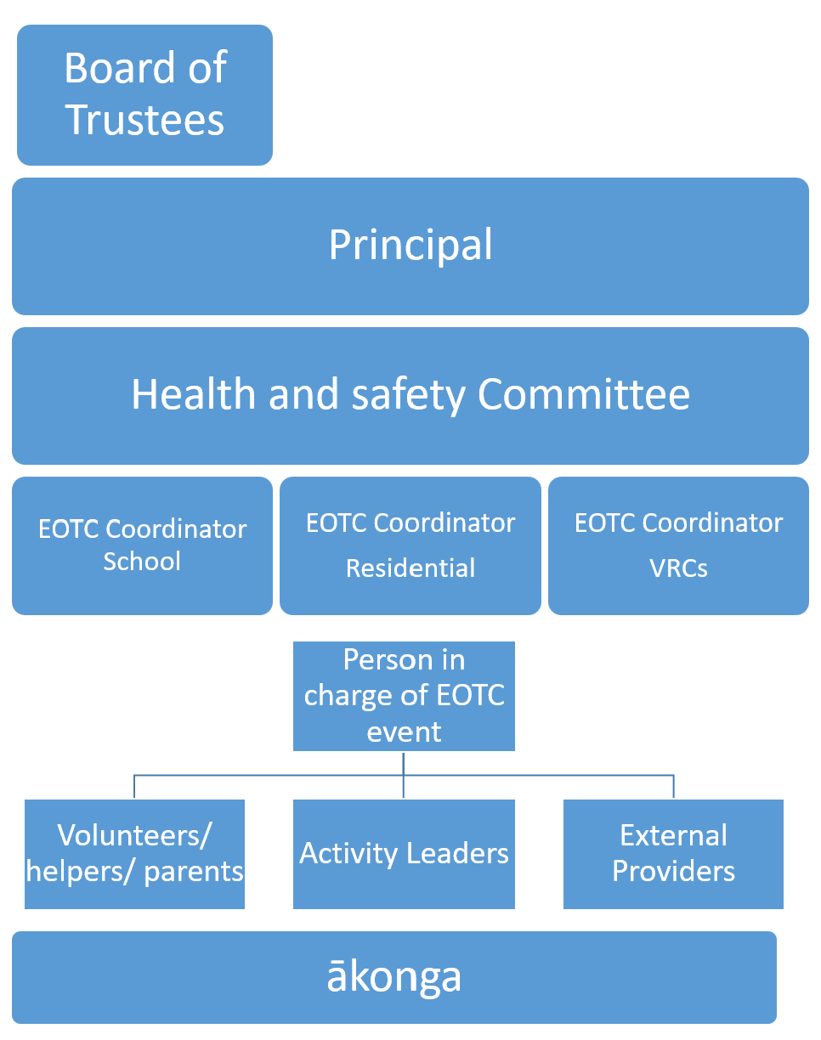

The Board of Trustees/ Principal
The Board of Trustees and principal are responsible for ensuring that EOTC activities are carried out safely and that they understand the EOTC Safety Management Plan.

The Board of Trustees have a responsibility under the National Administration Guidelines (NAG 5) to provide a safe physical and emotional environment for students and comply in full with any legislation currently in force, or that may be developed, to ensure the safety of students, employees, and others.

The Board of Trustees and the principal will ensure that:
- All EOTC practice is in accordance with the school’s overarching Safety Management System and the EOTC Safety Management Plan.
- Resources are provided to establish, implement, maintain, and continually improve the EOTC Safety Management Plan.
- There are opportunities for adequate ongoing professional learning for all leaders involved in EOTC.
- Responsibility for coordinating EOTC in the school has been assigned to competent staff (the principal, the EOTC coordinator, a senior staff member, or a committee) and is adequately resourced.
- Valid informed consent from parents/caregivers is obtained commensurate with the level of risk.
- Recommendations from the review of any incidents that either harmed or might have harmed any staff member, volunteer, or student are implemented.

The Board of Trustees chairperson and the principal sign this document to acknowledge their support and resourcing of EOTC.

EOTC Coordinators
The EOTC coordinators are the people with full overview of EOTC at BLENNZ.

It is their responsibility to ensure that planning, process, and procedures are in place across all EOTC activities and that these are current, appropriately delegated and implemented.

The EOTC coordinators are members of the BLENNZ leadership team and will have experience relevant to the school’s EOTC programme.

The EOTC Coordinators ensure that:

- EOTC is integrated, as far as possible, into all programmes
- Staff have an appropriate understanding of EOTC Safety Management Plan, processes and requirements, and are promptly informed of any changes.
- All staff perform relevant safety tasks and complete safety processes (for example, activity planning, risk identification, incident reporting).
- All incidents are accurately recorded, reported and properly investigated.
- Emergency response systems are in place, and all staff are prepared to respond to potential emergency situations.
- External review of the EOTC Safety Management Plan is carried out.
- The performance of the EOTC Safety Management Plan is reviewed, evaluated and reported to the Board of Trustees and principal.
- Strong safety leadership is provided in order to foster and support a strong safety culture within school EOTC.
- The school has a policy in place on health and safety in EOTC.
- Procedures are in place to support that policy.
- He or she is familiar with the Ministry of Education EOTC Guidelines.
- Only a competent person is approved as the person in charge or as an activity leader and that an activity leader’s competence is assessed against good practice.
- Competence (skills, knowledge and experience) and suitability (to work with young people) of all activity leaders and assistants is checked to meet good practice.
- All external providers used for EOTC meet good practice criteria and where outside provision of an adventure activity (as defined by the Health and Safety at Work (Adventure Activities) Regulations 2016) occurs a registered adventure activity provider is used.
- Roles and responsibilities of all persons involved and the procedures to be followed are clarified, understood and accepted.
- Communication devices are available, and a communications plan is in place for EOTC activities.
- Plans to respond to emergencies or traumatic incidents are in place, including a clear process for dealing with media, and that all staff are familiar with them.
- Where safety equipment and/or clothing is required, it is provided, and systems are in place for its correct use, safe storage and maintenance.
- Where there is a deviation from the policy, there is clear documentation of the reasons for it, and how it is being managed and reported to the Board of Trustees.

Person in Charge (PIC) of an EOTC Activity
This could be a Resource Teacher Vision, DOM, Youth Worker, or in the case of contracting an external provider to deliver EOTC, there is likely to be two PICs (one representing BLENNZ and one representing the provider).

The PIC is expected to:
- Take full responsibility for safety management, and take any action required to ensure the level of risk is kept at an acceptable level.
- Ensure that all EOTC safety management policies and procedures are adhered to.
- Complete all required documentation within the documented timeframes.
- Ensure that all supervisory and instructing roles and responsibilities have been clarified and agreed to before the activity.
- Ensure that the activity, venue, and staff and volunteer competence are all checked before the activity.
- Take all practicable steps to identify, assess and manage risks, and communicate risk and hazard information to staff, volunteers and students.
- Identify emergency procedures and convey these to all staff, volunteers and students.
- Ensure that appropriate safety equipment and clothing (personal protective equipment) is used when needed.
- Ensure that all equipment is returned to storage clean and in good repair and that the equipment log has been completed for all safety related equipment.
- Ensure that each student participating in an EOTC activity has access to a currently qualified first-aider and first aid kit.
- Ensure there are readily accessible lists of all the participating students, activity leaders, and assistants. The lists should include emergency contact details, medical profiles, and any other pertinent information.
- Ensure means of communication that will work at the event location are taken to the event.
- Obtain informed consent from parents, where required, by providing sufficient information about an EOTC event, in writing and/or in briefing sessions. Make arrangements for parents whose first language is not English.
- Oversee, manage and respond to any situations, for the whole group of students rather than be allocated direct responsibility for a group of students (where multiple groups and staff are involved).
- Ensure that students’ needs, and any risks associated with these (educational, cultural, health, medical, nutritional, and behavioural) are identified and managed.
- Ensure that activity leaders are provided with weatherproof copies of emergency procedures and contact details to take into the field.

In the case of multiple PICs there needs to be very clear lines of communication to ensure all the responsibilities are covered.

Activity Leaders
Activity leaders work under the leadership of a person in charge (PIC) and can be Resource Teacher Vision, DOM, Youth Worker, Teacher Aide, coaches, other staff, external providers (for example, instructors), adult volunteers, senior school students, or tertiary students.

Activity leaders are expected to:
- Only accept responsibility for leading activities that they have competence for. Saying “no” to leading an activity is an accepted and respected response.
- Brief assistants on their specific role and responsibilities, the activity outcomes, their allocated students and the relevant school or external provider safety management procedures and/or policies that apply.
- Instruct students in appropriate safety procedures and have practised them for themselves.
- Ensure that students experience “challenge by choice” (that is, they are encouraged, not forced or pressured, to participate in activities in a supportive group environment).
- Assess the needs and capabilities of the students against the demands and goals of the activity and make any necessary adjustments to the programme.
- Take all steps (as far as is reasonably practicable) to ensure their own safety and the safety of other staff, contractors, volunteers, and students during EOTC activities and ensure that no action or inaction on their part causes harm to any other person.
- Comply (so far as they are reasonably able) with any reasonable instruction, policy or procedure that is given by the school or external provider to allow the school or external provider to ensure health and safety of their workers and others.
- Manage risk during the event.
- Cancel an EOTC activity if an identified risk or hazard cannot be adequately controlled.
- Understand and know how to implement any applicable contingency plans and report all incidents.
- Use appropriate safety equipment and/or clothing when required.
- Understand and know how to implement safety procedures for specific activities and use of equipment.
- Refer to equipment logs before any equipment is used.
- Take first aid kits, emergency equipment, and a means of communication that will work in the location of the event.
- Ensure all equipment is returned to storage cleaned and in good repair, and that usage and repair logs are completed.
- Ensure that food and drink are taken regularly by participants, during an EOTC event, to maintain energy levels.

Assistants
Assistants can be Resource Teacher Vision, DOM, Youth Workers, Teacher Aides, support staff, adult volunteers, and tertiary or senior students. They differ from an activity leader in that they do not necessarily have the required competence for the activity leader role. Such people should be assigned to an activity leader as an assistant.

They should be given the students’ medical details and other relevant information on their group and the activity, and they should be briefed on the risk management and emergency procedures. The level for supervision of an assistant should be in proportion to the level of risk in the activity. Supervision of an assistant may, therefore, be direct or indirect.
Assistants are expected to:

If a school staff member
- Follow the instructions of the activity leader and person in charge and help with control and discipline.
- Stop the activity and notify the activity leader if they think the risk to the health or safety of the participants in their charge is unacceptable.

If an adult volunteer
- Only accept the responsibility of being a supervisor if they are comfortable with the role and the skills they have.
- Follow the instructions of the activity leader and the person in charge and help with control and discipline, if this has been included in their role.
- Not allow themselves to be left in sole charge of participants, except where it has been previously agreed as part of the risk assessment and appropriate vetting has been completed.
- Speak to the person in charge or the activity leader if they are concerned about their own health or safety or that of participants at any time during the EOTC experience.

Students (and other people in the workplace)
Are expected to:
- Take reasonable care for their own health and safety.
- Take reasonable care that their acts or omissions do not adversely affect the health and safety of other persons.
- Comply, so far as reasonably able, with instructions given to them by the person in charge, activity leader or activity assistants.
- Inform the activity leader if they feel unsafe and/or if they identify any unsafe equipment or actions.
- Actively participate according to the principle of ‘challenge by choice’.

Further information on these roles and responsibilities a can be found in chapter 2 of the Ministry of Education EOTC Guidelines, 2016.

4. EOTC – Event Procedures

This document provides an overview of the processes used to plan, prepare for, implement, and review BLENNZ’s EOTC activities (referred to as ‘events’ throughout).

The tools that we use to support these processes are identified throughout this document by underlining and italics (e.g., EOTC tool.doc) and can be found in Teams in the EOTC Team.

4.1 Overview of Process

Proposal | Purpose, Logistics, Initial Risk Assessment, Staffing  End point = Initial Approval
Plan | Risk Management  - Identify  - Assess – Risk Rating Matrix  - Manage  - Monitor  Staff Competence – including volunteers  - Skills required  - Recruit  - Internal staff  - External contractor, provider or volunteers  - Induct / train  - Support / monitor / appraise  - Engaging external providers (multiple PCBU’s)  Communication with Parents  - Information  - Risk disclosure  - Health information  Logistics detail  - Event Management Plan  - Transport  - Accommodation  - Meals  - Communication  - Equipment  - Contingency  - Emergency Planning  Final Approval
Prepare | Event Proposal, Approval and Intentions form  - Low Risk  - A week before  - Medium Risk  - A month before  - High Risk  - Six weeks  - In time for it to go to the BOT  - Immersions  - Two weeks before  - Expanded Core Curriculum Days  - A Month Before
Implement | Intentions  Communication, including with other PCBUs = Toolbox talks, daily decisions  Incident reporting  Event Finalisation Form  Emergency Response
Post Event | Reporting  Review and Evaluation  Equipment logging  Clean up

Proposal and Approval

The initial stage of the process is to gain approval for the event.

Use the Event Proposal, Approval and Intentions form to provide an overview of the proposed event, including the proposed purpose, logistics, initial risk assessment, and staffing.

When completing the Event Proposal, consider:

- The purpose
- What are you aiming to achieve?
- What are the desired learning outcomes?
- Where is the best place to achieve these outcomes?
- What are the student learning needs?
- What other benefits will the students gain? e.g., connect with local community, develop independence…
- Links to curriculum should be identified.
- Initial risk assessment
- What are the ‘high level’ risks that could be encountered? e.g., transport to and from the event, risks associated with the activity and/or the environment.
- Category
- Use the Event Category table (next page) to identify which category the event fits within, and what preparation and approvals are required.

Once initial approval is provided, event planning can continue.

Final approval is required before the event can go ahead.

Tools
Event Proposal, Approval and Intentions form

Event Category Table
Low Risk | Medium Risk | High
Routine and expected activities and environments  - School grounds  - Supervised local visits. | Travel more than 40kms  Large group involved (more than 20 students)  Adventurous activities  Public Transport  Hazardous environments e.g. large events. | Where risk exposure is greater than what would typically be the case at school  E.g., Activities involving direct contact with water; overnight trips including off campus residential excursions.
❑ Activity Proposal   Line Manager Approval | - Activity Proposal  - Line Manager Approval  - EOTC Coordinator/Senior Manager | - Activity Proposal  - Line Manager Approval EOTC Coordinator Approval  - Principal/BOT Approval
- Staffing allocated  - Blanket consent  - School notification and consent for itinerant RTVs | - Staffing allocated, supervision structure  - External provider contracts  - School notification and consent for VRCs  - Parental Notification and consent for School and VRCs  - Blanket consent for Residential  - Specific Risk disclosure | - Staffing allocated, supervision structure  - External provider contracts  - Parental Notification and consent  - Specific Risk disclosure
May include but not limited to:  - Event Finalisation Form  - Student medical lists  - Emergency contact information  - Risk assessment  - Emergency communication plan | May include but not limited to:  - Event Finalisation Form  - Student medical list  - Emergency contact information  - Risk assessment  - Transport plan  - Site plan and information  - Emergency communication plan | May include but not limited to:  - Event Finalisation Form  - Student medical list  - Emergency contact information  - Risk assessment  - Transport plan  - Site plan and information  - Emergency communication plan

Plan

Having gained initial approval, we can now plan some detail:

Risk Management Planning
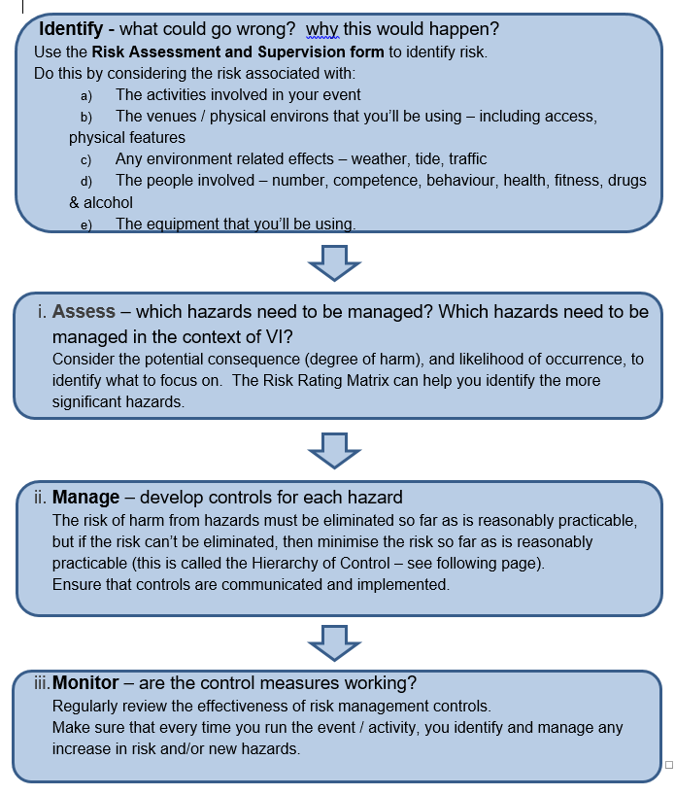

Tools
Risk Assessment and Supervision form

Risk Rating
Once identified, hazards should be assessed for potential severity of the consequences (the degree of harm), and likelihood of occurrence, to identify which ones to focus on.

Assessing Likelihood
Likelihood Levels | Description
Almost Certain | Expected to occur at least once during the task or activity
Likely | Could occur during the task or activity
Possible | It’s conceivable it could occur, but only expected infrequently
Unlikely | It’s conceivable that this could happen, although only in unusual circumstances
Rare | It's only conceivable that this could happen in exceptional circumstances

Assessing Severity
Severity Levels | Description
Insignificant | No injury or very minor injury or illness that does not require First Aid.  Temporary stress or embarrassment.  Minor or no damage to facilities or equipment.  Little or no environmental, financial, reputational or operational impact.
Minor | Injury or illness requiring only First Aid (No permanent disability).  Stressed beyond comfort level. Wants to leave activity.  Isolated and quickly repaired damage to facilities or equipment.  Some environmental, financial, reputational, or operational impact.
Moderate | Injury or illness that requires medical treatment or hospitalisation (with no permanent disability).  Very distressed. Requires on-site counselling or support. Does not want to participate in activities.  Damage to facilities or equipment resulting in temporary inability to use it.  Localised environmental, financial, reputational, or operational impact.
Major | Serious injury or illness to one or more people, resulting hospitalisation and possible permanent disability.  Therapy or counselling by a professional may be required.  Sustained or extensive damage to facilities or equipment.  Extensive environmental, financial, reputational or operational impact.
Critical | One or more fatalities.  Post-traumatic stress disorder. Long term counselling / therapy is likely to be required.  Loss of facilities or equipment.  Significant and widespread environmental, financial, reputational or operational impact.

Risk Assessment Matrix

Likelihood of injury/harm | Severity of injury/harm

 | Insignificant No / Minor injuries | Minor  First Aid | Moderate Medical treatment | Major Extensive injuries | Critical Fatalities
Almost Certain | Medium | Medium | High | Extreme | Extreme
Likely | Low | Medium | High | High | Extreme
Possible | Low | Medium | High | High | High
Unlikely | Low | Low | Medium | Medium | High
Rare | Low | Low | Low | Medium | High

Risk Levels
Risk Levels | Description
Extreme | = Stop, look for alternatives!  Unacceptable level of risk, don’t do it. A considerable potential for fatalities, serious injuries or illness, post-traumatic stress, loss of facilities or equipment. Significant widespread environmental damage. Significant financial, reputational, or operational impact.
High | = Control to eliminate risk where possible  We need to do something about this risk to eliminate or minimise it. There is moderate potential for injuries, illness or stress requiring hospitalisation, therapy or counselling, the damage of facilities, equipment, or localised environmental damage. Moderate financial, reputational or operational impact.
Medium | = Control to minimise risk as far as reasonably practicable  We need to do something about this risk to eliminate or minimise it. There is some potential for injuries, illness or stress requiring medical treatment, support, the damage of facilities, equipment, or localised environmental damage. Some financial, reputational or operational impact.
Low | = Continue  Can retain the risk but need to be vigilant that the risk level does not rise. Minimal potential for injuries or illness (above those requiring simple First Aid), stress or embarrassment, or any consequential damage to facilities or equipment, or the environment. Little to no financial, reputational, or operational impact.

NB: Assessing risk is not an absolute science:

- Multiple sources of information will help you derive a best estimate
- It is best considered by a team approach to achieve consensus.

The Hierarchy of Control
A combination of controls should be used if a single control is not sufficient for the purpose.

Definitions

Harm
Harm is illness, injury, or both, and includes physical and mental harm caused by work-related stress.

Hazard
A hazard is anything that does or could cause harm.

Risk
The likelihood that death, injury or illness might occur when exposed to a hazard (in other words, a risk means a chance of harm).

Staff Competence
Staff in this context, includes anyone who is involved in teaching or supervising students during an EOTC event. This could include school staff, external providers, parent helpers and other volunteers.

Skills Required
All staff involved in an EOTC event must have the necessary information and competence (skills, knowledge, experience), or be adequately supervised, so that they can safely perform their role.

Each event and role should be assessed to determine what competence is required (using the Event Competency, Staffing and Supervision Structure part of the Risk Assessment and Supervision form), making sure that staff:

- Have sufficient current competency to independently manage, and/or teach to the required level, a group of students in each activity and environment.
- Are well versed in risk assessment and management, are able to identify and assess risk throughout the event and act accordingly at all times.

Participants and staff should also have ready access to someone with appropriate and current first aid skills.

Competency requirements should be benchmarked against industry qualifications and the competencies utilised by other schools and operators. Competency can be established through:

- Sighting recognised qualifications
- Attestation of competency and sufficient experience (by a suitably qualified person)
- Observation and skills assessment (by a suitably qualified person).

Use the Volunteer Assistant Agreement form and Staff Competency Record form to gather information on all staff involved in EOTC.

[This could be collated into a matrix/spreadsheet for ongoing use].

Recruiting Staff
All paid staff will either be employed by the school, or have a written contract (see external providers below).

Staff Records
Records should be kept of staff competency, for at least five years, including induction, training and qualifications.

Induction and Training
All staff will be introduced to the BLENNZ EOTC processes during their induction.
All staff (including all volunteers) involved in EOTC events will receive event briefing and training as required.

School wide and EOTC specific emergency response processes will be practiced regularly.

Records of all training (including who, what and when) will be kept.

Support, Monitor and Appraise
New or inexperienced staff should operate under the supervision of an experienced staff member until they have sufficient experience and have been assessed as independently competent.

The EOTC coordinator will ensure that staff are appropriately supported, and the Person in Charge will monitor EOTC staff and endeavour to provide them with feedback and/or appraisal opportunities.

Roles and Responsibilities
Use the completed Risk Assessment and Supervision form to identify and describe the specific supervision structure that is required for the event.
Safety roles and responsibilities must be communicated to ensure that it is clear who is responsible at any given time for each aspect of ensuring the safety of every person (staff and students) associated with the event.

Tools
Risk Assessment and Supervision form
Volunteer Assistant Agreement form
Staff Competency Record form

Engagement of External Providers (as Person conducting a business or undertaking (PCBU’s)
When engaging external providers you must:
- Check if they are registered with WorkSafe NZ (if required by the HSWA (Adventure Activities) Regulations, 2016 – refer: Register of adventure activity operators).
- Check if they have a satisfactory safety record – ask for records of health and safety performance.
- Ask for details of their safety management systems (unless they are registered by WorkSafe NZ to provide the activity, as above), including staff competency and experience, risk management processes, and emergency preparedness.

- Require them to sign a contract (External Provider Agreement form) that clarifies who is responsible for implementing and supervising all health and safety requirements while EOTC students and school staff are on the event and how these responsibilities are shared between the safety management systems of both organisations.
- Provide them with appropriate information regarding the event/activity, risk they may be exposed to, relevant emergency procedures, student profiles and health information (including staff and students).

Once the external provider is engaged, it is important that you continue to:
- Consult – about shared risk and how this risk will be controlled.
- Cooperate – the PCBU that is closer to the work is likely to have more direct control and influence over the risk, and should be supported accordingly.
- Coordinate – to ensure that either PCBU’s safety efforts aren’t duplicated, or gaps aren’t left. E.g. who is providing and checking the safety equipment? Who is responsible for the students ‘after hours’ or during ‘free time’?
- Monitor the external provider’s efforts to ensure they are doing what has been agreed.
- Reserve the right to halt any event or activity conducted by an external provider for safety or other reasons.

Tools
External Provider Agreement form

Communication with Parents
Parents and caregivers must be appropriately informed and engaged, whenever students are involved in EOTC events.

‘Low Risk’ events may be covered by a Blanket Consent provided at the start of each year, however parents/caregivers will still require notification and information about EOTC events as the events occur during the year, and should be asked to update health information.

‘High Risk’ and ‘Overnight’ events require specific parental notification and consent. You should provide a Parent Information Letter, along with the Parental Consent form.
Consider including these items in the cover letter:

  - learning outcomes
  - activities students will be undertaking, and any significant risk associated with these activities
  - event dates with departure and return times and location/s
  - clothing and equipment required (include items not to be taken)
  - request to complete the Parental Consent form and date to return this by
  - request to complete (or update) dietary/health information
  - cost details
  - transport arrangements
  - venue/accommodation details
  - staffing including relevant experience and qualifications related to the activities
  - school rules, event rules (code of conduct) and discipline procedures (e.g. smoking, alcohol, illegal drugs, unsafe behaviour policies)
  - money to be taken, arrangements for safekeeping and spending money
  - insurance details and whether parents need to arrange additional cover
  - contact information – including in an emergency
  - an invitation to ask questions.

Also consider how best to provide accurate information about what the students will be doing – a website/YouTube link could aid understanding.

Tools
Blanket Consent form
Parent Information Letter
Parental Consent
Health Profile

Logistics Detail
To assist with planning, coordinating and communicating the detail of your event, consider:
- using the Event Plan, Prepare and Implement Checklist, and/or
- developing Standard Operating Procedures (SOPs) for events that have multiple leaders and/or occur multiple times, or
- developing an Event Management Plan, which would include risk management, staff competency and supervision structure information (Risk Assessment and Supervision form) and document every relevant consideration below:

Note: whichever documents you use the event and participant information is contained on the Event Proposal, Approval and Intentions form.

Transport
Develop a Transport Plan, including consideration of:
Route, map, travel times and alternatives
How you will ensure that drivers don’t drive while fatigued?
Appropriate child restraints are available
How you will record who is in which car?
Whether you need Driver and Passenger Permission? – where students are driven in private cars.

Accommodation
Do you have a plan of the venue / accommodation provider(s)?
What do they provide, what will you need to take (cooking equipment, bedding etc)?
How will you allocate sleeping spaces? - considering behavioural and medical issues.
How will you record who will be accommodated where?
If you are sharing accommodation (with other groups / the public), what strategies will need to be in place?
How is the accommodation being paid for?
Other considerations (coin showers etc)

Meals
Dietary requirements – students and staff
Budget
Menu and shopping lists
Food safety and hygiene
Method of payment

Communication
What communication capability will you have?
Have you checked that it will work?
Will there be any ‘blind’ spots for cell phone use? If so:

- do you need to organise alternate communication (satellite phone, locator beacon)?
- Make sure that you know how to use it.
- make sure that the school and parents understand when you will be out of contact.

Establish clear protocols for how you will, and if/ how parents and students can, communicate.
Your intentions (use the Event Proposal, Approval and Intentions form) should provide information detailing when you will call in, when you expect to return, what should be done if you don’t.

Equipment
Ensure that there will be sufficient clothing and equipment for the event - develop an Equipment List, covering personal, group and activity/specialist and emergency equipment.

- Identify what Personal Protective Equipment (PPE) will be needed for staff and students. Ensure that this is provided and used according the school’s PPE policy.
- All safety critical equipment (PPE) must be checked as fit for purpose (including correct fit and comfort) - whether it is provided by the school, the student or an external provider. Consider doing this before you depart for the event.
- Ensure that gear is checked after use, gear logs are completed and any damage notified.

Contingency Plan
Ensure that you have a robust contingency plan – that allows you to respond to natural disasters, weather effects, staff and student ill health, transport issues, and any other changes that may occur before or during the event.
Ensure there is a system in place to notify the school if there is a variation to the event plan that has been approved.

Emergency Planning
Ensure that you identify procedures to be followed in an emergency. These should:
- Include plans for potential emergency situations (e.g. a missing student, motor vehicle incident, natural disasters)
- Be explained to event staff during briefing
- Clarify staff roles and responsibilities in an emergency response – including who is to call for emergency help (111)
- Identify an ‘On Call’ contact person who is not at the event
- Identify what emergency response resources, including first aid supplies, need to be available to staff and students
- Be aligned with the school’s emergency response procedures, Traumatic Incident Policy OPO5-31 2018.
- Manage student cell phone use in the event of an emergency.

Consider providing event staff with an Emergency Response Guide

Final Approval
At this stage you should submit your Event Proposal, Approval and Intentions form
and Event Management Plan (or Standard Operating Procedures and other relevant information) for Final Approval.

Tools
Event Plan, Prepare and Implement Checklist
Standard Operating Procedures or Risk Assessment and Supervision Form
Transport Plan
Driver and Passengers Permission
Equipment List
Emergency Response Guide

Prepare

The Week Beforehand
This should be about gathering resources, information and checking that everything is on track.

Including:

- Food and equipment prepared
- All parental consents collected (if required) or all the students have blanket consent
- Student and staff health details summarised
- Leader(s) briefed
- First aid kit(s) checked
- HOD/EOTC Coordinator briefed
- Student clothing and equipment briefed and checked
- Relief requirements completed
- Weather forecast and AA road watch checked
- Pre-Activity Briefing and School Codes outlined with students
- Invoices/petty cash arranged
- Vehicles checked: WOF/COF, registration, Road User Charges, fuel, oil, water, chains, trailers
- Event management plan or SOP distributed to appropriate staff

Implement

Departure Day
- Weather forecast and road conditions (e.g. AA Road Watch or NZTA)
- Make decision to continue or postpone or cancel
- Communicate changes

Check
- Event Finalisation Form Left Behind
- EOTC Folder
- Copy of Event Finalisation Form
- Health Profiles of students
- Emergency Response Guide
- Students have arrived on time (check there are no changes to medical conditions)
- Students have the required footwear/clothing/equipment (action if not)
- Student medication collected
- Communication device and systems in place
- Equipment required and checked
- First aid kit(s)
- Final briefing for students and staff - remind all of School Code, confirm meeting points
- Intentions, including student and staff names:
- a) left at office and/ or with contact person
- b) with each leader.

Throughout
- Continue to monitor weather forecast and road conditions
- Make decision to continue or postpone or cancel
- Communicate – continue to discuss safety matters (concerns, emergency plans and other considerations), and consider at least a regular daily meeting with:
- Staff team
- External providers (other PCBUs)
- Ensure incidents are reported – as per school requirements or by using the following
- Incident reporting process.

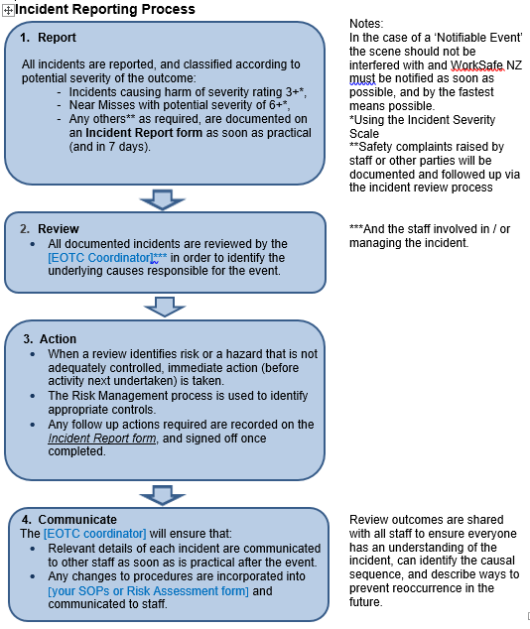

Incident Reporting Process

Tools
Incident Report

Severity Ratings
Incident severity is rated according to:

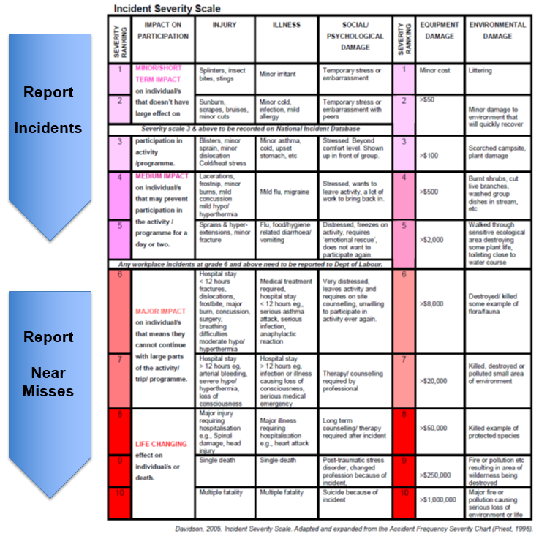

Termly Review
School/VRC and Residential EOTC Coodindators will share incident reports from their sector on a termly basis to establish any common contributing factors. This will feed into the annual review.

Annual Review
All Incident Reports should be reviewed at the end of each year by the BLENNZ Health and Safety Committee to establish any common contributing factors. Where trends are identified, remedial actions should be taken. The outcome of any review should be communicated to all EOTC staff.

Post Event

Complete your event by following up with:

Tidy Up
- Acknowledgement, thank you and/or feedback to staff, external providers and suppliers
- Complete/authorise any event related payments
- Clean and return equipment, completing any Equipment Logs required.

Review and Evaluation
- Complete an Event Review – wherever possible including the perspective of other stakeholders (students, volunteers, external providers)
- An evaluation of the actual effect of the event could be valuable - how well did you meet your learning objectives? Were there any other tangible benefits?
- Ensure where relevant, any review findings inform the review of the EOTC Safety Management Plan.

Reporting
- Finalise actual versus budgeted financial report
- Check that all incident reports have been actioned, and sent to the School/VRC or Residential Coordinator
- Upload report and/or results of the Event Review to the EOTC Review Folder in MSTeams.

Tools
Equipment Log
Event Review
MS EOTC Team

