Board of Trustees Policy: Principal’s Professional Expenses (NAG 4)

Blind & Low Vision Education Network NZ

Statement of Intent:
The Principal is the professional leader of the Blind & Low Vision Education Network NZ (BLENNZ) and the Board’s Chief Executive working in partnership with the Board of Trustees. The Board is tasked with ensuring the Principal is financially supported in terms of professional expenses and professional development.
This support will be achieved through the annual operating budget and does not form part of the Principal’s salary.

Policy Guidelines:
1. A budget for professional expenses and for professional development, including attendance at appropriate New Zealand based conferences, will be established annually in accordance with the Principal’s professional development plan contained in their performance appraisal agreement and be included in the budget. This will be approved by the Board during the annual budget cycle.
Professional development expenses may include but are not confined to: continuing education, books and periodicals, subscriptions to organisations, mentoring and attendance at Australasian based professional conferences.
2. Once approved the Principal is authorised to spend within budgeted allocations.
3. Overseas trips for professional development and/or attendance at conferences outside of the Australasian region will also be incorporated into the annual budget. Confirmation of the budget through BOT Minutes confirms approval for the Principal to undertake the professional development requested without having to seek further approval from the Board.
4. The Principal will be required to report back to the Board within one term of any overseas professional development on outcomes of the trip including future strategic directions for the Board to consider. A financial breakdown of expenditure incurred will be completed and made available to the Finance Committee upon request.
5. A summary of expenses will be presented to the Board annually, or as requested.

Supporting Documents:
BLENNZ Strategic and Annual Plans
Principal’s Professional Growth Cycle (Appraisal) Agreement
Ratified: 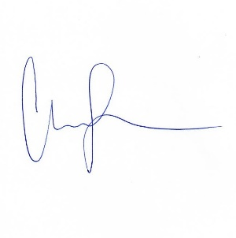
Date: 5 May 2023
Next Review: 2026

