**Blind and Low Vision Education Network NZ - Annual Report 2022**

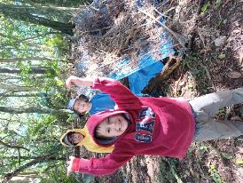 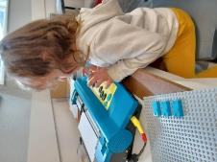 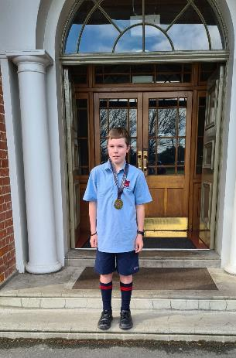 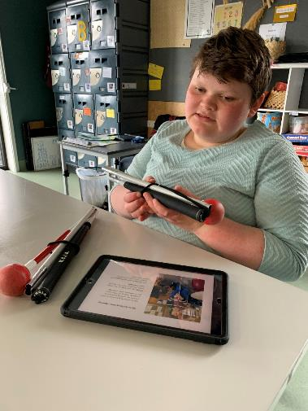

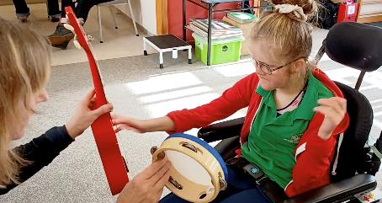  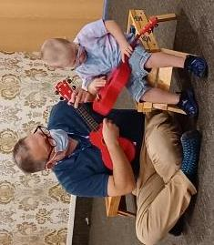

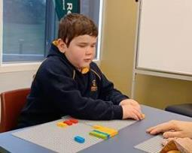 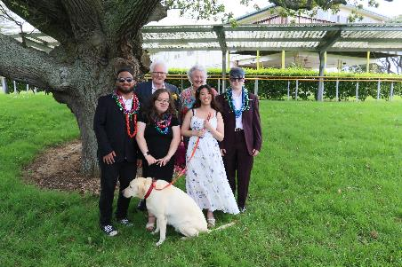 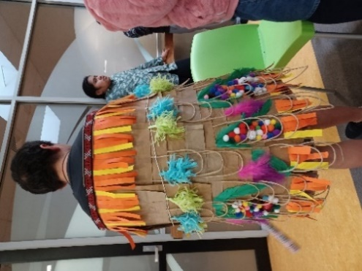

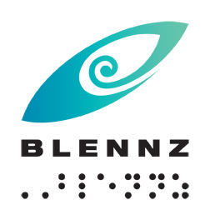

**Blind and Low Vision Education Network NZ**

**2022 Annual Report and Financial Statements**

School Address:

2 McVilly Road, Manurewa, Auckland 2012

School postal address

Private Bag 801, Manurewa, Auckland 2243

Contact details:

School Phone: (09) 2667109

School Fax: (09) 2674496

Email: [Admin@blennz.school.nz](mailto:Admin@blennz.school.nz)

Facebook: [BLENNZ Facebook](https://www.facebook.com/blindandlowvisioneducationnetworknz/)

Twitter: @BLENNZOnline

BLENNZ ICT: [info@blennz.school.nz](mailto:info@blennz.school.nz)



**Table of Contents**

Message from the Board Chair 8

Message from the Principal 9

Special Character School 11

Vision 13

Mission 13

Values 13

Organisational Culture 13

Beliefs 14

Learner Achievement 15

Homai Campus School 15

Residential Transition Report 16

Daredevil Jiu Jitsu 16

Assessment and Teaching 17

BELS 17

Whangarei Visual Resource Centre 18

Auckland North Visual Resource Centre 19

Auckland South Visual Resource Centre 20

Pukekohe Visual Resource Centre 22

Hamilton Visual Resource Centre 23

Tauranga Visual Resource Centre 24

Gisborne Visual Resource Centre 25

Napier Visual Resource Centre 26

Taranaki Visual Resource Centre 27

Palmerston North Visual Resource Centre 28

Wellington Visual Resource Centre 29

Nelson Visual Resource Centre 30

Christchurch Visual Resource Centre 31

Dunedin Visual Resource Centre 32

Invercargill Visual Resource Centre 33

BLENNZ National Assessment Service (NAS) 34

BLENNZ Residential Immersion 35

Regional Teaching Team 36

BLENNZ DOM 36

Covid successes: Hybrid Developmental Orientation and Mobility Programming. 36

BLENNZ VRC Coordinators 37

BLENNZ Music 2022 38

Individual Music Programme 38

Music School 38

General Music Developments 39

Key Facts and Figures 40

Learners attending Homai Campus School 40

Learners Receiving Services from BLENNZ Visual Resource Centres end of 2022. 42

Abridged Statement of Variance on the 2022 Annual Plan 44

Strategic Objectives 44

Operational Goals 45

Events from 2022 48

Te Whānau o Homai 49

31 October 2022 49

14 November 2022 49

Youth Library 49

Board of Trustees 50

BOT members and roles following the 2022 School Trustee Elections and as at 31 December 2022 50

Strategy Planning 51

The Framework of Indicators of Learner Achievement 51

School Services 51

Regional Network 54

Outcome Indicators 55

Learners verified for Ongoing Resourcing Scheme (ORS), primarily for vision 57

Process Indicators 61

Student Achievement 61

Assistive Technology Applications 2022 62

Hardware includes: 62

Software includes: 63

Other Educational Settings 64

Residential Services 64

2022 Immersion Courses 64

Compulsory School Courses 64

Immersion Courses for Early Childhood 65

Knowledge, Skills and Values 65

National Assessment Service (NAS) 2022 68

Background 68

Cumulative Data - 2022 Referrals 68

Caregiver Surveys 69

Questions: Sample Responses 69

Professional Surveys 71

Parent Survey – Sample Responses 73

Developmental Orientation and Mobility Services 74

Outcome end 2022: 74

All BLENNZ DOM 76

Statement of Resources 77

Physical Resources 77

School Roll and Days Open BLENNZ 79

Administration Services 79

Health and Safety 79

Statement of Variance Report (Full) on the 2022 Annual Plan Goals 82

Strategic Objectives 82

Operational Objectives 84

2022 Audited Financial Statement 89

# Message from the Board Chair

Kia ora tātou to all of our BLENNZ community,

It is my pleasure on behalf of the BLENNZ Board of Trustees to present the 2022 Annual Report.

This report provides a detailed overview of what has occurred over the past year within BLENNZ and the progress toward our goals.

What a successful year 2022 was for our students and staff members. We are privileged to be part of this BLENNZ team and each one of us contributes in our own way towards making this national school a fantastic learning community to be a part of.

As per our vision, we strive for each ākonga to be well-prepared to achieve in life, and I think that we are continuing to progress strongly towards that. Many thanks to our Principal, leadership team, staff, board members, volunteers and parent/caregivers for all the leadership, teaching and support which you provide.

The Board and the BLENNZ leadership team prioritised the strategic goals of developing Bicultural practice, for the school to provide a relevant, bicultural, and inclusive curriculum and to enhance our provision for O&M and Daily Living Skills. I am thrilled by what has been achieved by both our school team, ākonga and our nationwide community.

He waka eke noa

A canoe which we are all in with no exception.

Ngā mihi mahana



Chris Gunn

Board Chair

# Message from the Principal

Kia ora kotou katoa

Every year has its ups and downs, in more recent times, our greatest barrier has been in the ability to come together face to face. I think I speak for many of us in saying that we started 2022 with a sense of hope, really wanting to reestablish our connections both on campus and across the motu in more tangible ways. It was wonderful to watch the year unfold, and despite some ongoing disruption, there was a real sense of people reclaiming the wonderful rich human connections that are only possible in person.

Attendance at school increased, we were able to celebrate the graduation of our rangatahi from Transition, to increase our face-to-face engagement on campus through immersion, national assessment and gatherings, our teaching team increased their visits to educational settings and homes. In reality we began to get back to teaching and learning in a very grounded way.

On the property front we celebrated the completion of several projects including: the addition of our wonderful new Auckland North Visual Resource Centre and Satellite at Scott Point School; the opening of our wonderful pool facility at Homai Campus; and the completion of the refurbished Immersion space in Titoki whare on campus. All three create new opportunities for ākonga, whānau and staff.

With increased opportunity to meet face to face, we have been able to make positive gains in strengthening our collaboration with Blind Sports, Halberg Trust and others. We look forward to continuing to build these relationships from strength to strength.

My thanks go to Dr Elaine Gilmour, who stepped in as Acting Principal, for a term in the middle of the school year, and to those across our senior leadership team, whose contribution and support made this possible. During this time Ministry of Education signaled changes to the Contract for accessible format production and library services. Constructively exploring new ways of working in these areas was an important focus for the latter part of the year.

It has been exciting to initiate our three key strategic goals, each having relevance to the national Curriculum Refresh that is underway, focusing on Biculturalism, BLENNZ Curriculum Refresh and Orientation and Mobility / Life Skills. We look forward to continuing to progress this work with our community in the coming year.

We are a network made up of many parts, what we share is our commitment to the vision, mission and values that guide our network, in that we are united.

Enjoy the content that follows and the celebration of young people and staff working together. My thanks go to each and every one of our team, who through their different roles, contribute, to positively influence access to learning, and opportunity for tamariki.

He waka eke noa - We are all in this together.



Karen Stobbs

Principal

BLENNZ

# Introduction

Welcome to the 2022 Annual Report for the Blind and Low Vision Education Network NZ (BLENNZ). The primary focus of the report is to provide accountability to the community, a set of accounting statements providing accountability from a financial perspective; reports on achievement and challenges from an operational perspective; and strategic planning reports from a strategic perspective.

## Special Character School

The Blind and Low Vision Education Network NZ (BLENNZ) is a national school that provides a network of education services to 1614 blind, deafblind and low vision learners throughout New Zealand from birth to 21, including those who have additional special needs. BLENNZ was established as a national network of services eighteen years ago in January 2005. It is one of the special schools nationally that have been legislated to provide residential provision for learners.

The purpose of BLENNZ is to ensure that the education needs of blind, deafblind and low vision learners are identified and appropriate programmes and services are available. It aims to support the government goals for education by enhancing education opportunities for its learners, facilitating access to and participation in the regular curriculum and developing skills for independence.

Historically blindness education services were provided either by Blind Low Vision NZ, (RNZFB) through the services based on Homai Campus, or by Visual and Sensory Resource Centres that were part of the state education system. In July 2000, Homai National School for the Blind and Vision Impaired became a state residential special school and in 2005, all of the services were amalgamated to form the Blind and Low Vision Education Network NZ.

This amalgamation of services was achieved through many years of combined advocacy from parents, teachers, service providers and sector organisations, who expressed a strong desire for a unified, nationally coordinated system for service provision. BLENNZ aims to achieve such co-ordination and cohesion and to reflect the special character of the school through the following objectives:

* Development of nationally consistent practice which is evidence-based
* Implementation of the principles of the National Plan
* Learning and teaching in the Expanded Core Curriculum in the context of the Key Competencies, as expressed in the BLENNZ Curriculum
* Learning and teaching based on the Expanded Core Curriculum as a means of accessing Te Whāriki
* Determination, monitoring and review of learner outcomes
* Clear mechanisms for accountability
* Staffing levels within international benchmarks
* Improved access to services for children and their families/whānau
* Equitable, cohesive and seamless services

BLENNZ is a national school with a national community, which includes children and young people, their families/whānau, Resource Teachers Vision and blindness educators, partner service providers such as the Blind Low Vision NZ and blindness education sector groups including:

* Parents of Vision Impaired NZ (PVI)
* Blind Citizens of New Zealand Inc (ABC NZ)
* Deafblind (NZ) Incorporated
* Kāpō Māori Aotearoa NZ, and Te Whānau o Homai

BLENNZ education services are provided from 15 centres. These are:

* BLENNZ Homai Campus, Manurewa, Auckland
  + Homai Campus School and satellite classes at:
    - James Cook High
    - Tamaoho School
    - Scott Point
  + Residential Services, short and long term courses and residential
  + Early Learning Services
  + National Assessment Service
  + Auckland South Visual Resource Centre
* Whangarei Visual Resource Centre, Tikipunga High School, Whangarei
* Auckland North Visual Resource Centre, Scott Point School. Hobsonville, Auckland
* Pukekohe Visual Resource Centre, Tamaoho School, Pukekohe
* Hamilton Visual Resource Centre, Hamilton North School, Hamilton
  + Outposts: Thames and Taupo
* Tauranga Visual Resource Centre, Bethlehem, Tauranga.
  + Outposts: Whakatane and Rotorua
* Gisborne Visual Resource Centre, Riverdale School, Gisborne
* Napier Visual Resource Centre, Henry Hill School, Napier
  + Outpost: Wairoa
* Palmerston North Visual Resource Centre, Awapuni Primary School, Palmerston North
  + Outposts: Whanganui
* Taranaki Visual Resource Centre, New Plymouth Girls High School, New Plymouth
* Wellington Visual Resource Centre, 27 Kowhai Road, Kelburn, Wellington
* Nelson Visual Resource Centre, Salisbury School, Nelson.
  + Outpost: Blenheim
* Christchurch Visual Resource Centre, Burnside, Christchurch.
  + Outpost: Timaru
* Dunedin Visual Resource Centre, 38 Riselaw Road, Carton Hill, Dunedin
* Invercargill Visual Resource Centre, Ascot Community School, Invercargill.

## Vision

Every BLENNZ ākonga is well prepared to achieve in life.

## Mission

To enable ākonga who are blind, deafblind or have low vision to reach their full potential, BLENNZ provides quality education and specialist teaching services in partnership with whānau and the wider community.

## Values

The services and programmes of BLENNZ are aligned to support the principles and intent of government priorities, goals and strategies for education; the aims of the Disability Strategy for an inclusive society and the removal of barriers; and the principles of best practice in blindness education.

The guiding principles and values of the Blind and Low Vision Education Network NZ will reflect the following documents:

* Universal Declaration of Human Rights, Article 1
* Convention on the Rights of Persons with Disabilities, Article 3 and 24
* Te Tiriti o Waitangi
* New Zealand Disability Strategy 2016 -2026
* Ministry of Education Statement of Intent
* A National Plan for the Education of Learners who are Blind and Vision Impaired in Aotearoa / New Zealand Revised 2009: For Early Childhood and Compulsory Sector Learners
* Te Whāriki
* New Zealand Curriculum
* United Nations Rights of the Child

## Organisational Culture

As a community, BLENNZ has identified core values, which guide our organisation:

Whanaungatanga, Manaakitanga, Awhinatanga, Kotahitanga, Ako.

Our shared BLENNZ values and beliefs interweave to guide our community of learning and teaching, promoting the development of qualities that lead to engaged, confident, connected, lifelong learners. Qualities such as:

Can do attitude, Self-starters, Resourceful, Resilient, Contributing, Curious, Reflective, Explorer, Problem-Solvers, Connected, Confident, Belonging, Actively Involved, Making Choices, Confident communicators.

The services and programmes of BLENNZ are aligned to support the principles and intent of government priorities, goals and strategies for education; the aims of the Disability Strategy for an inclusive society and removal of barriers; and the principles of best practice in blindness education.

The children and young people of BLENNZ are represented across the various levels of education: early childhood, primary and secondary. While their education settings are diverse, the large majority of learners attend their local school or early childhood setting. Their means of communication and literacy include tactile material, braille, print, dual braille and print, sign, augmentative and alternative communication modes.

## Beliefs

The following beliefs underpin the BLENNZ approach to learning and teaching:

* Parents and whānau are the prime educators in their child’s learning,
* Education is focused on the learner within the context of whānau, community and culture,
* Learning occurs through active engagement in meaningful environments,
* Ākonga have unique needs requiring specialist learning and teaching approaches,
* Ākonga have the right to equitable access to education,
* Ākonga have a right to belong and to realize their potential as participating and contributing members of society,
* Team collaboration promotes positive outcomes for ākonga.

# Learner Achievement

## Homai Campus School

2022 was an exciting year, as we returned from learning at home to learning at school and ākonga were excited to be back with their peers.

We began the school year with the vision of ensuring we were all united as BLENNZ ākonga and staff, culminating in a collaborative artwork of a whare which is prominently displayed in our library.

Our Scott Point Satellite together with the Scott Point School was opened by the Prime Minister Jacinda Ardern in Term 2.

Staff and ākonga are enjoying the beautifully designed premises.

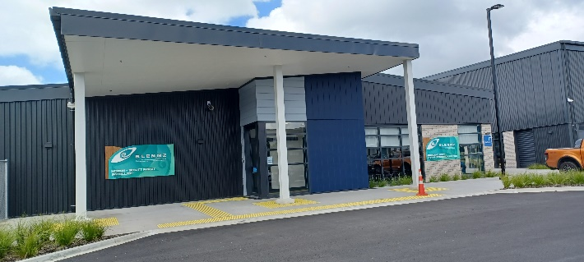

Photo: The outside entrance to Scott Point Satellite

Ākonga had the opportunity to participate in many events over the year supporting their learning - a trip to the All Blacks Expedition, a train trip to Britomart, the viewing of the play, Whale Rider in the Mangere Arts Centre, a visit from Batman and his Batmobile and a ‘Have a Go day’ hosted by Counties Manukau Sports.

The school produced a Wearable Arts parade showcasing their creations and the year culminated in a concert centred around our study on the Lorax.

Holly Gunn received a music award in prizegiving at James Cook High School.

## Residential Transition Report

## Daredevil Jiu Jitsu

In Term Three and continuing on into Term Four, we were lucky enough to have regular sessions with Clinton Terry otherwise known as the “Blind Grappler”.  Clinton, is a National and International BJJ (Brazilian Jiu Jitsu) Champion competing against and beating his sighted peers frequently, he invited us to his own gym in Henderson, Auckland aptly named, “Daredevil Jiu Jitsu”, He has also just successfully become the first blind Jiu Jitsu black belt in New Zealand.

From the get-go, Clinton had our ākonga fully immersed, grappling and learning different BJJ positions which everyone (including staff) loved. Ākonga had the opportunity to hear more about Clinton's life as someone who went blind at two years old, to becoming a fully independent adult, as well as his meteoric rise as an international BJJ champion.

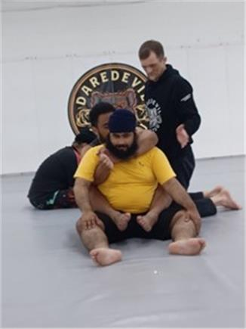

Photo: Tyrese is sitting behind Amitoj setting up a Rear Naked Choke submission.

# Assessment and Teaching

## BELS

BELS held two Professional Education Programmes this year for kaiako who support early childhood ākonga and their whānau. The focus for 101 in June was whānau centred practice, and 201 in August was building on having a coaching mindset when working with kaiako and whānau. The feedback from kaiako has been outstanding.

Consistent “aha” moments from 101 was the principle of “noticing, recognising, responding and revisiting” and 100% of the 201 participants responded that they had increased their knowledge around working in a routines based model as well as feeling that “as RTV we are using coaching in our practice, to a degree, but seeing how we could involve whānau and teachers by using a coaching mindset was inspiring.”

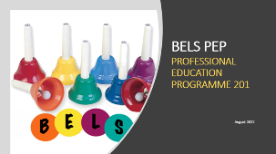

Figure 1: The BELS team logo on the PEP 201 programme

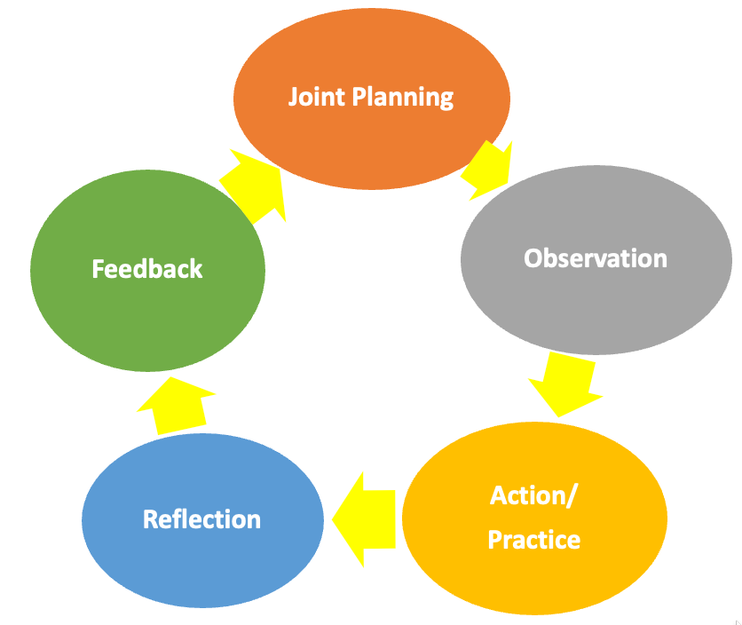

Figure 2: Five key components of coaching: Joint planning; Observation; Action/Practice; Reflection: Feedback

## **Whangarei Visual Resource Centre**

### Working in collaboration with Parafed Northland and Blind Sport NZ

This year the Resource Teachers of Vision have been working collaboratively with Parafed Northland and Blind Sport New Zealand to increase both our own and whānau knowledge of accessible sporting opportunities available for our ākonga. RTVs attended a fabulous sports session at MacKay Stadium with Casey from Blind Sport NZ, Sharon and Anna from Parafed Northland and James from Halberg. It was a wonderful opportunity to learn more about the Accessible Sports Equipment available to our ākonga and develop skills to support students to fully participate in sport and active recreation. We are all excited to continue this collegiality and teaming throughout the years.

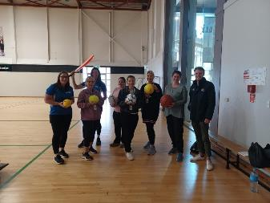

Photo 1: Blind Sport NZ, Parafed, Halberg and BLENNZ Whangarei team members

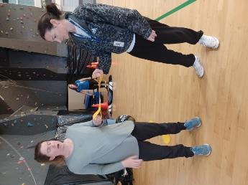

Photo 2: Casey (Blind Sport NZ) modelling the correct technique for using the running t*og*ether.

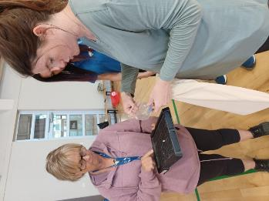

Photo 1: Casey (Blind Sport NZ) showing Katarina the accessible equipment.

## Auckland North Visual Resource Centre

Auckland North Visual Resource Centre moved into its permanent location at Scott Point School, Hobsonville in June. The purpose-built centre has a large open plan office for the Resource Teachers Vision, three BLENNZ satellite classrooms, whanau and meeting rooms.

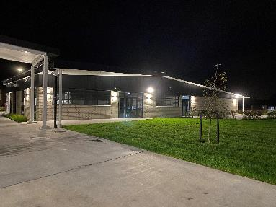

Photo 1: BLENNZ Centre at Scott Point School.

Learning spaces at Scott Point School are named after the Stars of Matariki. Our centre is Kāinga Waipunarangi. Waipunarangi supports us, provides for us and sustains us. It encourages us to be empathetic and inclusive of the world around us.

Officially opened by the Prime Minister, Jacinda Ardern on July 29th, the school and the BLENNZ Centre serve the growing Scott Point community and BLENNZ ākonga based in the Auckland North area.

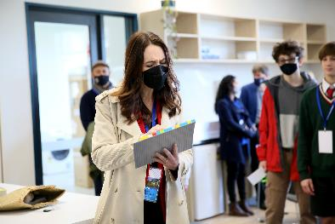

Photo 2: The Prime Minister exploring the LEGO Braille bricks.

## Auckland South Visual Resource Centre

### Auckland South’s 2022 Journey

2022 started with restricted service delivery and then ASVRC had a minor fire, so it was back to working from home. Things started to feel more normal from the start of term 2, with everyone happy to see us face to face.

We started our Taitamāhine group for girls between 8 – 12 years old, focusing on learning social etiquette, while having fun. The first session was hugely successful, with another session planned for term 4.

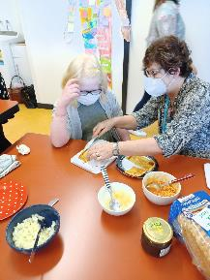

Photo 1: Female Resource Teacher showing a young girl how to cut her toasted sandwich, while seated beside each other at a table, during a session at the Taitamāhine group.

Another highlight was attending Cinderella the ballet. In term 4, ASVRC and the HBCS will be hosting a picnic, with the purpose of reconnecting families, as a result of the extended lockdown periods Auckland has experienced. We are looking forward to a fun evening.

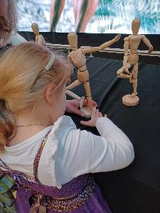

Photo 2: Young female learner, standing and touching the wooden manikins on the table.

## Pukekohe Visual Resource Centre

Pukekohe VRC established a new Expanded Core Curriculum group this year called Te Roopu Auaha – The Creative Group. Twelve ākonga from eleven primary schools came together once per term to focus on skills to build independence, team work, problem-solving and social skills. The first session was “Under the Sea” and focused on sensory arts and crafts. The next session has the theme ‘Adventure!’; ākonga went to Schlaepfer Park Scout Camp to build bivouacs, complete sensory team challenges, create art from nature and of course roast marshmallows around the campfire! Our third session ‘Lets Move it!’ focused on recreation and leisure activities, baking, playing sports and board/card games, ākonga loved using the Blindsport accessible sport kit!



Photo 1: Tommy, Ajaybir and Tanya show off their bivouac

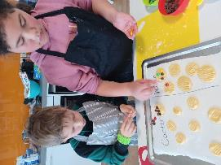

Photo 2: Carter and Wairua make shortbread cookies.

Hamilton Visual Resource Centre

Many of our ākonga have been enjoying the new sports kits set up by Blind Sport. Their teachers are able to borrow these kits to use with their whole class, which means that our ākonga are using accessible equipment alongside their peers. This has been a great opportunity for modelling accessible physical education sessions, for trying new sports and working out the best equipment to purchase for ākonga. This has tied in beautifully with our centre focus on encouraging our ākonga to get involved in physical activities. A group of ākonga were also involved in the local Halberg sports day and another group took part in Parafed’s sports taster.

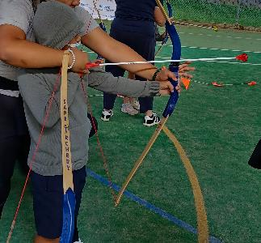

Photo 1: Ākonga learning how to shoot an arrow at Halberg Sports day.

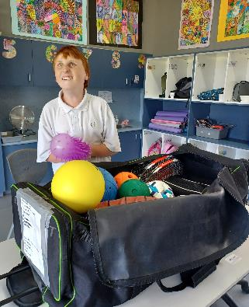

Photo 2: Ākonga exploring the huge range of sports equipment in the Blind Sport Equipment Kit.

## Tauranga Visual Resource Centre

At the end of term 2, BLENNZ Tauranga were fortunate to run the four-day Developmental Orientation and Mobility on Campus course for 10 RTVs. Involved in this event were 2 BLENNZ Developmental Orientation and Mobility specialists, Mark Gear and Ania Rutkowska as well as Dr Nicola McDowell from Massey University. We had RTVs from the teams in Tauranga, Hamilton and Pukekohe attending.

The four days included practical sessions on guiding, cane skills, room familiarisations and map making. The course explored the theory behind techniques to support our ākonga moving around their school environments safely as well as given the staff the experience of being blind or low vision in a respectful way. The staff comments included “it was an amazing learning experience.”

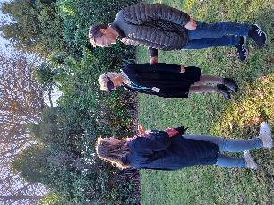

Photo: Three Resource Teacher Vision discussing the impact of wearing a blindfold on moving around safely.

## Gisborne Visual Resource Centre

The centre has undergone a transition period throughout the 2022 school year. A change in leadership and management began in Term 3 with a strategic approach that resulted in a new Team Lead/Manager on the ground permanently in Term 4. During that period of change, Saul Taylor as Acting Manager and the RTV/Admin team in Gisborne continued to provide reliable service to children and young people funded for vision and their whānau. For young people with moderate needs and funded through other categories, families, schools and kura were made aware of the transition across the two terms. BLENNZ contact with all parties have now resumed. Patrick Pink (BLENNZ National Assessment Service) has happily taken up the role as Team Lead/Manager.

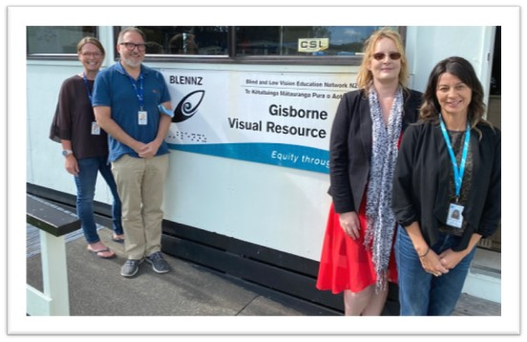

Photo: The current team at Tūranganui a Kiwa Gisborne VRC.

## **Napier Visual Resource** Centre

A celebration for Kahn, from BLENNZ Napier, has been to attend the October Halberg games in Palmerston North. Kahn participated in a variety of events, from swimming to track and field. He was placed in all the events he entered.

Kahn enjoyed meeting and connecting with the other young attendees. By attending, Kahn gained a greater realisation that he ‘is not the only one out there with challenges.’

Kahn further showed his sporting abilities in the National Taekwondo championships in Auckland, winning a gold medal within his classification. He continues to train in both disciplines.

A development for BLENNZ Napier is the inclusion of the Wairoa Outpost. We welcome the Wairoa ākonga, whānau, and Sonya Newton, Resource Teacher, Vision.



Photo: Kahn wearing his gold medal.

## Taranaki Visual Resource Centre

Our Taranaki Team Inquiry focus this year was to engage in ongoing professional development delivered by the NAS team to support our growth when working alongside complex needs ākonga, their whānau and the ākonga team.

This professional development included individual mentoring, regular team zoom meetings, and a visit to Taranaki from the NAS team to support us with our observation and assessment skills.

Our professional development will continue into 2023, when the NAS team will visit Taranaki in March to undertake full assessments specifically for our complex needs ākonga.

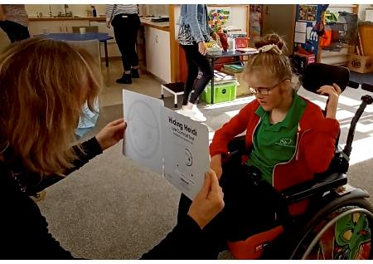

Photo 1: RTV using a formal assessment tool with ākonga.



Photo 2: Alt Informal assessment and observation.

## Palmerston North Visual Resource Centre

### Lego Braille Bricks

Integrating Lego Braille Bricks with writing and reading has been highly successful with my 5-year-old Braille learner, Lily.

They have been used incidentally initially, when Lily’s class were doing their letter of the day, along with a PIAF/Braille alphabet book and a collection of objects matching the sound.

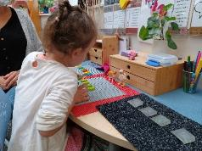

Photo 1: shows Lily’s Lego baseboard set up with ‘d’ bricks, with a number of models (dinosaur, dog, doll) on the table. On the right are flashcards in Braille and Lily is required to choose the matching letter.



Photo 2: shows Lily learning ‘i’. Lego Braille Bricks are set up on a baseboard and she is brailling these on the Mountbatten.

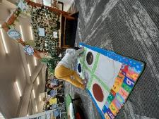

Photo 3: shows Lily playing our Braille Twister game. She is making an ‘i’ with her body. Her legs are on Dot 2, and her arms in Dot 4. Each dot is made from a different texture fabric.

## Wellington Visual Resource Centre

What a changeable world we have been walking in, pai kare! It's been a great chance to be innovative though and find new ways to get great outcomes for Ākonga.

In response, we created a series of online Professional Development opportunities for educators. The presentations are deliberately short in recognition of busy Kaiako and contain simple interventions that feel possible. Our approach was to get 'buy in' and 'action' by sharing uncomplicated do-able strategies, i.e: 'quick wins'.

They have been a success with our colleagues getting the engagement we sought. More educators have participated than through past kanohi ki te kanohi In-services. They've been seen as user-friendly, easy to understand, and providing a kete of ideas to apply to mahi right away.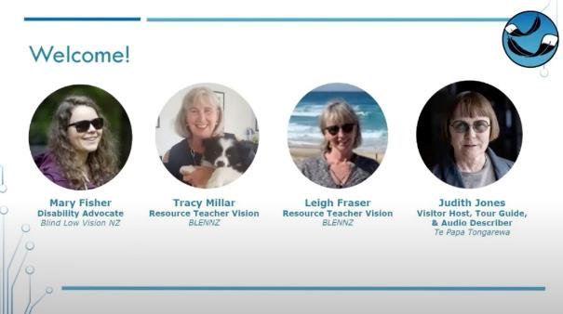

Figure 1: Tracy and Leigh presented alongside a Disability Advocate and Audio Describer to educators outside the classroom in the webinar “Accessible programmes for the visually impaired” using vimeo presentations as part of their presentation.

## Nelson Visual Resource Centre

### Full Inclusion in School Athletics Day

Laura was able to participate fully and be included in all of the athletics activities on her school’s athletics day. In order to achieve this goal Laura’s RTV initiated a core strengthening and balance programme well ahead of time. The programme involved supervising Laura in a range of activities including the use of a physio ‘wobble board’ as shown in the picture. The RTV was also in attendance on the day to offer encouragement and emotional support to Laura. The outcome for Laura was that she achieved full inclusion in the day’s programme, had a fun time with her peers and participated with confidence and reduced stress.

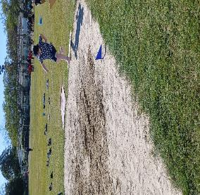

Photo 1: Laura making her best effort in Long Jump.

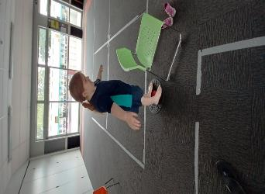

Photo 2: Laura working with her RTV on balance activities prior to the Athletics Day.

## Christchurch Visual Resource Centre

### BLENNZ Christchurch Whānau Group

Our Whānau group is a planned session usually run fortnightly at the CVRC to suit ākonga and whānau interests and needs. Whānau voice is important and over the year we have adapted our session to present via zoom due to changing circumstances. We have continued to evolve our whānau-based practice to provide connections between families, music and active exploration and movement and online links to resources that can be used while at home. The emphasis is on continuing to provide a fun, engaging atmosphere where whānau and ākonga feel supported, comfortable and welcomed.

Our CVRC Manager and the BELS team have provided wonderful support to guide, reflect on and continue to provide flexible home learning opportunities.

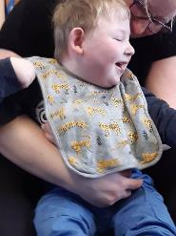

Photo 1: Photo of child with parent enjoying music and movement via zoom.

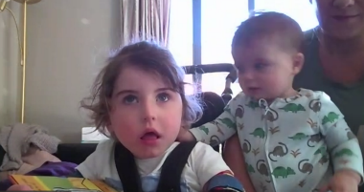

Photo 2: Photo of parent, child and sibling saying hello to all via zoom link.

## Dunedin Visual Resource Centre

In September we had a visit from the National Assessment Service (NAS) team, who saw most of our ORS Vision Only ākonga as well as some of our moderate learners. It was wonderful to welcome so many of our whānau to our new centre and all the rooms were well utilised, including the spaces of our RTLB and RTD colleagues.

A highlight of the visit for our out-of-town colleagues was the snow, which meant a late start on Day 2. However, everyone worked very hard to catch up and fit in all their appointments. Thank you to all the people who worked behind the scenes to make the NAS visit, so successful.

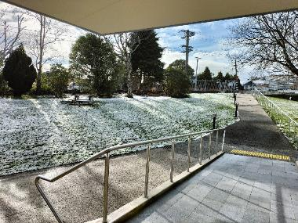

Photo: Snow at the Dunedin Visual Resource Centre later on Day 2.

## Invercargill Visual Resource Centre

### NAS Visit

After being postponed twice our NAS visit went ahead in February. This was a relief for everyone organising it and for ākonga and whānau who had waited patiently.

The opportunity for networking for and with whānau and other professionals was valuable. Everyone left feeling supported, listened to, valued, empowered and stronger – and this is before reports were even sent out.

One mother asked, “How often do NAS come?”

Two families shared knowledge about hearing aids and the process for getting what works best.

Communication device information was explained and changes understood by teams.

Vision was confirmed and next steps for monitoring were shared.

A service above and beyond that was enjoyed by all – Tau Ke (awesome).

A NAS Team  posing for a photo with Invercargill BLENNZ staff.



Photo 1: All of the Invercargill BLENNZ team with some of the NAS team



Photo 2: Patrick sitting with Hunter (2yrs 10mths) exploring ukeleles.

## BLENNZ National Assessment Service (NAS)

As a part of a National Assessment Service (NAS) visit to Dunedin, Reid undertook a functional sensory assessment that included assessing his listening skills and comprehension, as well as his tactile abilities. Reid was able to show the skills he is developing in literary braille and tactile graphics, including reading and writing the braille alphabet. Reid was also able to use the LEGO Braille Bricks (a teaching tool that LEGO has created that uses a braille letter on each brick).  He used these to write his name and to create other words based on the letters in his name. He was confident, accurate and engaged with all the activities that helped support braille literacy learning. Well done Reid!

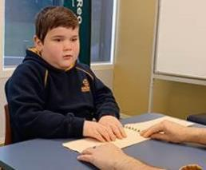

Photo 1: Reid is exploring shapes in a book with thermoform pages.



Photo 2: Reid is using the LEGO Braille Bricks to write his name.

## BLENNZ Residential Immersion

After a two year hiatus Transition was finally able to have a graduation ceremony for ākonga from 2021 and 2022. Representatives from the Blundell family came and presented the Blundell awards to four well deserving young people. The award for 2021 went to Jade Hoera; this young person is an active member of Kāpō Māori and has already represented BLENNZ at the yearly Kāpo Māori conference. The 2021 merit award went to Tyrese Schwenke. The award for 2022 went to Riley Hovell-Allomes, Riley has found a path and is proudly walking the talk. Riley is preparing to go on to further study and has set a clear plan for 2023. The 2022 merit award went to Grace Zhen.



Photo: 2021 and 2022 Blundell Award and Merit Award winners with Mr. and Mrs. Winstone.

## Regional Teaching Team

BLENNZ employs a number of Resource Teachers: Vision and Developmental Orientation and Mobility Specialists who are based at fifteen Visual Resource Centres and eight outposts located across New Zealand. The role of the specialist teachers is to advise, provide guidance and direct teaching to identified learners with a recognised vision concern, in order that they are able to access the curriculum while developing skills needed to reach their potential in life. The role of the DOM is to work collaboratively with Resource Teachers: Vision in the provision of specialist services in orientation and mobility.

Each Centre is led by a Manager who is in turn closely supported by a Centre Coordinator. Pedagogy and Practice is framed by the Mission, Beliefs and Values of the organization and is guided by the Strategic and Annual Plans with a clear focus on working collaboratively to meet the needs of all BLENNZ learners. Opportunities are provided for individuals and teams to meet regionally and nationally for professional development and to facilitate an approach that aspires to equitable informed service delivery and evidence-based positive learner outcomes.

The Regional Teaching Team also work in partnership with the National Assessment Service, Short and Long Term Residential Services and the Early Learning Service. These strands are based at the campus and are pivotal in supporting the regional teams.

BLENNZ continues to strive towards the provision of consistent specialised assessment and programme delivery for ākonga from an informed teaching team.

## BLENNZ DOM

## Covid successes: Hybrid Developmental Orientation and Mobility Programming.

Covid has meant that ‘hybrid’-in person and via zoom- Specialist programming has become a creative way to support learners and their teams. This has been a success story for some teams, including Trinity’s. The Specialist, at distance, has worked alongside Trinity and her team using a variety of methods, including zoom to share skills, Trinity sending videos and having conversations with the Specialist scaffolded by the team, and the use of g drive to share and support each other. The outcome being Trinity’s amazing self-determined travel and a skilled and confident team around her. The picture is taken from a video booklet that Trinity has made to show ‘newbies’ who work with her, her strategies and abilities.



Photo 1: Trinity is checking out her different canes and reviewing her book creator that she has recorded to share her O&M strategies with team members.

## BLENNZ VRC Coordinators

This year we have been part of the Curriculum Voices Group and Implementation and Design Working Group of Te Mātaiaho, which is the New Zealand Curriculum refresh. We are privileged to be part of these groups and to have our ākonga in mind as the curricula are being written.

We have shared this information across the BLENNZ Network in Accord days via Zoom. In the second Accord day we explored the Kaupapa of Te Mātaiaho, asking what do we aspire our BLENNZ ākonga to leave us with in so far as skills, dispositions, aspirations and values cloaked as a korowai.

We have also gathered information from the campus school ākonga and the BLENNZ BOT. We are theming the national threads and aligning them with our BLENNZ Values.

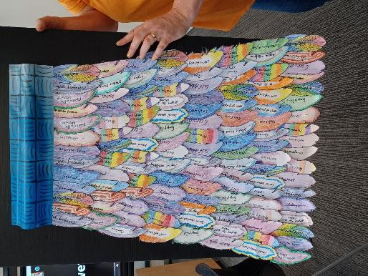

Photo 1: Picture of Auckland North Korowai.

# BLENNZ Music 2022

## Individual Music Programme

Ten ākonga received regular one to one music tuition in 2022. Six of these were held in person, and four via zoom. One ākonga continued to be supported online by an adult jazz pianist who is blind, two ākonga had specific large print/technology needs and the remaining ākonga continue to focus on developing Braille music skills and knowledge to support their school programmes.

## Music School

At the end of 2021, a survey was distributed to music school staff, ākonga, and whānau to reflect on several aspects of the programme with the intention of clarifying key areas of focus and need. The following key concepts were identified:

* Music school is an additive programme in that it adds knowledge and skills to music learning already in place. It is not designed to be the primary source of music education for BLENNZ ākonga.
* Focus of the programme remains in developing skills encompassed within the Expanded Core Curriculum. This includes learning how to actively use music knowledge and skills (e,g braille scores within vocal group setting), assistive tech, and social skills.
* 2021 survey feedback indicated that musicianship and vocal group were most helpful for music learning so these will remain integral to the programme, as will dance/movement and music appreciation.
* Friendship and social opportunities were also highlighted as key to the programme thus the goal will be to present learning opportunities as full-group collaborative activities.
* Programme content will be guided by four learning strands: musicianship, technology, performance, social and life skills.

Music school started 2022 with a new programme incorporating two sessions to provide for the specific needs to two different groups of learners. A targeted morning session for ākonga learning music, and a late morning/afternoon session with broader application for ākonga learning through music. In addition, 2022 marked 20 years of the music school programme so a celebration concert was held on November 12th which highlighted key moments and incorporated voices of past and present ākonga. The concert was professionally recorded with the intention of producing a highlights reel for the website. During the year, ākonga worked collaboratively on a music school song which is attached.

## General Music Developments

A number of broader music related events occurred during the year and are noted below:

* The Swiss Ball Boogie programme which started with the senior classes at Homai campus continues to develop with input from the campus physiotherapist.
* Additional learning sessions (facilitated through the immersion programme) were held during the year to support access to print music for ākonga with low vision.
* In September a small group of ākonga performed alongside the Auckland Philharmonic orchestra in a community “play-in” event. This required considerable effort for the ākonga to learn vocal parts from Braille, all in Italian. This was a fantastic experience for everyone involved and opened up new opportunities for community engagement.
* In October, a specialist music and performing arts teacher from the South Australia School for Vision Impaired visited for a professional development week which resulted in an exchange of ideas and collegial support.

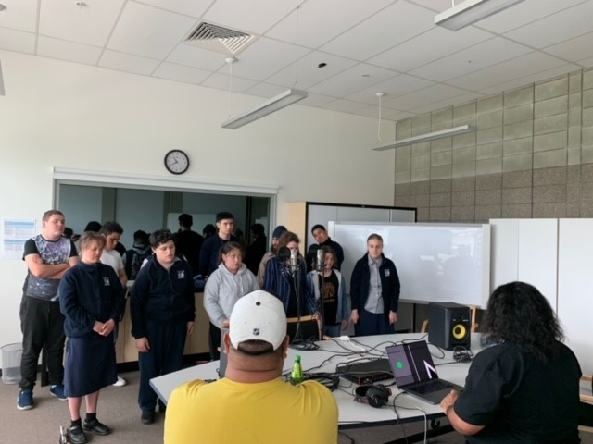

Photo: Music School Group Recording Session.

# Key Facts and Figures

## Learners attending Homai Campus School

**On 1 July 2022 the roll of the Homai School was 56**

Day Students 56

Residential Students:

* Attending Homai Campus School 3 (included in above figure)
* Attending Manurewa High School 0 (not included in above figure)

Male 33

Female 23

ORS:

* Very High needs 42
* High needs 14

Learners with moderate needs 0

Primary 22

Secondary 26 (does not include transition students)

**Analysis of Ethnicity**

NZ European 23%

Māori 14%

Samoan 16%

Tongan 5%

Cook Island Māori 11%

Indian 18%

Fijian 2%

Japanese 2%

Chinese 5%

Other European 2%

Other Asian 2%

82% of the students attend the BLENNZ Homai Campus School are non-European.

## Learners Receiving Services from BLENNZ Visual Resource Centres end of 2022.

| **Area** | **Roll No.** | **Early Childhood** | **Primary** | **Secondary** |
| --- | --- | --- | --- | --- |
| Whangarei | 51 | 9 | 33 | 9 |
| Auckland North | 164 | 32 | 76 | 56 |
| Auckland South | 240 | 67 | 126 | 47 |
| Pukekohe | 89 | 18 | 43 | 28 |
| Hamilton | 166 | 33 | 69 | 64 |
| Tauranga | 123 | 18 | 65 | 40 |
| Gisborne / East Cape | 44 | 7 | 21 | 16 |
| Napier | 64 | 7 | 33 | 24 |
| Taranaki | 65 | 8 | 39 | 18 |
| Palmerston North | 99 | 16 | 41 | 42 |
| Wellington | 123 | 15 | 56 | 52 |
| Nelson | 44 | 3 | 22 | 19 |
| Christchurch | 215 | 23 | 123 | 69 |
| Dunedin | 64 | 6 | 33 | 25 |
| Invercargill | 29 | 1 | 15 | 13 |
| **TOTAL** | **1580** | **263** | **795** | **522** |

| **Analysis of Ethnicity** | **Percentage** |
| --- | --- |
| European/Pakeha | 52.8% |
| NZ Māori | 22.8% |
| Samoan | 4.0% |
| Cook Island Māori | 2.1% |
| Chinese | 2.3% |
| Indian | 4.1% |
| Tongan | 1.7% |
| Niuean | 0.5% |
| Other | 9.7% |

# Abridged Statement of Variance on the 2022 Annual Plan

**Key:** Achieved, Not Achieved, Progressing

## Strategic Objectives

| **2022-24 Goal 1:**  All BLENNZ staff will demonstrate increased knowledge, skills and understanding with regards to integration of bi-cultural practice. | **2022 – 24 Goal 2:**  To review and revise the BLENNZ Curriculum (Expanded Core Curriculum) ensuring it reflects the intent of the national curriculum refresh, a bicultural and inclusive curriculum. | **2022-24 Goal 3:**  To work in collaboration with ākonga, whānau and teaching team to further develop the scope and integration of the BLENNZ Curriculum for O&M and daily living skills, this will inform and further develop the services for DOM and Life skills resulting in a holistic approach which leads to enhanced outcomes of ākonga. |
| --- | --- | --- |
| **Objective** | **Objective 2022** | **Status December 2022** |
| **1.Biculturalism** | In 2022 the objective was to begin this journey by focussing on **Runga -** Foundations, our relationship with community in Manurewa. | **Achieved** |
| **2. Curriculum Review** | Undertake a review process to inform the development of BLENNZ Refreshed Curriculum document. The review process will include: reflection of our current curriculum; the educational needs and contexts of BLENNZ ākonga; the vision of the National Curriculum Refresh; and the new content that has been developed in both early learning and compulsory schooling. | **Achieved** |
| **3. DOM Life Skills** | In 2022 we will consult with ākonga; whānau and teaching teams to review our current curricula and initiate a refresh of the curriculum to scope.  Scope and test provision based on the roles and interface that emerge. | **Progressing** |

## Operational Goals

### 4. Partnerships Organisational Relationships

| **Who** | **Objective 2022** | **Status December 2022** |
| --- | --- | --- |
| **4.1** Assistant Principal Head of School Services and Senior Teacher | Introduce the school to the Partnering Framework that will provide a shared understanding and guide the team in developing and maintaining positive outcomes when navigating relationships with ākonga, Build the capability of Coordinator School and Senior Teacher to take the lead in Partnering PLD. | **Achieved and continuing development** |
| **4.2** VRC Coordinators x 3 | Increased awareness and capability of effective partnering of targeted teams. | **Progressing** |

### 5. Systems and Resources

| **Who** | **Objective 2022** | **Status December 2022** |
| --- | --- | --- |
| **5.1** Digital Access | Working with MOE contribute to develop a resource of information that builds knowledge and understanding about digital access in schools with a view to informing decision making that promotes access for learning. | **Progressing** |
| **5.2a** AFM – Internal – Resource Production  **5.2 b** Marrakesh Treaty | Develop a system for internal resource production that meets the needs of ākonga and staff in a timely manner. Producing quality resources that meet BLENNZ’s obligations under the Marrakesh Treaty. | **Progressing** |
| **5.3** AFM – External - MOE | Work with Ministry of Education and BLVNZ to ensure resources (from hardcopy to electronic learning) are produced internally and in partnership in a sustainable way that support ākonga. | **Progressing** |
| **5.4** Wellbeing | To promote the wellbeing of staff through provision of information and strategies they can integrate into their work life. | **Achieved** |
| **5.5**  Child Protection | To provide Child Matters training to identified staff across the network to facilitate an organizational culture of child protection | **Achieved** |

### 6. Workforce Development

| **Objective** | **Objective 2022** | **Status December 2022** |
| --- | --- | --- |
| **6.1**  BLENNZ Curricula | Literacy through braille – introduction and trial of adapted programme to refine and amend for implementation as a PLD component for RTV is 2023. | **Achieved** |
| **6.2**  BLENNZ PLD path beyond induction | Complete a stocktake of PLD workshops and modules currently available, identify further workshop development and create a prioritised plan for PLD over time for staff according to their role. | **Progressing** |
| **6.3**  Ākonga with learning needs that are complex | To develop a working definition based on literature review, shaped understanding within the Network (gathering different voices) and in partnership with external allied professionals and to gather input/feedback internally and externally. | **Progressing** |
| **6.4** Digital competencies of staff | Conduct a stocktake of what staff competency is currently and identify need. Based on need begin implementation of PLD as required | **Achieved** |

### 7. Property

| **Objective** | **Objective** | **Status December 2022** |
| --- | --- | --- |
| **7.1** 10YPP | MOE to work with BLENNZ in terms of the establishment of a 10YPP for the Homai Campus as well as a cyclical maintenance plan for the Homai Campus and stand-alone Tauranga Visual Resource Centre base. To be completed and signed off during 2022 | **Progressing** |
| **7.2** PODs | Review of existing documentation re Occupancy Agreements for all centres and outposts for the purpose of securing updated agreements. | **Progressing** |

# 

# Events from 2022

1. The year started with a Whanau Hui and powhiri to welcome those ākonga, whanau and staff new to the Homai Campus.
2. Fire and flooding event in an area of the main building which resulted in staff from the Auckland South Visual Resource Centre working from home 5 weeks of Term 1.
3. Sabbatical leave for the Principal from 6 June to 28 August 2022.
4. The Homai Campus School Wearable Arts Celebration held on the 7 June with an umbrella learning that “There is no Planet B.

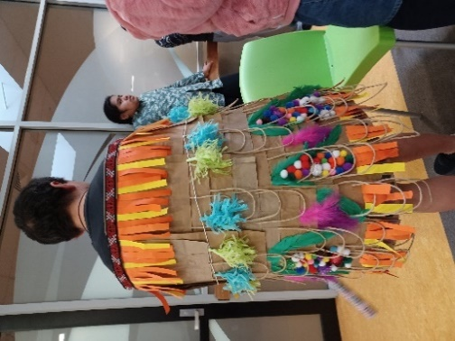

Photo: James Cook class created a korowai using brown paper supermarket bags. This was made colourful with pom pom, feathers and paper strips

1. On the 14 November the Homai Campus held a blessing for the new swimming pool followed by the official opening on the 15 November.

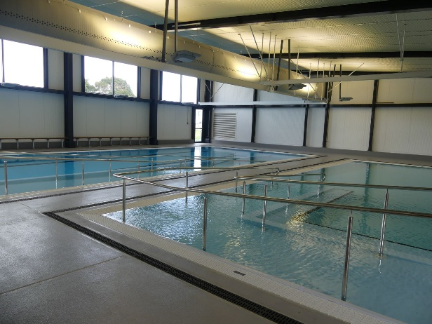

Photo: Homai Campus Indoor Swimming pool and hydrotherapy pool

# Te Whānau o Homai

## 31 October 2022

* Whakatau for new Residential staff member.
* Transition ākonga were responsible for the karakia.

## 14 November 2022

* Swimming pool blessing by Martin Cooper, kaumatua and kuia from Manurewa Marae
* Various people who had been involved in the design and building of the pool were invited to attend. Transition students also participated in the blessing.

# Youth Library

The BLENNZ Youth Library has undergone a number of significant changes in 2022. The library is now fully operational and is a welcome addition to BLENNZ managed services. Staffing is ongoing with a new librarian commencing in January 2023, with an assistant librarian to follow. Review of the resources and the range of formats in a changing educational environment is the key focus while ensuring material is provided to BLENNZ ākonga in a timely manner is critical. 2023 will see further initiatives to the team in respect to the development of resources through the employment of Specialist format staff.

The library is an attractive and inviting space for all to explore.

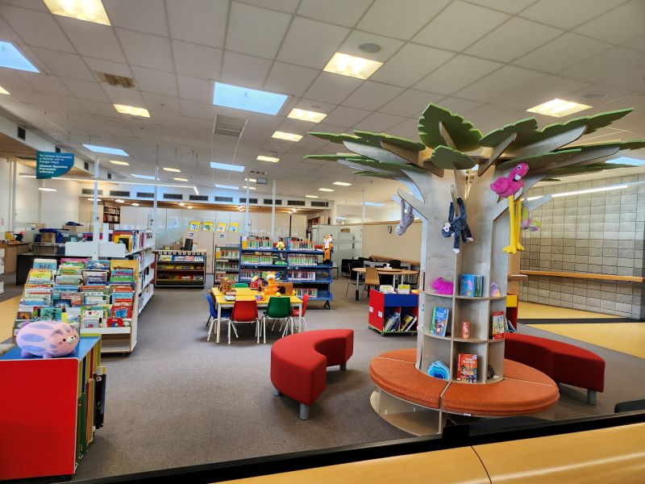

Photo: BLENNZ Youth Library showing the Acoustic Learning Tree in the foreground with learning resources behind it.

# Board of Trustees

BLENNZ has a national board of trustees, which is representative of BLENNZ and of the wider blindness education sector.

The role of the BLENNZ Board is to govern the school, with a focus on providing an environment that fosters achievement for ākonga and young people who are blind, deafblind or low vision.

In 2022 the BLENNZ Board met for seven meetings inclusive of one strategy planning meeting.

25 February, 1 April, 5 April, 27 May, 5 August, 28 October, 2 December.

The Board is made up of the following trustee positions:

* Four trustees elected by parents receiving services from Visual Resource Centres
* One trustee elected by parents of students enrolled at the Homai Campus School
* One trustee elected by staff
* One trustee appointed by the RNZFB, known as the Blind Low Vision NZ
* One trustee appointed by Blind Citizens NZ
* One trustee appointed by a panel of representatives of recognised Kāpo Māori organisations
* The Principal of BLENNZ

Board co-opted trustees, provided that the number of parent elected and VRC elected trustees is greater than the total number of co-opted and appointed trustees.

## BOT members and roles following the 2022 School Trustee Elections and as at 31 December 2022

Christopher Gunn – Board Chair and VRC Parent Elected Trustee

Karen Stobbs – Principal

Parent Elected Trustees – Visual Resource Centres

* David Cullen
* Ross Meikle

Parent Selected Trustee – Visual Resource Centre

* Kevin Manson

Appointed Trustees:

* Nigel Ngahiwi – Tangata Whenua
* John Mulka – Blind Low Vision NZ

Staff Elected Trustee:

* Tracey O’Sullivan

The position of Parent Elected Trustee Homai Campus School was not filled.

## Strategy Planning

### 2022-2024 Strategic Objectives

* Biculturalism
* Curriculum Review
* DOM Life Skills

# The Framework of Indicators of Learner Achievement

BLENNZ uses a network-wide approach to quantifying Ākonga achievement using a framework of evaluation indicators. This systematic approach is intended to enhance opportunities for evidence-based practice and to provide the data needed for the continuing development of nationally consistent practice.

In 2022 BLENNZ will continue to develop pedagogy and practice that supports effective evidence gathering tools and processes for the BLENNZ learning community. There will be specific work undertaken in 2022 to gather a comprehensive understanding of our current evidence-based practices in relation to our services provided through the School, National, and Regional teams.

BLENNZ will share this work with the network who continue to seek to improve outcome indicators. The Framework of Indicators will be reviewed accordingly.

## School Services

School Services are inclusive of both BLENNZ Homai Campus School and BLENNZ satellites.

### Outcome Indicators

#### Using Language, Symbols and Text

Data for reporting on this indicator will be aggregated from BLENNZ Literacy Profile forms which will be completed by teachers for all ākonga.

Identify the proportion of the Ākonga acquiring literacy by:

**The type of literacy programme (conventional or functional)**

* 14 ākonga participated in a conventional literacy programme.
* 36 ākonga participated in a functional literacy programme.

**Their stage of literacy development (Literacy Progressions)**

* 18 ākonga engaged with Real Objects to gain meaning in literacy
* 12 ākonga engaged with 2/3 dimensional pictures or tactual cues to gain meaning in literacy
* 19 ākonga engaged with print / Braille to gain meaning in literacy.

**Their level of participation in their literacy programme as defined in the BLENNZ Literacy Learning Progressions.**

* Exposure: 18 ākonga
* Awareness: 8 ākonga
* Emergent: 7 ākonga
* Early: 7 ākonga
* Fluent: 7 ākonga

#### Braille or Print Users

**Target**

Ākonga following a conventional literacy program will show growth in their reading, in their medium of choice.

**Target Achieved**

Running Records on appropriate texts and Probe (assessments) have been used with Braille / print users to identify 7 ākonga reading at, or above their chronological age. The remaining 12 ākonga are working below their chronological age, but are developing skills to decode, and to enhance their comprehension.

Barriers to learning for individual ākonga have been identified and are noted in their Literacy Profiles. These are addressed through specific goals in their IEP’s and through direct teaching and learning programmes.

#### IEP and ITP goal achievement

**Target:**

All Ākonga will have achieved the majority of their goals. Supporting evidence will reflect the growth and achievement of each Ākonga.

**Target Achieved**

Ākonga’s progress with their IEP / ITP goals are continually addressed and regularly collated to ensure progress and achievement data is accurate and meaningful to leaning.

A vision specific goal is included in each Ākonga’s goal setting.

Each time a goal is achieved a new goal is set in consultation with the student, whanau and the school team.

#### Homai Campus School Leavers

There were no ākonga who left school in 2022.

#### Quality of teaching

**Target**

All ākonga are identified on the Literacy Progressions of Learning in their preferred medium of learning. Achievement is monitored, assessed and recorded at regular intervals to reflect progress and to meet individual needs.

**Target Achieved**

All ākonga have a Literacy Profile, supported by Literacy progressions pertinent to their preferred medium of learning and their level, within the progressions.

These form the basis for teaching and learning programmes, coupled with assessment and identify what the student is working on and what the next learning steps are for the ākonga. Formative assessment is a critical component of this process.

#### Satisfaction with Service

* Conduct an annual survey of parents with ākonga attending the School /Satellites to determine the level of satisfaction with the service provided: mid and end of year 2022.

**Target**

* Whānau voice is sought through formal and informal practices to ensure that our programming, and communications are reflective of culture, expectations, aspirations and social, emotional health and wellbeing.

All whanau were offered the opportunity to participate in feedback on school services.

30/49 whanau responded with the results as follows:

* My child is well supported by the classroom programme – 20 strongly agreed, 8 agreed, 1 partly agreed and 1 disagreed.
* There is good communication between the classroom and home – 21 strongly agreed, 8 agreed, 1 partly agreed and 1 disagreed.
* I feel welcomed into the school and comfortable contacting staff – 22 strongly agreed, 6 agreed, 1 partly agreed and 1 disagreed.
* The health and safety of my child is well provided for – 20 strongly agreed, 8 agreed, 1 partly agreed and 1 disagreed.
* The information presented in the IEP/ITP is helpful to me - 19 strongly agreed, 7 agreed, 1 partly agreed and 1 disagreed.
* Are the 6F’s and Te Aro o, helpful in focussing on your child’s skills / needs - 13 strongly agreed, 9 agreed, 1 partly agreed and 3 disagreed.
* IEP / ITP meetings twice yearly are appropriate – 13 strongly agreed, 10 agreed, 3 partly agreed and 2 disagreed.
* The IEP / ITP gives a clear idea of what is the next step in learning - 16 strongly agreed, 8 agreed, 2 partly agreed.
* IEP says how learning can be supported at home - 12 strongly agreed, 12 agreed, 2 partly agreed.
* The School Report is informative and easy to read - 15 strongly agreed, 10 agreed, 2 partly agreed.
* The termly newsletter provides good information on the activities at school - 14 strongly agreed, 13 agreed, 1 partly agreed.
* My child was supported by the school when Learning From Home (during COVID) 15 strongly agreed, 7 agreed, 3 partly agreed and 1 disagreed.

Further Suggestions and Comments – extremely well supported, Very appreciative of all the support and understanding, enjoys going to school, happy with support and learning, best care and support, “school is like my family” support and kindness given to my child and myself is amazing, class and school as a whole is supportive, communication home to show us his growth is phenomenal, more math, reading and spelling is important

#### Next Steps

More home education is needed in 2023 with regard to 6Fs, Te Aro o and how they inform the IEP / ITP process.

# Regional Network

BLENNZ continues to use a network wide approach to quantify learner achievement for all BLENNZ learners within an established Framework of Indicators. This systematic approach reflects evidence-based practice and provides data needed to inform and guide nationally consistent practice.

Further to the changes in 2021 BLENNZ continues to focus on the importance of reporting of accurate, complete, and meaningful data in order to provide a broad picture of learner achievement for the BLENNZ learner population. The focus remains predominantly on the population of braille and print users, aged 5-12 years, who are verified for ORS primarily on their vision, and are following conventional programmes. This is the cohort for whom BLENNZ potentially has the greatest sphere of influence.

The total BLENNZ population in 2022 was 1608, however the regional population was 1547 (96%).

The Learner Achievement information for all is held on the electronic platform of eTAP and has been reviewed, updated then collated for this report.

## Outcome Indicators

### A. Literacy – Using Language, Symbols and Text

For all BLENNZ learners, data for reporting on this indicator will be aggregated from the BLENNZ Literacy Profile Forms, which are completed by BLENNZ teachers for all learners and collated electronically.

### Identify the proportion of the Ākonga acquiring literacy by:

* The type of literacy programme (conventional or functional)
* The stage of literacy development
* The level of participation in the literacy programme as defined in the BLENNZ Literacy Profile

### Reporting

BLENNZ teachers have completed the BLENNZ Literacy Profile and information has been collated to identify the type of literacy programme, level of participation and stage of development in literacy for the BLENNZ learner population.

1. **The type of literacy programme (conventional or functional)**

The following information outlines this data:

**53.7% (831) of learners follow a conventional literacy programme**

This is a formal instructional programme of reading and writing (in print or Braille) that generally begins at home and at Early Childhood Centres and continues throughout the school years. Learners in such programmes demonstrate continuous growth in literacy skills from year to year.

**37.7% (584) of learners follow a functional literacy programme**

These programmes have an emphasis on reading and writing for the purpose of increased independence in daily life.

**8.6% (132) of learners’ literacy programmes are yet to be determined, identified or recorded**

Learner age is the principal factor involved where the literacy programme has yet to be determined. Some omissions also relate to learners who are new enrolments. This figure is significantly higher than would be expected therefore further updates have been requested from the regional teams.

1. **Their stage of literacy development**

Literacy development for the BLENNZ learner is defined by the way the learner gains meaning of the world around them. This will start from actual objects through to visual or tactual codes and is described as: using real objects; 3 dimensional items (objects of reference); 2-dimensional picture or tactile cue (objects of reference); text symbols such as print or Braille.

The following information outlines this data:

**58.8% (910) use text symbols (printed or embossed)**

**12.2% (188) use 2 dimensional (pictures or cues)**

**2.8% (43) use 3 dimensional objects and**

**25.7% (398) use real objects**

**0.5% (8) of learners’ literacy development is not recorded**

1. **Learners’ level of participation in their literacy programme as defined in the BLENNZ Literacy Profile**

Learners may be at different levels of participation: exposure; awareness; emergent; early; or fluent. Each level reflects how the learner is engaged in literacy - for example at exposure level, the learner is presented or exposed to literacy materials and experiences, whereas at fluency level, the learner is integrating cues, thereby maintaining meaning through longer and more complex sentence structures, various kinds of prose, and poetry and adjusting the rate of reading to the purpose.

The following information outlines this data.

**Exposure – 29.2%** (452) of BLENNZ learners are participating in their literacy programme by being exposed to literacy materials and resources. A further 0.3% (4) are likely to be at this stage of participation as they are very young children or infants.

**Awareness – 13.1%** (202) of BLENNZ learners demonstrate an awareness of the literacy materials that are shared with them by attempting all or some of the following:

* Touching or looking at the illustration;
* Attending to the language of the story being shared – may vocalise with adult
* Turning pages
* Touching dots

**Emergent – 10.7%** (165) of BLENNZ learners are at an emergent level, showing interest in attempting to read text unaided, considering what is read with what is already known, discussing what is happening with what is likely to happen and recognising a number of words in various contexts.

**Early – 14.2%** (220) of BLENNZ learners are at an early level of literacy drawing out meaning from text using such strategies as:

* Using their background experience
* Taking risks and making approximations
* Using text and illustrations to sample, predict and confirm
* Using letter sound associations to confirm predictions

**Fluent – 32.1%** (496) of BLENNZ learners are at a level of fluency integrating cues, maintaining meaning through longer and more complex sentence structures, various kinds of prose and poetry and adjusting the rate of reading to the purpose.

**12 learners (0.7%) information is not recorded.**

## Learners verified for Ongoing Resourcing Scheme (ORS), primarily for vision

**All Braille users from 5-12 years old who participate in conventional literacy programmes**

* Identify their current progress as detailed in the Literacy Learning Progressions

**Outcome Achieved for 100%**

### Reporting for Learners Who Use Braille as Their Medium

There were 31 learners, ORS verified vision only, aged 5-12 years who use braille and participate in a conventional literacy programme, of these 2 are identified as Dual Media with braille as their current means of literacy.

**Literacy Learning Progressions - Learners using Braille**

| **School Level / Level Working at** | **0/1** | **2** | **3** | **4** | **5** | **6** | **7** | **Not Known** | **Total** |
| --- | --- | --- | --- | --- | --- | --- | --- | --- | --- |
| **Below 1** | 3 |  |  |  |  |  |  |  | 3 |
| **1** | 7 |  |  |  |  |  |  |  | 7 |
| **2** | 1 | 1 |  |  |  |  |  |  | 2 |
| **3** |  | 1 |  |  |  |  |  |  | 1 |
| **4** | 4 | 2 |  | 1 |  |  |  |  | 7 |
| **5** | 1 |  |  |  | 2 |  |  |  | 3 |
| **6** | 1 |  |  |  |  | 1 |  |  | 2 |
| **7** |  |  |  |  |  | 1 | 1 |  | 2 |
| **8** |  |  |  | 2 |  |  | 2 |  | 4 |
| **Unknown** |  |  |  |  |  |  |  |  |  |
| **Total** | **17** | **4** |  | **3** | **3** | **2** | **3** |  | **31** |

### Comments around progress:

* Learner enjoys stories and has been working on smooth fingers across a line of Braille.
* Learner has been working on speed reading through repeated reading, and correcting reversals. Comprehension has been a focus for the year.
* Learner can now recognise all letters by touch and is learning to read letters in words.
* Starting Braille for all reading so at a very early stage – progressing well
* Significant achievement in reading was noted for the BANZAT Challenge.
* Learner has been at school for less than 1 term. He is currently learning Braille well and is very interested in literacy.
* Learner is making great progress. She knows about 16 letters and is able to combine these to form 3 letter words. She is developing effective tracking skills.
* Learner has started to read for enjoyment.

### Reporting for Low Vision Learners Who Use Print as Their Medium

There were 134 BLENNZ learners in this category in respect to the information recorded. Of these 6 are identified as Dual Media with print as their current means of literacy.

**All Low-Vision Learners from 5-12 years old who use print in conventional literacy programmes**

* Identify their current progress as detailed in the Literacy Learning Progressions

**Outcome Achieved for 99.3%**

**Literacy Learning Progressions - Learners who are Low Vision**

|  |  |  |  |  |  |  |  |  |  |  |  |
| --- | --- | --- | --- | --- | --- | --- | --- | --- | --- | --- | --- |
| **School Level / Level Working at** | **0/1** | **2** | **3** | **4** | **5** | **6** | **7** | **8** | **9** | **Not Known** | **Total** |
| **Below 1** | 3 |  |  |  |  |  |  |  |  |  | 3 |
| **1** | 9 |  |  |  |  |  |  |  |  |  | 9 |
| **2** | 4 | 5 | 1 |  |  |  |  |  |  |  | 10 |
| **3** | 6 | 5 | 13 |  |  |  |  |  |  |  | 24 |
| **4** | 1 | 5 | 2 | 6 |  |  |  |  | 1 |  | 15 |
| **5** | 3 | 5 | 1 | 3 | 13 | 4 |  |  |  |  | 29 |
| **6** | 1 |  | 4 | 3 | 1 | 9 |  |  |  |  | 18 |
| **7** |  |  | 1 | 1 | 1 | 2 | 8 | 2 |  |  | 15 |
| **8** | 2 |  | 1 |  |  | 1 | 2 | 5 |  |  | 11 |
| **Unknown** |  |  |  |  |  |  |  |  |  | 1 | 1 |
| **Total** | **29** | **20** | **23** | **13** | **15** | **16** | **10** | **7** | **1** | **1** | **134** |

Examples of comments around progress

* Developmental delay, but is now showing greater readiness to read, more engagement.
* Autism diagnosis changing the way material is presented to learner and helps explain his reticence to add detail, understand the task etc.
* Has improved greatly with access to BLENNZ services and support to address visual needs.
* Loves to read, he is also listening to playaways and booklink and this is reflected in his progress.
* Learner has made significant achievement this year. The Early Literacy Phonemic programme the school is working is supporting him with his successes.
* She is more confident in herself and better able to discuss material she has read and how to answer questions in full.
* Reading above his chronological age, using his technology independently to access this literacy programme.
* Learner has improved greatly with access to BLENNZ services and support to address her visual needs. Improved from reading level 8 in April, to level 20 in October.
* Attending Extension Class, very capable student. Learning at a Year 9 level in Year 4.

### B. Mathematics

**Learners being supported by RTV itinerating from Visual Resource Centres.**

* Report on each learner’s achievement (ORS Vision Only Years 1-8) of individual numeracy targets.

All ORS Vision Only learners Year 0 – Year 8 who are following a conventional numeracy programme, will have their mathematics levels identified using the required assessment material.

Reporting

In 2022 we have continued our data collection of Mathematics with Resource Teachers Vision across the network in assessing learners. This is our third round of data collection.

|  |  |  |  |  |  |  |  |
| --- | --- | --- | --- | --- | --- | --- | --- |
| **School Level / Curriculum Level** | **1** | **2** | **3** | **4** | **5** | **6** | **Total** |
| **Y0** | 4 |  |  |  |  |  | 4 |
| **Y1** | 16 |  |  |  |  |  | 16 |
| **Y2** | 9 | 2 |  |  |  |  | 11 |
| **Y3** | 15 | 9 | 2 |  |  |  | 26 |
| **Y4** | 8 | 9 | 3 | 1 |  |  | 21 |
| **Y5** | 10 | 6 | 7 | 3 |  |  | 26 |
| **Y6** | 3 | 5 | 7 | 3 |  |  | 18 |
| **Y7** | 4 | 2 | 7 | 5 | 1 |  | 19 |
| **Y8** |  | 2 | 4 |  |  |  | 6 |
| **Total** | **69** | **35** | **30** | **12** | **1** |  | **147** |

### Approach used to collect data

* Assessment was completed for each learner using Junior Assessment in Mathematics (JAM) or Global Strategy Stage (GloSS).
* All judgments were moderated in each regional centre.
* Robust systems have been developed across the network to carry out the tests and data collection.

### Outcomes and Next steps:

* Data is now collated on an annual basis in Term 3 for the ORS vision only learners Year 0 - 8.
* Data is currently under analysis through eTAP systems.
* RTV have developed understanding about how to support class teachers with access for those who use Braille as their medium and for all those with low vision including those who require adapted formats.
* The data is showing that in the first 3 years of schooling, maths is presented orally which supports BLENNZ learners very well in accessing the curriculum.
* Reviewing how learners engage with written maths and what accessibility requirements are needed is a focus.
* We have found with our data collection and looking closely at key stages and progressions that learners start to move from “At” to “Below” levels. This was a worrying trend, however once we analysed the information, we saw the blocks were when learners were not able to count on.
* We also compared our data to other schools' data through NZCER and were able to ascertain that this is a trend seen in all schools at the Curriculum levels 3 and 4.
* We were also able to establish that access was not a barrier at this early level especially with Braille students, as they were more consistent at maintaining “At” across the board.
* As this is our third year of data, we can see the trends of our learners moving through the system. As the assessment is mainly oral in both assessments this has meant there is not a barrier to learning.

# Process Indicators

## Student Achievement

### A - Teacher Assessment Skills in Literacy

**BLENNZ Braille learners 5 – 12 years who are participating in a conventional literacy programme and acquiring literacy through touch.**

* BLENNZ teachers working with learners acquiring literacy through touch 5 – 12 years who are participating in conventional literacy programmes, will demonstrate the required skills in carrying out a Running Record assessment.

### Targets

1. All braille users from 5 – 12 years old participating in conventional literacy programmes will have their reading age assessed and documented by their BLENNZ teacher using the Running Records diagnostic assessment if this occurs as part of the school assessment programme.

**Target Achieved**

1. All teachers undertaking this assessment have demonstrated their competency.

**Target Achieved**

**BLENNZ ORS verified learners with low vision who are 5 – 12 years and participating in a conventional literacy programme**

* BLENNZ teachers working with ORS verified learners who have low vision from 5 – 12 years old who are participating in conventional literacy programmes, will demonstrate the required skills in carrying out a Running Record assessment.

### Targets

1. All ORS verified learners with low vision from 5 to 12 years old participating in conventional literacy programmes will have their reading age assessed and documented by their BLENNZ teachers, or in partnership with the classroom teacher / SENCO, using the Running Records diagnostic assessment if this occurs as part of the school assessment programme.

**Target achieved.**

1. All teachers undertaking this assessment have demonstrated their competency.

**Target achieved.**

### B - Teacher Skills in Assessing and Accessing Appropriate Technology for Learners

**School Learners across all age bands**

* Report on success rate for assistive technology applications to the Ministry of Education in support of curricula access for BLENNZ learners.

### Target

1. A 100% success rate with assistive technology applications for 2022.

**Target** **achieved.**

### Reporting

The assessment and procurement of assistive technology for BLENNZ learners remains an essential undertaking to ensure learners have access to digital learning environments. A range of technology and software has been recommended and approved by the MOE. The emphasis remains on promoting inclusive environments for all learners. This process is working well and aims to ensure all learners have what is required to maximise their independence in accessing all curricula.

BLENNZ continued to have termly meetings with the Ministry of Education Assistive Technology Team to strengthen this relationship and to keep abreast of new technology options. This relationship is becoming stronger, is collaborative with a very clear and robust process.

In the instances where the technology in no longer appropriate we work alongside the MOE to reassign it so another BLENNZ student can have access.

# Assistive Technology Applications 2022

| **Term** | **New Equipment** | **Replacement** | **Total** |
| --- | --- | --- | --- |
| 1 | 76 | 9 | 85 |
| 2 | 49 | 11 | 60 |
| 3 | 35 | 12 | 47 |
| 4 | 32 | 9 | 41 |
| Total | 192 | 41 | 233 |

## Hardware includes:

A range of technology was applied for which included the following:

* iPads in a range of sizes
* MacBook
* Polaris Braillenote
* BrailleSense
* Touch screen desktop
* Touch screen laptop
* Windows laptop including Surface pro
* Mountbatten
* Desk top computer

A wide range of accessories were applied for. They included:

* Noise cancelling headphones
* Carry cases
* Bluetooth keyboards
* Stylus
* Protective shells and cases
* High contrast keyboard
* Mouse
* Apple pencil

## Software includes:

A range of software was applied for to support the hardware. These included:

* Braille Music Editor programme
* JAWS
* TypeAbility

A range of applications were also applied for to support access on iPads. These included:

* Voice Dream reader suite
* Clicker 4
* Scanner pro
* PDF expert
* Readle productivity pack
* Notability
* Book link
* Dolphin Guide
* Speech auditory screen reader
* Big digits calculator
* Scribble press
* Graphio
* Explain everything
* Book creative
* Seeing AI

# Other Educational Settings

This includes Immersion Courses, Transition, National Assessment Service and Developmental Orientation and Mobility. The following information related to all BLENNZ learners involved in these programmes.

# Residential Services

* Conduct an annual survey of all parents of Ākonga who are in residence in the Homai Campus hostels to determine their increased competence in relation to their ECC Goals/Steps Programme. This will, in part, demonstrate compliance with the terms of the Hostel Licence.

**Target**

A 60% response rate of which 95% of respondents (parents/caregivers) evaluate the service provided as appropriate in terms of quality of communication with home, quality of recreational and cultural activities, student wellbeing and support for the educational programme for their ākonga.

95% of parents asked evaluated the programme as appropriate in terms of quality.

**Target achieved.**

## 2022 Immersion Courses

* Provide 17 short term Immersion Courses in 2022
  + 13 Courses were provided on campus – four were cancelled due to Covid
  + 20 Courses were provided on-line

## Compulsory School Courses

* Immersion - Conduct ākonga and/or parent surveys of Immersion Course participants to determine the level of satisfaction with the programme.

#### Target - Compulsory Sector

Compulsory Immersion 60% response rate of which 95% of respondents (ākonga, parents and teachers) surveyed evaluate the resources as appropriate and the content (skills and information gained) having had a positive effect on their compensatory skills following the course.

**Target achieved.**

100% of parents surveyed felt that the course content was appropriate and learning outcomes were positive.

100% of parents surveyed felt that their child had continued to maintain and further skills introduced on the course.

* Provide a Year Long Homai Campus Transition Course in 2022.

Students attending Homai Campus Transition Programme

* Conduct an exit survey of ākonga attending the Transition programme to determine their level of satisfaction with the programme.

**Target**

A 60% response rate of which 90% of students evaluate the programme as appropriate in terms of support for goal achievement, overall effectiveness and preparation for independent living and work.

90% of students evaluated the programme as appropriate in term of support for goal achievement, overall effectiveness and preparation for independent living and work.

**Target achieved.**

Ākonga attending the transition programme

* Collate STEPS goal achievement data for students.

**Target**

Ākonga attending the programme will achieve 80% of their Steps goals during 2022.

80% of ākonga achieved their STEPS goals.

**Target achieved.**

Ākonga attending Homai Campus Transition Programme

* At the end of each term students complete a self-review with regards to their increased competence in relation to their ECC Goals/Steps Programme
* Conduct an exit survey of ākonga attending the Transition programme to determine:
  + Their level of Transition preparedness as they move out of BLENNZ service provision.
    - 85% of ākonga felt prepared for the next steps in life.

# Immersion Courses for Early Childhood

## Knowledge, Skills and Values

### Process Indicators

**Target:**

Provide 3 Immersion Courses in 2022

**Target not achieved**

* 1 Early Childhood Immersion course was delivered in Term 1 via Zoom.
* 1 Early Childhood Immersion course was delivered in Term 3 face to face.
* 1 Early Childhood Immersion course was scheduled and planned for Term 4 but had to be cancelled due to whānau commitments during the pre-determined week of the course which was scheduled to follow Labour Weekend. Therefore, whānau preference was to defer to Term 1, 2023.

### Overview of all courses

| **Term** | **Ākonga** | **Staff** | **Parents** |
| --- | --- | --- | --- |
| **Term 1**  1 course was delivered via Zoom | Nil (parent / caregiver course via Zoom) | 2 BLENNZ Staff  3 x guest speakers | 8 parents / caregivers (of tamariki aged birth-2 years with SOD) |
| **Term 3**  1 course was delivered | 2 ākonga (another child and whānau were due to attend but unfortunately had to cancel on the day of the course due to a bereavement) | 4 BLENNZ Staff  2 x guest speakers | 4 parents / caregivers |

### BELS Immersion

1. Conduct a survey of whānau attending immersion courses to determine the level of satisfaction in opportunities to connect with and learn from other whānau and attending staff.

**Target**

A 60% response rate of which 90% of whānau surveyed evaluate the programme as appropriate in terms of whānau to whānau connection and learning opportunities.

**Target achieved**

March - 100% of whānau who attended agreed that the course provided opportunties to make connections with and learn from other whānau and attending staff during the course.

August – 100% of whānau who attended strongly agreed that the course provided opportunties to make connections with and learn from other whānau and attending staff during the course.

1. Conduct a follow-up phone interview of a sample of parents and whānau to determine ongoing impact of connecting and learning from whānau, RTV and guest speakers from the immersion course.

**Target**

A 60% response rate of which 90% of whanau interviewed identify an ongoing impact of connecting and learning from whānau, staff and/or guest speakers on the course.

**Target achieved**

March - 100% of whānau who attended identified an ongoing impact of connecting and learning from whānau, staff and/or guest speakers on the course, for example:

* + Learning techniques to deal with issues, creating a community.
  + Connecting with other families has been really helpful and supportive in our journey.
  + Knowing I’m not the only one in this boat.
  + Empowered us to understand more about the septum pellucidum and to help our child manage his experiences in light of this ie giving him more time to process stimuli.

August – 100% of whānau who responded identified an ongoing impact of connecting and learning from whānau, staff and/or guest speakers on the course, for example:

* Loved meeting the parent of the older child with the same eye condition and hearing her story. It was great to hear the positive feedback and it made us less worried about the future. We now believe we have a positive future to look forward to.
* It was great to connect with other whānau that are going through the same thing as you. It is good to have other eyes on us as a whānau and giving ideas to help. Always love coming up to Homai – it feels like family.

1. Conduct a survey of RTV attending immersion courses to determine value of strengthening relationships with whānau during and following the course.

**Target**

A 60% response rate of which 90% of RTV identify a strengthening of relationships with whānau.

**Target achieved**

August – 100% of staff who attended strongly agreed that the course helped them to strengthen the relationship with whānau during and following the course.

#### BELS Sharepoint

Survey RTV to determine the use and applicability of material available on BELS Sharepoint to support service delivery to ākonga and their whānau.

**Target**

A 60% response rate of which 90% of RTV surveyed evaluate the BELS resources as appropriate for supporting their work with early childhood ākonga and their whānau.

**Target achieved**

Of the Early Childhood RTV and Managers surveyed, 100% responded that they considered the BELS resources on The Hub appropriate tools for supporting their work with EC ākonga and their whānau.

#### Whānau Sessions at BELS Early Learning Centre

Conduct a survey of whānau attending these sessions, in written and/or oral format, to determine the impact of the programme on the child, whānau and wider community.

**Target**

A 60% response rate of which 90% of whānau surveyed identify an ability to apply their learnings from the centre into the home and community environments.

**Target not achieved**

100% of whānau who attend a session regularly, responded to the survey:

* 70% responded that it was either extremely easy or easy to apply their learnings from the centre into the home and community environments.
* 20% indicated that it was hard due to other circumstances, e.g. safety due to an older sibling
* 10% commented that it was a combination of easy and hard.

# National Assessment Service (NAS) 2022

## Background

The purpose of National Assessment Service is to provide professional assessment of learners based on a transdisciplinary model involving a team of educators, clinicians and therapists who bring their skills and knowledge to a collaborative assessment process in areas of the regular and expanded core curriculum.  They also focus on the goals of parents to support improved outcomes for learners.  In addition, the National Assessment Service provides professional development for Resource Teachers of Vision and learners’ wider teaching teams.

## Cumulative Data - 2022 Referrals

| **2022** | **Term 1** | **Term 2** | **Term 3** | **Term 4** | **Total** |
| --- | --- | --- | --- | --- | --- |
| 73 – 75 complex assessments (range of specialists) | 13 | 7 | 19 | 8 | 47 |
| 300 – 315  Clinic assessments (not including full) | 21 | 30 | 17 | 23 | 91 |
| Other assessments (one off)-one or two NAS areas | 13 | 16 | 3 | 4 | 36 |
| **Total** | **47** | **53** | **39** | **35** | **174** |

## Caregiver Surveys

In 2022, 34 caregiver surveys were returned**.**  The rating is as follows:

1= Excellent, 2 = Very Good, 3 = Satisfactory, 4 = Poor, 5 = Very Poor

Target is 95% and is rated by a score of 1-3 therefore 100% of target was achieved

| **Caregiver Surveys** | **Excellent** | **Very Good** | **Satisfactory** | **Poor** | **Very Poor** | **Target is 95% and is rated by a score of 1-3** |
| --- | --- | --- | --- | --- | --- | --- |
| Question 1 | 25 | 8 | 1 | 0 | 0 | 100% of target |
| Question 2 | 27 | 7 | 0 | 0 | 0 | 100% of target |
| Question 3 | 22 | 10 | 2 | 0 | 0 | 100% of target |
| Question 4 | 30 | 3 | 1 | 0 | 0 | 100% of target |

Some of the comments made in the Caregiver surveys follows:

## Questions: Sample Responses

### How appropriate and relevant were our assessments and verbal suggestions?

* Communication ahead of time, interaction with M. flowing and comfortable. Assessments were relative to M’s needs. Experience was heartful and welcoming.
* Appreciated use of Te Reo (offering functional vision assessment in Reo Māori and Patrick was great). E. really liked this. Good verbal suggestions.
* Assessors showed good knowledge of L.’s condition and tailored comments and suggestions accordingly.

### How effective was our communication throughout the assessment process?

* It was great to be given opportunities to voice my feedback and everything discussed was important to my child’s wellbeing/development.
* It was great to know who and where beforehand. The phone call beforehand was super valuable so there was some focus (so time not spent exploring a focus during the assessment).
* Clear and effective communication throughout assessments along with plenty of opportunities to ask questions and clarify.

### How timely was this assessment, in respect to the referral and the learner’s needs?

* Due to Covid lock downs and rising cases, I’m happy that we finally managed to attend the assessment!
* Very timely as B. has developed his learning. Having RTV involved in these sessions has been extremely beneficial.
* Extremely timely. His Lebers diagnosis is relatively recent, so very grateful for this intensive assistance so early on.

### How well did we meet your individual and cultural needs? Did you feel listened to and respected?

* Absolutely respected and listened to. Amazing how no judgements were made. All positive feedback.
* We have felt very listened to and had the opportunity to ask questions which was very helpful. We felt like the professionals talked with us rather than at us.
* Thank you for the referral and having empathy/understanding.

### Is there anything else you would have liked covered in the assessment?

* No, thank you for working so fast and accommodating us in Covid times.
* Directions on where to from here in reference to M.’s current learning situation – insight/lead/funding/non-funded avenues.
* Opportunity for counselling/psychologist session for child/young person

## Professional Surveys

In 2022, 20 professional surveys were returned (Term 4 2021 – no assessments due to Covid therefore no surveys for this term)**.**  The rating is as follows:

1= Excellent, 2 = Very Good, 3 = Satisfactory, 4 = Poor, 5 = Very Poor

Target is 95% and is rated by a score of 1-3 therefore 100% of target was achieved

| **Professional Surveys** | **Excellent** | **Very Good** | **Satisfactory** | **Poor** | **Very Poor** | **No Comment** |
| --- | --- | --- | --- | --- | --- | --- |
| Question 1 | 16 | 4 | 0 | 0 | 0 | 0 |
| Question 2 | 19 | 0 | 1 | 0 | 0 | 0 |
| Question 3 | 14 | 6 | 0 | 0 | 0 | 0 |
| Question 4 | 18 | 1 | 1 | 0 | 0 | 0 |

Some of the comments made in the Professional Surveys follow:

### Questions (Sample Responses):

#### 1. How appropriate and relevant were our suggestions to support this learner (in your role as RTV)?

* Excellent – especially the physio appointment which gave me ideas for monitoring L.’s gait etc during PE and other activities and the functional assessment where L. listened to the story rather than read it.
* Suggestions were relevant and the family, teachers and I walked away with a better understanding of how to support C.
* There were elements that I was able to take away and use for supporting H., however it did also bring up more questions about what is happening for her and next steps. Especially around advice of additional needs and advice on teaching strategies.

#### 2. How effective was the communication throughout the assessment process?

* Everyone was very clear and concise. They spoke respectfully with the ākonga and the mother.
* At all times I felt that any questions, unpacking and reflections on my part could be worked through with the NAS team available at all stages before, during and after the assessment and follow up process.
* Can’t fault it! Thanks guys – always ready to answer questions and go above and beyond to make this happen. Nothing was unknown as all info sent out in timely manner beforehand.

#### 3. How timely was the assessment in respect to the referral and the learner’s needs?

* Covid interrupted the timing but it was still valuable for the learner and her needs, despite being about a year later than originally planned.
* He had recently changed schools so it was good to be able to give up to date information to the new school.
* It worked well being able to have this shortened assessment to work in with E.’s visit to the Immersion course at Homai.

#### 4. How well did we meet the individual and cultural needs of the learner and their family? Did they feel listened to and respected?

* The fact that extended whānau kept popping in and were welcomed and accommodated for speaks volumes for this aspect of your practice.
* I believe that the family was treated at all times with respect. This family have been on a very unknown journey since M. was diagnosed and appreciate all the support that BLENNZ have offered to them. They also support the team effort, which allows us to gain a holistic picture of this young man in order to plan for the best way forward to meet his changing needs.
* Great that you could work around mum’s needs with the baby.

#### Is there anything else you would have liked covered in the assessment

* A paediatrician’s visit would have helped rather than the referral to one.
* I think for the amount of time and information the family received, this was as good as they could have got. The whānau pressures outside the assessments were starting to take their toll on the energy I think.

#### Has the report confirmed or extended your knowledge of the learner

* It did for me but also gave me a whole lot more knowledge about next steps and how these could be introduced, implemented and managed.
* Yes, as it has made me more aware of his capabilities and expectations.
* The FVA section of the assessment was very beneficial when it came to extending my understanding of H., especially when it comes to letters and numbers.

#### Please note any changes made as a result of the assessment process

* I have discussed with the class teacher the importance of touch typing and notetaking practise in preparation for school work in the future as it gets more complex for the learner.
* A deeper understanding of his needs and stronger direction of where to next to meet his learning needs. His whanau mentioned that they now have a better understanding of his eye condition and strategies that they can apply to help support him.
* School purchased some resources for K. in mind (e.g. a massager with a small button). I have taken on some of the preferences K. showed to use in our work together (resource choice). School SLT revising guidance around his meal consistency at school.

## Parent Survey – Sample Responses

**(re outcomes in relation to report recommendations)**

* H. has had recent ENT surgery. This was a direct result of recommendations made by the NAS SLT and Physio at the February assessment. Tash commented that they (as his parents) had been saying for some time that his respiratory system/dribbling/sleeping was not ‘normal’ however medical professionals would not investigate further until the NAS team also identified this as an issue.
* Mother reported the following positive outcomes for H. since his surgery e.g. H. is dribbling less, calmer and more focused on tasks, marked improvement in mood/speech.
* Staff at H.’s day care have noted an overall improvement in his relationships with other children are more positive (less aggression), he is happier in himself and his speech/hearing is much improved.
* Preparations have begun for H. to be enrolled at school with the support of the RTV.
* Mother stated that the assessment was ‘life changing’ for her, her partner and for H. They felt ‘unheard’ by local medical professionals before the assessment and with NAS professionals validating their concerns, these were investigated, and surgery found to be warranted.

# Developmental Orientation and Mobility Services

* Conduct a survey of learners, their family, and educational team members to determine:
  + Progress and impact of the BLENNZ DOM Service collaborative model: survey learners, families, team members

**Target**

A 60% response rate of which:

* + 90% of respondents feel the collaborative model enhances DOM programming.
  + 90% of respondents note people other than the Specialist have been involved in the DOM programme.
  + 90% of respondents listed more than one form of communication as used in the DOM programme.
  + 90% of respondents rated communication usefulness, consistency and quality as satisfactory or better.
  + 90% of respondents noted that they were satisfied or better with how all involved understood the DOM programme and worked to meet the agreed goals.
  + 90% of respondents were satisfied or better with the usefulness of the programme and that it made a difference.

## Outcome end 2022:

93 people were asked to respond and 62 responded: 66% (as at closing date for survey).

**Break down of respondents:**

* Parent: 19 (30.65%)
* Learner: 9 (14.52%)
* RTV: 20 (32.26%)
* Class Teacher: 6 (9.68%)
* Teaching Support: 6 (9.68%)
* Other: 2 (3.23%)

| **Question** | **Responses summary** | **FOI requirement** | **Question Purpose** |
| --- | --- | --- | --- |
| The BLENNZ DOM Service emphasizes enskilling as many people as possible to support learners. Do you feel this will improve DOM programmes? (Q3) | 61 (98.39%) of respondents answered yes; 1 not sure | 90% of people responding feel positive-met | The purpose of this question is to monitor feelings toward moving to collaborative model |
| From your knowledge who has been involved in the provision of Developmental Orientation and Mobility (DOM) with you or the learner? (Q4) | 64.52% family; 93.55% Specialist; 90.32% RTV; 27.42% teacher; 45.16% TA; 14.52% other | 90% note not just specialist | This question was designed to monitor shift to more than specialist provision of service. A range of people involved is noted here indicating more toward collaborative programming |
| Please rate, and comment below on how useful the forms of communication from those providing your DOM Programme were (Q5) | 100% satisfactory or better  (54.84% excellent; 29.03% very good;11.29% good) | 90% satisfactory or better-met | This question monitors perceptions of how useful the BLENNZ DOM service’s communication was to programming |
| List the forms of communication you received to share information and strategies (tick as many as needed) (Q6) | 90.32% ftf specialist DOM; 75.81% specialist report; 40.32% Specialist learning stories/books/handouts; 56.45% RTV sharing DOM report; 58.06% RTV report including DOM; 59.68% phone calls; 88.71% emails; 12.9% other | 90% report more than 1 form of communication | This question monitors that BLENNZ DOM Services uses a range of formats and avenues to communicate |
| Please rate, and comment below on, the consistency and quality of communication from those providing your DOM Programme (Q7) | 100% satisfactory or better  (51.61% excellent; 32.26% very good; 12.9% good) | 90% satisfactory or better-met | This question monitors consistency and quality of communication across the BLENNZ DOM Service |
| How well do you feel those involved in your DOM programme understood and endeavored to meet the agreed DOM Goals? (Q8) | 100% satisfactory or better  (48.39% excellent; 37.1% very good; 9.68% good) | 90% satisfactory or better-met | This question monitors perceptions of team understanding and work toward goals |
| Please rate and comment below on the usefulness of the programme. (Q9) | 100% satisfactory or better  (61.29% excellent; 29.03% very good; 4.84% good) | 90% satisfactory or better-met | This question asks about perceived usefulness of programming |
| Do you feel the BLENNZ Development Orientation and Mobility Service has made a difference? (Q10) | 100% good or better  (62.9% excellent; 27.42% very good; 9.68% good) | 90% satisfactory or better-met |  |

* Data on DOM Programme plans will be analysed to determine level of goal attainment and RTV involvement:

**Target**

90% of all collaborative learner programme plans

* Reviewed are noted as goals ‘achieved’ or ‘partially achieved’: data from 2022 mid-year MoE reporting 2022: 95% 162/170 achieved or partially achieved.

**Target achieved**

* Include formal support by RTV: MoE mid-year 2022 reporting data snapshot of active caseload: 33% RTV formally supporting programme 54/163.

**Target not achieved**

## All BLENNZ DOM

* Collate data on the percentage of BLENNZ DOM who have the post graduate qualification in Specialist Orientation and Mobility:
* **End 2022 data: active DOM Specialists 89% (8) of all specialist positions (9) have completed post grad. 1 trainee.**

**Target achieved**

**Target**

100% of permanent DOM staff have a recognised specialist qualification, or are under training towards this and are part of an O&M professional body and/or certified with ACVREP,

**End of 2022 data 67% (6) of active DOM positions (9) are part of OMAA and/or ACVREP**

**Target not achieved**

Themed qualitative comments from respondents

### RTV comment themes:

* Despite covid, limited capacity/staff, change of staff, the BLENNZ DOM collaborative service, makes a high level of difference to learners by sharing knowledge and skills with the learner as well as those around them.
* enskilling and sharing skills with others is seen as a positive approach, especially sharing between RTV and DOM.
* Specialists are consistently reported as effective and professional with consistent communication across a range of methods that is of a high standard.
* Specialist documentation, especially plans, are clear, easy to follow and practical. These are useful for RTV to share wider and for gathering information for next steps.

### Parent comment themes:

* Consistent positive comment regarding the importance of O&M and the Specialist role.
* Consistent positive comment about the impact of the DOM Service/programme.
* The ‘team’ work, relationships, communication lead by Specialist alongside RTV are vital, useful and supportive.

### Learner comment themes:

* Consistent comment about positive impact with confidence and skills to achieve their travel goals.
* Reports and communication supports sharing of skills and information with others.
* Comments were about Specialist and BLENNZ (DOM/RTV) service.

### Class teacher comment themes:

* Need for more connection with DOM/DOM skills and strategies-teacher often busy with class when Specialist/BLENNZ DOM team visit.
* Great teaming, support, empowering and valuable service that was enjoyed and made an impact.

### Learning Support person comment themes:

* Made significant impact on students’ confidence and independence.
* Great communication, professional and knowledgeable.
* Greatly benefits leaner and team.

# Statement of Resources

## Physical Resources

The BLENNZ Homai campus is sited on 55 acres of crown land.  Also situated on this site is the Blind Foundation’s Guide Dog Centre and Fale Kotuku (Pacific Island Services).  Some of the land is currently leased through the Ministry of Education to a farmer; however, the leased land is expected in time to become the site of the new Secondary School for Te Wharekura o Manurewa.

The property redevelopment was completed in 2012. Some work on the grounds was undertaken in 2013. Plans were drawn up and work commenced at the end of 2014, on the Outdoor Learning Environment. Stage 1 was completed in 2015.

School buildings comprise:

* The main building:
* Homai Campus School
* National Assessment Service
* National Special Formats Library (BLVNZ)
* Auckland Visual Resource Centre
* National Administration
* Early Learning Service
* Residential building:
* Long stay residential students
* National Assessment Service accommodation for visiting families
* Immersion course accommodation
* Main kitchen
* Whare Titoki (Residential Transition Programme building).

Remaining facilities include:

* School House (Ministry of Education has given permission for this building to be used for visiting staff and parent accommodation). Renovations to this building were completed in 2012.
* Swimming Pool. This is a Board funded building which replaces the original indoor swimming pool built in 1965. Building commenced in 2020, was delayed slightly due to the covid lockdown situation, but was completed and opened in late 2022.

SIP funding received from the MOE in 2021 has been used to upgrade Whare Titoki.  The Board also approved funding to assist with this project. This project was completed at the end of 2022 and comprises a second teaching space downstairs that will be used by the Transition Programme and Immersion Courses, and a self-contained flat upstairs for use by the Transition Programme.

The contract for the on-site national special formats library was transferred to BLENNZ by the Ministry of Education at the start of Term 4 2022. Prior to this it was the responsibility of Blind Low Vision NZ.

Section 70: Property Occupancy Documents for Visual Resource Centres are being established with the local schools where each VRC is based. Maintenance of VRC buildings is the responsibility of the local school Board of Trustees. The rebuild/refurbishment of Visual Resource Centres is part of the Sensory Resource Centre Capital Works Programme. Taranaki (2014), Hamilton (2015), Tauranga (2016), Wellington (2019), Palmerston North (2020), Northland (2020) and Otago (2020) Visual Resource Centres have all be either upgraded or rebuilt. The Visual Resource Centre and Homai Campus School satellite class base at Tamaoho School in Pukekohe was completed at the end of 2020 and opened at the start of 2021. The VRC and Satellite development at Scott Point (Auckland North) was completed in 2022.

As at 31 December 2022, contract staff included the services of a braille music teacher, physiotherapist, Pediatrician, Ophthalmologist and Optometrist.

## School Roll and Days Open BLENNZ

The RS32 1 July roll of the BLENNZ Homai Campus School was 56 however the school roll fluctuated during the year with a number of ākonga enrolling as the year progressed, as well as some ākonga being withdrawn from the roll through either leaving or being transitioned to their local school.

The school was open for the whole school year.

# Administration Services

Administration Services provide support to each of the education services within BLENNZ. It includes administration, personnel (including EdPay support), finance and property.

## Health and Safety

The National Health, Safety and Wellbeing (HS&W) committee met throughout 2022 via zoom as members are located around the regions. Meetings were held in February, April, May June, August, September, and November.

### Highlights from 2022

* Newly elected H&S Representatives attended the on-line training through Safety ‘n Action.
* Update of Health Safety &Wellbeing Brochure
* From the key elements of a Health and Safety System BLENNZ set the 2022 HS&W Goals:
  + PD – first aid training in respect to roles
  + Child Matters – raising the profile to ensure that PLD is available to all staff
  + COVID-19 – keeping up to date with information that is released by the MOE and MOH.
* Reporting at HS&W meetings of accidents/incidents throughout the year and reviews in terms of trends.
* Review at HS&W meetings of Risk Assessment Registers with queries followed up and monitored.
* Termly communications to all BLENNZ staff regarding COVID-19 updates.
* COVID-19 – In light of the mandate being removed BLENNZ undertook a Worker Risk Management Survey presenting the analysis of findings to the BLENNZ Board in May 2022.
* Review of Emergency Procedures: Fire Evacuation, Lockdown
* Emergency Drills carried out for the Homai Campus and regions covering – Fire, Earthquake and Lockdown
* Participation in the New Zealand Shakeout, national earthquake drill and tsunami Hikoi on the 27 October 2022.
* Policy, Risk Register and Procedures written for the new campus indoor swimming pool.
* Review undertaken of 2022 HS&W goals.
* For Terms 1 and 2 workers continued to record their Health and Safety professional development by completing their individual Health and Safety Training Plan and Record. The information from these plans was then inputted into the Training and Certification section within Safety Monitor – the cloud-based tool used by BLENNZ for managing, monitoring and reporting Health and Safety activities.
* Office 365 Survey undertaken of all BLENNZ staff to record their Worker’s Health and Safety Training/PLD undertaken for terms 3 and 4 2022 and analysis of responses completed and exported into Excel format.
* At the end of 2022 one of the H&S Representatives left the employment of BLENNZ. Election of a replacement will take place in Term 1, 2023.
* Reporting on National Health, Safety and Wellbeing is provided to the BLENNZ Board of Trustees at each Board meeting.

| **Goal** | **Description** | **Outcome** |
| --- | --- | --- |
| 1 | **Risk Identification Assessment and Management**   * Regular review of risk assessment and frameworks in response to advice received from Ministry of Health and Education * New guidelines and information are shared across teams | **Achieved**   * Workers are proactive in terms of COVID-19 updates and information * Workers take part in risk assessments |
| 2 | **Professional Development**  PD – First aid training in respect to roles  Senior Managers of respective teams will consult to determine the relevant training requirements for respective roles within their service strand. This will be tabled at the end of term 3 with the H&S Committee in preparation for budget requirements for 2023. | **Achieved**   * PowerPoint presentation for the First Aid Requirements – Role Based completed. * Tabled at the HS&W Committee Term 3 in preparation for 2023 Budget Requirements. |
| 3 | **Professional Development**   * All policies are reviewed and revised by Child Matters. * New staff are made aware of the policy requirements and training is planned for them. * In-depth training with senior members of our service strands who carry a leadership responsibility in this area. * Preparation for sustainable training for our service strands is progressed with the support of Child Matters. * Keeping up to date with new information coming through. | **Achieved**   * Policy reviewed and circulated. * All staff have been offered and have had a Child Matters training course available to them. * In addition to this the 4-day Child Protection Studies Programme was undertaken during the Term 3 break and was attended by 10 BLENNZ staff members – 7 members of the BLENNZ Leadership Team, the Senior Teacher School, Immersion Course Facilitator and Lead Youth Worker. |
| 4 | **Professional Development**   * Emergency drills carried out with staff understanding their roles and responsibilities – inclusive of Fire, Earthquake, Lockdown.   + Homai Campus including Early Childhood and Residential.   + Residential after hours.   + VRCs – stand-alone and host schools. | **Progressing**   * Emergency Drills for the Homai Campus carried out during terms 1-3. * A report on the emergency drills carried out for the VRCs – stand alone and host school will be provided in February 2023. |

# Statement of Variance Report (Full) on the 2022 Annual Plan Goals

## Strategic Objectives

**Key:** Achieved, Not Achieved, Progressing

### Strategic Objectives

| **Objective** | **Who** | **Objective** | **Status December 2022** |
| --- | --- | --- | --- |
| **1.**  **Biculturalism** | Coordinator Residential and Coordinator School | At the end of the next three years the overarching goal with regards to biculturalism in the BLENNZ setting is to know and partner meaningfully and sustainably with the tangata whenua of our rohe; to work to meet their needs and desires regarding their interactions with us.  In 2022 the objective was to begin this journey by focussing on **Runga -** Foundations, our relationship with community in Manurewa. | **Achieved**  Homai Campus Whānau Day has been planned and it is anticipated that 300 members of our community will attend (this was postponed due to weather).  Two visits to Manurewa Marae have occurred and a number of others have been planned to engage with programmes being offered by the Marae.  Contact has been made with the Principal (Maahia Nathan) of the new kura that is being built on Browns Road and Natalie is attending a site meeting and Maahia Nathan will be invited to the opening of the new BLENNZ pool.  Some VRCs have reported that they are meeting regularly with local iwi and for others this is a work in progress that will continue into 2023.  The Bicultural Space has been created but we are yet to upload information – this will continue into 2023/24.  New ākonga have been identified and approached to update the ākonga voice stories on the BLENNZ website. These will be updated as they come through.  The Te Kura Tapa Wha books are going into next year’s budget for the school and will be part of their professional PLD. |
| **2.**  **Curriculum Review** | Principal  Coordinators | Undertake a review process to inform the development of BLENNZ Refreshed Curriculum document. The review process will include: reflection of our current curriculum; the educational needs and contexts of BLENNZ ākonga; the vision of the National Curriculum Refresh; and the new content that has been developed in both early learning and compulsory schooling. | **Achieved**  Principal Coordinators along with designated team members have engaged in two Special School Curriculum Refresh Reviews with MOE held at Homai Campus, focusing on Understand, Know, Do in the context of subject areas.  1 network day of PLD on Curriculum (Mataiaho) and Expanded Core Curriculum. Introduced kaupapa and staff identified skills and attributes that a BLENNZ learner would ideally acquire for their personal kete, in support of post-school. Developed this into a Korowai under the BLENNZ Values; Whanaungatanga, Manaakitanga, Ako, Awhinatanga and Kotahitanga. |
| **3.**  **DOM Life Skills** | DOM Coordinator | * In 2022 we will consult with ākonga; whānau and teaching teams to review our current curricula and initiate a refresh of the curriculum to scope. * Scope and test provision based on the roles and interface that emerge. | **Progressing**  End of 2022: Coordinator copied Senior DOM and Coordinator DOM draft Power point of framework, gaps and 2023 next steps into leadership folder. Framework is proposed so variance to achievement of term 4 outcomes is the need for further conversation and agreement from Board/leadership then critical friends as to proposed framework and next steps. 2023 work proposes socialization of agreed framework (if approved). alongside in 2023 practical steps on role clarity, tools to evidence LS and O&M work across the network and drafting foundations PD as per “engagement” component of specialist services pathway commence., |

## Operational Objectives

### 4. Partnerships / Organisational Relationships

| **Objective** | **Who** | **Objective** | **Status December 2022** |
| --- | --- | --- | --- |
| **4.1**  **Partnerships/ Organisational Relationships**  **- School** | Assistant Principal Head of School Services and Senior Teacher | Introduce the school to the Partnering Framework that will provide a shared understanding and guide the team in developing and maintaining positive outcomes when navigating relationships with ākonga, Build the capability of Coordinator School and Senior Teacher to take the lead in Partnering PLD. | **Achieved and continuing development**  The school was introduced to The Partnering Framework in a one-day Professional Learning Development session.  The Assistant Principal Head of School Services and Senior Teacher have continued to be upskilled by WITT and this has filtered through to the development of a positive staff culture.  2023 will involve the entire Homai campus staff, consciously working within the Framework. |
| **4.2**  **Partnerships/**  **Organisational Relationships – National Strand** | VRC Coordinators x 3 | Increased awareness and capability of effective partnering of targeted teams. | **Progressing**  This has still not been achieved due to time pressures and Tauranga needing more prep before we were able to come in. Auckland North has had a resignation and a manager going on leave and Napier and Gisborne has had a new manager appointed. We have prioritized this work for 2023. The work with centres that have already completed the workshops have continued and are working at embedding the partnership framework this is an area that will continue to grow and develop as we get more fluent in this way of being. |

### 5. Systems and Resources

| **Objective** | **Who** | **Objective** | **Status December 2022** |
| --- | --- | --- | --- |
| 5.1 Digital Access | Coordinator DAel | Working with MOE contribute to develop a resource of information that builds knowledge and understanding about digital access in schools with a view to informing decision making that promotes access for learning. | **Progressing**  This has not been achieved in 2022. During this year contact was made with MoE staff but we did not hear back from there. Work has taken place around the resource we have at BLENNZ which can be shared with other educational professionals. |
| 5.2a  AFM – Internal – Resource Production  5.2 b  Marrakesh Treaty | Senior Manager A&T  VRC Coordinator Communication | Develop a system for internal resource production that meets the needs of ākonga and staff in a timely manner. Producing quality resources that meet BLENNZ’s obligations under the Marrakesh Treaty. | **Progressing**  We have set up the 4 resource producers with the tools they need to complete the AFM request that are less complex. We are beginning to put systems in place to look at quality assurance. We are also looking across the Network to see who else can work towards the braille qualifications - we have identified two other resource producers at this point  Priority Matrix and supporting flow charts contribute to this process. |
| 5.3 AFM – External - MOE | Senior Manager A&T | Work with Ministry of Education and BLVNZ to ensure resources (from hardcopy to electronic learning) are produced internally and in partnership in a sustainable way that support ākonga. | **Progressing**  Due to the changes in MOE contracting this goal has altered somewhat. Internal systems are in place for the production of noncomplex material while complex material is to be produced by BLVNZ in partnership with theMOE. |
| 5.4 Wellbeing | VRC Coordinator Fiona Hansen | To promote the wellbeing of staff through provision of information and strategies they can integrate into their work life. | **Achieved**  Wellbeing Navigators in each service and centre have shared strategies provided through the online webinars from NZIWR with their teams. |
| 5.5  Child Protection | Senior Manager A&T | To provide Child Matters training to identified staff across the network to facilitate an organizational culture of child protection | **Achieved**  This training has been provided for the Leadership Team as planned. The course was intensive in respect to better understanding of working with vulnerablechildren**.** |

### 6. Workforce Development

| **Objective** | **Who** | **Objective** | **Status December 2022** |
| --- | --- | --- | --- |
| 6.1  BLENNZ Curricula | Senior Manager A&T | Literacy through braille – introduction and trial of adapted programme to refine and amend for implementation as a PLD component for RTV is 2023. | **Achieved**  The course in currently in the trial phase with 4 RTV. Feedback is occurring on a regular basis and amendments occurring if required. It is anticipated the course will be ready as PLD for RTV in 2023. |

|  |  |  |  |
| --- | --- | --- | --- |
| **Objective** | **Who** | **Objective** | **Status December 2022** |
| 6.2  BLENNZ PLD path beyond induction | BELS Coordinator | Complete a stocktake of PLD workshops and modules currently available, identify further workshop development and create a prioritised plan for PLD over time for staff according to their role. | **Progressing**  A nationwide stock take of Visual Resource Centre PLD workshops and modules has been gathered in and collated into individual spreadsheets. These VRC workshops and modules have been themed to create a final list of current modules existing in various VRCs nationwide.  In 2023 the focus will be on identifying individual and group need and develop appropriate PLD to meet that need (being agile and responsive to need). |
| 6.3  Ākonga with learning needs that are complex | Sue Arrojado in conjunction with Sharon D, Karen Callaghan | To develop a working definition based on literature review, shaped understanding within the Network (gathering different voices) and in partnership with external allied professionals and to gather input/feedback internally and externally. | **Progressing**  Gathering of and reading of articles and literature being compiled in Teams is ongoing. Discussions with two current researchers have taken place and collation of information gathered has begun. With limited personnel available to progress this objective, this plan will continue in 2023. Focus for 2022 was on the staff PLD for this group of learners. The work being done with the Taranaki VRC team has progressed and will inform next steps for the network. The eTap data base is in the process of being updated to ensure it is accurate for data collection in 2023. |

|  |  |  |  |
| --- | --- | --- | --- |
| **Objective** | **Who** | Objective | **Status December 2022** |
| 6.4  Digital competencies of staff | Coordinator DAel | Conduct a stocktake of what staff competency is currently and identify need. Based on need begin implementation of PLD as required | **Achieved**  This year a survey of staff was undertaken to determine levels of competence when using Microsoft 365 and about accessibility. This provided very helpful information to determine areas of need and what PLD and resources are the priority for BLENNZ. Now in the process of creating specific resources as identified in the survey. |

### 7. Property

| **Objective** | **Who** | **Objective** | **Status December 2022** |
| --- | --- | --- | --- |
| **7.1** | Principal/Senior Manager Administration | MOE to work with BLENNZ in terms of the establishment of a 10YPP for the Homai Campus as well as a cyclical maintenance plan for the Homai Campus and stand-alone Tauranga Visual Resource Centre base. To be completed and signed off during 2022 | **Progressing**  Further information requested by MOE in terms of the SEPE has been provided. We are still awaiting the completed 10YPP and allocation of funding. On 5 July we received $1350 which is the 5YA FF&E allocation |
| **7.2** | Principal  Senior Manager A&T | Review of existing documentation re Occupancy Agreements for all centres and outposts for the purpose of securing updated agreements. | **Progressing**  The re-establishment of the National Sensory Schools Capital Works Group has progressed this matter however it remains incomplete due to MOE staffing changes. BLENNZ continues to work through this matter for centres and outposts. |

# 2022 Audited Financial Statement

(Refer to separate audited Financials)